1. Depth-First Search (DFS)

goal = (1, 2, 3, 4, 5, 6, 7, 8, 0)
initial = (1, 2, 3, 4, 0, 6, 7, 5, 8)

def get_neighbors(state):
neighbors = []
zero_idx = state.index(0)
row, col = zero_idx // 3, zero_idx % 3

moves = [(-1, 0), (1, 0), (0, -1), (0, 1)]

for dr, dc in moves:
r, c = row + dr, col + dc
if 0 <= r < 3 and 0 <= c < 3:
new_idx = r * 3 + c
state_list = list(state)
state_list[zero_idx], state_list[new_idx] = state_list[new_idx], state_list[zero_idx]
neighbors.append(tuple(state_list))

return neighbors

def dfs(start, depth_limit=10):
stack = [(start, [start])]
visited = set()

while stack:
state, path = stack.pop()

if state == goal:
return path

if len(path) <= depth_limit:
visited.add(state)
for neighbor in get_neighbors(state):
if neighbor not in visited:
stack.append((neighbor, path + [neighbor]))

return None

path = dfs(initial)

if path:
print(f"DFS Found Solution in {len(path) - 1} moves!")
for step in path:
print(step[0:3])
print(step[3:6])
print(step[6:9])
print("---")
else:
print("No solution found within depth limit.")

output :

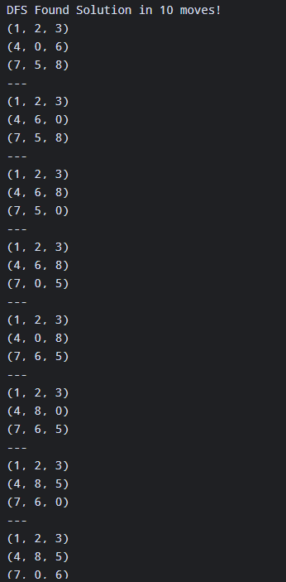

2. Iterative Deepening Search (IDS)

goal = (1, 2, 3, 4, 5, 6, 7, 8, 0)
initial = (1, 2, 3, 4, 0, 6, 7, 5, 8)

def get_neighbors(state):
neighbors = []
zero_idx = state.index(0)
row, col = zero_idx // 3, zero_idx % 3

moves = [(-1, 0), (1, 0), (0, -1), (0, 1)]

for dr, dc in moves:
r, c = row + dr, col + dc
if 0 <= r < 3 and 0 <= c < 3:
new_idx = r * 3 + c
state_list = list(state)
state_list[zero_idx], state_list[new_idx] = state_list[new_idx], state_list[zero_idx]
neighbors.append(tuple(state_list))

return neighbors

def dls(state, limit, path, visited):
if state == goal:
return path
if limit == 0:
return None

visited.add(state)
for neighbor in get_neighbors(state):
if neighbor not in visited:
result = dls(neighbor, limit - 1, path + [neighbor], visited.copy())
if result is not None:
return result

return None

def ids(start, max_depth=20):
for depth in range(max_depth + 1):
result = dls(start, depth, [start], set())
if result is not None:
return result, depth
return None, max_depth

path, depth = ids(initial)

if path:
print(f"IDS Found Optimal Solution at depth {depth} ({len(path) - 1} moves)!")
for step in path:
print(step[0:3])
print(step[3:6])
print(step[6:9])
print("---")
else:
print("No solution found within maximum depth limit.")

output :
