Caption Kanban
Application Documentation Report
A premium productivity and collaboration platform designed to organize tasks, boards, workflows, realtime teamwork, and smart project management.
May 2026

1. Splash Screen
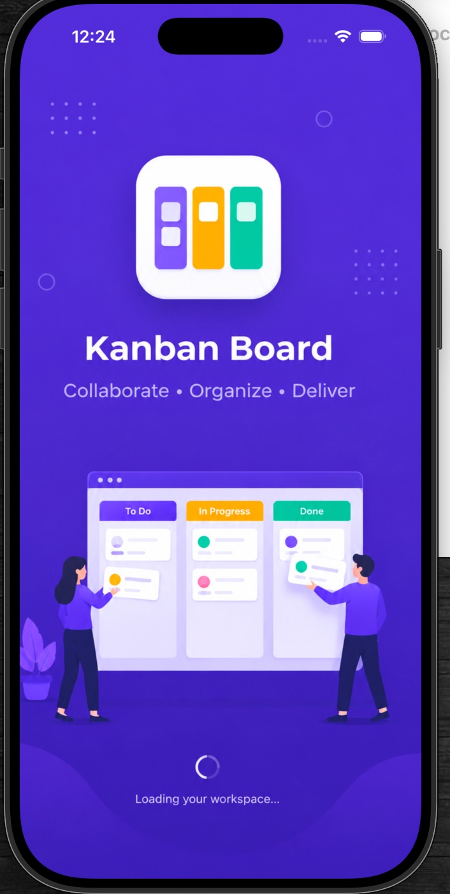
Figure 1 – Splash Screen with Kanban Board branding and loading animation
The Splash Screen is the initial screen displayed when the application starts. It presents the branding of the "Caption Kanban" application with an attractive user interface and loading animation. This screen improves user experience by giving a professional first impression while initializing Firebase services and loading user data.

Features
- App logo and branding
- Animated loading indicator
- Modern gradient UI design
- Initial Firebase setup and session checking

2. Login Screen
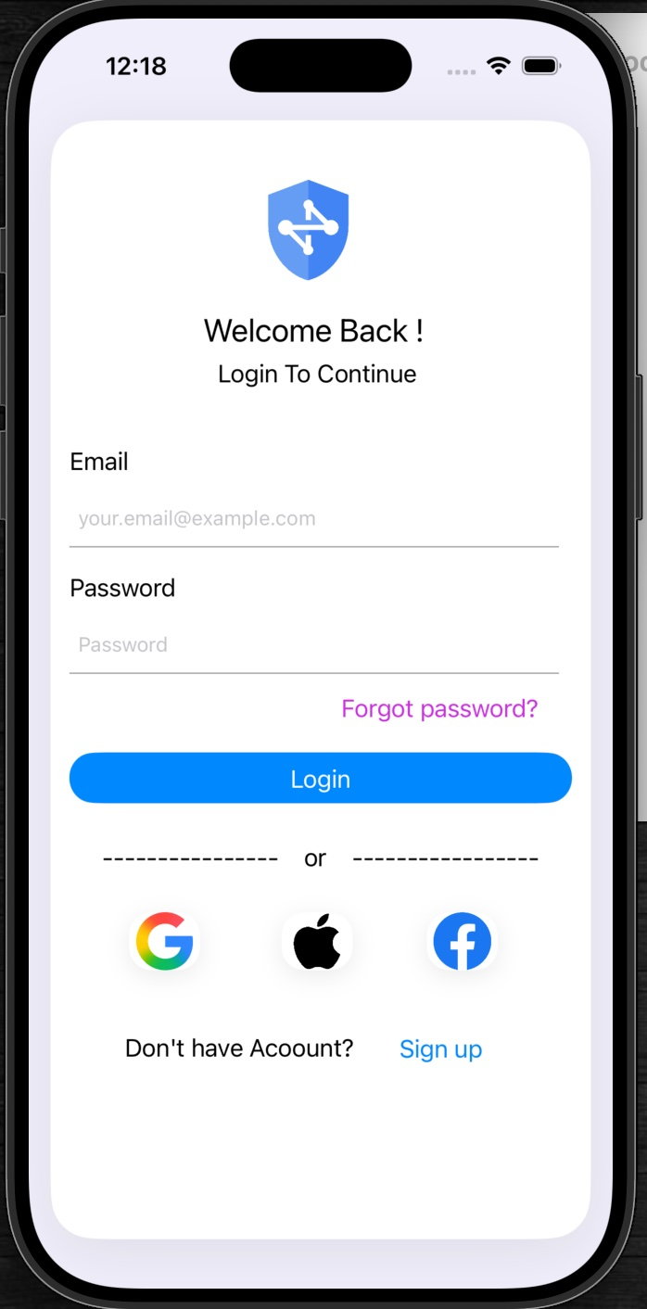
Figure 2 – Login Screen with email/password and social sign-in options
The Login Screen allows registered users to securely access the application using their email and password. It also supports social authentication methods such as Google, Apple, and Facebook login for faster and more convenient access.

Features
- Email and password authentication
- Forgot password option
- Google, Apple, and Facebook login integration
- Firebase Authentication support
- Input validation and secure login handling

3. Signup Screen
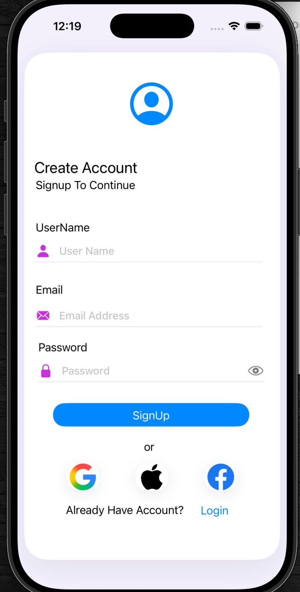
Figure 3 – Signup Screen for new user account creation
The Signup Screen enables new users to create an account in the application. Users can register by entering their username, email address, and password. Social signup options are also provided for simplified registration.

Features
- User registration form
- Password visibility toggle
- Social media signup integration
- Firebase Authentication integration
- Secure user account creation

4. Google Authentication Screen
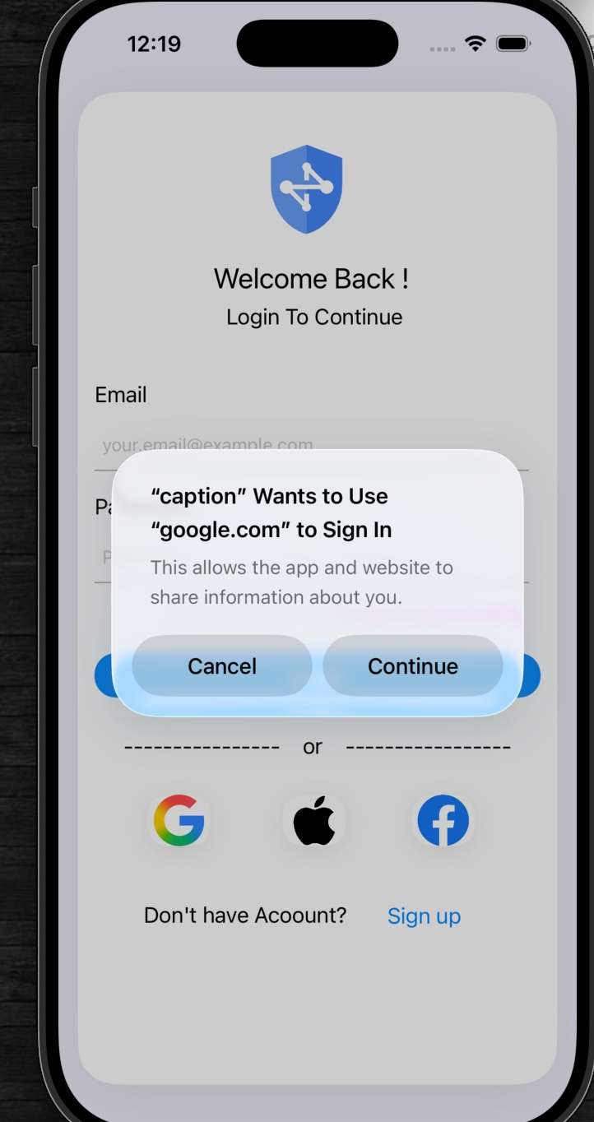
Figure 4 – Google Sign-In permission dialog triggered from the Login Screen
This screen demonstrates the Google Sign-In integration used in the application. It securely authenticates users using their Google account through Firebase Authentication services. When a user taps the Google icon, iOS presents a permission dialog confirming the app wants to use google.com to sign in, and the user may proceed or cancel.

Features
- Secure Google OAuth authentication
- Firebase Google Sign-In integration
- Quick account access
- Simplified login experience

5. Home Dashboard Screen
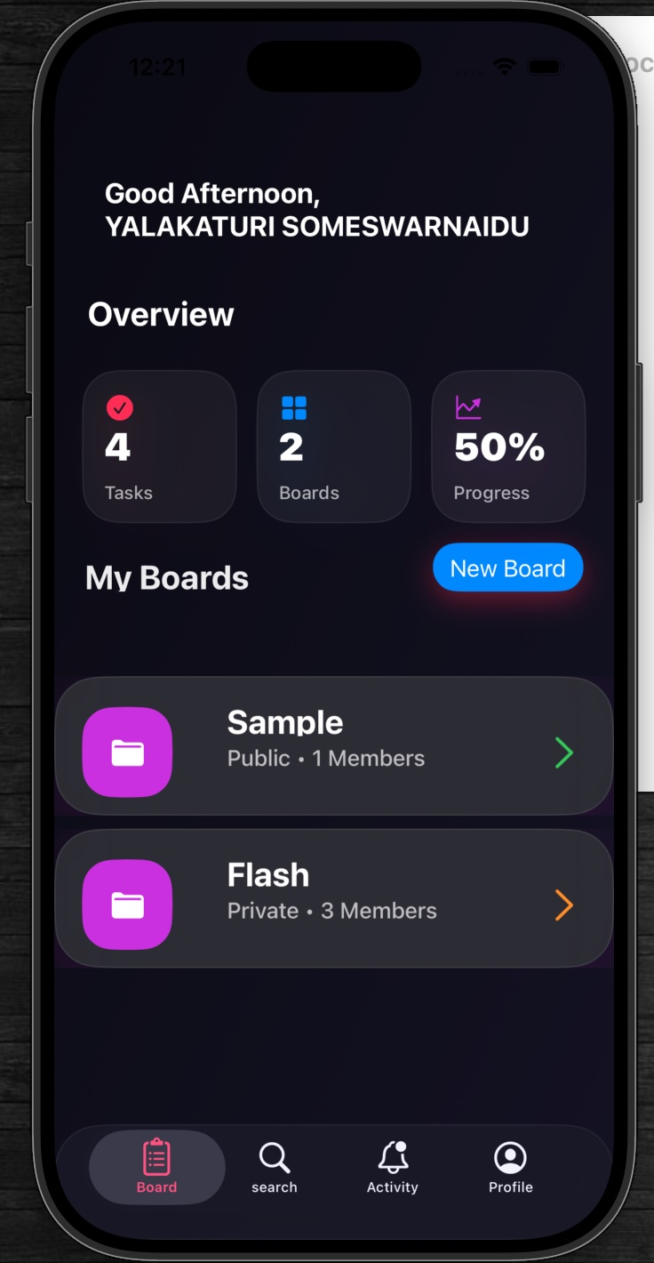
Figure 5 – Home Dashboard showing task stats, boards, and progress overview
The Home Dashboard provides an overview of the user's productivity data including total tasks, boards, and overall progress. It acts as the central workspace where users can quickly access and manage their boards.

Features
- User greeting section
- Task statistics overview (Tasks, Boards, Progress %)
- Board management with quick navigation
- Progress tracking
- Bottom navigation bar (Board, Search, Activity, Profile)
- Real-time Firebase data fetching

6. Create Board Screen
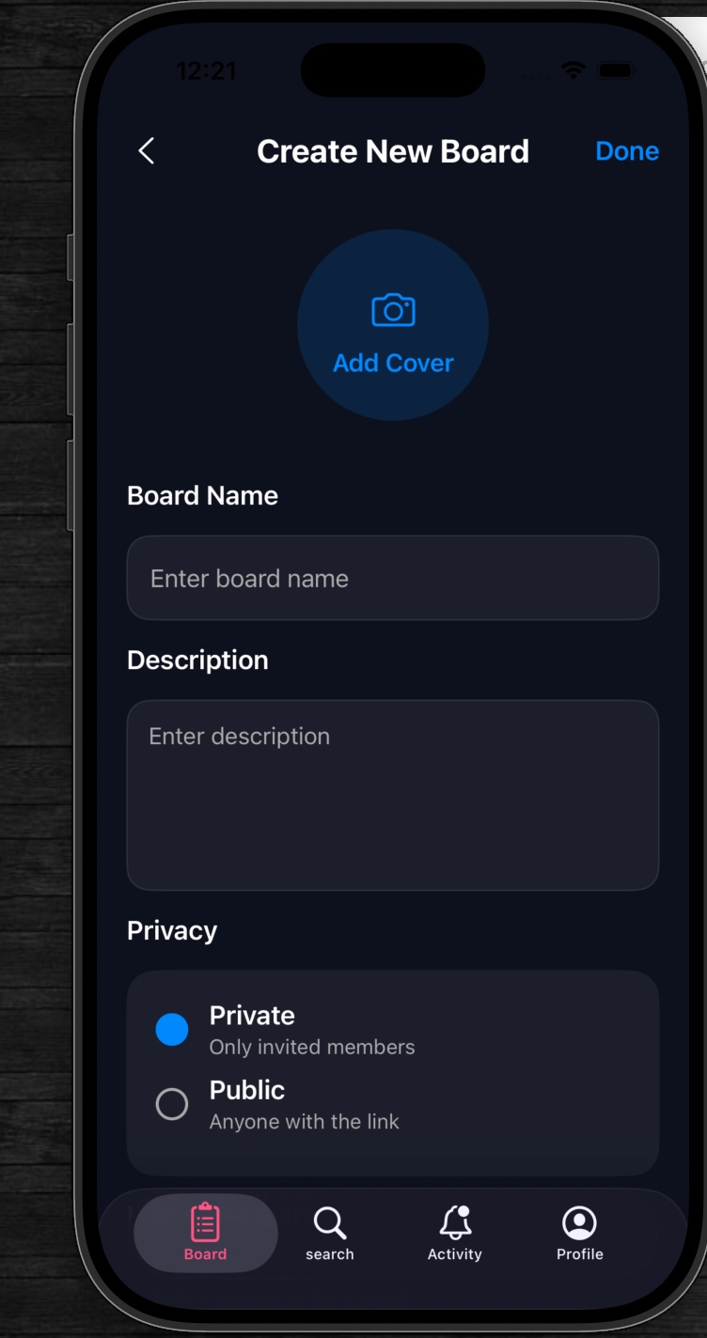
Figure 6 – Create New Board form with privacy settings
The Create Board Screen allows users to create new Kanban boards by entering board details such as board name, description, privacy settings, and cover image.

Features
- Board creation form with name and description fields
- Cover image upload via camera icon
- Public and Private board options
- Firebase Firestore integration
- User-friendly form validation

7. Board Details Screen
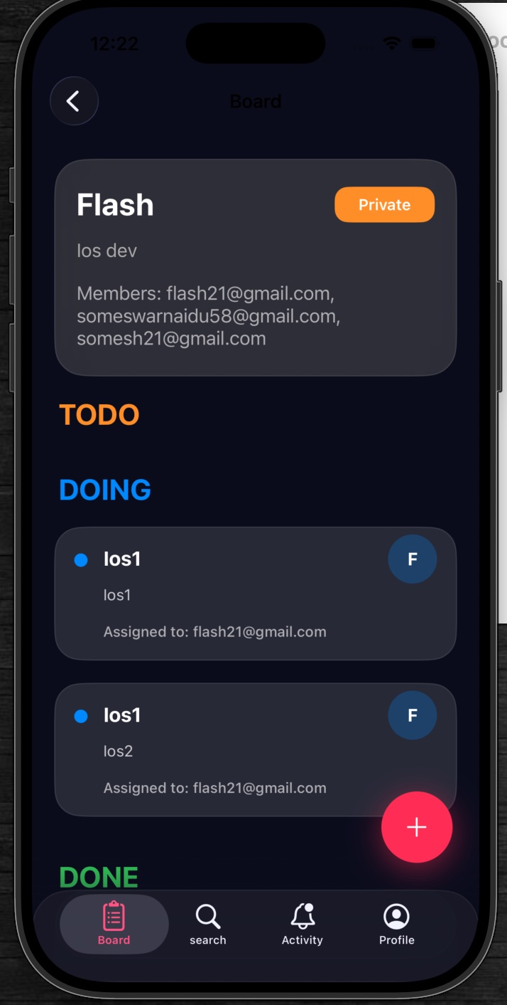
Figure 7 – Board Details showing TODO, DOING, and DONE task columns
The Board Details Screen displays complete information about a selected board, including members and categorized tasks such as TODO, DOING, and DONE. It helps users manage project workflow efficiently with a classic Kanban layout.

Features
- Task categorization across TODO, DOING, and DONE columns
- Member management with email display
- Real-time task updates
- Kanban workflow management
- Firebase cloud synchronization
- Interactive task cards with assignee info and floating + button

8. Create Task Screen
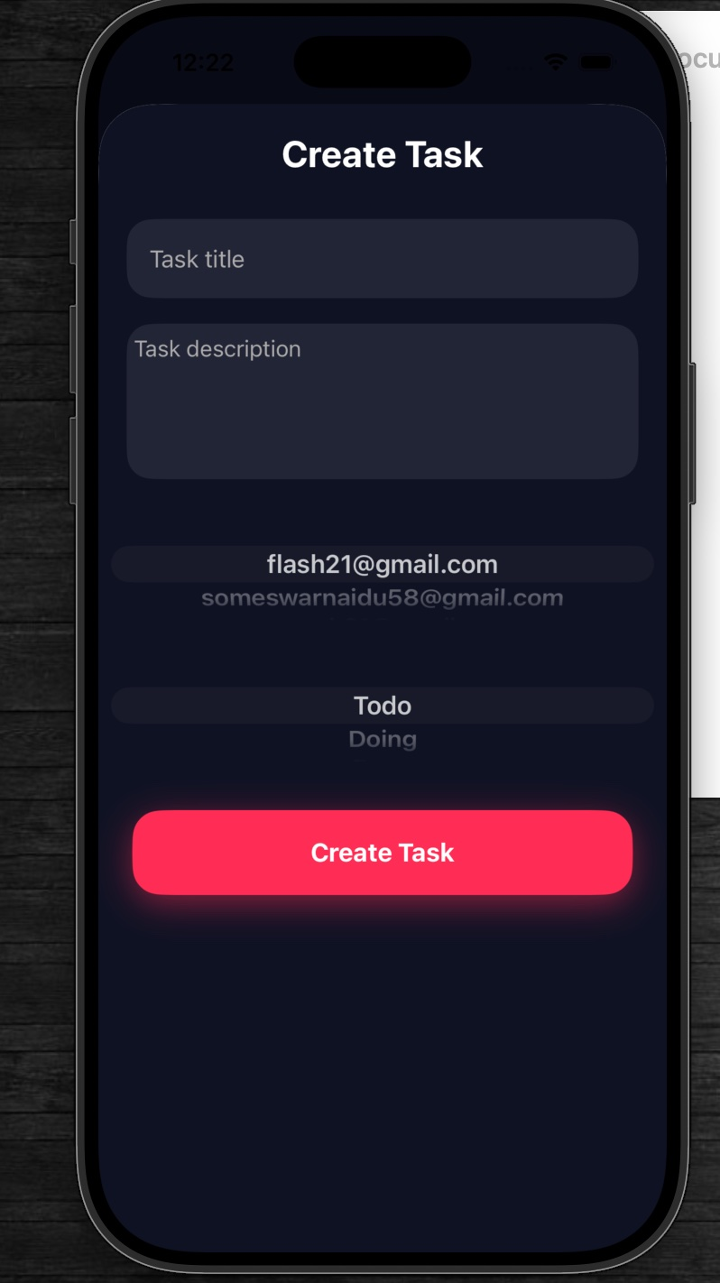
Figure 8 – Create Task sheet for adding tasks to a board
The Create Task Screen allows users to add new tasks to a selected board. Users can enter task details, assign members, and select the workflow status such as Todo or Doing. This screen helps teams efficiently organize and distribute work within the project.

Features
- Task title and description input
- Member assignment functionality
- Task status selection (Todo / Doing)
- Real-time Firebase Firestore storage
- Simple and user-friendly interface
- Workflow management support

9. Search Screen
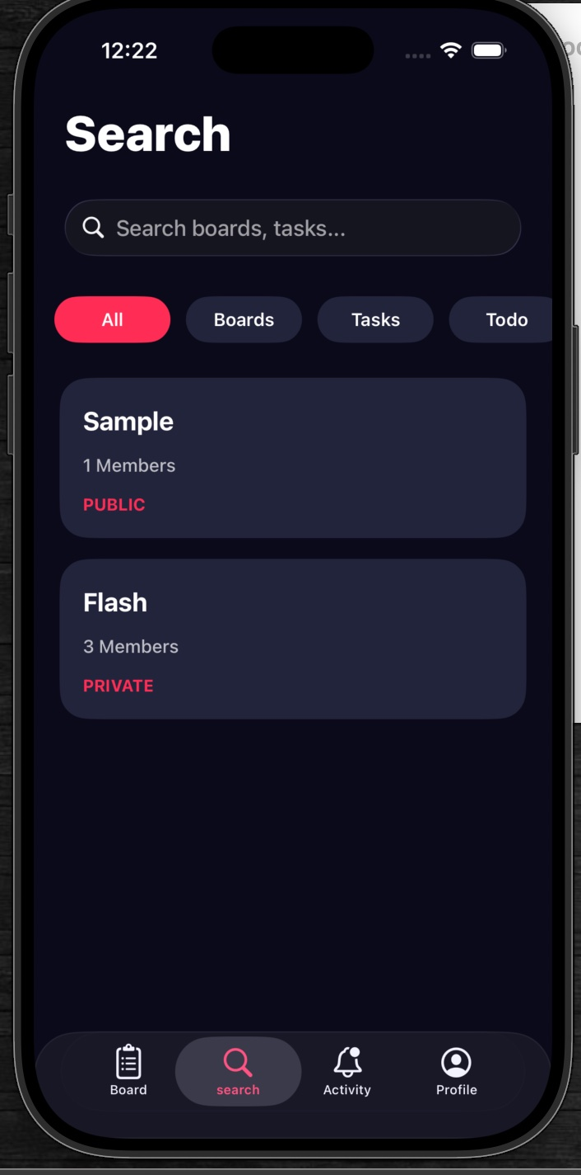
Figure 9 – Search Screen with All / Boards / Tasks / Todo filters
The Search Screen helps users quickly search and filter boards or tasks within the application. Different category filters improve navigation and accessibility for large project data.

Features
- Real-time search functionality
- Board and task filtering
- Category-based search tabs (All, Boards, Tasks, Todo)
- Dynamic search results display

10. Notifications Screen
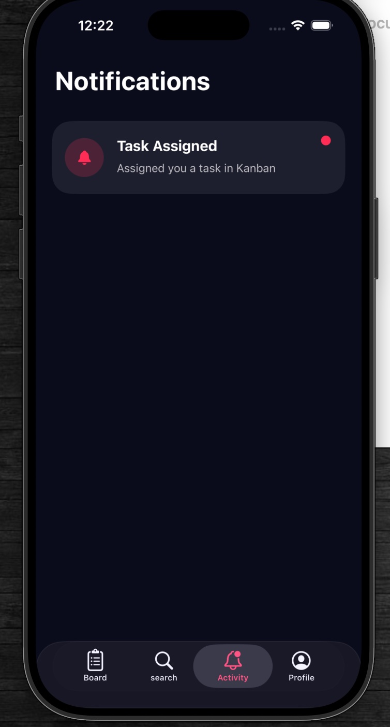
Figure 10 – Notifications Screen showing task assignment alerts
The Notifications Screen displays important updates and alerts related to board activities and assigned tasks. It helps users stay informed about project progress and collaboration activities in real time.

Features
- Task assignment notifications
- Real-time activity updates
- Firebase-based notification handling
- Unread notification indicators (red dot)
- Clean and organized notification cards

11. Profile Screen
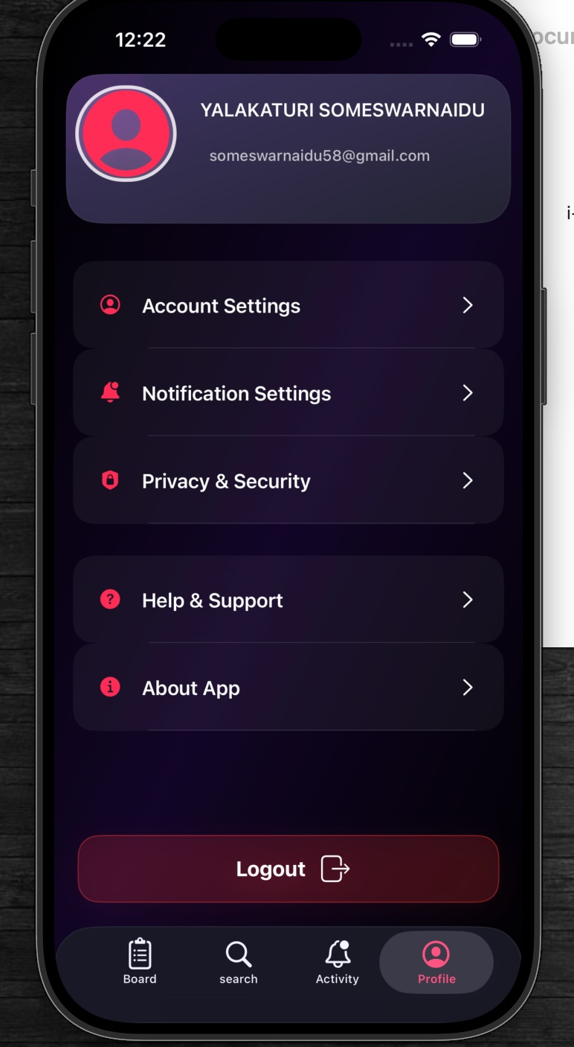
Figure 11 – Profile Screen with account settings and logout
The Profile Screen contains user account information and application settings. It allows users to manage account preferences, privacy settings, notifications, and logout functionality.

Features
- User profile details (name and email)
- Account Settings
- Notification Settings
- Privacy & Security
- Help & Support and About App
- Logout functionality

12. About Application Screen
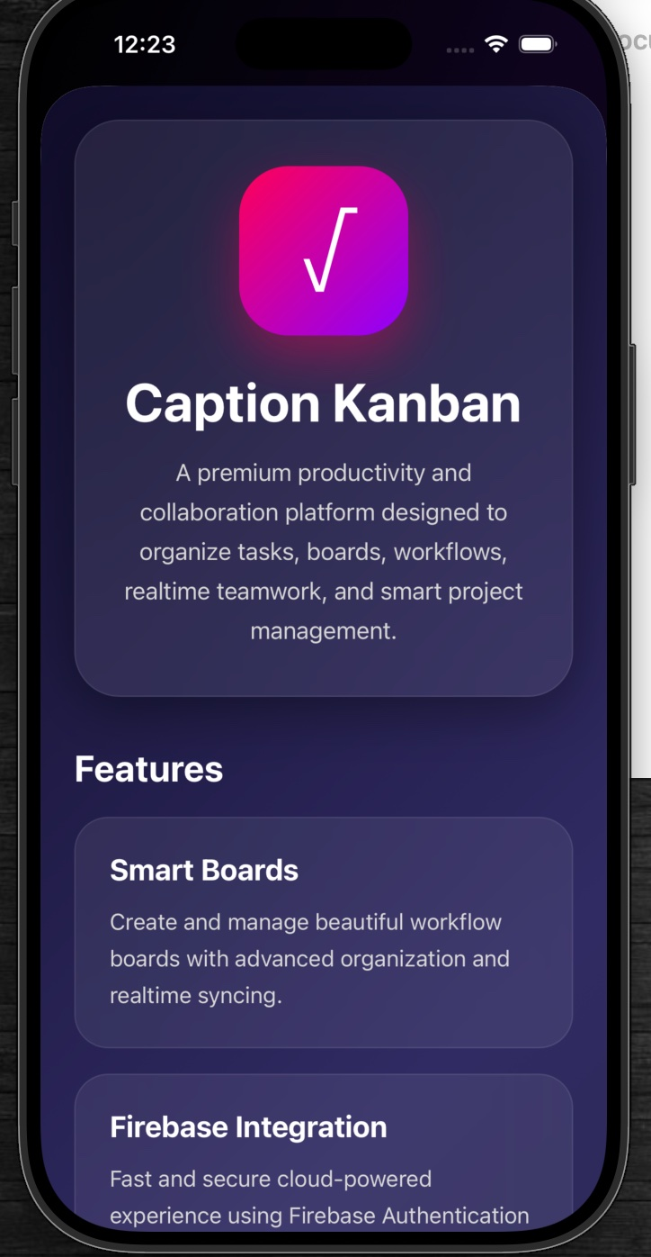
Figure 12 – About Application Screen highlighting features and Firebase integration
The About Application Screen provides information about the "Caption Kanban" project, its purpose, and core functionalities. It highlights the technologies and features used within the application.

Features
- Application overview and description
- Smart Boards feature description
- Firebase Integration details
- Project workflow explanation
- Modern UI presentation

