Glaucoma Detection ​Using Deep Learning

B.Akhileswar Reddy, G Someswara Reddy, K.Lokesh, Ms.Sree Vidya, Mr.Rajesh

*Department of Computer Science and Engineering,  
Amrita School of Computing, Bengaluru,  
Amrita Vishwa Vidyapeetham, India*

**Abstract:** **The work of eye doctors is to examine in detail all the scans of eyes in order to decide whether the patient has glaucoma or not. This glaucoma diagnosis system project is going to use cutting-edge deep learning techniques like EfficientNet, ResNet, and MobileNet to build an effective system. The use of such models is to develop an efficient and comprehensive system for glaucoma diagnosis. This system will be available by means of a user-friendly website interface where one would do a remote test for signs of glaucoma. This program is very much vital for eye clinics; it is a scalable and accurate tool to determine and manage early glaucoma cases thus eye health outcomes will be improved.**

**Key Words: Deep Learning, Glaucoma Detection, Efficient Net, Web Application**

**I.Introduction**

Among the numerous ocular diseases, glaucoma is the most serious disorder resulting in optic nerve injury and even up to blindness. It is by far the main cause of eye impairment globally. The early diagnosis which is paramount for avoiding any vision problem. Glaucoma diagnosis requires a specialized device and professional training to use it, but in order to screen the largescale populations in countries without enough resources, this becomes a challenge. Consequently, our research concentrates on a fresh technique, which is the deep learning solution for glaucoma detection. This might lead to the establishment of local screening posts and the beginning of more user-centred paths.

A subfield of AI, referred to as deep learning, has been developing quickly and has become popular for image analysis and especially for diagnostic medicine. Such is the case of the convolutional neural networks (CNN), which are deep learning models, can identify even the minute patterns visible in medical images or micro-level patterns and thereby reach a great level of accuracy. It produces in them such situation where the entire team is engaged in glaucoma diagnosis. CNNs can be applied in image analysis more which can be used in the model development to determine the presence of glaucoma.

Concerning the glaucoma detection system we will implement RNNsS, this will be used in combination with the Convolutional Neural NetworksS. RNNs successfully wrestle with this wide functionality by successively processing data that may be important to the scrutinization of glaucoma degeneration over time as well. Along with the full exploration of the VGG19 structure that is highly complex and well-known for being effective in the area of image classification, the underlying construction of the network will also be inspected. VGG19 can be employed as an alternative method in detecting meaningful elements which facilitates feature extraction and representation; as a result, this network will deny false positives and boost the performance.

A user-friendly web-based screening platform for glaucoma has been successfully developed by the team I do. This instrument is simple to use, one just needs to take a retinal photo and send it to the website for diagnosis. with this, it will go on about determining the possibility of glaucoma in real time. We believe that the project will achieve this goal through enabling the increasing availability of screening tools because of this healthcare professionals and individuals will be empowered to to proactively watch and maintain their health of the eye. This will enable people to get diagnosed and treated in time before the condition gets worse.

The granting of deep learning in the diagnosis of glaucoma could greatly be improved if not technically the eye care sector. Primarily this is possible over areas where there is scarcity of specialised ophthalmologists. Through AI and modern web tools amplification, we aim to achieve the objective of decreasing the effect of glaucoma related blindness and improving vision results globally. This strategy opens up the possibilities to renovate the ophthalmology area where the poor communities are being reckoned in greater hazards.

**II.Related Works**

[1] The paper "Glaucoma Detection using Image Processing Techniques: A Literature Review is a short article, which speaks about the functionality of early glaucoma detection and the role of automated image processing in diagnosis of this disease. In this section, the paper explains the various types of glaucoma, Clinical diagnosis methods are discussed, different retinal datasets are presented and Information on how to extract anatomical components from retinal images is provided. It consists of critique of existing strategies and an identification of the challenges and a direction in which research may move in. It makes clear the importance of the development of the precision diagnostics technologies, of which early diagnosis plays the prominent role in reducing the unaccounted cases and costs. [2] The paper brings a deep learning model known as ALADDIN, which performs the detection of glaucoma from eye images relatively unsupervised. Decompose the deep convolution neural networks by which it learns unique features on the fundus image. The proposed technique embraces the use of multilayer perceptron and a tailor-made training strategy for the high accuracy of detected glaucoma cases. Conductive tests on the ORIGA and SCES datasets maintain a lead in production, scoring above all currently available methods with AUC metrics of 0. 838 and 0. 898 respectively. Developed new approach to the digital diagnostics of glaucoma based on deep learning algorithms, the method thus has a potential to be applied to the early detection of ocular disorders. [3] This paper argues for an AI-guided Convolutional neural network that can locate and damage and examine the area without the assistance of a human surgeon. This encapsulates the AG CNN model that consists of two individual subsets, the attentional pathology prediction subnet and the pathological area localizing subnet. The following text summarizes a model of the AG CNN which is used to solve a particular problem. However, this strategy fulfilsS the needed accuracy of those conditions when they occur rather than gathering the information before that. Thus, the development of this work has proved the effectiveness of the method. The research is constructed using LAG dataset for both the trial and verification process, with part of the analytics performed using the RIM ONE information. which consists of optometrists specifically on the care so that the attentional process is effective and the visual field is enhanced during treatment should be enhanced. AI-driven CNN technique is a portrait of its high overall accuracy of both glau­coma detection and condition diagnosing. They differ this way since the model does not just indicate the work space but instead the area which is called the beaten path defeat than the other existing methods evidently by the indexes applied. [4] What is presented here is the problems of a disease known as glaucoma, which the reason why there should be reliable eye tests accessible to our customers. Now this gives rise to the other part of the story, i.e. the shortcomings of the existent surveillance units and how crucial is to stand up and make the necessary changes. The method that will be used is a deep learning based model that contains six levels of neural networks. These levels include convolutional layers, response normalization layers and overlapped pooling layers, the most useful features of which are to be used for the recognition of glaucoma disease patterns in eye images. Two data fare, ORIGA and SCES, are included in the situation with the composite AUCs that are designed to produce the positive outcomes. 882 and 0. 822 respectively. The work in the other parts of the article considers other machine learning approaches besides the CNN approach, and establishing the proposed CNN based technique as a reliable approach which has been proved to be an efficient way of the glaucoma detection is discussed in details. [5] The aim of this work is to help diagnosing the glaucoma with an automated procedure relying on the feature extraction methodology from fundus images. The way it works is by means of the histogram and texture and fractal patterns extracted from the obtained ocular images by using analysis and diagnosis of the glaucoma. The other approach which is different from the first one involves the use of a convolutional neural network which is the most suitable network that results in a more accurate feature extraction when it is compared to the other options. The survey illustrates automatization of analysis that is aimed at reducing human participation to avoid subjective rating and as a result enhance the accuracy of diagnosis. Moreover, the paper examines the effect of noise and lighting on medical images and introduces the main methods of enhancement and segmentation including principal component analysis and Canny edge detection, which are covered in the second part. [6] A diagnostic method of glaucoma visualized by digital eye images that we used is the media. This part describes the image processing methods for glaucoma diagnosis and compares the images of normal and glaucoma eyes. The methods of working on the images include gaining of the noise free image, enhancing the contrast, analysis through PCA to identify the key features, and finally classifying the images using the SVM algorithm. MATLAB software holds these methods and allows the user to implement any of the included image processing options. This paper aims at exploring type 2 diabetes and glaucoma which are conditions that impair the optic nerve resulting in vision loss. The major harm is a result of intraocular pressure (IOP) or even sometimes in cases of normal IOP.[7] The paper describes a ground breaking and very effective application of color fundus photographs in detecting glaucoma. By way of employing an efficiently tuned convolutional neural network architecture, the system is able to reflect outstanding results performance-wise, including the accuracy of 97. 4 cross accuracy and 97 percent. 3% F1 score. Implementing the You Only Look Once (YOLO) CNN model, an objective and efficient tool is demonstrating its potential in glaucoma detection. Additionally, the approach is compared to famous CNN models as the accuracy and computational efficiency shows the high-performance feature it has. [8] Paper presented on the outstanding innovations of deep learning that are successfully used to diagnose glaucoma. This program is aimed at proving the necessity of early detection to save eyesight. The paper summarizes the processes by which these visualization methods provide easy comprehension and transparent operation of those models. The experiment designs the MobileNetV2 network on the G1020 dataset, focusing on glaucoma differentiation. The paper points to the great potential of AI, deep learning in particular, in changing the approach in glaucoma diagnosis and management with the help of the cutting edge technology tools such as transfer learning and data preprocessing.

[9] This novel method which employs a densely connected neural network with 201 layers, is proposed in the research to detect glaucoma early by the system. The designed system scored at about 97% accuracy and F1 score of 0.0. 969. The importance of early detection of glaucoma is vital because glaucoma can lead to permanent blindness to left untreated. Researchers stress on using digital imaging and the deep learning techniques for glaucoma diagnosis and, thus, helping to develop non-invasive and dependable diagnostics methods. The paper shows a performance of a new Dense Net 201 model versus the previous DenseNet121 model to determine which approach is more effective. The research concludes by mentioning aspects of the evolving model that need to be improved, revealing areas for future optimization and better results. [10]

The approach with involvement of the dense and highly interconnected DCNN is used for the pilot part of diagnostic processes implemented in the early stage of the procedure. As a result, the team with researchers got up to 95 accuracy from applying the 121 Dense Net that was already in a pre-training mode. The model evaluates 6% of the labels to be correct and the F1 score comes out to be 0. Foundation of our clinical trials is the algorithm that was created for the detection and monitoring of glaucoma of both the early and advance stage. The accuracy is the 97% one among the dataset we have. This helps identify the unsatisfactory performance of the convolutional network as a comparatively cheaper tool to carry out screening and thus save the many people who suffer from blindness at the later stages which unfortunately are considerately serious and only a few patients are identifiable at the early stages before the pathology has surpassed the conjunctiva and has caused the optic nerve damage which is permanent. [11] This paper will present a technical strategy for laying the photomontage implemented for glaucoma detection on retinal fundus pictures. It, such as the ability to morph objects through a range of classes represented by the features that it picks to give the best output. It is primarily the better performance of this desktop application that makes the practice of medicine easy to perform everywhere in the world, including disadvantaged areas. This also aids in creating strong global outlook among doctors. The model is highly proficient and it proves its effectiveness by impeccably predicting the segmentation and the pressing cases of glaucoma or healthy ones can even be predicted in real world. The APTOS and HRF (Humanoids Research) provide these possibilities. It accomplishes these tasks, including the incapability to detect the peripheral papillary atrophy in the presence of wet macula and the need for either strip data or labeled datasets which is a challenging issue. The developed assessment plan was implemented based on datasets that have not been explored before and has proven to have high sensitivity and accuracy which is also a confirmatoin that the method can be used as a robust and generalizable. [12] This paper is Classification and Diagnosis of the various diseases among them breasts complication, heart and eyes glaucoma The metrological approach mechanism is mannered by the measurements of the shape, the texture analysing techniques and various algorithms. The paper presents the ways, feature extraction techniques, and methods precision as the implementation of various researchers’ website messuages like the imaging using machine learning. It shows how the approach by Correntropy and others ways such as Wavelet Transforms can be used to achieve highly reliable glaucoma detection method. [13] The approach then elucidates the databases classification and image collection role in image processing and medical categorization to accomplish medical image processing and classification research study. This article report a new machine learning approach to deal with the glaucoma detection utilizing the fundus images by building a system incorporating the Inception v3, VGG19, and ResNe­t50 models. The study dedicates some more cells to analysis of rival study, with an example of the neural network getting to 98 % of the accuracy of the algorithm. With a mean of 52% the IBM Inception model is used, data augmentation is performed, and techniques like U-Net and attention architecture are used to segment optic disc and cup respectively. Examples of the datasets utilized are RIM ONE and ACRIMA and the parameters were i. e. Dice Coefficient and Jaccard Coefficients as well as accuracy, sensitivity, and specificity which were used for the assessment of the performance. The study becomes the reason why deep learning matters for medical imaging with an in-depth analysis on glaucoma diagnosis.

This work is a deeper look on the deep learning valuable in glaucoma Diagnostics [14,15]. So, the goal structure the scientists generated neural network models with the whole-optic disc initiallyS being fed by cropped fundus images focusing only on the cup and disc portions. However, we got larger images as the outcome of this, what resulted to low accuracy and overfitting, but this amended the diagnostic performance by cropping areas. The various parameter for evaluation of the system efficiency was set equal to confusion matrix, validation accuracy and also another common metrics that are precision, recall and ROC- AUC applied for computer vision and deep learning tasks respectively. Culture disease, this essay focuses on the application of performance learning methods especially the attention to every convolutional neural network [16], looking for abnormality’s early stages of either cancer kind. The perceptron-based NN and the CNN CTC also provided very good outputs with a accuracy of 98%. 6% of women point out colon cancer, breast cancer, oral cancer and skin cancer. Accordingly, the early detection of cancer turning out to be what matters for effective treatment of cancer is evidenced in this study. Beyond that, it will do so by creating an intuitive interface which people will find easy and understand and display the inputs and the outputs. As the genuine results are being produced, this approach can also be extended to other cancer types as well as SVMs classification method as a technique to try out. This work endeavours to construct a research project employing methods for improving a convolutional neural network models for image analysis for medical images. [17] The scan is carried out by the use of microscopic images to facilitate the diagnosis of TB and also by the sound of cough from an obstructed lung to diagnose pneumonia. The article includes creating the comparisons between algorithms for optimization, Adam, SGD, and Respro, having these metrics: accuracy, recall, and precision. The subject of this data set is the Chest X-ray images provided with the Train, Test and Validation subset. Study performs the pre-trained CNN with a multi-convolutional and max-pooling layers to catch very important features and dropout to prevent overfitting. The results seem that at training and testing with RMS Prop optimizer, there is the high accuracy as well as good recall and precision for pneumonia detection, thus, the model should be validated correctly. [18] The analysis applied to Twitter messages can be called sentiment analysis, as it implies an emotive value to the tweets. While its intention is to employ the algorithms for deep learning and machine learning with the motive for sentiment classification in these messages, it leaves a number of questions that need answers. The article looks into the frequently occurring sentiment analysis tactics, which include finding all emotionality comprised in the gathered data. The last paragraph therefore gives a glimpse of the function of sentiment analysis in various organizations as majority picked which include instance, sentiment analysis in cyber reputation management and improvement of services. The former point in the paragraph is concerned with approaches and measures of evaluation used while developing the testing models.

The writing style that I have to foster is supposed to be pure without other ornament wording because I need simple words to get the idea clear and concise. Both the words and the tone are carefully picked to meet the requirement and the tone is clear and undisputed like a historian is sharing the topic with the general audience. this article proposes on a breast cancer dent using deep learning as its main mechanism. [19] This framework would achieve this by doing a parallel comparison and evaluation of the SVM-CNN framework as compared to other vision-based detection models like VGG16, RESNET 50, and INCEPTIONV3 for breast cancer detection. The data‐set consisted of a total of 3,538 online reviews. Figuratively, one can interpret such results to mean that SVM CNN model was the most efficient since its accuracy was 93%. The Instructional Model’s rollout has a 35 percent higher performing rate as compared to similar models of its kind. The re­­­­search puts the importance of early breast cancer detection as well as it shows possibilities of automated image classification by machine learning algorithms for the better and quicker diagnostics. These functions allow the doctors to not perform invasive and hence vulnerable procedures that include breast biopsy. T1 [20] The article illustrates the concept of tomato leaf disease recognition based on model designed using PyTorch and CNNs. ResNet model yielded a great accuracy of 97% following down sampling process. The orchestration of deep learning methodology, data augmentation, and transfer learning facilitates the model to gain plenty of knowledge. Moreover, the model is resistant to overfitting problem. Therefore, in addition to forecasting of issues such as diseases, the model acts as an inseparable tool to farmers detecting tomato diseases. The system uses ResNet-50, an already trained network of 50 layers with speedier learning patterns among the other existing models. The hypothesis starts by clarifying the problem that CNN has been encountering followed by the description of CNN and ends by highlighting the success of the medical plan. Startingly, the model had a very high accuracy (as high as 94%) but then we took data augmentation in this model in order to improve its overall accuracy. This measure also increased the outflow of goods and resources, which initially reached 61% and later went up to 100%. That accuracy is 0 indeed. 1% once having the new class enriched and for the new calculation of six classes.

III. METHODOLOGY

**a. Dataset Description:**

This dataset has been developed for the classification problem; it aims at determining whether the glaucoma eye disease is present or not in eye images. Glaucoma is a collection of eye diseases that are aggressive on the optic nerve – a pillar for clear vision – and are mostly associated with high eye fluid pressure level. Early detection is vital to prevent vision loss.

Classes:

“Glaucoma Present” = 1

“Glaucoma not Present” = 0

Data Splits:

Training, Testing, Validation each containing images labelled as either "Glaucoma Present" or "Glaucoma not Present.

Training Data

Number of images: 10,000

Purpose: Used to train the machine learning model.

Test Data

Number of images: 3,000

Purpose: Used to evaluate the performance of the model after training.

Validation Data

Number of images: 4,000

Purpose: Used to tune the model's parameters and make decisions on model improvements during the training process.

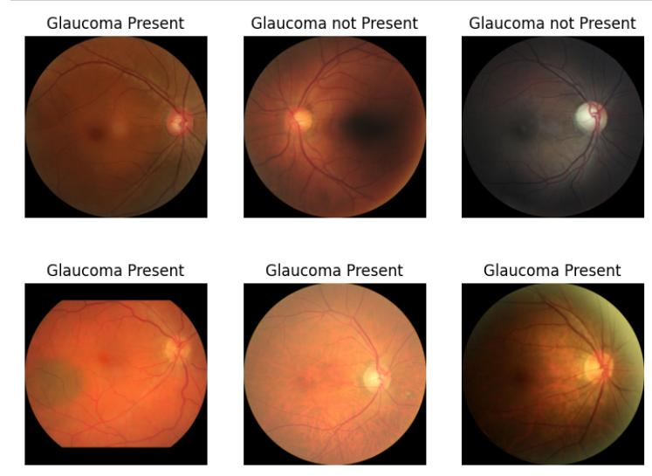

Fig 1: Scans in the Dataset

**b. Image Transformations**

* Training Transformations:

This will help the model to learn better by applying the images' resizing randomly cropping the images, flipping images horizontally and vertically, and applying slight rotations and translations. By the way, we randomly delete some parts of some images to make the model more robust against the flaws.

* Testing Transformations:

In the case of testing, the images remain in their original size, and the extra augmentations will not be applied in order to keep the uniformity, and this very process will be performed for the model to solve its problems and to accomplish the data visualization tasks of the model as well.

S

**c. Model Selection**

Examining various deep learning models for the purpose of glaucoma detection on eye photographs, we explored the ResNet, MobileNet, and EfficientNet architectures. Each model comes with its advantages and limitations, which empowers them to be suitable for different parts of computer vision for this task. In continuation of our previous explanation, here is a brief description of each of the three models and their relevance to& the project.

ResNet (Residual Networks)

ResNet (which stands for Residual Networks) is a powerful vision learning approach that introduces the residual learning paradigm, allowing for the training of deep neural networks through solving the problem of vanishing gradients. The main innovation in ResNet is to use the shortcut connections that miss one or more layers so that the network learns only the remainder functions with respect to the layers outputs using weight layers. This method is especially profound in image classification tasks where the network is able to have the large number of layers without the issues of performance degradation. ResNet, for example, provides the most effective platform for identifying glaucoma by using the myriad of light and dark spots in the eye images.

MobileNet

MobileNet is developed for efficient and low-powered execution on both mobile and edge devices, which makes it a good candidate for deployment in the said platforms. It is able to achieve the right balance between accuracy and computational cost by implementing depth-wise convolution. This move in turn reduces the number of parameters a great deal, as well as the overhead of the computational load versus regular convolutional networks. Its primary-use case is in health care, where there might be limitations in the computational resources. For instance, in the case where real-time glaucoma screening on portable devices is necessary, MobileNet promises to be exceptionally beneficial. That is because its small size allows for fast and efficient image processing.

EfficientNet

EfficientNet is the band of models which use a compound scaling method to conserve network dimensions (depth, width, and resolution) in a principled fashion. It is also the one which is extraordinarily accurate even with few parameters and low computational cost. As a result, EfficientNet is often the model of choice for the glaucoma detection team since it confuses high performance with pretty low computational cost. The pacing scaling concept is to make sure that there is a balance of the particulars of eye images, so even without pushing the computational toll hitherto, the detection precision is improved.

**d. Model Evaluation**

Once we had trained the ResNet, MobileNet, and EfficientNet models using our glaucoma detection dataset, we proceeded to evaluate their capabilities by means of key metrics. These were accuracy, precision, recall, and F1-score. These testing measures, in turn, furnish a solid documentary of how each particular model shows a reasonable performance in identifying glaucoma in eye images.

Evaluation Metrics

Accuracy: The Accuracy is a fraction of the true positives which have been classified correctly out of the whole number of images.

Precision: It is the fraction of true positives which are predicted among all the positive predictions the model makes. It is a measure of the accuracy of positive predictions.

Recall: The Recall is the ratio of true positive predictions which are predicted correctly out of the actual positive cases. It shows the model's ability to identify all positive cases.

F1-score: The F1-score is a harmonic mean of precision and recall, which is the only metric that takes into account both positive and negative examples.

**e. Testing with Web Application**

To make the glaucoma detection model accessible and user friendly, we developed a web application in which the user could upload his eye scan and get an immediate prediction of glaucoma availability. Below is the detailed process associated with this particular task:

**Model Selection and Preparation**

After analysing multiple model options, it was decided that EfficientNet was the most optimal choice as the model demonstrated an outstanding accuracy level for glaucoma detection. Additionally, the model was balanced on three key evaluation metrics: precision, recall, and f1-score. Consequently, it was chosen as the final model and trained. It has shown the following characteristics on our dataset: accuracy – 94.0%; precision – 94.0%; recall – 94.0%; f1-score – 94.0%. Once the model was trained, it was saved using the pickle Python module for convenience and simplicity during loading and deployment.

**Web Application Development**

Practical online portal was developed for patients or healthcare providers to upload retina scan images and get instant eye challenges photos.

The web application has been created through using a couple of front-end and back-end technologies on isolating behind-scene operations from the interface handling.

**Workflow of the Web Application**

**User Interface**: Members of public have an opportunity to browse the website anytime using their web browsers. The interface is a simple button for uploading eye scan images and the guide of its functioning application. The tutorial is the beginning and will provide the user with the knowledge on how to start the process easy and simple.

**Image Upload:** User will input camera reading data into the right window indicated by letter (a). g. , JPEG, PNG). Image uploading is eased and fast because the app checks if the image is the desired resolution and quality.

Eventually, the process is completed when the application will load the pickled EfficientNet model upon an image submitting.

The picture that is reserved for being uploaded is undergoing preprocessing where resizing and normalization are accounted for so they can work properly with the EfficientNet model.

The treatment, in turn, is processed and the image is fed into the downstream EfficientNet for classification into abnormal/normal categories.

Display Results: The application engage directly with the user and such the prediction output show to the user. If any eye is affected by glaucoma then "Glaucoma Present" will show up, otherwise it will be "Glaucoma Not Present.

**Suggestions**

**For negative results:** Easy eye care instructions along with maintenance of eyes to prevent glaucoma and have good vision.

**For positive results:** A list of suggestions was provided that includes getting an eye exam appointment, following the instructions of the doctor, and always being alert of the lifestyle choices to help manage the glaucoma well.

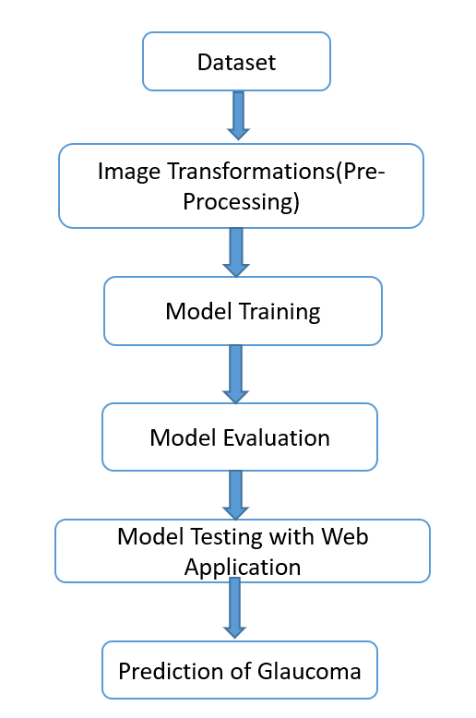

Fig 2: Flow diagram representing the proposed methodology.

IV. RESULTS AND ANALYSIS

`Table 1: Performance Metrics of Machine Deep Learning models

|  |  |  |  |  |
| --- | --- | --- | --- | --- |
| **Algorithms** | **Accuracy** | **Precision** | **Recall** | **F1 Score** |
| Resnet | 91 | 92 | 91 | 91 |
| Mobile Net | 90 | 90 | 90 | 90 |
| Efficient Net | 94 | 94 | 94 | 94 |

As depicted in the Table 1 Efficient Net outperformed compared than other Deep Learning Algorithms like Res Net and Mobile Net with an accuracy and F1-score of 94%.

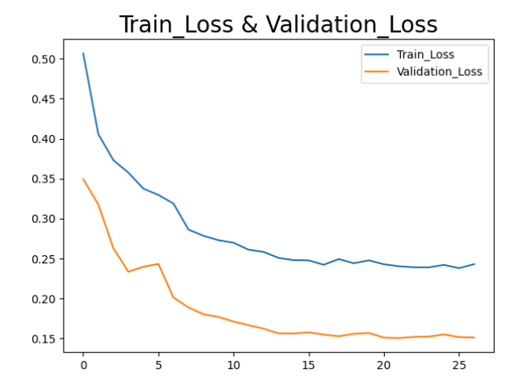

Fig 3: Graph of Train Loss and Validation Loss of Efficient Net Model

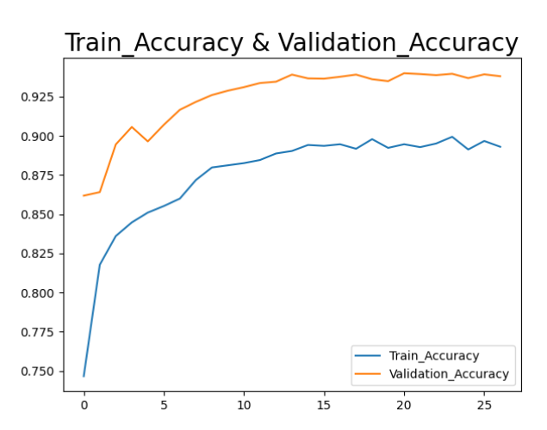

Fig 4: Graph of Train Accuracy and Validation Accuracy of Efficient Net Model

Fig 5: Web Application For Testing

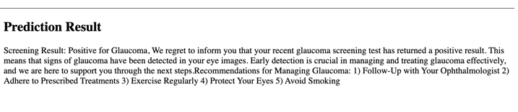

Fig 6: Glaucoma Positive Prediction

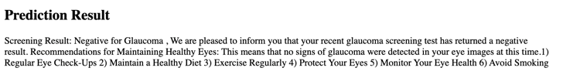

Fig 7: Glaucoma Negative Prediction

V. CONCLUSIONS AND FUTURE SCOPE

The proposed work successfully created a strong web app for glaucoma detection using the EfficientNet mode whose power stems from its high precision and performance. The app provides an automated screening process that can be done on the spot by the eye doctor most of the time, hence, avoiding the need for a manual review of eye scans. Through giving rapid and reliable forecasts the web application helps to make an early detection and timely getting problem resolved, as a result, the more effectively the outcomes of patients will be and the more efficient will be the usage of healthcare resources.

Our Future Work includes integration with Eye scanners, Real-Time Data Analytics and Reporting.​

References

[1] Abdullah Sarhan, Jon Rokne, Reda Alhajj,Glaucoma detection using image processing techniques: A literature review, Computerized Medical Imaging and Graphics, Volume 78,2019,101657,ISSN 0895-6111,

https://doi.org/10.1016/j.compmedimag.2019.101657.

(<https://www.sciencedirect.com/science/article/pii/S0895611119300758>)

[2] Chen, X., Xu, Y., Yan, S., Wong, D.W.K., Wong, T.Y., Liu, J. (2015). Automatic Feature Learning for Glaucoma Detection Based on Deep Learning. In: Navab, N., Hornegger, J., Wells, W., Frangi, A. (eds) Medical Image Computing and Computer-Assisted Intervention – MICCAI 2015. MICCAI 2015. Lecture Notes in Computer Science(), vol 9351. Springer, Cham. <https://doi.org/10.1007/978-3-319-24574-4_80>

[3] L. Li et al., "A Large-Scale Database and a CNN Model for Attention-Based Glaucoma Detection," in IEEE Transactions on Medical Imaging, vol. 39, no. 2, pp. 413-424, Feb. 2020, doi: 10.1109/TMI.2019.2927226.

[4] A. Saxena, A. Vyas, L. Parashar and U. Singh, "A Glaucoma Detection using Convolutional Neural Network," 2020 International Conference on Electronics and Sustainable Communication Systems (ICESC), Coimbatore, India, 2020, pp. 815-820, doi: 10.1109/ICESC48915.2020.9155930.

[5] Shubham Joshi,B. Partibane,Wesam Atef Hatamleh ,Hussam Tarazi, Chandra Shekhar Yadav, and **Daniel Krah** Department of Computer Engineering, SVKM’S NMIMS MPSTME Shirpur, Shirpur 425405, Maharashtra, India

[6] Dey, Abhishek, and Samir K. Bandyopadhyay. "Automated glaucoma detection using support vector machine classification method." British Journal of Medicine and Medical Research 11.12 (2016):

[7] Santos, Dheiver. (2023). Glaucoma Detection with Machine Learning: An Innovative Approach. 10.32388/NVILQK.

[8] S. Ovreiu, E. -A. Paraschiv and E. Ovreiu, "Deep Learning & Digital Fundus Images: Glaucoma Detection using DenseNet," 2021 13th International Conference on Electronics, Computers and Artificial Intelligence (ECAI), Pitesti, Romania, 2021, pp. 1-4, doi: 10.1109/ECAI52376.2021.9515188.

[9] S. Ovreiu, I. Cristescu, F. Balta and E. Ovreiu, "An Exploratory Study for Glaucoma Detection using Densely Connected Neural Networks," 2020 International Conference on e-Health and Bioengineering (EHB), Iasi, Romania, 2020, pp. 1-4, doi: 10.1109/EHB50910.2020.9280173.

[10] . Rutuja Shinde,Glaucoma detection in retinal fundus images using U-Net and supervised machine learning algorithms, Intelligence-Based Medicine,Volume 5,

2021,100038,ISSN 2666-5212, <https://doi.org/10.1016/j.ibmed.2021.100038>. (<https://www.sciencedirect.com/science/article/pii/S2666521221000144>)

[11] S. Kaushal, S. Datt Sharma and S. Jain, "Investigation of Image Processing Techniques for Glaucoma Detection in Human Eyes," 2018 Fifth International Conference on Parallel, Distributed and Grid Computing (PDGC), Solan, India, 2018, pp. 747-753, doi: 10.1109/PDGC.2018.8745976.

[12] Shyamalee, T., Meedeniya, D. Glaucoma Detection with Retinal Fundus Images Using Segmentation and Classification. *Mach. Intell. Res.* **19**, 563–580 (2022). <https://doi.org/10.1007/s11633-022-1354-z>

[13] Saha S, Vignarajan J, Frost S. A fast and fully automated system for glaucoma detection using color fundus photographs. Sci Rep. 2023 Oct 27;13(1):18408. doi: 10.1038/s41598-023-44473-0. PMID: 37891238; PMCID: PMC10611813.

[14] M. T. Islam, S. T. Mashfu, A. Faisal, S. C. Siam, I. T. Naheen and R. Khan, "Deep Learning-Based Glaucoma Detection With Cropped Optic Cup and Disc and Blood Vessel Segmentation," in IEEE Access, vol. 10, pp. 2828-2841, 2022, doi: 10.1109/ACCESS.2021.3139160.

[15] Somnath Sinha, Sriram R, ”An Educational based Intelligent Student Stress Prediction using ML” 2022 3rd International conference for Emerging Technology(INCET) Belgaum,India,May 27-29,2022.

[16] S. Chethana, S. S. Charan, V. Srihitha, A. Thakur and N. P. T V, "Multi-Class classification of Different Cancer Types Using CNN," 2023 14th International Conference on Computing Communication and Networking Technologies (ICCCNT), Delhi, India, 2023, pp. 1-5, doi: 10.1109/ICCCNT56998.2023.10306850.

[17] A. Tripathi, T. Singh and R. R. Nair, "Optimal Pneumonia detection using Convolutional Neural Networks from X-ray Images," 2021 12th International Conference on Computing Communication and Networking Technologies (ICCCNT), Kharagpur, India, 2021, pp. 1-6, doi: 10.1109/ICCCNT51525.2021.9580140.

[18] K. S. Naveenkumar, R. Vinayakumar and K. P. Soman, "Amrita-CEN-SentiDB: Twitter Dataset for Sentimental Analysis and Application of Classical Machine Learning and Deep Learning," 2019 International Conference on Intelligent Computing and Control Systems (ICCS), Madurai, India, 2019, pp. 1522-1527, doi: 10.1109/ICCS45141.2019.9065337.

[19] N. B. Nair, T. Singh, A. Thakur and P. Duraisamy, "Deployment of Breast Cancer Hybrid Net using Deep Learning," 2022 13th International Conference on Computing Communication and Networking Technologies (ICCCNT), Kharagpur, India, 2022, pp. 1-6, doi: 10.1109/ICCCNT54827.2022.9984513.

[20] N. K. E., K. M., P. P., A. R. and V. S., "Tomato Leaf Disease Detection using Convolutional Neural Network with Data Augmentation," 2020 5th International Conference on Communication and Electronics Systems (ICCES), Coimbatore, India, 2020, pp. 1125-1132, doi: 10.1109/ICCES48766.2020.9138030.

Top of Form

Top of Form