**Enhanced Stock Market Prediction through a Multi-Modal Approach​**

**Team - 12**

Bedadala Akhileswara Reddy, Gopireddy Someswara Reddy, Kollepara Lokesh, Dr.Murali K

*Department of Computer Science and Engineering,  
Amrita School of Computing, Bengaluru,  
Amrita Vishwa Vidyapeetham, India*

**Abstract: This comprehensive study was designed to improve stock market prediction by using a wide variety of techniques including many regressors, deep learning and classifiers. Our major goal was to develop a robust and flexible algorithm, which could forecast stock prices for various firms in an efficient manner. So how did we do it? We assigned regressors to dig into historical stock data, find subtle patterns and relationships therein--on account of their ability to analyze both numerical and serial information in time. At the same time, we incorporated deep learning techniques (including neural networks), in order to exploit the hierarchical features that are hidden within data and increase forecast accuracy. Our study not only predicted stock prices but also compared a number of stocks via classifiers. Thus we incorporated several classification algorithms to find patterns and trends in individual equities, so as to better understand their market behavior. Its purpose is to provide insight into the different characteristics of each equity and many hints for investors as well.**

**Key words:** Deep Learning, Neural Networks, Stock Prediction, Accuracy, Precision, Machine Learning, Regressor.

1. **Introduction**

A stock market prediction would have a huge effect on financial decision making, so the subject has long been matter of research and development. Estimating stock prices effectively is a difficult, but obligatory skill for investors, traders and financial experts. In this work, we examine some new directions in stock market prediction such as combining traditional regression-type models with deep learning techniques to see how various stocks measure up against each other.

Understanding and predicting stock market trends are important for skilled investing. Investors scout for tools and methods capable of delivering believable gauges on the future direction of stock prices. Precise predictions help to raise revenues, reduce risks and improve portfolio management. Aiming at the urgently needed accurate stock market prediction aids, it employs multiple abstract methods to capture the complexities of financial markets.

Models of traditional regression are often used to estimate stock values in finance. These models look at past price data, technical indicators and other relevant factors to predict future stock prices. Regressors are used to try and model linear as well as non-linear relationships in the data, providing a framework for analyzing market patterns. The efficiency of regressors in projecting stock prices across various market environments is our special study.

In particular, deep learning based on neural networks is very adept at detecting complex patterns in vast datasets. This research will explore the use of deep learning techniques such as Long Short-Term Memory (LSTM) networks and Multilayer Perceptrons (MLPs), to predict the value of stock. Maybe hidden patterns have been overlooked by standard approaches. These models can automatically learn hierarchical representations from historical data.

Beyond predicting an individual stock's price, we also apply our approach to tracking the performance of multiple stocks. Stocks are classified according to several characteristics using classifiers such that investors can assess in an objective manner whether their portfolios have sufficient diversification. In evaluating and comparing the prediction abilities of various classifiers on a large number of equities, through our effort we bring some light to bear upon the relative strengths and weaknesses in different forms of investment.

The idea is to explore a full array of methods in the changing climate for stock market prediction. Thus, in using regressors with deep learning and classifiers we hope to give a better insight into changes of stock prices. Our investigation covers numerous stocks, enabling a comparison of the accuracy of predictions. Fundamentally, the aim is to offer truly important lessons and very real applications for persons as well as institutions in today's rapidly changing environment of financial markets.

1. **Related Works**

The aim of this research paper is to enhance the accuracy of stock price predictions by developing machine learning (ML) models. It highlights the significant potential of combining deep learning (DL) and ML to create more efficient and resilient models that can quickly and accurately analyze real-time data, ultimately promoting progress in various interdisciplinary fields. The paper effectively demonstrates the superiority of DL algorithms in predicting stock prices, emphasizing their accuracy and introducing more effective and resilient techniques for forecasting stock market trends. A thorough presentation of the methodology, results, and comparative analysis adds to the overall significance and impact of this study[1].This research facilities use gadget learning and deep getting to know fashions that read the stock market. The aim is to determine the big parameters and learn something about the characteristics of stocks on stock markets. It underlines the importance of choosing an appropriate model, forecasting stock values, avoiding redundant dimensions and models, and using algorithms to offer investors suitable investment choices. So examines unique, diversified kinds of research and stresses the need in predicting stock prices to add recent articles and customer attitudes. Secondly, it solves the shortcomings found in previous research and advances ability-upgrades for destiny examine[4]. The last purpose is to present green and effective inventory tips to customers.This research study examines the application of machine learning techniques in finance (including neural networks, regression trees, support vector machines and random forests. These algorithms are very good at discovering complex patterns and nonlinear relationships in financial data. They can also predict portfolio returns and future values of financial assets. The study describes the increase in interest and ongoing investigations into use of a machine learning approach for financial analysis, evaluation and decision-making.This research of some artificial intelligence techniques used to predict stock markets which appear in the study article, including predictive data mining•stock price fluctuations analysis using event-related Twitter feeds•evaluating intrinsic value of stocks by means Monto Carlo simulation[8]. It explains the results of a number of models, highlighting that low generalization error can be obtained using Support Vector Machines (SVM), and there is no need to fear overfitting. The research also includes sentiment analysis and keyword analysis of Twitter data on stock market activity. It helps in identifying relations between datasets. It also mentions regression analysis of stock market values for forecasting future ones.Using neural networks, the research study suggests a way of predicting daily stock values[11]. In this research the results of neural network forecasting are compared with statistical forecastings. Insights into how effective a technique like that might be for stock market monitoring thus emerge. The authors point out the role of artificial neural networks in making predictions about the stock market, to help intelligent finance catch up.This research paper focuses on using machine learning techniques, in particular the Random Forest algorithm, for stock market prediction. The methodology involves preparing the stock market data, classifying it using machine learning algorithms and lastly calculating a polarity score to predict correct results[5]. It attempts to demonstrate the usefulness of Random Forest for predicting stock prices, acknowledging that trying to forecast trends in a vague area such as the stock market is always going to be tough. The paper also takes up the use of sentiment analysis in forecasting, demonstrating further applications of the research in financial analysis and prediction. This study explores stock market predictions using the machine learning algorithms, which requires accurate statistical analysis. It shows how sites such as Yahoo Finance, Quandl and Kaggle deliver relevant data for stock market predictions[10]. Looking at the use of algorithms such as Linear Regression and Exponential Smoothing indicate that data analysis is essential in getting statistical or tabular findings for forecasts, importance[7]. Furthermore, it talks about how the sample size will affect prediction accuracy and emphasizes that you must have a deep understanding of machine learning techniques to make accurate stock market predictions.The research article examines the accuracy of linear and nonlinear models in forecasting stock market behavior. It offers a review of recent works in this area, showing how these models perform differently. This research has also recognized the limitations of finding intricate relationships between future stock prices and important characteristics, such as market microstructure[3]. Besides, it calls for more intensive research on this front with larger data sets and higher performance computing resources.This research article is about using different kinds of machine learning techniques to predict the future performance of the Karachi Stock Exchange (KSE). The prediction model includes oil prices, gold and silver rates, interest rate, foreign exchange (FEX) rate as well NEWS value for the social media feed. In addition to the historical data analysis approach, Simple Moving Average (SMA) and Autoregressive Integrated Moving Average (ARIMA), this study also incorporates application of machine learning algorithms[8]. Moreover, news and Twitter data are mined using text mining. The study also discusses how to normalize attributes for the model. The study also points out elements effecting market performance and describes the structure of a proposed prediction model.This research study on Stock Market Prediction Using Machine Learning uses Regression and Long Short-Term Memory (LSTM) models to forecast the future value of financial stocks using variables, including open, close, low highs for that day as well as volume. The study consists of running the models on stock exchange data, then looking at the results by means of charts showing price fluctuations and actual versus forecasted values[11]. It also goes further to explore related work, enumerate the technical methodologies used in creating these models and present findings with citations.This research discusses using the Naive Bayes Algorithm to predict share market return on investment. This algorithm is extremely promising in the analysis and prediction of market trends, probing that traditional strategies are ill-equipped to contend with uncertainties and ambiguities when investing on the stock exchange. The authors further state that there is a group of users whose traffic patterns perform well day in and out who could be turned into indicators for the inspection of markets[2].This research projects employs machine learning techniques, such as artificial neural networks to predict stock market index. The experimental design, network topologies and data employed in the studies are described. Comparisons of different theories are drawn. This study points out the potential limitations of relying on data from just one market. The necessary knowledge and interdependence in an increasingly integrated world can no longer be limited to simple borders or political entities. The results, including accuracies as well as comparisons with previously published work, are given and the performance of 24-hour single index model is presented. The study also examines differences in strategies and practices from previous research, aiming to provide traders with a more comprehensive decision-making kit[12].

**III. Proposed Methodology**

a. **Data Preparation:** The data set is composed of the last 5 years stock data with each row containing formatted Date, Open, High, Low, Close, Adj Close, Volume. Finding out null values and cleansing them to reduce errors in model training.

b. **Data Formatting:** An important step involves getting rid of dollar signs ($) from any columns in the dataset that contain numerical data. The procedure is used to ensure consistency in representation and guard against possible errors generated by currency symbols. Also, a rigid procedure of converting the data types in certain columns to float values was included. Not only did this translation make it easy to perform numerical operations but also eliminated any incompatibilities between the different data type allocations of the original. These data formatting methods were key to generating a concise, uniform dataset which provided firm footing for the multi-modal approach used in developing the stock market prediction system.

c. **Exploratory Data Analysis:** At this point, we will systematically analyze the given dataset in order to explore its various characteristics and clues about potential problems. The analysis can also be used for further modeling decisions. First, the structure, size and types of data present in any given dataset will be determined through initial data profiling. To explore the central tendencies and distribution of values for numerical variables, descriptive statistics such as mean, median and standard deviation will be calculated. Patterns, trends and possibly correlations between features can be revealed through the use of various visualizations such as histograms, box plots and correlation matrices. Besides, we will look at whether there are missing values or outliers in the data and other “anomaly problems”, so that one has a full sense of just how good its quality is. The EDA process will provide the basis for all subsequent steps in our multimodal approach, as we make informed choices with regard to feature engineering, preprocessing and model selection so that any predictions on stocks can be robust.

d**. Splitting the Data;** When it comes to preparing the dataset, for machine learning we need to divide it into training and test sets by applying feature scaling. After that we use the function to split the dataset into training and test sets allocating 80% of the data for training and 20%, for testing. This division is really important as it helps us evaluate how well the model performs on data.

e**. Model Building**::Five machine learning classifiers, seven machine learning regressors and six neural network models were included in context

evaluation of the respective model.

**Machine Learning Classifiers implemented:**

**Logistic regression:** Logistic regression is a statistical technique used in many binary classification problems. The purpose here is to classify instances based on the chance that they belong to some given class. Although named logistic regression, this is not a regression algorithm but one of classification. Using the logistic function for a linear combination of their input characteristics, it describes the relationship between some dependent binary variable and one or more independent variables. The logistic or sigmoid function converts any real-valued number into the range between 0 and 1, which is why it can be used to describe probabilities. The model's coefficients are trained using a maximum likelihood estimation technique, aiming to find an optimum set of constants such that the probability of seeing this given data is maximized. Because logistic regression is simple and easy to interpret, as well as effective in capturing complicated correlations between input features and binary outcomes, it has been used widely across many domains: medical science; finance; machine learning.

**Random Forest classifier:** An ensemble learning method commonly used for classification and regression is the RF classifier. It does so by generating a vast number of decision trees during training and outputs the class with highest probability for classification or average prediction in regression. A random portion of the training data and a subset of features are used to generate each tree in the forest, which means that they will be decorrelated in this way, rather than overfit. A model that marries robustness and accuracy is thus formed, by combining the aggregate of all individual predictions made by each tree. One of the reasons that Random Forests are so popular in many fields is their versatility, scalability and ability to handle high-dimensional data.

**Support Vector Machines**: SVM are advanced supervised learning models for classification and regression problems. The real aim of SVM is to look for a hyperplane that separates the data in different classes so as to separate them by maximizing their margins. The "support vectors" are the data points closest to the decision boundary, and they play a major role in deciding on an optimal hyperplane. SVMs are particularly adept at handling high-dimensional data, and also have the unique feature of being able to handle nonlinear relationships by means of kernel functions. Its flexibility makes SVMs widely applicable in a variety of fields, such as image classification and text categorization; it also can be applied to the field of bioinformatics. Its resilience and versatility make it a very popular model in machine learning applications. Here, accurate and efficient categorization are of the essence.

**Naïve Bayes classifier**: The naive Bayes approach to machine learning is a probabilistic algorithm based on Bayes 'theorem. It assumes that the features used to define an instance are conditionally independent, given the class label. The naive premise of feature independence notwithstanding, Naive Bayes has proven to be remarkably effective in many different classification tasks--especially those involving natural language processing and spam filtering. To this end, the posterior probability of a particular instance being assigned to class C is computed from its prior probability and likelihood. In cases where the independence condition holds pretty well, Naive Bayes is simple to implement and computationally efficient. This simplicity and effectiveness make it a favorite choice for text classification and other applications with high-dimensional data.

**Extreme Gradient Boosting:** XGBoost is an extremely powerful and common machine learning algorithm. It has a reputation as one of the best algorithms to use in predictive modeling and classification problems--it even breaks world records thousands of times over. It is an example of ensemble learning, the boosting variant in particular. Weak learners are accumulated to create a strong and accurate predictive model for classification or regression problems. XGBoost can handle structured/tabular data well and has earned popularity for its speed and efficiency. It uses the following framework: You optimize your model by adding a set of weak decision trees each time to correct for mistakes made previously. To reduce overfitting, XGBoost uses regularization methods. It also offers flexibility in the design of target functions and is well-suited to many applications. Its success in data science contests as well as realistic applications indicates its ability to produce high predicted accuracy.

**Machine Learning regressors implemented:**

**Linear regressor**: Linear regression is a statistical method for modeling the relationship between a dependent variable and one or more independent variables by fitting a line to observed data. The idea is to choose the best-fitting line that has the smallest sum of squared discrepancies between predicted and actual values. The model suggests that the input variables and the output are linearly related to one another, so this humble tool is easy to apply even if it can only predict numeric outcomes Y = Ax + b is the way this equation for a linear regression model is always written, in which A and B are given special meanings. During the training phase, coefficients (m and b) are calculated which enable the model to generate predictions with new input data. The advantage of interpretability, coupled with ease of application have made the linear regression a favored method in many fields such as economics. finance, biology and engineering.

**Ridge Regressor:** Ridge Regression is a linear regression technique that tackles the problem of multicollinearity in multiple regulatoin data. In traditional linear regression, if the independent variables are highly correlated in effect it becomes nearly impossible to accurately estimate the coefficients and slight differences have a large impact on estimates. Ridge Regression introduces a regularization term, which is the L2 norm of coefficients. Large magnitude coefficients are penalized in this way and it helps stabilize the model. Its addition to the least squares objective function equalizes coefficients without causing them all to become zero, a compromise between simplicity and fixing the data. This regularization tends to improve the generalizing ability of the model, so that Ridge Regression is particularly effective when there are correlated features or a high-dimensional feature space.

**Support vector Regressor**: SVR is a machine learning algorithm for regression tasks; its aim to predict continuous results. In accordance with the theory of Support Vector Machines (SVM), SSVR attempts to find a hyperplane that describes best how input variables affect target values. Unlike most regression algorithms, SVR concentrates on maintaining a margin of error about the predicted values, allowing for variations between actual data points and the forecasts. It attempts to reduce the error falling within this range, and provides resistance for outliers while promoting generalization. Using a kernel trick to map input data into higher dimensions, where SVR finds complex relations. SVR attains the optimum balance between accuracy and margin breadth through optimizing a cost function. With great regression performance, it is particularly good at tasks which are not suited to linear models.

**Decision Tree Regressor:** A Decision Tree Regressor is a machine learning technique for predicting numerical outcomes. It does so by recursively splitting the input data into subsets according to different values of attributes, and forming a decision tree-like representation. At each of the tree-nodes, this algorithm chooses among all possible characteristics and selects that one which best splits the data to have low variance for its target variable in these subsets. The leaves of the tree represent these final estimated values. The advantages of Decision Tree Regressors include simplicity, interpretability and their ability to capture non-linear correlation in data. But they tend to overfit, and procedures like pruning or depth limitations are often used to prevent this. Also, ensemble methods like Random Forests can be used to improve the robustness and generalization quality of the model.

**Random Forest Regressor**:The Random Forest Regressor is a versatile, strong machine learning technique that has widespread application in regression problems. It is an ensemble classifier, which uses the predictions of many decision trees to increase accuracy and robustness. The feature selection and data sampling help to keep the decision trees in this forest unpredictable. While each one generates itself independently, it is trained on only a fraction of the total dataset available for learning purposes. A refined and accurate model is thus obtained by averaging the predictions made by all those trees, with a lower likelihood that it will overfit. Random Forest Regressor performs very well in handling complicated correlations between data, and provide a stable solution to the regression problems encountered in finance; healthcare as well environmental check. Its ability to catch complex patterns and guard against overfitting makes it quite popular with those who want a reliable, interpretable regression model.

**Gradient Boosting Regressor**: GB Regressor is a powerful machine learning technique for predictive modeling and regression. It is one of the many members that fall under ensemble learning, which combines weak learners (such as decision trees) to form a powerful predictive model. The procedure is iterative. Trees are fitted to the residuals left over after each previous tree, with this minimizing wrong predictions. The name contains the word gradient; it is related to the optimization process, in which an algorithm aims at minimizing a loss function by moving along paths of steepest descent. Such a strategy produces an extremely accurate and robust model that can deal with complex relationships between the data. With its versatility, good predictive performance and resistance to overfitting Gradient Boosting Regressor is a frequently used algorithm in different real life applications from banking to healthcare.

**XGBoost Regressor:** Extreme Gradient Boosting Regressor is a powerful machine learning method widely used for predicting continuous numerical values. Boosting is an instance of the ensemble learning family, and it works by merging numerous weak learners (typically decision trees) to build a strong model. XGBoost is very good at managing complex relationships between data. It can deal with cases of missing values automatically, and it uses regularization techniques to avoid overfitting the training set. Its main source of clout rests in its ability to balance bias and variance at the same time, thereby improving model performance. These days XGBoost Regressor is a ubiquitous presence in both data science contests and real-world applications, becoming the de facto algorithm for regression tasks requiring precise results which you can stake your life on.

**Neural Network models implemented:**

**Multilayer Perceptron:** MLP is the basic form of artificial neural network commonly used in machine learning. A three-layered structure with an input layer, one or more hidden layers and an output layer, MLPs are particularly well suited to difficult problems such as those encountered in classification processes. Weighted connections link neurons in each layer. Non-linear activation functions introduce non-linearity to the model, allowing it can solve problems that require more than linearly expanding two variables. During the training process, we adjust these weights by backpropagation to minimize differences between expected and actual results. MLPs have proven themselves in many fields: from picture and speech identification to financial prediction, they demonstrated that intelligence is no respecter of boundaries.

**Recurrent Neural Network:** RNNs are a class of artificial network designed to process sequential data. Therefore they have special application in time-dependent information is needed. However, unlike in standard feedforward neural networks, RNNs incorporate a feedback loop which creates the ability for them to hide away an internal state. The hidden states carry knowledge about inputs that have already occurred via sequence order into subsequent calculations and predictions. This design is a boon for such applications as natural language processing, speech recognition or time-series analysis. But the RNN has problems, like the vanishing gradient problem. Because of that their ability to absorb long-term dependencies in data is limited. Nevertheless, RNNs have opened the door to more elaborate architectures like Long Short-Term Memory (LSTM) networks and Gated Recurrent Units (GRUs), which help tackle some of these problems head on but also increase substantially how much context information a model can capture.

**Artificial Neural Networks:** ANNs are one of the many types of machine learning models inspired by how human beings organize their brain. ANNs are composed of interconnecting nodes or artificial neurons arranged into layers, and train by examining the relations between input data through a series of weightings. They can then learn complicated patterns from which they make predictions. During a training process, adjusting the network's weights according to the error between what is expected and actual outcomes allows it gradually acquire an ability to generalize from new data. In different applications, such as image and speech recognition, natural language processing or in predictive analytics work on the other hand has demonstrated that real world problems can well be handled by ANNs.

**Single-Layer Perception**: The simplest type of a neural network is called a Single-Layer Perceptron (SLP), which involves only one layer containing artificial neurons, or perceptrons. In the field of neural networks, SLP was introduced as a major building block. Its ability to solve binary classification problems defines it most clearly. A perceptron in the layer takes a group of input values, applies weights to these inputs and adds them together. This is then passed through an activation function generating an output (1 or 0). During training, the weights are altered in order to reduce prediction errors on the network. SLPs can only handle linearly separable problems and are unable to handle complex patterns. Nevertheless, they provide a cornerstone concept in the study of neural networks and pave the way for more advanced structures like multi-layer perceptrons (MLPs).

**Deep Neural Networks:** DNN are a type of artificial neural network with many layers between the input and output layer, which can model intricate relations or representations in data. Each layer of a DNN has interconnected nodes, or neurons. The connection between every two pairs is assigned an adjustable weight during training. The depth of the network means that it can obtain hierarchical features from input data automatically. Thus, DNNs are especially powerful for use in tasks such as image and speech recognition, natural language processing, or other complicated pattern identification problems. The training process is based on the technique of feeding input data through the network, computing its output value and comparing it to what was desired. In this way weights are adjusted inwards towards zero from their starting places using a method known as backpropagation so as to reduce differences between reality and required performance. DNNs have shown remarkable capabilities in various domains, leveraging their ability to capture data's complex patterns and connections as long as abundant computational resources can be applied for training.

**Long Short-Term Memory:** LSTM is a type of recurrent neural network architecture specially developed to overcome some limitations in using the regular RNN structure for collecting long range dependencies. LSTMs have memory cells and an array of gating devices--input gate, forget gate and output gate. These gates enable LSTMs to selectively accept or reject information over time, so that they can effectively learn and recall relevant information even with longer sequences of data. The architecture lends itself especially well to applications involving time-series data, natural language processing and other tasks where the nature of temporal connections is critical. Some of the tasks that RNNs are capable of performing.

f. **Comparision and Analysis**: The evaluation metrics, such as accuracy and its submetrics precision, recall,F1 score, Mean Squared Error, Root Mean Squared Error, Mean absolute Error, R_Squared give an idea of how well the model can make predictions. In addition, the proposed methodology detects for overfitting or underfitting by comparing the model' performance on training and test sets. This systematic approach to hyperparameter tuning and evaluation helps achieve a robust model capable of performing well on the classification task at hand.

**IV. Results**

After the evaluation of models on the trained and test datasets the following are the results:

Comparison among the ML classifiers :

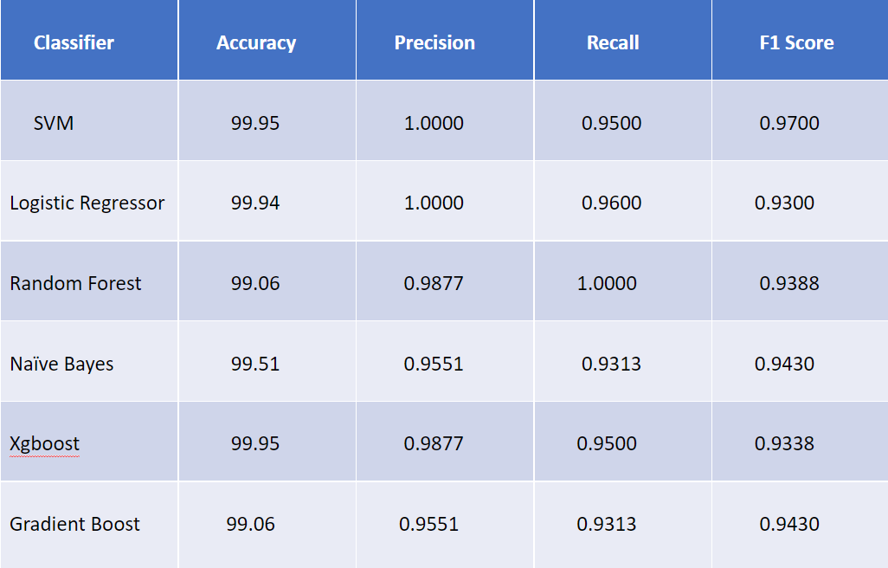

**Figure 1:Performance of Classifiers**

Comparison among the ML Regressors:

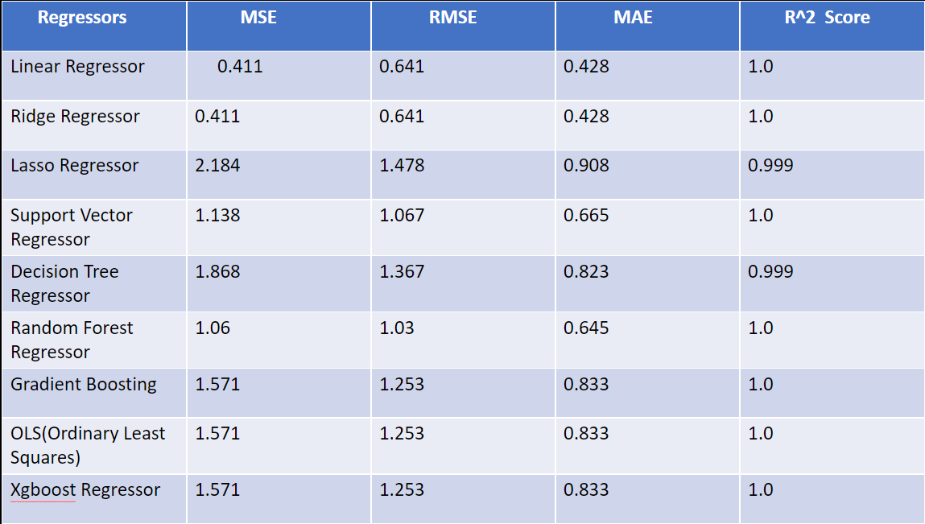

**Figure 2:Performance of Regressors**

Comparison among the Deep Learning algorithm:

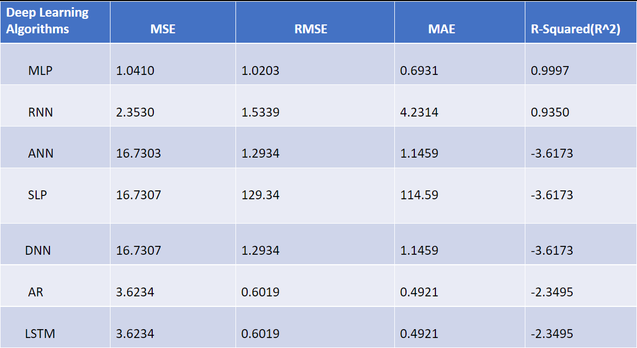

**Figure 3:Performance of Deep Learning Algorithms**

**V. Conclusion**

In conclusion, this project has successfully explored various different machine learning models for predicting stock market trends. Of the deep learning models assessed, MLP utilizing Mean Squared Error (MSE) of -1.0410 and Root Means SQUARED error (RMSE), at 1.0283 emerged as best able to capture complex patterns within the data with strong model predictive abilities. Also, the research chose Linear Regressor as its best-performing machine learning method for regression with an MSE of 0.41 and RMSE of 6 standard error units (which correspond to Rs) successfully predicting all underlying relationships in stock market data.

The team also addressed the problem of classification and used a multi-modal approach to compare different equities. The machine also selected a classifier which performed very well, with an accuracy rate of 99. This demonstrates the model's ability to tell apart vastly different equities and its usefulness for making investment choices. All in all, the comprehensive research carried out here enhances our grasp of stock market forecasting and offers practical guidance about how to select model types for both regression as well as classification problems involved in financial prognostication.

**VI. References**

1. Malti Bansal, Apoorva Goyal, Apoorva Choudhary,Stock Market Prediction with High Accuracy using Machine Learning Techniques,Procedia Computer Science,Volume 215,2022,Pages 247-265,ISSN 1877-0509,https://doi.org/10.1016/j.procs.2022.12.028.
2. JOUR,Sarma, Seethiraju,Sekhar, Dorai,Murali, Gudipatu,2023/02/01,552,560,Stock market analysis with the usage of machine learning and deep learningalgorithms,12,10.11591/eei.v12i1.4305,Bulletin of Electrical Engineering and Informatics
3. Moghar, Adil & Hamiche, Mhamed. (2020). Stock Market Prediction Using LSTM Recurrent Neural Network. Procedia Computer Science. 170. 1168-1173. 10.1016/j.procs.2020.03.049.
4. Ray, Ruchira & Khandelwal, Prakhar & Baranidharan, B.. (2018). A Survey on Stock Market Prediction using Artificial Intelligence Techniques. 594-598. 10.1109/ICSSIT.2018.8748680.
5. Vaisla, Dr. Kunwar & Bhatt, Dr. Ashutosh. (2010). An Analysis of the Performance of Artificial Neural Network Technique for Stock Market Forecasting. International Journal on Computer Science and Engineering.
6. Kompella Subhadra and Chakravarthy Chilukuri, Kalyana, Stock Market Prediction Using Machine Learning Methods (March 16, 2020). International Journal of Computer Engineering and Technology.
7. M Umer Ghani, M Awais and Muhammad Muzammul, Stock Market Prediction Using Machine Learning(ML)Algorithms(2019).Department of software Engineering,Government College University Faisalabad.
8. Chong, Eunsuk & Han, Chulwoo & Park, Frank. (2017). Deep Learning Networks for Stock Market Analysis and Prediction: Methodology, Data Representations, and Case Studies. Expert Systems with Applications. 83. 10.1016/j.eswa.2017.04.030.
9. Usmani, Mehak & Adil, Syed & Raza, Kamran & Ali, Syed Saad. (2016). Stock market prediction using machine learning techniques. 322-327. 10.1109/ICCOINS.2016.7783235.
10. Ishita Parmar, Navanshu Agarwal, Sheirsh Saxena, Ridam Arora, Shikhin Gupta, Himanshu Dhiman, Lokesh Chouhan, Stock Market Prediction Using Machine Learning, National Institute Of Technology Hamirpur, INDIA.
11. Shubhrata, Mahajan & Kaveri, Deshmukh & Chate, Parinita. (2016). Stock Market Prediction and Analysis Using Naïve Bayes. 4. 121-124.
12. Malagrino, Luciana & Roman, Norton & Monteiro, Ana. (2018). Forecasting Stock Market Index Daily Direction: a Bayesian Network Approach. Expert Systems with Applications. 105. 10.1016/j.eswa.2018.03.039.