System parts

Physics

The flowchart below gives a high level overview on how physics is simulated during a single tick in my program:

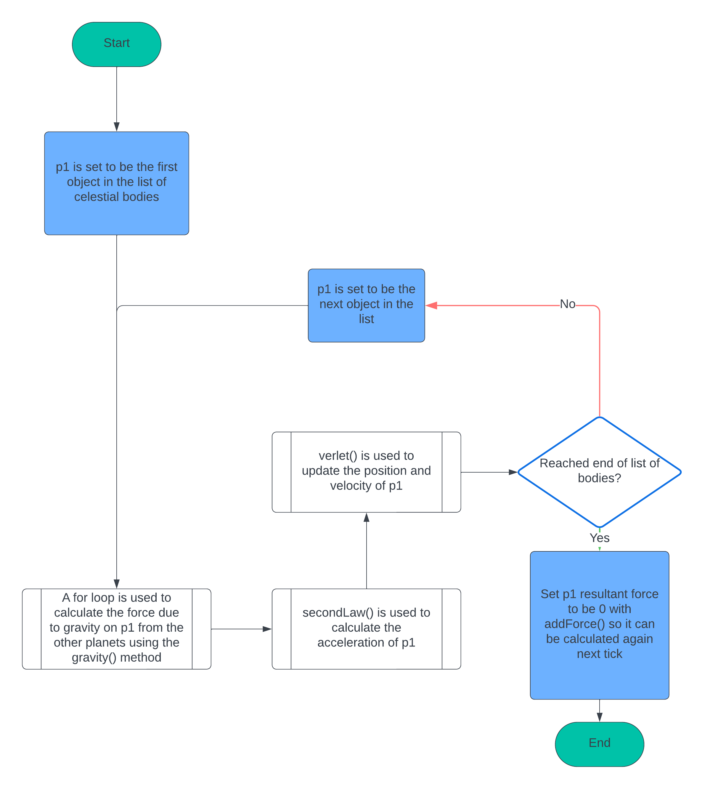

The flowchart below describes the for loop used to calculate the gravitational force on a planet.

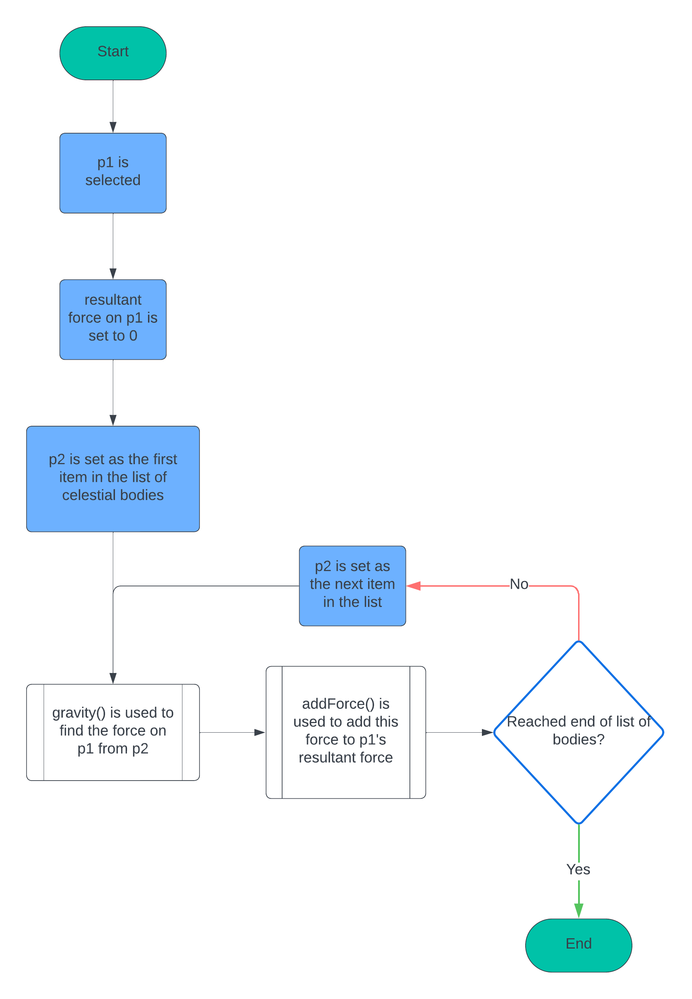

Methods used

gravity

The gravity() method will need to take two planets as arguments. The target planet p1, the one we are working the force out for, and the other planet, p2, to work out the force from. Newton’s law of universal gravitation will be used as mentioned in the analysis:

$$F=\frac{Gm_{1}m_{2}}{r²}$$

G is the gravitational constant, I’ll take its value from wikipedia, 6.6743015\*10-11. m1 is the mass of p1 and m2 is the mass of p2. r is the distance between the two planets, so r² is the square of that distance, r\*r.

The method should return the force in the form of a vector, because the program needs the direction of the force as well as its magnitude.

secondLaw

This is a setter function. It will not return anything, but just set the acceleration of the planet to be what it should be based on the resultant force on it. So, the function needs to take in the planet as an argument, and then can just use the resultant force and mass attributes of the planet to set the acceleration. It will set the acceleration using Newton’s second law of motion:

$$a=\frac{F}{m}$$