The evidence for the tests will primarily be in the form of a video which is accessible here:
However the first two tests for objectives 1aii and 5 will be evidenced with screenshots, as there is nothing animated that needs to be shown.
Objectives 1aii and 5 were implemented with separate files and then those files were imported as modules into the main program, the functions in these files should be tested independently of the main program. The main() function for these files will be used to test them and demonstrate they work. Here is the code for test 01:
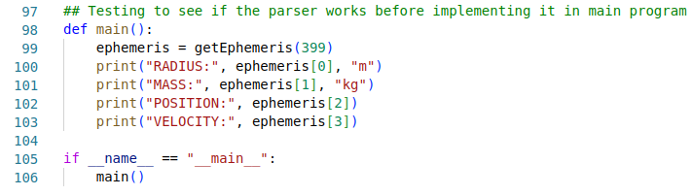
And here is the code for test 02:
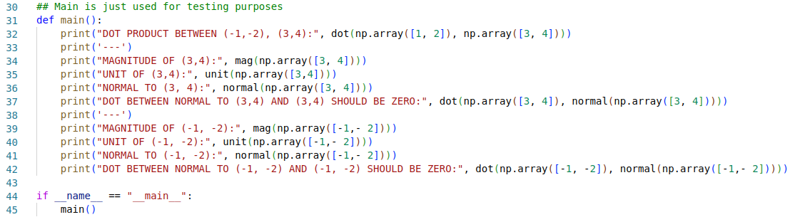

The tests have been chosen in an order that allows me to do most of them in a single run of the program. I’ve tried to also make the order sensible, i.e. The first test for the main program is with the start screen, as that’s the first thing you’ll see when you open the program. Some tests will inevitably destroy the solar system, I will restart after test 20 to do the last few tests.
I have done my best to explain what inputs I will be doing when carrying out each test. Note that I will scroll up and down to zoom in and out to make the tests easier to see, I have not added the scrolling to every input section as it’s unnecessary and would clutter it a lot.
Test number | Objective tested | Description | Input data / event | Expected results | Actual results | Timestamp in video | Date
01 | 5 – Use JPL’s Horizons system to automatically import data on planets via API requests, 5a – parse the data and extract relevant values | I will run the horizonsParser file by itself which will get the ephemeris for Earth and print the extracted values for mass, radius, position and velocity. These values can then be checked against an ephemeris generated using NASA’s website, and with a search engine. | N/A | The values given by my parser should match those given by NASA and google. | As expected | N/A | 2024-12-10
02 | 1aii – Necessary vector operations should be implemented in a separate file | I will run the vectors file by itself. This will run a test that tests all 4 functions (dot product, magnitude, unit and normal) on the test vectors (-1,-2) and (3,4) and print the results of these operations on the test vectors. These are chosen because 3,4 is a pythagorean triple so the unit and magnitude are nice values instead of being irrational and (-1, -2) tests if it handles negative elements correctly. | N/A | The results printed by my program should match the mathematically correct answers. | As expected | N/A | 2024-12-10
03 | 2a - a start screen that explains keybinds | The start screen should be displayed | N/A | A start screen displaying keybinds and telling the user to press “Enter” to start the program will appear.
04 | 3 – display the solar system, 5b – Use data from NASA to load the real solar system via dynamic object creation | The user should be able to start the program with a button press and this should display the solar system. | “Enter” key | Upon pressing enter the program should hide the start screen and display the solar system. If the solar system is being displayed that means the data from NASA was successfully used to load the solar system as I have not hardcoded anything in that the data from NASA doesn’t get imported.
05 | 1c – energy and momentum should be conserved, 2ci – the menu should display kinetic, potential, total energy and momentum, 2b – The program should explain Newtonian physics by demonstrating key concepts like energy conservation | Energy and momentum should be calculated and displayed, total energy and momentum should not change. Conservation is the single most important part of astrodynamics, if energy and momentum are conserved in my program this is a very, very strong indication that the physics is correct. | N/A | There should be numbers in the top left of the screen showing energies and the momentum, and the total energy and momentum should stay constant and never change.
06 | 3b – Orbital lines should be shown to demonstrate the path of the planets | The path of planets should be traced out by a line matching their colour. | N/A | Ensure that planets trace out a coloured path.
07 | 3c – The user should be able to focus the camera on any planet of their choosing or the center of mass | Should be able to switch focus by pressing the arrow keys and focus on the c.o.m. by pressing space. | Right arrow key x20, left arrow key x3 | Pressing the right arrow key should cycle through the planets and eventually loop back to the sun when pressed enough times. Pressing the left arrow key should cycle in the other direction.
08 | 2cii – information about planet from a reliable source should be shown, 2ciii – the information should be stored as attributes of a class (if 2cii is successful that means 2ciii works as 2cii is displayed using getter methods of the class) | Information about a planet should be displayed in the top right, can be checked against real values using a search engine e.g. google or duckduckgo | N/A | The mass, radius and distance from the sun of a planet should be displayed in the top right. These values should match the values shown by a search engine. I will do this while cycling through planets in test 07, showing the google search results for a few planets compared to what is displayed by my program.
09 | 3d – The user should be able to zoom in and out | It should be possible to zoom in and out of the solar system to see more of it or to get a more detailed view of one specific part of it | Scroll up, scroll down | Earth should be selected following the previous test. Scrolling up should zoom in and make the Earth-Moon system visible, scrolling down should zoom out and make the rest of the solar system visible.
10 | 3c – The user should be able to focus the camera on any planet of their choosing, or on the center of mass | With the mass of Saturn having been significantly increased, the center of mass of the solar system should now be roughly half way inbetween the Sun and Saturn, so pressing space should put the camera inbetween them. | Space x2 | Pressing space once should toggle the focus to be on the center of mass, and it should be inbetween Saturn and the Sun. Pressing space again should change the focus to be back on a planet.
11 | 3a – Accurately display the solar system with a scale model, 5b – Use data from NASA to load the real solar system with dynamic object creation | Compare my solar system side by side with NASA’s Eyes model, to ensure that the model is accurate. If they look similar this shows my model is accurate. | N/A | My program should match what is shown my NASA in terms of scale (note that NASA uses different colours than my model does, e.g. Mercury is purple in their model but grey in mine, this has no effect on the accuracy of the model). If it is accurate then this is an indication that the data from NASA I used was accurate and the solar system was loaded correctly.
12 | 1a – Model the effects of gravity using Newton’s laws of motion, 1ai – Laws should be implemented as methods in the celestialBodies class, 1b – Calculate the motion of objects using verlet integration, 1bi – Verlet integration should be implemented as methods in the celestialBodies class | The paths of planets should look sensible and match physical intuition, i.e. They should be roughly circular / elliptical around the sun, and moons should orbit their hosts. This can be checked by comparing their paths to the orbits shown by NASA’s Eyes. | Right arrow key x8 | Planets should orbit the sun in ellipses, moons should orbit their host planets. I will check their orbits against those displayed by NASA’s Eyes to see if they are accurate.
13 | 4 – Include the ability to compare sizes of planets | The comparsion mode should show planets side by side at their correct relative sizes | C, left arrow, right arrow x5, left arrow x5 | Upon pressing C the sun and Jupiter should be in comparison. Pressing the left and right arrows should cycle through the planets to compare different bodies.
14 | 4a – The menu should display info on both planets being compared | The comparsion mode should display the information of the left planet in the left corner and the information of the right planet in the right corner | C, left arrow, right arrow x5, left arrow x5. | Upon pressing C, information about the sun (its mass, size, and distance from itself) should be in the top left corner, and information about Jupiter should be in the right corner. This should change to show information about the other planets as I change which planets are being compared.
15 | 2bi – Force diagrams should be included to explain the motion of the planets using Newtonian physics | When pressing “F” to turn on arrows, arrows showing the forces on planets should pop up on the currently selected planet | F, Right arrow x6 | Arrows should appear on one planet and point towards the other planets, for most planets the resultant arrow (the one that’s the colour of the planet) should point towards the Sun. I will turn on arrows then press the right arrow key a few times to show the arrows working on different planets.
16 | 2d – Users should be able to speed up and slow down the simulation | When pressing the up and down arrow keys the simulation should speed up and slow down | Up arrow x4, down arrow x5, down arrow key x3, up arrow key | When pressing the up arrow key the simulation should speed up, when pressing the down arrow key the simulation should slow down. After pressing the down arrow key 5 times the simulation should be paused. Trying to press it again should do nothing, the simulation should not enter negative time as that is nonsense. Pressing up arrow should then resume the simulation.
17 | 2civ – Users should be able to press A to edit attributes | Pressing A should enter a mode that lets users edit attributes, and the menu should change to explain the keybinds to do that | A | Pressing A will change the menu into something that explains the keybinds needed to change attributes
18 | 2civ – Users should be able to press A to edit attributes, 2civ2 – Users should be able to edit the mass of planets | Decreasing the mass of a planet should have a visible effect. | Right arrow x3, A, Dx10 | I will decrease the Earth’s mass, this should be reflected in the display that shows its mass, and it should cause the moon’s orbit to become wider until Earth loses hold of the moon and the moon is flung out of its orbit.
19 | 2civ – Users should be able to press A to edit attributes, 2civ2a – The mass of planets should never be negative | It shouldn’t be possible to make the mass negative | A, Ex40 | This is just to demonstrate that the logarithmic scale works, every time the mass decreases by an order of magnitude the amount it decreases every time D is pressed should change too, so that it can never become negative.
20 | 2civ – Users should be able to press A to edit attributes, 2civ2 – Users should be able to edit the mass of planets | Increasing the mass of a planet should have a visible effect | Right arrow x8, then too many E presses to count | I will select Saturn and increase its mass until its mass is around that of the sun. This should cause the inner solar system to drift towards Saturn, and should significantly disturb the orbit of the other planets.
21 | 2civ – Users should be able to press A to edit attributes, 2civ1 – Users should be able to edit the value of G | Making G bigger should have a visible effect | A, W x10 | Pressing A followed by pressing W should increase the value of G. Pressing W 10 times should make gravity substantially stronger, which would cause planets to enter more elliptical orbits or fall into the sun and get flung out of the solar system.
22 | 2civ – Users should be able to press A to edit attributes, 2civ1 – Users should be able to edit the vaule of G | Making G smaller should have a visible effect | A, S x10 | Pressing A followed by pressing S should decrease the value of G. This should make gravity substantially weaker which should make planets exit their orbits, as gravity will not be strong enough to hold them in their orbit anymore.
23 | 2civ – Users should be able to press A to edit attributes, 2civ1a – G should never become negative | It shouldn’t be possible to make G negative | A, S x40 | This is just to demonstrate that the logarithmic scale works, every time G decreases by an order of magnitude the amount it decreases every time S is pressed should change too.
24 | 6 – Be sufficiently optimised and not suffer frame drops | This will be evident by just looking at the program for the duration of the testing, if there are no frame drops while doing all the other tests then this is a good indication that my program performs well. I will be running the program on my 15 year old laptop, so if it runs well on that it should run well on any modern computer. | N/A | There shouldn’t be any frame drops while testing the program and the motion of everything should look smooth.

Here are the results of test 01:
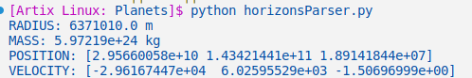
The radius of the earth is 6371km which is 6371000 so the first result is correct.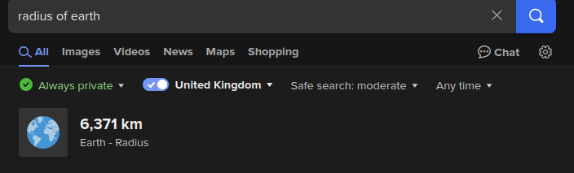
The mass of the earth is 5.792*10^24 so that’s correct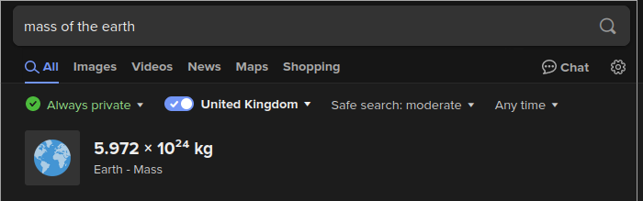
And the positions and velocities match the NASA ephemeris results:
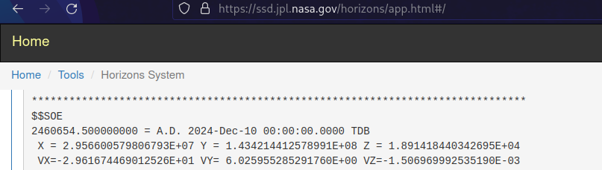
Note that instead of listing them as X =, Y = etc I have put them into vectors. Top row in this screenshot is the position, bottom row is the velocity.

Here are the results of test 02:
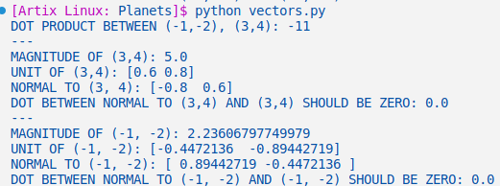
These are the mathematically correct results. The dot product between (-1, -2) and (3,4) is -1*3* -2*4 = -3-8 = -11, which is correct. The magnitude of (3,4) is sqrt(3²+4²)=sqrt(25)=5, and so on. Every result here is correct so the test is successful.

