A level Computer Science Programming Project

Candidate name: Archie Russell Pennycook
Candidate number:
Centre name: South Wilts Grammar School
Centre number:
Project Title: Solar System Simulation

Analysis 4
Introduction 4
How a simulation of the solar system works 4
What teachers want in a simulation of the solar system 5
Current alternatives 8
NASA’s Eyes 8
PhET: My Solar System 8
What I’ve learned from the alternatives 9
Modelling the problem 10
Class diagram 10
NASA’s API 10
The maths of simulating a solar system 13
Verlet Integration 13
Gravity 13
Vectors 16
Displaying the system 16
Interface 19
Objectives 20
Documented design 22
Modules 22
pygame 22
horizonsParser, datetime & requests 22
getEphemeris 22
Getting the request 23
Parsing the request 24
extractValue 29
Finding the scale 31
Finding the value 31
math(s) 32
numpy 33
vectors 33
Magnitude of a vector 33
Finding a unit vector 34
Finding a normal vector 34
File Structure 34
Data dictionary 35
Classes 36
Satellite / planet 38
Overall system design 44
Initialisation 44
Adding the planets 44
Setting up pygame 46
System parts 47
Simulating a tick 48
Methods used 51
addGPE / addKE / addMomentum 51
gravity 51
secondLaw 52
verlet 52
Display 53
The start screen 55
Displaying the solar system 55
Methods used 59
offscreen 59
focusAdjustment 59
scaledPos 59
drawPlanet 60
displayPlanets 60
displayLines 61
drawArrow 62
displayArrows 64
Comparison mode 65
Interface 66
Menu 66
Inputs 69
left / right arrows 69
up / down arrows 69
space 69
F 69
A 70
W, S, E and D 70
Mousewheel up and down 70
Miscellaneous functions 71
com 71
sumPhysicalProperties 72
zoom 72

Analysis

Introduction
The solar system is an important part of the physics curriculum, and it’s something that children often find more interesting than other core physics topics such as circuits or mechanics. I think it’s important to teach the solar system because it’s fun, and because it can also help students understand the more boring topics, such as forces or energy, as forces and conservation of energy can be demonstrated with the solar system.
However, there is a lack of interactive tools available for teaching the solar system that also incorporate other physics topics such as energy. It would be useful to teachers, and students, to have a progam that can use an interesting topic like space that also teaches important concepts from other topics such as conservation of momentum or Newton’s laws.

How a simulation of the solar system works
The orbits of the planets are governed by two fundamental laws of physics:
- Newton’s second law of motion: $F=ma$, where F is the force acting on a body, m is the mass of a body, and a is the acceleration of the body
- Newton’s law of universal gravitation: $F=\frac{GMm}{r²},$ once again F is the force, G is something called the “gravitation constant”, M and m represent the masses between two bodies, and r² is the distance between them.
To demonstrate this, a force diagram is attached.
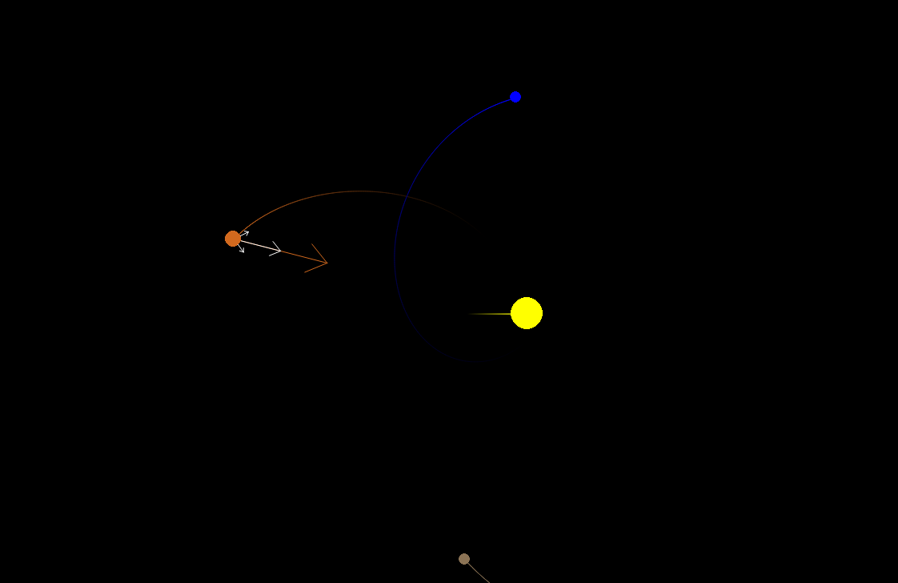
The orange planet has 4 arrows around it. These are the forces acting on it. The arrow shows the direction of each force and the length of the arrow represents the strength of the force. The white arrows are individual forces, you can see one pointing towards the brown planet, one pointing towards the blue planet, and one pointing towards the yellow sun. The arrow pointing towards the sun is much longer than the other arrows, representing that it has a stronger effect. This is because the sun has a larger mass, and so the force of gravity due to it is a lot stronger.
The brown arrow is the resultant force. This is what happens when you pull the planet in the direction of all three arrows at the same time. Because the force from the sun is so much stronger than the force due to the other planets, the resultant force is pretty similar to the force from the sun.

What teachers want in a simulation of the solar system
These are extracts from an interview with the South Wilts physics department
Question:
“What content is covered when teaching lower school classes?”
Answer:
“We do a little bit of work with Y7 looking at the order of the planets in the Solar System and the properties of some of the planets.
“In Y11 we look at the objects in the solar system and orbital motion. They need to know that gravity provides a centripetal force and how closer planets orbit faster.
How this impacts the project:
I need to accurately display the solar system with the planets in the correct order, show the orbits of the planets, and have a way to show that gravity provides a centripetal force.

Question:
Do you currently use any interactive tools when teaching the solar system? If so, which, and how do you use them? Do you think there’s anything they’re lacking that would help kids learn better?
Answer:
Not with Y11.
Y7 have the opportunity to complete independent research on a planet in the solar system and we share this link https://eyes.nasa.gov/apps/orrery/#/home. It has easy links to extra information and a size comparison.
It would be good to see this combined with something that shows the orbital motion of satellites.
https://phet.colorado.edu/sims/html/my-solar-system/latest/my-solar-system_all.html
This simulator is great to show the effect of changing mass on the theoretical solar system. I wonder if there could be a simulator which enabled us to ‘play’ with the masses in our actual solar system to see what happens – probably this would be more useful Y11 onwards.
How this impacts the project:
I need to create something that shows the motion of planets, as well as having size comparisons, like in the link above. Should be possible to edit the masses of objects to show the effect it has too like in the PHeT simulator. I think allowing the user to change the value of G would be informative as well, to show what it actually does.

Question:
What other features would you want in an interactive program that would make it useful for teaching?
Answer:
With younger students it is good to be able to show them information when setting them independent tasks to avoid them just copying and pasting things they don’t understand from incorrect sources.
Impact on project:
Planets, satellites and other celestial objects should display their properties (e.g. mass and size) so that the program can act as a source of information, rather than students finding erraneous sources online.

Question:
What format would be most convenient, e.g. would a website be preferable to an app you had to download?
Answer:
An executable file would work well

Question:
Should the program focus entirely on the solar system, or would it be useful to also use the orbits to demonstrate concepts like Newton’s laws, conservation of energy and conservation of momentum?
Answer:
We look at the solar system right at the end of Y11 so if there was a program which linked to key Newtonian Physics, it would be a great way to re-visit these laws in a different context.
Impact on project:
Should include things such as force diagrams and total energy to link the solar system to these concepts.

A review of the features requested:
- Display extra information in the program
- Size comparison
- Interactively changing the mass of the planets
- Demonstrating concepts of Newtonian physics
- Make the program downloadable e.g. a python file

Feature 1 can be implemented with an object oriented approach. There will be a celestial body class. Celestial bodies will be stored as objects. Their masses, positions and sizes will be stored as attributes. I can just display those attributes (these attributes will be fetched from a NASA database as explained later, which is a reliable source.)
Feature 2 can be done by splitting the screen in half, displaying the chosen object in the left half, and scaling the left half so that it fits the chosen object. Then display the other chosen object for comparison in the right half at the same scale.
Feature 3 is doable. The mass of planets is already stored as an attribute for them. All that needs to be done is to let users edit the mass of said planets.
For feature 6 the challenge is figuring out how to do it in a way that a 12 year old can understand. The program already conserves momentum, energy, and uses Newton’s laws of motion because it’s supposed to be an accurate simulation. The hard bit is trying to make it clear to kids how those things are happening in the program, and help them get a better understanding of it. I will try displaying both the potential and kinetic energy of the system, as well as the total. This will show that while the types of energy change, the total amount of energy stays constant.

Current alternatives

NASA’s Eyes on the Solar System
https://eyes.nasa.gov/apps/solar-system/#/home
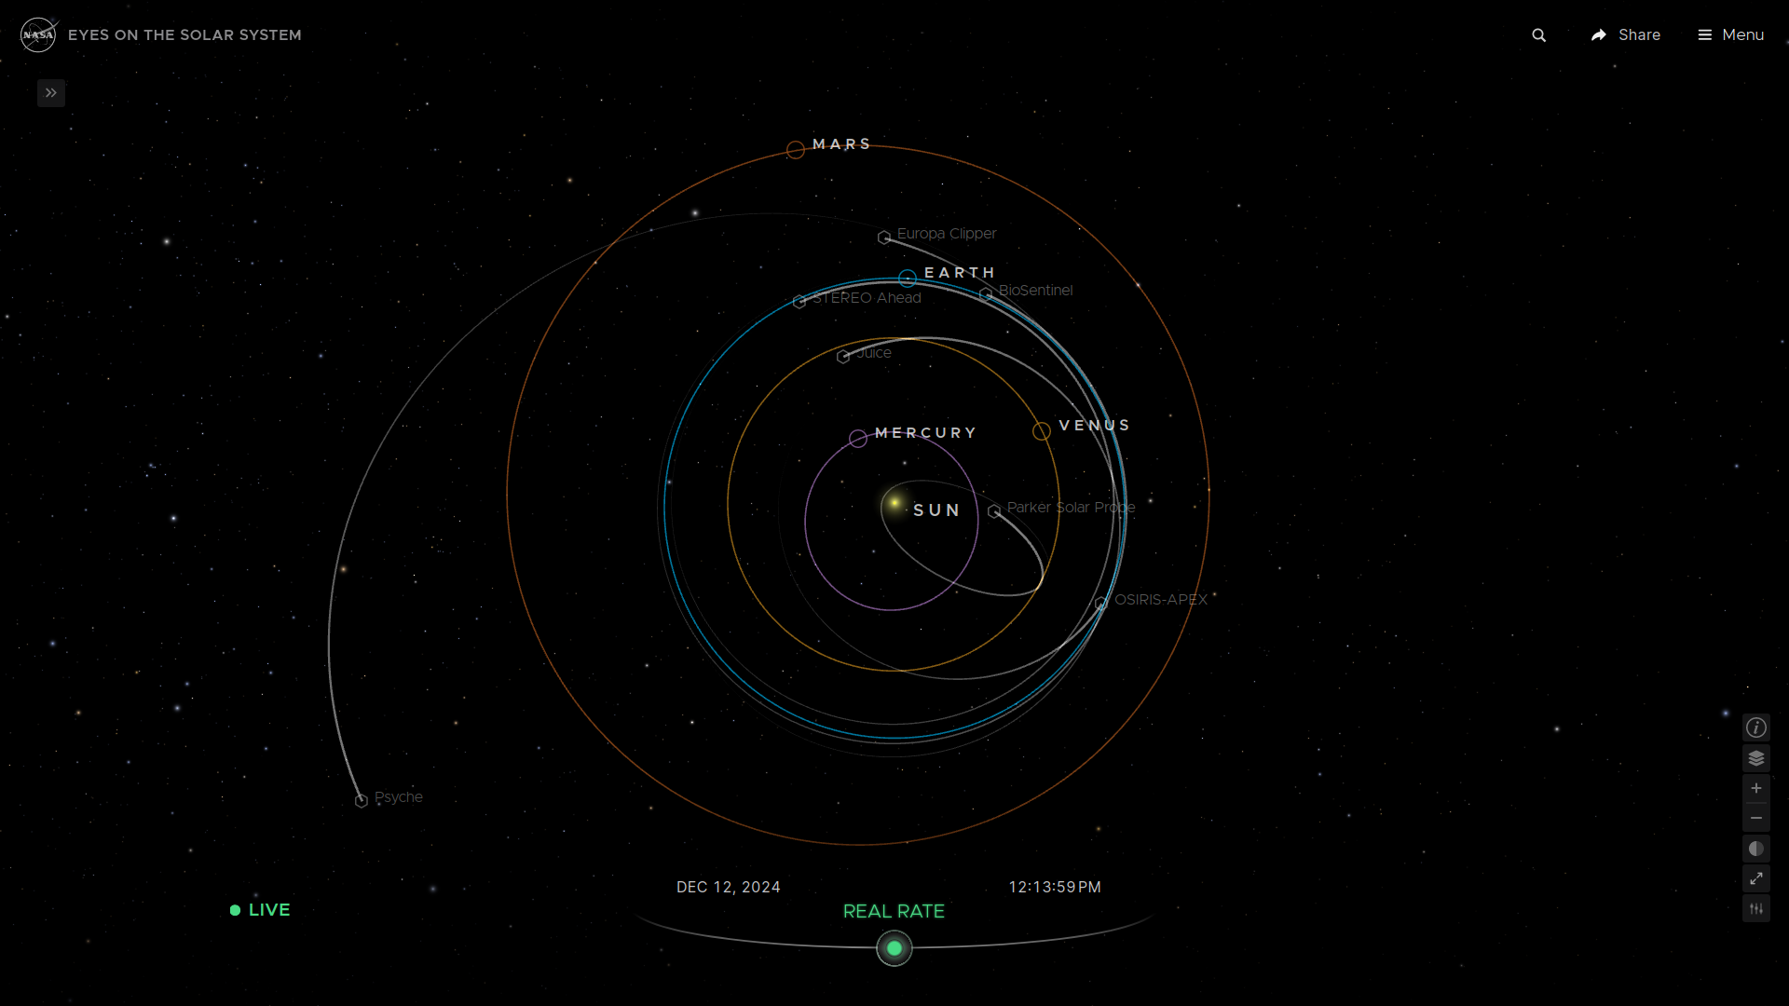
Eyes is a suite of products developed by NASA used for visualising their data. Their orrery, shown in the figure above, demonstrates the orbits of planets, asteroids, comets, and certain satellites. My school currently uses this to teach year 7’s, primarily because it has links to further reading for their research project. It also accurately shows the trajectories of planets and other celestial bodies.
This site allows you to move the camera and to focus on specific planets, which is something I think is very beneficial for teaching as it gives you different perspectives of the solar system, and it is something I want in my own project.
However, the site lacks a few things. There is no connection to Newtonian mechanics, nothing demonstrating it, and no way to change the mass of the planets.

PhET: My Solar System
https://phet.colorado.edu/sims/html/my-solar-system/latest/my-solar-system_all.html
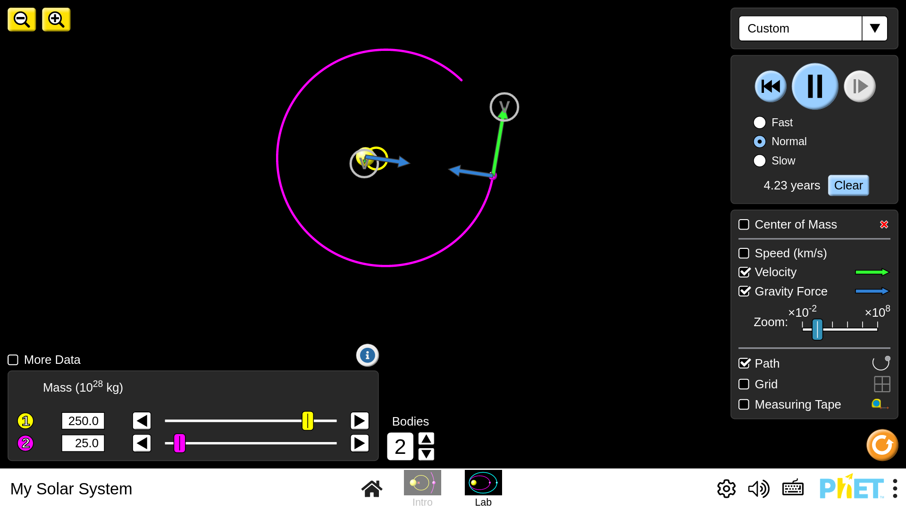
PhET (Physics Education Technology) is a website hosting a large amount of interactive physics simulations where students can tweak parameters and see the effects in real time. Its simulations are used by schools all around the world, and mine is no exception. As mentioned in the interview, my school finds the PhET simulation for the solar system useful because it lets you change the masses of the bodies in the solar system. It also includes force and velocity vectors, which can be used to help link back to Newtonian mechanics.
The drawback is that it’s all on a fictional solar system. You can’t put it into context with our actual planets. This would both be entertaining for students (who doesn’t want to know what would happen if the Moon weighed as much as Jupiter?) and help them visualise the effects of changing mass.

What I’ve learned from the alternatives
I aim to merge all the useful features in the alternatives listed above, and package them in an inuitive, easy to use software that benefits both teachers and students. This means being able to edit attributes of planets like in the PhET simulation, while also being accurate to our own solar system like NASA’s Eyes.
Some general design principles / tips from looking at the alternatives:
- A downloadable program is the most accessible format for teachers
- Interactivity and being able to edit parts of the system is beneficial to learning and should be in the program
- The program should show the actual solar system, not a fictional one
- Arrows and other visual tools should be used to intuitively show physical quantities such as force and velocity

Modelling the problem

Class diagram
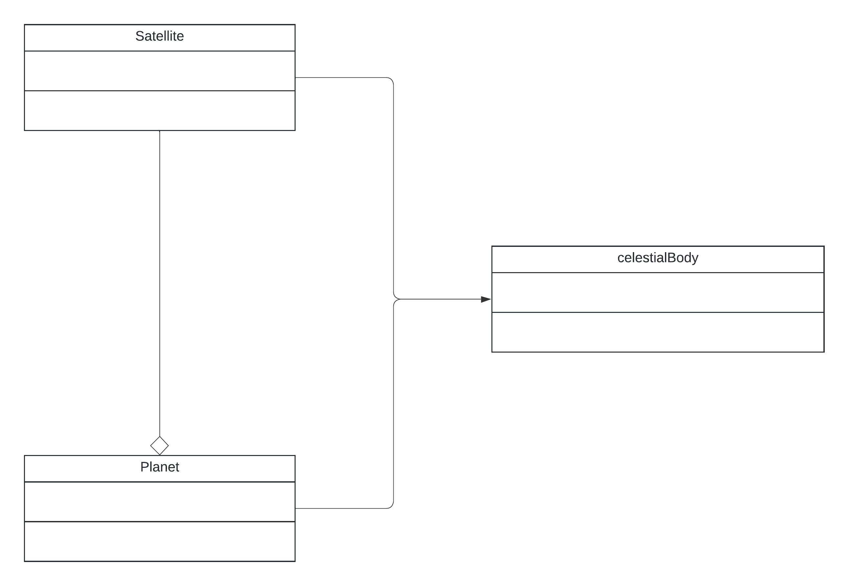
The main object in the solar system is a celestialBody, this is a catch all for pretty much every object in the system. Satellite and planet both inherit from celestialBody to tweak the behaviour slightly. The distinction between planet and satellite in the program is based on the astronomical definition, not the colloquial definition. A satellite is a body that orbits a host that isn’t a star, while a planet is anything else. That’s the only distinction, this means that the Sun and the Voyager satellites are classed as planets, because they do not have a host they orbit. Meanwhile the moon is a satellite because it orbits the Earth.
Satellites need to always orbit a host planet, and this host is one of their attributes, so they are aggregated with Planet. The Satellite’s existence is not dependent on the planet, e.g. if the Earth disappeared today the moon would continue existing, so aggregation is used instead of composition.
The methods have been omitted for brevity, there are a lot that are required. They will be in the class diagram in the design.

NASA’s API
The client requested the ability to change masses (simple), but for real planets in our solar system (less simple). This means I need to somehow have data on all of the planets, and to keep it up to date. Luckily, NASA has a solution for us:
https://ssd.jpl.nasa.gov/horizons/
Horizons is an online database that hosts real time information on planets. The idea will be to access this data using their API, which uses HTTP POST queries, and then translate that data to parameters for planets in my program, and load the solar system. Parsing the data may be tricky, but once I have the mass, positions and velocites of the planets it should be rather simple to load the solar system. This is because planets are already stored as objects with all of those attributes in my code, so I just need to create objects with their attributes set to be the ones retrieved from the Horizons query.
This is the request I will be using:
https://ssd.jpl.nasa.gov/api/horizons.api?format=text&COMMAND='"+target+"'&OBJ_DATA='YES'&MAKE_EPHEM='YES'&EPHEM_TYPE='VECTORS'&START_TIME='"+startTime+"'&STOP_TIME='"+stopTime+"'&CENTER='500@0'&STEP_SIZE='1%20d'&QUANTITIES=''’
Target, startTime and stopTime represent variables that will be set by the program. The rest of the request will not change. Here is an explanation of the important settings I’ve used in the request:
EPHEM_TYPE: This has multiple options. However the other options are all intended for uses not relevant to my program, e.g. making telescope observations or planning space missions to other planets. VECTORS is the type that NASA recommends for programming on their own site:
https://ssd-api.jpl.nasa.gov/doc/horizons.html#ephem_type
So it’s the one that I use.
CENTER: This is the reference location for the coordinates returned by Ephemeris. 500@0 is the ID for the Solar Barycenter, the center of mass of the solar system. This is the most objective reference point available for our solar system, so is the one that I use.
STEP_SIZE: This just means the ephemeris generates coordinates every day, this isn’t really relevant to the program as I’m only using the initial coordinates given in the response and simulating the rest from there.
QUANTITIES: This lets you request a bunch of very cool information, but none of it is needed by my program, so to make getting the request faster and to reduce the size of the requests it is set to be empty.

Once the request is received, it must be parsed so that the relevant parameters can be extracted. The basic strategy I’ll use is to first search for key phrases in the text like “Mass” or “Radius” which indicate that a parameter I want is about to come up. Once a key phrase is found, this algorithm will be used to get the numerical value out:

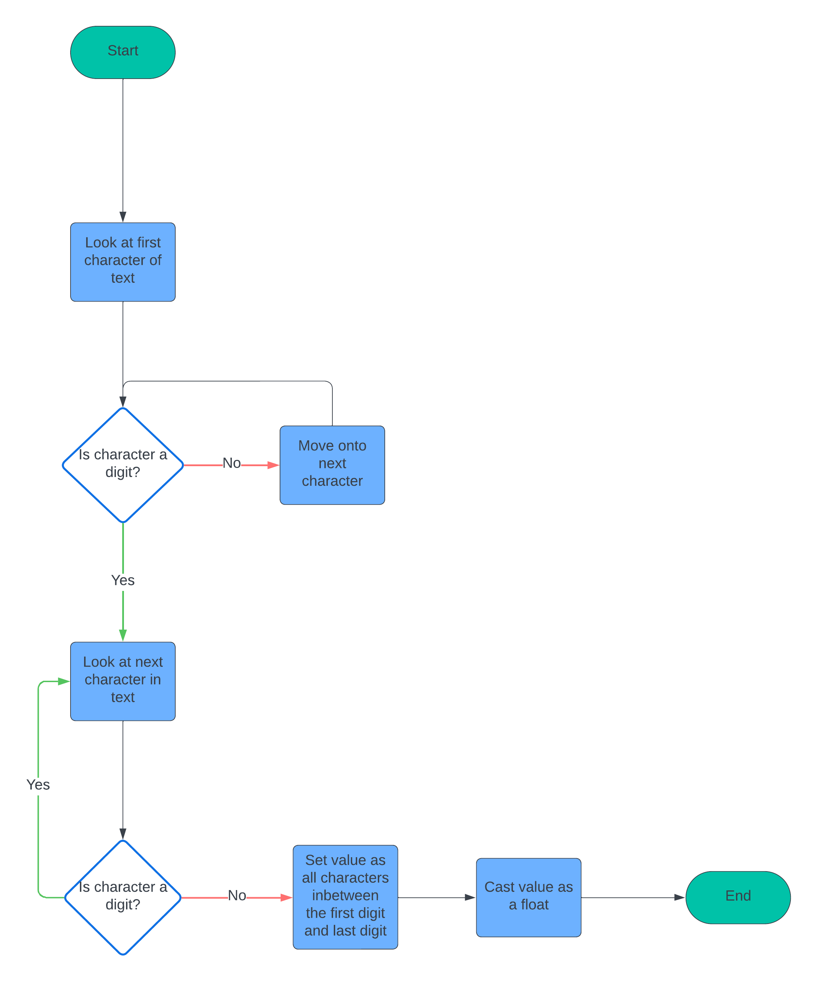
Because NASA formats their data horribly, there are a lot of caveats involved that will need to be overcome in order to sucessfully parse the data. This will be covered in the design.
The functions to request and extract data from NASA will be in a separate file, horizonsParser, so that it can be imported as a module.

The maths of simulating a solar system

Verlet Integration
Verlet integration is a computationally efficient method for simulating the motion of objects.
This is the equation for basic Verlet:
$$x_{n+1}={ 2x}_{n}-{ x}_{n-1}+{ a}_{n}{Δt}^{2}$$
This looks very scary, but isn’t actually that bad. $x_{n}$ is the current position of the object. $x_{n-1}$ is its previous position. $x_{n+1}$ is its updated position. ${ a}_{n}$ is the acceleration of the object. ${Δt}^{2}$ means a very very small step forward in time.
We can do some factoring to get a more useful form of the equation:
$$x_{n+1}={ x}_{n}+x_{n}-{ x}_{n-1}+{ a}_{n}{Δt}^{2}$$
$$x_{n+1}=x_{n}+(x_{n}-x_{n-1})+{ a}_{n}{Δt}^{2}$$
$$x_{n+1}=x_{n}+v_{n-1}Δt+{ a}_{n}{Δt}^{2}$$
$$x_{n+1}=x_{n}+ (v_{n-1}+a_{n}Δt)Δt$$
$$x_{n+1}=x_{n}+v_{n}Δt$$
This is the equation that will actually be used in code. What it means is that, given an object at position $x_{n}$, and with a certain speed $v_{n}$, its position $x_{n+1}$ after moving forward a small amount of time ($Δt$) is its old position + its speed multiplied by that small amount of time. Example:
A car is 9 miles along a road (so $x_{n}=9$). It is moving at 60 miles an hour. After 1 minute ($Δt$ = 1 min = 1/60 hr), the new position of the car will be $x_{n+1}=9+60*\left(\frac{1}{60}\right)= 10$ miles along the road.
So, all we need to do to find the new positions of our planets after each tick, is add their current velocities multiplied by a time factor ($Δt)$ to their current position.
There is also a similar equation for velocity and acceleration that will be used throughout the code:
$$v_{n+1}=v_{n}+a_{n}Δt$$
Where you add the acceleration to get the new velocity.
The $Δt$ term lets us change the speed of the simulation. The larger it is the faster the simulation is, it might cover a year of orbits in a single second for instance, but also the larger $Δt$ is the less accurate the simulation is. The user will be able to change $Δt$ with keybinds to suit their own needs.

Gravity
As mentioned earlier, the two equations used to simulate gravity are:
$$F=ma$$
$$F=\frac{GMm}{r²}\hat{r}$$
The goal here is simply to work out the acceleration on a planet due to gravity. Once that is done, the acceleration of the planet is handed over to the Verlet integration algorithm, which handles everything else.
Let’s start with the simpler equation, $F=ma$. Here, F is the force, m is the mass of the object, and a is the acceleration. We will calculate the force using the other equation, $F=\frac{GMm}{r²}\hat{r}$, and we already know the mass of all of our planets. We want the acceleration. So, solving for acceleration we get:
$$a = \frac{F}{m}$$
Which is quite nice. To find the acceleration, we just take the force acting on the planet and divide it by its mass.
Now let’s cover $F=\frac{GMm}{r²}\hat{r}$. Here, M and m are the masses of the two objects in question (M is conventionally the mass of the larger planet), r is the distance between them, $\hat{r}$ is a unit vector pointing from one planet to another, and G is a physical constant. It’s important to note that the F here is NOT the same F as the one in F = ma. The F in F = ma is the *resultant* force, the sum of all the forces acting on an object, while the F in this equation is just the force due to the gravitational pull of one planet.
This means to get the resultant force acting on a planet, we must compute $F=\frac{GMm}{r²}\hat{r}$ for that planet and all the other bodies in the system. We then add those forces up (some may be negative and cancel each other out) to get the resultant force. This is then given to F = ma, and the acceleration from that is given to Verlet integration. Note that we must

To summarise everything covered in this section, a flow chart on the next page describes what happens to a single planet on each tick of the program:
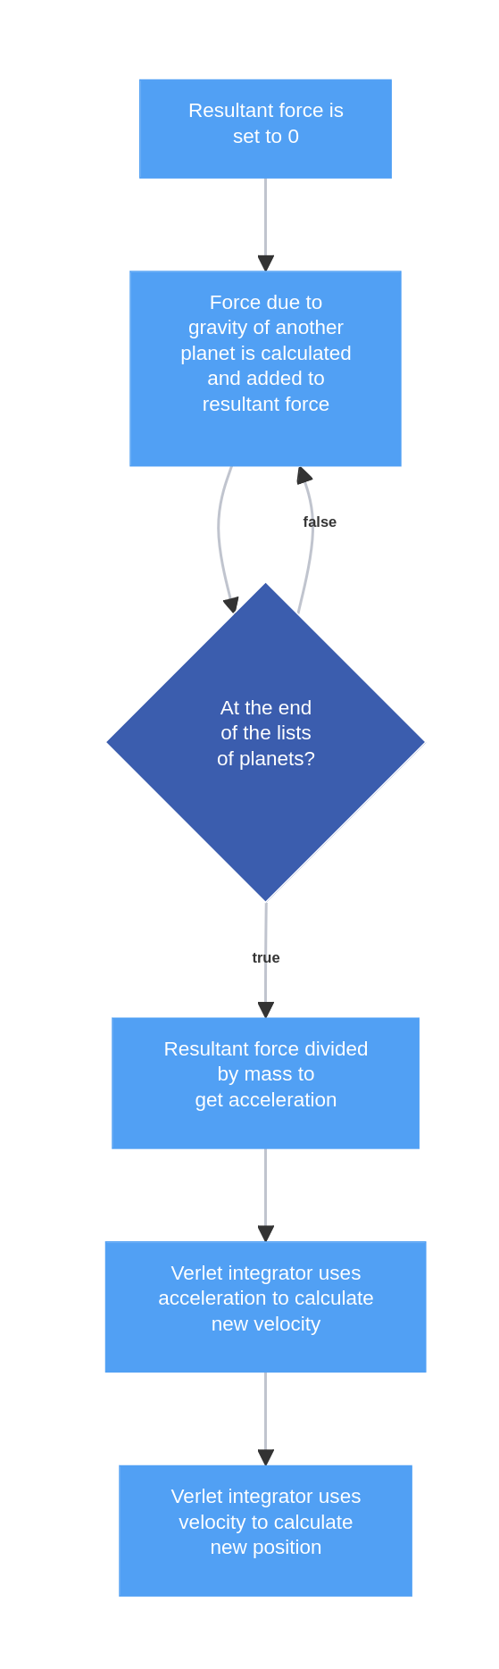

Vectors
To use verlet integration and Newton’s law of gravity we will need to have access to a few basic vector operations. These are:
- Finding the magnitude of a vector
- Finding the unit of a vector
- Finding the perpendicular to a 2d vector
To find the magnitude of a vector you simply square each element, add them up, and then take the square root. E.g. if we have the vector (1, 2, 2) then the magnitude is sqrt(1²+2²+2²)=sqrt(1+4+4)=sqrt(9)=3. This is needed to find “r” in the gravity equation, as the distance between two planets is the magnitude of the vector between them.
To find the unit of a vector is very simple, you find its magnitude and then divide every element by it. So the unit of (1, 2, 2) would be (1/3, 2/3, 2/3). This is needed to find $\hat{r}$ in the gravity equation.
To find a perpendicular to a 2d vector you swap the elements around and negate one of them. So e.g. the two perpendiculars to (1,2) would be (-2,1) and (2,-1). It is arbitrary which you negate so I will just negate the first element. This is needed to draw arrows, the two lines at the end of the arrow need to lie on a perpendicular to the main line of the arrow. This will be explained more in the design, drawing arrows is surprisingly technical.
These operations will be put in a separate file so they can be imported as a module.

Displaying the system
I will use a simplistic design philosophy for this project. I want to get the relevant information across: Relative sizes of planets, orbital paths, positions of planets. But I want to do this without impacting performance or making the display hard to understand. To do this, I will use solid coloured circles for the planets, as this makes it clear where they are, and thin lines to show their trajectories. This is a mockup of what the system would look like with a few planets:
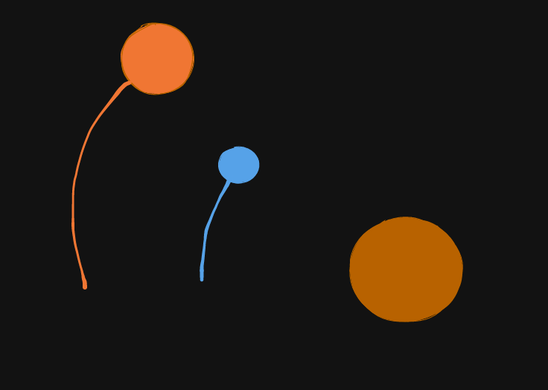
The two smaller circles on the left with lines coming off them are planets, orbiting the central mass in the middle, which represents a star. The star does not have any lines coming off it as stars do not tend to move much relative to the centre of mass of their solar system, because they are so big. Sometimes our sun will move slightly though, and this would be represented with a line showing its path.
This approach makes all the information I want to convey clear, and is quite simple to understand, but is also very easy to render so will not impact performance.
I want all the distances to be to scale in my program, but this is quite difficult as the distances involved in the solar system are absolutely huge. To achieve this I will use a scaling factor, so everything in the system will be scaled by the same amount. This keeps all the relative sizes accurate, e.g. the moon will still be roughly 1/4 the size of Earth, but it won’t take a 2000 kilometre wide screen to display it. To do this in code I will take the radius of a planet, multiply it by the scaling factor, and then draw a circle with that radius. If the scaling factor is chosen correctly then all the planets will be visible and it should look like an accurate model of our solar system.

This also makes size comparisons, which were requested by the client, quite easy to do. You simply draw the circles for the two desired planets side by side, rather than at their normal position. Because of the scaling factor the two planets will have the correct relative sizes, so the size comparison will be accurate. This is a mockup of what a size comparison might look like:
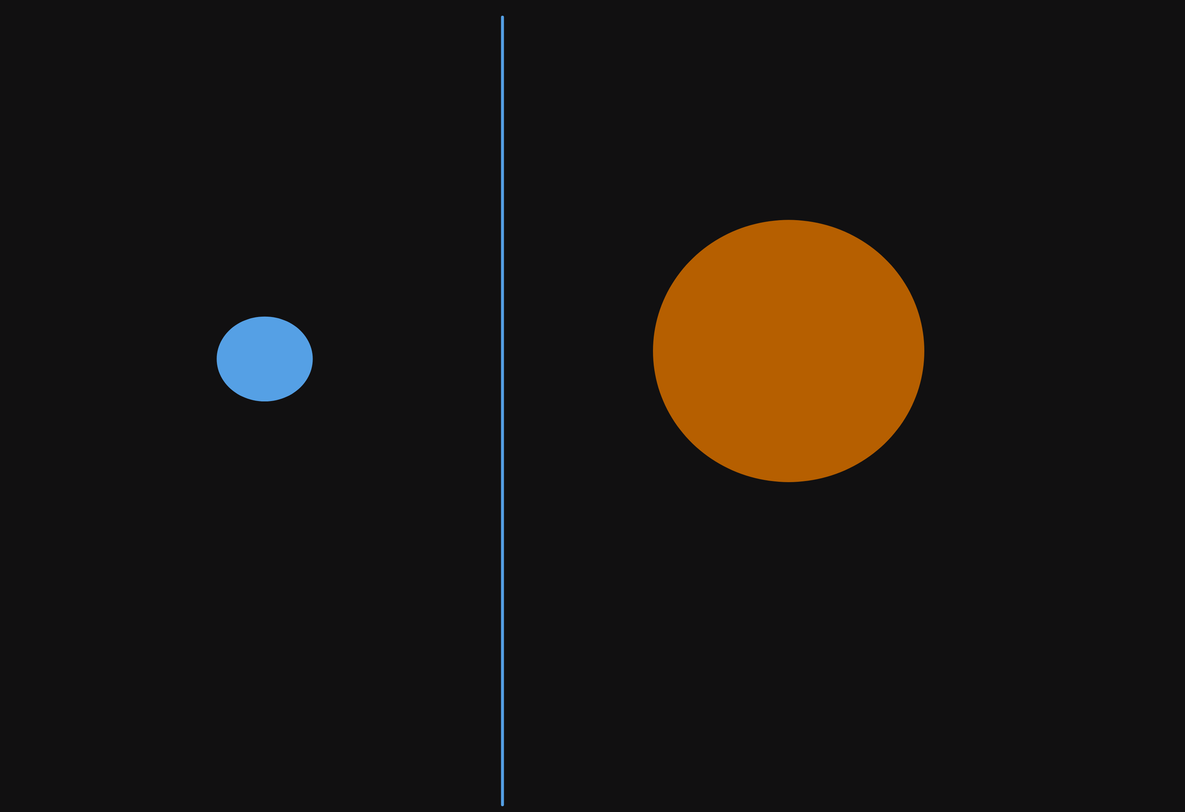
Like mentioned when looking at NASA’s Eyes, I want the user to have the ability to move the camera. I will not give complete freedom to move the camera, as the solar system is very big and this could easily lead to them getting lost in a lot of empty space between two planets, and just seeing a blank screen. Instead, I think the camera should centre on a planet or other object and the user should be able to choose which object it focuses on. As well as being able to centre on the planets like in NASA’s Eyes, I want to also let the user centre the camera on the centre of mass of the system. While this isn’t particularly useful for our solar system usually, as the centre of mass is always inside or very close to the surface of the sun, this will be helpful when users start changing the mass of planets, as the solar system will quickly spin out of control and focusing on the centre of mass will make everything easier to see. It will also place you inbetween the sun and whatever planet you’ve increased the mass of by an absurd amount, so you get a good position to view the system.
Focusing on planets will be done by pressing the left and right arrow keys, this will cycle through objects, which will be ordered based on their proximity to the sun, so pressing the right arrow key makes you move further away from the sun and the left arrow key makes you move closer (until you reach the furthest out object then it will bring you back to the sun and the loop starts again.)
The way the focusing will be done in code is by calculating the vector between the selected object and the centre of the coordinate system. This is our “adjustment”, which can then be added to the positions of all the planets during the display process, so that they’re all in the correct position relative to the selected planet. The full process is quite mathematical so will be explained in detail during the design.
The user should be able to zoom in and out as well. This lets them focus on the motion of one or two planets, or get a full scale view of the system.

Interface
I will use a simple text and keyboard based menu to allow the user to interact with the program. This will be used to display the energies and momentum as needed to teach conservation of energy / momentum, as well as to let the user edit the mass of planets. I want the user to be able to switch the planet that the program is focused on, and to be able to speed up or slow down the simulation to their liking. I will display text at the top of the screen showing the relevant statistics like the total energy in the system, the mass of the planet, etc. This can be done using pygame’s font.render() method. A start screen will be displayed at the beginning of the program that explains all the keybinds, as well as obviously letting the user start the simulation (which will be done through pressing enter). Here is a mockup of what the start screen will look like:
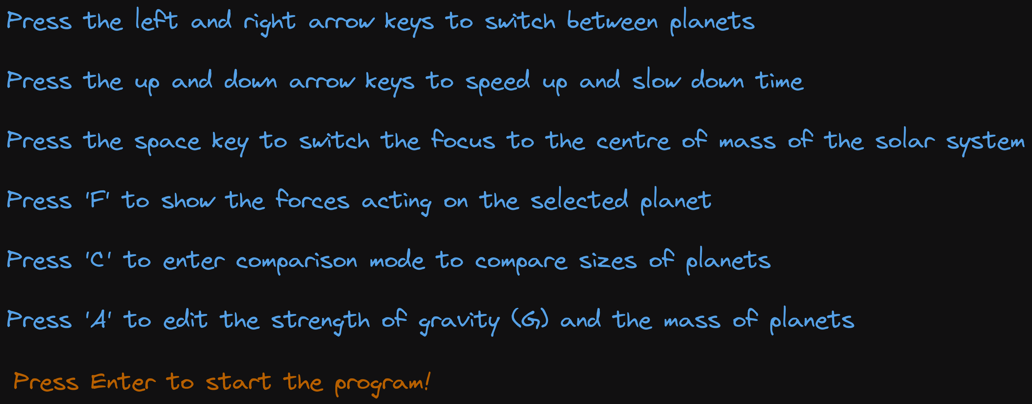
The last line telling the user how to start the prorgam is coloured red, differently from the other lines, to get their attention because if they don’t see it they won’t know how to start the program.
An “edit mode” will be included that lets the user edit the masses of planets and the value of G by pressing keybinds. The mode should explain all the necessary keybinds so that users do not need to memorise them. Here is a mockup of what the interface will look like outside of edit mode:
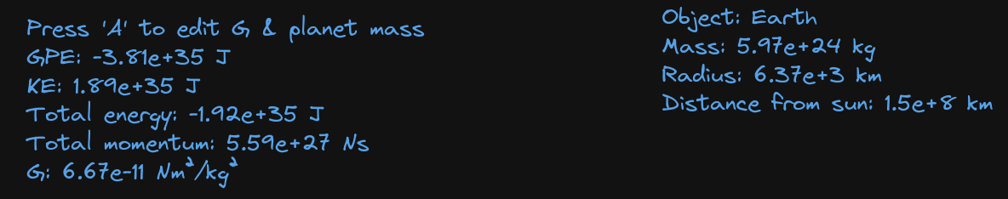
All of the information relevant to the physics the kids are learning is shown; the energies, the momentum, and stats about the planet. Kids are expected to know the acronyms GPE and KE for GCSE, so it is okay to use them.
Here is a mockup of what the interface will look like in edit mode:
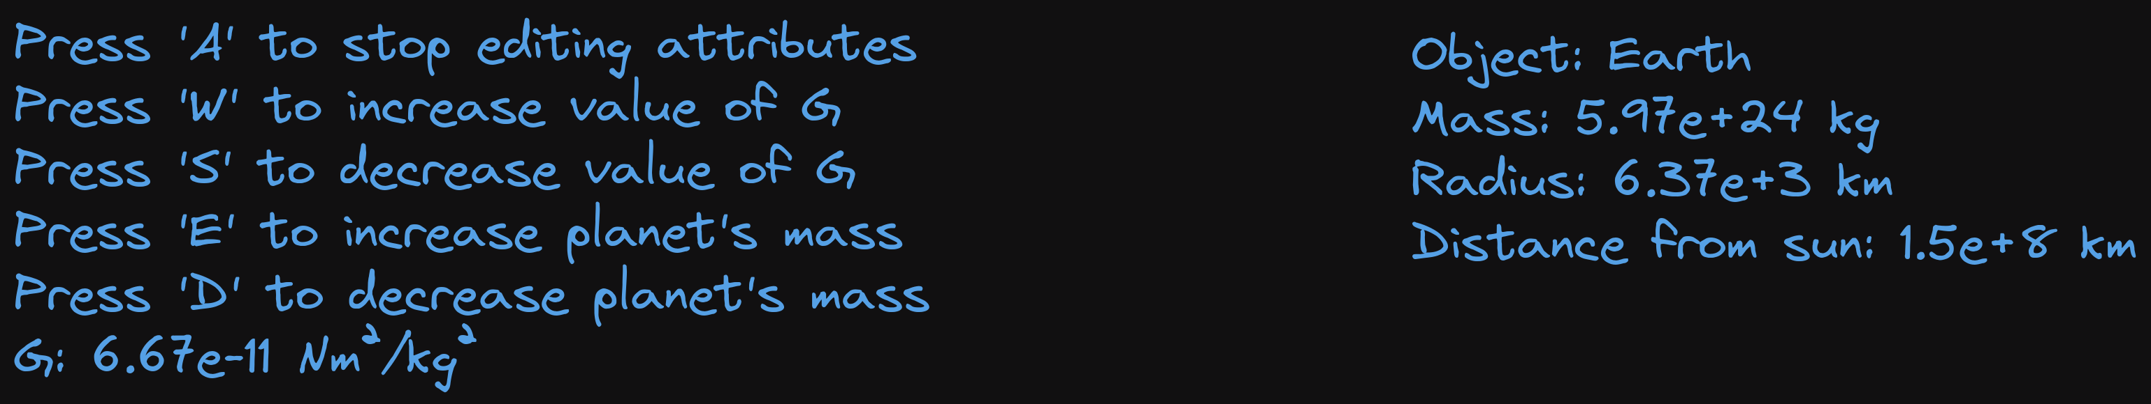
It shows the keybinds the user needs to press to interact with the program, and the value of G is still displayed so that the user can see the effects of their changes. The mass of the planet is also still shown so that the user can see their changes to that too.
Reading the inputs will be done with pygame’s event.get() system and else if statements. The elifs will be used to check what key is pressed. When ‘A’ is pressed this will toggle a boolean value, changingAttributes, and when this boolean is true the program will accept inputs of W, S, E and D and change G / the masses accordingly. When it is false the program will not accept those inputs. The other inputs that are mentioned in the start screen will also all be done with elifs, when the space key is pressed it toggles a boolean that makes the program focus on the centre of mass, when the up arrow is pressed it increments the timescale, etc.
We don’t want G, the mass or the timescale to be negative, as this would be weird and could lead to many bugs. timeScale is simply changed in increments of a tenth of a year, which works fine, so an if statement will just be used to check if it goes below zero and change it back to 0. For G and the mass, these need to be able to take on values across a huge range of orders of magnitudes. The Sun weighs one hundred million times more than our moon. If we were to choose any fixed increment to change mass by, either the moon’s mass would increase by a factor of a few million on a single button press, or the sun’s mass would barely change at all. To deal with this a logarithmic scale is used, upon pressing a button to increase or decrease a planet’s mass or G, the value will change by 0.5*floor(log(value)) where the log is base 10 and floor returns the largest integer less than log(value). This means the amount that a planet’s mass changes by is relative to the current mass of the planet. This also has the side effect of stopping the values from becoming negative, as the increment gets smaller and smaller as you decrease the mass.

Objectives
- Be physically accurate
  - Model the effects of gravity using Newton’s laws of motion
    - These laws should be implemented as methods for a class used to represent planets and other celestial bodies
    - These laws will require the use of vector operations, the vector operations should be implemented in a separate file, vectors, so they can be called from a module.
  - Calculate the motion of objects using verlet integration
    - This should also be implemented as methods for the celestialBody class.
  - Energy and momentum should be conserved (this should naturally arise from using Newton’s laws if they’re implemented correctly)
- Provide an interface that facilitates teaching of the concepts requested by client
  - Have a start screen that explains the keybinds to improve user experience
  - Explain how Newtonian physics connects to the solar system through force diagrams and showing key concepts like energy conservation
    - Include force diagrams to aid with this by showing how the forces cause the motion of the planets
  - Have a menu that displays stats and lets the user edit certain values as requested by client
    - Should display kinetic, potential and total energy, and momentum (This aids objective 2b, explaining how Newtonian physics connects to the solar system.)
    - Should show information about the planet from a reliable source (NASA, see objective 5)
      - Mass
      - Radius
      - Distance from Sun
    - The information should be stored as attributes of the celestialBody class (or in the case of distance from sun can be calculated from celestialBody class).
    - Users should be able to press “A” to enter a mode where they can edit attributes
      - Should let users edit the value of G
        - G should never become 0 or negative, this would cause a lot of severe bugs due to the way the maths of gravity works. Hence a logarithmic scale will be used so that G can get closer and closer to 0 but never reach it
      - Should let users edit the mass of planets
        - Once again this shouldn’t become negative
  - Let users speed up and slow down the simulation so they can look at the solar system far into the future
- Accurately display the solar system with a scale model
  - This should preserve the relative sizes and distances of all the planets
  - Orbital lines should be shown to demonstrate the path of the planets
  - The user should be able to focus the camera on any planet of their choosing, or on the center of mass
  - Let users zoom in and out
- Include the ability to compare sizes of two planets as requested by client.
  - The menu should work slightly differently here and display info on both planets being compared, instead of displaying info on one planet and then displaying info about energies and momentum.
- Access NASA JPL’s Horizons system to automatically import up to date data on planets via API requests
  - Should be able to parse the data to extract relevant values (mass, size, position, velocity).
  - Use said data to load our real solar system into a list of planets (celestialBodies) via dynamic object creation
- Be sufficiently optimised and not suffer frame drops as this would impact the user experience

Documented design

Modules
Here I will explain the modules used in my program, the reasons for using them / where I use them, and for the ones that I created I will explain how they work.

pygame
This module is needed for objectives 2, 3 and 4 to display the menu, display the solar system and compare planet sizes.
For my program to be of any use, you need to be able to see the planets. It doesn’t matter how accurate the physics is if you can’t see it in action. I have chosen pygame for handling the graphics as it allows easy drawing of lines and circles, which are the two shapes I need to draw planets and their orbital paths as well as things like force arrows. Pygame also allows for input handling which means I can make events happen on key presses, e.g. changing the selected planet.
Extensive use will be made of the pygame.draw() function to draw the planets and other parts of the graphics. How I plan to use this function will be explained later in the display section.

horizonsParser, datetime & requests
These modules are needed for objective 5 to access the NASA database.
I want my program to be accurate. That means the initial conditions of the planets should match their actual positions at the time of launch. The easiest way to do this is by fetching the initial conditions from a server, and I have chosen NASA’s Horizons database as the place to fetch the values from because NASA is a reliable source of information, their servers have good uptime, and their API is easy to use (even if the data provided for it is horribly formatted.) Hence I will create a function, getEphemeris (ephemeris is the technical name of the kind of data that NASA provides) that fetches the required data and put it in a separate file, horizonsParser, so it can be imported as a module by the main program.
To achieve this, the requests and datetime python modules will need to be imported. Requests is needed so that I can actually make a request using requests.get(), and datetime is needed to get the current date to put in the request.
Also, NASA does not provide a useful format for their data. They do provide a json, but it only has one section which is just a bit of text containing the entire response. I have emailed them about fixing this but they did not reply. This means that to actually get values out of their ephemeris a lot of parsing must be done, which is the main reason this module exists.

getEphemeris
The way getEphemeris will work is by first getting the request from NASA’s database, and then iterating through the characters in the response searching for key phrases that indicate an attribute that I’m looking for (mass, position, velocity, radius). Once a key phrase is found, the position of the key phrase, along with the text of the response, is given to a function called “extractValue” which extracts the numeric value of said attribute and returns it. This repeats until all desired attributes are found and are returned in a list. This will be done by starting a counter once the key phrase for position is found (other attributes appear multiple times before position in some ephemeris’s returned by NASA, but not other, so a counter used before then is not helpful) and breaking the for loop in the program once the counter is at 6 (i.e. all 3 coordinates for position and all 3 for velocity have been found.)
Here is a flowchart summarising this information:
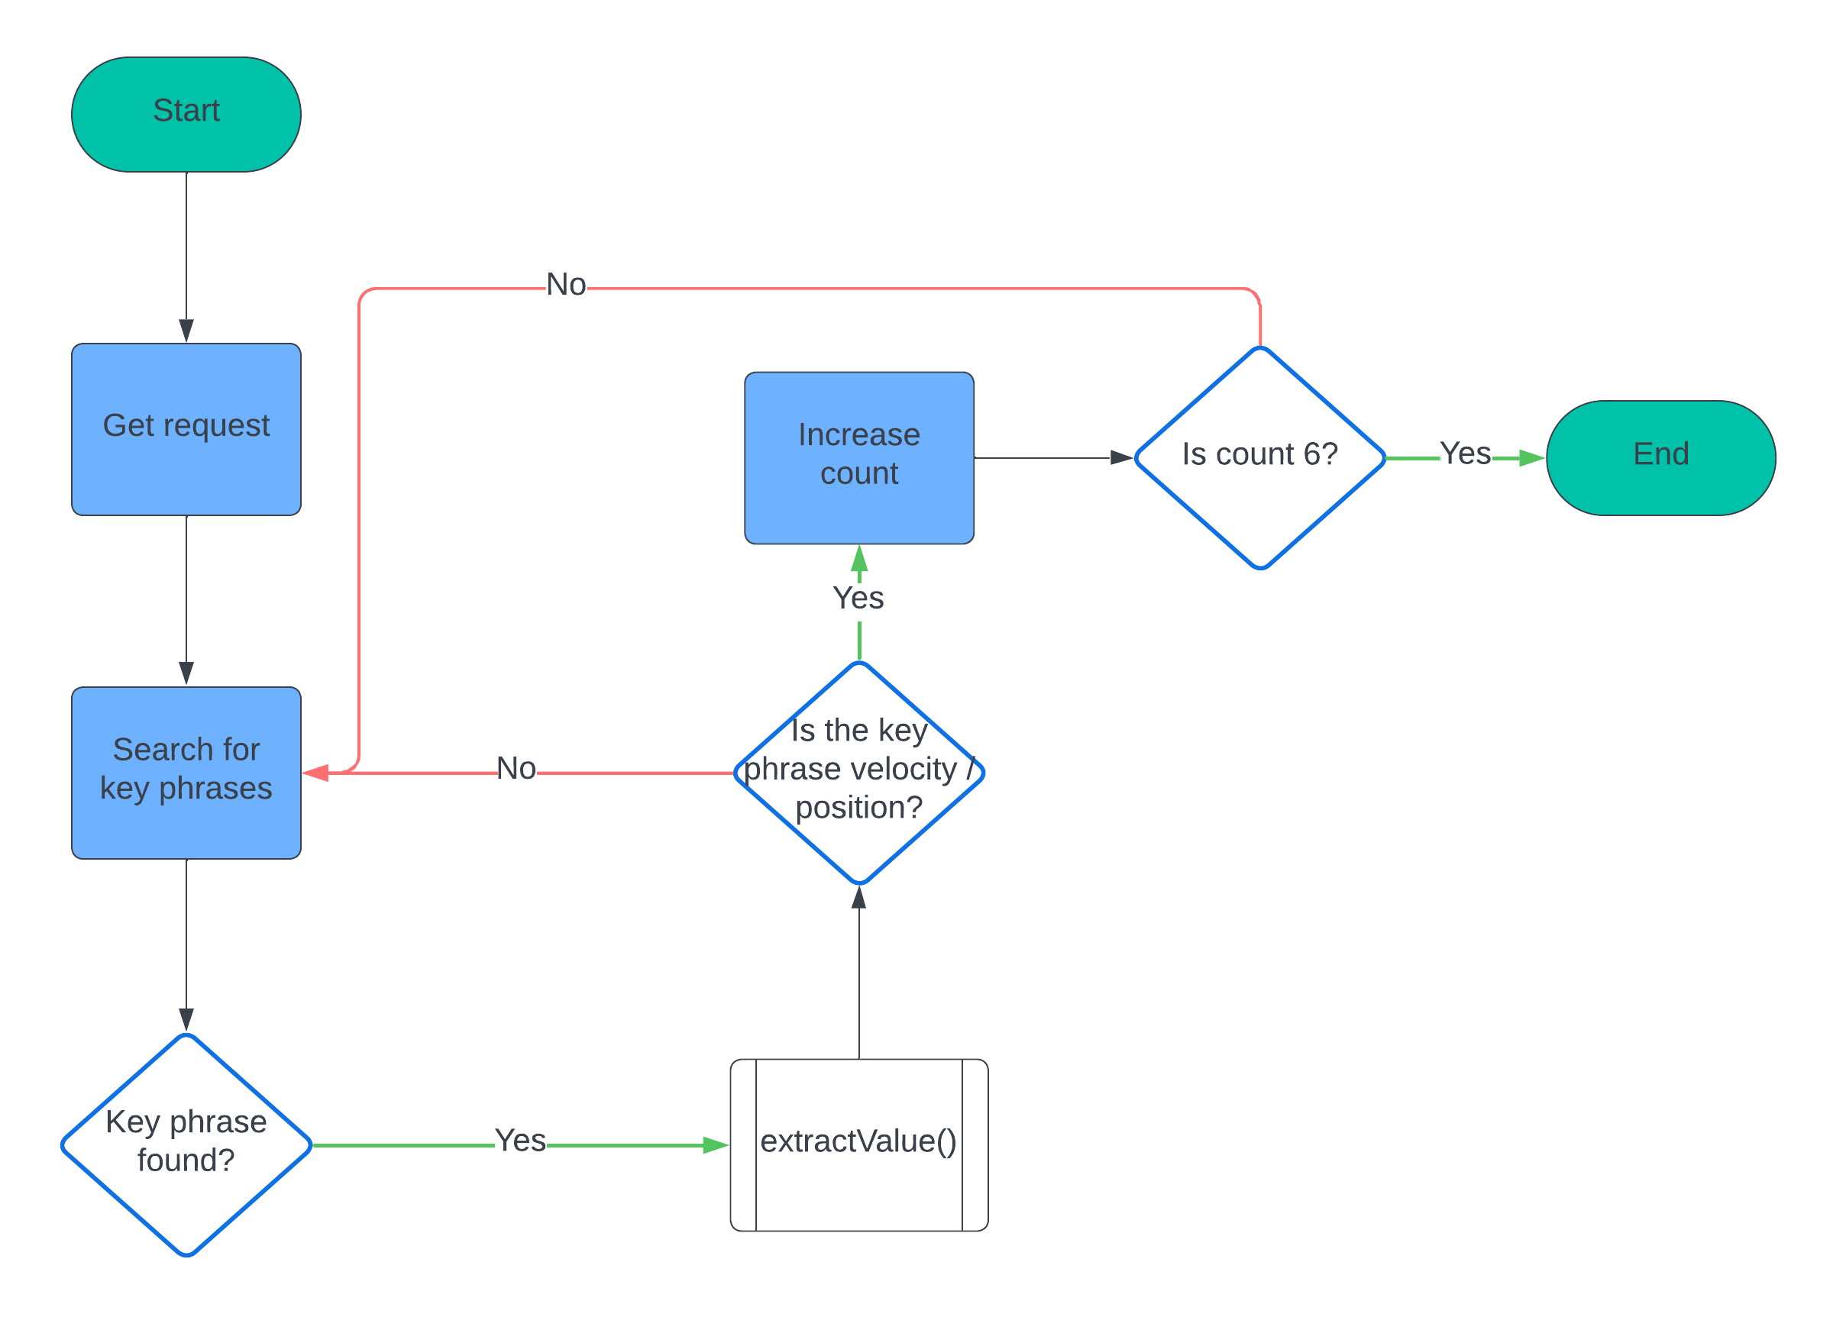

Getting the request
getEphemeris will be given the target planet to get the request for. The first thing to do is to cast this target to a string, in case it’s been given in the form of a numerical ID, as the request format can only take strings.
NASA then also requires a start and stop time for the ephemeris, as it has the capability to produce a list of coordinates for a planet over a time period. We just want the current position of the planet, but NASA does not let you make a request for just a single day, so I go with the shortest option available, the start time being the current day and the stop time being the day after. This will be found using datetime.datetime.now() from the datetime module. NASA requires the date to be in yyyy-mm-dd format, so I will format the date like this using .strftime() from the datetime module.
This is all we need to make the request, as the rest of the parameters do not need to change and will be the same for every request. This is the request that I have settled on using after some trial and error:
https://ssd.jpl.nasa.gov/api/horizons.api?format=text&COMMAND='"+target+"'&OBJ_DATA='YES'&MAKE_EPHEM='YES'&EPHEM_TYPE='VECTORS'&START_TIME='"+startTime+"'&STOP_TIME='"+stopTime+"'&CENTER='500@0'&STEP_SIZE='1%20d'&QUANTITIES=''’
As you can see target, startTime and stopTime are inserted using string concatenation. Some other notable settings are:
EPHEME_TYPE: This has multiple options. However the other options are all intended for uses not relevant to my program, e.g. making telescope observations or planning space missions to other planets. VECTORS is the type that NASA recommends for programming on their own site:
https://ssd-api.jpl.nasa.gov/doc/horizons.html#ephem_type
So it’s the one that I use.
CENTER: This is the reference location for the coordinates returned by Ephemeris. 500@0 is the ID for the Solar Barycenter, the center of mass of the solar system. This is the most objective reference point available for our solar system, so is the one that I use.
STEP_SIZE: This just means the ephemeris generates coordinates every day, this isn’t really relevant to the program as I’m only using the initial coordinates given in the response.
QUANTITIES: This lets you request a bunch of very cool information, but none of it is needed by my program, so to make getting the requests faster and to reduce the size of the requests, it is set to be empty.
Once we’ve got the request, I will assign it to the variable “response.” The text of the response can be accessed by doing response.text.

Parsing the request
We need 4 key attributes to create a planet, the size, mass, position and velocity. The way we will get these is by searching for key phrases in the ephemeris that signify that a numeric value for one of these attributes is about to appear. To make things easier to understand, here is a sample ephemeris for Earth:
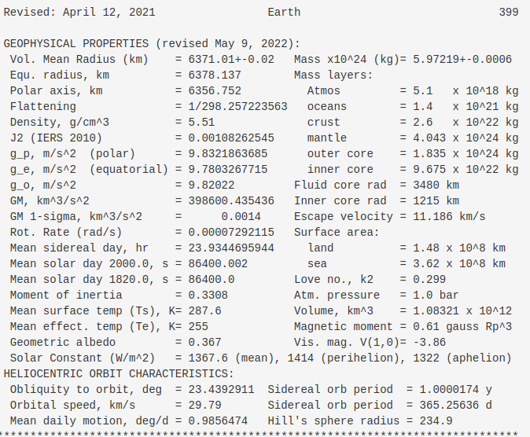

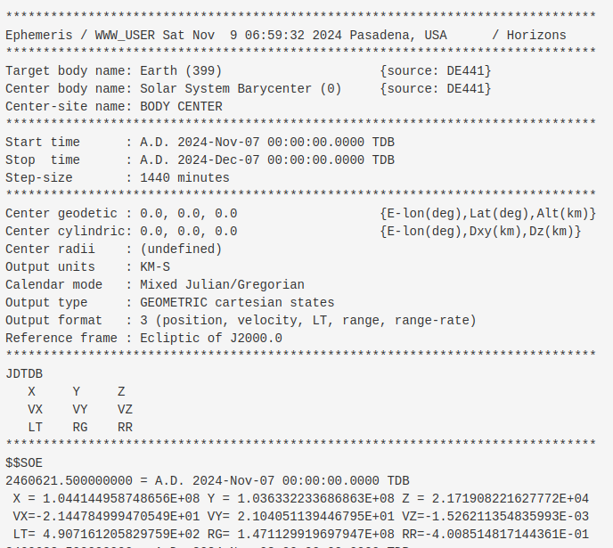
So for example, if we want to get the mass of the planet, we need to look for the phrase “Mass “. Except this appears multiple times, so to be truly unique, we need to look for the phrase “Mass x” which only appears once. This will be done by iterating through each character with a for loop and checking that character along with the next 5 characters after it. So I will check response.text[i:i+6] where i is the dummy variable I’m using in a for loop. The phrases needed differ by planet, *and* have different lengths sometimes, as NASA does not have a standard formatting for their ephemeris, so a lot of OR statements will be used inside the program to handle all the different possible cases. The key phrases have been manually found by me through trial and error with different ephemerides (yes that’s the plural of ephemeris) and then put into the program.
Once a key phrase is found, the numerical value needs to be extracted. I will skip over how this works for now and explain it in the next section on extractValue. Once we have the numerical value, the relevant attribute (e.g. mass) is set to be that value. So here mass would be set to “5.97219x10²⁴” as that is the value given by the ephemeris.
A slightly different approach needs to be used for position and velocity, as they are vectors. I will create two numpy arrays for position and velocity at the start and set all the elements to 0, these elements can then be updated as the values for them are found. This is because arrays are fixed length so you cannot append values to them.
To decide which element to update, a dictionary will be used containing all the key phrases, like this:
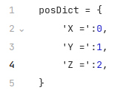
And I will then update position[posDict[response.text[i:i+3]] so that I update the correct element. I will do the same thing for velocity, but a different dictionary will be used as the key phrases for velocity are different.
Once the final velocity element, velocity[2], is found (i.e. it’s no longer 0, the chance of a velocity component of a plane naturally being 0 is so small that it will never happen during the lifetime of the Earth), then the for loop should break and size, mass, position and velocity should be returned in a list.
There are two optional flags that can be set in getEphemeris. The first will be “useGM.” Some ephemerides, for example the ones for Jupiter’s moons, give a physical attribute “GM” instead of the planet’s mass. The mass however can be derived from this by simply multiplying the value by a constant. If “useGM” is true then the program should ignore the key phrases relevant to mass and instead search for the key phrases relevant to GM, and should extract the value and multiply by the constant to then get the mass of the planet.
The other flag is “ignoreMassSize”. For particularly small objects, especially human-made satellites, the mass and size of the object are not given. In this case the mass and size of the object will be manually passed into getEphemeris as arguments and the key phrases relating to them will be ignored.
Now that all of that is explained, here is some pseudocode for getEphemeris:
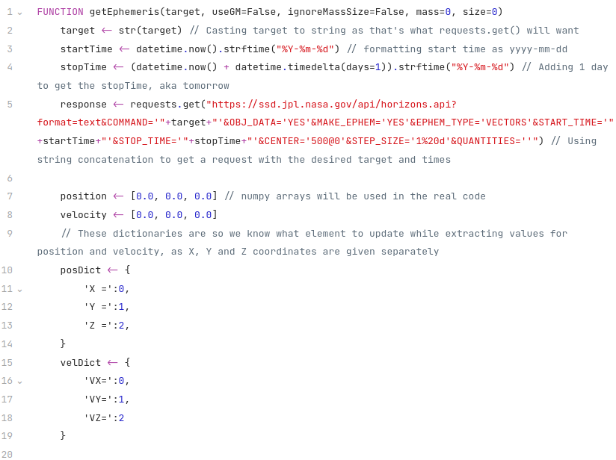
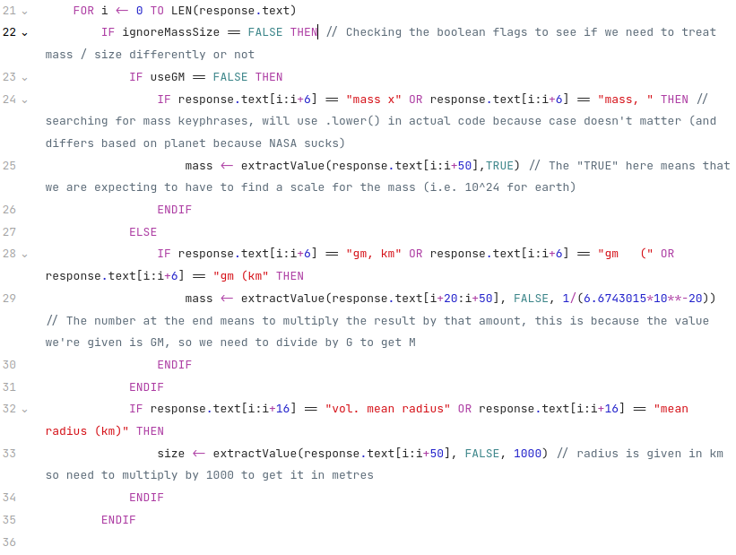
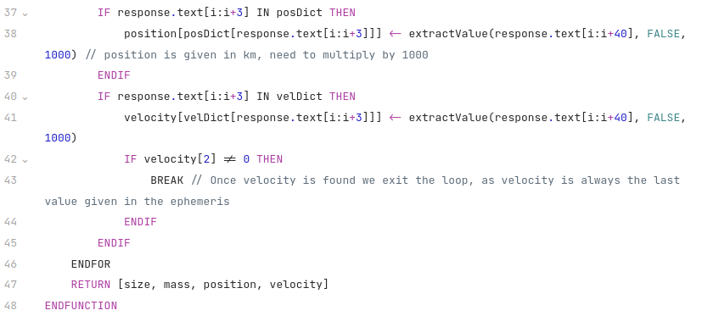

extractValue
Now that we have a high level overview of how getEphemeris works, let’s analyse how it actually gets numeric values from the text. extractValue will be given a section of the response starting from the key phrase and continuing for a few dozen characters so that it only gets the number relating to the attribute we’re interested in and doesn’t accidentally find the value of something else. extractValue will need to do two things:
- Find, if there is one, the scale given by NASA. E.g. they might give the scale as 10^24, and then the numeric value would be 57.9. This means you should interpret the number as 57.9 * 10^24. If no scale is found, scale should be set to 1 by default.
- Find the actual numeric value for the attribute.
We will pass in a boolean value telling the function whether or not it should look for a scale. We will also have the option of passing in a “conversion factor”, which is just a number we want to multiply the final answer by. Handy if the value is given in non-SI units by NASA and we want to convert it to SI.
Here is a flowchart explaining the basic algorithm used to get a number from a piece of text once the position of a key phrase has been found:
This same basic algorithm will be used by both the loop that finds the scale, and the loop that finds the numeric value of the attribute we’re interested in. Here is how one might implement it in pseudocode with a given piece of text:
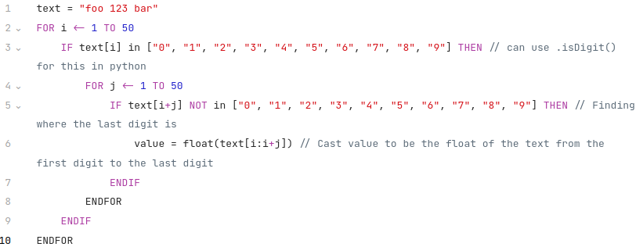
Some caveats will need to be introduced, with the scale we need to evaluate it as a power of 10, and with the value we need to take into account the fact that it could be negative or have a decimal point and could also be written using “E notation” (a way of writing standard form that uses E to represent the 10^ part, e.g. 1250 = 1.25 * 10^3 = 1.25E3). I will describe how I’ve handled this in the individual sections on finding the scale and finding the value.

Finding the scale
The scale in the ephemeris is always in the form 10^x, where x is a natural number. This means we can find a ^ character (they only appear in scales and nowhere else) and then use the algorithm above to find x. Since x is always a natural number, no extra tricks are needed with the algorithm. Once we have found x, we evaluate 10**x using python’s eval function and set scale equal to that.
We will then also create a variable, “scaleAt”, and set it equal to the position of the last digit. This is so that the next part of the function, which finds the value, can start just after the scale. If we do not do this then we would end up accidentally finding the scale again when trying to find the value

Finding the value
We will need to make some modifications to the algorithm above when it comes to finding the value. Instead of just checking if the current character is a digit, we need to check if it’s a digit, a + sign, a – sign, a decimal point . or E. Luckily if you use float() on a string written in E notation in python it can successfully convert that string to a number, so we do not need to worry about evaluating E notation ourselves. Python can also handle positives and negatives when casting to a float.
Now the only thing to worry about is “error margins”. NASA wants to make it clear that their values are not exact, so they put error margins on them. This means that instead of writing a mass as 500, they might write it as 500+-1. This is a bit problematic. We count + and – as “digits” because we need to be able to handle negative values, so our program would continue until it got to the 1, and only then would it cast the string to a float. But python cannot cast 500+-1 as a float, because it’s not a simple number. So, what we need to do is search for any instances of ‘+-‘ in the string, and if we find one, then we slice the string to only include characters before the +-.
Once that’s done, we can safely float our value, and we’re finished. All we need to do is return scale*value*conversionFactor, and that’s the attribute for our planet.
Here is some pseudocode for the whole function:
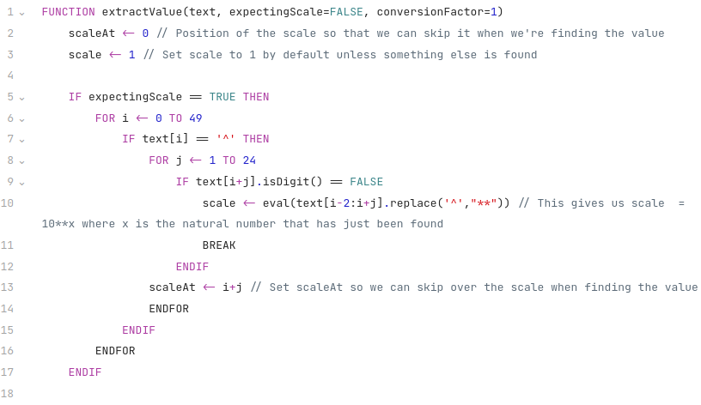
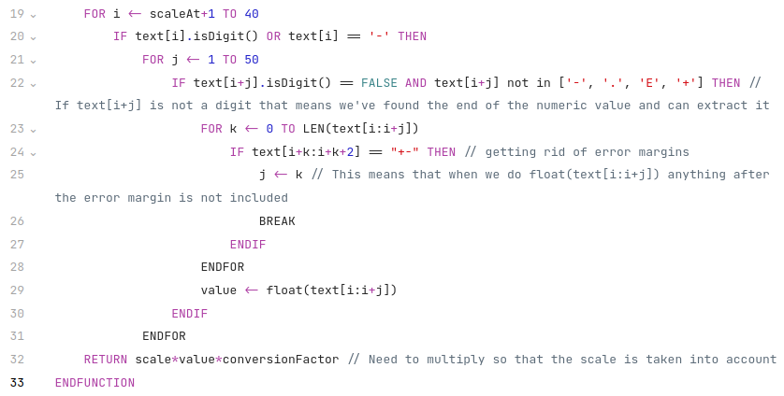
The numbers chosen for i and j to range over are fairly arbitrary, I just picked some numbers that would be large enough that we’d get all the numbers we needed but wouldn’t include any numbers from other attributes that we might accidentally return.

math(s)
This module (as well as numpy and vectors) are needed to do the maths required to accurately simulate the solar system, so are needed for objective 1.
Due to the way I’ll handle vectors in my physics I do not need to make extensive use of python’s math module. Other implementations of Newton’s second law would require a lot of trigonometry which would require the math module, but I have avoided this, which is good for performance as trigonometric functions are computationally expensive.
However, I do still need to be able to square root values so that I can find the magnitude of vectors, so I need the math module (this can be done with **0.5 without math, but this is worse for readability and makes it less clear what the code is doing.) I also need to calculate logarithms for non-linear scaling when drawing force arrows (this will be explained more in the display section), for which I definitely need the math module. Logs will also be used at one point for changing the value of G, so that the changes are always relative to the order of magnitude at G at that point (explained later down in input section.)
As I am British, and because this program is intended for a British audience, I will import math as maths. This improves readability for a British person, who may be disturbed by seeing what they perceive as an incorrect spelling of maths otherwise.

numpy
Numpy is needed for one thing and one thing only. Its arrays. Numpy arrays support vector addition and subtraction, which is a life saver for me as you cannot do physics without it. I could have created my own implementation of vectors but this would have hurt perfomance. Numpy is mostly written in C, which is a compiled programming language with a lot less overhead than python. This means that numpy arrays are a lot, lot faster than any implementation you could create using python. Numpy has also been used for hundreds of thousands of projects around the world without issue, whereas any implementation of vectors I could make would be prone to bugs. Hence, I use numpy’s arrays to create vectors instead.

vectors
Physics, especially gravity, relies heavily on vectors. Because of this, some way to implement vectors is needed. As explained earlier I will use arrays from the numpy module as they support vector addition and subtraction, which is very useful. There are a few vector operations that my program needs, these will be implemented in a separate file from the main one and imported as a module. The module will be imported as “vec” which is why you will see things like “vec.mag(vector)” in later pseudocode. The thrree operations needed are:
- Finding the magnitude of a vector
- Finding the unit vector for a vector
- Finding a normal to a vector
Luckily these are all relatively simple to implement.

Magnitude of a vector
The magnitude of a vector is the square root of the sum of the squares of all its elements. This is easier to understand in code, here is some pseudocode:
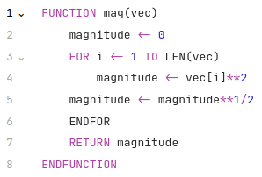

Finding a unit vector
The unit of a vector is a vector in the same direction as it of magnitude 1.
To find a unit vector, simply divide every element in it by the magnitude of the vector. Numpy supports dividing whole vectors by a number, so this is even easier, just divide the vector by the magnitude. So, the unit() function will simply return vector/mag(vector)

Finding a normal vector
For a vector (a,b), a vector normal to that vector is (-b,a). However we want this vector to be of length 1, so that it is easy to scale. Hence we will return unit(-b,a).

File Structure
I only have 2 modules that I’ve created, vectors and horizonsParser, so this keeps the file structure fairly simple. I have a file for each of those modules, along with the main file that runs the program. Here is a diagram showing the file structure:
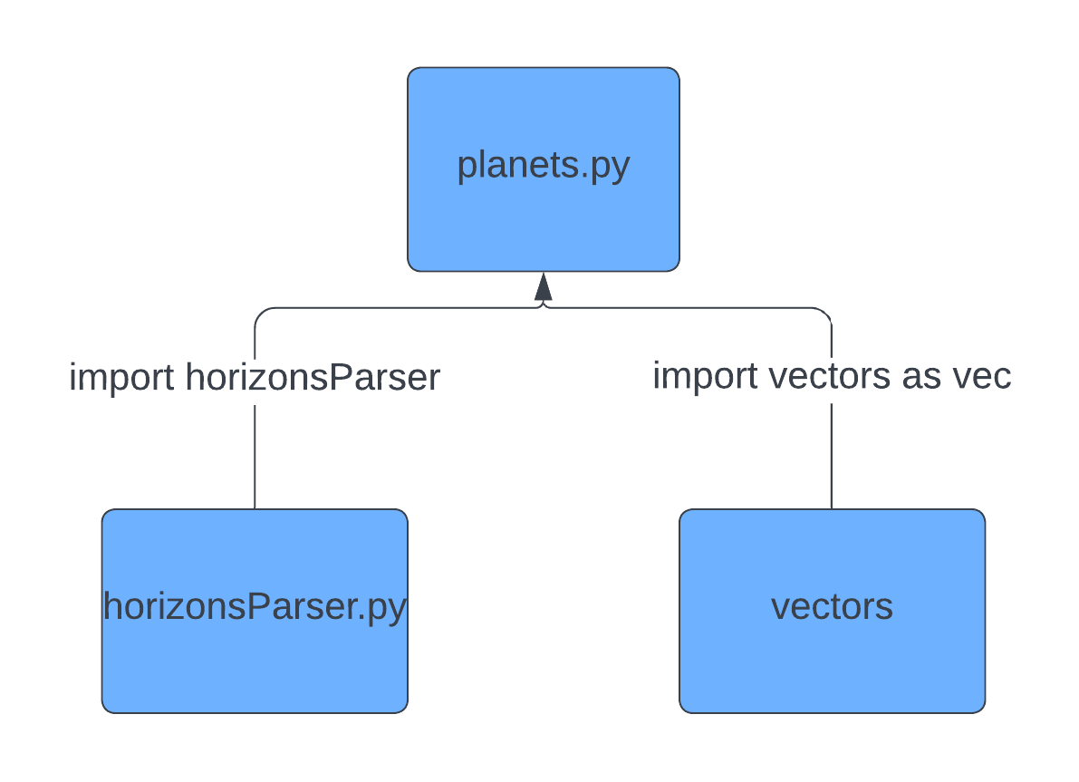

Data dictionary
Here are the important global variables (some of the less important ones are left out) in the main program and their types, initial values and a description of their purpose:
Data item | Type | Initial value | Description
x | integer | 0 | x and y are mapped to 0 and 1 respectively for indexing purposes, this means if I want the x component of a vector I just need to write vector[x], which makes the program a lot more readable.
y | integer | 1 | See above description.
framerate | integer | 120 | How many frames to display per second
YEAR | float | 31536000/framerate | How long an Earth year is in the program, timeScale is done relative to this.
timeScale | float | 0.05*YEAR | How much real life time is covered during each tick of the program
distScale | float | 4*10⁻⁹ | How zoomed out the display should be
G | float | 6.6743015*10⁻¹¹ | Determines how strong the gravitational force is
MAX_LINES | integer | 200 | This sets the max amount of orbital lines that can be drawn on screen, with no limit they would just continue increasing and this would lead to large amounts of lag.
planets | array | Empty | A list of all the celestial bodies in the program, including non-planet objects (it’s called planets as celestialBodies is a bit cumbersome to type all the time)
focus | integer | 0 | The current planet to center the camera on, 0 means center on the sun
comFocus | bool | False | Whether or not to focus on the center of mass of the solar system
comparison | bool | False | Whether or not to compare the sizes of different planets
started | bool | False | Used in the loop displaying the start screen, once the user starts the program started is set to true and the loop is therefore exited
changingAttributes | bool | False | Turned to true when the user presses ‘A’, this enters them into edit mode which lets them change the value of G and the masses of planets.

Classes
There will be three classes, celestialBody, planet and satellite. Here is a diagram showing how they’re connected:
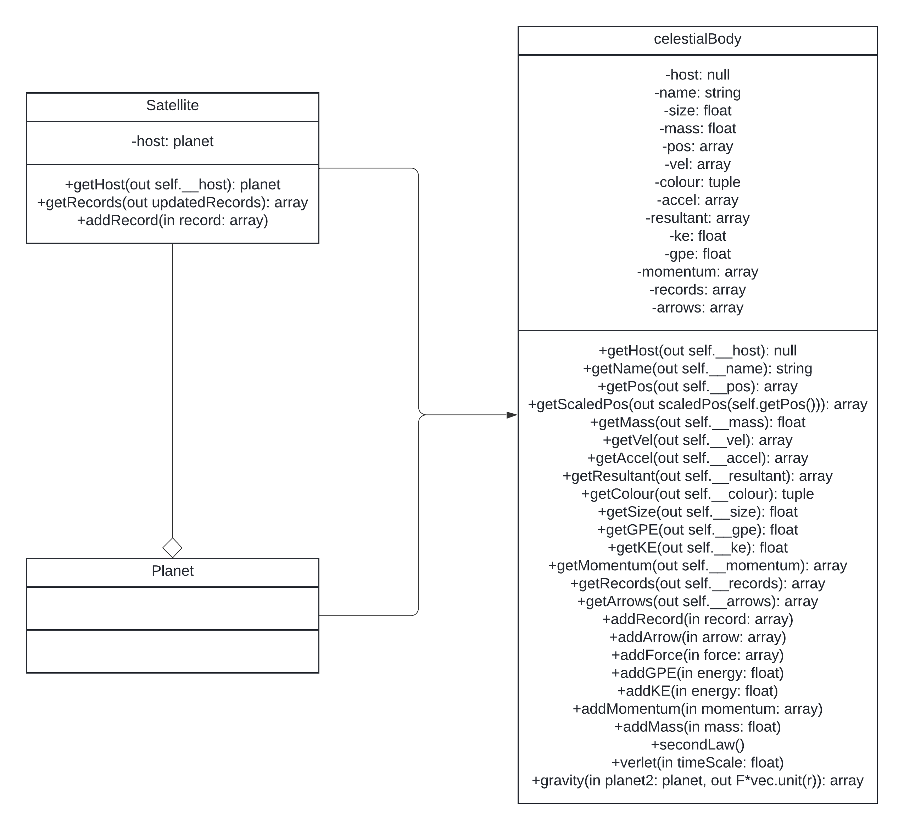
As you can see, here, there aren’t many classes. celestialBody is the main template for every object in the solar system, and has all the basic methods needed by any object. All celestial bodies need to be able to:
- Output their attributes
- Keep a record of their previous positions so that we can draw orbital lines
- If they’re the currently selected planet, keep a record of the forces acting on them so that force arrows can be drawn if the user has them turned on
- Keep a record of their physical properties: Kinetic and potential energy, and momentum, so that these can be summed up across all bodies and displayed to demonstrate conservation of energy and momentum
- Have methods that facilitate physical simulation so that the program accurately represents the solar system.
The methods that are related to physical simulation will be covered in the section on physics. So let’s cover the rest.
First, outputting their attributes. This is all done with “getter” functions. You can see a function is a getter function because it starts with a get. Every get function in the class diagram returns the attribute in its name, i.e. getVel() returns vel (velocity) and getKE returns ke (kinetic energy.) I do this rather than just using planet.pos or planet.vel so that I can implement encapsulation, which improves security. It also means I can edit the output before it’s returned, which is used in the satellite subclass to change the way its orbital lines look to make them look better. Making everything a getter leaves room open for further editing in the future if needed, and makes the program more robust. Note that there is a getHost() function even though the host attribute is always null and never used by the celestialBody class. This is to ensure compatibility with the satellite subclass, we can run getHost() on an object without having to worry about if it’s a satellite or planet, and if the host is null then we just ignore it.
Next, keeping a record of their previous positions. This is quite simple, as we’ll see later I’ll just add their position to a list of all their positions while simulating the tick. This list is “records”, which you can see in the attributes in the class diagram. To add a record to it, we’ll have a function, addRecord(). This is important, because having a function do it means we can get rid of the oldest entries in the list whenever we add a record, so that the list of positions doesn’t grow indefinitely. addRecord() will use the line length to shorten the list whenever it gets too long. Here is a pseudocode snippet that demonstrates how that might work:
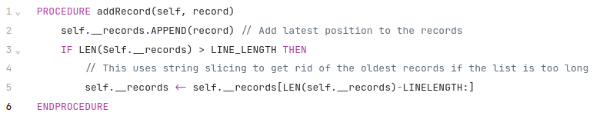
So e.g. if LINE_LENGTH was 10 and records was 11 long, then it would set records to be records[11-10:] which means all but the first element of records, so it would be back to 10 elements like we wanted.

Keeping a record of the arrows is fairly similar. We want to draw arrows from one planet displaying the forces on it from the other planets, and also an arrow displaying the resultant force. This means we need to draw one arrow for every planet in the system except the one we’ve selected, as well as an arrow displaying the resultant force. This means overall the amount of arrows drawn should be the same as the amount of planets in the system, so we can use the same kind of code as with records to reset the length, we just replace LINE_LENGTH with len(planets).

Keeping a record of their physical attributes like kinetic energy and momentum will be done by having an attribute for each property we want to measure, resetting all the attributes to 0 at the start of a tick and then calculating the attributes during the tick. This will be explained in the physics section as they are done at the same time as working out all the physics

Satellite / planet
These classes are both subclasses of celestialBody. The distinction between planet and satellite in my program is a bit different than how the words are used in normal life. In my program, a satellite has a host object, and its orbital lines are drawn relative to the motion of the host object. This is why it’s called a satellite, as the proper, physical definition of a satellite is just an object orbiting another object, e.g. the moon is a satellite of Earth. A planet will not have changes from the parent class, celestialBody, but the class is there to make clear the distinction between planet and satellite.
Since the only thing the satellite class needs to do differently is change how the orbital lines are drawn, there are only a few things we need to change. First, we should make the host attribute something other than null. We will use aggregation to set the host attributes, the host attribute should be the object that the satellite has as a host. This object will be another planet. Satellites orbiting satellites is possible, but there is no instance of that in our solar system, so in the class diagram I just showed satellite as aggregated with planets, but you could aggregated it with another satellite if you really wanted to. All this means that getHost() will now return an object instead of null.
Secondly, addRecord() and getRecords() should be edited so that the path they display is relative to the motion of the host.
But why do the orbital lines need to be drawn relative to the motion of the host? Well, this is what the moon’s path looks like if its path is not drawn relative to Earth’s motion:
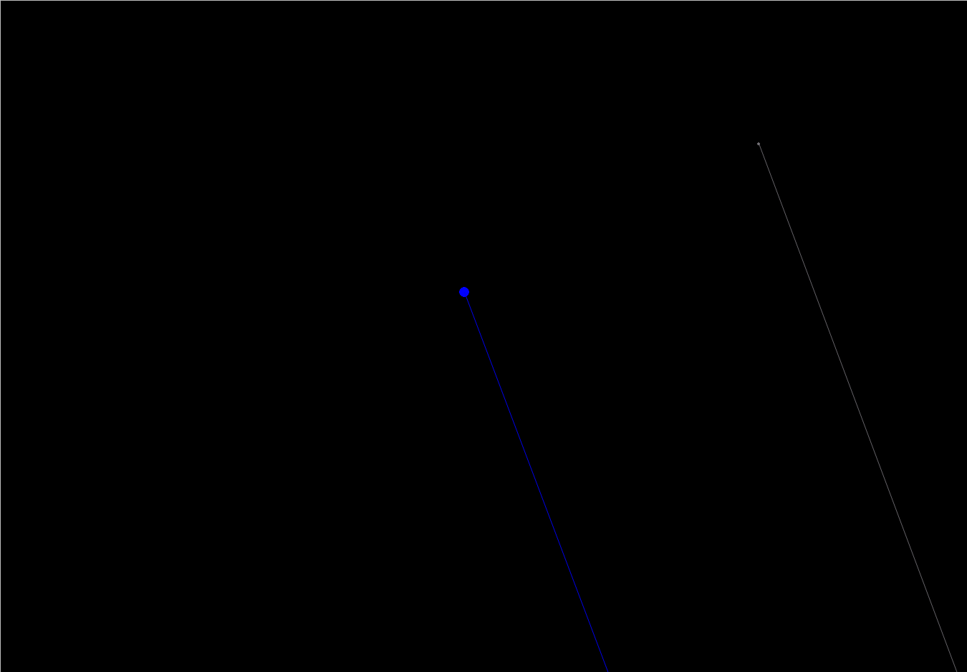

The moon is orbiting Earth, but it’s also orbiting around the sun. The path the moon follows just makes it look like it orbits the sun, with very slight wiggle because of its orbit around the Earth. This is not very illustrative and will confuse students as they might not get how the moon is technically orbiting both the Earth and the Sun. When we talk about the moon’s orbit, we mean its orbit around Earth. What this means physically is the motion of the moon relative to the motion of Earth. If we draw its path relative to Earth’s motion, we get this:
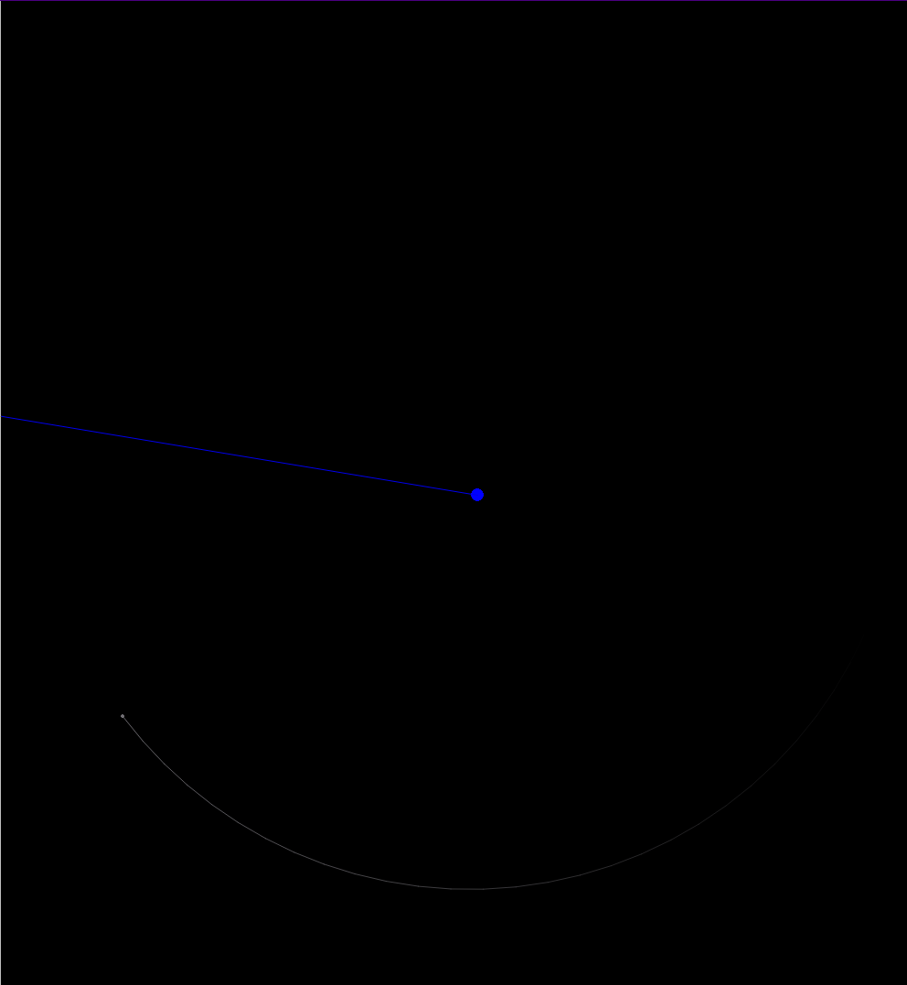
The path drawn is the arc of a circle around Earth, exactly as it should be. This is much better.
How do we achieve this in code? Well, for a normal celestialBody object, its records is a list of displacements from the origin. We can think about displacements as a vector pointing from the origin to another point in space, like this:

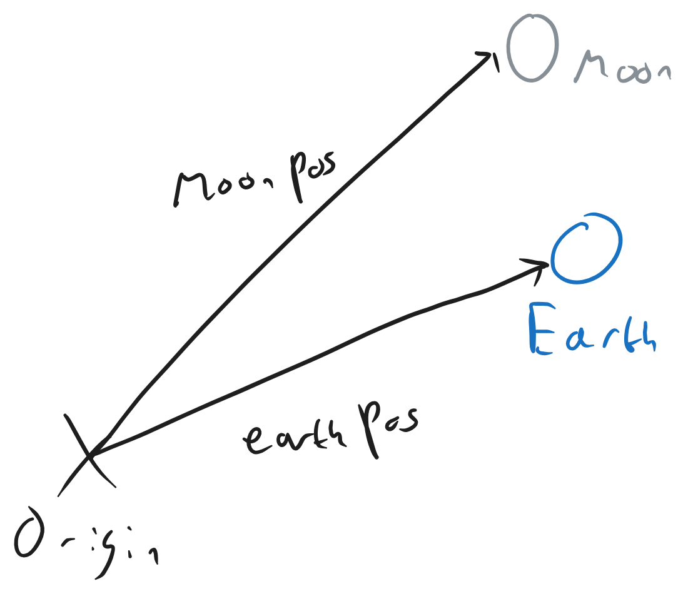
We want to instead have the moon’s displacement relative to Earth, i.e. an arrow pointing from Earth to the moon, like the purple arrow in this diagram:

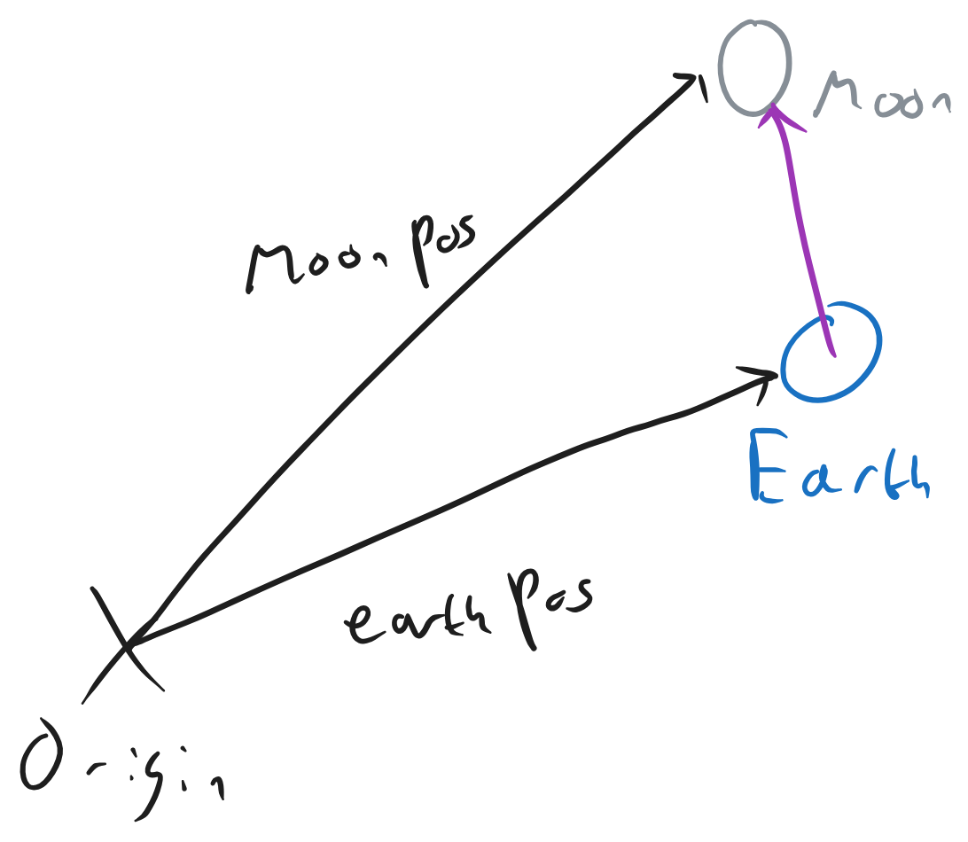
It turns out, rather conveniently, that the purple arrow there is just the vectors moonPos - earthPos. So we can just subtract one position from the other to get the relative position. This is how addRecord() will work for satellites, it will find the host’s current position and then add record – hostPosition instead of just adding record to the array of records, this way we have a history of all the *relative* positions of the satellite, not the actual positions.
addRecord() will use the same trick as in celestialBody to ensure that the list of records does not exceed the desired length.
Here is pseudocode explaining how it will all work:
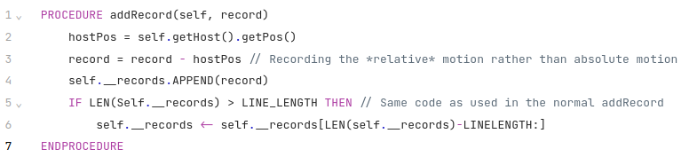

Next, we need to consider how getRecord() will work. If we just return the records as is, the vectors from the Earth to moon, and try and draw them, we have a problem. The program doesn’t know to start at the Earth and then follow the vector to get to the point where the line is supposed to be drawn. It will instead start at the origin and then follow the vector. For example, if we use the same purple arrow as in the previous diagram, we’d get this:
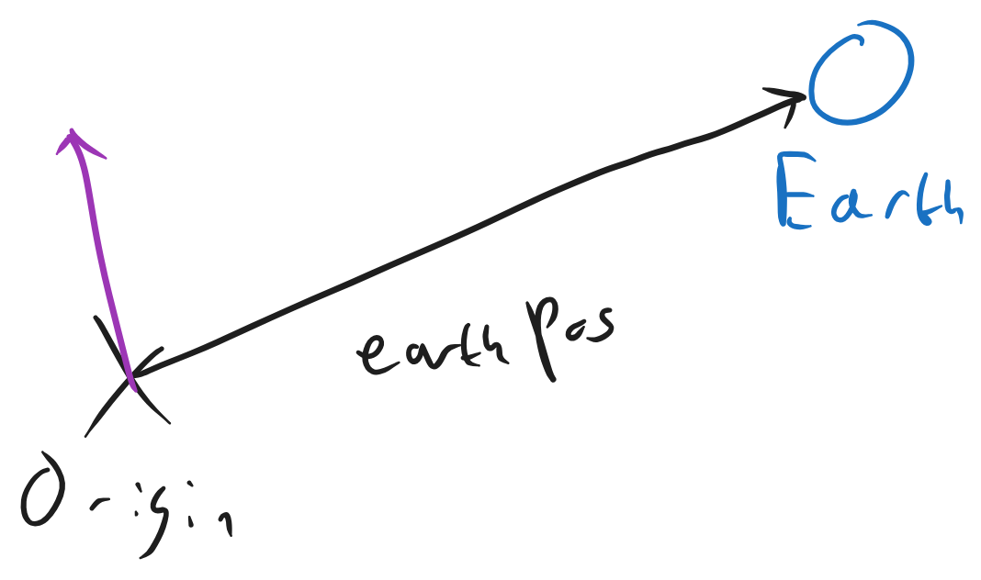

Which is not good, as that is nowhere near the Earth.
There is a very simple fix though, all we need to do is add the Earth’s current position to all the records. This can be done with a for loop, like this:
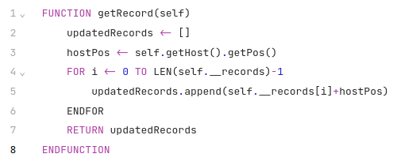
Note that this will be done with list comprehension when I implement it in python to make the code more pythonic.

Overall system design
This is a system flowchart explaining how my program works: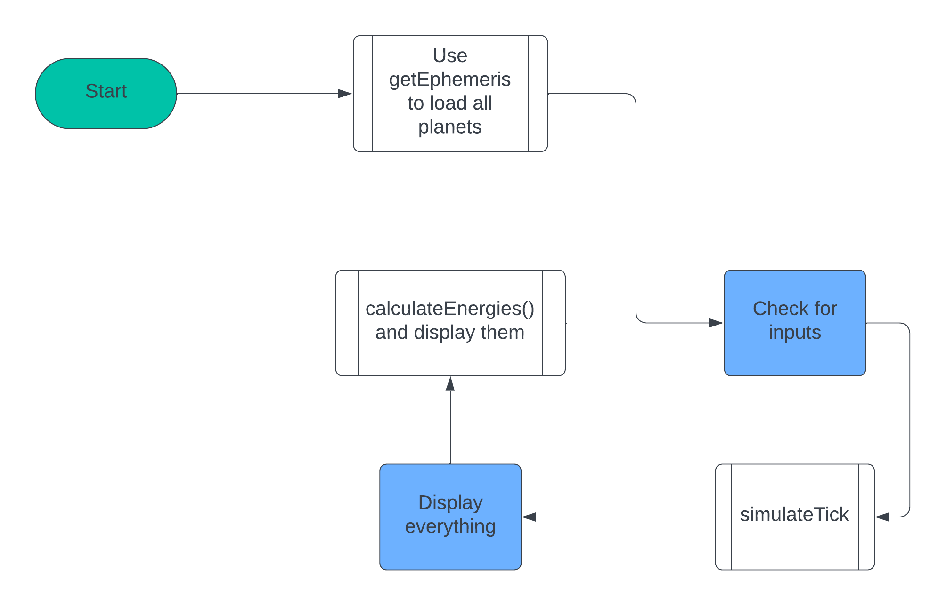

getEphemeris() uses Nasa’s Horizons database to get the positions of the planets at the date and time the program. The program then enters its main loop. It checks for any inputs in case the user has tried to do anything, it simulates the tick and does all the physics, it displays the planets, and then it calculates the energies and outputs them to the console to demonstrate conservation of energy as requested by client. In my system parts section I will explain everything in the main loop of this flowchart in detail.

Initialisation
Here I will explain everything to do with how the program is started, including all the variables created, as well as how getEphemeris() is used to instantiate all the celestial body objects. Essentially everything before getting to the loop in the system flowchart.
3 things happen in the initialisation. All the necessary variables are defined, every planet that’s going to be simulated is instantiated as an object and pygame is set up so that we can start displaying everything. The important variables are mentioned above in the Data Dictionary, so let’s cover the other two parts.

Adding the planets
A planet requires 6 attributes to be instantiated: Name, size, mass, position, velocity and colour. A satellite additionally requires a host to be given. NASA provides four of these, the size, mass, position and velocity in their ephemerides, which will be referenced as ephemeris[0], ephemeris[1] etc as getEphemeris() returns a list. NASA does also provide a name but it’s incredibly hard to extract due to how they present it, and because the name won’t change over time (unlike velocity and position) I’ve decided to ignore that. So, name and colour will have to manually be given. To get the ephemeris, we also have to pass in an ID, that will also have to manually be given.
The colours for the planets are fairly arbitrary. I’ve just picked colours that I think represent the planets quite well, so e.g. the sun is yellow, Earth is blue and so on. I’ve chosen solid colours instead of pngs of the planets to keep the program simple, and it makes it easier to modify to create custom solar systems with made up planets where you don’t necessarily have images of them.
My program will include the Sun, all 8 planets, Pluto and Voyager 1 and 2. The sun and planets are in there because, well, they’re what make the solar system. If my solar system simulator didn’t have planets it would be a pretty bad one. Pluto has been added as it’s still recognisable and historically was a planet, and the voyagers have been added for educational purposes as they’re an important part of human history and something that children should know about. It’s also cool to see how far away they are from the rest of the solar system. I’ve decided to only add our moon, as adding Jupiter and Saturn’s moons would quickly get out of hand (they have hundreds of them.) 600 objects all circling around Jupiter is not something my program could cope with.
Each time a planet object is created, it will be appended to a list, “planets”, which as mentioned in the Data Dictionary will contain all celestial objects. This list should contain the planets roughly in order of how far away they are from the Sun, so it should go Sun, Mercury, Venus, ... Neptune, Pluto, Voyager 1, Voyager 2. This means the sun will be instantiated first so that it is the first object appended to the list.
The ID for the planets follows a basic pattern. Mercury is 199, Venus is 299, Earth is 399, and so on up to Pluto being 999 (I guess NASA still counts Pluto as a planet, silly organisation.) This means we can iterate through them with a loop, and have a list of planet colours and names to iterate through at the same time to easily create all the planets. The sun, moon and the two voyager satellites will need to be created manually as their IDs do not follow any simple pattern.
As mentioned, the sun will be instantiated first.
The moon should be created just after the Earth is created, so that if you go to the next celestial object from Earth it takes you to the moon. The moon is a satellite with Earth as its host, so it will be given Earth for its host attribute.
Jupiter has an odd quirk. Its mass is given in grams, not the SI unit, kilograms. It is the only planet with this trait. So, a check will need to be made to see if a planet is Jupiter, once we do get to Jupiter, we need to divide its mass by 1000 to convert it to kilograms before it is added to the list of planets.
The voyager satellites’ ephemerides do not give their mass and size, so those will be provided manually by me. This will require using the “ignoreMassSize” flag in the getEphemeris() function. Because the Voyagers need this special treatment with getEphemeris, they will be created manually without their names or colours being in a list like the sun and planets.
Here is pseudocode putting that all into effect:
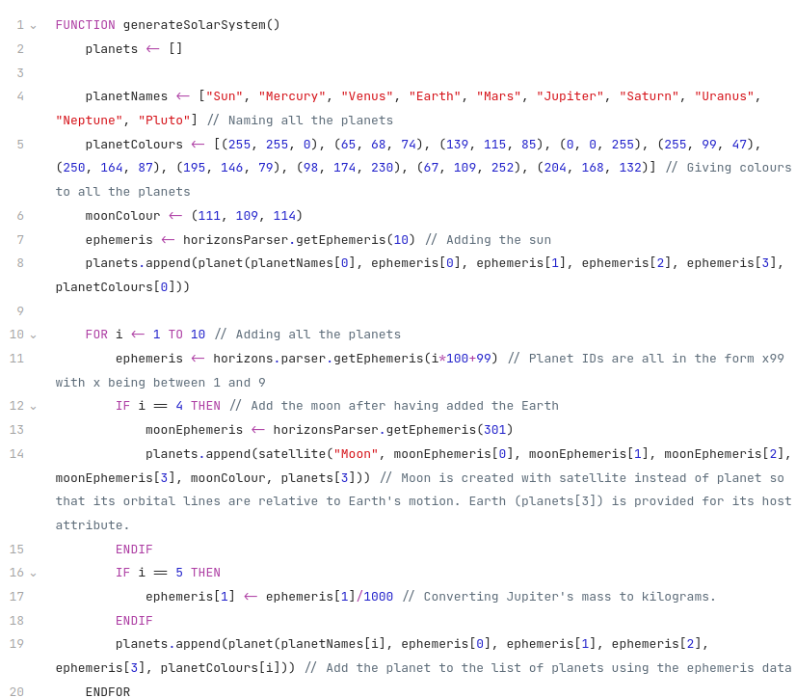
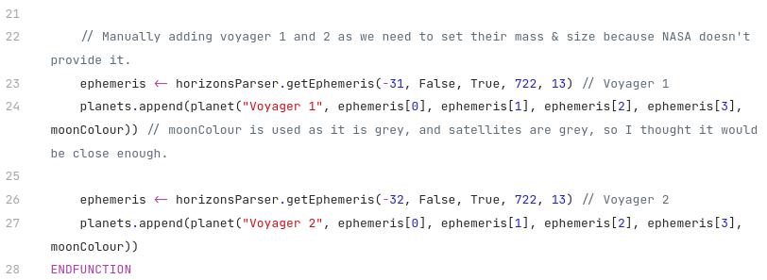

Setting up pygame
This will be a simple section, there’s just a list of different things we need to create for pygame to work properly.
First thing’s first, LINE_LENGTH. As mentioned in the data dictionary, we already have MAX_LINES, which determines how many total orbital lines can be on the screen at once. Now that we know how many planets we have, we can use this to work out the length of the orbital line of each of the planets. We simply divide MAX_LINES by the amount of planets there are, and int it. Aka set LINE_LENGTH = MAX_LINES/(len(planets))
However I’ll actually do MAX_LINES / (len(planets)-3), because the moon and the two voyagers are hardly ever visible and don’t really impact performance, so we can ignore them.
Next thing to do is to run pygame.init(), without this pygame will not do anything. We also need to create our screen. I will do this with pygame.display.set_mode((0,0), pygame.FULLSCREEN) as this means pygame will handle the size of the window. This lets the program work on monitors of any resolution, thus making it more accessible to people with different kinds of monitors.
We can also use the window that pygame just created after we made our screen to find the centre of the screen, which is needed for scaledPos() to scale things accurately so that the focus is always at the center. To do this, we simply get the width and height of the window with pygame.display.get_surface().get_size(), and then divide that by 2 to get the centre. This array will be called centre, so centre[x] is the x position of the centre and centre[y] is the y position. This also means that centre[x]*2 and centre[y]*2 are the width and heights of the window respectively.
We need to create the clock for keeping a consistent tickrate, this is done with pygame.time.Clock().
We need to create two surfaces used for comparing planets, comparisonSurface1 and comparisonSurface2. They are both made centre[x]-3 wide and centre[y]*2 tall, this means that they take up the full screen vertically and about half the screen each horizontally, with a 6 pixel gap in the middle for a barrier between the two surfaces.
planetsToCompare is created, this is a length 2 list containing the index of the first planet and second planet to compare, so planets[planetsToCompare[0]] returns the object for the first planet and planets[planetsToCompare[1]] returns the object for the second planet.
And finally, we need to create the interface. This means selecting a font (I use codenewroman at size 18, and the same font at size 32 for the start menu) and creating two menu surfaces for the text to be displayed on. These menu surfaces will have lowered opacity to make them look nicer and so that they don’t block out objects behind them.
Now we’re done setting up the program, we can look at the main loop, which is what the next section is on.

System parts
Here I will explain the main loop in the system flowchart.
There are three main parts to the loop, the physics, which governs how the planets actually move, the display, which shows the solar system and includes some tricks to make the camera move / follow other planets, and the inputs / interface which lets the user interact with and see details about the program.

Simulating a tick
Here I will explain the physics in the program, the part that makes the planets actually behave like planets, accurately. I will describe the behaviour of simulateTick(), which is the function that does all the physics for a single tick, as well as handling some information that will later be needed for the display part of the program.
The flowchart below gives a high level overview on how physics is simulated during a single tick in my program:
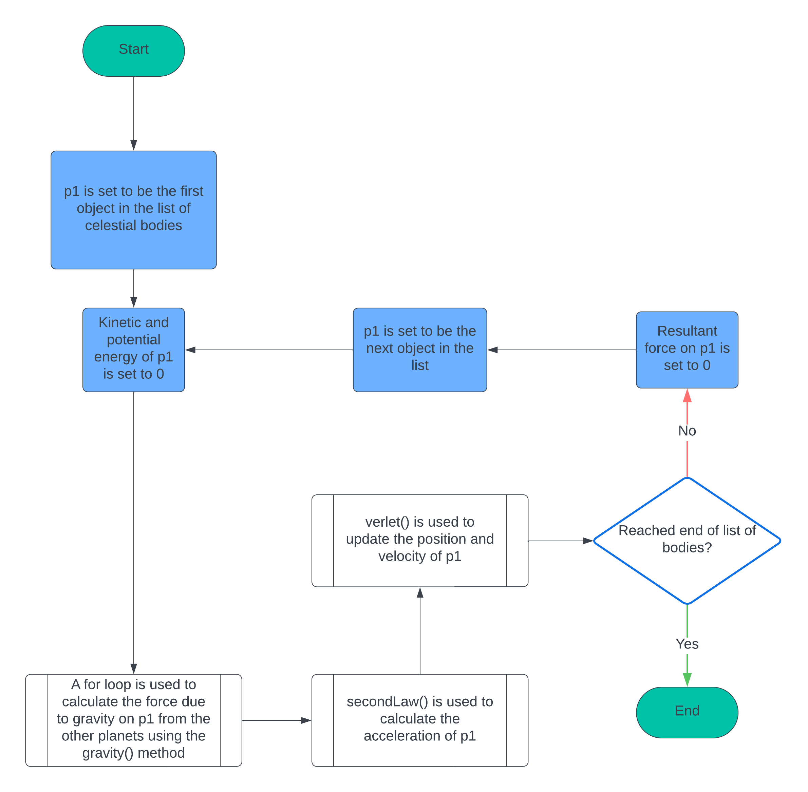
Here, the function (simulateTick()) takes in planets, focus and comFocus. Planets is a list of all the celestial bodies, focus and comFocus are for the display and not relevant yet. simulateTick() iterates over this list to do calculations for all the planets. It sets the kinetic and potential energies of the planet to 0, they are worked out during the verlet integration and gravity calculations. It works out the resultant gravitational force on each planet, and then uses secondLaw() to work out the acceleration on each planet. Verlet integration is then performed (explained later below) to get the new position and velocity of the planet. The resultant force on the planet is then reset to 0 so it can be calculated next tick.
The program needs to be able to draw orbital lines showing the paths of planets. To do this we will draw lots of small lines that will create what looks like a smooth trajectory. To draw the small line, we need two points. Those two points will be the position of the planet at the start of the tick, i.e. before verlet() is run (that’s when its position is updated) and its position after verlet(). These two points will be added to the lines attribute of the planet.

The flowchart below describes the for loop used to calculate the gravitational force on a planet.
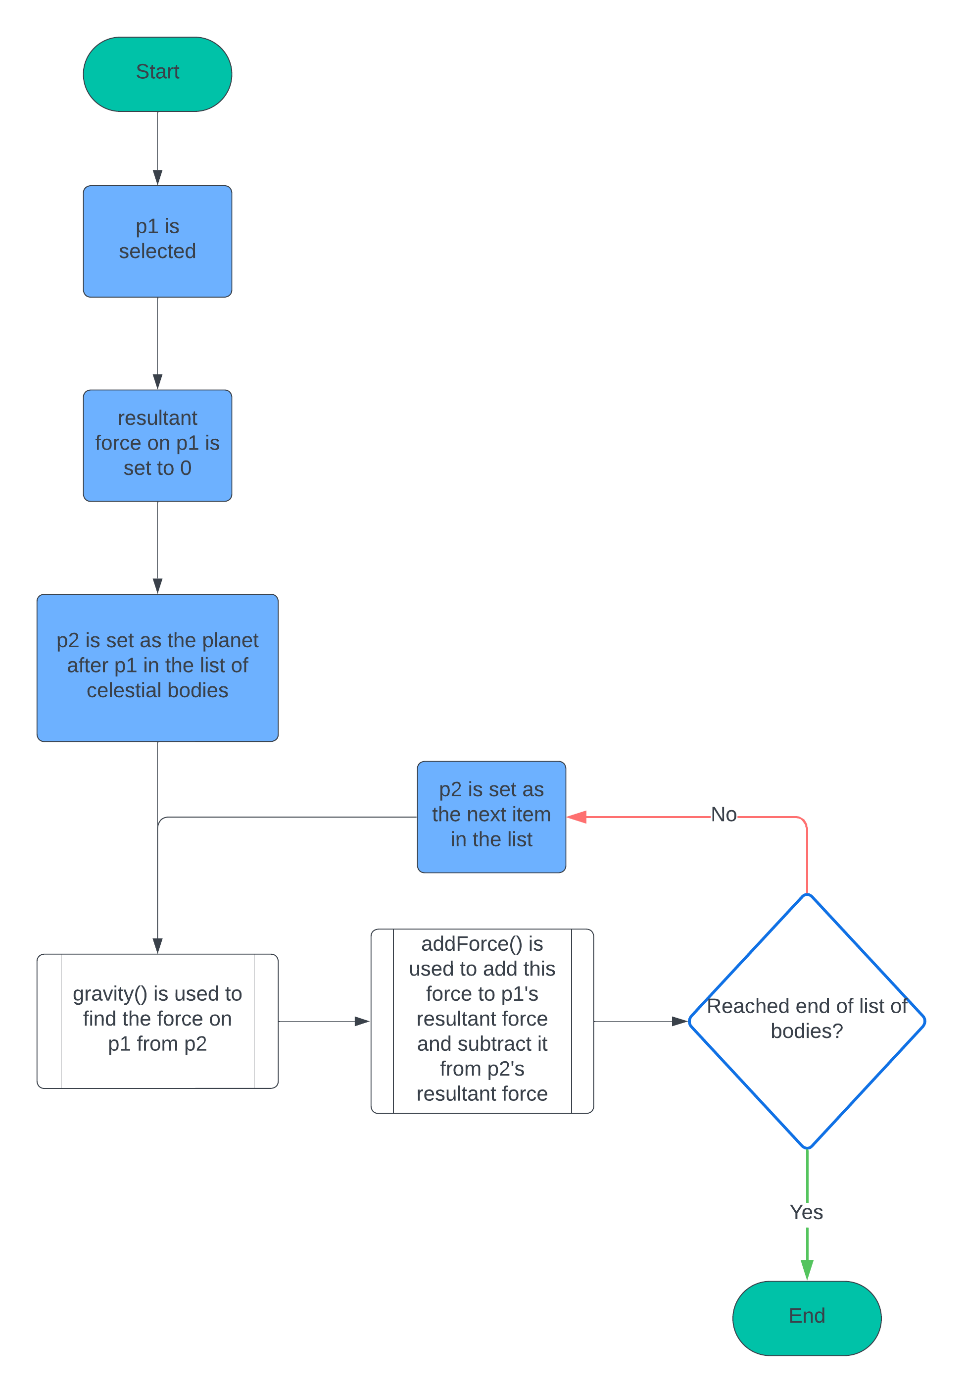
Force is a vector quantity, this means to find the resultant force on a planet, you have to find all of the individual forces on it from other planets and sum them. Hence, we use a for loop to iterate through the list of planets and use the gravity() function to find the forces. We then add each force to the resultant attribute of a planet until we’ve reached the end of the list.
We know however, because of Newton’s third law, that each action has an equal and opposite reaction. This means that the force on p1 from p2 is the negative of the force on p2 from p1. So, to save some iterations, we can also subtract the calculated force from p2’s resultant force. This means that each for loop starts at the planet just after p1, rather than at the start of the list of planets every time.
Also, we want the option to display arrows illustrating the forces on the currently selected planet. To do this, we check with an if statement if the p1 or p2 are selected, and if so, we add the force acting on them from the other to their arrows attribute, and we make these arrows white.
At the end of the loop, if p1 is the selected planet, we add another arrow representing its resultant force, and make this arrow the same colour as the planet to signify that it’s the resultant.
Now that we’ve covered how simulateTick works, here is some pseudocode with comments to demonstrate it more concretely:
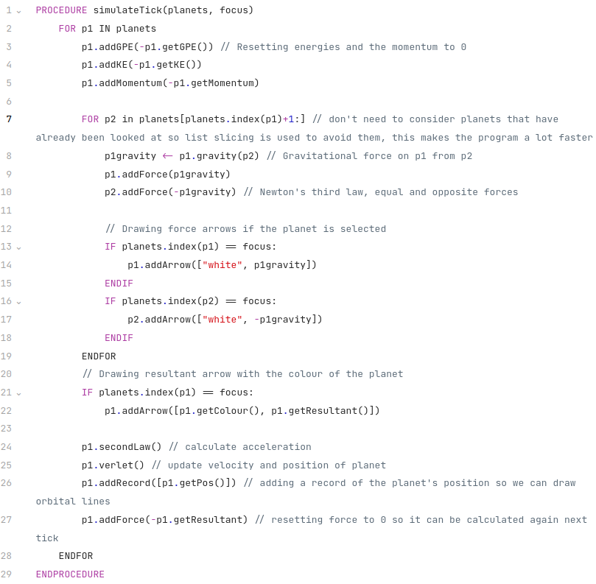

Methods used
All the methods used in simulateTick() are methods of the celestial body class, because simulate tick is operating on attributes of celestial bodies (their positions, velocities, etc.) This is nice as it means functions do not need to take many arguments, as a lot of the values they need can be found as attributes of the object they’re operating on.
I won’t explain the basic getter / setter methods like addArrow and getPos as they’re not relevant to the physics and are explained in the section on classes.

addGPE / addKE / addMomentum
Self explanatory, pass in a value and it adds that value to the GPE or KE attribute of the body respectively. These exist because one of the purposes of the program is to demonstrate that certain physical properties (momentum, energy) are conserved. Because my program uses the laws of physical to do the simulation, the quantities are indeed conserved as expected.

gravity
This uses Newton’s law of gravitation to find the force on one planet from another. This was explained in the analysis, but for a quick recap, here is how to find the magnitude of the gravitational force on a planet, p1, from another planet, p2:
$$F=\frac{Gm_{1}m_{2}}{r^{2}}$$
Where $r$ is the vector from planet 1 to planet 2.
This is calculated by finding the vector from p1 to p2, by doing p2.getPos() – p1.getPos().
But force is a vector quantity, so the full equation is:
$$F=\frac{Gm_{1}m_{2}}{r^{2}}\hat{r}$$
Where $\hat{r}$ is the unit vector pointing from p1 to p2, calculated using the unit() function from the vector module.
It also makes sense to use this function to calculate the GPE of the planets at the same time, to save on calculations later. If we already have the force it is very easy to calculate GPE, the GPE of planet1 from planet 2, E, is given by:
$$E=-F|r|$$
Where $|r|$ is the magnitude of the vector $r$. The GPE on planet 2 is the same but with the opposite sign. So we just add these values to the GPE attributes of the respective planets.
Here is commented pseudocode putting these ideas into action:
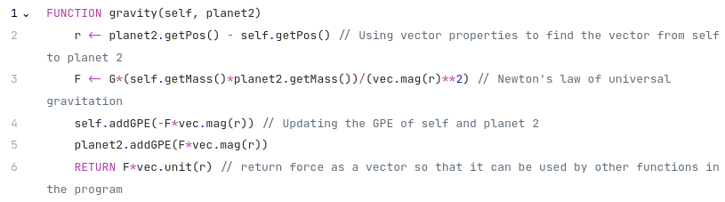

secondLaw
This uses $F=ma$, Newton’s second law of motion, to set the acceleration attribute on the planet, which can then be used by the verlet integrator to update the positions and velocity. It’s given the resultant force of the planet, which will have been calculated by summing the results of gravity() in the nested for loop section of simulateTick()

verlet
Verlet integration was explained in the analysis, but for a quick recap, here are the formulas for finding velocity and position with verlet integration:
$$x_{n+1}=x_{n}+v_{n}Δt$$
$$v_{n+1}=v_{n}+a_{n}Δt$$
Here $Δt$ is the timeScale variable in the program.
As verlet is updating velocity, it is a convenient time to set the properties of the planet relating velocity, the kinetic energy and momentum.
Here are the formulas for both ($E$ is kinetic energy and $p$ is momentum):
$$E=\frac{1}{2}mv^{2}$$
$$p=mv$$
Here is some pseudocode for performing the verlet integration:
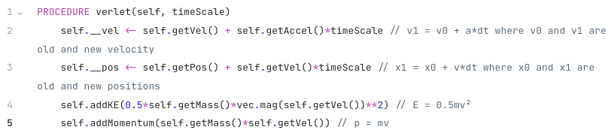

Display
There are three states the display can be in. When the program is first launched it will enter a loop where it displays the start screen. Once the user presses enter to start the simulation a boolean variable, started, will be set to true, so that the program can exit the loop. The display wil then either show the solar system and let the user switch focus between different planets, or show two planets side-by-side so their size can be compared. Which it does will be dependent on whether or not a boolean variable, comparison, is true. Here is a flowchart demonstrating how the state of the display is decided:
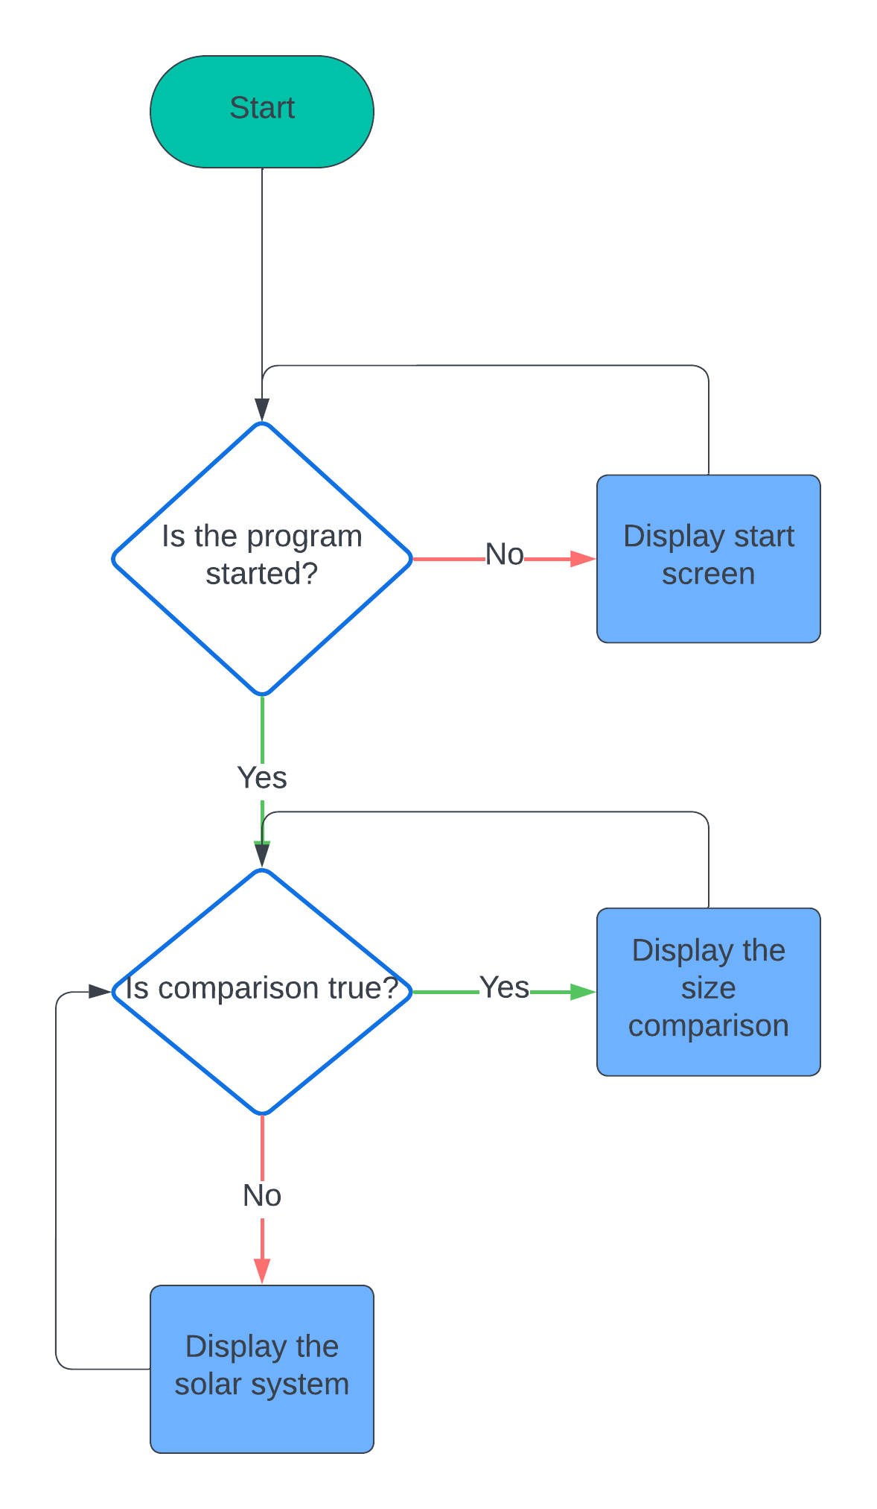

Let’s look at these states individually.

The start screen
As shown in the analysis, the start screen will be a collection of text explaining to the user how the program works, and telling them how to start the program, like this:
This will be done very simply in code, there will be a boolean variable, started, set to False initially. A while loop will continuously run displayStartScreen() which just uses pygame’s font.render() method to display all the text, and it will check for inputs. If enter is pressed, then started will be set to True and the program will exit the loop.

Displaying the solar system
The purpose of the display is to give a view of the solar system, enable zooming in and out, and have the ability to focus the centre of the view (the “camera”) on any specific object / the c.o.m. (this is an actual acronym used by physicists for the centre of mass) of the system.
But the solar system is huge, so how can we display it accurately? This is done by scaling the positions of the planets. Inside the display, instead of using the actual positions of planets we used their scaled positions. This just means we multiply their position vector by a scalar, the distConst. distConst is effectively a conversion from metres to pixel, it’s how many pixels are in a metre. scaledPos(vec) will do this for us, and return that vector*distConst. Doing everything this way will preserve the relative sizes and distances of the system. This will make the program educationally useful as it helps kids understand the scale of the solar system and so is suitable for the client.
distConst will be determined by how zoomed in the user is, a smaller distConst means a more zoomed out solar system.
Next, we need to make the display be centred on a specific planet. This means we want the planet in question to be displayed at (w/2, h/2) on the screen where w is the width in pixels of the window and h is the height. This is calculated by using pygame’s get_size() method to get (w, h) and then dividing it by 2. Here is a diagram showing the situation:
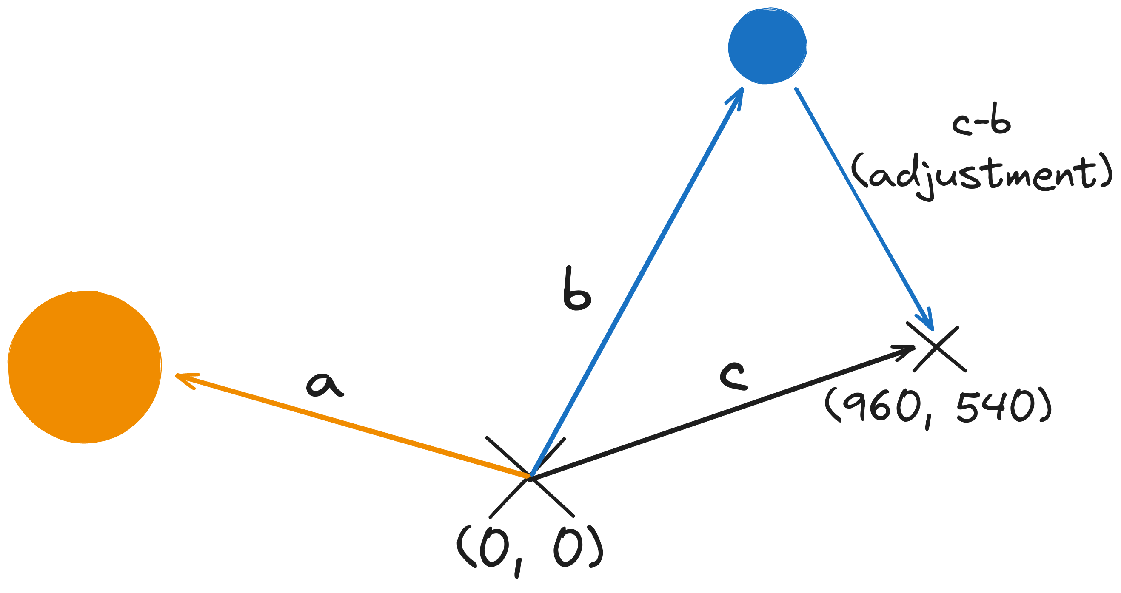
Here a is the scaled position vector of the sun and b is the scaled position vector of Earth. c is the centre of the screen, (960, 540) for a standard 1080p display. The “adjustment” is calculated, the adjustment is the vector pointing from Earth to the centre of the screen, c - b. If we were to add this adjustment vector to Earth’s position vector, we would just end up with c, the location of the centre:
b (Earth’s position) + c - b (adjustment) = c.
So if we calculate the adjustment and then add it to Earth’s position, and then display Earth at that location, Earth will be at the centre of the screen.
If we want to display the sun we now just add the adjustment to its position vector. This will put the sun at the same position relative to Earth as it was before. The result is this:
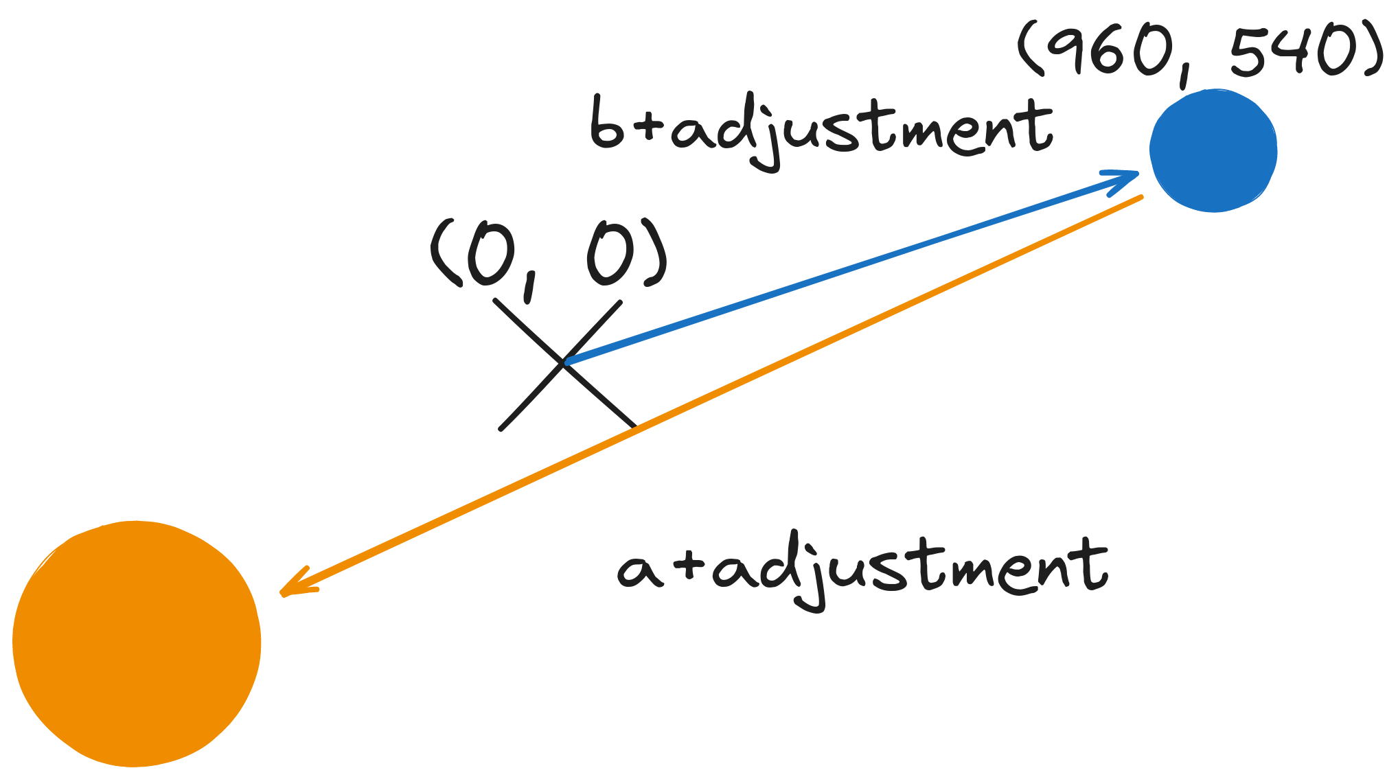
So Earth would be displayed at the centre of the screen, and the sun would be displayed in the bottom left as it is down and to the left from Earth. We can repeat this process for any planet we want, to display it we just scale its position vector by distConst and then add the adjustment to that vector. We then display a circle at that position on the screen. If we want to focus on the centre of mass instead of a planet, that is very similar, the maths is the exact same except you use the scaled position vector for the c.o.m. Here is pseudocode for focusAdjustment(), the function that calculates the adjustment:
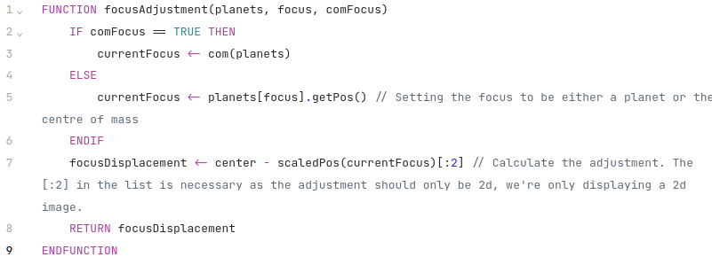

So, for every object that I want to draw (orbital lines and planets pretty much), I will take their position, scale it and add the adjustment and draw it at that position. Now that we understand that let’s look at how the solar system is actually displayed.

This is the render pipeline for displaying the solar system:

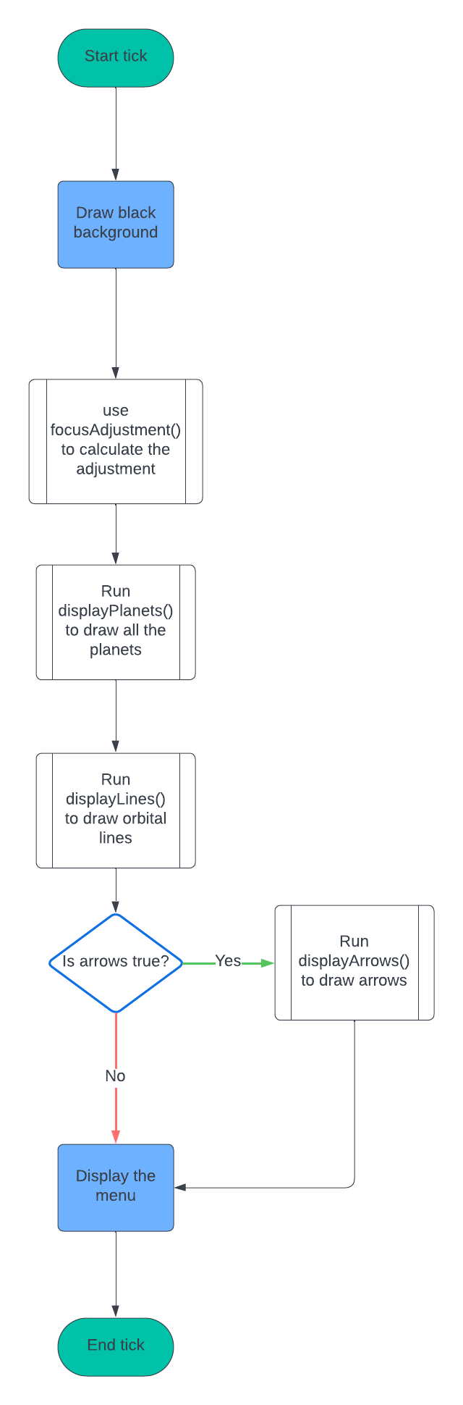
First we draw a black background, because space is black so the background should be black. Next the adjustment is calculated as this is needed to draw any object as explained above. Then we draw the objects in the order planets, lines, and if applicable, arrows. This order is chosen as sometimes with objects that don’t move much because they’re very massive (e.g. the sun) will have visible movement, but the orbital path will stay entirely inside the object. Drawing paths after the planets lets that path still be visible. Likewise with arrows, for very small forces the arrow is contained entirely within the planet. Drawing the arrow after drawing the planet lets it still be visible. Finally the menu is displayed, showing information on attributes and the currently selected planet. The text should be visible above everything else which is why the menu is the last part to be rendered. The menu itself will be covered in the next section on interface, so is not described here.
To make the program more optimised, objects are not drawn if they’re offscreen, so I have made a function, offscreen(), to check if objects are out of view.
I will now go through each method individually.

Methods used

offscreen
This is very simple. A vector is offscreen if either its x or y coordinate is less than 0 or greater than the width or height of the screen respectively. So an if statement is just used to check this, here’s pseudocode showing how:
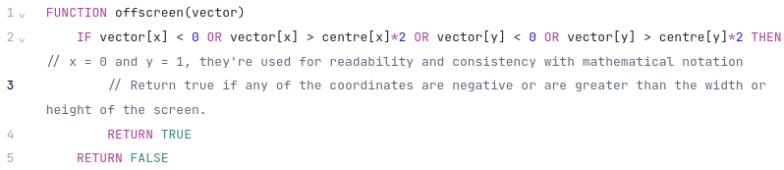

focusAdjustment
This was explained earlier in the section with pseudocode.

scaledPos
Very simple, literally just multiplies the input by distConst, here is the pseudocode:
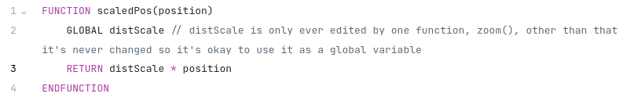
If you’re questioning why this is even a function, it’s to improve the readability of the program. It makes it clear I’m scaling the position.

drawPlanet
drawPlanet() needs to be able to draw a planet at any place on any surface. This is needed for the comparison mode as in that mode we are drawing planets at specific points that aren’t related to the position of the planet itself, and during the comparison the planets are drawn on surfaces other than the screen surface. It also needs the planet object itself to get the size and colour of the planet. These will all be passed in as arguments to the function.
The pygame.draw.circle() method will be used to draw the planet as a solid coloured circle. It will be given the surface to draw the circle on, get the colour of the circle with p.getColour(), draw the circle at the position given to it, and draw the circle with a radius of the scaled size of the planet, distScale*p.getSize().
Telling pygame to draw a very large circle (i.e. millions of pixels in diametre) can cause a lot of lag. This would occur in my program if you were very zoomed in on a planet for whatever reason. To avoid this, a check will be done to see if the scaled radius of the planet is larger than the diagonal radius of the screen. This can be done by seeing if distScale*p.getSize() < vec.mag(centre) or not. If this happens, then a circle will not be drawn, and instead the surface will just be filled with the colour of the planet.
Here is pseudocode for all of this:
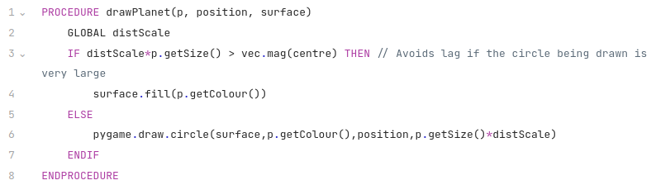

displayPlanets
Drawing the planets is done with displayPlanets which runs a for loop iterating over the list planets and uses drawPlanet() to display each one. It only runs drawPlanet() if the planet would be visible to save on resources, no point drawing planets offscreen. It uses offscreen() to check this. It passes in the scaled and adjusted position of the planet to drawPlanet() so that the circle is drawn at the correct position. Here is pseudocode showing this:
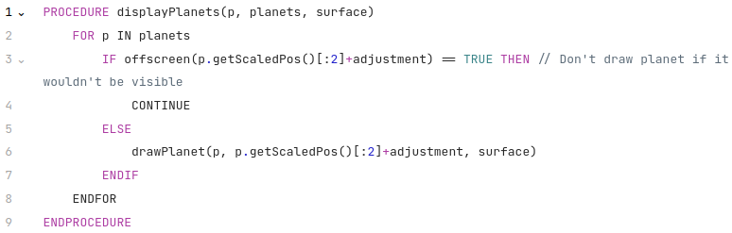

displayLines
displayLines() works in a similar way with a for loop iterating over planets, but then it also needs to draw a few hundred lines for each planet. It does this by using getRecords() to get a list of the planet’s previous positions in chronological order, with the oldest record being the first item in the list. This list will be 300 long in the standard solar system, applying scaledPos() individually to every vector in this list would be very computationally expensive, and a bad idea. Luckily since all scaledPos() does is multiply by a scalar, the distConst, we can use numpy arrays to do this operation all in one go, as you can multiply matrices by scalars in numpy. This is a massive performance increase and is the only reason the program runs at a reasonable framerate. At the same time adjustment is added to all of the positions. The list created is called orbitalPath.
A variable, index, is set to -1. This is used to keep track of what line we’re on, as we want to draw older lines with a more faded colour. This will give a visual indicator of where the planet was at what time. If the line was all one solid colour it would not be clear where the planet was recently and where the planet was a while ago.
A for loop is then used to iterate over orbitalPath, drawing a line between each consecutive pair of positions. Index will be incremented by one each loop and an “indexRatio” is calcuated, this is index/len(orbitalPath). This is used to determine the colour of the line.
There are two situations where we don’t want to draw a line:
- The line is offscreen so there is no point in drawing it. This is checked with offscreen()
- The line belongs to a satellite who’s host isn’t focused on at the moment and the satellite itself isn’t focused on. If the host is not focused on it’s very unlikely the satellite would be visible as moons are so much smaller than planets, so in this case there’s no point drawing it. To have access to this information displayLines() will be passed focus and comFocus as arguments, we will check first if the current planet is a satellite by seeing if p.getHost() == None or not and then check if the planet is focused on and if the planet’s host is focused on.
If neither of these criteria are met then the line is drawn. This is done using pygame.draw.aaline() as it produces a smoother result than using pygame.draw.line().
Pygame.draw.aaline() needs a surface to draw the line on, the colour of the line and the start and end points for the line. The surface will be given to the function as an argument. The colour will be indexRatio*p.getColour(). This makes it so that older lines are drawn darker, with the darkest ones being drawn as black and completely fading into the background. The start and end points will simply be the current position and the next position in orbitalPath. Here is pseudocode showing all of this:
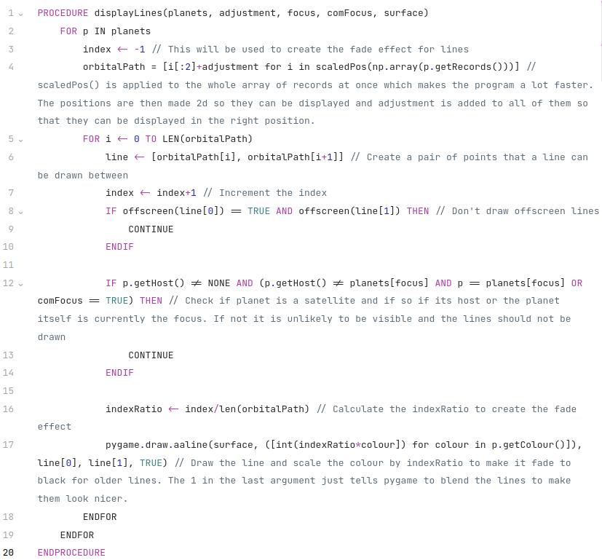

drawArrow
drawArrow should be able to take in a surface to draw an arrow, the colour to draw the arrow, and the start and end points of that arrow. To do this, we need to think about how an arrow is drawn. An arrow is made up of 3 lines, like this:
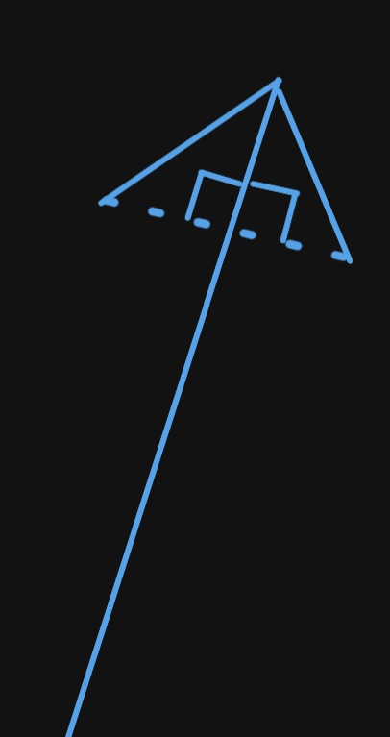

The key thing to notice is that the two diagonal lines, the ones that make up the arrow head, lie on the perpendicular to the main line of the arrow. This means to draw an arrow we need to first draw a main line, and then pick two points that are on the perpendicular to that line near the tip. We then connect the tip to those two points with lines, and we have an arrow.
The way this is done in code is by making a vector representing the main line, this is endPos - startPos where endPos and startPos are the ends and beginning of the line respectively. Let’s call this mainVector, so mainVector = endPos – startPos. We then use pygame.draw.aaline() to draw a line between those tow points.
Next, we calculate the normal to mainVector. This is done using the vec.normal() method from my vectors file. So normal = vec.normal(mainVector). To pick our two points, we start at our startPos, go most of the way along mainVector, and then go a tiny bit along the normal in one direction or the other, like this:
point1 = startPos + 0.9*mainVector + 0.05*length*normal
point2 = startPos + 0.9*mainVector - 0.05*length*normal
This will generate two points lying on the perpendicular to mainVector. Now all we have to do is draw two lines between these points and the endPos of the line.
Here is pseudocode showing how this all works:
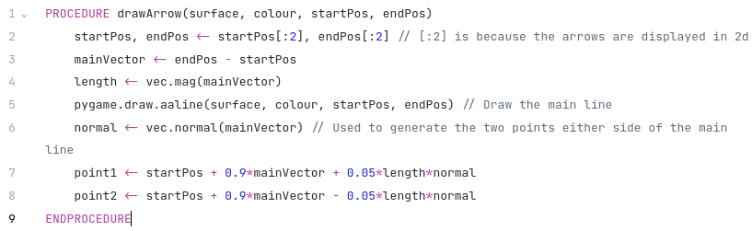

displayArrows
displayArrows() needs to draw arrows that come out of the currently selected planet based on the forces acting on that planet. The function should have a check to see if comFocus is true as if it is that means no planet is selected and it shouldn’t display any arrows. A copy of the forces on the planet are stored in its arrows attribute and can be accessed with p.getArrows(). The currently selected planet can be found using planets[focus].
The function will iterate over every arrow in p.getArrows() and draw them each.
drawArrow() takes 4 inputs, the surface, the colour, the startPos and the endPos. The surface will simply be passed into displayArrows() as an argument. The colour is just the first item stored in an arrow. The startPos should be the scaled and adjusted position of the planet.
The endPos is the complicated bit. It will be the adjusted and scaled position of the planet + some vector that represents the force. That vector should be in the direction of the force (referred to as arrow[1] from here on out) acting on the planet to accurately show the direction of it, and its length should be related to the size of arrow[1] as well as distScale so that arrows get smaller as you zoom out. However just making it directly proportional to arrow[1] would cause issues, as the forces are far, far too big to visible, and also the forces acting on an object like the sun are way bigger than forces acting on an object like the earth.
One idea would be to simply divide by the mass of the planet, this means the arrow would represent acceleration instead of force. The problem with this is that the arrows on the sun would end up being the same length as the arrows on the earth, which would look silly as the sun is way bigger compared to the arrows so less of them would be visible, and also because it wouldn’t convey the idea that the sun does have more force on it than the earth does.
What I’ve settled on to achieve a visually appealing and physically representative arrow is to instead divide by the log of the mass, this stops the arrows from getting too big but still means that larger masses have larger arrows. So the vector will be proportional to distScale*arrow[1]/log(p.getMass()). The proportionality constant is arbitrary, I have chosen 2*10^-12 as it leads to reasonably sized arrows.
So the endPos = p.getScaledPos()[:2]+adjustment+2*10^-12*distScale*arrow[1][:2]/log(p.getMass())
Note that the [:2] makes everything 2d.
Here is pseudocode recapping everything said here:
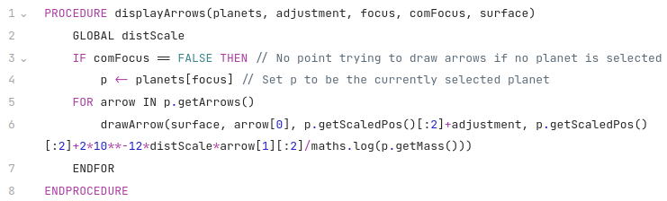

Comparison mode
This is the last part of the display. The purpose of the comparison mode is to give users a good way to understand the size difference between planets and other objects. The way this will be achieved is by displaying the two objects being compared next to each other, with the same distScale. This means their relative sizes will be the same as they are in real life. The screen will be split vertically down the middle into two rectangles. The first planet will be displayed at the centre of the left rectangle, and the other at the cnter of the right rectangle. These rectangles will be represented by pygame surfaces. This is done so that the planet cannot “escape” its side of the screen, if both planets were drawn onto one surface then they could overlap and this would look silly.
There is an array, planetsToCompare, which holds the two planets that need to be compared. How this array is manipulated will be covered in the section on inputs. For the sake of brevity I will refer to these planets as p1 and p2, in code they will be referenced as planetsToCompare[0] and planetsToCompare[1].
First the comparison surfaces are filled with black to create the background, the same way the screen is filled with black when displaying the solar system. Next the planets are drawn at centre[x]/2, centre[y] to each surface, which puts them at the centre of each rectangle. p1 is drawn to comparisonSurface1 and p2 is drawn to comparsionSurface2. This is done using drawPlanet(), with the position being passed in as (centre[x]/2, centre[y]). drawPlanet() will automatically do the scaling for us and draw the planets at the correct scale.
Next we need to use pygame to blit the surfaces to the screen. The first surface is at (0,0) and the second surface is drawn at (centre[x]+3, 0), leaving room for a 6 pixel wide barrier to distinguish the two surfaces.
A 6 pixel wide blue barrier is drawn using pygame.draw.line(), its startPos is (centre[x],0) and endPos is (centre[x],centre[y]), which means it goes straight down the middle of the screen. This makes the distinction between the two sides clear.
Finally, information on both planets is displayed using displayPlanetInfo(), which will be explained below in the interface section. This works the same way as displaying the planet information normally, it’s just that info is now shown for two planets instead of one.
Here is pseudocode showing how all this works:
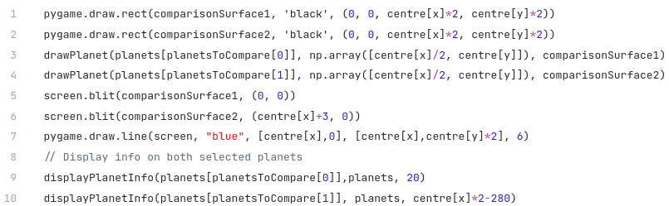
The 20 and centre[x]*2-280 being used as arguments to displayPlanetInfo() tell it where to display the info. 20 means 20 pixels from the left edge of the screen and centre[x]*2-280 means 280 pixels from the right edge of the screen (so very close to the right edge.) This will make more sense when displayPlanetInfo() is explained in the interface section below.

Interface
I will split the interface into two parts: The menu, which shows the user information about the planets as requested by the client and also tells them some of the keybinds, and the input system, which lets the user actually interact with the program.

Menu
A mockup for the menu was already shown in the analysis. There are two sides to it, on the left will be information about energies and G, and on the right will be information about the planet selected. Each section displaying information will be on a transparent black background, menuSurface1 and menuSurface2 for displaying energies and displaying planet info respectively. The opacity of the surface will be lowered to make the interface look more natural, i.e. it won’t completely obscure things behind it. Text will then be rendered in front of the surface using pygame’s font.render() method. This will meet the client’s needs as it shows the info they’ve requested and also lets users edit planet masses as requested. Here is what the menu might look like:
I will make two functions for the menu, displayAttributeInfo() and displayPlanetInfo(). Putting them into functions makes the code neater and allows them to be reused, displayPlanetInfo() is used differently in the comparison mode from how it’s used in the normal solar system display mode. The horizontal offset of the text will given as an argument to the functions so that the place where the text is displayed can be chosen.
displayAttributeInfo() will need to display different text based on whether the user is currently changing attributes or not, as explained in the analysis. If they are changing attributes then the function should display different text explaining the keybinds. The function will be given changingAttributes, a boolean telling whether or not the user is changing attributes, as an argument, so that it can use an if statement to determine what to do. Here is what the menu would look like when editing attributes:
The functions themselves are quite simple, each line of text is rendered and then blitted onto the screen, that’s it.
Here is pseudocode showing how displayAttributeInfo() works, displayPlanetInfo() will work in a very similar way, just with different text and without the if statement:
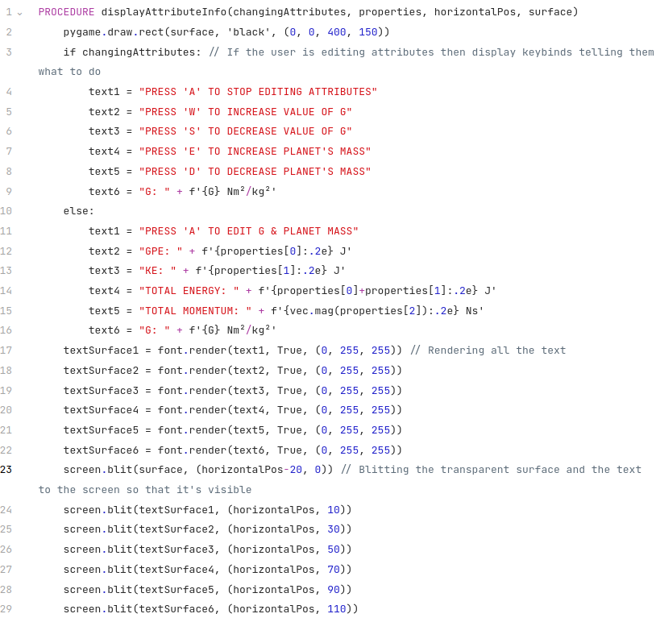
And here is the result, showing the translucent property of the menu surface:
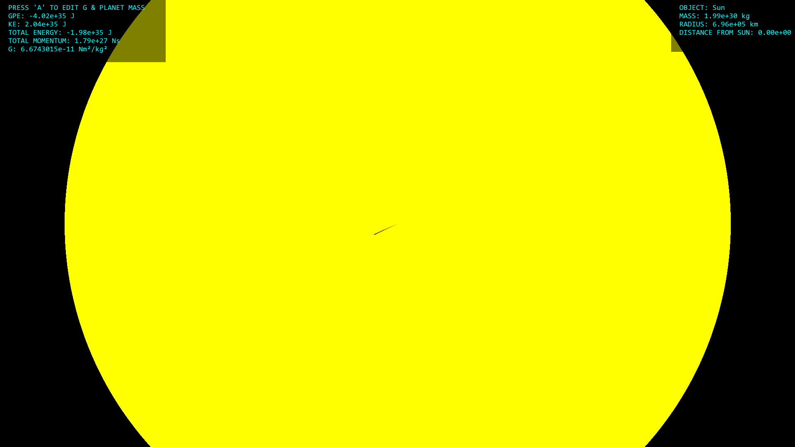
As you can see the sun is still visible behind the menu surface, but the translucent black background makes the text easier to read.

Inputs
Checking for inputs is done with pygame.event.get() and a bunch of if statements for every relevant input. I will just cover what each input does and how it works.

left / right arrows
If comparison is true then we’re in comparison mode, so the left arrow key increments planetsToCompare[0] by 1 modulo len(planets), and the right arrow key increments planetsToCompare[1] by 1 modulo len(planets), having the effect of changing which planets are displayed. The reason we do it mod len(planets) is so that once the end of the list is reached it wraps round back to the start instead of causing an index out of range error.
If comparison is false then the left arrow decrements focus by 1 modulo len(planets) and the right arrow increments focus by 1 modulo len(planets). This leads to the camera being centred on a different planet, as explained in the display section.

up / down arrows
The up arrow key increments timeScale by 0.1*YEAR and the down arrow key decrements timeScale by 0.1*YEAR. An if statement is used to check if decrementing the timeScale would make it negative, in which case it is set to be 0. If the timeScale is 0 and the user presses the up arrow key then it is set to be 0.05*YEAR as that’s the default value for timeScale.

space
Very simple, just toggles the value of comFocus.

F
Also very simple, just toggles the value of arrows, which is whether or not displayArrows() should be run.

A
Toggles the value of changingAttributes.

W, S, E and D
W and S increment and decrement the value of G, and E and D increment and decrement the mass of the currently selected planet. Because the masses of the planets take such a huge range of values across many orders of magnitude, and likewise for the values G needs to be able to take to have any visible effect on the system, a more involved approach is needed than just increasing and decreasing them by a fixed value.
This is the formula I’ll be using to change the values:
x = x±0.5*10^maths.floor((maths.log(x, 10)))
Where maths.floor(a) returns the greatest integer <= a.
This has the effect of making the increments x changes in based on the order of magnitude of x. Let’s say x = 5100, which is 5.1*10^3. Then log(x, 10) = 3.7075702..., so floor(log(x, 10)) = 3. This means x would change in increments of 0.5*10^3, which is 500, so x would go 5100, 5600, 6100, etc up until 9600, where it changes to 10,100. Now its increments would change because floor(log(x, 10)) = 4, so now it goes up in increments of 5000. This works going the other way too.
This lets users quickly increase the mass of planets to be a different order of magnitude and provides a much smoother experience when editing values. It also has the side effect of preventing masses and G from becoming negative as the increments get smaller and smaller so you can never get past 0. This is good because negative G or mass would cause a lot of issues as it is something that does not ever happen in the real world.

Mousewheel up and down
Scrolling down will zoom out (decrease zoomScale) and scrolling up will zoom in (increase zoomScale). Just like with G and mass, the distance scale needs to be able to take a very wide range of orders of magnitudes, from being able to zoom in on and show the Earth-Moon system to being small enough to show the voyager satellites and the Sun in the same view. A different approach will be used to the one used with G and mass though, due to the way zooming is handled in code to make it look smooth and natural
Essentially, there are two scales, zoomScale and distScale. distScale is what’s actually used when displaying planets. zoomScale is a target that distScale asymptotically approaches over time via interpolation, and is the value that gets changed by the user when scrolling. How this interpolation is done will be explained in more detail in the next section covering miscellaneous functions, including zoom(). This is done because it means that when zooming in or out it initially changes very quickly (but smoothly) and then slows down over time, which looks natural to humans. zoomScale will changed based on percentange, zooming in increases it by 40% with each scroll, and zooming out decreases it by 40% with each scroll. This lets it change quickly and in a way that doesn’t look jarring to people. So, scrolling up increases zoomScale by 40% and scrolling down decreases zoomScale by 40%
There is one other thing to take into account though. If someone has zoomed out so quickly that distScale is taking a while to catch up to zoomScale and then tries to zoom in, zoomScale will change but it will still be smaller than distScale, so the program will still be zooming out. So, if the user scrolls up to zoom in and zoomScale is smaller than distScale, then before increasing zoomScale by 40% linear interpolation is done to bring zoomScale much closer to distScale so that the program actually starts zooming in. This works the same way for zooming out if zoomScale is larger than distScale. Pseudocode showing how this works is below:
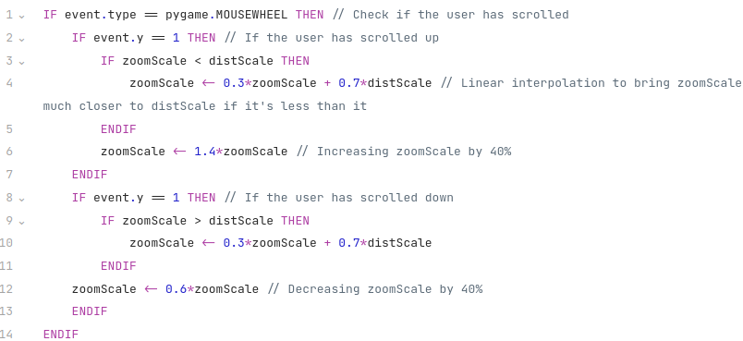

Miscellaneous functions
This section is just to cover the few functions that haven’t fit neatly into the other sections. These are com(), which finds the centre of mass of planets, sumPhysicalProperties() which adds up the energy and momentum of planets, and zoom() which handles the interpolation for the distScale.

com
com stands for centre of mass, it’s a real acronym used by physicists. We need the centre of mass so that the user can focus on it, particularly useful when the mass of planets has been increased by a large amount. To find the centre of mass is quite simple, this is the formula for it:
$$\frac{\sum{m_{i}x_{i}}}{\sum{m_{i}}}$$
Where $m_{i}$ is the mass of the ith planet and $x_{i}$ is its position vector. This can be done very simply with a for loop in code, just use p.getMass() to get the mass of the planet and p.getPos() to get the position of the planet. Here is pseudocode showing how it works:
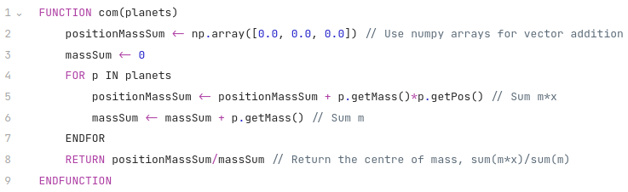

sumPhysicalProperties
The client has said that displaying energy and momentum to show conservation laws would be helpful, so this will need to be done. Luckily, planets already have their energies and momentum as attributes, so all this needs is a simple for loop to add them up, shown here:

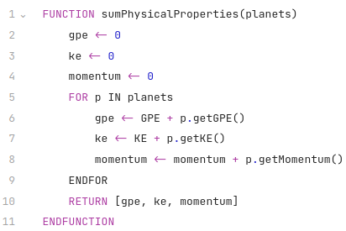

zoom
The problem with zooming is making it look natural. Clearly just changing the distScale instantly when you scroll would be extremely jarring, as the program would just snap to being more zoomed out or zoomed in. So, an extra variable is created, zoomScale, which is the intended new value for distScale. One approach would be to do linear interpolation between distScale and zoomScale so that you smoothly zoom out at a constant rate, but this would still have an abrupt stop once distScale reached zoomScale. Instead, a non-linear interpolation is used. This makes it so that distScale asymptotically approaches zoomScale, there is no abrupt stop. A graph of how this works is shown here, with distScale starting at 0 and then going up to 1:

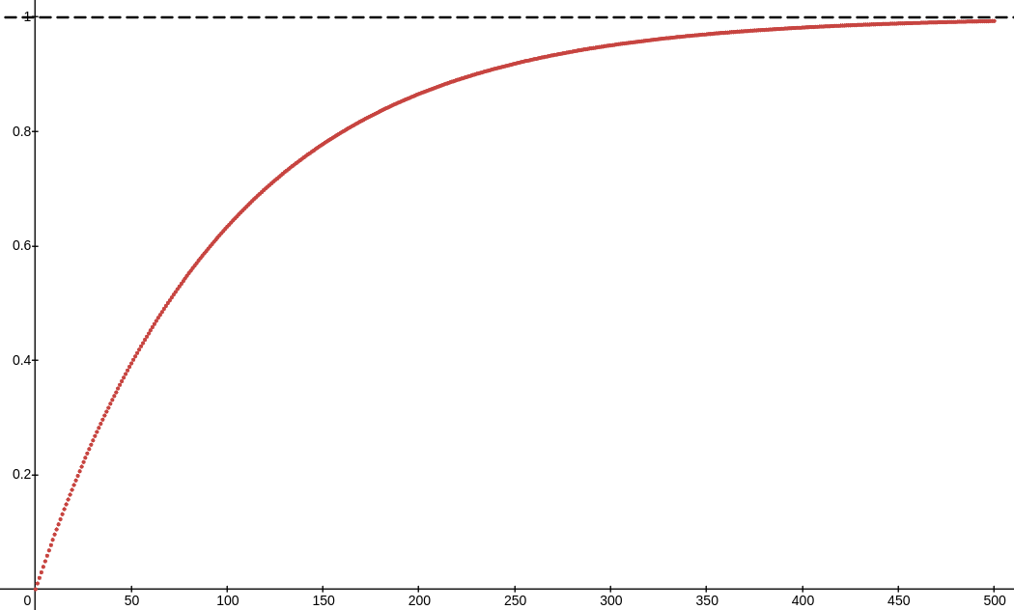

The x-axis is time and y-axis is the value of distScale. As you can see distScale grows quickly at the start and then the growth slows down, and it approaches 1 but never quite reaches it. The dotted black line is the asymptote at y=1. This ends up creating a natural and smooth animation for zooming out that stops gradually instead of abruptly.
So, how is this interpolation done? Lets say distScale is at some value $x_{0}$ at tick $t=0$ and we have a target zoomScale of $Z$. Then we can use this recursion relation to calculate the value of distScale at the next tick:
$$x_{t+1}=ax_{t}+(1-a)Z$$
Where $a$ is a constant that determines how fast distScale approaches $Z$. $a$ must be between 0 and 1, if it is less than 0 then distScale still approaches $Z$ but it oscillates around it, sometimes being negative sometimes positive, which looks ridiculous, and if $a$ is greater than 1 then distScale diverges away from $Z$ instead of approaching it. Through experimentation I have found that $a=0.9$ is a suitable value for the program.
One thing to note is that if distScale grows very large it can cause lag due to pygame attempting to draw circles with very large radii, something it’s not good at. There is no point for distScale to be particularly big as the users would not be able to see anything, the planet they’d selected would fill the whole screen, so distScale is capped at 1000.
Zoom() will be run every tick to carry out this interpolation process, and it makes distScale change smoothly over time. Here is pseudocode for it:
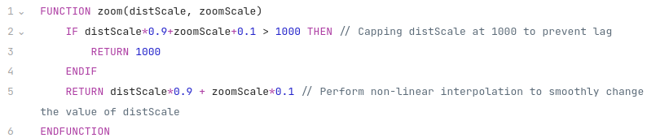

References
Eyes on the Solar System - NASA/JPL (no date). https://eyes.nasa.gov/apps/solar-system/#/home.

