Analysis

Introduction
The solar system is an important part of the physics curriculum, and it’s something that children often find more interesting than other core physics topics such as circuits or mechanics. I think it’s important to teach the solar system because it’s fun, and because it can also help students understand the more boring topics, such as forces or energy, as forces and conservation of energy can be demonstrated with the solar system.
However, there is a lack of interactive tools available for teaching the solar system that also incorporate other physics topics such as energy. It would be useful to teachers, and students, to have a prorgam that can use an interesting topic like space that also teaches important concepts from other topics such as conservation of momentum or Newton’s laws.

How a simulation of the solar system works
The orbits of the planets are governed by two fundamental laws of physics:
- Newton’s second law of motion: $F=ma$, where F is the force acting on a body, m is the mass of a body, and a is the acceleration of the body
- Newton’s law of universal gravitation: $F=\frac{GMm}{r²},$ once again F is the force, G is something called the “gravitation constant”, M and m represent the masses between two bodies, and r² is the distance between them.
To demonstrate this, a force diagram is attached.
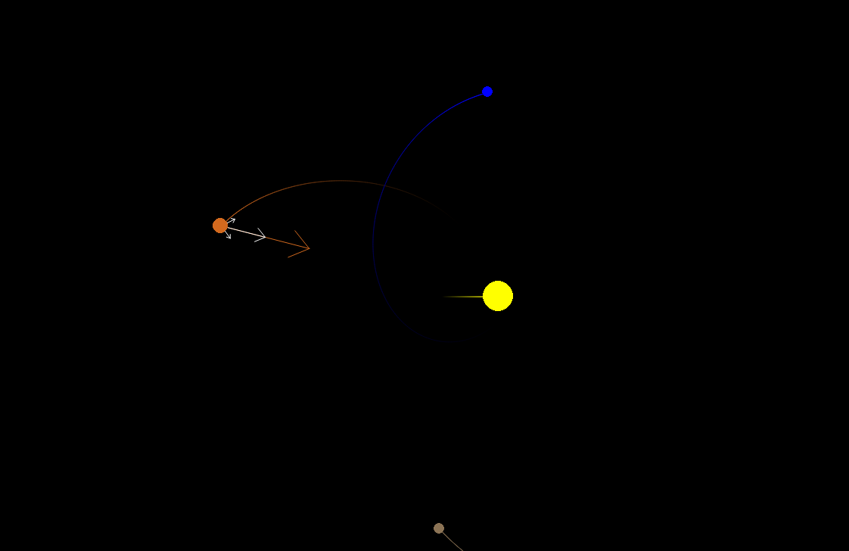
The orange planet has 4 arrows around it. These are the forces acting on it. The arrow shows the direction of each force and the length of the arrow represents the strength of the force. The white arrows are individual forces, you can see one pointing towards the brown planet, one pointing towards the blue planet, and one pointing towards the yellow sun. The arrow pointing towards the sun is much longer than the other arrows, representing that it has a stronger effect. This is because the sun has a larger mass, and so the force of gravity due to it is a lot stronger.
The brown arrow is the resultant force. This is what happens when you pull the planet in the direction of all three arrows at the same time. Because the force from the sun is so much stronger than the force due to the other planets, the resultant force is pretty similar to the force from the sun.

What teachers want in a simulation of the solar system
These are extracts from an interview with the South Wilts physics department
Question:
“What content is covered when teaching lower school classes?”
Answer:
“We do a little bit of work with Y7 looking at the order of the planets in the Solar System and the properties of some of the planets.
“In Y11 we look at the objects in the solar system and orbital motion. They need to know that gravity provides a centripetal force and how closer planets orbit faster.
How this impacts the project:
I need to accurately display the solar system with the planets in the correct order, show the orbits of the planets, and have a way to show that gravity provides a centripetal force.

Question:
Do you currently use any interactive tools when teaching the solar system? If so, which, and how do you use them? Do you think there’s anything they’re lacking that would help kids learn better?
Answer:
Not with Y11.
Y7 have the opportunity to complete independent research on a planet in the solar system and we share this link https://eyes.nasa.gov/apps/orrery/#/home. It has easy links to extra information and a size comparison.
It would be good to see this combined with something that shows the orbital motion of satellites.
https://phet.colorado.edu/sims/html/my-solar-system/latest/my-solar-system_all.html
This simulator is great to show the effect of changing mass on the theoretical solar system. I wonder if there could be a simulator which enabled us to ‘play’ with the masses in our actual solar system to see what happens – probably this would be more useful Y11 onwards.
How this impacts the project:
I need to create something that shows the motion of planets, as well as having size comparisons, like in the link above. Should be possible to edit the masses of objects to show the effect it has too like in the PHeT simulator. I think allowing the user to change the value of G would be informative as well, to show what it actually does.

Question:
What other features would you want in an interactive program that would make it useful for teaching?
Answer:
With younger students it is good to be able to show them information when setting them independent tasks to avoid them just copying and pasting things they don’t understand from incorrect sources.
Impact on project:
Planets, satellites and other celestial objects should display their properties (e.g. mass and size) so that the program can act as a source of information, rather than students finding erraneous sources online.

Question:
What format would be most convenient, e.g. would a website be preferable to an app you had to download?
Answer:
An executable file would work well

Question:
Should the program focus entirely on the solar system, or would it be useful to also use the orbits to demonstrate concepts like Newton’s laws, conservation of energy and conservation of momentum?
Answer:
We look at the solar system right at the end of Y11 so if there was a program which linked to key Newtonian Physics, it would be a great way to re-visit these laws in a different context.
Impact on project:
Should include things such as force diagrams and total energy to link the solar system to these concepts.

A review of the features requested:
- Display extra information in the program
- Size comparison
- Interactively changing the mass of the planets
- Demonstrating concepts of Newtonian physics
- Make the program downloadable e.g. a python file

Feature 1 can be implemented with an object oriented approach. There will be a celestial body class. Celestial bodies will be stored as objects. Their masses, positions and sizes will be stored as attributes. I can just display those attributes (these attributes will be fetched from a NASA database as explained later, which is a reliable source.)
Feature 2 can be done by splitting the screen in half, displaying the chosen object in the left half, and scaling the left half so that it fits the chosen object. Then display the other chosen object for comparison in the right half at the same scale.
Feature 3 is doable. The mass of planets is already stored as an attribute for them. All that needs to be done is to let users edit the mass of said planets.
For feature 6 the challenge is figuring out how to do it in a way that a 12 year old can understand. The program already conserves momentum, energy, and uses Newton’s laws of motion because it’s supposed to be an accurate simulation. The hard bit is trying to make it clear to kids how those things are happening in the program, and help them get a better understanding of it. I will try displaying both the potential and kinetic energy of the system, as well as the total. This will show that while the types of energy change, the total amount of energy stays constant.

Current alternatives

NASA’s Eyes
https://eyes.nasa.gov/apps/orrery/#/home
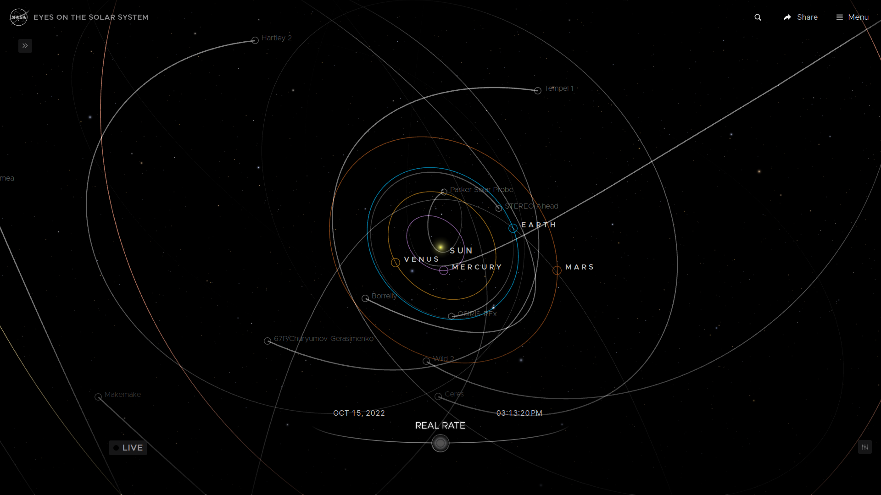
Eyes is a suite of products developed by NASA used for visualising their data. Their orrery, shown in the figure above, demonstrates the orbits of planets, asteroids, comets, and certain satellites. It is freely available from any browser, no download required, which is very convenient. My school currently uses this to teach year 7’s, primarily because it has links to further reading for their research project. It also accurately shows the trajectories of planets and other celestial bodies.
This site allows you to move the camera and to focus on specific planets, which is something I think is very beneficial for teaching as it gives you different perspectives of the solar system, and it is something I want in my own project.
However, the site lacks a few things. There is no connection to Newtonian mechanics, nothing demonstrating it, and no way to change the mass of the planets.

PhET: My Solar System
https://phet.colorado.edu/sims/html/my-solar-system/latest/my-solar-system_all.html
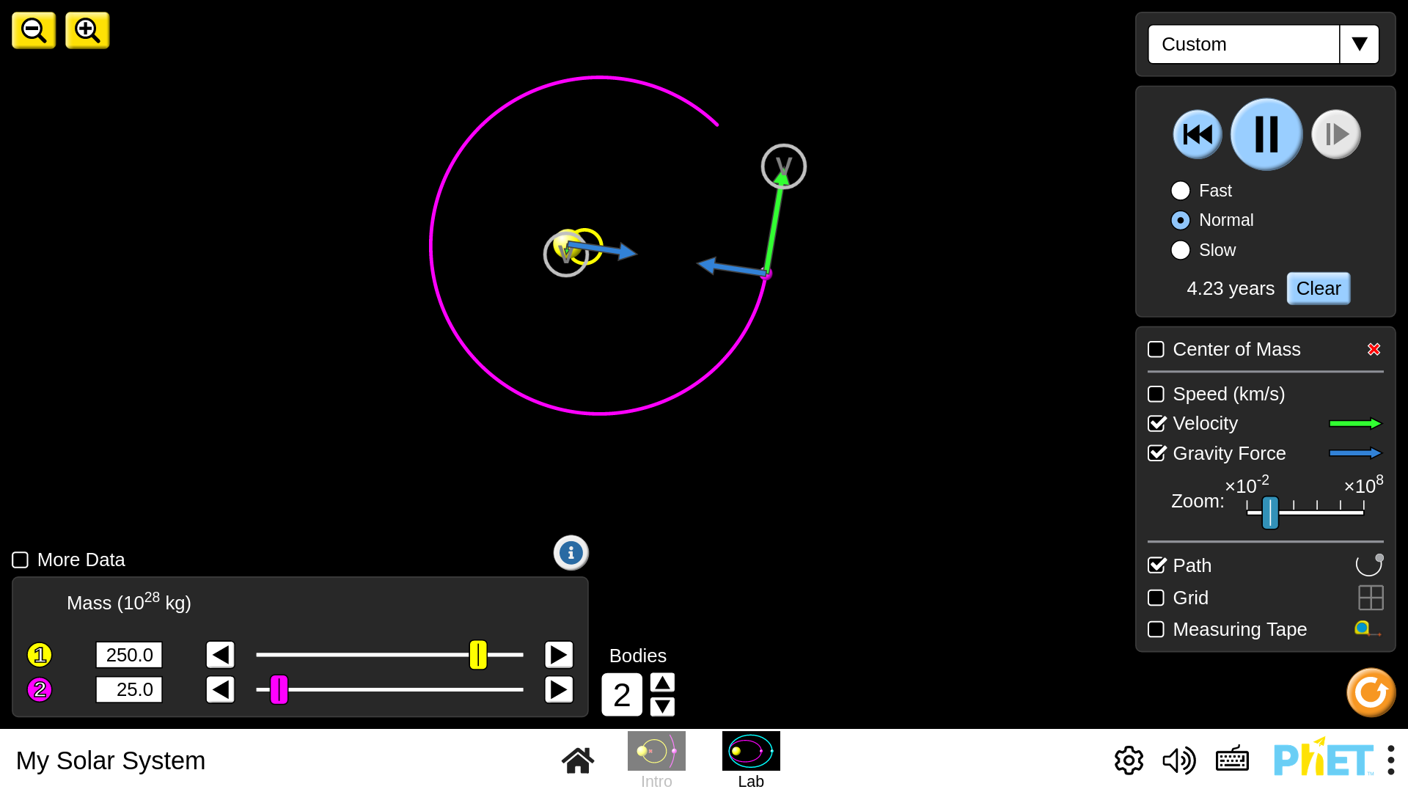
PhET (Physics Education Technology) is a website hosting a large amount of interactive physics simulations where students can tweak parameters and see the effects in real time. Its simulations are used by schools all around the world, and mine is no exception. As mentioned in the interview, my school finds the PhET simulation for the solar system useful because it lets you change the masses of the bodies in the solar system. It also includes force and velocity vectors, which can be used to help link back to Newtonian mechanics.
The drawback is that it’s all on a fictional solar system. You can’t put it into context with our actual planets. This would both be entertaining for students (who doesn’t want to know what would happen if the Moon weighed as much as Jupiter?) and help them visualise the effects of changing mass.

What I’ve learned from the alternatives
I aim to merge all the useful features in the alternatives listed above, and package them in an inuitive, easy to use software that benefits both teachers and students. This means being able to edit attributes of planets like in the PhET simulation, while also being accurate to our own solar system like NASA’s Eyes.
Some general design principles / tips from looking at the alternatives:
- A downloadable executable is the most accessible format for teachers
- Interactivity and being able to edit parts of the system is beneficial to learning and should be in the program
- The program should show the actual solar system, not a fictional one
- Arrows and other visual tools should be used to intuitively show physical quantities such as force and velocity

Modelling the problem

Class diagram
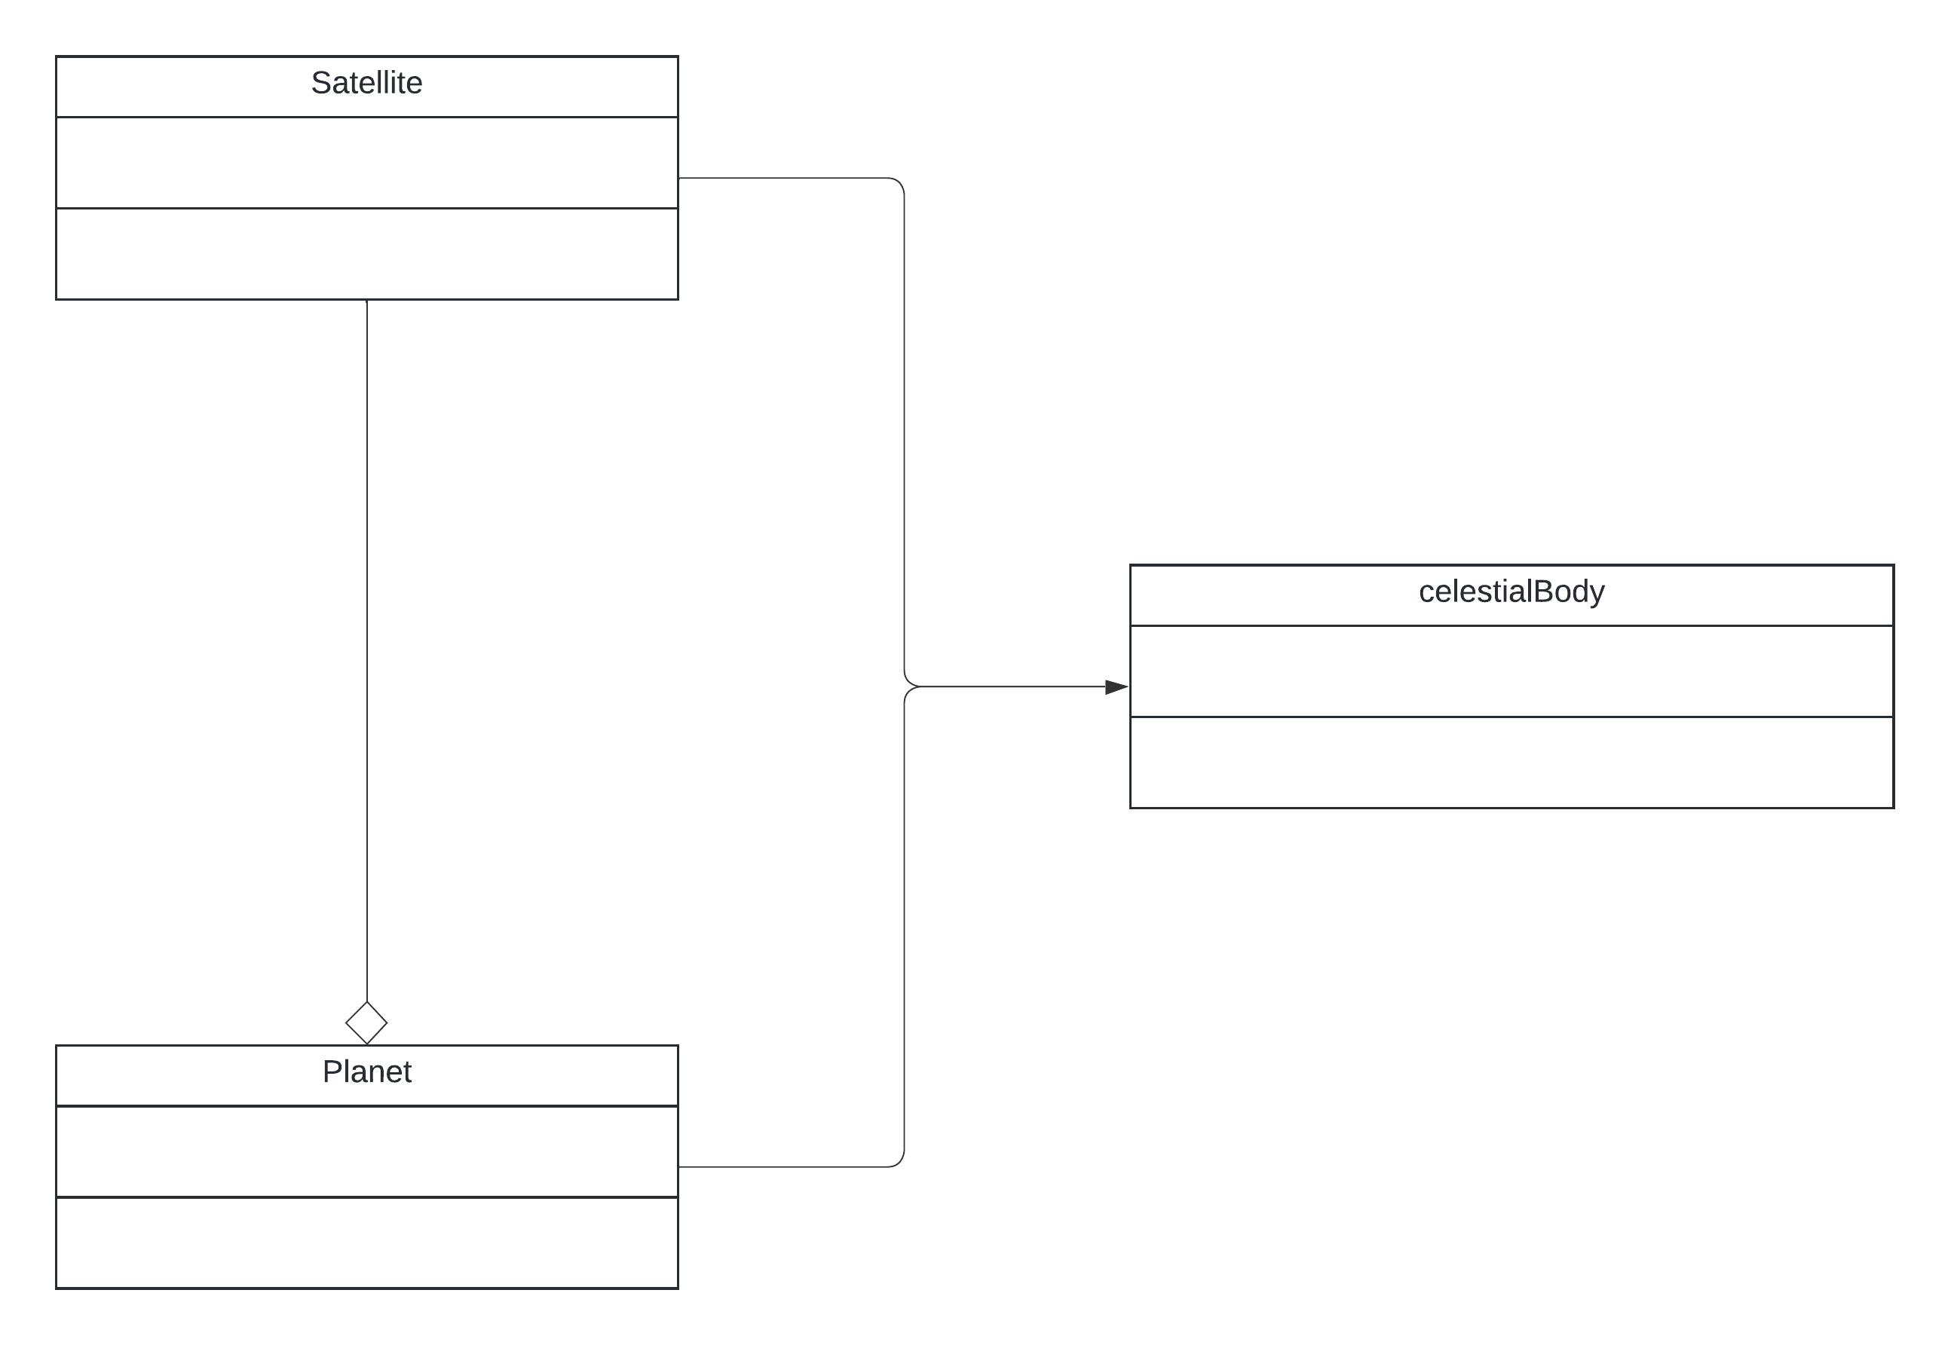
The main object in the solar system is a celestialBody, this is a catch all for pretty much every object in the system. Satellite and planet both inherit from celestialBody to tweak the behaviour slightly. The distinction between planet and satellite in the program is based on the astronomical definition, not the colloquial definition. A satellite is a body that orbits a host that isn’t a star, while a planet is anything else. That’s the only distinction, this means that the Sun and the Voyager satellites are classed as planets, because they do not have a host they orbit. Meanwhile the moon is a satellite because it orbits the Earth.
Satellites need to always orbit a host planet, and this host is one of their attributes, so they are aggregated with Planet. The Satellite’s existence is not dependent on the planet, e.g. if the Earth disappeared today the moon would continue existing, so aggregation is used instead of composition.

NASA’s API
The client requested the ability to change masses (simple), but for real planets in our solar system (less simple). This means I need to somehow have data on all of the planets, and to keep it up to date. Luckily, NASA has a solution for us:
https://ssd.jpl.nasa.gov/horizons/
Horizons is an online database that hosts real time information on planets. The idea will be to access this data using their API, which uses HTTP POST queries, and then translate that data to parameters for planets in my program, and load the solar system. Parsing the data may be tricky, but once I have the mass, positions and velocites of the planets it should be rather simple to load the solar system. This is because planets are already stored as objects with all of those attributes in my code, so I just need to create objects with their attributes set to be the ones retrieved from the Horizons query.
This is the request I will be using:
https://ssd.jpl.nasa.gov/api/horizons.api?format=text&COMMAND='"+target+"'&OBJ_DATA='YES'&MAKE_EPHEM='YES'&EPHEM_TYPE='VECTORS'&START_TIME='"+startTime+"'&STOP_TIME='"+stopTime+"'&CENTER='500@0'&STEP_SIZE='1%20d'&QUANTITIES=''’
Target, startTime and stopTime represent variables that will be set by the program. The rest of the request will not change. Here is an explanation of the important settings I’ve used in the request:
EPHEM_TYPE: This has multiple options. However the other options are all intended for uses not relevant to my program, e.g. making telescope observations or planning space missions to other planets. VECTORS is the type that NASA recommends for programming on their own site:
https://ssd-api.jpl.nasa.gov/doc/horizons.html#ephem_type
So it’s the one that I use.
CENTER: This is the reference location for the coordinates returned by Ephemeris. 500@0 is the ID for the Solar Barycenter, the center of mass of the solar system. This is the most objective reference point available for our solar system, so is the one that I use.
STEP_SIZE: This just means the ephemeris generates coordinates every day, this isn’t really relevant to the program as I’m only using the initial coordinates given in the response and simulating the rest from there.
QUANTITIES: This lets you request a bunch of very cool information, but none of it is needed by my program, so to make getting the request faster and to reduce the size of the requests it is set to be empty.

Once the request is received, it must be parsed so that the relevant parameters can be extracted. The basic strategy I’ll use is to first search for key phrases in the text like “Mass” or “Radius” which indicate that a parameter I want is about to come up. Once a key phrase is found, this algorithm will be used to get the numerical value out:

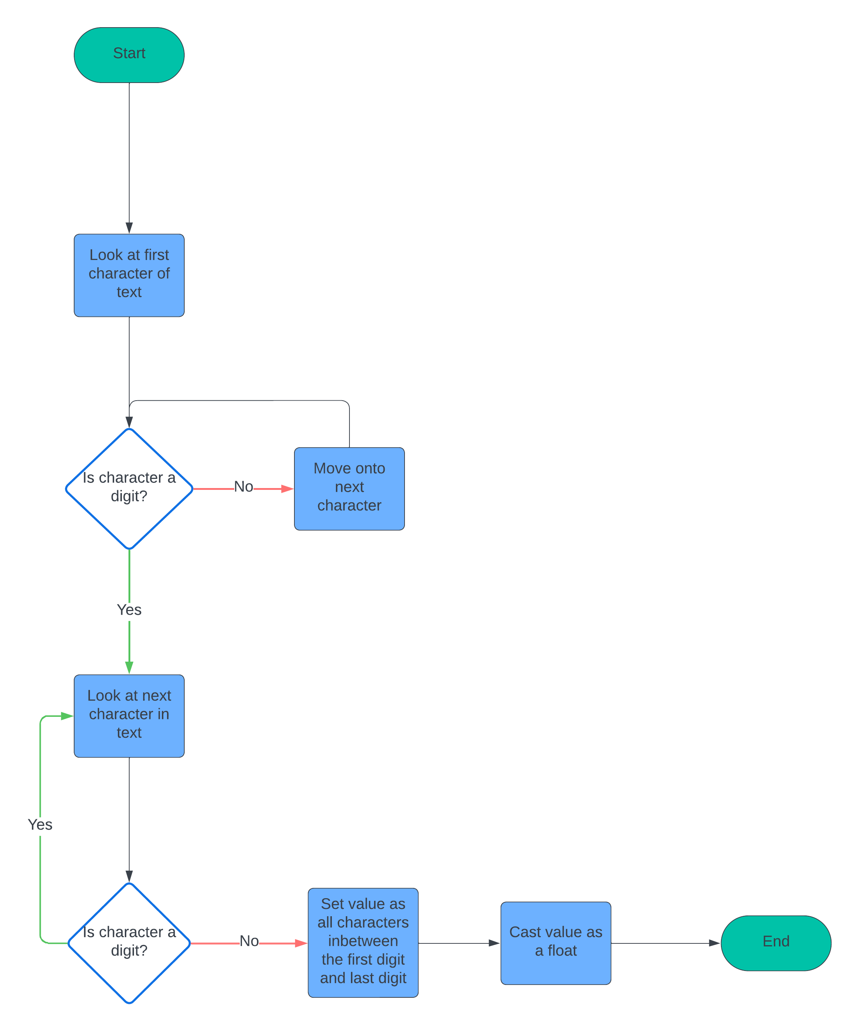

Because NASA formats their data horribly, there are a lot of caveats involved that will need to be overcome in order to sucessfully parse the data. This will be covered in the design.

The maths of simulating a solar system

Verlet Integration
Verlet integration is a computationally efficient method for simulating the motion of objects.
This is the equation for basic Verlet:
$$x_{n+1}={ 2x}_{n}-{ x}_{n-1}+{ a}_{n}{Δt}^{2}$$
This looks very scary, but isn’t actually that bad. $x_{n}$ is the current position of the object. $x_{n-1}$ is its previous position. $x_{n+1}$ is its updated position. ${ a}_{n}$ is the acceleration of the object. ${Δt}^{2}$ means a very very small step forward in time.
We can do some factoring to get a more useful form of the equation:
$$x_{n+1}={ x}_{n}+x_{n}-{ x}_{n-1}+{ a}_{n}{Δt}^{2}$$
$$x_{n+1}=x_{n}+(x_{n}-x_{n-1})+{ a}_{n}{Δt}^{2}$$
$$x_{n+1}=x_{n}+v_{n-1}Δt+{ a}_{n}{Δt}^{2}$$
$$x_{n+1}=x_{n}+ (v_{n-1}+a_{n}Δt)Δt$$
$$x_{n+1}=x_{n}+v_{n}Δt$$
This is the equation that will actually be used in code. What it means is that, given an object at position $x_{n}$, and with a certain speed $v_{n}$, its position $x_{n+1}$ after moving forward a small amount of time ($Δt$) is its old position + its speed multiplied by that small amount of time. Example:
A car is 9 miles along a road (so $x_{n}=9$). It is moving at 60 miles an hour. After 1 minute ($Δt$ = 1 min = 1/60 hr), the new position of the car will be $x_{n+1}=9+60*\left(\frac{1}{60}\right)= 10$ miles along the road.
So, all we need to do to find the new positions of our planets after each tick, is add their current velocities multiplied by a time factor ($Δt)$ to their current position.
There is also a similar equation for velocity and acceleration that will be used throughout the code:
$$v_{n+1}=v_{n}+a_{n}Δt$$
Where you add the acceleration to get the new velocity.
The $Δt$ term lets us change the speed of the simulation. The larger it is the faster the simulation is, it might cover a year of orbits in a single second for instance, but also the larger $Δt$ is the less accurate the simulation is. The user will be able to change $Δt$ with keybinds to suit their own needs.

Gravity
As mentioned earlier, the two equations used to simulate gravity are:
$$F=ma$$
$$F=\frac{GMm}{r²}$$
The goal here is simply to work out the acceleration on a planet due to gravity. Once that is done, the acceleration of the planet is handed over to the Verlet integration algorithm, which handles everything else.
Let’s start with the simpler equation, $F=ma$. Here, F is the force, m is the mass of the object, and a is the acceleration. We will calculate the force using the other equation, $F=\frac{GMm}{r²}$, and we already know the mass of all of our planets. We want the acceleration. So, solving for acceleration we get:
$$a = \frac{F}{m}$$
Which is quite nice. To find the acceleration, we just take the force acting on the planet and divide it by its mass.
Now let’s cover $F=\frac{GMm}{r²}$. Here, M and m are the masses of the two objects in question (M is conventionally the mass of the larger planet), r is the distance between them and G is a physical constant. It’s important to note that the F here is NOT the same F as the one in F = ma. The F in F = ma is the *resultant* force, the sum of all the forces acting on an object, while the F in this equation is just the force due to the gravitational pull of one planet.
This means to get the resultant force acting on a planet, we must compute $F=\frac{GMm}{r²}$ for that planet and all the other bodies in the system. We then add those forces up (some may be negative and cancel each other out) to get the resultant force. This is then given to F = ma, and the acceleration from that is given to Verlet integration.

To summarise everything covered in this section, a flow chart on the next page describes what happens to a single planet on each tick of the program:
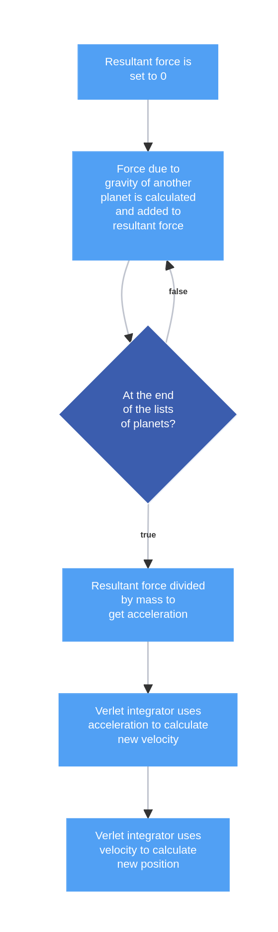

Displaying the system
I will use a simplistic design philosophy for this project. I want to get the relevant information across: Relative sizes of planets, orbital paths, positions of planets. But I want to do this without impacting performance or making the display hard to understand. To do this, I will use solid coloured circles for the planets, as this makes it clear where they are, and thin lines to show their trajectories. This is a mockup of what the system would look like with a few planets:
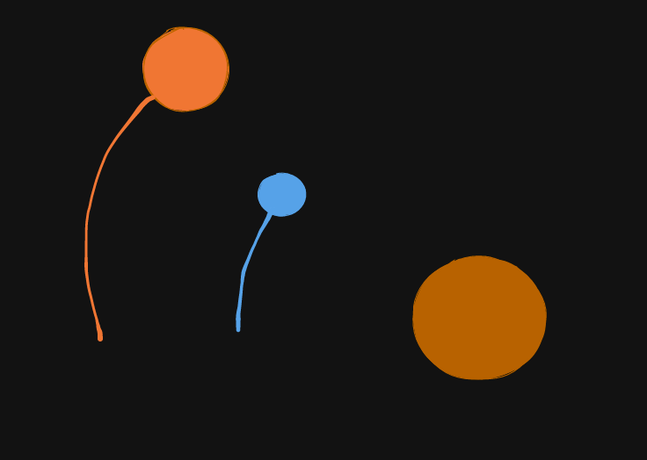
The two smaller circles on the left with lines coming off them are planets, orbiting the central mass in the middle, which represents a star. The star does not have any lines coming off it as stars do not tend to move much relative to the centre of mass of their solar system, because they are so big. Sometimes our sun will move slightly though, and this would be represented with a line showing its path.
This approach makes all the information I want to convey clear, and is quite simple to understand, but is also very easy to render so will not impact performance.
I want all the distances to be to scale in my program, but this is quite difficult as the distances involved in the solar system are absolutely huge. To achieve this I will use a scaling factor, so everything in the system will be scaled by the same amount. This keeps all the relative sizes accurate, e.g. the moon will still be roughly 1/4 the size of Earth, but it won’t take a 2000 kilometre wide screen to display it. To do this in code I will take the radius of a planet, multiply it by the scaling factor, and then draw a circle with that radius. If the scaling factor is chosen correctly then all the planets will be visible and it should look like an accurate model of our solar system.

This also makes size comparisons, which were requested by the client, quite easy to do. You simply draw the circles for the two desired planets side by side, rather than at their normal position. Because of the scaling factor the two planets will have the correct relative sizes, so the size comparison will be accurate.
Like mentioned when looking at NASA’s Eyes, I want the user to have the ability to move the camera. I will not give complete freedom to move the camera, as the solar system is very big and this could easily lead to them getting lost in a lot of empty space between two planets, and just seeing a blank screen. Instead, I think the camera should centre on a planet or other object and the user should be able to choose which object it focuses on. As well as being able to centre on the planets like in NASA’s Eyes, I want to also let the user centre the camera on the centre of mass of the system. While this isn’t particularly useful for our solar system usually, as the centre of mass is always inside or very close to the surface of the sun, this will be helpful when users start changing the mass of planets, as the solar system will quickly spin out of control and focusing on the centre of mass will make everything easier to see.
Focusing on planets will be done by pressing the left and right arrow keys, this will cycle through objects, which will be ordered based on their proximity to the sun, so pressing the right arrow key makes you move further away from the sun and the left arrow key makes you move closer (until you reach the furthest out object then it will bring you back to the sun and the loop starts again.)
The way the focusing will be done in code is by calculating the vector between the selected object and the centre of the coordinate system. This is our “adjustment”, which can then be added to the positions of all the planets during the display process, so that they’re all in the correct position relative to the selected planet. The full process is quite mathematical so will be explained in detail during the design.

Interface
I will use a simple text and keyboard based menu to allow the user to interact with the program. This will be used to display the energies and momentum as needed to teach conservation of energy / momentum, as well as to let the user edit the mass of planets. I will display text at the top of the screen showing the relevant statistics like the total energy in the system, the mass of the planet, etc. This can be done using pygame’s font.render() method. A start screen will be displayed at the beginning of the program that explains all the keybinds, as well as obviously letting the user start the simulation (which will be done through pressing enter). Here is a mockup of what the start screen will look like:
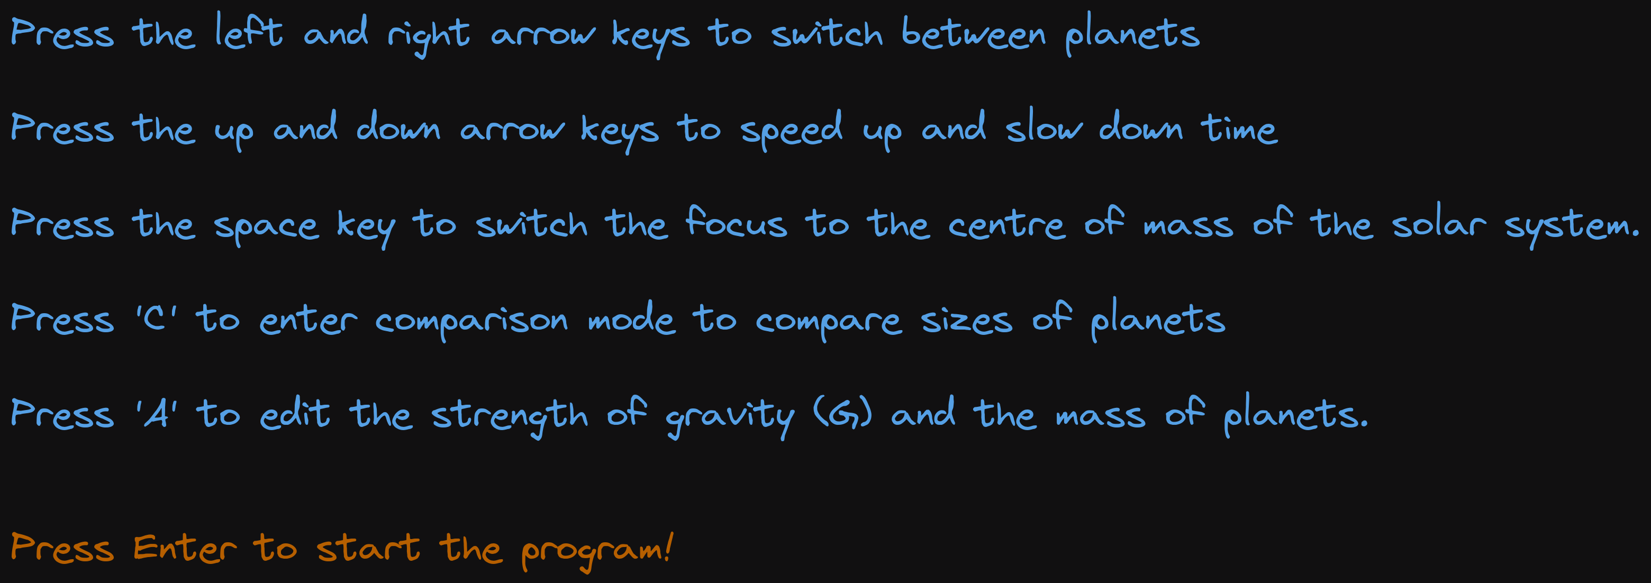
The last line telling the user how to start the prorgam is coloured red, differently from the other lines, to get their attention because if they don’t see it they won’t know how to start the program.
An “edit mode” will be included that lets the user edit the masses of planets and the value of G by pressing keybinds. The mode should explain all the necessary keybinds so that users do not need to memorise them. Here is a mockup of what the interface will look like outside of edit mode:
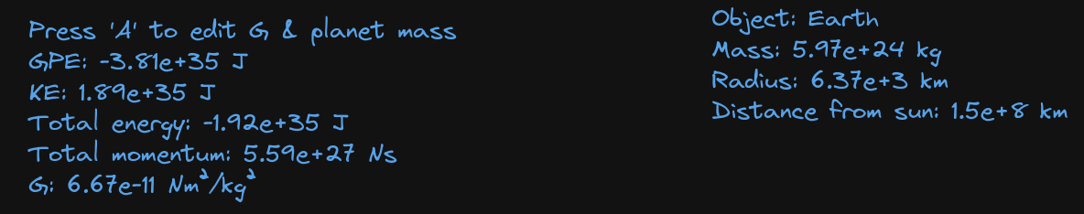
All of the information relevant to the physics the kids are learning is shown; the energies, the momentum, and stats about the planet.
Here is a mockup of what the interface will look like in edit mode:
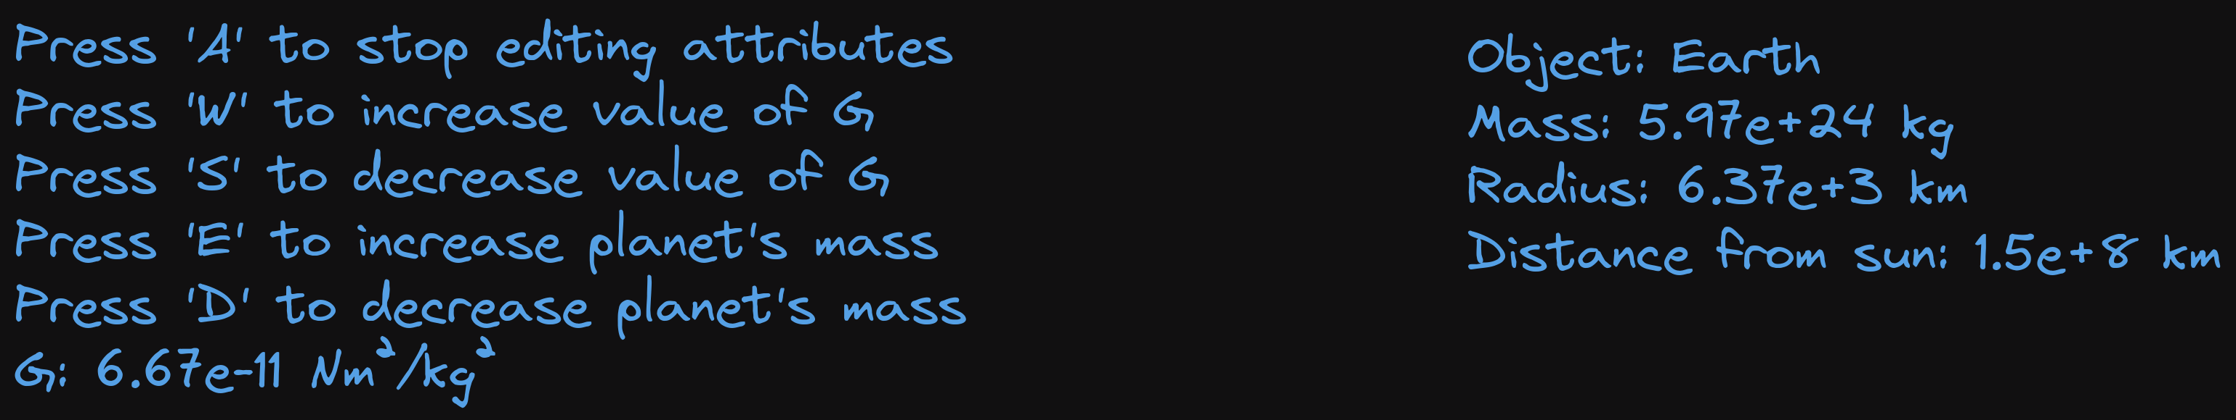
It shows the keybinds the user needs to press to interact with the program, and the value of G is still displayed so that the user can see the effects of their changes. The mass of the planet is also still shown so that the user can see their changes to that too.
Reading the inputs will be done with pygame’s event.get() system and else if statements. The elifs will be used to check what key is pressed. When ‘A’ is pressed this will toggle a boolean value, changingAttributes, and when this boolean is true the program will accept inputs of W, S, E and D and change G / the masses accordingly. When it is false the program will not accept those inputs. The other inputs that are mentioned in the start screen will also all be done with elifs, when the space key is pressed it toggles a boolean that makes the program focus on the centre of mass, when the up arrow is pressed it increments the timescale, etc.

Objectives
- Be physically accurate
  - Model the effects of gravity using Newton’s laws of motion
  - Energy and momentum should be conserved (this should naturally arise from using Newton’s laws if they’re implemented correctly)
- Provide useful tools to aide teaching of concepts requested by client
  - Explain how Newtonian physics connects to the solar system
    - Include force diagrams to aid with this
    - Have a total energy counter + momentum counter to show that they never change
  - Have a menu that displays stats and lets the user edit certain values
    - Should display total energy and momentum
    - Should show information about the planet
      - Mass
      - Radius
      - Distance from Sun
    - Should let users edit the value of G
      - G should never become 0 or negative, this would cause a lot of severe bugs due to the way the maths of gravity works. Hence a logarithmic scale will be used so that G can get closer and closer to 0 but never reach it
    - Should let users edit the mass of planets
      - Once again this shouldn’t become negative
- Accurately display the solar system with a scale model
  - This should preserve the relative sizes and distances of all the planets
  - Orbital lines should be shown to demonstrate the path of the planets
  - The user should be able to focus the camera on any planet of their choosing
- Include the ability to compare sizes of two planets
- Access NASA JPL’s Horizons system to automatically import up to date data on planets
  - Use said data to load our real solar system into the program
- Be sufficiently optimised and not suffer frame drops as this would impact the user experience

