Test-Wiseness in Multiple-Choice Questions
Can you pick the right answer without reading the question? A look at 124,096 real exam questions.

What we did
We took 124,096 multiple-choice questions from real exams (university tests, the SAT, LSAT, science exams, reading comprehension, and commonsense reasoning). Then we hid the questions and kept only the answer choices. Could simple tricks in the wording of the answers still find the right one?
If you just guessed randomly, you would score about 24.5%. Anything above that means the answer choices are leaking information.

The short answer
Yes, a little. The best trick is simply picking the longest answer. It works about 29.0% of the time. That is above the 24.5% you would get by guessing, but it is not a cheat code. Most questions are written well enough that no trick reliably cracks them.
Here is how every trick we tested performed:
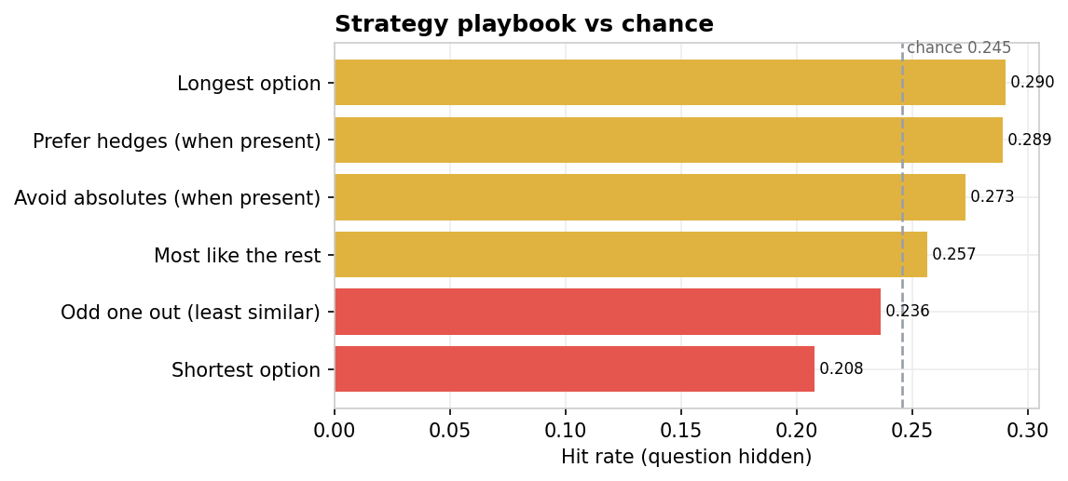
Figure 1. Each trick compared against the random guessing line.
Trick | Hit rate | Guessing | Lift
Longest option | 29.0% | 24.5% | 1.18x
Shortest option | 20.8% | 24.5% | 0.85x
Odd one out (least similar) | 23.6% | 24.5% | 0.96x
Most like the rest | 25.7% | 24.5% | 1.05x
Avoid absolutes (when present) | 27.3% | 24.5% | 1.11x
Prefer hedges (when present) | 28.9% | 24.5% | 1.18x

Longer answers tend to be correct
When we ranked each answer by length within its own question, a clear pattern appeared. The longest answer was correct 29.0% of the time, and it dropped steadily from there. The shortest answers were correct just 16.9%. Exam writers, it seems, add a bit more detail when writing the correct answer.
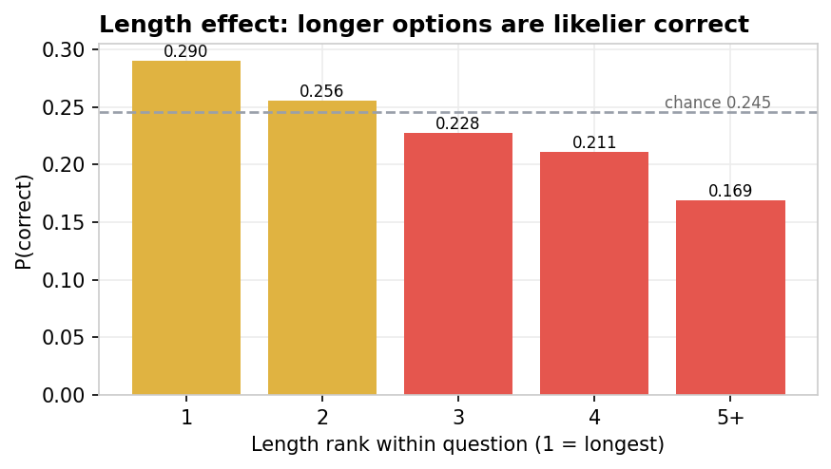
Figure 2. The longer the answer, the more likely it is to be right.

Position does not matter much
We checked whether the right answer tends to sit in a particular slot (A, B, C, or D). On four-choice questions, every slot was close to 25%. There is a tiny lean toward C, but nothing you could rely on.
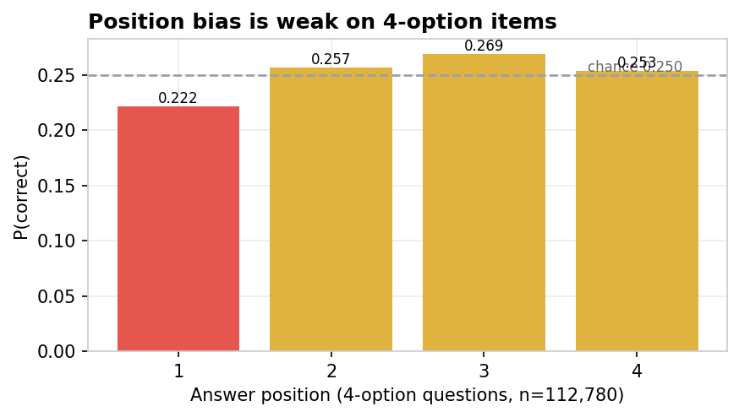
Figure 3. Answer position on four-choice questions. All close to 25%.

"All of the above" is almost always right
When the phrase "all of the above" appeared as one of the choices, it was the correct answer 70.3% of the time. That is a real tell. On the other hand, "none of the above" was correct only 18.1%, which is worse than guessing. It acts more like a trap than a giveaway.
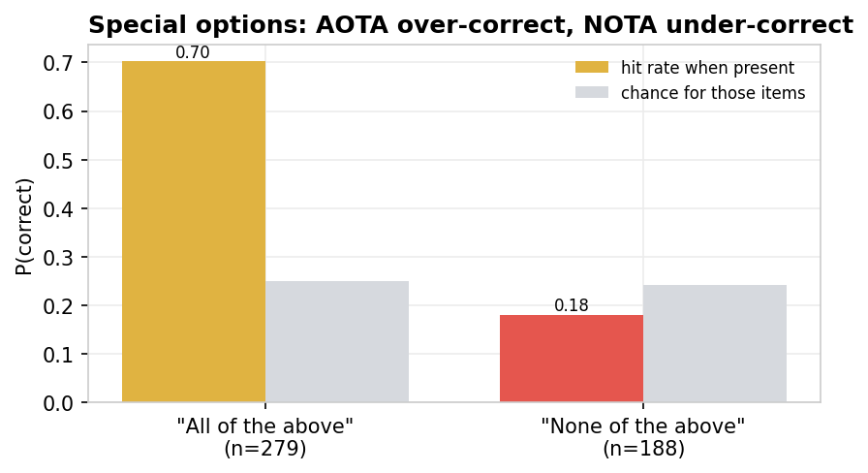
Figure 4. "All of the above" versus "none of the above" when they appear.

Tricky questions do not break the pattern
Questions with words like NOT or EXCEPT in the stem did not weaken the longest-answer trick. It scored 30.1% on those tricky questions, compared with 28.0% on normal ones. The length signal holds up either way.
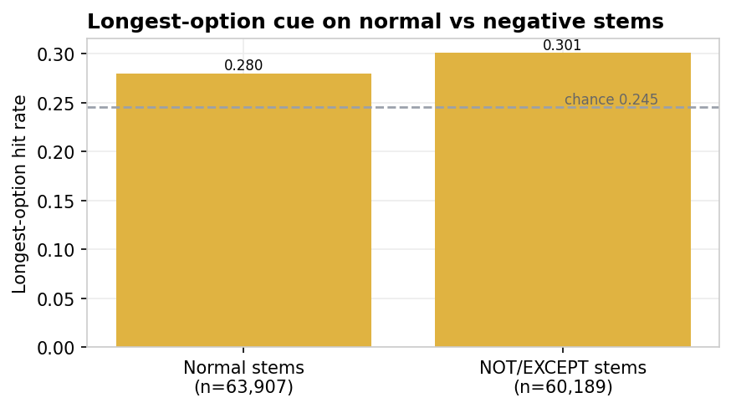
Figure 5. The longest-answer trick on normal versus NOT/EXCEPT questions.

Combining every trick does not help much
We built a computer model that weighs up all the tricks at once. It scored 29.4% under cross-validation. That is above guessing, but barely better than just picking the longest answer on its own. The tricks overlap: they are mostly detecting the same thing (the correct answer tends to be longer).
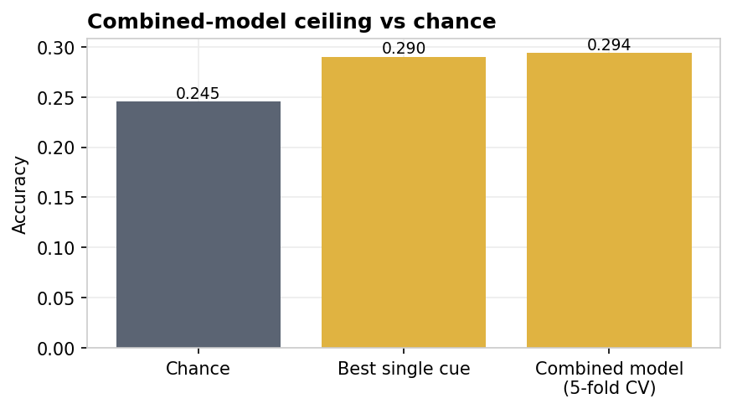
Figure 6. The combined model versus guessing and the best single trick.
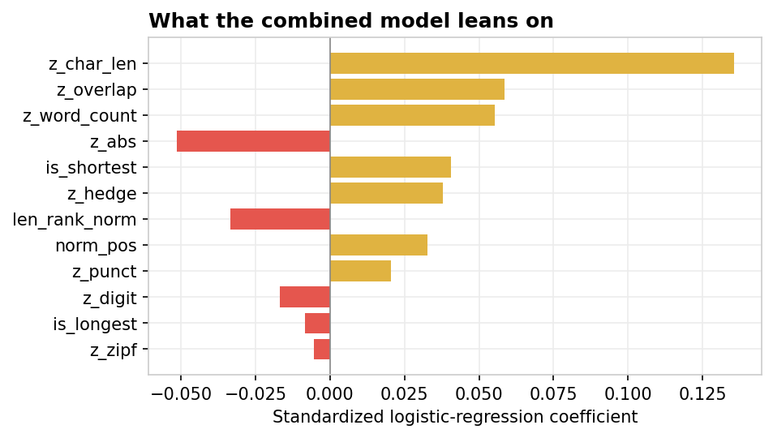
Figure 7. What the model leans on. Answer length dominates.

Most questions do not give themselves away
For each question, we counted how many of the six tricks pointed at the correct answer. The typical question had just one trick (or none) pointing at the key. Fewer than 3% of questions had three or more tricks lining up. The leak is real but concentrated in a small minority of items.
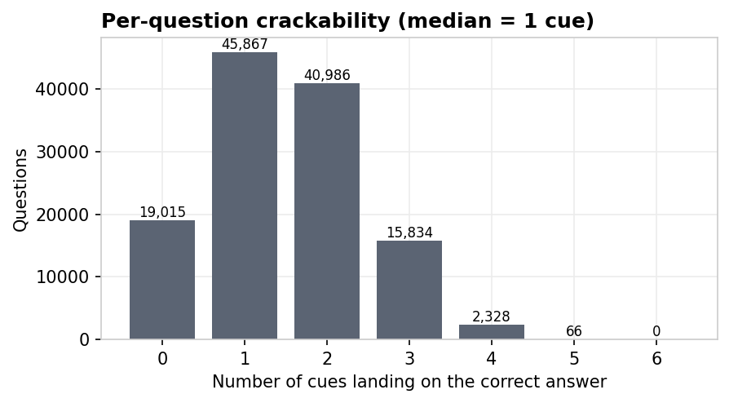
Figure 8. How many tricks land on the right answer per question.

When tricks agree, pay attention
On the rare questions where four or more tricks pointed at the same answer, that answer was right much more often than guessing. Agreement between tricks is the strongest signal we found.
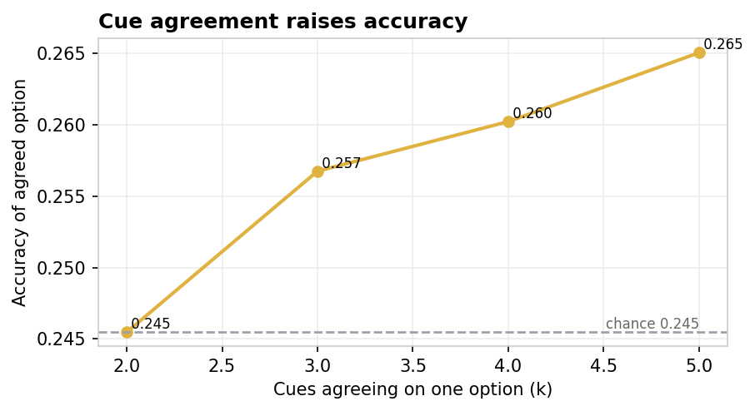
Figure 9. The more tricks agree, the better the odds.

Sanity check
To make sure we were not fooling ourselves, we scrambled the answer keys so there was nothing real to find and re-ran everything. Every trick and the model dropped straight back to the guessing level (about 24.8%). That confirms the patterns above are genuine, not an artefact of the method.

What this means
Exam writers leak a little information through the wording of their answer choices. The biggest habit is making the correct answer slightly longer and more detailed than the wrong ones. A few special phrases like "all of the above" are strong giveaways. But for most questions, these tricks do not reliably identify the answer. A student who knows nothing and tries to game the wording will do only slightly better than guessing.
For anyone writing exams: keep your answer choices roughly the same length, use "all of the above" sparingly, and vary which slot the answer lands in. That closes most of the gap.

The fine print
The pool mixes questions from MMLU (57 academic subjects), AGIEval (SAT, LSAT, AQuA-RAT, LogiQA), RACE (English reading exams), ARC (science), and CommonsenseQA (commonsense reasoning). All questions have five choices or fewer. Results are pooled across every source and never broken out by dataset. The tricks that rely on specific English words (like "usually" or "always") only apply to the English-language portion, which here is everything. The combined model uses logistic regression with grouped five-fold cross-validation.

References
Haladyna, T. M. and Downing, S. M. (1989). A taxonomy of multiple-choice item-writing rules. Applied Measurement in Education, 2(1), 37 to 50.
Haladyna, T. M., Downing, S. M. and Rodriguez, M. C. (2002). A review of multiple-choice item-writing guidelines for classroom assessment. Applied Measurement in Education, 15(3), 309 to 333.
Hendrycks, D. et al. (2021). Measuring Massive Multitask Language Understanding. ICLR.
Zhong, W. et al. (2023). AGIEval: A Human-Centric Benchmark for Evaluating Foundation Models. arXiv 2304.06364.
Lai, G. et al. (2017). RACE: Large-scale Reading Comprehension Dataset From Examinations. EMNLP, 785 to 794.
Talmor, A. et al. (2019). CommonsenseQA: A Question Answering Challenge Targeting World Knowledge. NAACL-HLT.
Clark, P. et al. (2018). Think you have Solved Question Answering? Try ARC, the AI2 Reasoning Challenge. arXiv 1803.05457.
Anonymous (2024). On the leakage of the longest option and answering with the question withheld. arXiv 2410.19278.

