N7BYU Satellite Rotator Computer Control
by Lloyd Brown, KC7NGB (1 January 2018)

Overview
The BYU Amateur Radio Club currently has a Yaesu G-5600 antenna rotator, which allows antennas to be pointed in both azimuth (compass directions, eg. Northwest), and elevation (angle above the horizon). This allows the antennas attached to the rotator to be pointed in any direction, and, with the right computer interface and software, can be used to track satellites.
The rotator currently has some highly-directional, circularly-polarized antennas for the 145 MHz, 450 MHz, and 1200 MHz bands. These antennas are currently connected to a Kenwood TS-790 radio in the BYU ARC club shack.
The rotator comes with a manual control device, which could theoretically be used to manually point the antenna, but currently some of the manual switches are having trouble. Additionally it is difficult to manually manage both the radio and the antenna rotator simultaneously. Computer control of the rotator is much preferable than manual tracking.
For reference, the rotator hardware is capable of 360° of azimuth rotation, and 180° of elevation rotation.

Design

Preliminary Information
The Yaesu G-5600 antenna rotator has a manual control device which has an 8-pin DIN connector for external control, which provides the following pins:
TODO: include connector pinout here
This connector provides voltages that indicate the position of the azimuth and elevation rotators, and pins that can be connected to ground to tell the rotator to go left or right (azimuth), or up and down (elevation).

Interface Device
Yaesu sells a GS-232 device that can be used to interface between a computer and the manual rotator controller. However, these generally cost more than $550, likely due to their low sales volume. Instead, this project utilized an Arduino device, along with the firmware designed by Anthony Good, K3NG. This device appears to a computer as a RS-232 Serial, emulating the same interaction as the Yaesu GS-232B variant. Any computer software that can interact with a Yaesu GS-232B, should be able to utilize this device. However, this document will only describe the use of the hamlib and gpredict software for Linux.

Hardware
This project utilizes the following parts:
- 1x Arduino Uno R3 SMD Clone
- 1x Custom Daughterboard (schematic below)
- 1x 8-Pin DIN Cable (Digikey Item #839-1081-ND)
- 2x Momentary SPDT toggle switches (for manual azimuth and elevation control)
- 1x DPDT toggle switch (for toggling elevation direction)
- 2x Momentary SPST buttons (for Park and Stop functionality)
- 6x 0.01 microfarad capacitors
- 1x 10 microfarad capacitor (electrolytic in this case)
- 6x 1 kOhm resistors, ¼ watt
- 4x 10 kOhm resistors, ¼ watt
- 1x 120 Ohm resistor, ¼ watt
- 3x 2n3904 Transistors

Daughter Board Schematic
The schematic and board layout, formatted for the eagle schematic design software, can be found in the shield_layout folder of this github repository: https://git.io/vQgPt
For reference, here is the schematic diagram:
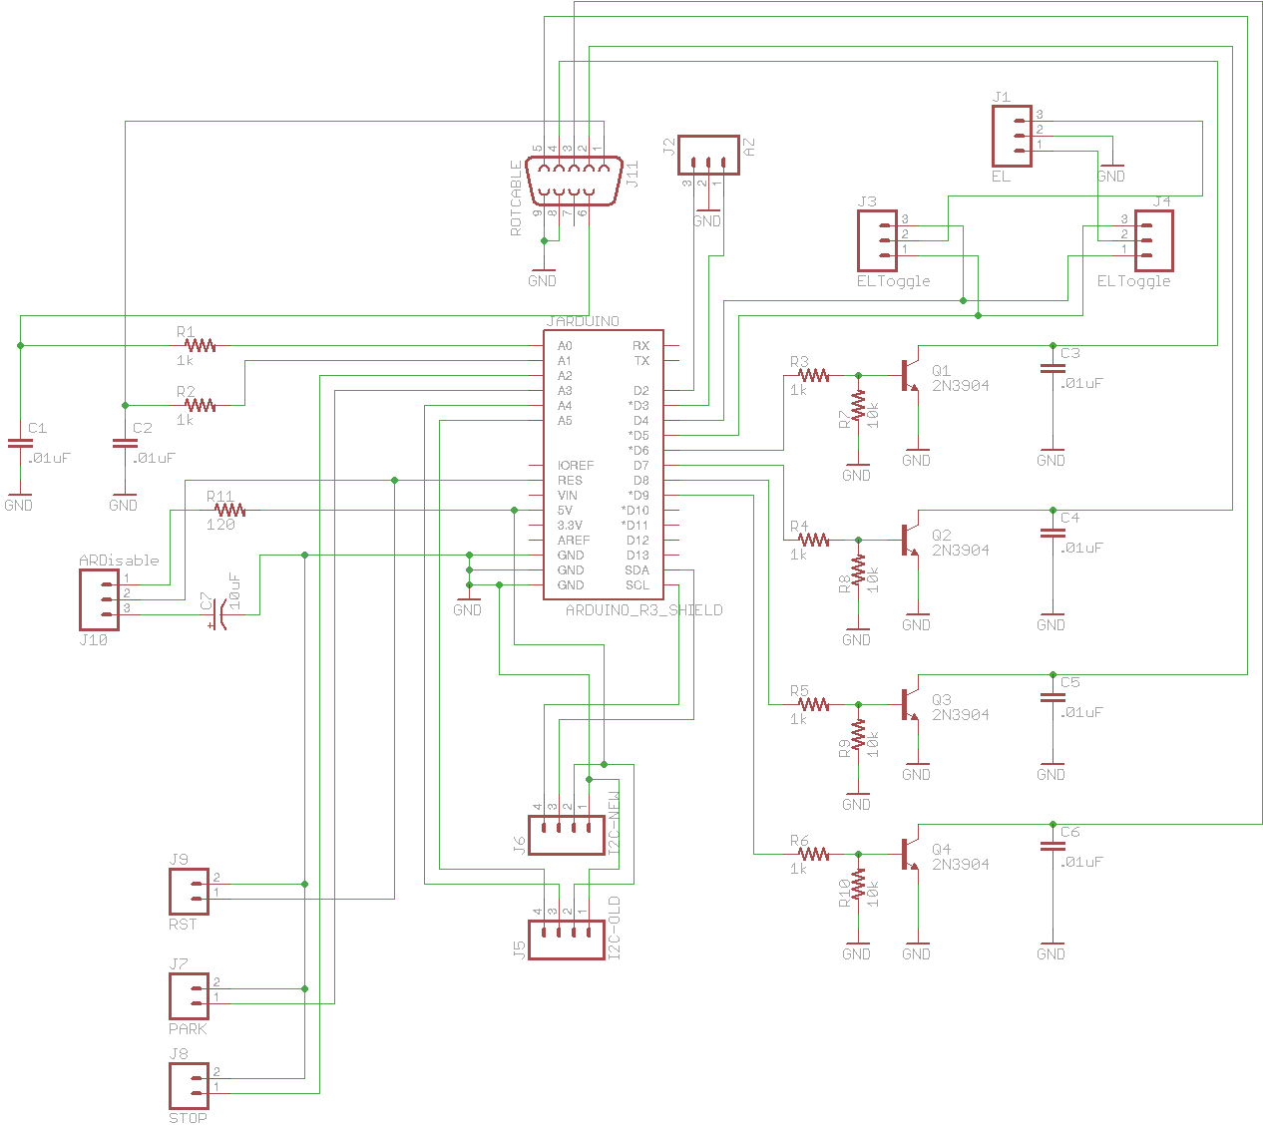Figure 1: N7BYU Rotator Controller Arduino Shield Schematic
The following is the pinout for the interface cable that goes between the shield, and the Yaesu G-5600 controller:
TODO: include pinout for interface cable

Computer Software
This setup has (so far) been tested on the Linux operating system, but will likely work under other operating systems. The specific setup under Linux will be documented here, but any setup that is capable of interacting with a Yaesu GS-232B device, should work here.

Linux Software Setup

Hamlib
The hamlib libraries/tools exist to provide a standard interface between various ham-related hardware components (both antenna rotators, and controllable radios/rigs), and the application software that utilizes them. The tool set includes command-line tools like rotctl (rotator control), and rigctl (radio/rig control), as well as corresponding daemons (named rotctld and rigctld) that stay resident on the computer, and respond to commands over a network socket.
While it is technically possible to run the rotctld daemon on a different computer than the application software (eg. gpredict), this is not generally recommended, due to security concerns. Instead, generally they are run on the same host, and the application software simply connects to the localhost to communicate with the daemon.
This is the recommended syntax to launch rotctld for this interface device:
rotctld --model=603 --rot-file-device=/dev/ttyUSB0
For further information, please consult the main hamlib website and documentation: http://www.hamlib.org/

gpredict
The software gpredict is an open-source, real-time satellite tracking and orbit prediction application, written mainly by Alexander Ceste, OZ9AEC. When set up correctly, it can send the antenna rotator a series of azimuth/elevation angles, that can approximate the path of the satellite. In addition, gpredict can also calculate the uplink and downlink frequencies (corrected for Doppler-shift), and send those to a radio, but this is not working well at the moment. You may use the software for these calculations, but will still have to manually tune the uplink and downlink VFOs on the radio.
This document will show how to get the gpredict software to interact with the rotator controller. However, there is a great deal more to do to set up gpredict completely, but that is beyond the scope of this document.
In order to set up the rotator, you will generally follow the following steps:
- Launch gpredict
- Open the settings section, by going to Edit->Settings. Click on the Interfaces icon on the left, and then the Rotators tab on the top.
- Click on the Add New button and specify the following parameters (many are the default):
  - Name: Whatever you want to call this rotator. Something like “N7BYU_G5600B” is pretty descriptive and distinctive.
  - Host: localhost (or another hostname if you are sending the rotator control commands over the network – not recommended)
  - Port: 4533 (default)
  - Az type: 0°->180°->360°
  - Min Az: 0
  - Max Az: 360
  - Min El: 0
  - Max El: 180
  - Azimuth end stop position (extremely important!!!): 180
- Click OK to close the “Edit rotator configuration” dialog box, and then OK to close the “GPREDICT Preferences” window.
For information on how to begin the tracking of a satellite, see the Automatic Operation section below.

Issues

Azimuth Rotation Stops
Most azimuth rotators have rotation stops, positions that they cannot rotate beyond, most often located either in the North or the South positions. The convention is that if the rotator is described as using a “-180°->0°->180°” range, the rotation stops are in the South (or +/-180° azimuth), while a rotator described as a “0°->180°->360°” rotator, has the stops in the North (or 0°/360° azimuth).
The N7BYU rotator is an exception to this rule. It uses the “0°->180°->360°” range description, but has its rotation stops in the South (at 180° azimuth). This is why specifying the Azimuth Stop Position described above is so important. Without this set correctly, you cannot correctly do a Flip-Pass Operation, which is quite limiting.

Flip-Pass Operation
In order to understand a flip-pass, think about the following hypothetical scenario: A satellite you're tracking will appear in the Southeast (135° azimuth) at 45° elevation above the horizon, and will track west, at a constant 45° elevation, eventually disappearing in the Southwest (225° azimuth), still at 45° elevation.
If the azimuth rotator had rotation stops in the North, this path would not be a problem. However, the N7BYU rotator has rotation stops in the South. This means that if you're tracking this satellite, it would approach, and eventually hit the rotation stops. Then, in order to continue to track the satellite, it would need to swing all the way back around (S->SE->E->NE->N->NW->W->SW->S) in order to catch the satellite on the other side of the rotation stops. This process can take nearly a minute, during which time your antenna is not pointing at the satellite.
The solution is a flip-pass, also known as a “flipped” pass. For our hypothetical path described above, we can just begin tracking in the Northwest (315° azimuth) at 135° elevation above the horizon, and track east, ending in the Northeast (45° azimuth), still at 135° elevation.
Because the elevation rotator can go past 90° (straight up), the flip-pass essentially tracks the same path as before, but avoids hitting the rotation stops, and therefore avoids the time when you can't hear the satellite.
Note that gpredict does handle flip-pass calculations automatically, based on the specified Azimuth end stop position. Whether other software does the same, will depend on that software's authors.

Operational Procedures

Calibration
When setting up the rotator for the first time, it may be necessary to calibrate, so that it actually points to where it thinks it its. This should not normally be necessary, unless you've noticed some miscalibration problems. To calibrate you can use the following procedure:
- Stop any process on the computer that would be communicating with the interface device over serial/RS-232, including rotctld.
- Open a serial console program and connect it to the interface device using the following serial port parameters:
  - TODO: include the serial parameters here
- Azimuth Calibration
  - In the serial console, type the O command, and press Enter
  - Manually rotate the rotator fully counter-clockwise (South, approaching from the West)
  - Press Enter in the serial console again
  - Type F in the serial console, and press Enter.
  - Manually rotate the rotator fully clockwise (South, approaching from the East)
  - Press Enter in the serial console again.
- Elevation Calibration
  - In the serial console, type the O2 command, and press Enter
  - Manually rotate the rotator fully down (0° elevation)
  - Press Enter in the serial console again
  - Type F2 in the serial console, and press Enter.
  - Manually rotate the rotator fully up (180° elevation)
  - Press Enter in the serial console again.

Operation

Manual Operation
The interface device contains the following control switches/buttons, which can be used to manually control the rotator position:
- Azimuth
  - Lets users manually instruct the rotator to go left or right in azimuth
- Elevation
  - Lets users manually instruct the rotator to go up or down in elevation
- Elevation Direction Toggle
  - This is intended to allow individuals to choose which direction means “up” vs “down” on the elevation switch, similar to people preferring the traditional vs “natural” scroll settings on a computer mouse's scroll wheel
- Stop
  - This button can be used to stop the rotator interface device from completing it's current rotation.
  - Note that many tracking programs like gpredict send the satellite's path as a series of azimuth/elevation positions, frequently sending new positions as often as every second. If the tracking program is still sending positions, this button won't cancel all of them. Just the current one. Users really need to stop the tracking software. Or hold down this button, I suppose.
- Park
  - This button will instruct the rotator to go back to it's parking position, currently set at 0° azimuth (North), and 0° elevation. This is wise to do routinely, to minimize the wind load on the antenna system.

Automatic Operation
As described before, this document assumes that you've set up the full gpredict software, including the connection to the rotator. Once that is done, you can set up an automatic antenna tracking operation using the following steps:
- Make sure that rotctld is launched and running with appropriate parameters. Depending on the exact system setup, this may mean launching manually as discussed in the Hamlib section above, or through some system-level service or process.
- Launch gpredict
- If needed, update TLE and Transponder data via the Edit menu options; you should do this frequently
- Click on the Module options / shortcuts icon, usually located in the upper-right of the window, which looks like this:
- Click on the Antenna Control option in the shortucts list, as shown here:
- In the new Gpredict Rotator Control window that appears, select the specific satellite to track in the Target pull-down, and click the Track button, as shown in this example:
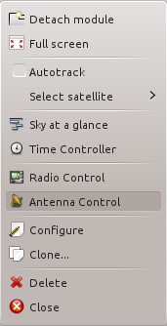Figure 2: Gpredict Shortcut Drop-down
- Select the correct rotator device, using the name you defined, in the Device pull-down, in the Settings section. Modify the Cycle and Tolerance values if desired, and click on the Engage button to begin the tracking cycle.
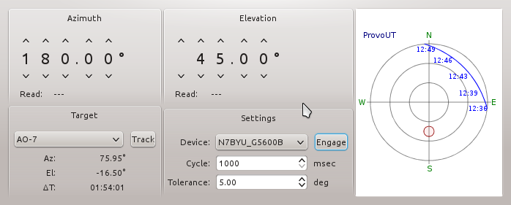Figure 3: Gpredict Rotator Control Window
- When done tracking the satellite, click on the Engage button again to dis-engage the connection to the satellite.
- Be sure to park the antenna rotator when you're done by pressing the Park button on the interface device.

References
- Main Hamlib website: http://www.hamlib.org/
- Main gpredict website: http://gpredict.oz9aec.net/
  - Support Information, including forums, mailing list, etc: http://gpredict.oz9aec.net/User_Support.php
- AMSAT-NA – Radio Amateur Satellite Corporation, North America: https://www.amsat.org/
- RadioArtisan website (interface firmware): https://blog.radioartisan.com/yaesu-rotator-computer-serial-interface/
  - Documentation: https://github.com/k3ng/k3ng_rotator_controller/wiki
  - This specific branch is what's currently loaded on the interface device: https://git.io/vQgPt
  - Mailing list (includes other projects by the same author): https://groups.yahoo.com/neo/groups/radioartisan/info
- CelesTrak website (satellite orbital information, or Keplerian Elements); gpredict downloads TLE information from this site: https://www.celestrak.com/
- SATNOGS – Satellite Network of Ground Stations, an open-source hardware/software platform for satellite ground stations: https://satnogs.org/
  - Includes a database of satellite transponder information, which gpredict uses to update frequencies, etc.: https://db.satnogs.org/

available at https://blog.radioartisan.com/yaesu-rotator-computer-serial-interface/.
The rotctld daemon will respond to any commands on the appropriate TCP port (4533, by default), without any encryption or authentication. This could be handled using some kind of SSH or SSL tunneling, etc., if that is desired. If the data connection traverses an amateur radio link, however, be careful to not violate the anti-encryption provisions of the Part 97 rules.
The exact path to the serial device may vary, depending on the system configuration. But '/dev/ttyUSB0' is common for a usb-to-serial converter, like the one built into the arduino device.
See http://gpredict.oz9aec.net/
It is extremely unlikely that a satellite would stay at a constant elevation throughout it's pass, but this example still illustrates the problem that a flip-pass can solve.
For an example of one way to calculate a flip-pass, see https://git.io/vbpvY and https://git.io/vbpv4 (in the gpredict source code).
In Linux, I prefer minicom, but there are others available.
This is also an example of unnecessary over-engineering. Feel free to blame me. It's totally my fault.

