Order Management System (OMS)
Technical Requirement Document

1. Executive Summary
This document defines a simplified, production-oriented Order Management System . The objective is to assess full-stack capability across design, implementation, testing, and delivery without introducing enterprise-scale complexity.
The solution must be modular, maintainable, and functional end-to-end. It should demonstrate basic authentication, product management, order creation, order status tracking, validation, and data persistence. The design intentionally avoids microservices, messaging systems, caching layers, and advanced workflow orchestration.

2. Goal and Out of Scope
In Scope | Out of Scope
• Login and logout  • Role-based access for Admin and User  • Product CRUD  • Order creation and order listing  • Order status update  • Inventory reduction on successful order placement | • Microservices  • Message queues / event streaming  • Refunds, returns, and cancellations  • Multi-warehouse inventory  • Payment gateway integration  • Advanced analytics dashboards  • SSO / OAuth / external identity providers
The implementation should stay small enough to complete within the allotted period while still showing sound engineering judgment.

3. Business Context
The OMS represents a simplified retail back-office application. An administrator maintains the catalog, and an authenticated user can place orders against available products. Each order contains one or more order items, and the total amount is computed from the selected products and quantities.
The application is expected to provide a clean user experience, predictable API behavior, and consistent data integrity rules in the database and service layers.

4. Functional Requirements

FR-1 Authentication
- Users shall log in using username and password.
- The system shall support two roles only: Admin and User.
- Admin users can access product maintenance and all orders.
- User accounts can place and view their own orders.
- Passwords shall be stored as hashes only; plain text storage is not allowed.

FR-2 Product Management
- Admin shall create, update, view, and deactivate products.
- Each product shall store name, SKU, unit price, stock quantity, and active flag.
- Product list shall be searchable by name or SKU.
- Inactive products shall not be selectable for new orders.

FR-3 Order Creation
- Authenticated users shall create an order by selecting one or more products and specifying quantity per item.
- The system shall validate stock availability before order confirmation.
- The system shall calculate order total from item quantities and unit prices.
- On successful order creation, stock quantity shall be reduced atomically.

FR-4 Order Tracking
- Users shall view only their own orders.
- Admin shall view all orders.
- Admin shall update order status through a limited lifecycle.
- Order status values shall be limited to Created, Processing, and Completed.

5. Order Lifecycle and Business Rules
The recommended status flow is: Created → Processing → Completed.
Status changes must be controlled by the server. The client may request a change, but the API must enforce allowed transitions.
- Created orders are editable only before processing, if edit support is added.
- Completed orders are read-only.
- An order may not be placed if any requested quantity exceeds available stock.
- Order total must be computed on the server, not trusted from the client.
- SKU values must be unique across products.

6. Non-Functional Requirements
- Performance: Typical read requests should complete within acceptable UI latency; the implementation should avoid obvious inefficiencies such as repeated database calls per order item.
- Reliability: The order creation flow must be transactional. Either all order items and stock updates succeed, or the operation fails without partial persistence.
- Security: Use hashed passwords, authorization checks on protected APIs, and server-side validation. Sensitive configuration values must not be hard-coded.
- Maintainability: Code must follow a layered structure with controllers, services, repositories, models, and DTOs separated clearly.
- Usability: The Angular UI should provide clear forms, validation messages, loading states, and error feedback.
- Testability: Core service methods should be unit testable. Critical flows should be covered by integration tests or end-to-end manual test cases.

7. Proposed Technical Architecture
A three-tier layered design is sufficient for this goal. The frontend is an Angular single-page application. The backend is a .NET Web API exposing REST endpoints. The persistence layer uses SQL Server or PostgreSQL through Entity Framework Core or a comparable data-access abstraction.
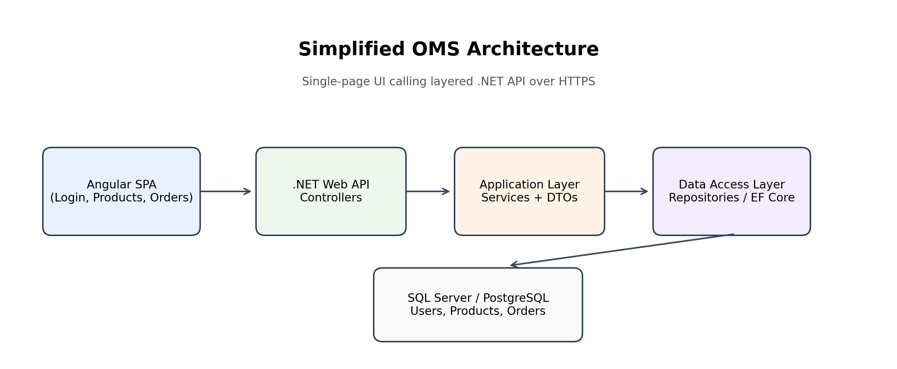
Figure 1: Simplified OMS architecture

7.1 Backend Layer Responsibilities
- Controllers: Accept HTTP requests, return response DTOs, enforce authorization attributes.
- Services: Contain business logic such as stock validation, order totals, and allowed status transitions.
- Repositories / DbContext: Encapsulate database access and persistence.
- DTOs: Transfer only the fields needed by the client.

8. Entity Model and ER Structure
The data model should be kept intentionally small. The following four entities are sufficient for a functional OMS and are recommended for implementation.
Entity | Purpose | Key Fields | Notes
User | Stores application login and role | UserId, Username, PasswordHash, Role, IsActive | Role is limited to Admin or User
Product | Catalog item that can be ordered | ProductId, Name, SKU, Price, StockQuantity, IsActive | SKU must be unique
Order | Represents a placed order | OrderId, OrderNo, UserId, Status, TotalAmount, CreatedAt | OrderNo can be generated sequentially
OrderItem | Line items inside an order | OrderItemId, OrderId, ProductId, Quantity, UnitPrice, LineTotal | One order has many order items
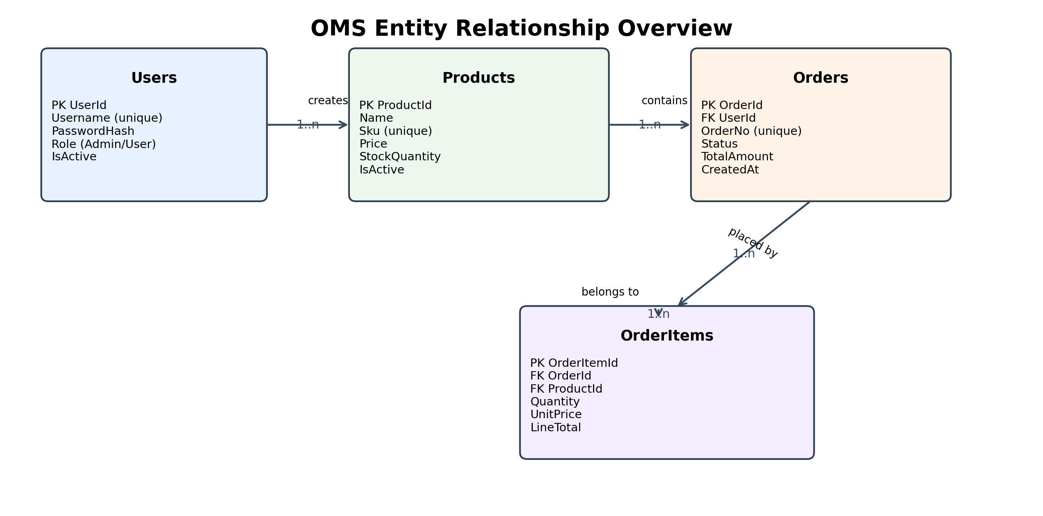
Figure 2: Entity relationship overview

8.1 Relationship Rules
- A User can place many Orders.
- An Order belongs to exactly one User.
- An Order contains one or more OrderItems.
- An OrderItem references exactly one Product.
- A Product can appear in many OrderItems across different orders.

8.2 Field-Level Entity Definition

User
- UserId: unique identifier, integer or GUID.
- Username: unique login name.
- PasswordHash: hashed password string.
- Role: Admin or User.
- IsActive: indicates if login is enabled.

Product
- ProductId: unique identifier.
- Name: display name.
- SKU: unique stock keeping code.
- Price: positive decimal value.
- StockQuantity: non-negative integer.
- IsActive: whether the product can be ordered.

Order
- OrderId: unique identifier.
- OrderNo: business-facing order number.
- UserId: foreign key to User.
- Status: Created, Processing, Completed.
- TotalAmount: computed server-side.
- CreatedAt: timestamp in UTC.

OrderItem
- OrderItemId: unique identifier.
- OrderId: foreign key to Order.
- ProductId: foreign key to Product.
- Quantity: positive integer.
- UnitPrice: snapshot of price at order time.
- LineTotal: Quantity × UnitPrice.

9. API Requirements
The API should be REST-like and versioned if the implementation baseline already uses versioning. The following endpoints are sufficient for this goal.
Module | Method | Endpoint | Purpose
Auth | POST | /api/auth/login | Authenticate user
Products | GET | /api/products | List products
Products | GET | /api/products/{id} | Get product by id
Products | POST | /api/products | Create product
Products | PUT | /api/products/{id} | Update product
Products | PATCH | /api/products/{id}/deactivate | Deactivate product
Orders | POST | /api/orders | Create order
Orders | GET | /api/orders | List orders
Orders | GET | /api/orders/{id} | Get order details
Orders | PATCH | /api/orders/{id}/status | Update order status

9.1 API Response Expectations
- Return 200 OK for successful reads and updates.
- Return 201 Created for successful resource creation.
- Return 400 Bad Request for validation failures.
- Return 401 Unauthorized when authentication is missing or invalid.
- Return 403 Forbidden when the role is insufficient.
- Return 404 Not Found when the requested entity does not exist.
- Return 409 Conflict for duplicate SKU or insufficient stock during concurrent order placement.

10. Frontend Requirements
The Angular application should remain simple and standard: reactive forms, reusable services, route guards, and basic shared components. The goal is to demonstrate front-end structure rather than advanced UI engineering.
- Login page with form validation.
- Dashboard landing page after login.
- Product list and product form pages for admin.
- Order creation page with product selector and quantity entry.
- Order listing page with filters by status and date range.
- Route guards for authenticated and role-based pages.

11. Validation Rules
- Username and password must be required.
- Product name, SKU, and price are required.
- SKU must be unique and not empty.
- Price must be greater than zero.
- Stock quantity must be zero or a positive integer.
- Order must contain at least one item.
- Order item quantity must be greater than zero.
- Requested quantity must not exceed available stock.

12. Edge Cases
- Invalid login credentials should return an error message.
- Non-admin users should not be able to access admin APIs.
- Product creation should fail if the same SKU is already used by another product.
- Product creation/update should fail if required fields (name, price, SKU) are empty.
- Product price or stock should not be negative.
- Order should fail if quantity is zero or negative.
- Order should fail if requested quantity is greater than available stock.
- If two users try to order the last item, only one order should succeed and the other should fail.
- Any total amount sent from the client should be ignored; server should always calculate total.
- Completed orders should not be updated.
- Orders should not be edited once they move beyond "Created" status.
- If order creation fails, no partial data should be saved.

13. Implementation Standards
- Use a layered folder structure: Controllers, Services, Repositories, Models, DTOs, Validators, and Tests.
- Use DTOs for all API boundaries; do not expose ORM entities directly to the client.
- Use dependency injection consistently.
- Use transaction handling for order placement and stock deduction.
- Use logging for authentication failures and critical order exceptions.
- Use consistent error response format across all APIs.

14. Deliverables
- Source code in a Git repository.
- Working backend API and Angular frontend.
- Database schema or migration scripts.
- README with setup and run instructions.
- Short architecture explanation in the README.
- Basic test evidence or test cases.
- Demo-ready application flow: login, product management, create order, update order status.

15. Acceptance Criteria
- User can log in and access only permitted pages.
- Admin can fully manage products.
- User can create an order from available products.
- Stock is reduced correctly after order placement.
- Order details are stored and retrievable.
- Validation prevents bad data and unsafe state changes.
- Application can be demonstrated end to end without manual database edits.

