Assignment -2

* **Connect to the Store Sales Data and do the following: -**

− Remove all the blank rows.

− Update the column header if they are not updated

* 1. − Create a text table and show the sales in terms of o Customers
  2. o Product Category
  3. o Regions

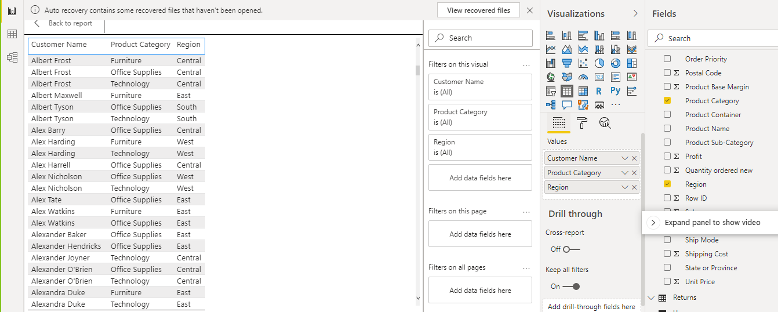

* **Create a line and Clustered Column Chart showing the Sales and Discount as per the State or Province**

− Format the bars and line with different colors

− Which state has the highest sales in terms Technology 🡪 California

Clustered column chart

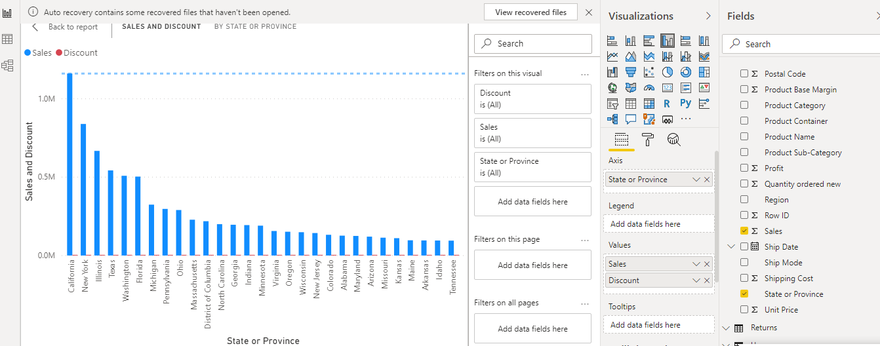

Line chart

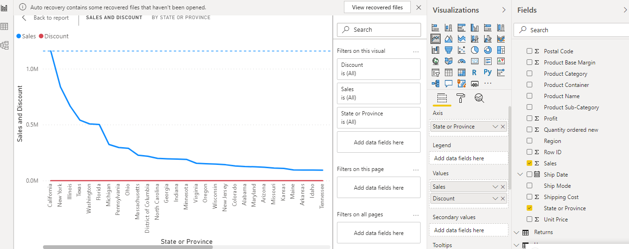

* **Create a** *Donut Chart* **showing sales in terms of Product category**

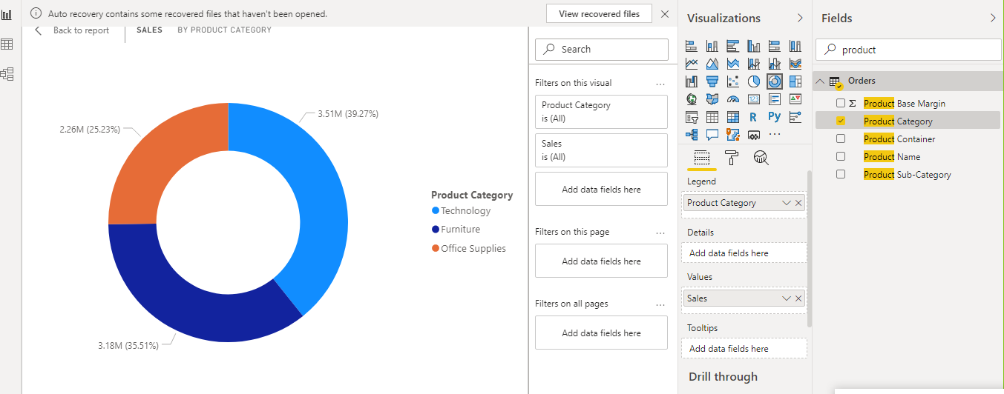

* **Create a** *Slicer* **and show the regions in dropdown. See how all the visuals mentioned above behaving when a particular region is selected.**

When slicer created and given the filters as dropdown on region then while selecting any particular region donut chart also takes respective region and shows the sales for that particular region only ..

Ex- first screenshot selection

Region – east

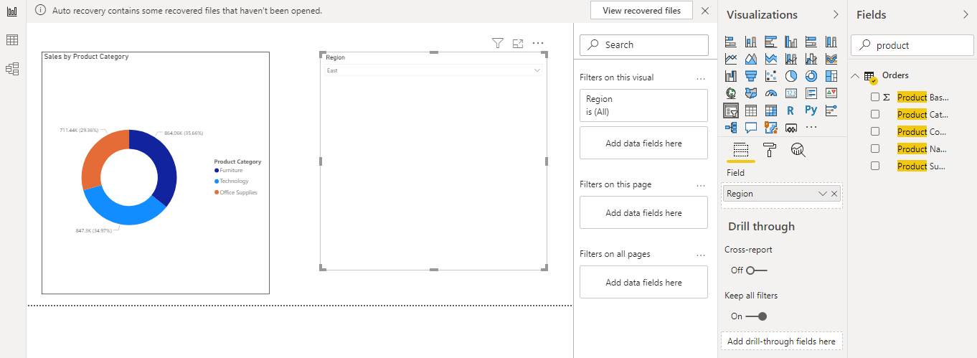

Ex- Second screenshot selection

Region – central

