KinderGarten System Project

A school system software based on a SQL database called “Smart Kids” that deals with data of students , teachers .

For students, it takes their (first name , second name , Age , Id, Phone Number,Address ).

You can search for a student using his id number.

In the database the primary key is (student_id) .

For teachers, the project takes their personal data (id , salary , phone ,name, address , subject, age) .

You can search for a teacher using his id number or name.

The primary key is (teacher_id) .

Datebase there is table called “teacher _has_student” contains (teacher_id , student_id).student_id connect student to “teacher _has_student” teacher_id connect teacher to “teacher _has_student” .

# System ERD

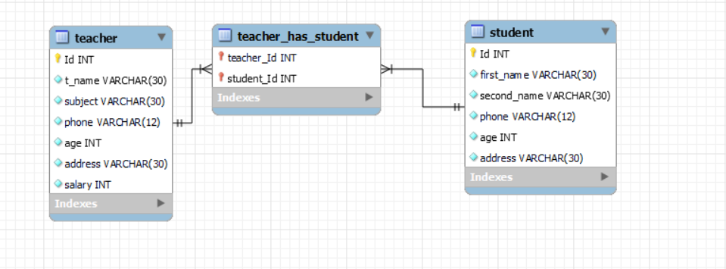

# System Mapping

M

learn

M

teacher

Student

.

## Home Frame

We can go to “ log in ,register, exit”

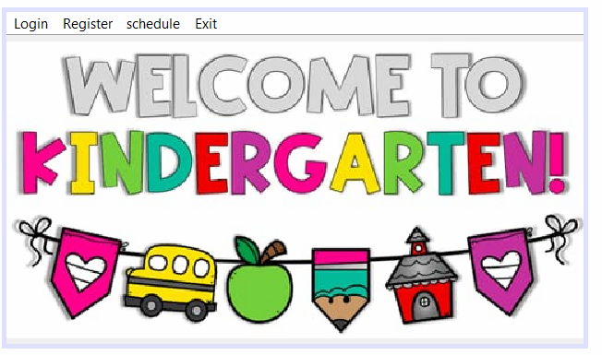

In every data frame

there are 2 fixed buttons (edit ,).

➔ Edit button allows the user to update the data.

➔ Delete button allows the user to delete a row from the table.

Using (try – catch) to test for errors … To access the database there is a connection statement typed first in try block.

Connection con =

DriverManager.getConnection("jdbc:mysql://localhost:3306/smart_kid", "root", "root

Insert (EX from students)

Programmed button to access the database getting data from the text fields then sending it to the table to be stored .

After connection statement here comes the prepared (insert) statement from the database.

PreparedStatement Stm= con.prepareStatement("insert into student( Id , first_name , second_name , phone , age , address) values (?,?,?,?,?,?)");

Now we get data from the text fields through (getText) function accessed through text field name then stored into variables like:

String first_name=ID_f1.getText();

String second_name=ID_f2.getText();

Then we set culomn’ s data into the table using their variables through (setString) function like:

Stm.setString(2,first_name);

Stm.setString(3,second_name);

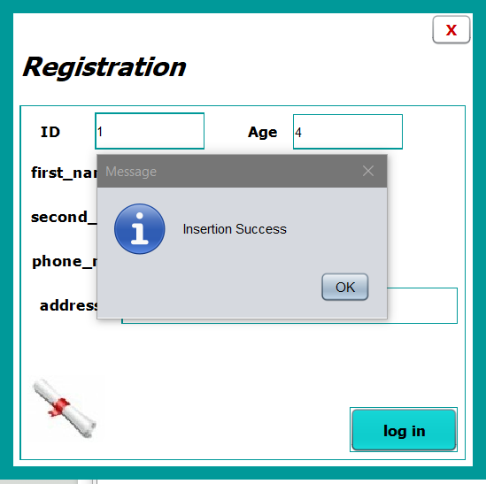

code

### In Every data table

There is a mouse clicked event that allows us to select a row from the table and send its data back to appear in the text fields , so we can edit and delete a row if we needed.

First we have to know the row selected , so we have to make an integer value that stores it and get it from the table using (getSelectedRow) function.

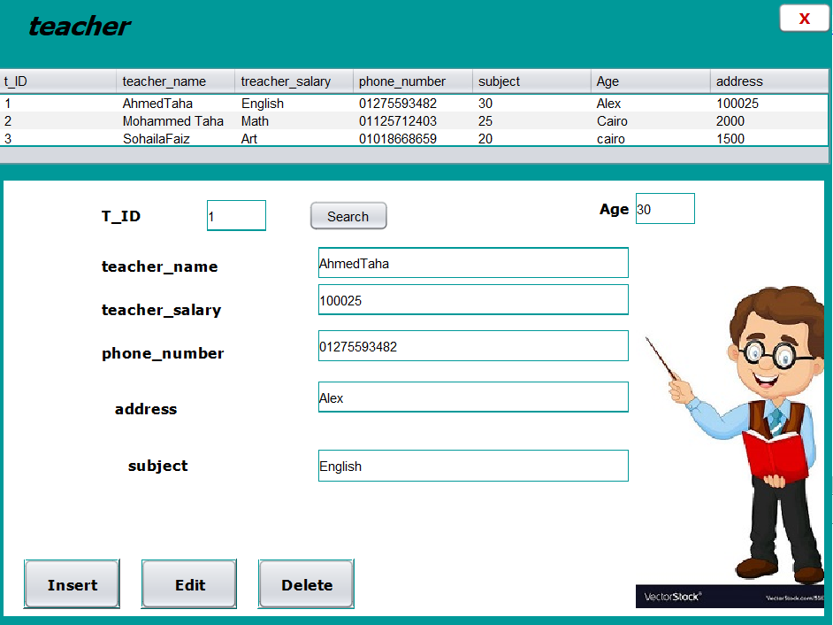

Edit (EX from timetable)

Programmed button to get the selected data from the table row to let us update it.

The selected (update) statement will be called from the database

PreparedStatement Stm= con.prepareStatement("update student set first_name=?,second_name=?,phone=?,age=?,address=? where id=?");

String firstName= ID_f2.getText();

After selecting the row that we want to update from the table , the data will appear in the text fields to update it.

So we have to get the data from the text fields , as we used field name to get the data then store it into a variable like:

String first_name=ID_f1.getText();

After editing the data we have to insert it into the table putting the column number and data variable.

Stm.setString(1, firstName); Stm.setString(2, lastName);

Execute the selected statement stm.executeUpdate();

JOptionPane.showMessageDialog(null, "successfully Updated"); //message showed after execution

Now we have to empty text fields by setting to it an empty value

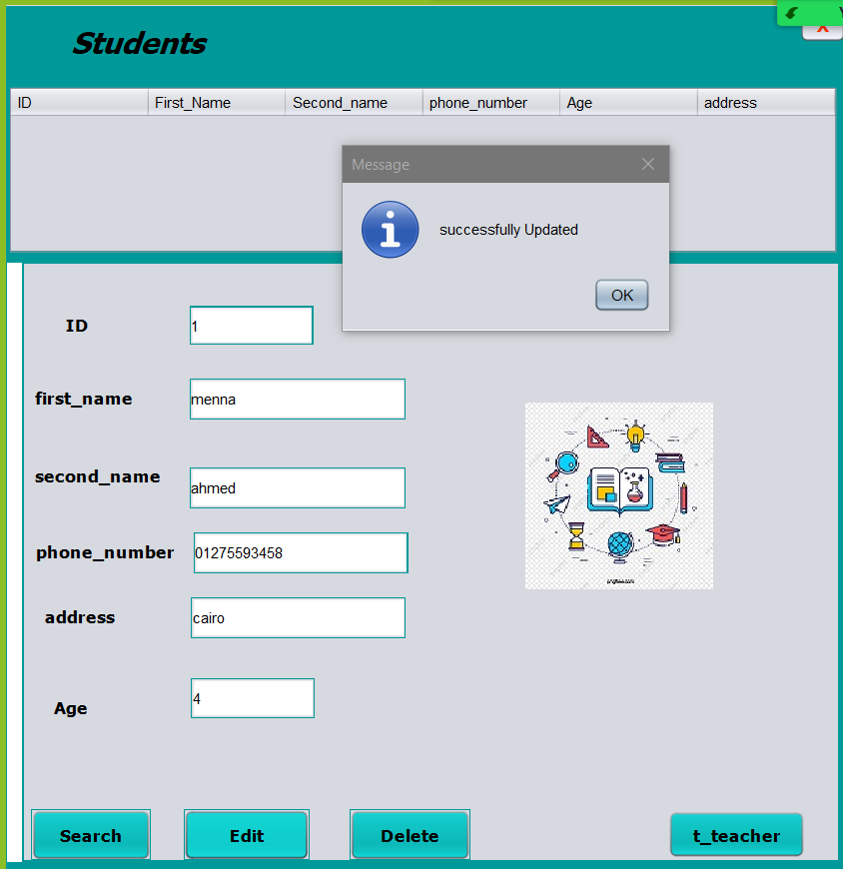

Delete (EX from teacher)

Programmed button to remove the selected row from the table.

The selected (drop) statement will be called from the database

PreparedStatement Stm= con.prepareStatement("delete from student where Id='"+id+"'");

After selecting a teacher his data will be shown in the fields.

Get the teacher id from its text field and set it to the prepared drop statement to be executed.

int checkId=0;

String id=ID_f.getText();

try {

Connection con;

con = DriverManager.getConnection("jdbc:mysql://localhost:3306/smart_kids","root","osha");

PreparedStatement Stm= con.prepareStatement("delete from student where Id='"+id+"'"); ResultSet rs=Stm.executeQuery();

while (rs.next()){

checkId=1;

ID_f2.setText(rs.getString(2));

ID_f3.setText(rs.getString(3));

ID_f4.setText(rs.getString(4));

ID_f6.setText(rs.getString(5));

ID_f5.setText(rs.getString(6));

}

if(checkId==0)

JOptionPane.showMessageDialog(null, "Member ID dosn't Exist");

} catch (Exception e) {

JOptionPane.showMessageDialog(null, e);

}

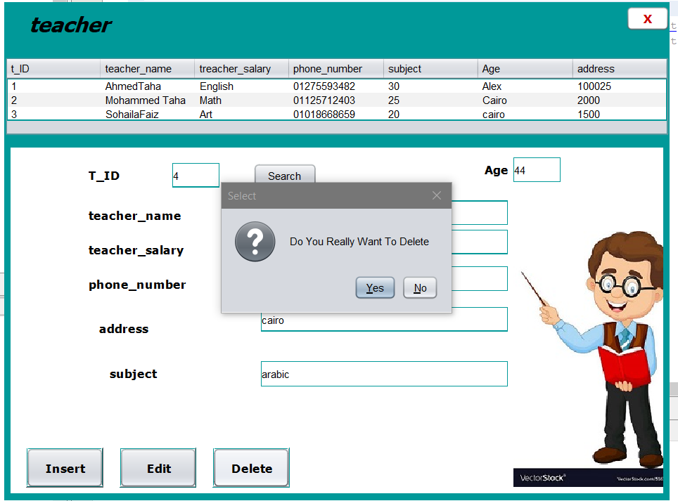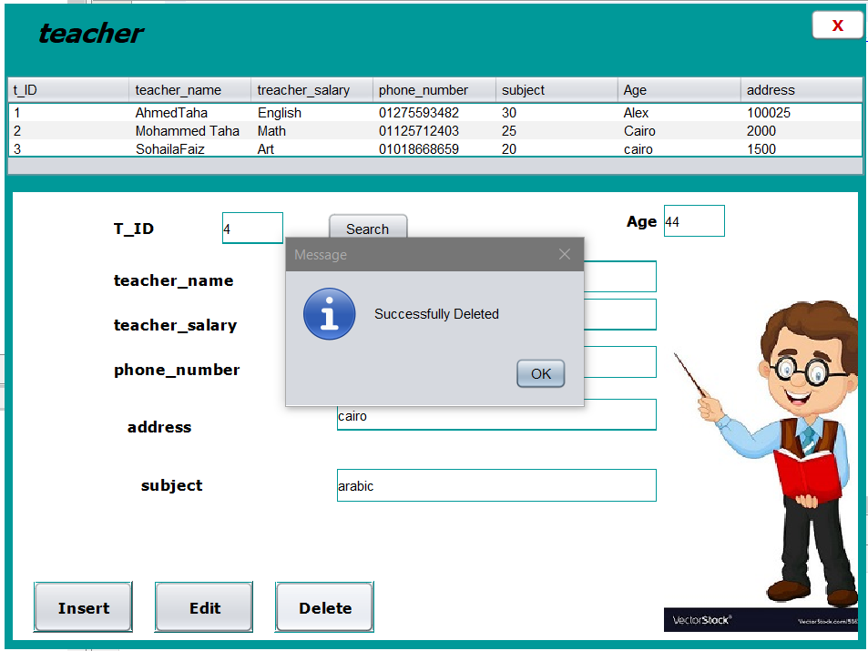

#### Know the deletion is done and the row is deleted from the table

### Now the table is empty

#### In teacher and student frames

There are 2 buttons to search in the table search by search using id .

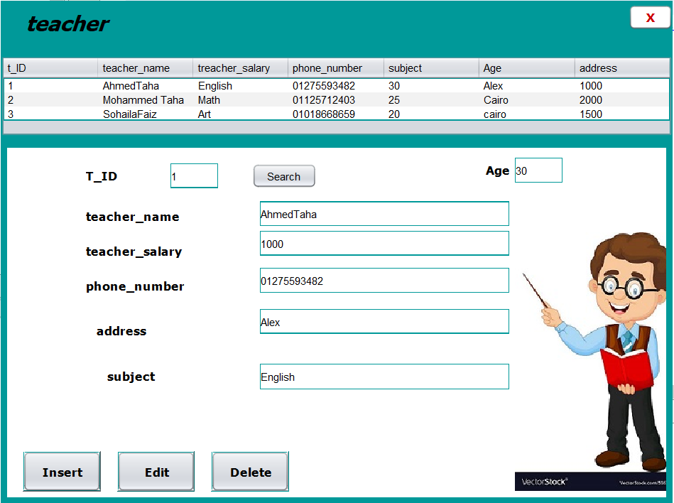

Search by (id)

To do this we first have to get the text typed in the text field in a variable

String searchKeyword=jTextField4.getText();

Then writing the show button code with a little difference .

In the while loop we have to put an if statement to check whether the string typed is the same as any string (id) in culomn 1 in the table then give it to the table row to appear.

PreparedStatement Stm= con.prepareStatement("select * from student where Id='"+id+"'");

ResultSet rs=Stm.executeQuery();

while (rs.next()){

checkId=1;

ID_f2.setText(rs.getString(2));

ID_f3.setText(rs.getString(3));

ID_f4.setText(rs.getString(4));

ID_f6.setText(rs.getString(5));

ID_f5.setText(rs.getString(6));

}

if(checkId==0)

JOptionPane.showMessageDialog(null, "Member ID dosn't Exist");

} catch (Exception e) {

JOptionPane.showMessageDialog(null, e);

}