Software Engineering Iteration 1 Report
Project Name: Bidwork
Client: TAMU Business School Mays

Team Members:
Sorush Omidvar
Seyedhooman Sajjadi
Ruben Lopez V
Shrinath Prahalathan
Zhenyu Wu
Rahul Sridhar
Mounika Kunduru

- Customer Meeting Time and Zoom link:
Tuesday 3PM – 3:30 PM
https://tamu.zoom.us/j/91871112262

- Pivotal tracker
https://www.pivotaltracker.com/n/projects/2467299

- Github repo:
https://github.com/somidvar/team01
git@github.com:somidvar/team01.git

- Heroku URL: http://serene-brushlands-89338.herokuapp.com/

- Customer feedback was positive. We showed her the features implemented in iteration 1. We are expecting to implement the core functionalities of bidding and selling in forthcoming iterations.

- Concerns: It took us a good amount of time to start working as a team.

- User Stories implemented this iteration:

Feature 1: Home Page
As an user
I should be able to see the home page when I enter the URL.

Description: The home page is the entry point to access all the main services:
- Register
- Login
- Home
- About

Iteration 0 had “Browse” which is removed now since it seemed unnecessary. “Help” feature may or may not be implemented based on needs. It will be decided in future iterations whether Help can be in the form of pop up on mouse over item or it should be in a separate page.

The home page is referred by the main internet address of the auction site : http://serene-brushlands-89338.herokuapp.com/

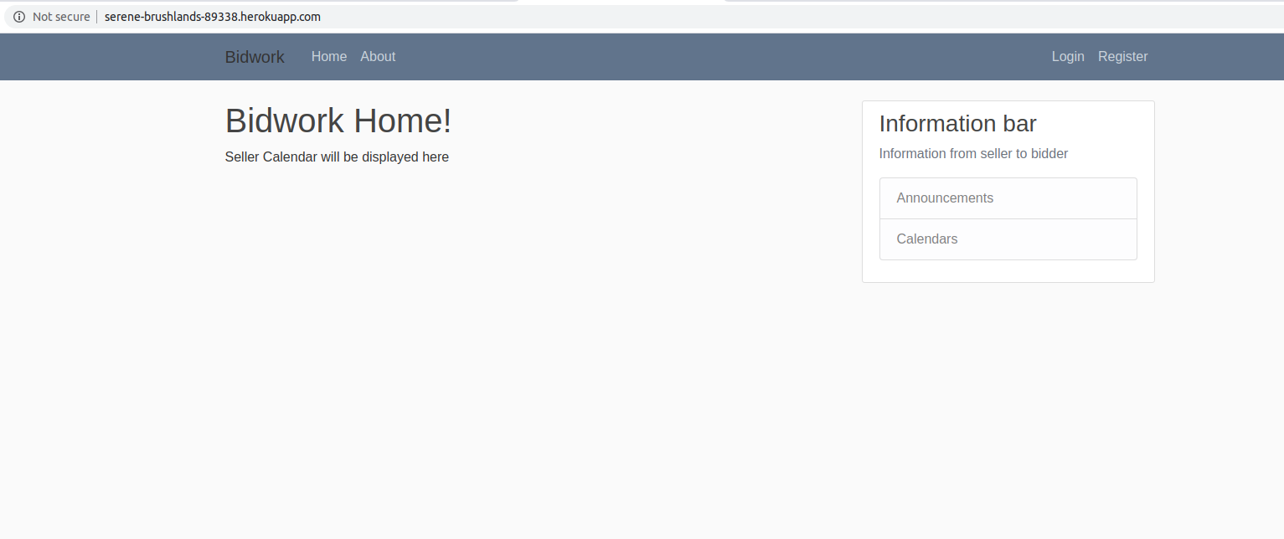
Fig 1: Homepage

Feature 2: Register for buyers
As an user,
I want to register using a registration form
So that I would be able to login with a user ID and Passwords

Description: The registration page contains the information such as
username, email, password and confirm password. It performs basic validations on the entered data which is also displayed on the page, and it throws an error message or registers the users based on the data.

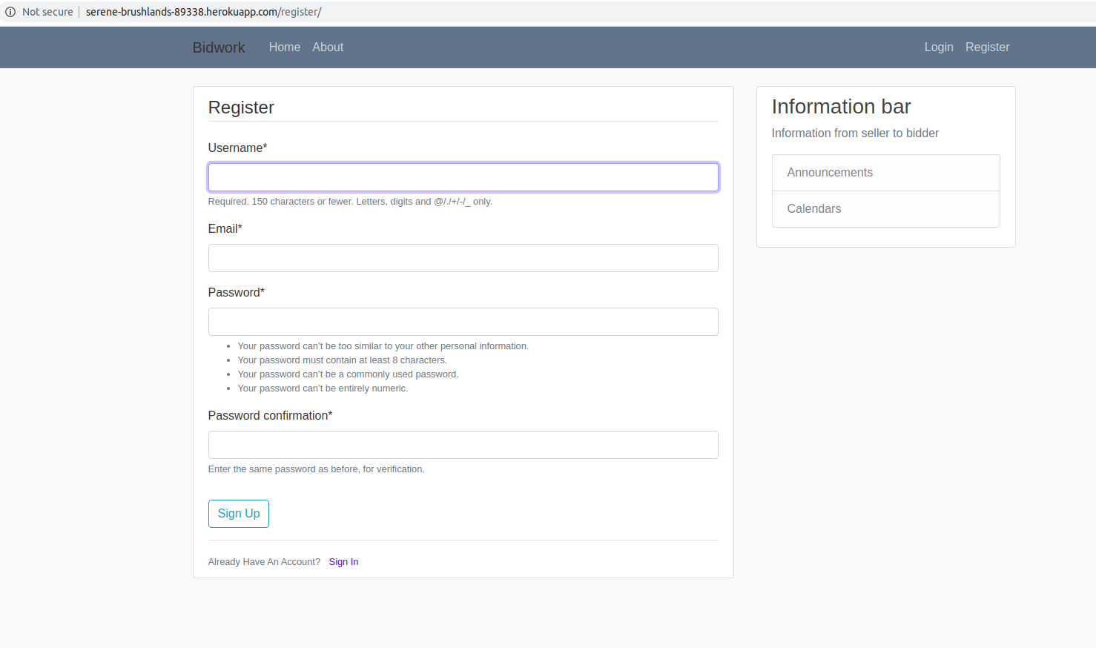
Validate and insert
Register page

Backend DB

Feature 4: Login
As an user, if I have registered,
I should be able to login
So that I would be able to access my profile

Description: Every time the user tries to access his profile, he/she is asked to provide his/her username and password . These are entered through a form. If username and password are correct, the user will be logged in, else an error message will be displayed.
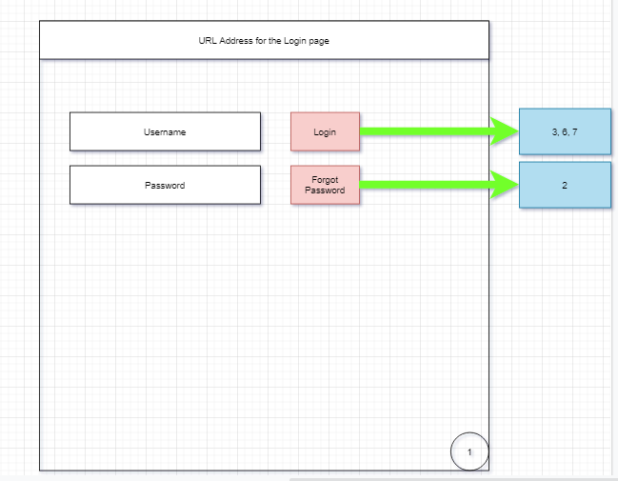
Backend DB
Validate and fetch
Login design

Feature 5: Admin
As an administrator,
I want to have administrative rights
So that I can have privileges to manage the auction

Admin login URL: http://serene-brushlands-89338.herokuapp.com/admin/

Description: The admin has a separate login URL. This account is created as a superuser.
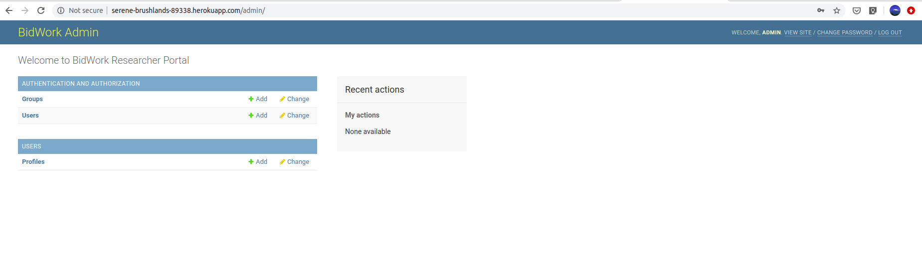
Admin page

Feature 5: About

Displays the information about the client

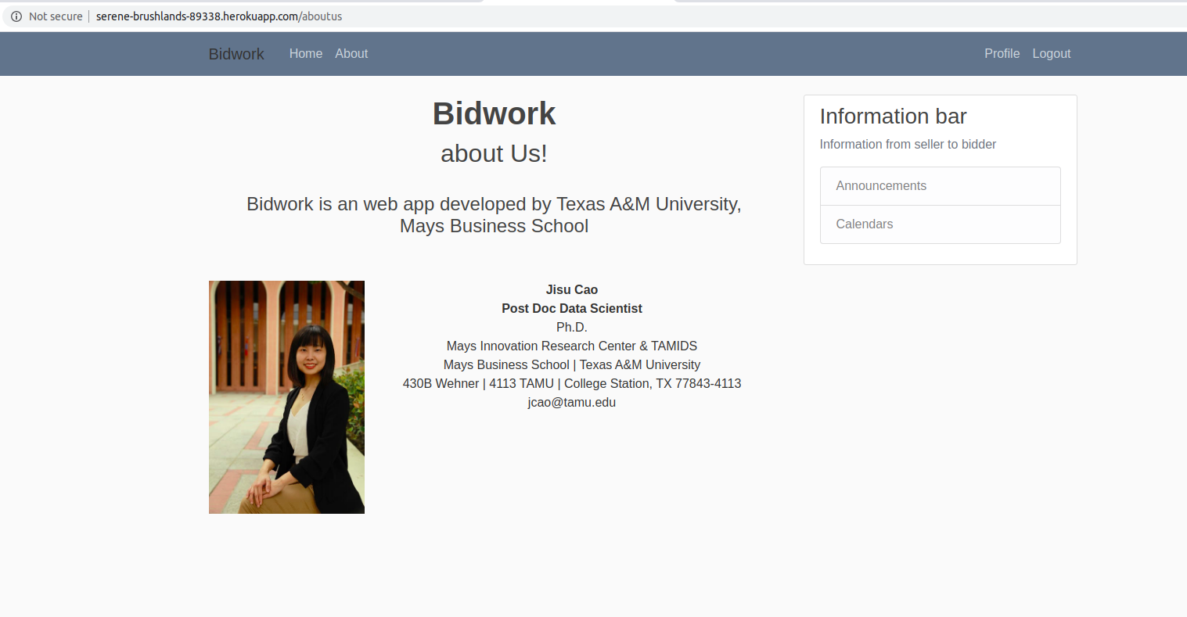
About page
The screenshots of below mentioned blue boxes’ are attached above. The following is the design diagram of this iteration showing the relations of implemented entities.
User register
Login
Superuser
(admin)
Homepage
Database
save
Authenticate
Redirect to homepage on log in
Authenticate
Redirect to admin page
adminpage

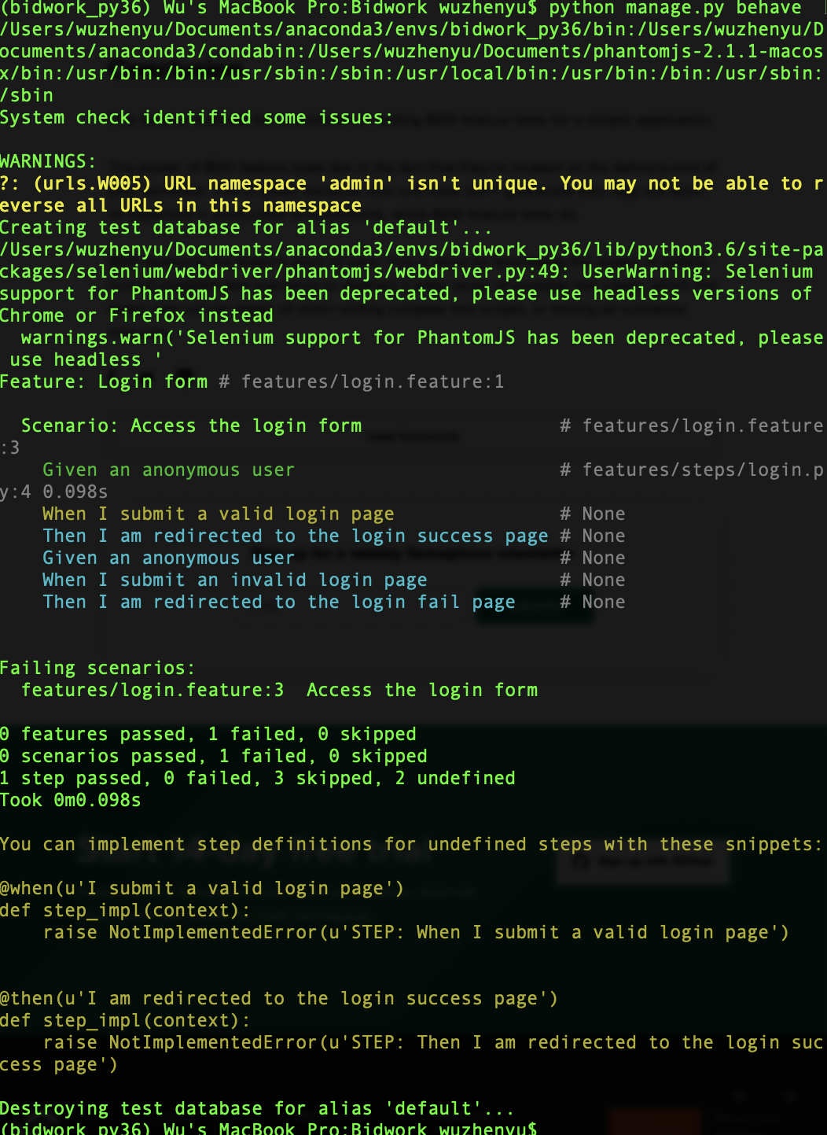
Screenshots of testing results BDD and TDD:

