**CSCE 606 Software Engineering Project**

**Group Assignment: Iteration 2**



**Project Name:** Bidwork

**Client:** TAMU Mays Business School

**Team Members:**

Sorush Omidvar

Seyedhooman Sajjadi

Ruben Lopez V

Shrinath Prahalathan

Zhenyu Wu

Rahul Sridhar

Mounika Kunduru

Pivotal Tracker: <https://www.pivotaltracker.com/n/projects/2467299>

Github Repo: <https://github.com/somidvar/team01.git>

Heroku URL: <http://serene-brushlands-89338.herokuapp.com/>

Customer meeting date to demo this iteration

The meeting with the customer was on Oct 27th, 2020 at 3:00 pm.

**User stories implemented in this iteration**

**Feature 7: Bidding view**

As a bidder,

I would like to see the bidding view

So that I will be aware of the Available hours and the Current price per hour

Description: The bidding view consists of a table, which includes the week no., the available hours for that week and the current price per hour. This will help the bidders in submitting their bids, where they will specify the number of hours they would like for the week, and the maximum price he/she is willing to pay per hour.

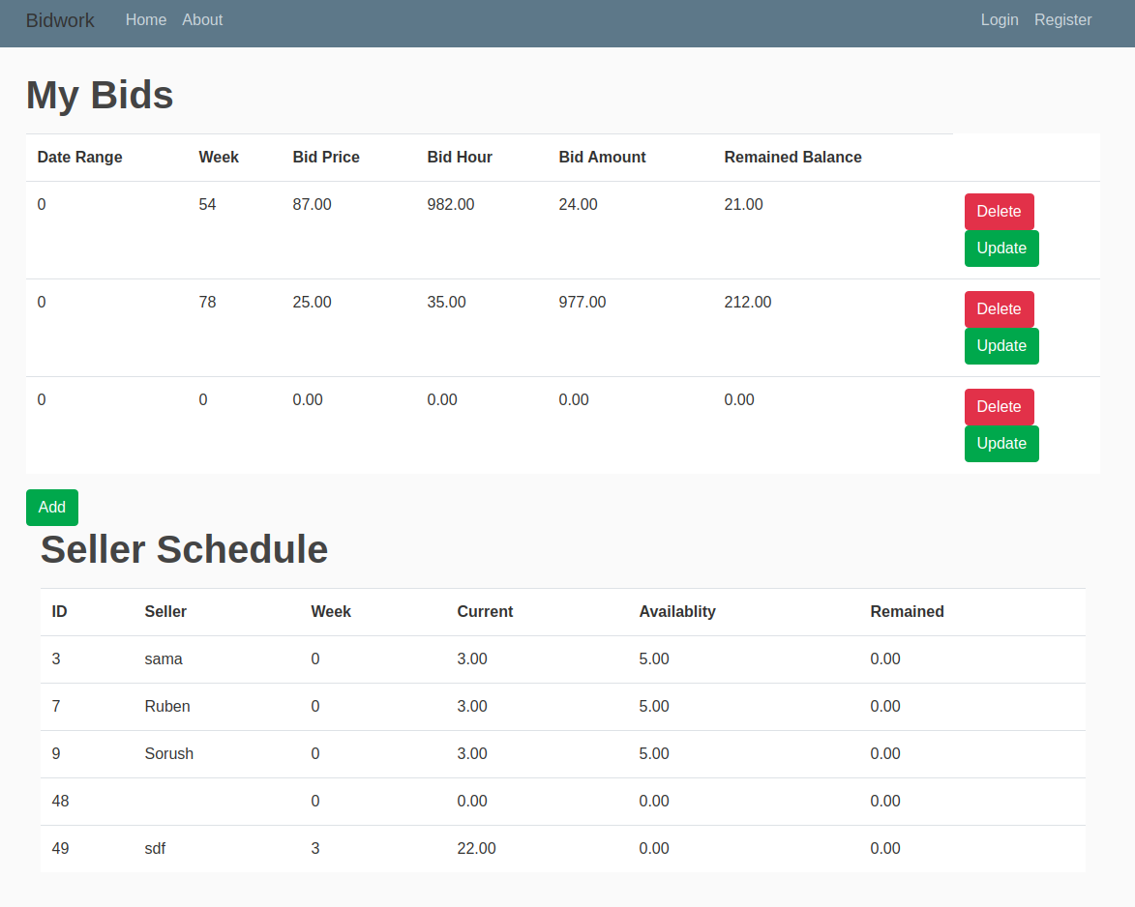

**Feature 12: Seller**

As a seller,

I would like to enter the units to be auctioned,

So that the buyers will be able to input their bid

Description: The seller inputs the units to be auctioned on her interface. She should also be able to see the current winning bids on her dashboard.

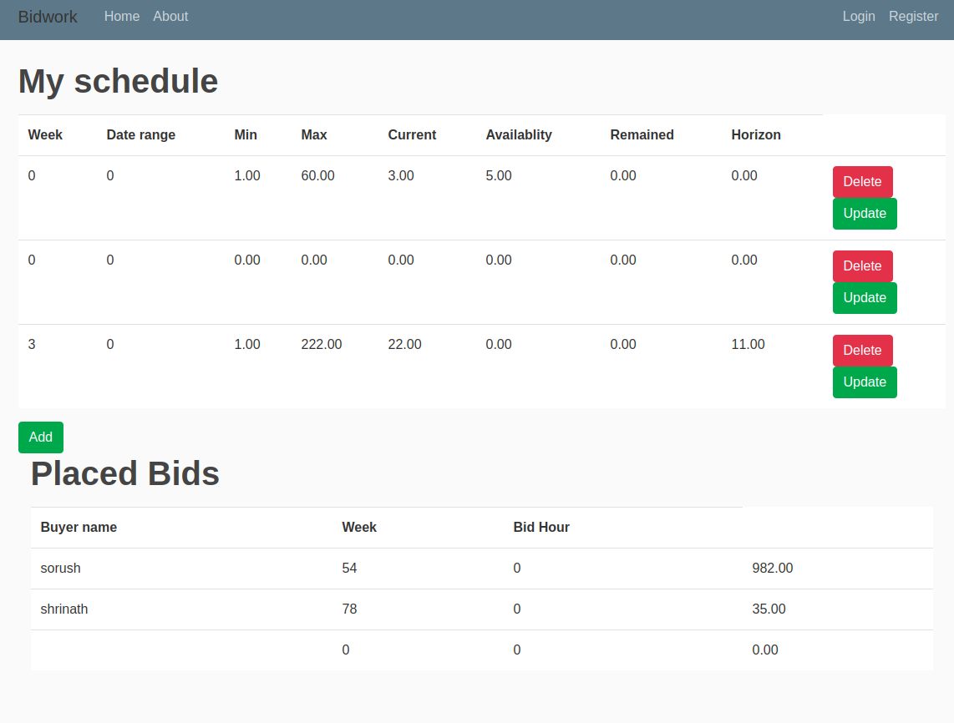

**Design diagram for this iteration**

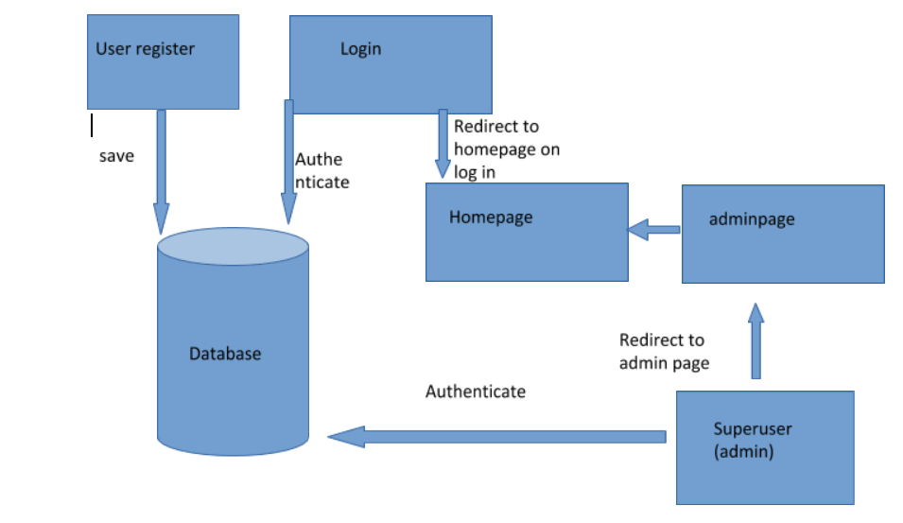

The above diagram represents the design of the login and registration of buyers in bidworks.

The following **legend** will be followed for the DB columns and UI:

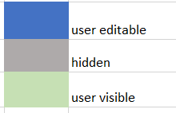



*Fig: User information view*

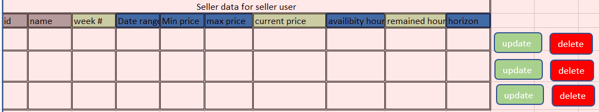

*Fig: Seller data for seller user. Data displayed on the seller's page*



*Fig: Buyer data for seller user. Data displayed on the seller's page.*

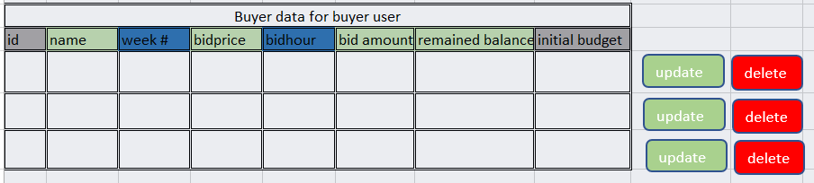

*Fig: Buyer data for buyer user. Data displayed on the buyer’s page.*



*Fig: Seller data for buyer user. Data displayed on the buyer’s page.*

The supported operations are and . Add button adds a new row and the user editable fields can be edited. Update button allows update of user editable fields and delete button deletes the row. All the operations are also reflected in the DB. Only the views which include these buttons could be manipulated.

**Functionalities of significant columns:**

**Seller’s side:**

**Week#:** The week should be made available by the seller for the buyer to buy. Also, if the week is fully bought, no more time will be available to buy. Error is thrown if an attempt is made.

**Availability hours:** Gives the total number of hours that are going to be available for bids (per week per seller)

**Remained hours:** The hours that are currently available (after past bids, it will change every time a bid is placed or removed). This is calculated behind the scene.

**Bid price:** The price at the time of the bid if the bid was already submitted or current price if the bid is being created. It is extracted from the current price of the seller.

**Current price:** Will be calculated by formula .

**Buyer’s side:**

**Bid hour:** The amount of hours bidded or to be bid.

**Bid amount:** The total cost of the bid (price*hours), calculated behind the scene.

**Remained balance:** The budget balance after placing the bid, calculated behind the scene.

**Initial budget:** The budget before transaction. Set a default value when user is created or changed by admin.

Any additional documentation related to the user stories, e.g. changes to lo-fi UIs

N/A

If you were not able to implement all the stories that you initially chose for this iteration, please list which ones and why not.

We implemented the stories, although there is a modification for next iteration based on customer requests. The request was to remove some columns from the view of the users and add a column for date, the date column and visibility were implemented in the UI but next iteration will be to make that part work.

If you have changed any of your stories, please write a short description of the changes made and the reason behind the changes.

No changes to the stories, just changes to the UI.

Evaluations of your code and tests