**CSCE 606 Software Engineering Project**

**Group Assignment: Iteration 3**



**Project Name:** Bidwork

**Client:** TAMU Mays Business School

**Team Members:**

Sorush Omidvar

Seyedhooman Sajjadi

Ruben Lopez V

Shrinath Prahalathan

Zhenyu Wu

Rahul Sridhar

Mounika Kunduru

Pivotal Tracker: <https://www.pivotaltracker.com/n/projects/2467299>

Github Repo: <https://github.com/somidvar/team01.git>

Heroku URL: <http://serene-brushlands-89338.herokuapp.com/>

Customer meeting date to demo this iteration

The meeting with the customer was on Oct 27, 2020 at 2 pm.

Zoom link: https://tamu.zoom.us/j/93078936187

**User stories implemented in this iteration**

**Feature 7: Bidding view/ Buyer’s page**

As a buyer,

I would like to see the Seller Schedule

So that I will be aware of the available hours and the Current price per hour

Description: The bidding view consists of :

I) Seller schedule

This includes the week number, the available hours for that week and the current price per hour. This will help the bidders in submitting their bids, where they will specify the number of hours they would like for the week.

2) My Bids

This consists of bids placed by the buyer.

The buyer will input the number of hours, based on the remaining hours ( this is the remaining available hours of the seller) and when he clicks the Bid button, his bid will be seen in the My bids of the buyer page and also under Placed Bids in the seller page

Few modifications are made in the Bidding view in this iteration from the previous one. They are listed below:

1. The week number field is added, and the combobox is created for the week number

2. The authorization and redirecting to the correct URL is handled, based on the user.

3. The Bid button is added.

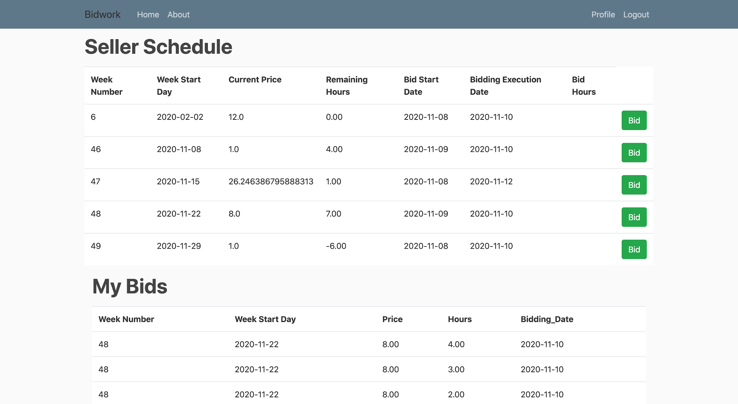

**Fig 1:**  Buyer page

**Feature 12: Seller**

As a seller,

I would like to enter the units to be auctioned,

So that the buyers will be able to input their bid

Description: The seller inputs the units to be auctioned on her page. She should also be able to see the current winning bids on her dashboard.

I) My schedule

This includes the week number ( the week for which the bidding is going to happen), the week start day is the starting day of the week for which the bidding will take place. The bidding start date and bidding execution dates denotes the duration of time during which the bidding actually takes place. These dates should be less than the week starting day. The min and max price is set by the seller. The current price is automatically calculated using the formula

The total availability is set by the seller and the remaining availability is calculated based on the number of hours left after the buyer bids for a specific number of hours.

2) Placed Bids

This consists of bids placed by the buyers.

Few modifications in the seller page in this iteration from the previous one are:

1.The Add Button and the Delete button is fixed.

2. The week number field is added and combobox is created for the week number.

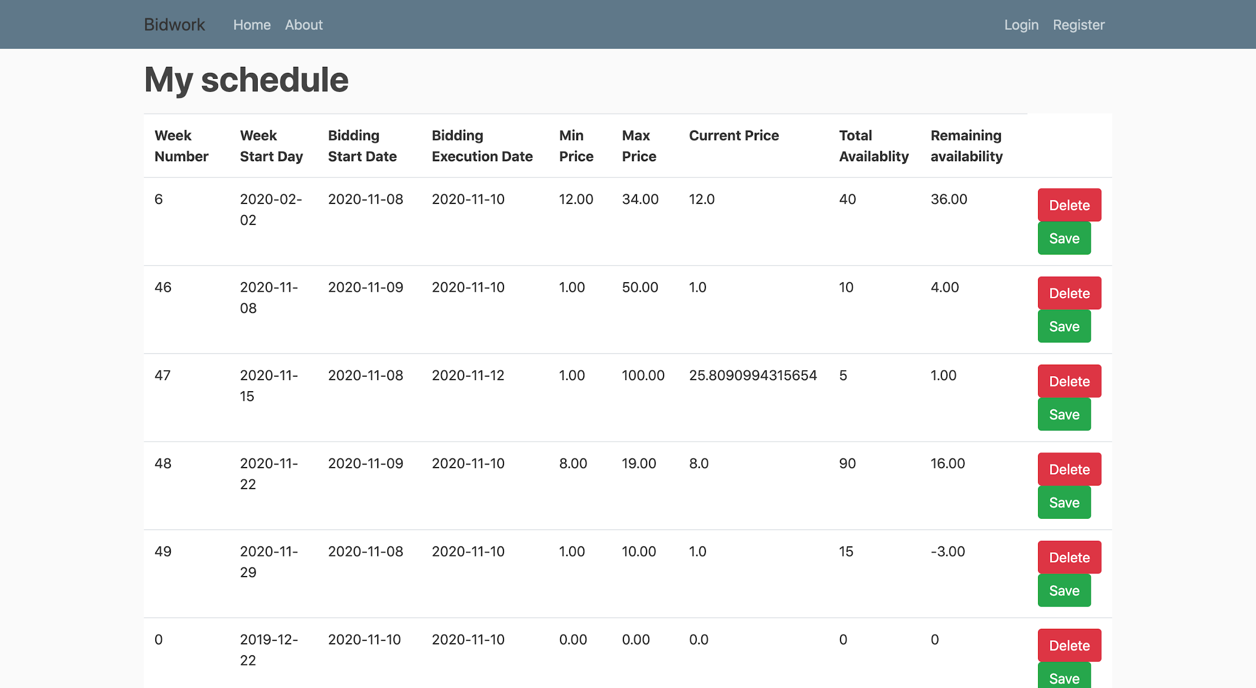

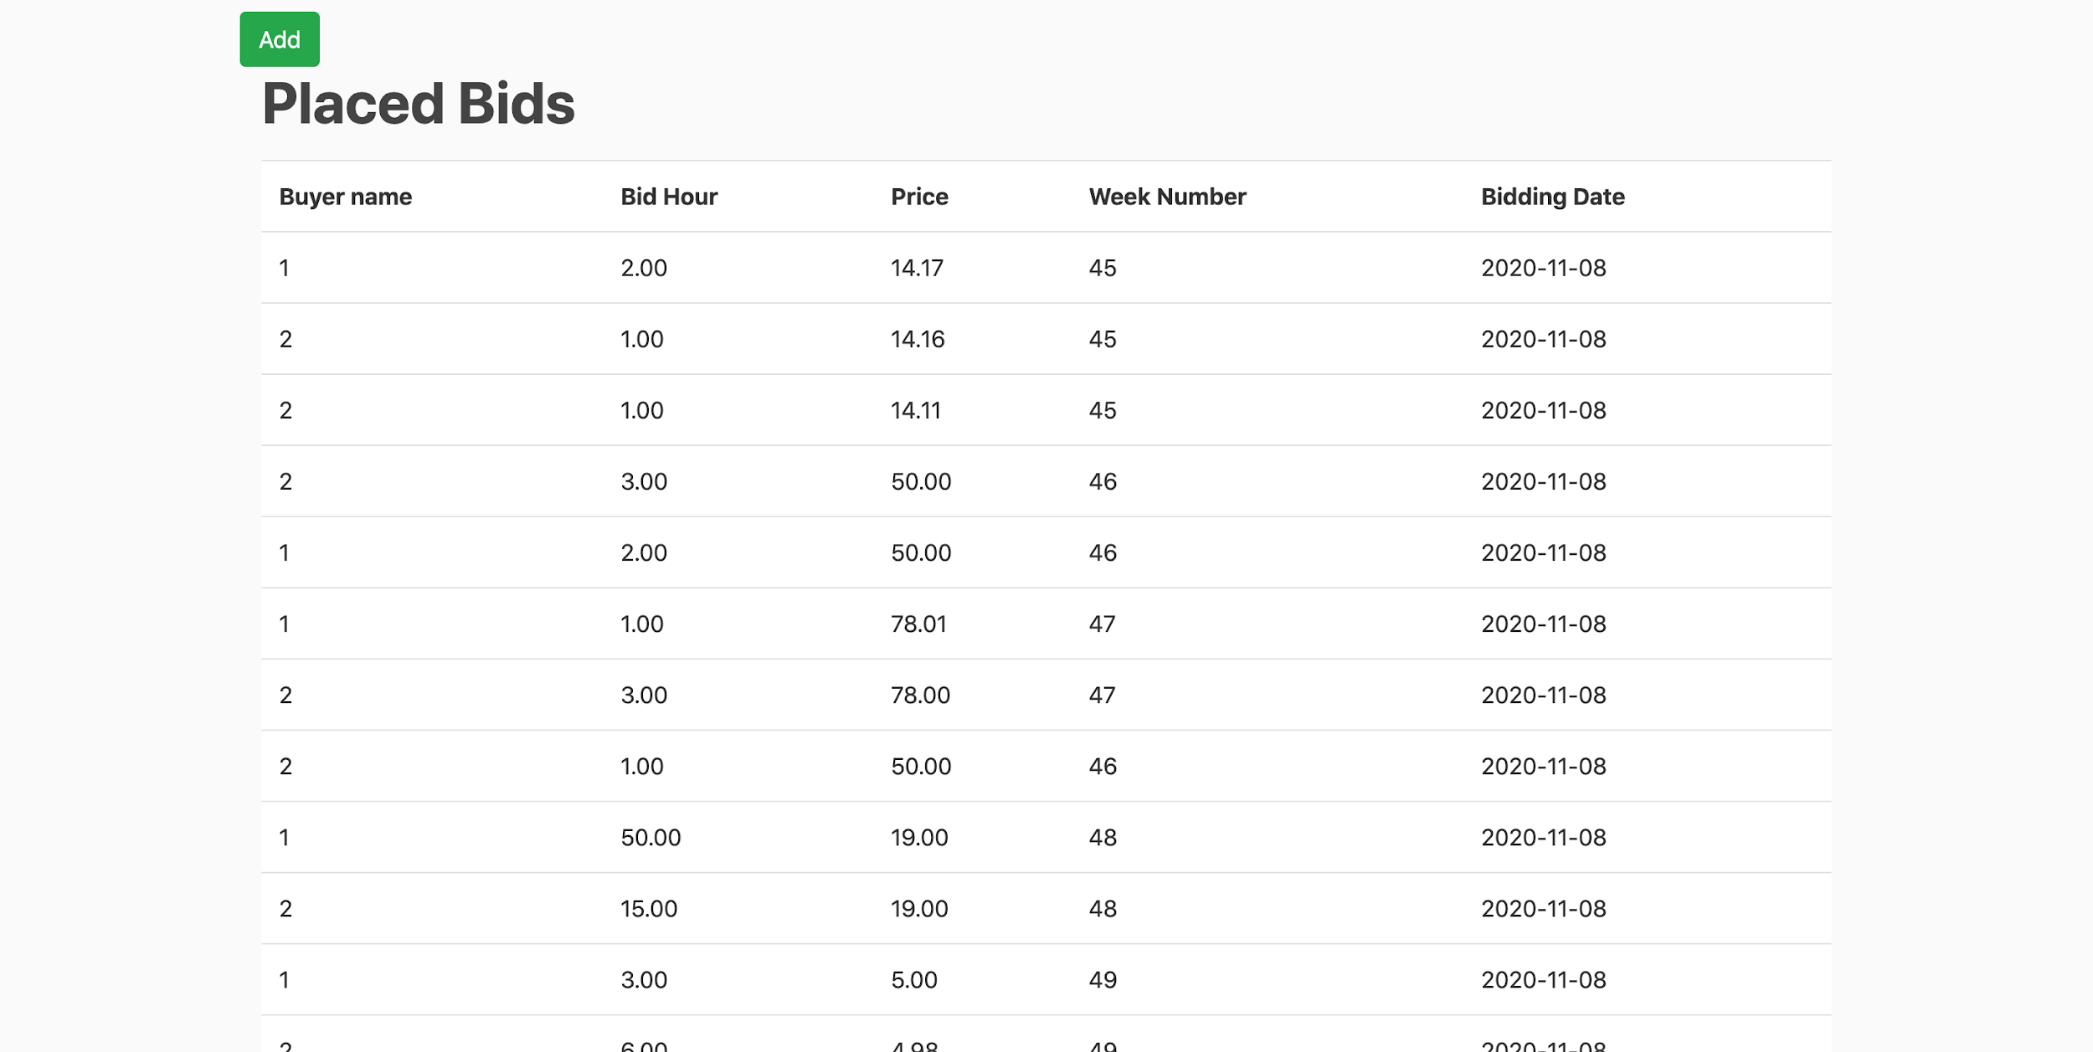

**Fig 2:** Seller page

**Design diagram for this iteration:**

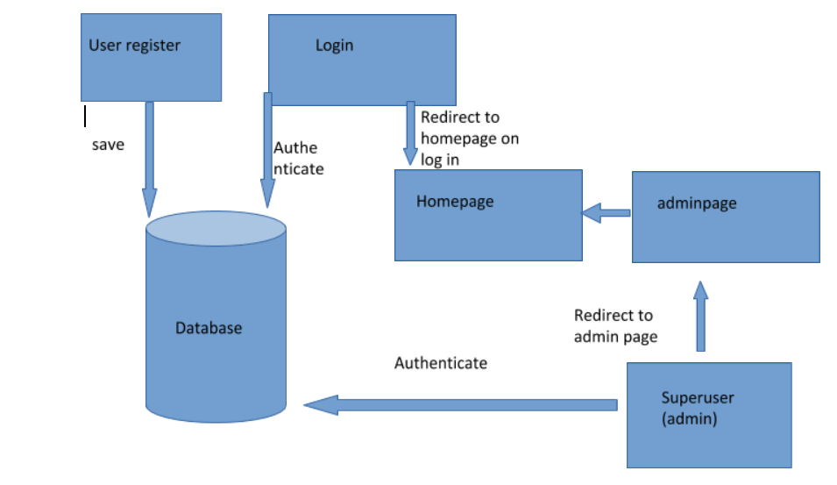

The above diagram represents the design of the login and registration of buyers in bidworks.

The following designs are used for the buyer and the seller page.

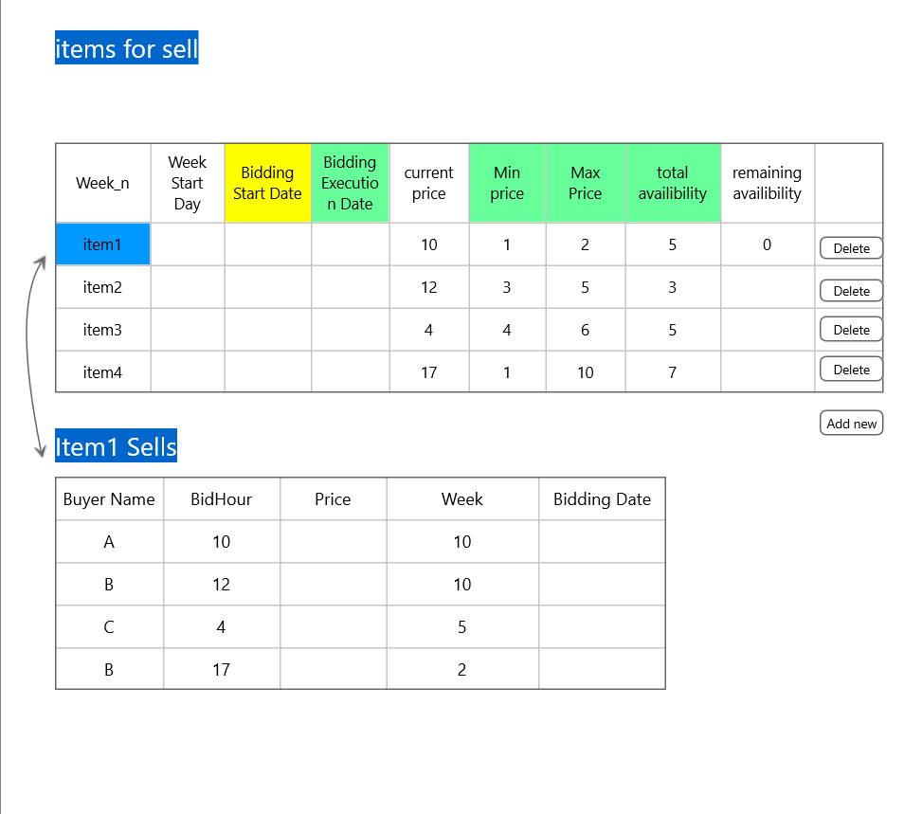

**Figure 4 :**  Seller page

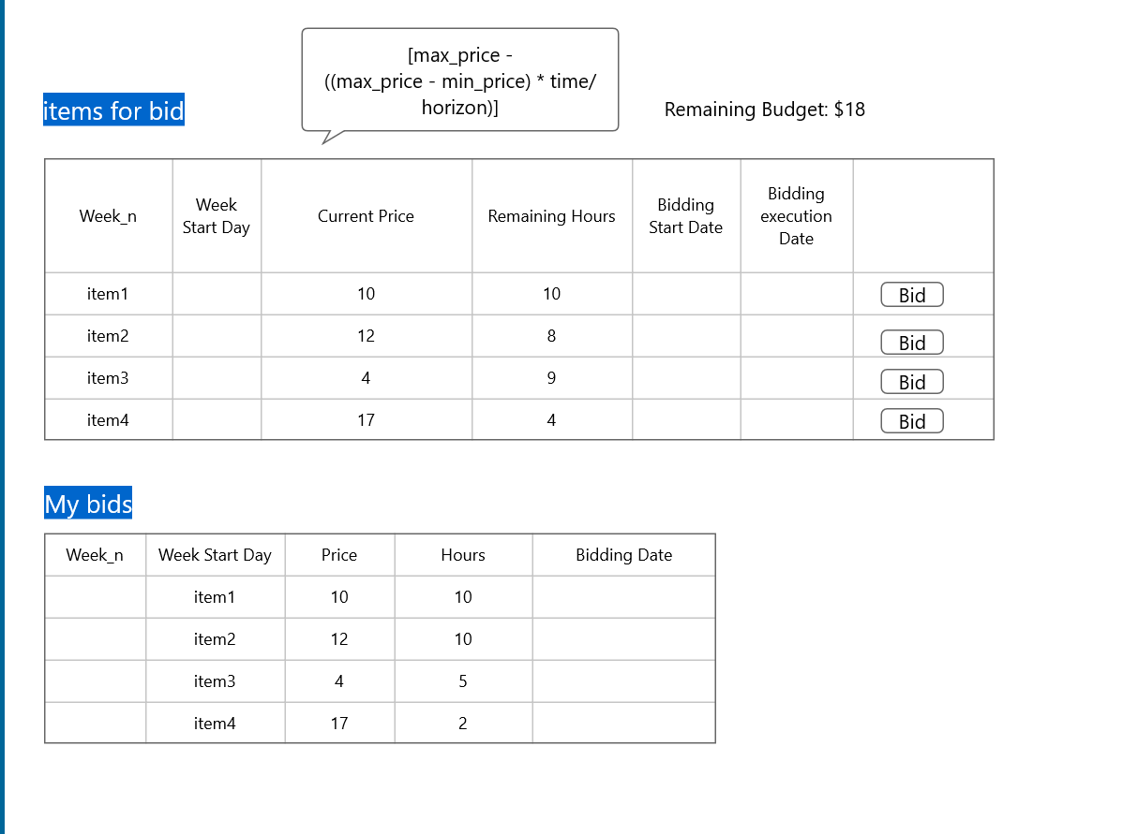

**Figure 5:** Buyer page

The database consists of the following tables:

**Item table:**

Week_n Min Max horizon total availability start_date post_date

**Biddings table:**

Week_n Buyer_id price hours bidding date

**Buyer table:**

User_id total_budget name picture spent

Any additional documentation related to the user stories, e.g. changes to lo-fi UIs

N/A

If you were not able to implement all the stories that you initially chose for this iteration, please list which ones and why not.

We implemented all the stories that we started in the previous iteration and which requires modifications. We need to modify a few more attributes, like validating the start date and end date, and making all the price values to integers. These will be done by the next iteration.

If you have changed any of your stories, please write a short description of the changes made and the reason behind the changes.

No changes to the stories, just changes to the UI. The designs of the buyer page and seller page are modified.

**Testing**

The testing is done using the behave module in Django and the selenium webdriver is used. As of now, the login page, the registration page, the admin page and the home page are tested.

The step definitions are written for the 4 features, login, admin, registration and the home page.

**Registration Page**

Given an unregistered user on Registration page

When I fill out the signup form and click Sign Up

Then I should be directed to the Home Page and receive a notification that an account is created

Given a registered user on Registration page

When I fill out the signup form and click Sign Up

Then I should be redirected to the Registration page and receive error message

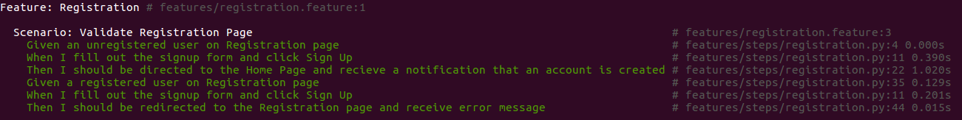

***Figure 6:*** *Registration Feature BDD Test Results*

**Login Page**

Given a registered user on Login page

When I submit a login request

Then I should be directed to the Home page

Given an unregistered user on Login page

When I submit a login request

Then I should be redirected to the Login page and receive error message

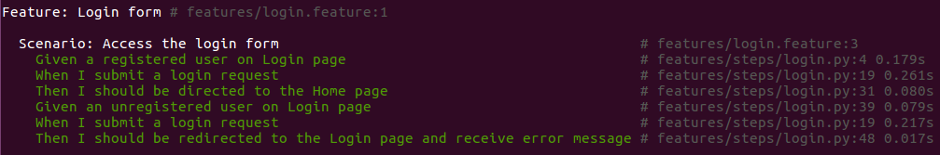

***Figure 7:*** *Login Feature BDD Test Results*

**Admin Page**

Given an user with administrative rights

When I submit an admin login request

Then I should be directed to the Admin page

Given an user without administrative rights

When I submit an admin login request

Then I should receive an error message

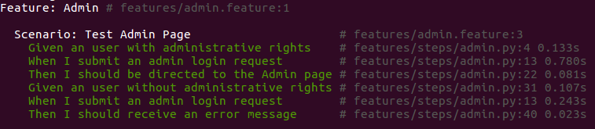

***Figure 8:*** *Admin Feature BDD Test Results*

**Home Page**

Given a user on homepage

When I select About Us

Then I should be directed to the About Us page

When I select Register

Then I should be directed to the Register page

When I select Login

Then I should be directed to the Login page

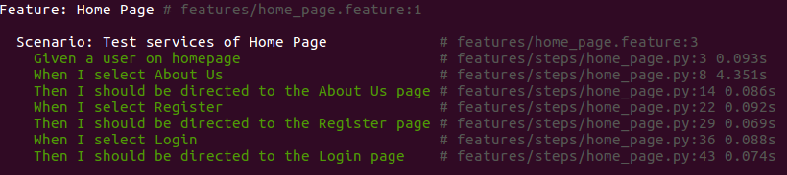

***Figure 9:*** *Home Page Feature BDD Test Results*