**CSCE 606 Software Engineering Project**

**Group Assignment: Iteration 4**



**Project Name:** Bidwork

**Client:** TAMU Mays Business School

**Team Members:**

Sorush Omidvar

Seyedhooman Sajjadi

Ruben Lopez V

Shrinath Prahalathan

Zhenyu Wu

Rahul Sridhar

Mounika Kunduru

Pivotal Tracker: <https://www.pivotaltracker.com/n/projects/2467299>

Github Repo: <https://github.com/somidvar/team01.git>

Heroku URL: <http://serene-brushlands-89338.herokuapp.com/>

Customer meeting date to demo this iteration

The meeting with the customer was on 11/17/2020 at 4 pm.

**User stories implemented in this iteration**

**Feature 7: Bidding view**

As a bidder,

I would like to see the bidding view

So that I will be aware of the Available hours and the Current price per hour

Description: The bidding view consists of a table, which includes the week no., the available hours for that week and the current price per hour. This will help the bidders in submitting their bids, where they will specify the number of hours they would like for the week, and the maximum price he/she is willing to pay per hour.

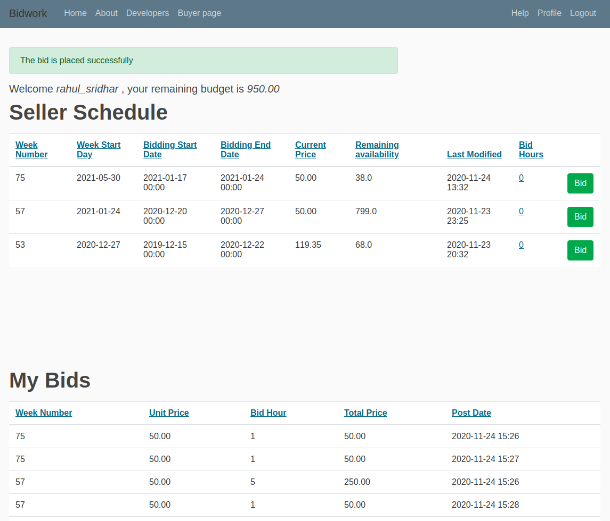

***Figure 1:*** *Buyer Page Website*

After logging in, you should see your username and budget on top of the page as well as the schedule of the data analyst (aka seller) followed by your bid history (lower table). For the upper table, each row shows the details of a week where the week number (1st column) and week start date (2nd column) denotes the week starting from 29 Dec 2019. The 3rd and 4th columns show the bidding start and its end date. Please note that you can only bid during the period of the beginning-end bid date. The next column shows the current price which is a linear function of maximum and minimum price (set by the seller) as well as the elapsed bidding time. The remaining hour for the regarding week is reported next. The system logs all of the activities and 'Last-Modified' suggests the last time when the seller modified the item. Finally, the bid hours is the only editable column where you need to enter the hours you need to hire the seller. Such a number should be 1) an integer, 2) smaller than the available, and 3) bigger than zero. After entering the hour, press the "bid" button to place your bid. Shortly, you will get a success/failure notification at the top of the page. The past weeks are shown in the gray background and the table can be sorted ascendingly or descendingly by clicking on the header. For more information, please contact your administrator.

The lower table shows the history of the bids that you have placed. Each row contains the week number, bid price (per hour), bid hours, and the total bid price followed by the time that it has been placed.

**Feature 9: Help**

As an user,

I want a help button

So that I get tips on how to perform all possible actions on the website

Description: The system must provide certain tips, explaining the main components and functionalities of the website

**Feature 12: Seller**

As a seller,

I would like to enter the units to be auctioned,

So that the buyers will be able to input their bid

Description: The seller inputs the units to be auctioned on her interface. She should also be able to see the current winning bids on her dashboard.

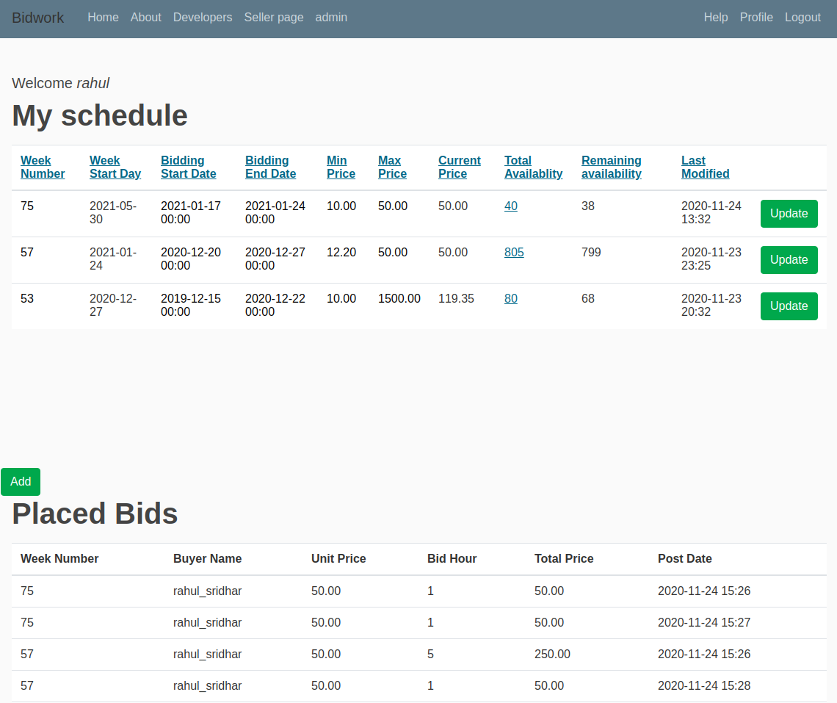

***Figure 2:*** *Seller Page Website*

After logging in, you should see your username or admin at the top of the page followed by your schedule and the placed bids by faculties (aka buyers). Each row shows the details of a week where the week number (1st column) and week start date (2nd column) denotes the week starting from 29 Dec 2019. The 3rd and 4th columns show the bidding start and its end date. The minimum (5th column) and maximum (6th column) and current price (7th column) are next in the list. The current price is a linear function of maximum and minimum price as well as the elapsed bidding time. The total availability is dictated by you and is the total number of hours that you are working in that specific week while the remaining hour shows the left hours (not bided yet). The system logs all of the activities and 'Last-Modified' suggests the last time that you modified the item.

To make a new item (week), press the "Add" button and a new record will show up in the table. Subsequently, you need to update the numbers/dates and press the "update" button designed at that row. You only can delete the weeks which are not bided yet (the weeks with bids do not have the delete button). Also, for the weeks with the present bidding, you shall only update the record by increasing the total availability hour. The editable fields are denoted in blue underlined style. After updating, a notification will be shown at the top of the page with the proper message. The following validations are in-place for updating/adding an item: 1) the week number shall be unique and not repeated (you can increase the availability number if needed), 2) the maximum price should be bigger or equal to the minimum price, 3) the total availability should be higher than the amount which is already bided, 4) the total availability should be bigger than 0 and less than 168 hours (full load), 6) the bid end date should be later than the bid start date, 7) the bidding end date should be sooner than the week start date (i.e. if you are updating the week starting in 10th of October, the end date should happen by 9th).

**Design diagram for this iteration**

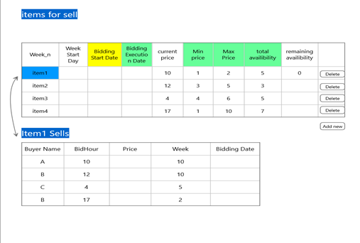

***Figure 3:*** *Seller page Design Diagram*

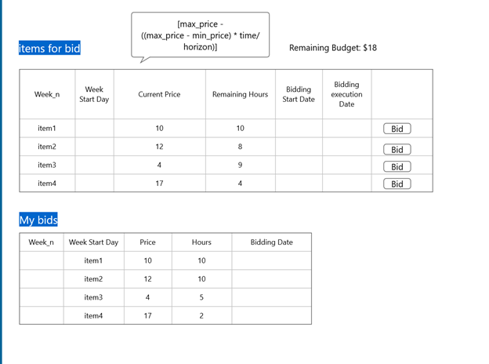

***Figure 4:*** *Buyer page Design Diagram*

There was no specific design change

Any additional documentation related to the user stories, e.g. changes to lo-fi UIs

N/A

If you were not able to implement all the stories that you initially chose for this iteration, please list which ones and why not.

All the user stories have been implemented

If you have changed any of your stories, please write a short description of the changes made and the reason behind the changes.

Feature 1 Home Page: We changed the whole architecture: after login it goes to the bid/sell page directly, we added link for the home page.

Feature 4 Login: Done, the forgot password is also added as an extra

Feature 8 Bid: Done (the seller schedule and the bids are merged in the same page)--> Feature 6 (Browse), 7 (Bidding View), 8 (Bid) are merged

Feature 10 Administration activities: Done (the admin can only remove the sells or bids and not modify them in any other way. This was done to ensure the safety of the whole bidding and avoiding complications in the bids)

Feature 11 Bid Status: Cancelled, the client changed her mind

**Testing**

The testing is done using the behave module in Django and the selenium webdriver. All the user stories have been tested. For this iteration the Buyer and the Seller pages have been tested.

Below are the step definition and the test results for the Buyer and Seller page.

**Buyer Page**

Given a logged in buyer on the Buyer Page with the below bids

| Week Number | Bid Start Date | Bid End Date | Min Price | Max Price | Total Availability |

| 35 | 2019-12-05 00:00 | 2019-12-10 00:00 | 10.00 | 60.00 | 5 |

| 40 | 2020-08-10 00:00 | 2020-08-15 00:00 | 20.00 | 70.00 | 10 |

| 45 | 2020-09-15 00:00 | 2020-09-20 00:00 | 30.00 | 80.00 | 15 |

| 50 | 2020-10-20 00:00 | 2020-10-25 00:00 | 40.00 | 90.00 | 20 |

| 53 | 2020-12-05 00:00 | 2020-12-10 00:00 | 50.00 | 100.00 | 25 |

When I enter the number of Bid Hours and select "Bid" button

Then I should see the bid under "My Bids" on the Buyer page

And as a seller I should see the bid under "Placed Bids" on the Seller page

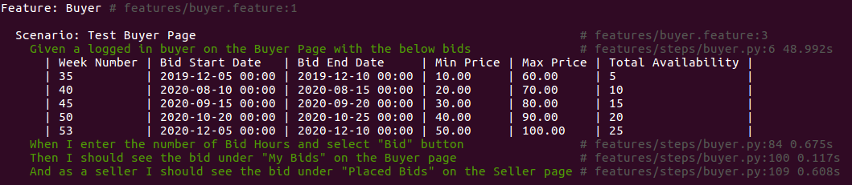

***Figure 5:*** *Buyer Page BDD Test Results*

**Seller Page**

Given an seller user with administrative rights

When I enter the budget for a buyer

Then the budget should be assigned to the buyer

Given a logged in seller on the Seller Page

When I Add the below bids

| Week Number | Bid Start Date | Bid End Date | Min Price | Max Price | Total Availability |

| 35 | 2019-12-05 00:00 | 2019-12-10 00:00 | 10.00 | 60.00 | 5 |

| 40 | 2020-08-10 00:00 | 2020-08-15 00:00 | 20.00 | 70.00 | 10 |

| 45 | 2020-09-15 00:00 | 2020-09-20 00:00 | 30.00 | 80.00 | 15 |

| 50 | 2020-10-20 00:00 | 2020-10-25 00:00 | 40.00 | 90.00 | 20 |

| 53 | 2020-12-05 00:00 | 2020-12-10 00:00 | 50.00 | 100.00 | 25 |

Then I should see the bid on the Buyer and Seller page

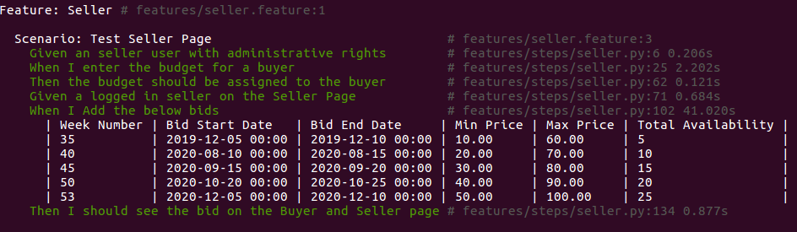

***Figure 6:*** *Seller Page BDD Test Results*

**Profile and Help Page**

Given a logged in user on the homepage

When I select Help

Then I should be directed to the Help page

And I should see “Faculties Help” and “Data-analyst Help” section

When I select Profile

Then I should be directed to the Profile page

And I should see my Username and Email Address

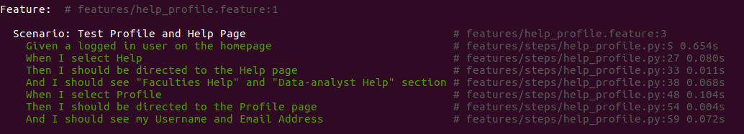

***Figure 7:*** *Profile and Help Page BDD Test Results*

BDD test results for the entire project

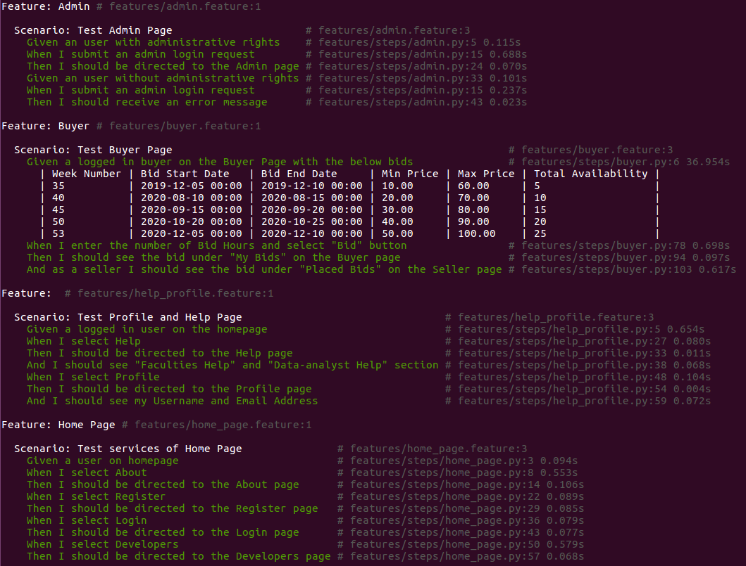

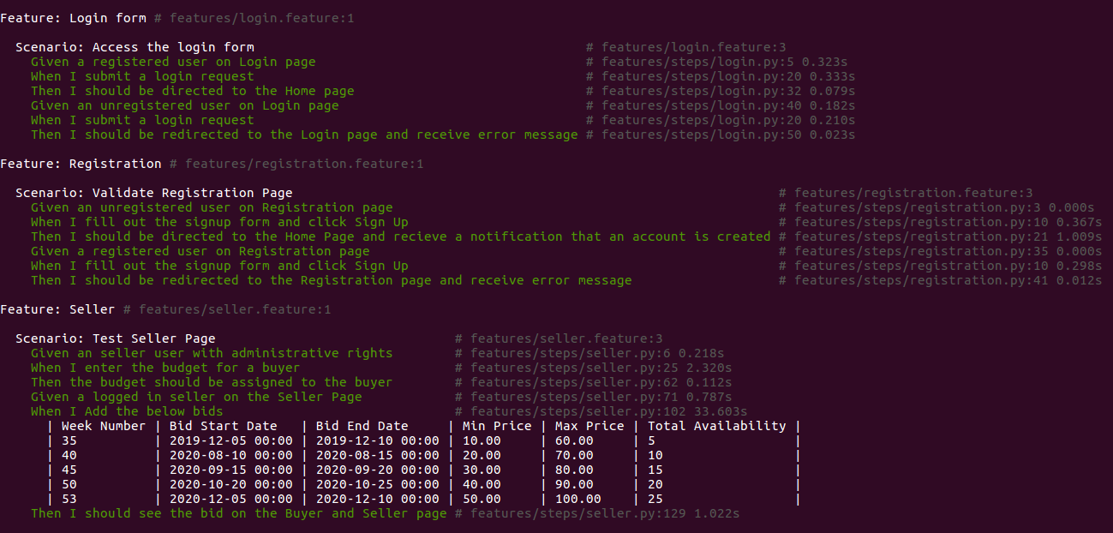

***Figure 8:*** *BDD Test Results for the entire project*