Before anything, please install the following packages (python 2.7):

***pandas, bokeh, numpy, xlrd***

by using:

*pip install (package_name)*

NB: you should make sure your version of bokeh is 0.13.0 or up

To run, open command line window in the same directory of this Readme file, and put:

*bokeh serve 38B --show*

*python27 –m bokeh serve 38B --show*

After it ran successfully, in the default brower, you will see the figure. It has three parts, the plot, the input window, and the table

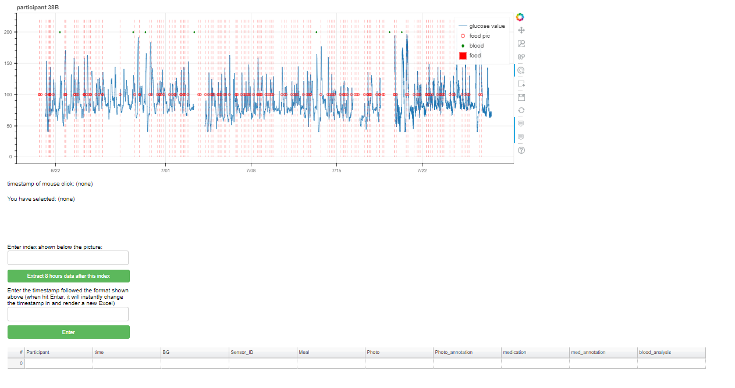

1. **The plot**
2. The tools on the RHS of the plot have popups of their usage.



Pan

Box Zoom

Wheel Zoom

Tap

Box Edit Tool

Save

Reset

Hover Tool 1

Hover Tool 2

Documentation

To activate the tool, just left click it.

1. To see a timestamp of any given data point in the plot, click it in the plot and it will show a corresponding timestamp right under the plot (if you hover a food picture or blood file data point, it will show the corresponding in the popup window too.)



1. If you click a food picture data point, it will show its place among all the food picture (starting from 0)



1. **The input boxes**
2. Index input box

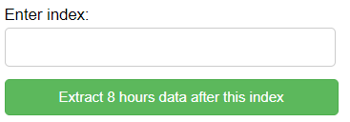

This box lets you put an index. To know a food picture or blood file’s index, hover the data point and it will show in the popup. After you input the index, the table below will show the 8 hours of data after this index. So if you want a lab day’s 8 hour data, just input the index of the green dot in that day and click the extract button, it will let you download a csv file.

1. The timestamp input box

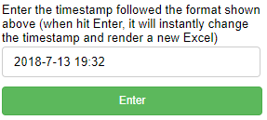

This box lets you modify the timestamp of an entry in the table. Please follow the format of the timestamp shown above, or you can just copy that to this box. When hit Enter, it will render a new Excel file in your directory name “all_record_38B(new).xlsx”. Only one cell is changed, which is denoted by your index and your timestamp. To give a new plot, delete “(new)” at the end of the file name and replace the old one with this one, and run the command again.

1. **The table**

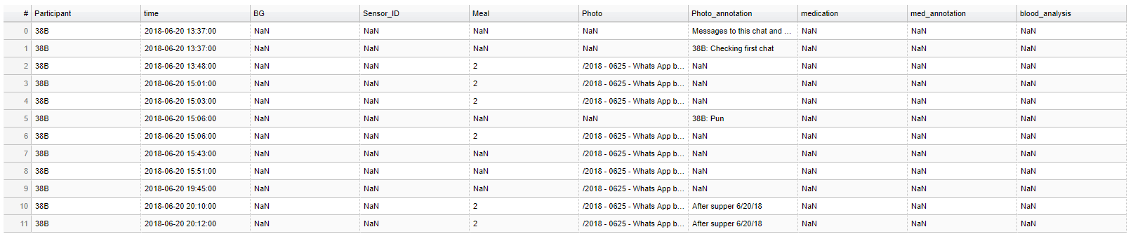It will show content controlled by the first input box (8 hours data after the index)

For a typical example, if you want to modify the timestamp of the first food pic (timestamp: 2018-6-20 15:43) in the plot, you drag it to the appropriate place and input the index of the pic (right under the food pic in the popup. In this example, 7) to the first box, and copy/paste the new timestamp to the second box. When finishing input, click Enter, there will be a new file called "all_record_38B(new).xlsx" in your directory, with one cell changed (the one you specify the index and timestamp). So, the given food pic will be associated with a new timestamp, and if you delete "(new)" in the new file's name and replace the old Excel with this one, after run the command above again, you will get a new plot with the modified timestamps.

For a separate example, if you want to download 8 hours data after a blood file, input the index of the blood file and put it into the first box, and then click “Extract 8 hours data after this index”, it will let you download a csv file.