Visualization of all patients’ standard meals

38A:

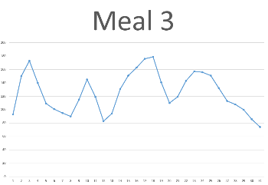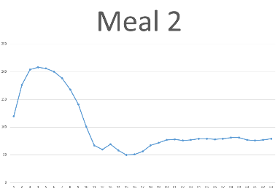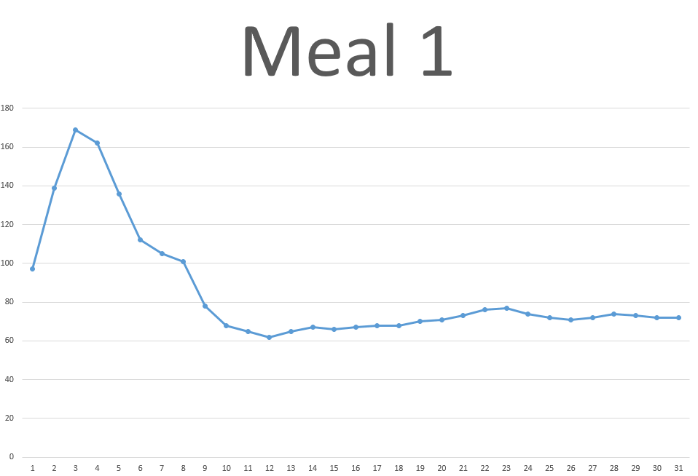

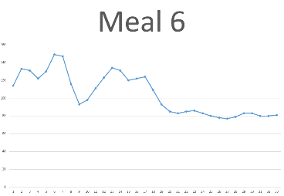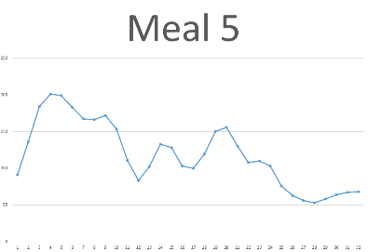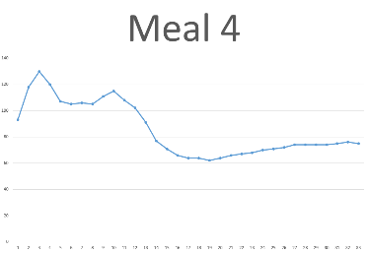

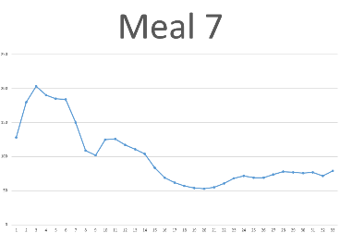

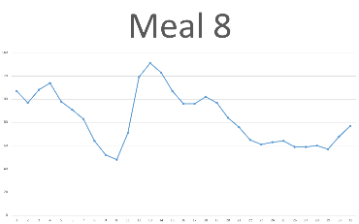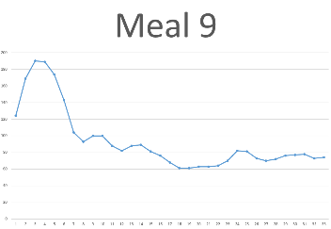

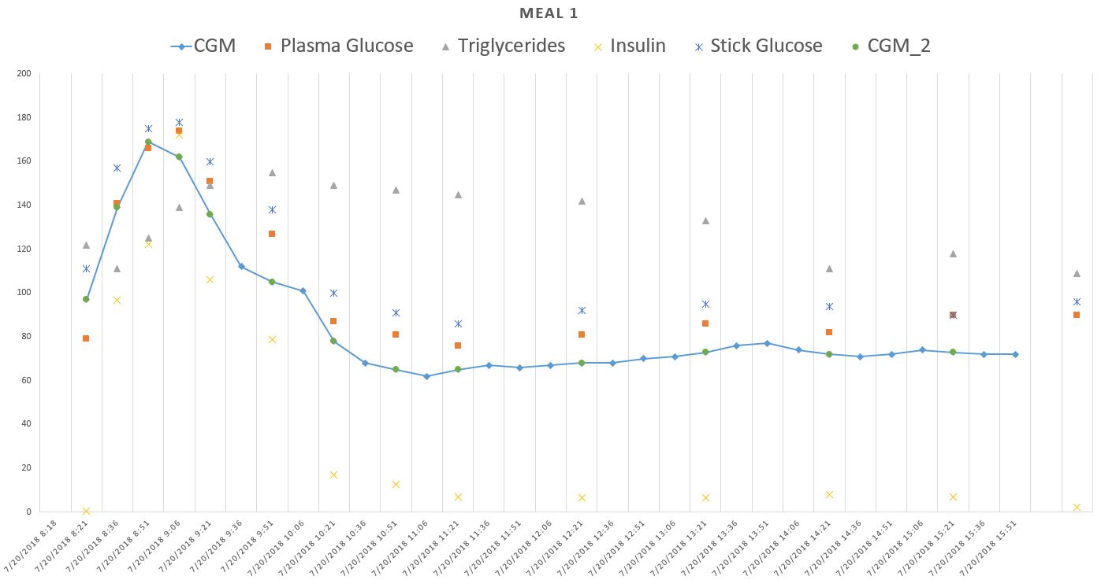

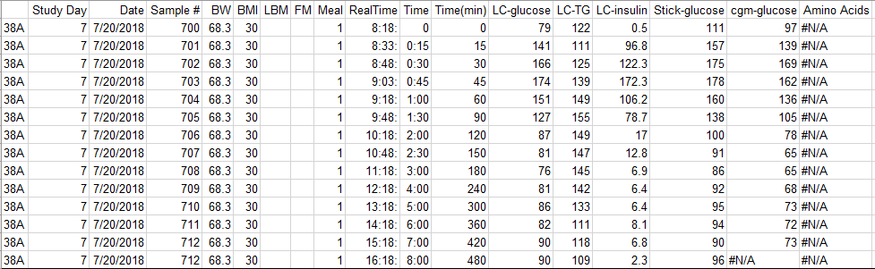

Timestamp issue (it applies all the meals): the timestamp in blood draw file does not match the one in CGM reading txt file. Blood draw file above has

|  |  |
| --- | --- |
| RealTime | cgm-glucose |
| 8:18 | 97 |
| 8:33 | 139 |

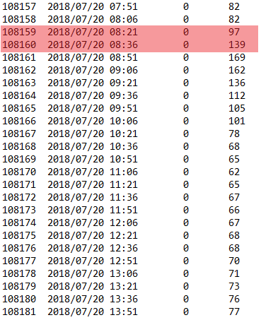but cgm reading txt file has

|  |  |
| --- | --- |
| RealTime | cgm-glucose |
| 8:21 | 97 |
| 8:36 | 139 |

In the plot, all timestamp are used in CGM reading txt file (here time difference is 8:21 – 8: 18 = 3mins)

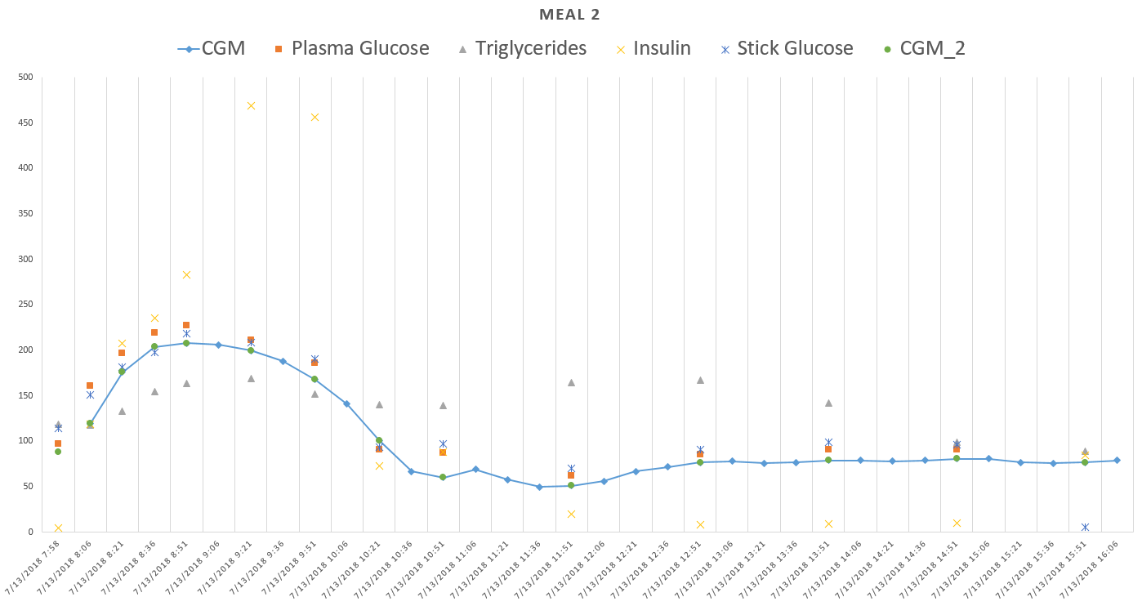

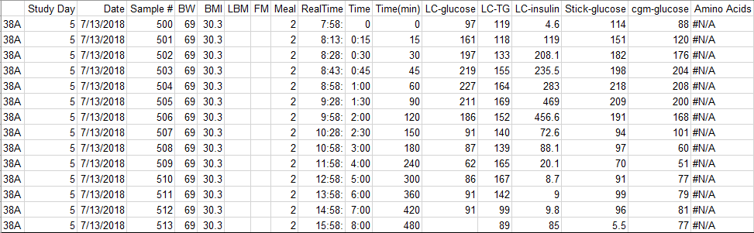

Time difference between cgm reading file and blood draw file: 7 mins

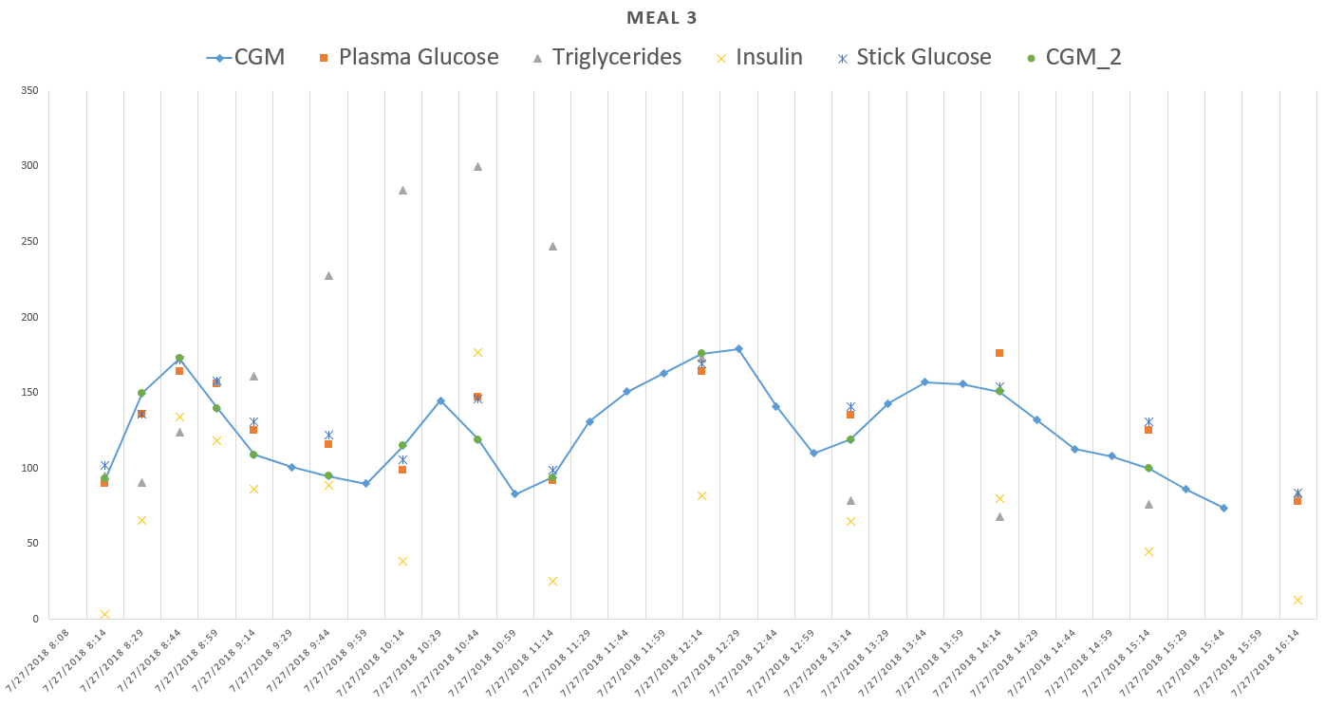

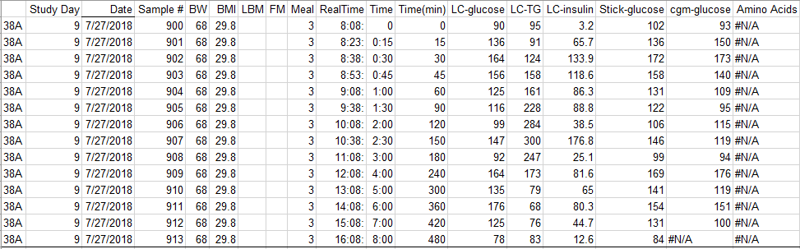

Time difference: 6mins

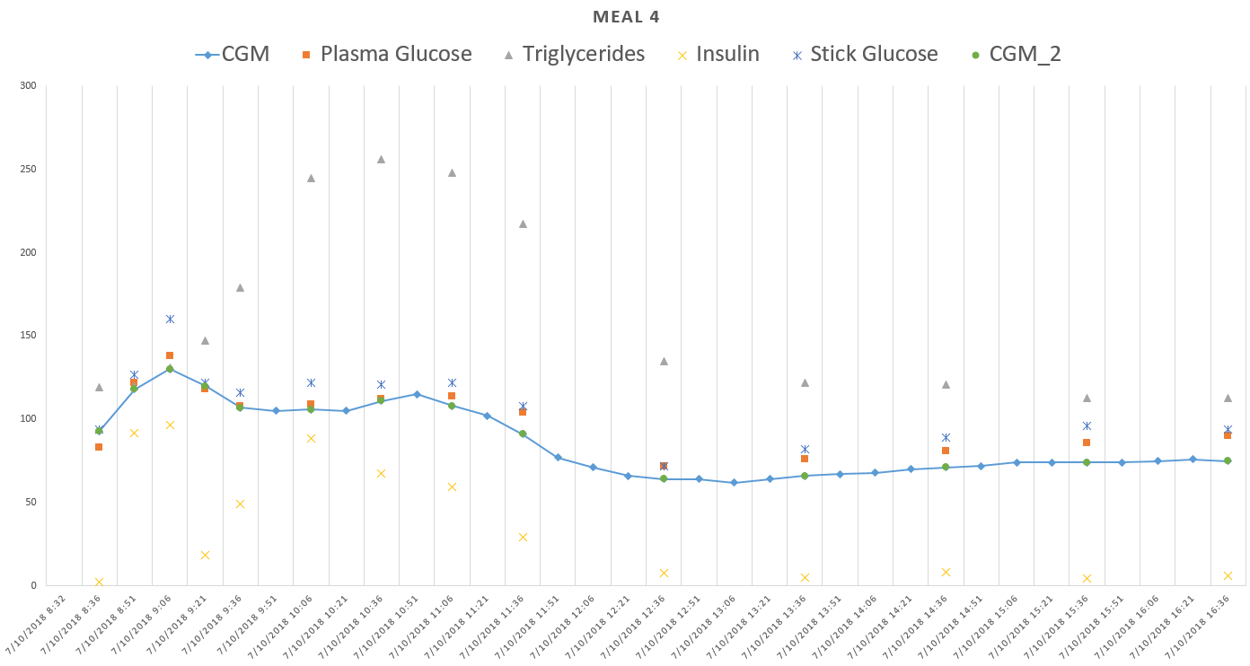

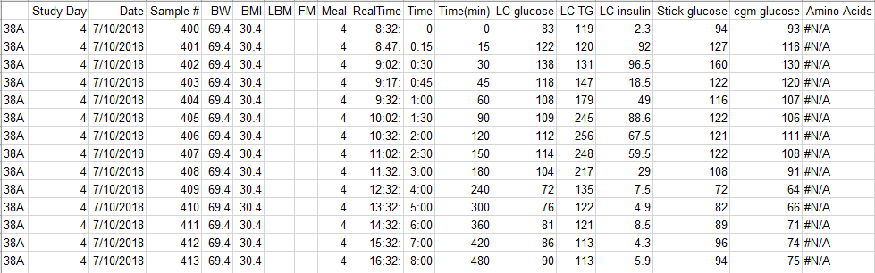

Time difference: 4mins

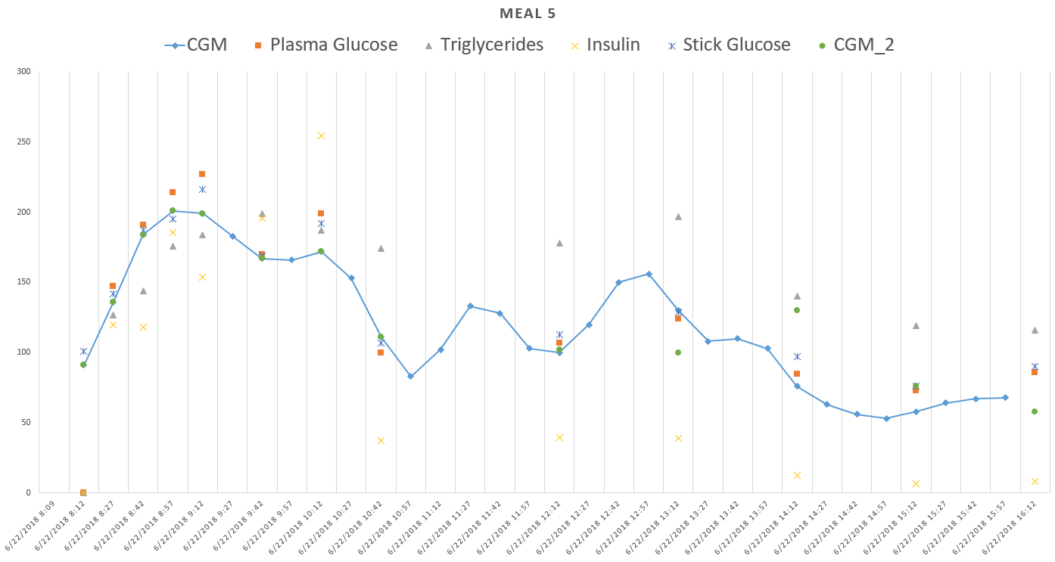

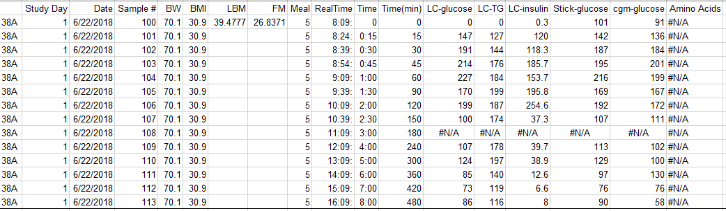

Time difference: 3 mins

For this meal, after 10:42, the cgm reading in txt file does not match the blood draw file

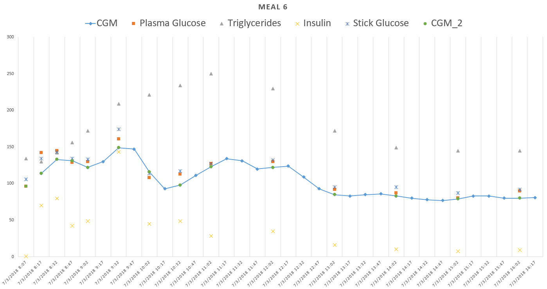

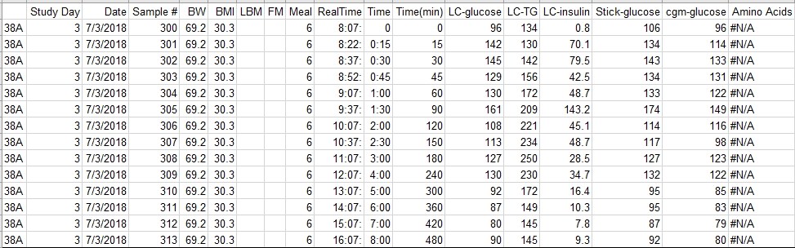

Time difference: 5 mins

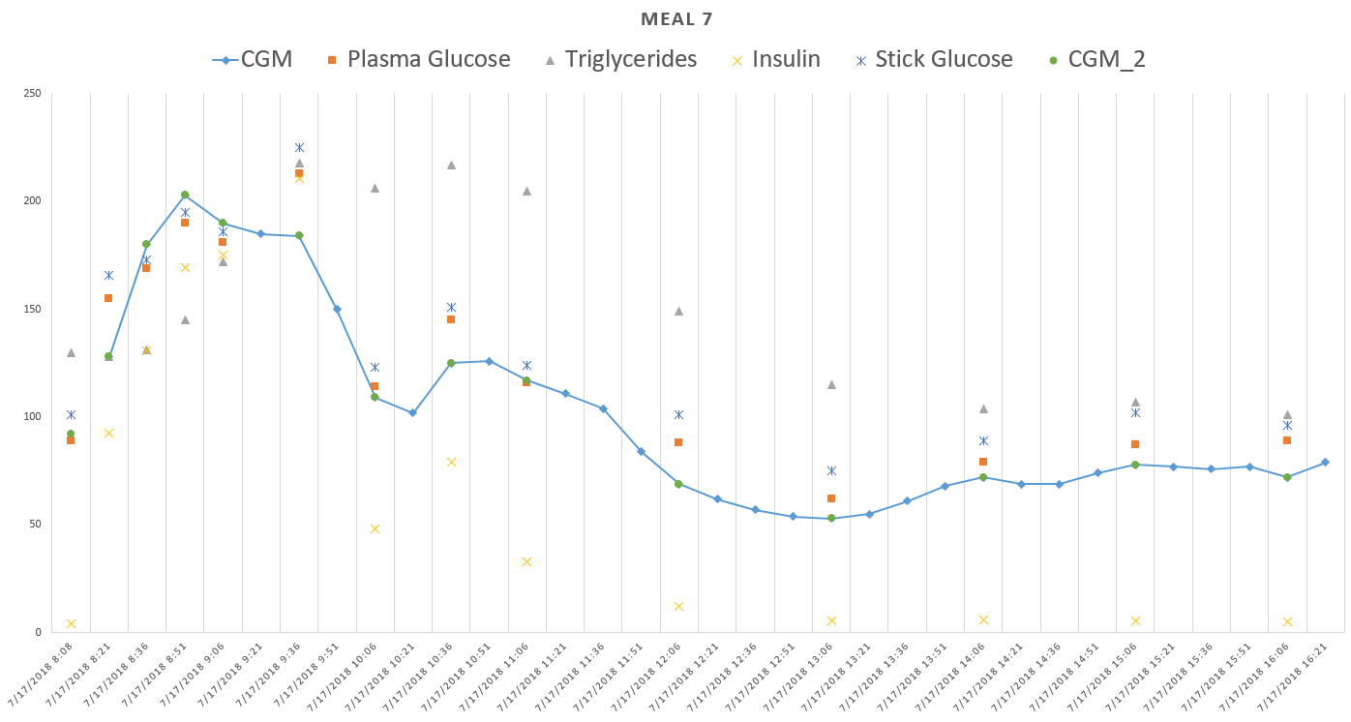

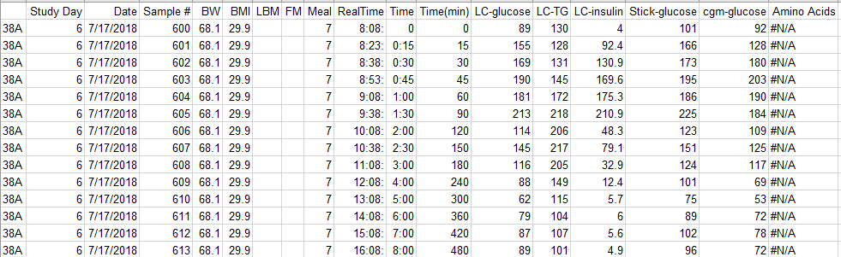

Time difference: 2 mins

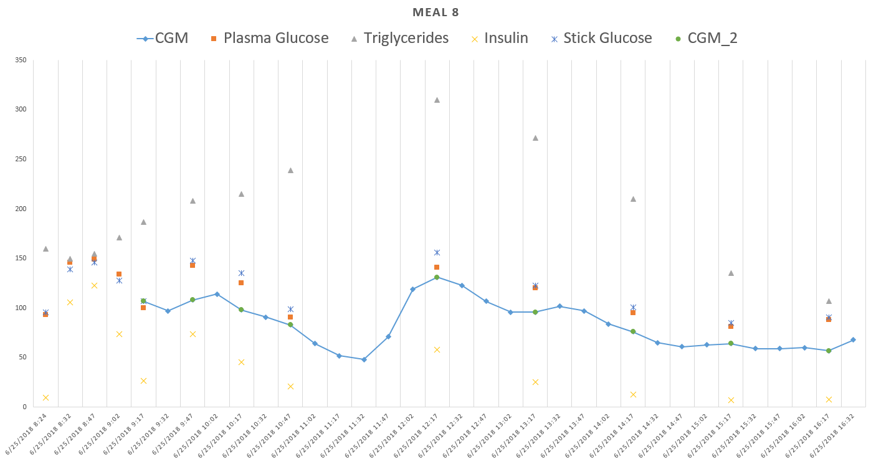

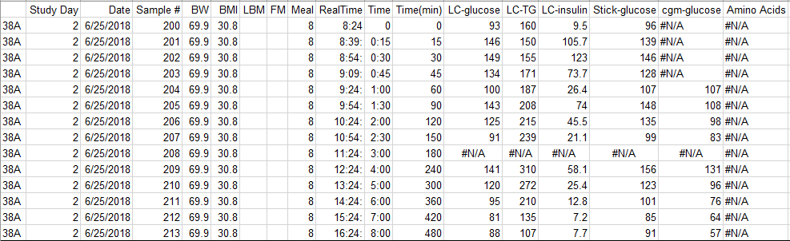

Time difference: 7 mins

Also, for this meal, glucose starts recording after almost 1 hour of the shake (we might miss the first peak data)

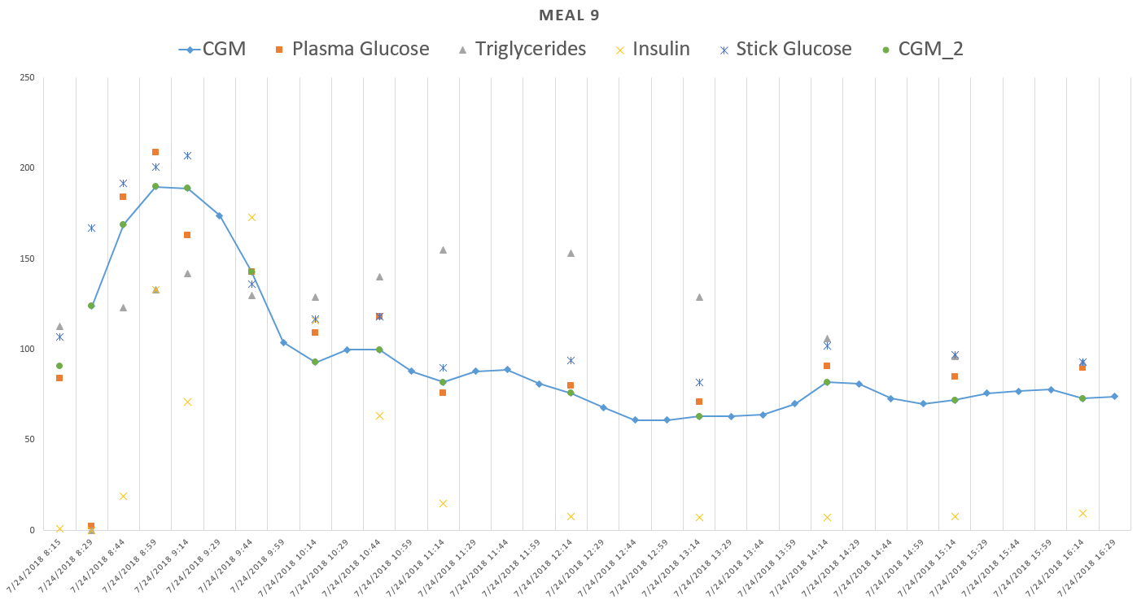

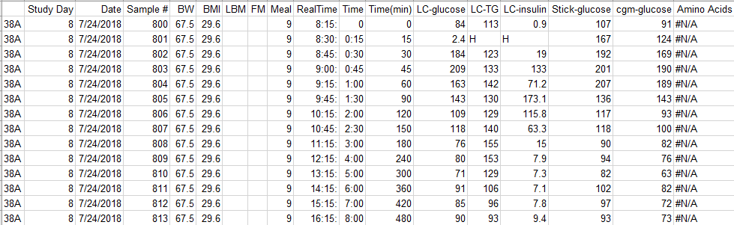

Time difference: 1 min

Problem of this one, at 3:34pm it has food picture

