

LAB REPORT

COURSE NO: EEE 2252

COURSE TITLE: SESSIONAL BASED ON EEE 2251

EXPERIMENT NO: 01

EXPERIMENT NAME: ***No Load magnetization curve of a separately excited DC genetator***

SUBMITTED TO:

### Sunjidah Hossain

**Lecturer**

**Department of EEE,RUET**

SUBMITTED BY:

NAME: Md.Minhazul Islam

ROLL: 1903098

SECTION: B

DEPARTMENT: CSE

DATE OF EXPERIMENT: 23/10/22

DATE OF SUBMISSION: 06/11/22

Experiment Name: Study of voltmeter range extension.

Objectives:

1. To know about the method to extend the voltmeter range.

2. To know the internal circuit connection of voltmeter.

3. To measure the high voltage using a low range voltmeter

Required Apparatus:

1.AC supply 230V

2 Variac 0-400V

3 Voltmeter 0-450V

4 Multimeter 0-600V,0-10A

5 Variable Resistor 1MΩ

6 Connecting wire

**Theory:**

Due to difficulty in measuring high voltages with normal voltmeters, it is, therefore, necessary to bring those high values to normal values that can be measurable by voltmeters. This process is called the extension of range of voltmeter. In this, an external device is connected to the measuring instrument to increase the measuring range of the instrument. Similar to the ammeter, the range of the voltmeter can be extended by using a multiplier. It can be used for both ac and dc voltmeters. A multiplier is basically a resistor connected in series with the voltmeter. The main function of the multiplier is to limit the flow of current through the voltmeter in such a way that the deflection of the pointer should not exceed the full-scale deflection. It must ensure that the voltmeter should be connected in parallel or across two points, to measure the potential difference.

Let,

• Rm = Internal resistance of the meter

• Rs = Resistance of multiplier

• I = Full-scale deflection current of meter

• V1 = Voltage being measured

• V2 = Full deflection voltage of the meter

V1 = IRs + IRm

V2 = IRm

m = 𝑉1 𝑉2 = 𝑅𝑠+𝑅𝑚 𝑅𝑚 Rs = Rm (m-1)

Hence, to extend a voltmeter range for m times. The resistance of the multiplier required is (m1) × resistance of the meter.

**Circuit Diagram:**

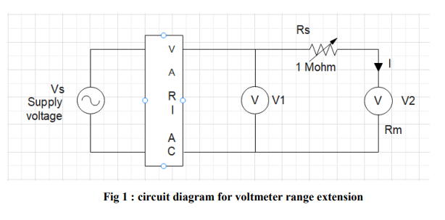

Data Table:

|  |  |  |  |  |  |
| --- | --- | --- | --- | --- | --- |
| SL No | Supply Voltage(V) | Voltmeter Reading V1(V) | Voltmeter Reading V2(v) | Multiplier m=V1/v2 | Avg M |
| 1 |  |  |  |  |  |
| 2 |  |  |  |  |  |
| 3 |  |  |  |  |  |

**Discussion and Conclusion :**

The experiment was about the study of voltmeter range extension. From the experiment we observed that we can extend the range of the voltmeter by using extra resistance called multiplier. In the experiment we connect the higher range of resistor in series of the voltmeter so that it can limit the flow of current. Here, a resistor box was used to get higher resistance. This resistor should designed specially that it’s resistance should not change respect to the time. Thus we can extend the voltmeter range. The percentage of error was very low. We took all the precaution to avoid the error. But these small error occur the instrument was old and the heating of the instrument. Overall, our main objectives was fulfilled and the experiment was done successfully.