GHG Emissions Report

Facility Information
Name: test facility
Address: test address
Sector: Manufacturing
Responsible Person: test person

Emissions Summary
Total Emissions: 6016.0 kg CO2e
Scope 1 Emissions: 5296.0 kg CO2e (88.0%)
Scope 2 Emissions: 720.0 kg CO2e (12.0%)
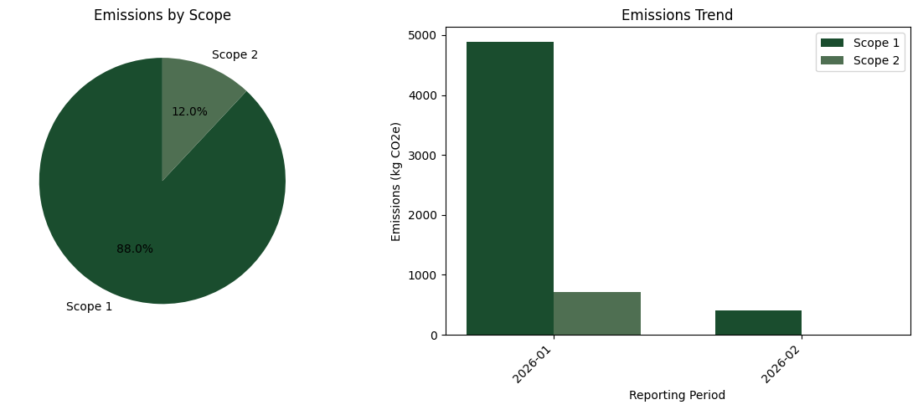

Detailed Emission Records
Period | Scope | Category | Quantity | Factor | Total (kg CO2e)
2026-01 | Scope 1 | stationary_combustion | 1000.0 | 2.03 | 2030.0
2026-01 | Scope 1 | fugitive | 2.0 | 1430.0 | 2860.0
2026-01 | Scope 2 | electricity | 1000.0 | 0.72 | 720.0
2026-02 | Scope 1 | stationary_combustion | 200.0 | 2.03 | 406.0

