

Sustain Corp

Greenhouse Gas (GHG) Inventory Report
Prepared as per ISO 14064-1:2018
Reporting Period: February 2025 - March 2026

DISCLAIMER
This report is generated through SustainRepo platform. The data presented in this report has been provided by Sustain Corp through the SustainRepo platform. While the information has been compiled as submitted, SustainRepo does not independently verify the accuracy or completeness of the data provided. Accordingly, SustainRepo shall not be held responsible for any inaccuracies, misstatements, or omissions in the information, nor for any resulting consequences, including reputational or financial loss arising from reliance on this report.

ABBREVIATIONS
Abbreviation | Full Form
GHG | Greenhouse Gas
CO₂ | Carbon Dioxide
CH₄ | Methane
N₂O | Nitrous Oxide
tCO₂e | Tonnes of Carbon Dioxide Equivalent
ISO | International Organization for Standardization
Scope 1 | Direct GHG Emissions
Scope 2 | Indirect GHG Emissions from Purchased Energy
GWP | Global Warming Potential
NCV | Net Calorific Value
EF | Emission Factor
IPCC | Intergovernmental Panel on Climate Change

CHAPTER 1: GENERAL DESCRIPTION OF THE ORGANIZATION AND INVENTORY OBJECTIVES

1. Organization
1. Address:
Street Address: test address
City: FARIDABAD
Pincode: 121007
State: Haryana
Country: India
2. General Description:
NA
3. Mission of the organization:
NA
4. Vision of the organization:
NA
5. Process Description:
NA
6. Person Responsible:
NA
7. Purpose of Reporting:
NA
8. Reporting Frequency:
Yearly
9. Number of Facilities:
2
10. Other Information:
NA

2. Facilities

2.1 test-ruthvik
a) Sector/Industry:
Manufacturing
b) Address:
Street Address: 113
City: FARIDABAD
Pincode: 121007
State: Haryana
Country: India
c) Products/Services:
this is the products and services for testing purpose. this can be multiple and single and all. this will also contain details of the quantity of products produced.
d) Machinery and Equipment:
this is the details of the machine and the equipments used, there will be details and description of them.
e) Process Description:
rfevcresbwvgf
f) Person Responsible:
test person2
g) Monitoring Frequency:
Monthly
h) Reporting Frequency:
Monthly
i) Other Information:
remarksssm km

2.2 test-somil
a) Sector/Industry:
Agriculture
b) Address:
Street Address: 113
City: FARIDABAD
Pincode: 121007
State: Haryana
Country: India
c) Products/Services:
NA
d) Machinery and Equipment:
NA
e) Process Description:
NA
f) Person Responsible:
test-person-2
g) Monitoring Frequency:
Weekly
h) Reporting Frequency:
Quarterly
i) Other Information:
NA

CHAPTER 2: ORGANIZATION BOUNDARIES
It is known that there are two types of approaches for selecting organizational boundary. They are:
Equity Share Approach – Under this approach, a company considers and accounts for greenhouse gas emissions from various operations according to its share of equity in those operations.
Control Approach – Under this approach, a company considers and accounts for 100% of the greenhouse gas emissions from operations over which it has either operational or financial control. It does not report the GHG emissions from those operations in which it has no control.

Sustain Corp has not specified an organizational boundary approach.

CHAPTER 3: REPORTING BOUNDARIES
After determining the organizational boundary based on its ownership or control over operations the organization identifies the emission sources associated, categorizes the sources as Direct and Indirect GHG emission sources, and hence determines the scope of accounting and reporting.

Direct GHG emissions (Scope 1) are emissions from sources that are owned or controlled by the organization.

Indirect GHG emissions (Scope 2) are emissions that result from the generation of purchased or acquired electricity, heating, cooling, and steam consumed by the organization.

3.1 test-ruthvik

3.1.1 List of Emissions
Direct/Scope 1 Emissions:
• testing process - Diesel

Indirect/Scope 2 Emissions:
• No emission reported

3.1.2 Source of Emissions
Direct/Scope 1 Sources:
• Diesel

Indirect/Scope 2 Sources:
• No emission reported

3.2 test-somil

3.2.1 List of Emissions
Direct/Scope 1 Emissions:
• fire extinguisher - CO2

Indirect/Scope 2 Emissions:
• elecctricity - Electricity

3.2.2 Source of Emissions
Direct/Scope 1 Sources:
• CO2

Indirect/Scope 2 Sources:
• Electricity

CHAPTER 4: QUANTIFIED GHG INVENTORY OF EMISSIONS AND REMOVALS

4.1 Methodology
Methodology followed for calculation of GHG emissions from GHG activity level data:

Scope 1 / Direct Emission Factor (quantity basis):
Calorific Value × Density (if applicable) × Default Emission Factor (energy basis)

Scope 1, Scope 2 and Biogenic Emissions:
Quantity × Emission Factor (quantity basis)

Total Emissions Calculation:
tCO₂e = tCO₂ + tCH₄ × GWP(CH₄) + tN₂O × GWP(N₂O)

Data Sources and Standards:
- Emission factors from IPCC Guidelines and national standards
- Global Warming Potentials (GWP) from IPCC Fifth Assessment Report (AR5)
- Activity data collected from facility records and monitoring systems
- Calculations performed as per ISO 14064-1:2018 guidelines

4.2 Facility - test-ruthvik

4.2.1 List of Emissions
Direct/Scope 1 Emissions:
• testing process - Diesel

Indirect/Scope 2 Emissions:
• No emission reported

4.2.2 Source of Emissions
Direct/Scope 1 Sources:
• Diesel

Indirect/Scope 2 Sources:
• No emission reported

4.2.3 Summary of GHG Emissions - February 2025 - March 2026
Scope | Category | Fuel | Month | tCO2e | tCO2 | tCH4 | tN2O
Scope 1 (Direct) | Stationary Combustion | Diesel | Feb-2025 | 743,484.00 | 741,000.00 | 30.00 | 6.00
Scope 1 (Direct) | Stationary Combustion | Diesel | Feb-2025 | 743,484.00 | 741,000.00 | 30.00 | 6.00
Scope 1 (Direct) | Stationary Combustion | Diesel | Mar-2025 | 9,590.94 | 9,558.90 | 0.39 | 0.08
Scope 1 (Direct) | Stationary Combustion | Diesel | Mar-2025 | 9,590.94 | 9,558.90 | 0.39 | 0.08
Scope 1 (Direct) | Stationary Combustion | Diesel | Apr-2025 | 1,459,870.33 | 1,454,992.87 | 58.91 | 11.78
Scope 1 (Direct) | Stationary Combustion | Diesel | Apr-2025 | 1,459,870.33 | 1,454,992.87 | 58.91 | 11.78
Scope 1 (Direct) | Stationary Combustion | Diesel | May-2025 | 17,518.44 | 17,459.91 | 0.71 | 0.14
Scope 1 (Direct) | Stationary Combustion | Diesel | May-2025 | 17,518.44 | 17,459.91 | 0.71 | 0.14
Scope 1 (Direct) | Stationary Combustion | Diesel | Jun-2025 | 20,438.18 | 20,369.90 | 0.82 | 0.16
Scope 1 (Direct) | Stationary Combustion | Diesel | Jun-2025 | 20,438.18 | 20,369.90 | 0.82 | 0.16

Summary Totals (all values in tCO₂e):
Total Direct Emissions (A): 4,501,803.81 tCO₂e
Total Indirect Emissions (B): 0.00 tCO₂e
Total Emissions (A + B): 4,501,803.81 tCO₂e
Total Removals/Sinks (C): 100.00 tCO₂e
Total Biogenic: 0.00 tCO₂e
Total GHG Emissions (A + B - C): 4,501,703.81 tCO₂e

4.2.4 Emissions of Previous Years
Category | Fuel | FY 2025
Stationary Combustion | Diesel | 31,969.81

4.2.5 Analysis
Total emissions from test-ruthvik amount to 4,501,803.81 tCO2e.
Scope 1 (Direct) emissions contribute 100.0% (4,501,803.81 tCO2e) of total emissions, while Scope 2 (Indirect) emissions contribute 0.0% (0.00 tCO2e).
Among Scope 1 categories, Stationary Combustion is the dominant source, contributing 100.0% of direct emissions.
In terms of fuel consumption, Diesel is the primary contributor, accounting for 100.0% of Scope 1 emissions.

The following figures illustrate the emission distribution:

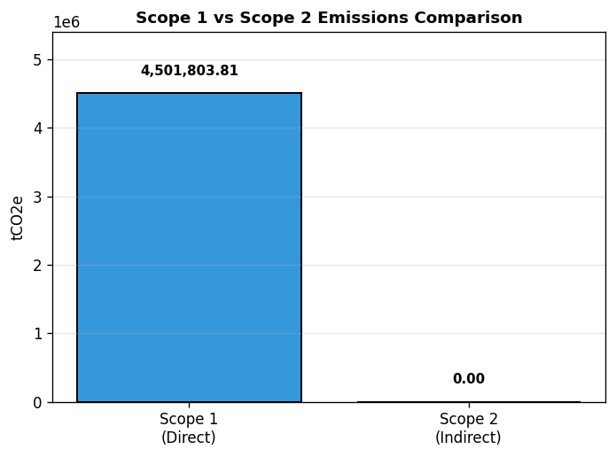
Figure: Scope 1 vs Scope 2 Emissions Comparison

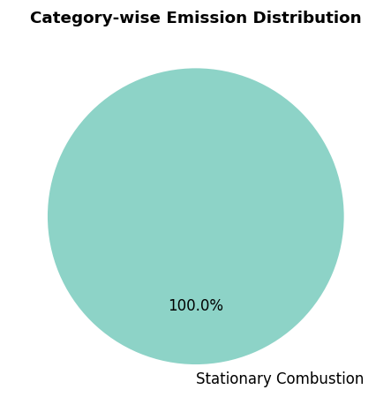
Figure: Category-wise Emission Distribution

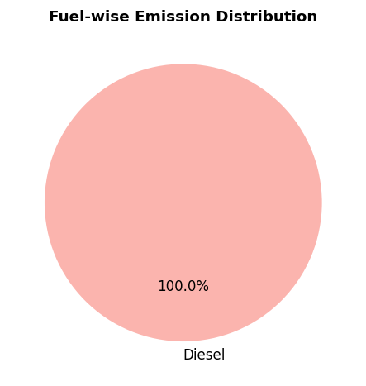
Figure: Fuel-wise Emission Distribution

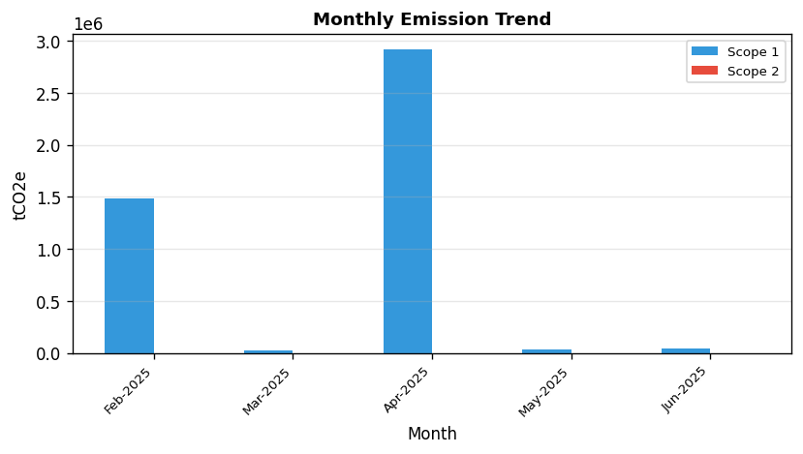
Figure: Monthly Emission Trend

4.3 Facility - test-somil

4.3.1 List of Emissions
Direct/Scope 1 Emissions:
• fire extinguisher - CO2

Indirect/Scope 2 Emissions:
• elecctricity - Electricity

4.3.2 Source of Emissions
Direct/Scope 1 Sources:
• CO2

Indirect/Scope 2 Sources:
• Electricity

4.3.3 Summary of GHG Emissions - February 2025 - March 2026
Scope | Category | Fuel | Month | tCO2e | tCO2 | tCH4 | tN2O
Scope 1 (Direct) | Fugitive Emissions | CO2 | Jan-2026 | 0.40 | 0.40 | 0.00 | 0.00
Scope 1 (Direct) | Fugitive Emissions | CO2 | Jan-2026 | 0.40 | 0.40 | 0.00 | 0.00
Scope 1 (Direct) | Fugitive Emissions | CO2 | Feb-2026 | 0.60 | 0.60 | 0.00 | 0.00
Scope 1 (Direct) | Fugitive Emissions | CO2 | Feb-2026 | 0.60 | 0.60 | 0.00 | 0.00
Scope 1 (Direct) | Fugitive Emissions | CO2 | Mar-2026 | 80.00 | 80.00 | 0.00 | 0.00
Scope 1 (Direct) | Fugitive Emissions | CO2 | Mar-2026 | 80.00 | 80.00 | 0.00 | 0.00
Scope 2 (Indirect) | Purchased Electricity | Electricity | Feb-2025 | 142.00 | 142.00 | 0.00 | 0.00
Scope 2 (Indirect) | Purchased Electricity | Electricity | Feb-2025 | 142.00 | 142.00 | 0.00 | 0.00
Scope 2 (Indirect) | Purchased Electricity | Electricity | Mar-2025 | 213,000.00 | 213,000.00 | 0.00 | 0.00
Scope 2 (Indirect) | Purchased Electricity | Electricity | Mar-2025 | 213,000.00 | 213,000.00 | 0.00 | 0.00
biogenic | Stationary Combustion | Wood / Wood Waste | Feb-2025 | 3,859.07 | 3,494.40 | 9.36 | 0.37
biogenic | Stationary Combustion | Wood / Wood Waste | Feb-2025 | 3,859.07 | 3,494.40 | 9.36 | 0.37
biogenic | Stationary Combustion | Wood / Wood Waste | Mar-2025 | 5,788.60 | 5,241.60 | 14.04 | 0.56
biogenic | Stationary Combustion | Wood / Wood Waste | Mar-2025 | 5,788.60 | 5,241.60 | 14.04 | 0.56

Summary Totals (all values in tCO₂e):
Total Direct Emissions (A): 162.00 tCO₂e
Total Indirect Emissions (B): 426,284.00 tCO₂e
Total Emissions (A + B): 426,446.00 tCO₂e
Total Removals/Sinks (C): 0.00 tCO₂e
Total Biogenic: 19,295.33 tCO₂e
Total GHG Emissions (A + B - C): 426,446.00 tCO₂e

4.3.4 Emissions of Previous Years
Category | Fuel | FY 2025
Purchased Electricity | Electricity | 7.10
Stationary Combustion | Wood / Wood Waste | 0.19

4.3.5 Analysis
Total emissions from test-somil amount to 426,446.00 tCO2e.
Scope 1 (Direct) emissions contribute 0.0% (162.00 tCO2e) of total emissions, while Scope 2 (Indirect) emissions contribute 100.0% (426,284.00 tCO2e).
Among Scope 1 categories, Fugitive Emissions is the dominant source, contributing 100.0% of direct emissions.
In terms of fuel consumption, CO2 is the primary contributor, accounting for 100.0% of Scope 1 emissions.

The following figures illustrate the emission distribution:

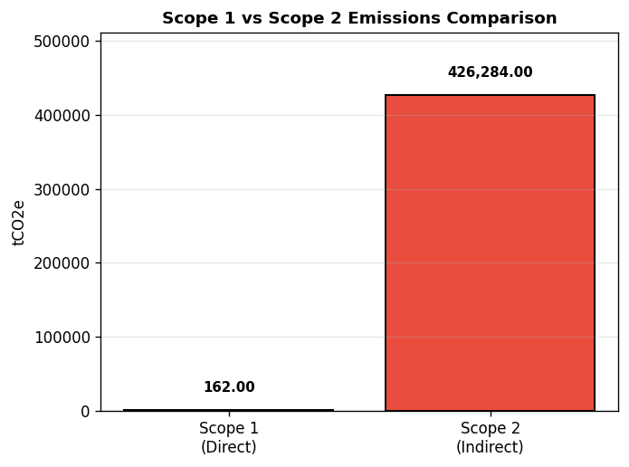
Figure: Scope 1 vs Scope 2 Emissions Comparison

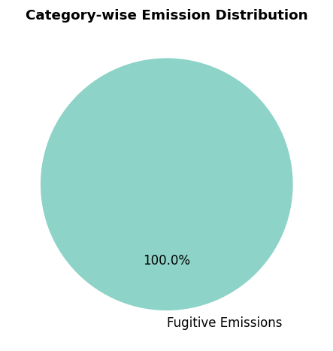
Figure: Category-wise Emission Distribution

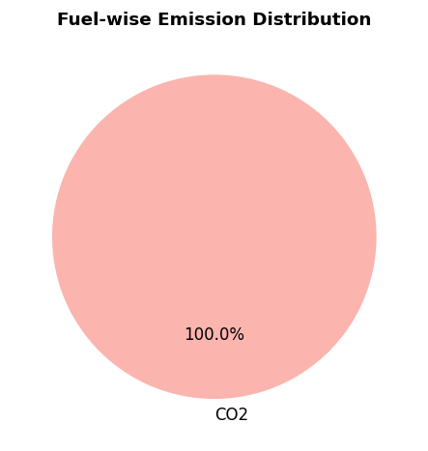
Figure: Fuel-wise Emission Distribution

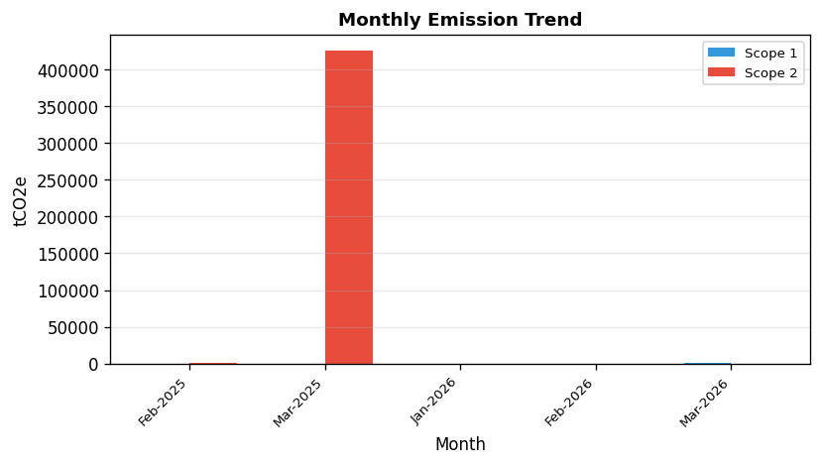
Figure: Monthly Emission Trend

4.4 Organization Emissions
Category | Fuel | Total Emissions (tCO₂e)
Direct/Scope 1 Emissions
Fugitive Emissions | Diesel, CO2 | 162.00
Stationary Combustion | Diesel, CO2 | 4,501,803.81
Indirect/Scope 2 Emissions
Importing electricity from grid | Electricity | 426,284.00
Biogenic Emissions
Biogenic sources | - | 19,295.33
Sinks/Removals
Carbon sinks and removals | - | 100.00

Organization Summary Totals (all values in tCO₂e):
Total Direct Emissions (A): 4,501,965.81 tCO₂e
Total Indirect Emissions (B): 426,284.00 tCO₂e
Total Emissions (A + B): 4,928,249.81 tCO₂e
Total Removals/Sinks (C): 100.00 tCO₂e
Net GHG Emissions (A + B - C): 4,928,149.81 tCO₂e

4.5 Organization Analysis
The total GHG emissions for Sustain Corp amount to 4,928,249.81 tCO2e across 2 selected facilities.
At the organizational level, Scope 1 emissions account for 91.4% of total emissions, while Scope 2 emissions account for 8.6%.
Facility-wise emission contribution:
• test-ruthvik: 4,501,803.81 tCO2e (91.3%)
• test-somil: 426,446.00 tCO2e (8.7%)
Mathematical Validation:
Sum of facility totals: 4,928,249.81 tCO2e
Organization total (A+B): 4,928,249.81 tCO2e
Sum of facility percentages: 100.0%
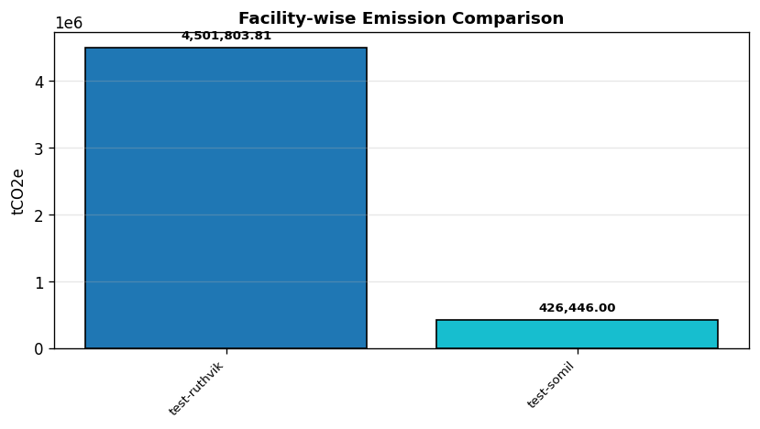
Figure: Facility-wise Emission Comparison

CHAPTER 5: GHG REDUCTION INITIATIVE AND INTERNAL PERFORMANCE TRACKING

5.1 GHG Reduction Initiatives
The organization has not documented specific GHG reduction initiatives at this time.

5.2 Internal Performance Tracking
Internal performance tracking mechanisms are being developed to monitor and improve GHG performance over time.

CHAPTER 6: CONCLUSION
This GHG Inventory Report presents a comprehensive assessment of the greenhouse gas emissions for Sustain Corp. The inventory has been prepared in accordance with the principles and requirements of ISO 14064-1:2018.

The organization is committed to:
- Continuously monitoring and reporting GHG emissions in accordance with international standards
- Implementing measures to reduce emissions across all operational facilities
- Improving data collection and verification processes
- Setting science-based targets for emission reduction
- Engaging stakeholders in climate action initiatives

This report serves as a foundation for informed decision-making regarding climate action and sustainability strategies. The organization remains dedicated to environmental stewardship and will continue to enhance its GHG management practices in alignment with global climate goals.

