{ Company Name}
{Company Logo}

Greenhouse Gas (GHG) Inventory Report
Reporting Period: {Reporting Period}

ABBREVIATIONS
GHG | Greenhouse Gas
ISO | International Organization for Standardization
IPCC | Intergovernmental Panel on Climate Change
tCO2e | Tons of Carbon dioxide equivalent
CV | Calorific Value
EF | Emission Factor
CO2 | Carbon dioxide
CH4 | Methane
N2O | Nitrous Oxide
kWh | Kilo Watt Hour
MWh | Mega Watt Hour

Chapter1: GENERAL DESCRIPTION OF THE ORGANIZATION OF GOALS AND INVENTORY OBJECTIVES

1. Organization's Overview

1. Address:
- Street Address: {Street Address}
- City: {City}
- State: {State}
- Pin/Zip Code: {Pin/Zip Code}
- Country: {Country}
2. General Description: {General Description}
3. Mission of the organization: {Mission}
4. Vision of the organization: {Vision}
5. Process Description: {Process Description}
6. Person Responsible: {Person Responsible}
7. Reporting Frequency: {Reporting Frequency}
8. Number of Facilities:
9. Other Information: {Other Information}

2. Facilities

2.1 {Facility -1 Name}
a) Sector/Industry: {sector/Industry}

b) Address:
- Street Address: {Street Address}
- City: {City}
- State: {State}
- Pin/Zip Code: {Pin/Zip Code}
- Country: {Country}
c) Products/Services: {Products/Services}
d) Machinery and Equipment: {Machinery and Equipment}
e) Process Description: {Process Description}
f) Person Responsible: {Person Responsible}
g) Monitoring Frequency: {Monitoring Frequency}
h) Reporting Frequency: {Reporting Frequency}
i) Other Information: {Other information}

2.2 {Facility -2 Name}

Chapter 2: Organization Boundaries
It is known that there are two types of approaches for selecting organizational boundary. They are:

Equity Share Approach –
- Under this approach, a company considers and accounts for greenhouse gas emissions from various operations according to its share of equity in those operations.
Control Approach –
- Under this approach, a company considers and accounts for 100 % of the greenhouse gas emissions from operations over which it has either operational or financial control. It does not report the GHG emissions from those operations in which it has no control.

{Organization Name} has chosen {Organization Approach Chosen}.{if equity share chosen write the % of the equity share added by the customer, if control approach is chosen share will be 100%, so write something like __% of GHG Emissions will be accounted to the organization (paraphrase the line and don’t just simply write the percentage) }. {Additional Boundary Notes}

Chapter3: Reporting Boundaries

After determining the organizational boundary based on its ownership or control over operations the organization identifies the emission sources associated, categorizes the sources as Direct and Indirect GHG emission sources, and hence determines the scope of accounting and reporting.

“Direct GHG emissions are emissions from sources that are owned or controlled by the company.”

“Indirect GHG emissions are emissions that are consequences of the activities of the company but occur at sources owned or controlled by another company.”

{Facility – 1 Name}

List of Emissions
Direct/Scope 1 Emissions: {List of emissions under scope1 in format -> Name of process – Fuel}
Indirect/Scope 2 Emissions: Importing electricity from grid - Electricity

3.2.2 Source of Emissions
Direct/Scope 1 Sources: {name of fuels (should be unique)}
Indirect/Scope 2 Sources: Electricity
{Facility – 2 Name}

List of Emissions
Direct/Scope 1 Emissions: {List of emissions under scope1 in format -> Name of process – Fuel}
Indirect/Scope 2 Emissions: Importing electricity from grid - Electricity

3.2.2 Source of Emissions
Direct/Scope 1 Sources: {name of fuels (should be unique)}
Indirect/Scope 2 Sources: Electricity

Chapter 4: QUANTIFIED GHG INVENTORY OF EMISSIONS AND REMOVALS

3.1 Methodology
Methodology followed for calculation of GHG emissions from GHG activity level data:
Scope 1/Direct Emission Factor (quantity basis): Calorific Value x Density (if applicable) x Default Emission Factor (energy basis)
Scope 1, Scope 2 and Biogenic Emissions: Quantity x Emission Factor (quantity basis)
tCO2e = tCO2 + tCH4*GWP(CH4) + tN2O * GWP(N2O)
3.2 Facility - test-ruthvik

3.2.1 List of Emissions
Direct/Scope 1 Emissions: coaling - Crude Oil, testing it - Crude Oil, Forklifting - Diesel, Testing2 - Diesel, Testing1 - Diesel, ForkLifting - Diesel, food - Crude Oil
Indirect/Scope 2 Emissions: Importing electricity from grid - Electricity

3.2.2 Source of Emissions
Direct/Scope 1 Sources: Crude Oil, Diesel
Indirect/Scope 2 Sources: Electricity

3.2.3 Summary of GHG Emissions - February 2025 - February 2026
Scope | Category | Fuel | Month | tCO2e | tCO2 | tCH4 | tN2O
Scope 1 (Direct) | Stationary Combustion | Diesel | Jan-2026 | 29197.41
Scope 1 (Direct) | Stationary Combustion | Crude Oil | Jan-2026 | 27174.09
Scope 1 (Direct) | Stationary Combustion | Diesel | Feb-2026 | 58394.81
Scope 2 (Indirect) | Purchased Electricity | Electricity | Jan-2026 | 7100.00
Scope 2 (Indirect) | Purchased Electricity | Electricity | Feb-2026 | 142.00

Total Emissions Direct (A) | 114766.31 tCO2e
Total Emissions Indirect (B) | 7242.00 tCO2e
Total Emissions (A + B) | 122008.31 tCO2e
Total Removals/Sinks (C) | 0.00 tCO2e
Total Biogenic | 0.00 tCO2e
Total GHG Emissions (A + B - C) | 122008.31 tCO2e

3.2.4 Emissions of Previous Years
Category | Fuel | FY 2024 | FY 2025
Stationary Combustion | Crude Oil | 38406.50 | 31851.45

3.2.5 Analysis
The facility 'test-ruthvik' has a total GHG emission of 122008.31 tCO2e for the reporting period.
Scope 1 (Direct) emissions contribute 94.1% while Scope 2 (Indirect) emissions contribute 5.9% of total emissions.

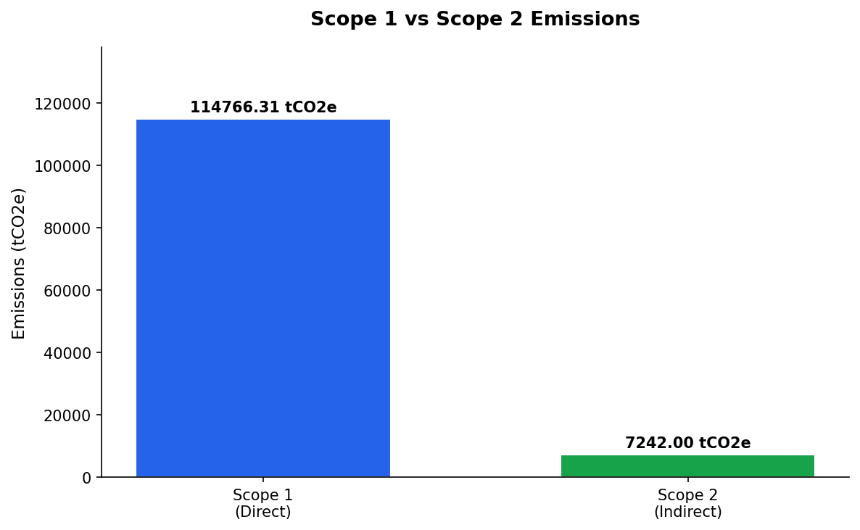
Figure: Scope 1 vs Scope 2 Emissions Comparison

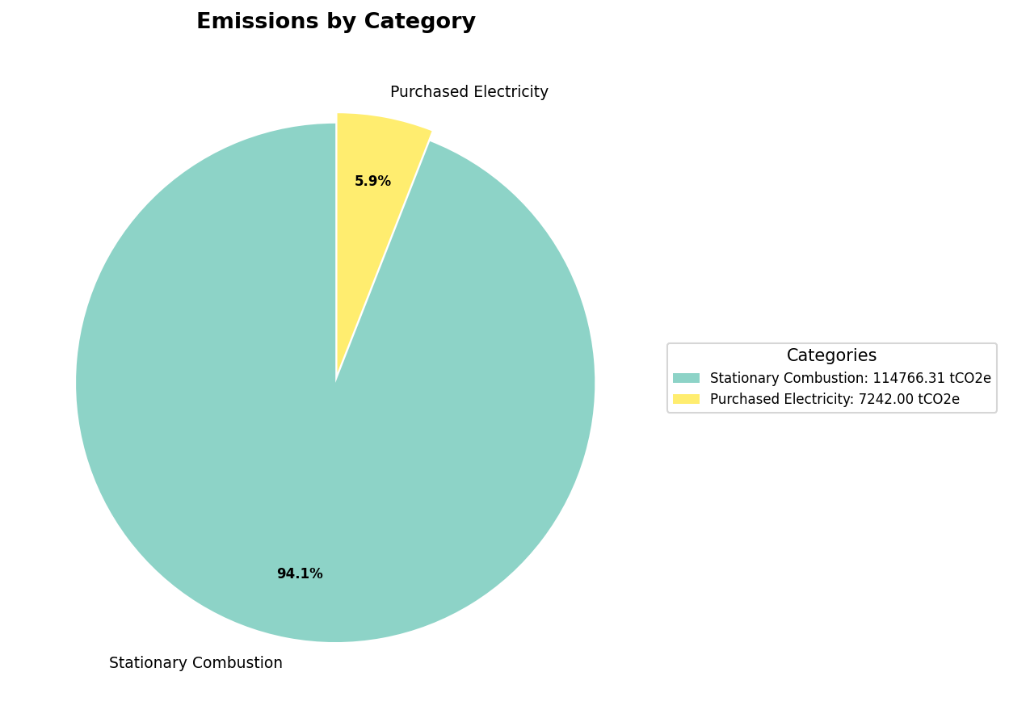
Figure: Category-wise Emission Distribution

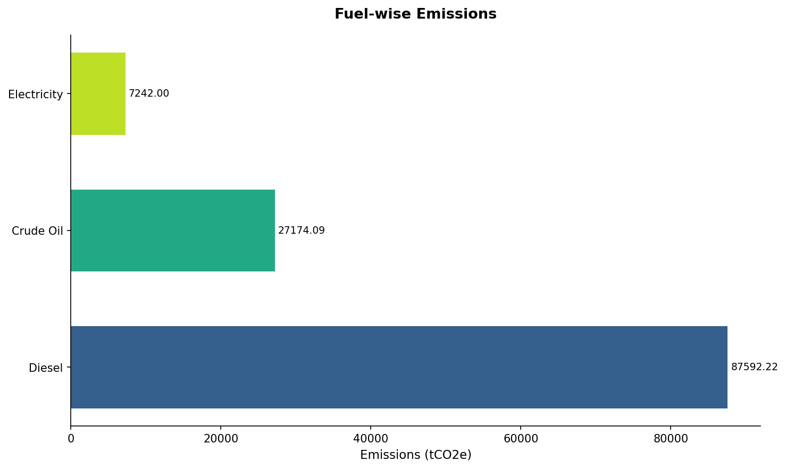
Figure: Fuel-wise Emission Distribution

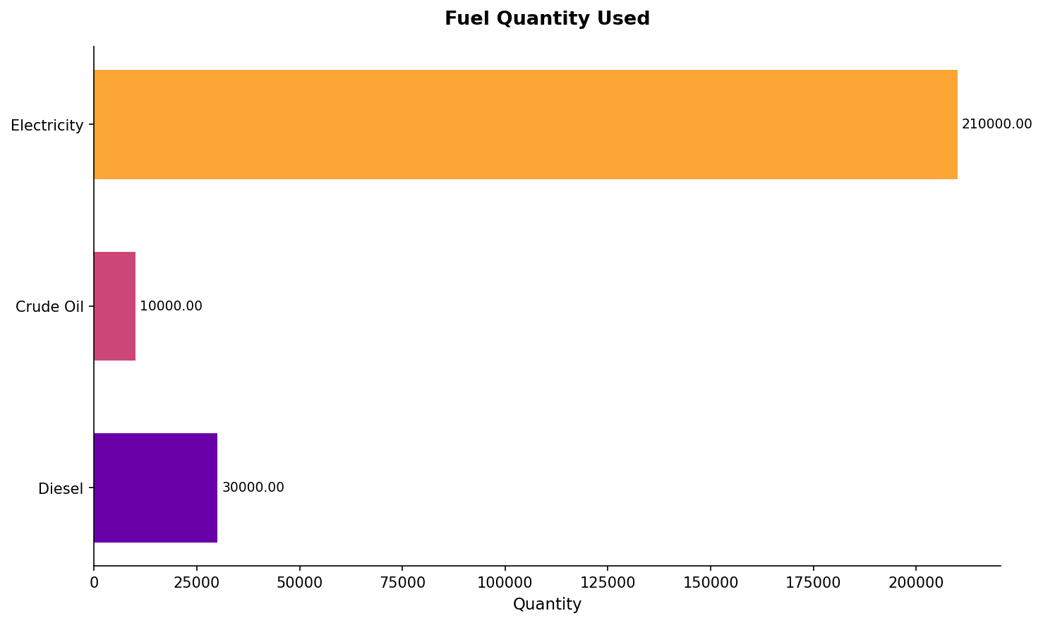
Figure: Fuel Quantity Distribution

3.3 Facility - test-somil

3.3.1 List of Emissions
Direct/Scope 1 Emissions: vol test - Diesel, testing5 - Diesel, testing6 - Diesel, testing4 - Diesel
Indirect/Scope 2 Emissions: Importing electricity from grid - Electricity

3.3.2 Source of Emissions
Direct/Scope 1 Sources: Diesel
Indirect/Scope 2 Sources: Electricity

3.3.3 Summary of GHG Emissions - February 2025 - February 2026
Scope | Category | Fuel | Month | tCO2e | tCO2 | tCH4 | tN2O
Scope 1 (Direct) | Stationary Combustion | Diesel | Jan-2026 | 3727.22
Scope 1 (Direct) | Stationary Combustion | Diesel | Feb-2026 | 16027.05
Scope 2 (Indirect) | Purchased Electricity | Electricity | Jan-2026 | 16.00
Scope 2 (Indirect) | Purchased Electricity | Electricity | Jan-2026 to Dec-2026 | 42.60
Scope 2 (Indirect) | Purchased Electricity | Electricity | Feb-2026 | 63.89

Total Emissions Direct (A) | 19754.27 tCO2e
Total Emissions Indirect (B) | 122.49 tCO2e
Total Emissions (A + B) | 19876.76 tCO2e
Total Removals/Sinks (C) | 0.00 tCO2e
Total Biogenic | 0.00 tCO2e
Total GHG Emissions (A + B - C) | 19876.76 tCO2e

3.3.4 Emissions of Previous Years
Category | Fuel | FY 2025
Stationary Combustion | Diesel | 75186.08

3.3.5 Analysis
The facility 'test-somil' has a total GHG emission of 19876.76 tCO2e for the reporting period.
Scope 1 (Direct) emissions contribute 99.4% while Scope 2 (Indirect) emissions contribute 0.6% of total emissions.

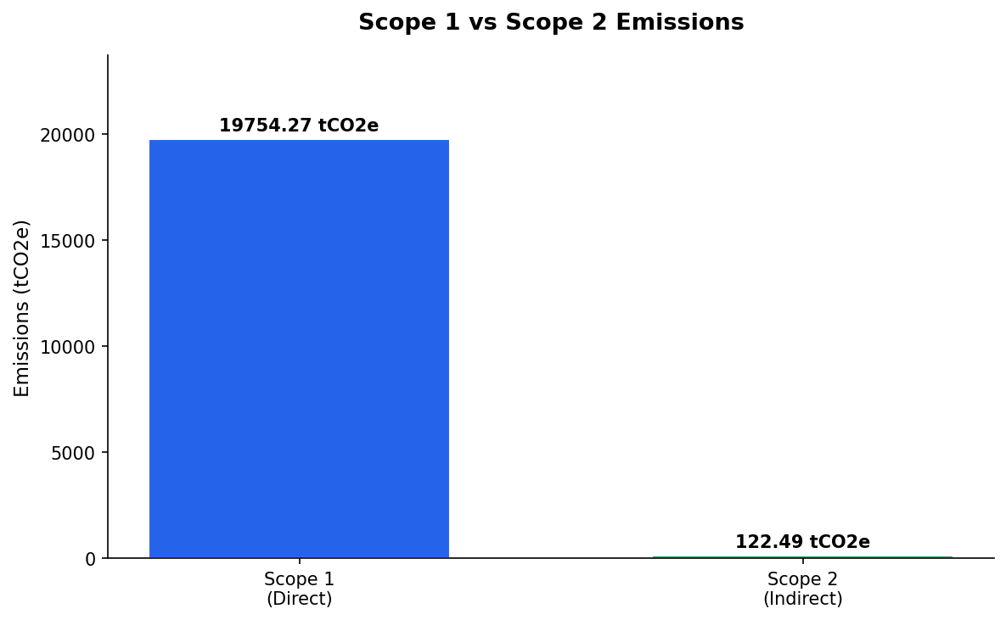
Figure: Scope 1 vs Scope 2 Emissions Comparison

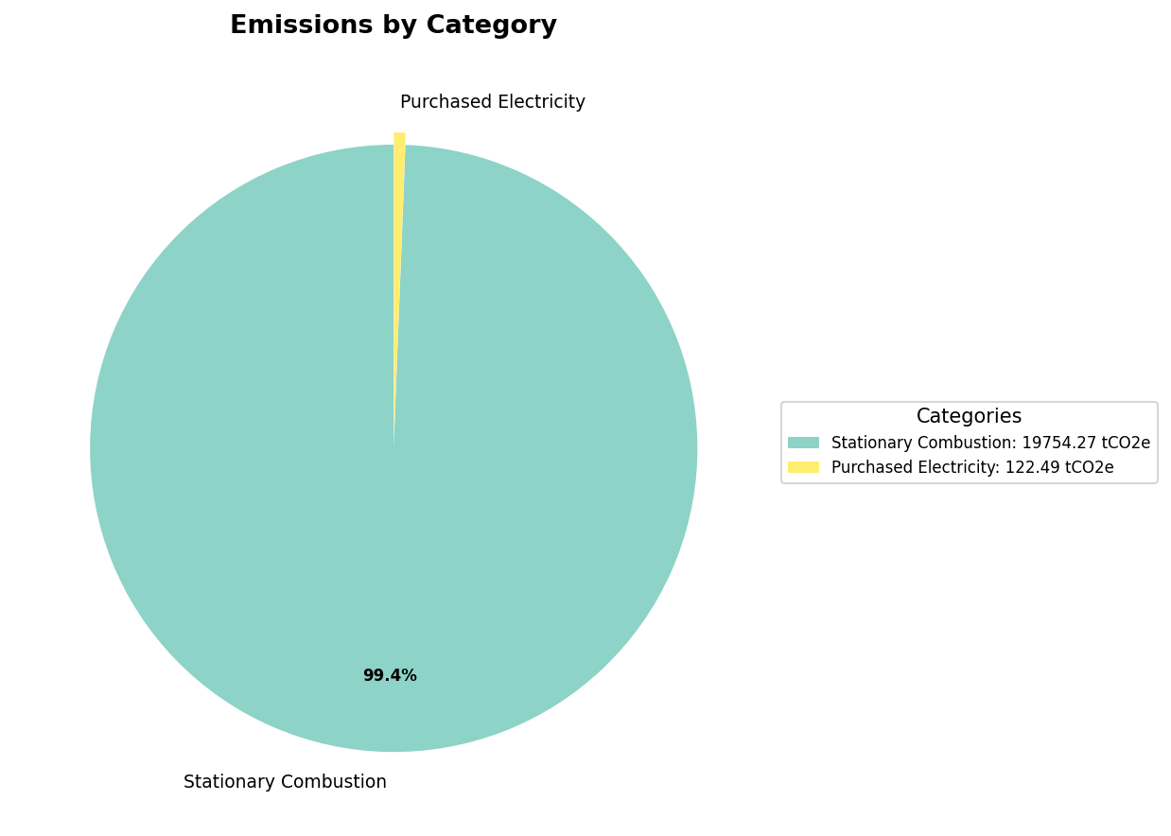
Figure: Category-wise Emission Distribution

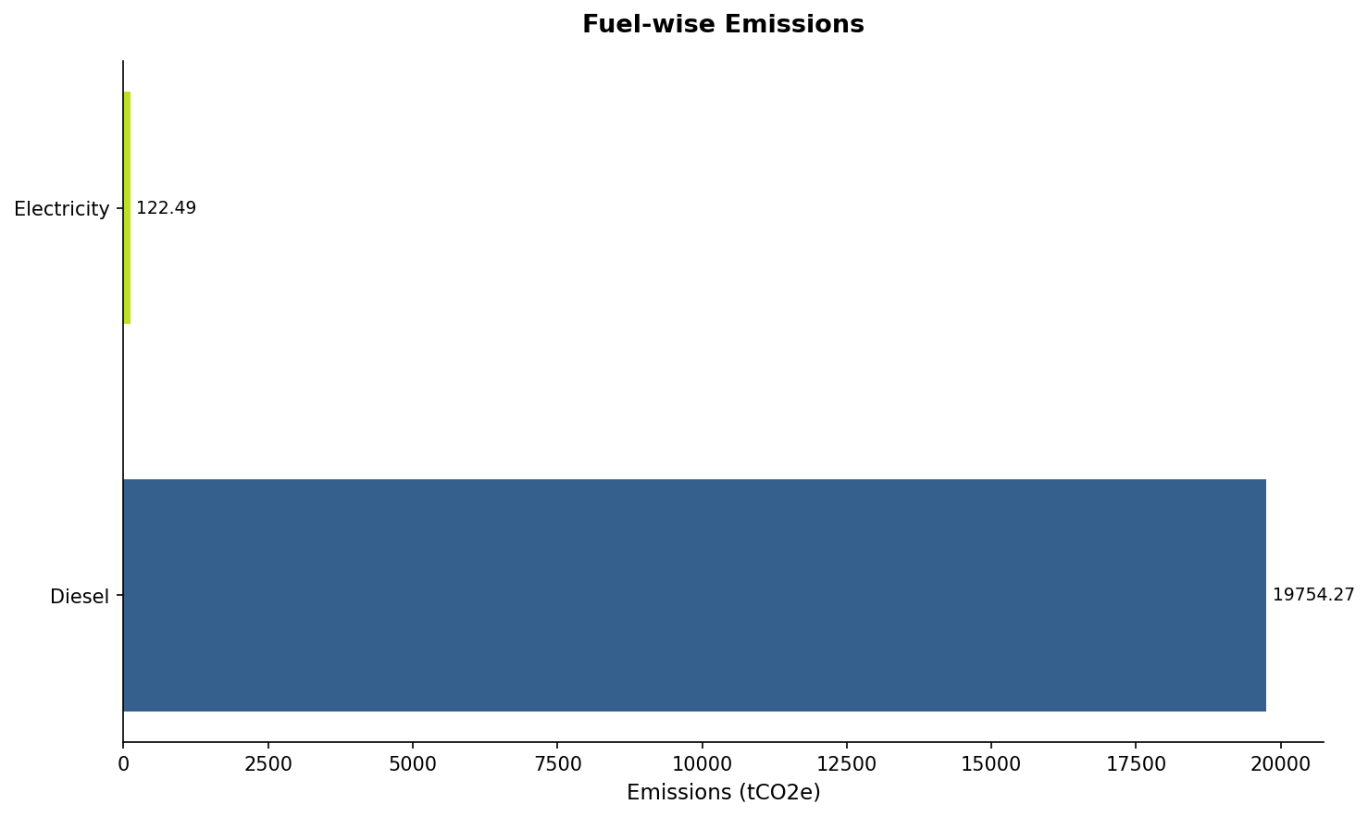
Figure: Fuel-wise Emission Distribution

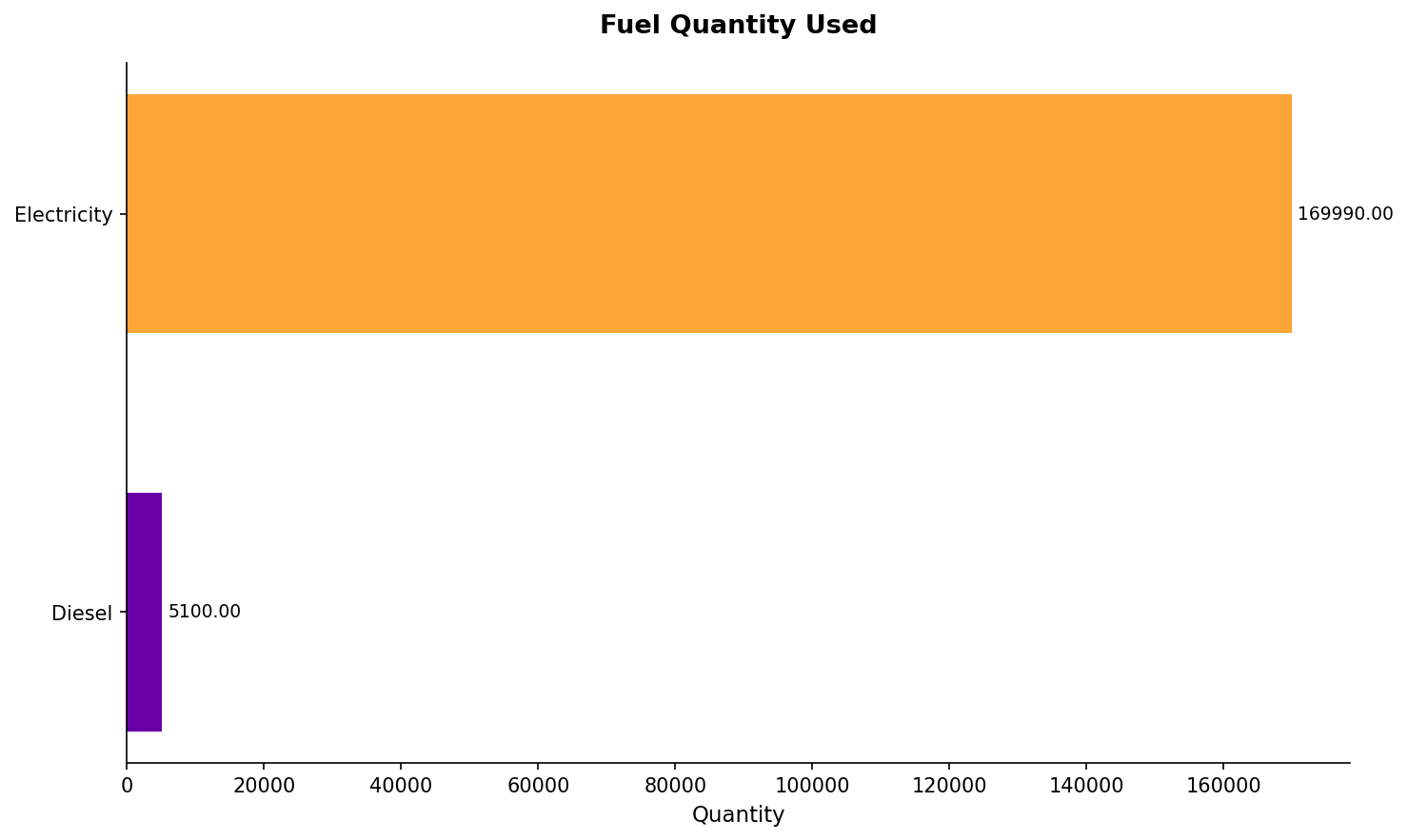
Figure: Fuel Quantity Distribution

3.4 Organization Emissions
Category | Fuel | Total Emissions (tCO2e)
Direct/Scope 1 Emissions
Stationary Combustion | Crude Oil, Diesel | 134520.58
Total Direct Emissions (A) |  | 134520.58
Indirect/Scope 2 Emissions
Importing electricity from grid | Electricity | 7364.49
Total Indirect Emissions (B) |  | 7364.49
Total Emissions (A + B) |  | 141885.07

3.5 Organization Analysis
The organization has a total GHG emission of 141885.07 tCO2e across 2 selected facility(ies) for the reporting period.

Facility-wise Emission Comparison:
test-ruthvik: 122008.31 tCO2e (86.0%)
test-somil: 19876.76 tCO2e (14.0%)

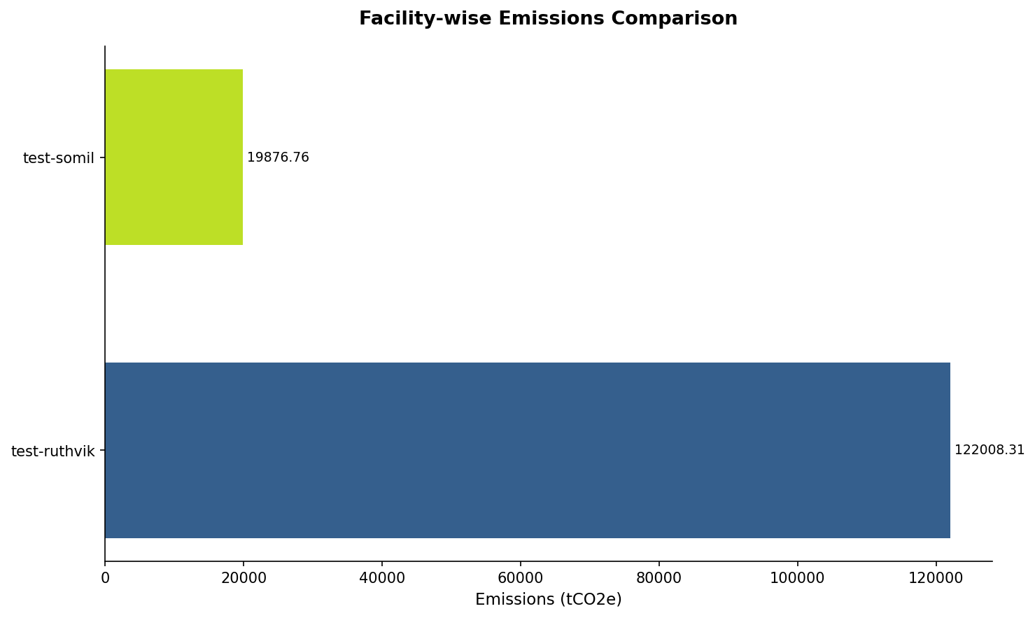
Figure: Facility-wise Emissions Comparison

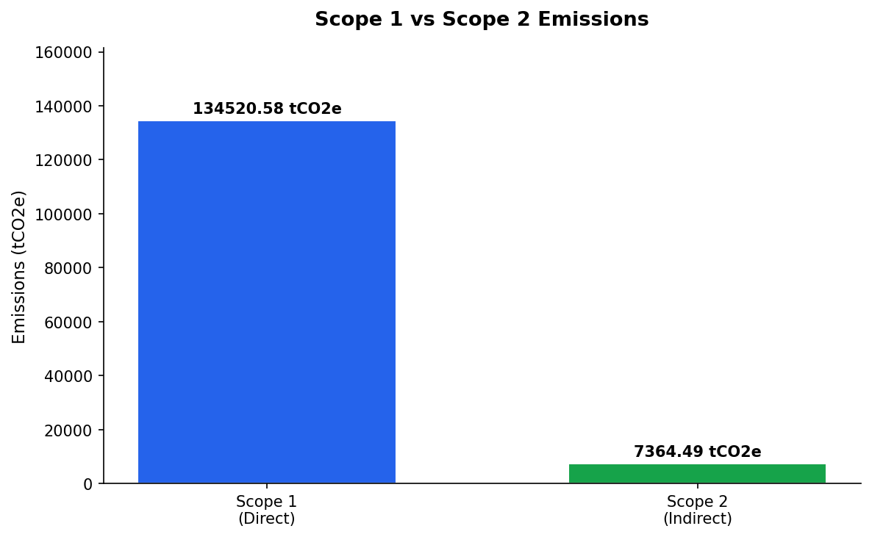
Figure: Organization Scope 1 vs Scope 2 Distribution

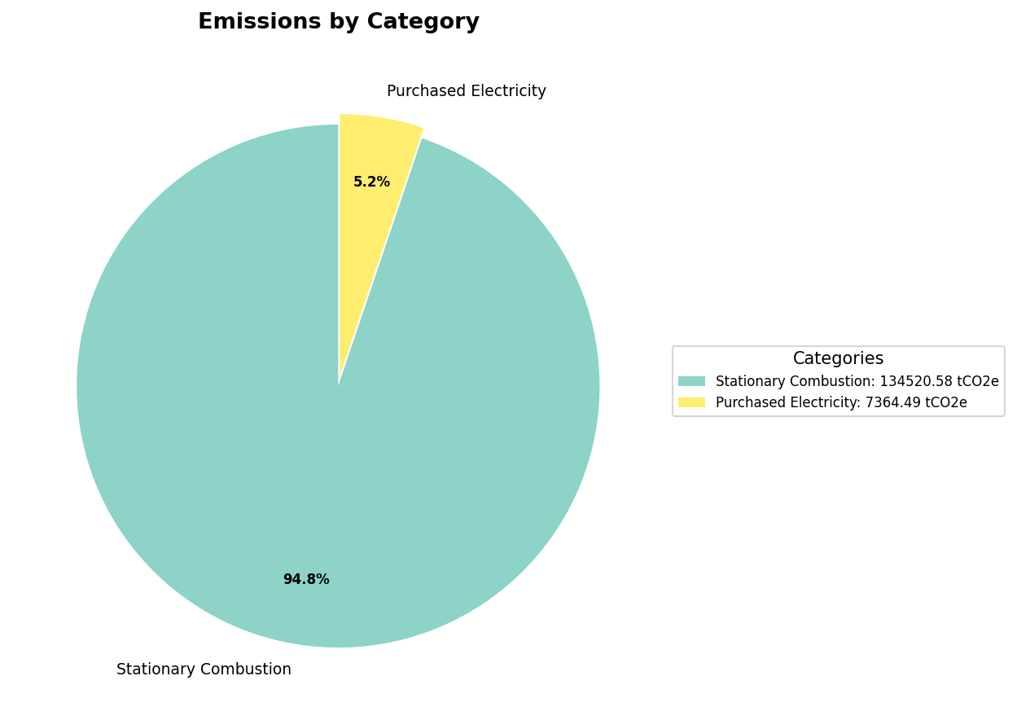
Figure: Organization Category-wise Emission Distribution

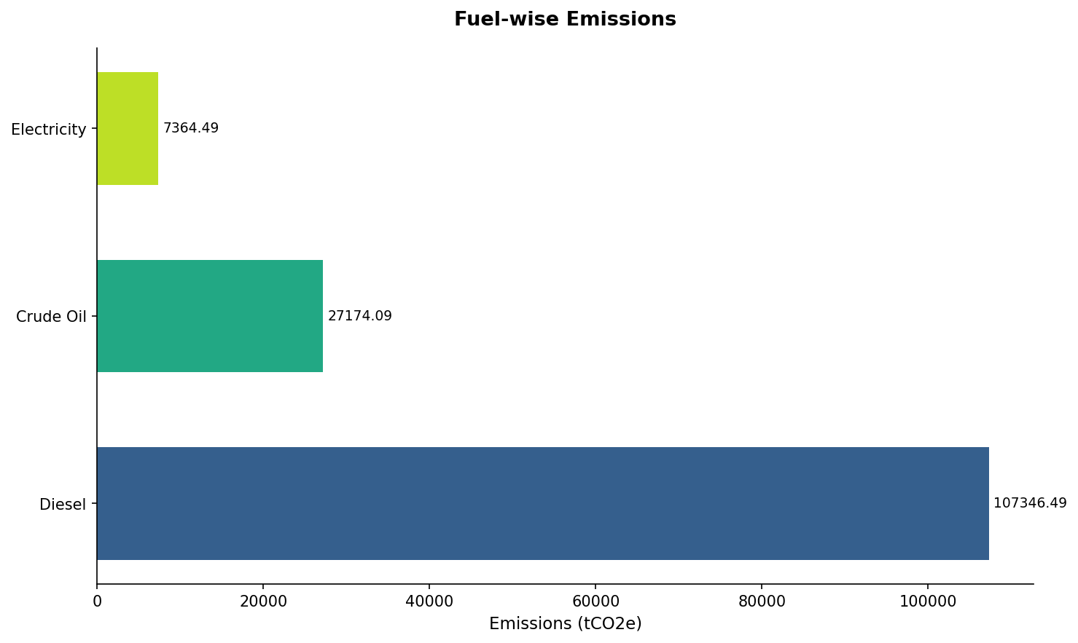
Figure: Organization Fuel-wise Emission Distribution

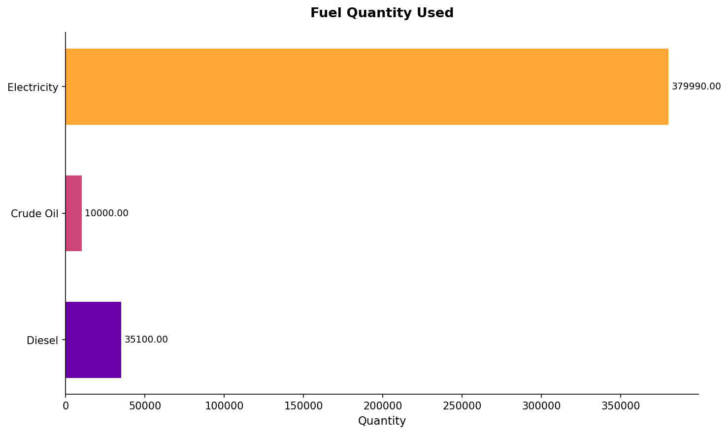
Figure: Organization Fuel Quantity Distribution

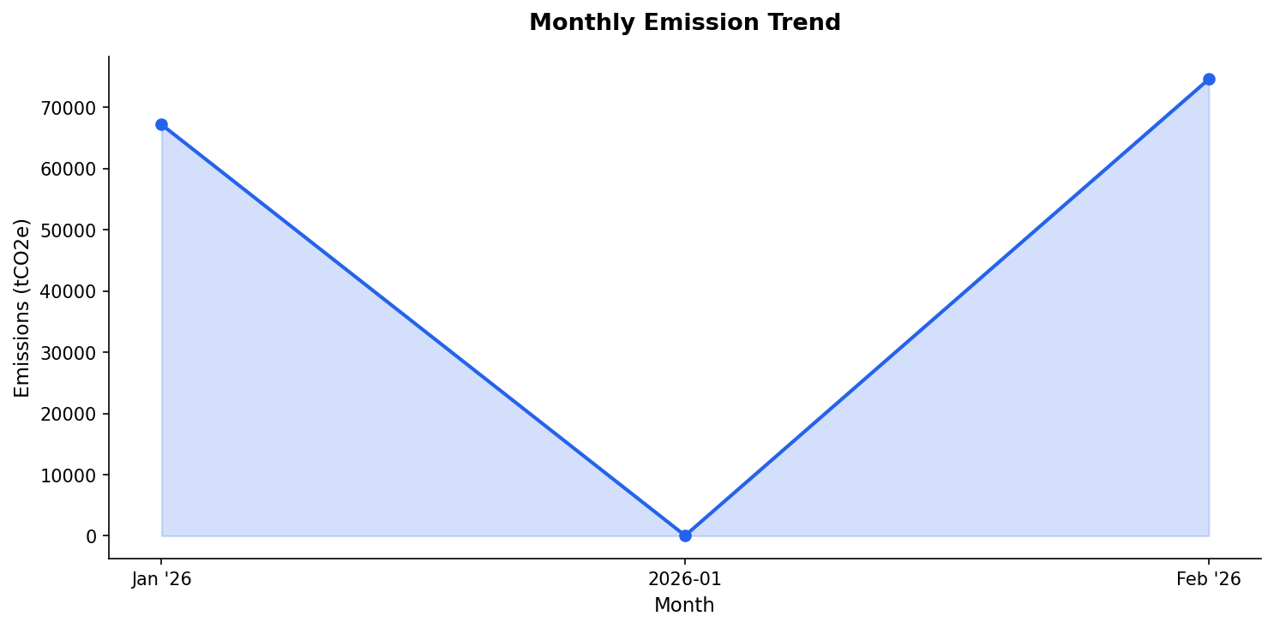
Figure: Monthly Emission Trend

Chapter 5: GHG REDUCTION INITIATIVE AND INTERNAL PERFORMANCE TRACKING
The organization report on its GHG reduction initiatives and the results of its internal performance tracking.
Reduction Initiatives
{ Reduction Initiatives}

Internal Performance Tracking
{ Internal Performance Tracking}

Chapter 6: Conclusion
The GHG report has been prepared in accordance with ISO 14064-1:2018 norms.
If any fact regarding GHG emission, which is not already being considered in the report, is identified on a later date after the report is being published, it will be notified to the verifying body for appropriate action.

{Organization Name} is committed to environmental protection and sustainable growth. Hence in its endeavor to continue this trend, the company will put all our efforts to bring down the GHG emissions further in future as well.

