Clarice D’Cunha (Retired)
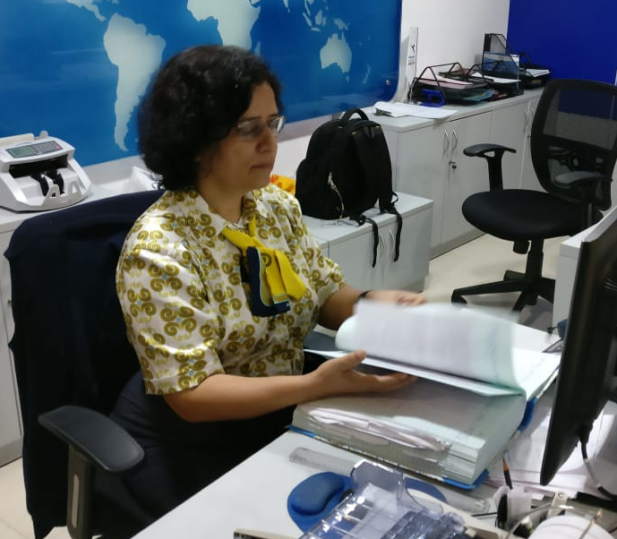

Being a retired person, I was in a search of an investment that would be safe and at the same time, fetch me good returns. Through one of my neighbor’s reference, I came across WEALTHY4EVER. They showed me the investment options that met all my goals. Who knew you could start financial planning at the age of 60? My best wishes. Keep growing!

Malav Shah (Lawyer)

WEALTHY4EVER always looks for the best way to maximize the return on my investment at minimum risk. They are knowledgeable and trustworthy financial planners. They are insightful about market investment opportunities and share recommendations based on facts. They are technically brilliant! For me, they are Subject Matter Experts who make sure that I understand the logic behind every decision we make. Having worked with them over the last 8 years, setting my finances in order, I am very confident about my finances today. They have taken care of my investments as their own. I am glad that I engaged with such thorough professionals.

Maitri Shah (CA professional)
I did feel that Financial Planning was important but could never really devote enough time for it. It was always low on my priority list. I would do ad-hoc investments in equity and mutual funds based on my friends’ tips, without thinking too much. I never tracked my investments. I realized that this was not the right approach and started looking for help. Internet obviously gave me huge amount of information, but it was all very distributed and inconsistent.
While browsing on the internet, I came across WEALTHY4EVER and contacted them. I was apprehensive before meeting them because I always thought Financial Planners essentially sell you insurance plans or investment schemes. My first meeting with them changed my perspective. The idea of financial planning, as explained to me by them, made a lot of sense. It was simple – you invest based on your goals. Over the next few meetings, I could see the importance of giving time to my finances. I rate them very high and strongly recommend them to you!

Somil Shah (Engineer)
Not being from a financial background, I was always scared to discuss about finance. One fine day scrolling through my Instagram feed, I stumbled upon WEALTHY4EVER. I could so relate to their memes. After seeing a few posts, I contacted them. Since then, everything has become so simple. With their pointed questions, I could figure exactly what my financial goals were in life and how I could reach them. They are super organized and thorough professionals.

Kishor Solanki (Human Resource Manager)

I have been investing since the past 20-25 years. I was reluctant to engage in a fee based financial planning. After all, when everything is available online for free, why pay for the advice? But eventually, I realized that there is a lot of unwanted information around, that confuses rather than convince you. So, it’s wise to have a professional financial planner by your side. WEALTHY4EVER professionals are very patient. Their ultimate objective is to make things understandable and clear to the client. They can simplify even the most complex investment products for you to comprehend. Their help in goal setting, mapping investing surplus to different goals, knowing me and my family’s risk profile, knowing when to disagree and why… has made my financial life clear and growth oriented. I get filtered information, which is relevant for me. They are a one-stop-shop for all my financial doubts.

Parinda Vedsen (Interior Designer)

I always thought that managing finance was my husband’s lookout. But after attending W4E’s Women’s Special Seminar, my perspective completely changed. They simplified everything for me. I could now understand finance so much better. They really know what they are talking about and strongly believe in it. Their approach is logical and reasonable. They are very open to discussions and suggestions. They examine what is presented to them and then lay down various options meeting your goal for you to decide your pick. Just like I design and execute interior designs for homes in accordance with their preference, WEALTHY4EVER designs and execute financial plans.
Parin Sheth (Debt-market Analyst)

My profession demands me to look at the markets all day long. To top it up, I also had to worry about my own investments. But now, having a professional handling all of that is a relief! The idea of financial planning, as explained to me by them, made a lot of sense. It was simple – you invest based on your goals. Over the next few meetings, I could see the importance of giving time to my finances. Now I am stress-free and can focus more on my work. I am able to give more time to the people who are important to me. I knew Financial Planning was important but didn’t know they have such an impact on your day-to-day life.

Aldrin Kanchan (Canada based Marketing Head)

I am currently working in Canada and also, earning my daily bread. I wanted to invest into Indian markets but couldn’t find a way to do it. Somehow, I came across WEALTHY4EVER and started investing with their help and expertise. They have answered my calls even at 2am IST just to answer my silly questions. They are always there to help you in any situation without any excuse. Services tendered by them are practical, transparent, honest, well-researched and above all, based on facts and figures. Prior to their services, I was very confused, feeling insecure about my investment decisions but after their consultation, I was relieved of my financial worries. It just took me 3 days to start implementing their financial advice and by the end of one month, I had achieved what I always wanted.

Sharal D’Souza (MH registered staff nurse working in London)

People have family doctors who know their health inside out. They know what kind of problems you are predisposed to and what medicine works best for you and your family. They are the first ones you call in an emergency and who are always available to help you out. In the same way, WEALTHY4EVER is my family doctor for finances. Based on my risk profile, they suggest solutions personalized for me. Before taking all major financial decisions, I discuss it with them. They are always there to guide me to make the right financial decisions. They also highlight the risks with the decisions I am taking. I am very confident about my financial health because of them.

Hetvi Doshi (Actuaries professional)

My experience with the whole financial planning and financial planner was excellent. I was in a mess and had no knowledge of Financial Planning. I used to read a lot of articles, invest as per advice of friends but all in vain. Now I am on track and can see some money at my disposal even for emergencies. One major thing I learned after working with WEALTH4EVER is that you save so much of time that you otherwise would have spent worrying about your investments, its returns, your goals or searching for better products, reading financial books, following Money-Control or CNBC and other media channels. With a financial planner by your side, you enjoy your time and give your time to the other important areas in your life. I am proud of my decision. I am hopeful and confident for a brighter future with help of WEALTHY4EVER.

N P Polyprints (printing business)

We are a printing partnership firm and WEALTHY4EVER has been planning our finances for more than 10 years. In this lockdown, our factory was shut. However, we still weren’t affected because we had kept emergency funds, over the last 7-8 years, which finally came to use. They take care of all our investments and insurance. They have financial solutions for everything – short term goals, long term goals, wealth creation, or wealth protection. They have helped us in claim settlements as well. They not only made financial plan for our partnership firm but also for most for all our partners and employees. Their approach is to educate clients in a way that is easily understood. I would highly recommend them to anybody who is looking for financial planning!

Nishit Doshi (Counselor & Teacher)

I used to invest money on my own without mapping them to my goals before I met WEALTHY4EVER. I always thought that the amount which I was investing was sufficient for me. But they opened my eyes. They showed me exactly how much I needed to invest and made a small one-page Financial Plan so that I could map all my investments to my goals and achieve them. They also provided me with an app where I can view all my investments and insurance policies in a single click. I am happy to have them provide me with their expert services.

