Three Branches of Musical Definition

**Figure 1**: Three Branches of Musical Definition (makenote)

Pitch Frequency (Midi)

Velocity (Midi)

Duration (milliseconds)

makenote

noteout

Input

Output

|  |  |  |  |  |  |  |
| --- | --- | --- | --- | --- | --- | --- |
| Note # | Pitch Frequency (Midi) | Velocity (Midi) | Duration (ms) | Bass Freq. (Midi) | Bass Velocity (Midi) | Bass Duration (ms) |
| 1 | 69 | 97 | 1000 | 50 | 79 | 500 |
| 2 | 65 | 80 | 1000 | 45 | 98 | 1000 |
| 3 | 65 | 85 | 1000 | 50 | 64 | 2000 |
| 4 | 64 | 68 | 0 | 50 | 69 | 500 |
| 5 | 64 | 92 | 0 | 52 | 79 | 1000 |
| 6 | 62 | 67 | 500 | 52 | 86 | 500 |
| 7 | 62 | 95 | 1000 | 53 | 89 | 500 |
| 8 | 62 | 85 | 2000 | 53 | 93 | 2000 |
| 9 | 65 | 91 | 500 | 52 | 78 | 2000 |
| 10 | 64 | 82 | 500 | 50 | 78 | 500 |
| 11 | 64 | 90 | 1000 | 47 | 76 | 500 |
| 12 | 62 | 95 | 500 | 43 | 87 | 2000 |
| 13 | 62 | 91 | 1000 | 47 | 84 | 1000 |
| 14 | 57 | 82 | 2000 | 41 | 80 | 1000 |
| 15 | 52 | 71 | 1000 | 40 | 89 | 500 |
| 16 | 52 | 62 | 0 | 38 | 72 | 1000 |
| 17 | 52 | 69 | 1000 | 43 | 60 | 500 |
| 18 | 50 | 88 | 0 | 40 | 83 | 500 |
| 19 | 55 | 88 | 500 | 40 | 73 | 500 |
| 20 | 55 | 81 | 500 | 38 | 96 | 500 |
| 21 | 55 | 87 | 500 | 38 | 60 | 0 |
| 22 | 52 | 92 | 500 | 40 | 90 | 0 |
| 23 | 50 | 76 | 1000 | 40 | 87 | 2000 |
| 24 | 50 | 69 | 1000 | 41 | 94 | 2000 |

**Table 1**: Numerical Data for First 24 Pulses (v2.0.1)

Final Product

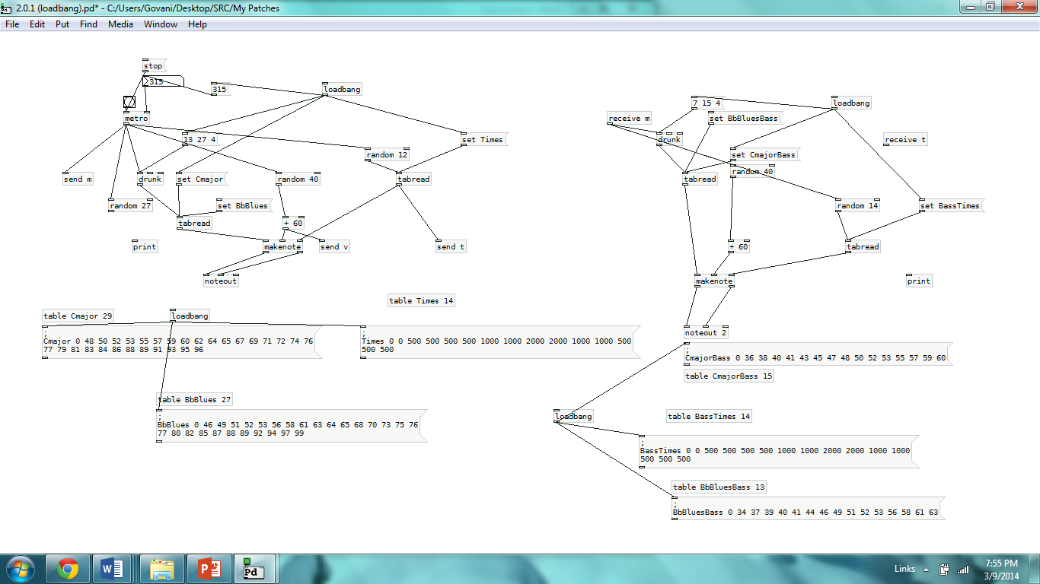

**Figure 3**: Final Patch (2.0.1)

**Figure 2:** Scientific Qualities in Music

**Figure 5**: Future Implementations