Ideation Phase

The IMovies Brainstorm and Idea Prioritization

Date | 25 October 2026
Team ID | Not assigned
Project Name | The IMovies
Maximum Marks | 4 Marks

Project context
This working session applies the IMovies project brief to identify ways to make movie discovery, showtime selection, and seat reservation clear and dependable. The ideas and priority estimates in this document are proposals for team discussion.
Use the idea pool and impact-versus-feasibility matrix as starting points. Confirm, revise, or reject them with the project team before treating them as requirements.
Planning basis: IMovies project brief supplied for this project.

Step 1: Define the challenge and perspectives

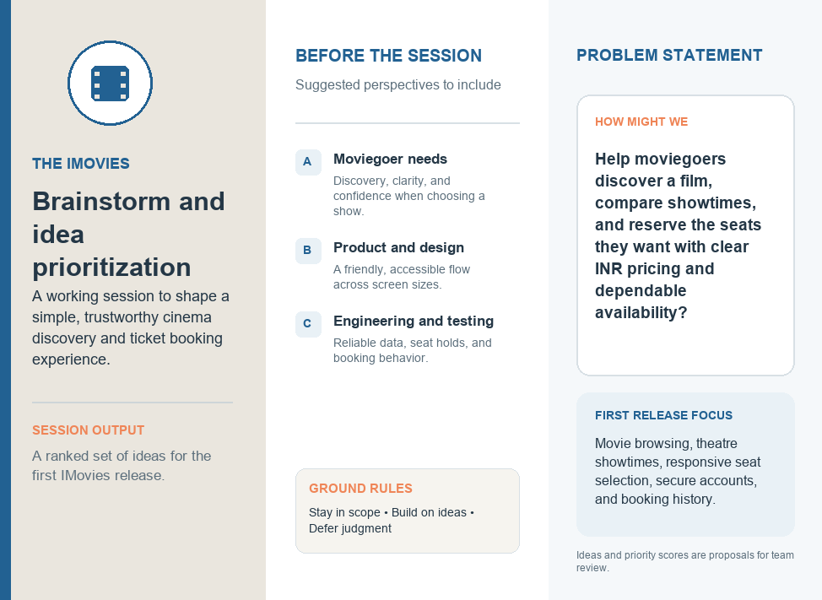

Step 2: Brainstorm and group ideas
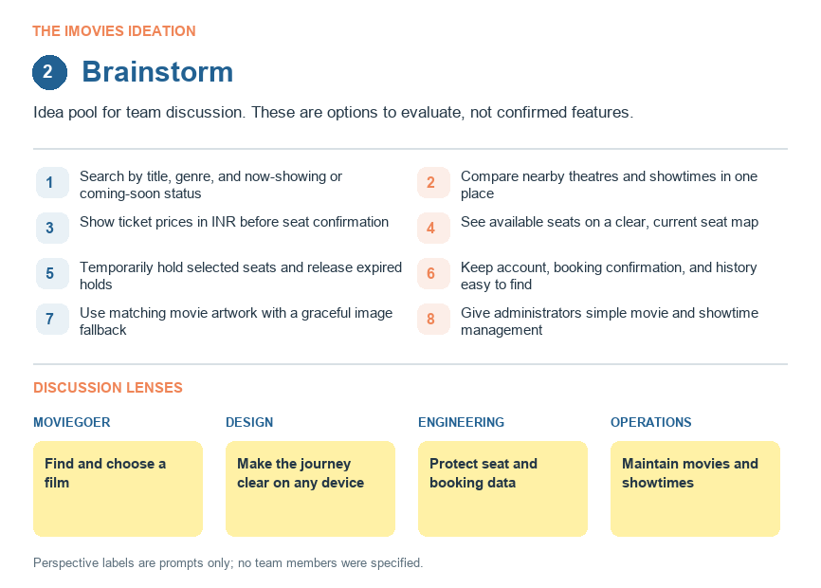
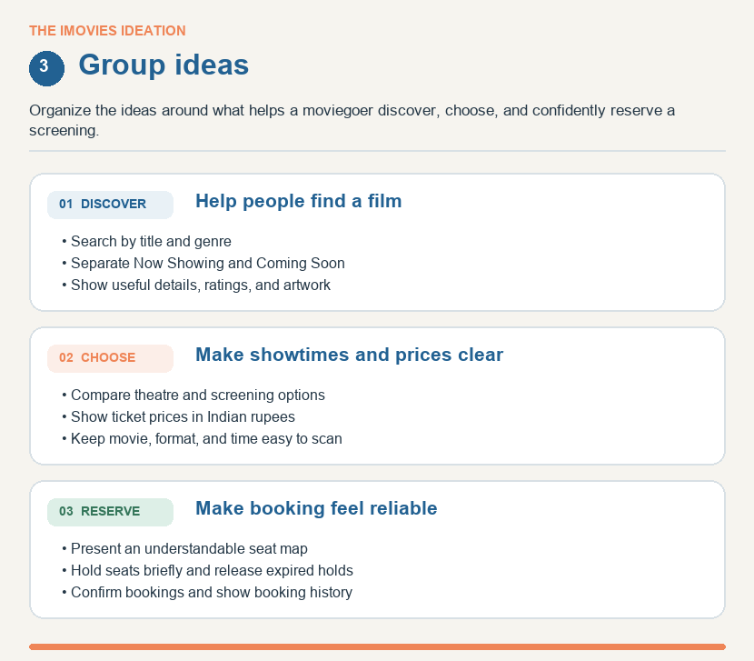

Step 3: Prioritize ideas by impact and feasibility
