Ideation Phase
Empathize and Discover

Date | 25 October 2026
Team ID | Not assigned
Project Name | The IMovies
Maximum Marks | 4 Marks

Empathy map purpose
Explore the possible needs, thoughts, feelings, and behaviors of a moviegoer using The IMovies to find a film, compare showtimes, and reserve seats. This map is based on the project brief and should be validated with real users.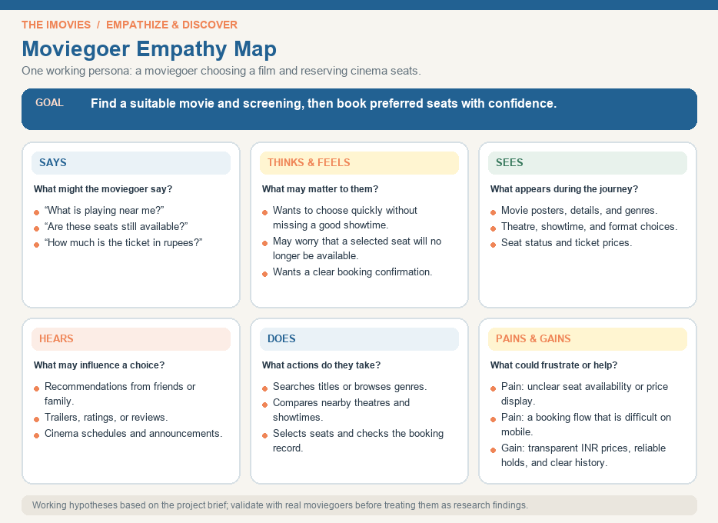

Validation note: Treat this map as a set of working hypotheses, not completed user research.

