Ideation Phase

The IMovies Problem Statements

Date | 25 October 2026
Team ID: | Not assigned
Project Name | The IMovies
Maximum Marks | 2 Marks

Purpose
These working problem statements translate the IMovies project brief into moviegoer needs around discovery, showtimes, seat availability, INR pricing, responsive booking, and reservation history. They are hypotheses to validate with target users, not findings from completed user research.
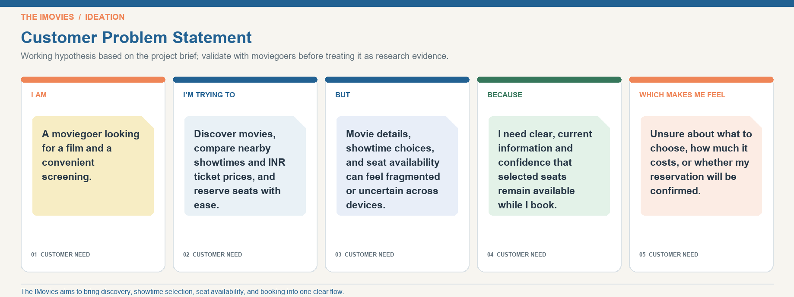
Method note: Statements are based on the supplied project description and should be validated with moviegoers.

Problem Statement (PS) | I am (customer) | I am trying to | But | Because | Which makes me feel
PS-1 | A moviegoer | discover movies and compare nearby showtimes | movie details and choices can be spread across screens | I need a searchable catalog with clear theatre, showtime, and movie details | unsure where to go or what to watch.
PS-2 | A ticket buyer | select preferred seats and confirm a reservation | seat availability may change while I am booking | I need current seat status and a clear temporary hold | uncertain whether my chosen seats are secured.
PS-3 | A price-conscious moviegoer | compare ticket costs before choosing a show | currency and price displays may be unclear or inconsistent | all booking steps should show accurate INR prices | confused about the cost.
PS-4 | A moviegoer using a phone | browse and finish a booking on mobile | search, showtime choice, and seat selection can be harder on small screens | the flow needs responsive layouts and accessible controls | frustrated or likely to abandon the booking.
PS-5 | A registered customer | review a booking confirmation and past reservations | confirmation and booking details may be difficult to find | I need a secure account area with clear booking history | unsure whether my reservation succeeded.

