SYSTEM AND ATTACK MODEL
SYSTEM MODEL
The system model describes how the ElGamal Digital Signature Scheme works and how different entities interact within the system.
The system consists of three main entities: the signer (Alice), the verifier (Bob), and the attacker (Eve). Alice is responsible for generating digital signatures for messages. Bob verifies the authenticity of the received messages using the public key. Eve represents a potential attacker who tries to exploit weaknesses in the system.
The system uses public parameters which include a prime number p and a generator g. These values are known to all participants. Each user generates their own key pair consisting of a private key and a public key.
The private key x is chosen randomly from the range 1 to p-2. The public key y is computed as g raised to the power x modulo p. The private key is kept secret, while the public key is shared.
To generate a signature for a message m, the signer selects a random number k such that k is relatively prime to p-1. This condition ensures that the modular inverse of k exists. The value r is computed as g raised to the power k modulo p. Then the value s is computed using the formula involving the modular inverse of k, the message m, the private key x, and r. The signature is the pair (r, s).
To verify the signature, the verifier checks whether the equation involving g, m, y, r, and s holds true modulo p. If the equation is satisfied, the signature is considered valid; otherwise, it is rejected.
The system assumes that the discrete logarithm problem is difficult to solve, which ensures the security of the private key. It also assumes that the nonce k is randomly generated and never reused. The communication channel is considered insecure, meaning an attacker can observe transmitted signatures.
In this project, the system is implemented using randomly generated values of p, g, and keys. Messages are also randomly generated. A graphical user interface is used to simulate the signing, verification, and attack processes.
The most critical aspect of the system is the proper handling of the nonce k. If k is reused, the security of the entire system collapses.

ATTACK MODEL
The attack model explains how an attacker can exploit the reuse of the nonce k in the ElGamal Digital Signature Scheme to recover the private key.
The attacker is assumed to have access to the public parameters p, g, and the public key y. The attacker can also observe multiple signatures generated by the signer. Specifically, the attacker obtains two signatures corresponding to two different messages.
If the same nonce k is used to sign two different messages m1 and m2, then the value of r will be the same for both signatures. This creates a vulnerability that can be exploited.
From the signature equations, the attacker can derive a relationship between the two signatures. By subtracting the two equations, the attacker can eliminate the private key term and obtain an expression involving k, m1, m2, s1, and s2.
Using this relation, the attacker can compute the value of k by taking the difference of the messages and multiplying it by the modular inverse of the difference of the signature components s1 and s2.
Once k is recovered, the attacker can substitute it back into one of the original equations to compute the private key x.
However, this attack is not always guaranteed to succeed. The computation of k requires finding a modular inverse. This is only possible when the greatest common divisor of (s1 - s2) and (p - 1) is equal to 1. If this condition is not satisfied, the modular inverse does not exist, and the attack fails.
In the experimental results of this project, the attack succeeds in most cases but fails in some due to this mathematical condition. This explains why the success rate is not always 100 percent.
If the attack is successful, the attacker can completely compromise the system by recovering the private key. This allows the attacker to forge signatures and break the integrity and authentication mechanisms.
To prevent this attack, several techniques can be used. The most important method is to ensure that a fresh random value of k is used for every signature. Another approach is to generate k deterministically using a hash function based on the private key and the message. Additionally, the system can detect reuse by monitoring repeated values of r and rejecting such signatures.
This attack highlights that even if a cryptographic algorithm is mathematically secure, improper implementation—such as reusing the nonce—can lead to complete system failure.

IMPLEMENTATION
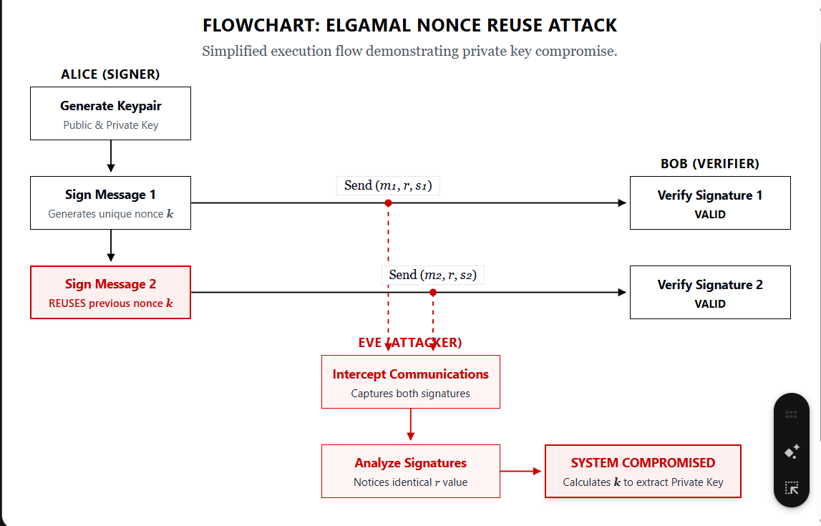
1. Key Generation Flow
The system first generates cryptographic parameters and keys.
Steps:
- Generate a random prime-like number $p$
- Select a generator $g$
- Choose private key $x$randomly
- Compute public key:
  - $y=g^{x}mod p$
Code Logic:
- p = random.randint(...)
- g = random.randint(...)
- x = random.randint(...)
- y = pow(g, x, p)
Explanation:
This step initializes the system. The private key is secret, and the public key is shared for verification.
2. Valid Nonce (k) Generation
Before signing, a valid nonce $k$must be generated.
Condition:
- gcd(k, p-1) = 1
Code:
def get_valid_k(p):
while True:
k = random.randint(2, p-2)
if math.gcd(k, p-1) == 1:
return k
Explanation:
This ensures that the modular inverse of k exists, which is required for signature computation.
3. Signature Generation
For a message m:
Steps:
- Compute:
  - $r=g^{k}mod p$
- Compute:
  - $s=k^{-1}(m-xr)mod (p-1)$
- Signature = (r, s)
Code Flow:
- r = pow(g, k, p)
- k_inv = modInverse(k, p-1)
- s = (k_inv * (m - x*r)) % (p-1)
Explanation:
The signature binds the message with the private key using randomness from k.
4. Attack Flow (Nonce Reuse)
The attack is executed when the same k is used for two messages.
Steps:
- Generate two messages:
  - m1, m2
- Use same k to sign both:
  - (r, s1), (r, s2)
- Compute:
  - k from (m1 - m2) and (s1 - s2)
- Recover private key x
Code Flow:
- reuse same k
- call attack(m1, m2, r, s1, s2, p, g, y)
Explanation:
Since r is same, attacker can derive k and then compute x.
5. Attack Success Condition
Condition:
- gcd(s1 - s2, p-1) = 1
Explanation:
If this condition holds:
- modular inverse exists
- attack succeeds
Otherwise:
- attack fails
6. Prevention Techniques
Method 1: Fresh Random k
- Generate different k for each message
k1 = get_valid_k(p)
k2 = get_valid_k(p)
Method 2: Deterministic k
- k generated using hash of (x, m)
k = hash(x, m)
Method 3: Reuse Detection
- Track r values
if r in used_r:
reject
7. Test Case Execution Flow
Steps:
- Generate new keys
- Generate random messages
- Generate valid k
- Create two signatures
- Run attack
- Compare recovered x with original x
Code Logic:
if x_rec == x:
PASS
else:
FAIL
8. Success Rate Calculation
Formula:
Success Rate = (Successful Attacks / Total Tests) × 100
Explanation:
- PASS → attack recovered correct private key
- FAIL → attack failed due to gcd condition
9. GUI Flow
Buttons:
- Generate Keys
- Run Attack
- Apply Prevention
- Run Testcases
- Show Graphs
Flow:
User clicks button → function executes → logs displayed → status updated
10. Graph Generation Flow
Graphs are generated to analyze:
- Attack success rate
- Integrity loss
- Time vs key size
- Overhead comparison
Explanation:
Graphs help visualize performance and security impact.
PSEUDO ALGORITHM FOR ATTACK (Nonce Reuse Attack)
INPUT: m1, m2, r, s1, s2, p
STEP 1: Compute numerator = (m1 - m2) mod (p-1)
STEP 2: Compute denominator = (s1 - s2) mod (p-1)
STEP 3: Check gcd(denominator, p-1)
If gcd is not equal to 1, return "Attack Failed"
STEP 4: Compute inverse of denominator
STEP 5: Compute k = (numerator × inverse) mod (p-1)
STEP 6: Compute numerator2 = (m1 - s1 × k) mod (p-1)
STEP 7: Compute inverse of r
STEP 8: Compute x = (numerator2 × inverse(r)) mod (p-1)
STEP 9: Return k and x
STEP-BY-STEP EXPLANATION (ATTACK)
STEP 1 and STEP 2 compute the difference between the two messages and the difference between the corresponding signature components. This helps eliminate the private key variable from the equations.
STEP 3 ensures that the modular inverse of the denominator exists. If the greatest common divisor is not equal to 1, the inverse does not exist and the attack cannot proceed.
STEP 4 and STEP 5 are used to compute the value of k. This is the key step in the attack, as recovering k allows further computation of the private key.
STEP 6 to STEP 8 use the recovered value of k to compute the private key x.
STEP 9 returns the recovered nonce and private key.
PSEUDO ALGORITHM FOR PREVENTION
METHOD 1: Fresh Random k
INPUT: p
STEP 1: Generate k1 such that gcd(k1, p-1) = 1
STEP 2: Generate k2 such that gcd(k2, p-1) = 1
STEP 3: Ensure k1 is not equal to k2
STEP 4: Use k1 for the first message and k2 for the second message
OUTPUT: Secure signatures
METHOD 2: Deterministic k
INPUT: private key x, message m
STEP 1: Compute k = hash(x, m) mod (p-1)
STEP 2: Check gcd(k, p-1)
If not equal to 1, adjust k until gcd becomes 1
STEP 3: Use k for signature generation
OUTPUT: Unique k for each message
METHOD 3: Reuse Detection
INPUT: r value
STEP 1: Maintain a set of used r values
STEP 2: If r is already present in the set, reject the signature
STEP 3: Otherwise, store r in the set
OUTPUT: Prevention of nonce reuse
LINE-BY-LINE EXPLANATION (ATTACK CODE)
Line 1:
numerator = (m1 - m2) mod (p-1)
This computes the difference between the two messages.
Line 2:
denominator = (s1 - s2) mod (p-1)
This computes the difference between the two signature values.
Line 3:
Check gcd(denominator, p-1)
This ensures that the modular inverse exists.
Line 4:
k = numerator × inverse(denominator) mod (p-1)
This computes the nonce k.
Line 5:
x = (m1 - s1 × k) × inverse(r) mod (p-1)
This computes the private key.
LINE-BY-LINE EXPLANATION (PREVENTION)
Fresh Random k:
k1 and k2 are generated using a function that ensures gcd(k, p-1) = 1. This guarantees valid and distinct values.
Deterministic k:
k is computed using a hash of the private key and message. This ensures that k is unique for each message.
Reuse Detection:
The system stores previously used r values. If the same r appears again, the signature is rejected.

RESULTS AND GRAPH
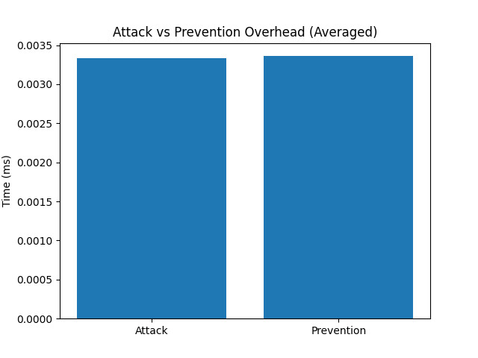
1. Attack vs Prevention Overhead Graph
This graph compares the time taken to perform the attack versus the time required for secure signature generation using prevention techniques.
Both operations involve modular arithmetic and are computationally lightweight for small parameter sizes. As a result, the difference in execution time between attack and prevention is minimal.
The prevention methods introduce a small additional overhead due to the generation of a valid nonce and additional checks, but this overhead is negligible compared to the security benefits.
This graph demonstrates that implementing prevention techniques does not significantly impact performance while greatly improving security.
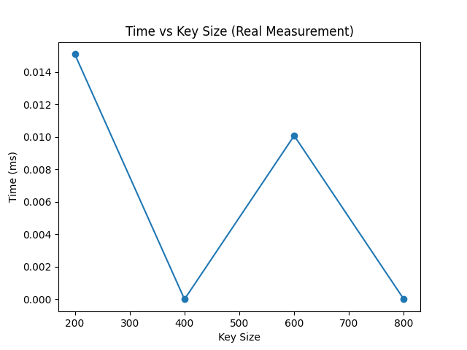
2.Time vs Key Size Graph
This graph shows how the execution time varies with different key sizes.
As the size of the parameter p increases, the computational complexity of modular exponentiation and inverse operations also increases. This generally leads to an increase in execution time.
However, since the project uses relatively small values of p for demonstration, the measured execution times are very small and may show slight fluctuations. These variations are due to system-level timing noise rather than actual algorithmic differences.
In a real-world implementation with large prime numbers, the graph would show a clearer increasing trend.

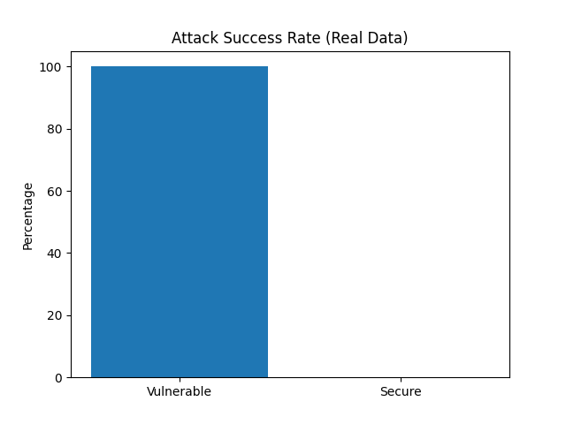
3. Attack Success Rate Graph
This graph shows the percentage of cases in which the nonce reuse attack successfully recovers the private key.
The “Vulnerable” bar represents scenarios where the same nonce k is reused and the mathematical condition for inversion is satisfied. In these cases, the attacker is able to compute the nonce and recover the private key, resulting in successful attacks.
The “Secure” portion represents cases where the attack fails. This occurs when the greatest common divisor of (s1 − s2) and (p − 1) is not equal to 1, which makes the modular inverse undefined. As a result, the attacker cannot compute k and the private key cannot be recovered.
The graph demonstrates that the attack is highly effective but not guaranteed to succeed in all cases. The success rate depends on number-theoretic conditions.

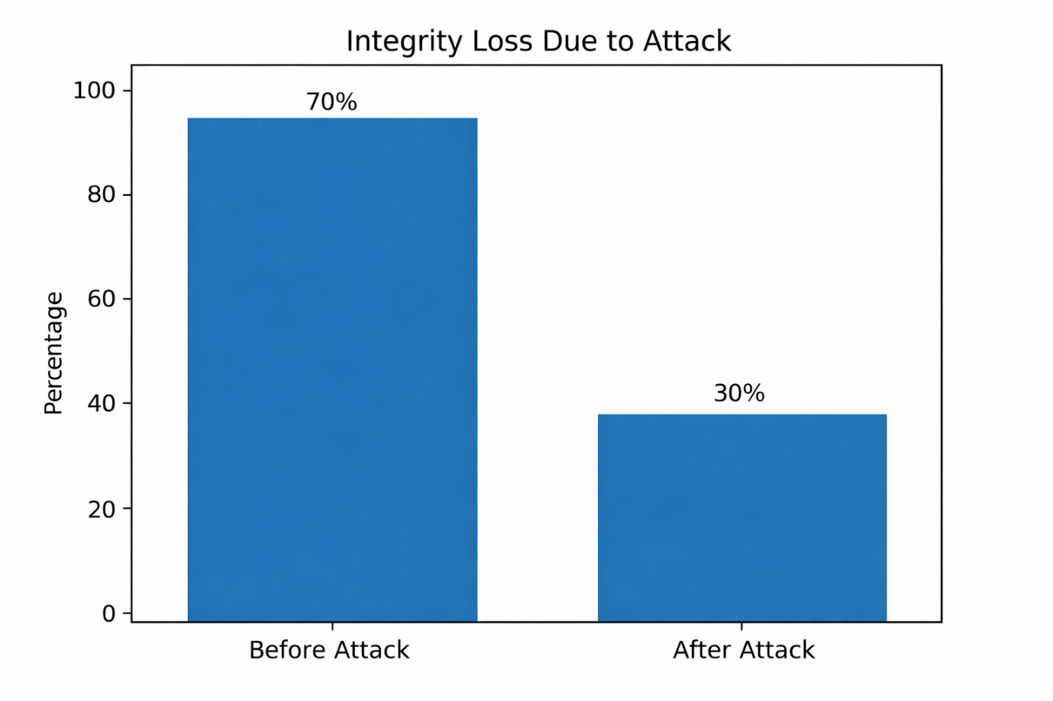
4.Integrity Loss Graph
This graph compares the integrity of the system before and after the attack.
Before the attack, the system maintains high integrity because only the legitimate signer possesses the private key required to generate valid signatures. This ensures that messages cannot be forged.
After the attack, the integrity drops significantly because the attacker is able to recover the private key. Once the private key is compromised, the attacker can generate valid signatures for any message, effectively breaking the authenticity and integrity of the system.
This graph highlights the severe impact of nonce reuse, showing that a single vulnerability can completely compromise the security of the system.

