**Name: Somit Jain**

**Reg. No. 20BDS0181**

**Course: Mathematical Modelling for Data Science(CSE3045 ELA)**

**Faculty: Dr. Ilanthenral K P S K**

**Slot: L49+L50**

**Lab-Assignment 2**

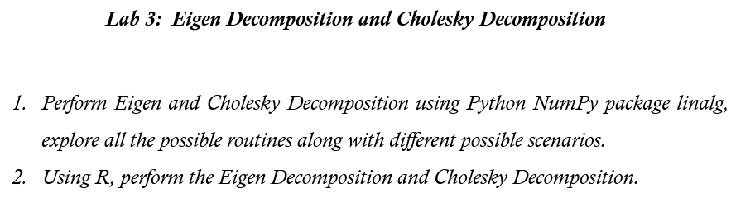

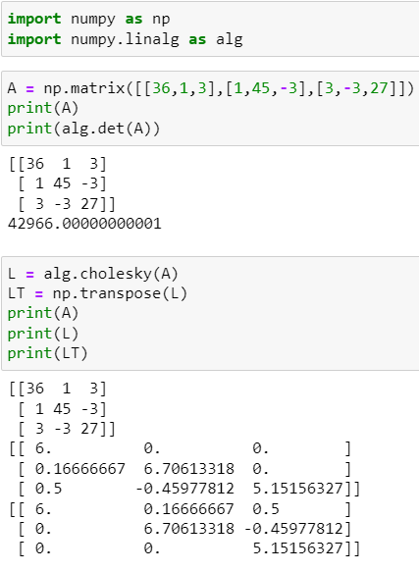

When matrix is not positive definite:

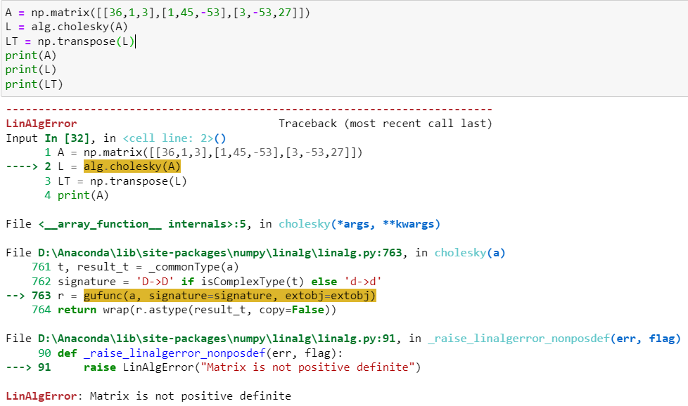

When matrix is not square matrix:

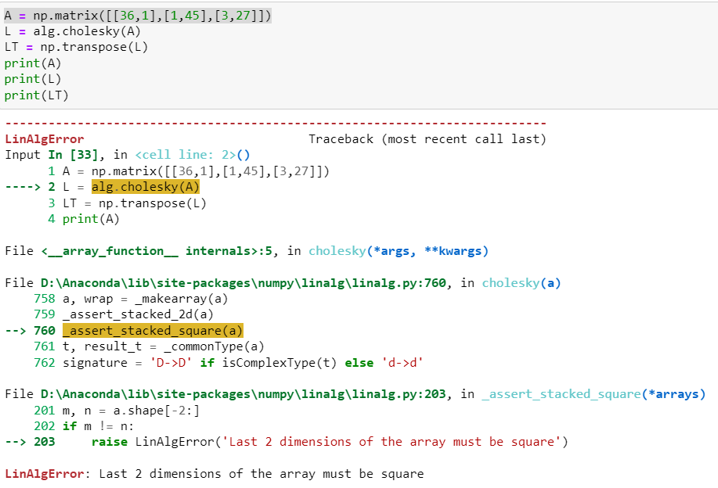

EIGEN VALUES:

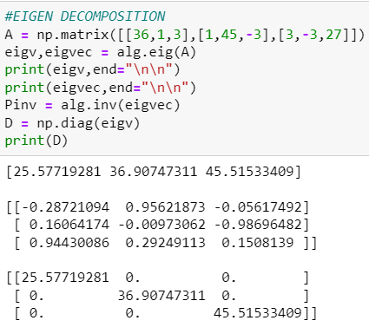

When matrix is not square matrix:

