SAIC sysadmin test 2022

Somit gond

B21138

**Challenge 1 :**

Nmap scan results:

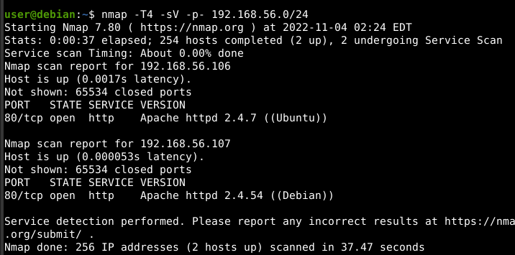\

By visiting the website I got to knew it us running cutenews 2.0.3 .After searching for bit I found arbitrary file upload vulnerability in cutenews 2.0.3 website. So I found a php script powny shell (<https://github.com/flozz/p0wny-shell>) to get a shell .

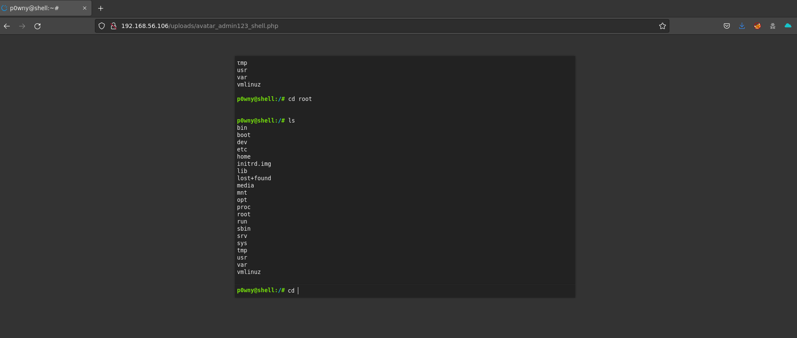

To get reverse shell I went to revshell.com and then copied php revshell command which I ran in powny_shell terminal and got reverse shell.

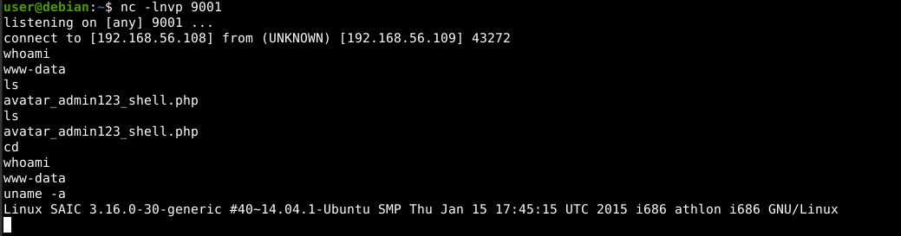

I found it is running ubuntu 14.04 . I found a script to get root shell on it.

I found this VM is similar to hackthebox Passage box . I found different writeups about . I found users and their password hashes But I was not able to crack it.

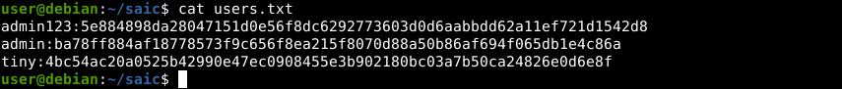

**Task 2:**

Approach : change environment variable for http_proxy and https_proxy when connected to wifi

**Task 4:**

My Dockerfile for CP-Dashboard-main webapp

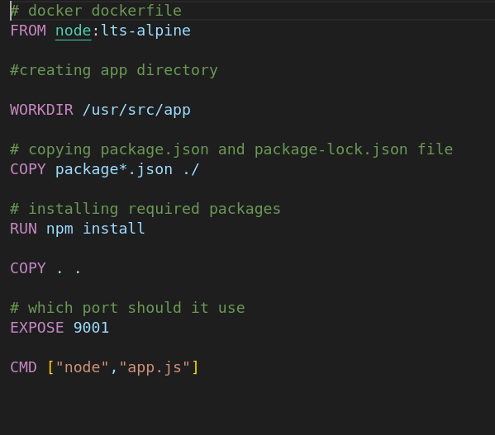

Error encountered:

