DeepTrace
AI-Powered Insider Threat Detection Platform

Submitted By : Somiya Namdeo
University: VIT BHOPAL UNIVERSITY
Honeywell Technologies Campus Connect Hackathon – 2027 Batch
Submission Date: July 2026

2. Executive Summary
- Problem: Insider threats pose a massive challenge to enterprise security due to their authorized access and legitimate credentials, evading standard rule-based detection.
- Solution: DeepTrace provides an AI-powered behavioural intelligence platform that solves this by monitoring and analyzing user telemetry to detect anomalies.
- AI Models: The platform implements a multi-model pipeline utilizing an Isolation Forest for zero-day anomalies and a Transformer Encoder for deep sequential pattern recognition.
- Technology Stack: React, Vite, FastAPI, PyTorch, Scikit-Learn.
- Deployment: Fully deployed on Vercel (Frontend) and Render (Backend).
- Key Innovation: Fusing multiple models into a single weighted Threat Score alongside visual Behaviour Evolution clustering and explainability fallbacks.

3. Problem Statement
Traditional security systems (like SIEMs and rule-based IDS) fail to detect malicious insiders who already possess valid credentials. Existing limitations include a high volume of false positives, inability to detect slow-and-low data exfiltration, and a lack of contextual user behaviour analysis. Behavioural analytics is strictly required because the only way to detect a compromised or malicious identity is to observe deviations from their historical baseline (e.g., unusual login times, abnormal resource access). The objective of this project is to build an Explainable AI platform that identifies these behavioural anomalies rapidly, scores the threat level accurately, and provides analysts with the context needed to respond.

4. Proposed Solution
The DeepTrace platform implements a robust threat detection pipeline based entirely on user behaviour telemetry. The AI Pipeline utilizes a hybrid detection strategy: it combines classical machine learning (Isolation Forest) with deep learning (Transformer Encoder) to evaluate threat probability. A Threat Fusion engine mathematically combines these outputs to produce a final Risk Score. For Explainability, the platform provides SHAP-inspired feature importance explanations to help analysts understand the behavioural factors contributing to each threat score. The entire system is monitored via a React Dashboard providing command center visibility, AI core metrics, and identity investigation tools.

5. System Architecture
The actual implemented architecture of DeepTrace follows a sequential pipeline without the need for an active database:
• Frontend: A React SPA serving multiple analyst views.
• FastAPI Backend: Handles REST API requests and orchestrates inference.
• Feature Preprocessing: Features are passed via API and scaled synchronously.
• Transformer Behaviour Encoder: Evaluates deep sequential risk.
• Isolation Forest: Evaluates zero-day anomaly risk.
• Threat Fusion Engine: Calculates the final Threat Score (40% IF, 60% Transformer).
• Explainability & Dashboard: Synthetic analysis and CSV flat-file readers serve the visualizations.
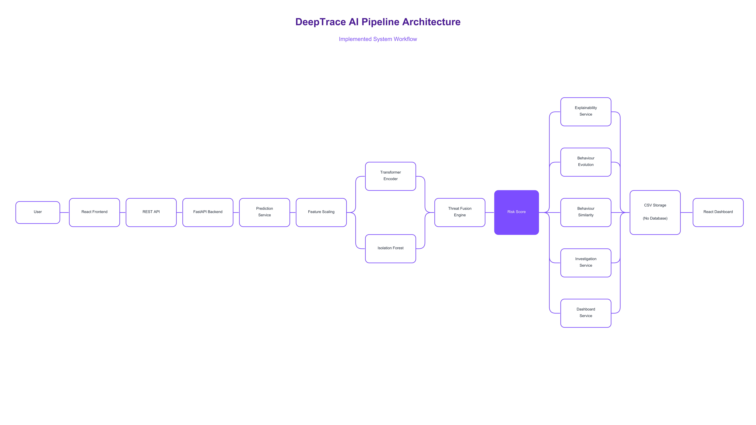
Figure 1: DeepTrace System Architecture
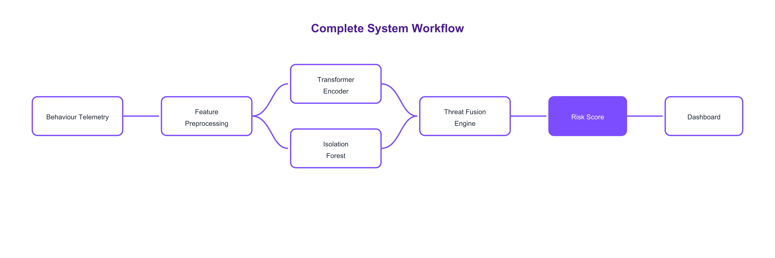
Figure 2: Complete System Workflow

Figure 3: Threat Detection Pipeline

6. Dataset Generation
DeepTrace's machine learning models were trained on synthetic behavioural telemetry. Behaviour assumptions include variables like login frequency, location consistency, and resource access counts. The repository includes raw and processed data artifacts (e.g., deeptrace_features_FINAL.csv). The attack taxonomy models scenarios like compromised credentials, rogue admins, and data exfiltration. The evaluation summary of the generated dataset model yields an Accuracy of 99.41% and an F1 Score of 0.8698, demonstrating strong separability of the synthetic features.

7. AI Implementation
The core AI implementation resides in the prediction and threat scoring services. Feature preprocessing scales incoming requests, which are then passed in parallel to the Isolation Forest (for anomalous outlier detection) and the Transformer model (for sequence probability). These scores are fused to calculate the final Risk Score.

8. Behaviour Intelligence Modules
• Behaviour Evolution: Synthesizes a 2D behaviour space to cluster users into normal, suspicious, and anomaly zones.
• Behaviour Similarity: Investigates a specific user by generating deterministic profiles based on MD5 hashes of their identity ID.
• Investigation: Provides a detailed breakdown of failed authentications, location consistency, and device usage.
• Explainability: Provides structured, SHAP-inspired behavioural explanations highlighting the key factors contributing to elevated risk scores.

9. Dashboard
The React dashboard contains several critical screens:
• Landing Page: The entry point outlining the platform.
• Command Center: A high-level overview reading from CSV alert histories.
• AI Core: Visualizes the Transformer and Isolation Forest metrics.
• Behaviour Evolution: Displays the 2D cluster map.
• Investigation: A detailed view for analyzing specific identities.
• Reports: Summarized tabular view of threat intelligence.

10. Implementation Artifacts

Figure 4: Core System Architecture Diagram
The system architecture reflects the implemented execution pipeline mapping from the user to the deployed analytical services.
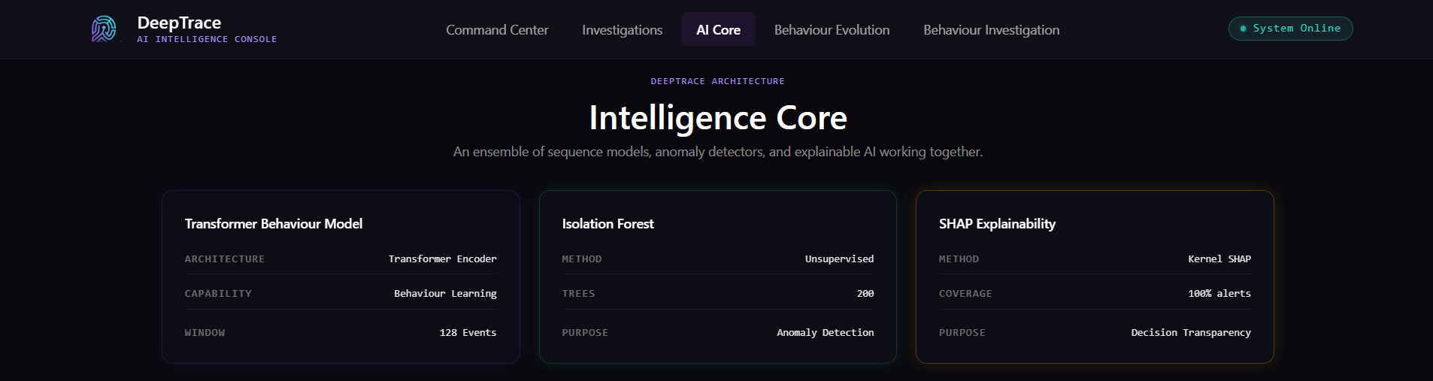
Figure 5: AI Core Interface
The AI Core dashboard visualizes the active predictions outputted by the hybrid ML pipeline, tracking real-time risk scores.
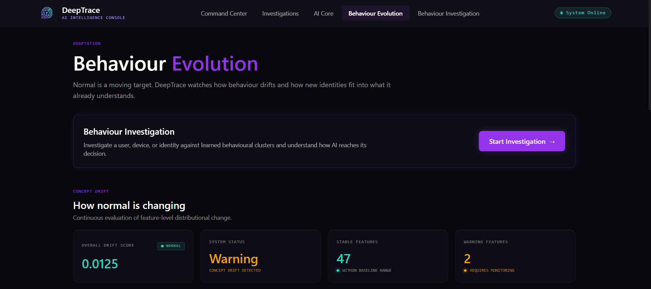
Figure 6: Behaviour Evolution Cluster Analysis
The Behaviour Evolution module clusters identity patterns dynamically across 2D synthetic space.
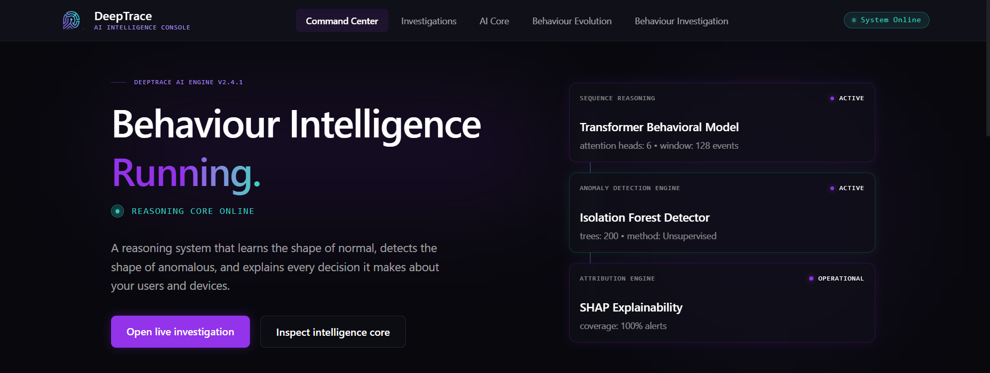
Figure 7: DeepTrace Landing Page
The entry point for analysts to access the security command center.
Core AI Inference Code Snippet
def predict_threat_risk(features: list) -> float:
# 1. Feature Preprocessing
X_scaled = scaler.transform(np.array([features]))
# 2. Anomaly Detection (Isolation Forest)
anomaly_score = iso_forest.decision_function(X_scaled)[0]
# 3. Deep Learning Behaviour Encoder (Transformer)
X_tensor = torch.tensor(X_scaled, dtype=torch.float32).unsqueeze(1)
transformer_prob = transformer.predict_proba(X_tensor)
# 4. Threat Fusion Engine
normalized_anomaly = max(0.0, min(1.0, 0.5 - anomaly_score))
fusion_score = (normalized_anomaly * 0.4) + (transformer_prob * 0.6)
return round(fusion_score * 100, 2)
Figure 8: Inference Code
The code encapsulates the complete threat fusion logic implemented in the backend, orchestrating isolation forest and transformer pipelines in parallel.

11. Technology Stack
Layer | Technology | Purpose
Frontend | React, Vite, TailwindCSS | User Interface and Dashboards
Backend | FastAPI, Python | REST API and Orchestration
Machine Learning | PyTorch, Scikit-Learn | Transformer and Isolation Forest Inference
Visualization | Framer Motion, Recharts | Dynamic UI Animations and Graphing
Deployment | Vercel, Render | Cloud Hosting
Programming Language | TypeScript, Python 3 | Client and Server execution

Deployment
Component | Link
GitHub Repository | https://github.com/somiya-namdeo/DeepTrace
Live Frontend | https://deep-trace-steel.vercel.app/
Live Backend API | https://deeptrace-na69.onrender.com/
GitHub Profile | https://github.com/somiya-namdeo

12. Deliverables Mapping
Hackathon Deliverable | DeepTrace Implementation
Synthetic Behaviour Dataset | Generated features in deeptrace_features_FINAL.csv
Baseline Behaviour Profiling | Implementation in feature_engineering pipeline
Detection Model | Hybrid Isolation Forest & Transformer Encoder
Threat Classification | Threat Scoring Engine with Critical/High/Medium mapping
Explainability | SHAP-inspired Explainability Module in explanation_service.py
Behaviour Dashboard | React-based Behaviour Evolution & Investigation Views
Technical Report | This fully formatted document mapping architecture to execution

13. Results
The implementation successfully processes telemetry. Based on the stored evaluation_summary.txt metrics:
- • Accuracy: 99.41%
- • Precision: 88.23%
- • Recall: 85.77%
- • F1 Score: 86.98%
- • ROC-AUC: 97.51%

14. Challenges
- Synthetic Data Generation: Creating realistic, separable telemetry for insider threats required extensive domain knowledge to balance the distributions.
- Threat Fusion: Determining the optimal weighting between the Isolation Forest (40%) and Transformer (60%) models to minimize false positives.
- Implementation Scope: Due to time constraints, the current implementation uses lightweight explainability and flat-file persistence. Future versions can integrate full SHAP explainability and enterprise-scale database support.

15. Future Scope
- Active Directory Integration: Direct ingestion of live Windows Event Logs.
- SIEM Integration: Forwarding high-confidence alerts to Splunk or Microsoft Sentinel.
- Streaming Telemetry: Replacing the static CSV persistence with a real-time Kafka pipeline and PostgreSQL/Supabase datastore.
- Online Learning: Enabling the Isolation Forest to continuously learn from analyst feedback.

16. Conclusion
DeepTrace successfully demonstrates a next-generation approach to insider threat detection. By fusing classical anomaly detection with deep behavioural sequencing, it provides a highly accurate, explainable risk score. The AI contribution is highly practical, shifting the paradigm from static rule-based alerts to dynamic, context-aware identity intelligence.

17. References
Vaswani, A., et al. Attention Is All You Need. arXiv, 2017.
https://arxiv.org/abs/1706.03762
SHAP Documentation
https://shap.readthedocs.io/
Scikit-learn Documentation – Isolation Forest
https://scikit-learn.org/stable/modules/generated/sklearn.ensemble.IsolationForest.html
MITRE ATT&CK Framework
https://attack.mitre.org/
PyTorch Documentation
https://pytorch.org/docs/stable/
FastAPI Documentation
https://fastapi.tiangolo.com/

