**data** a;

x=**1**;

**run**;



**data** a;

x=**1**;

y='sdfsdf';

**run**;



**data** a;

x=**1**; output;

x=**2**;

**run**;



**data** a;

x=**1**; output;

x=**2**; output;

**run**;



**data** a;

do i=**1** to **4**;

end;

**run**;



**data** a;

do i=**1** to **4**;

output;

end;

**run**;

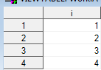

**data** a;

do x=**1** to **3**;

y=i;

output;

end;

**run**;

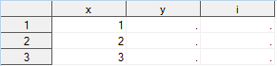

**data** a;

do x=**1** to **3**;

y=x;

output;

end;

**run**;

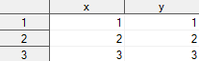

**data** a;

do x=**1** to **3**;

output;

end;

**run**;

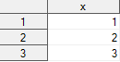

**data** b;

set a;

x=x+**100**;

**run**;

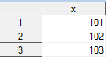

**data** b;

set a;

y=x+**100**;

**run**;

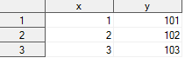

**data** b;

put _all_;

set a;

put _all_;

y=x+**100**;

put _all_;

**run**;

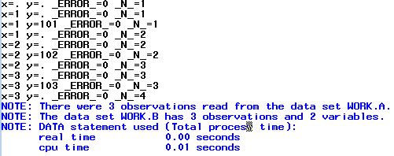



**data** b;

put 'Pierwszy ' _all_;

set a;

put 'Drugi ' _all_;

y=x+**100**;

put 'Trzeci ' _all_;

**run**;

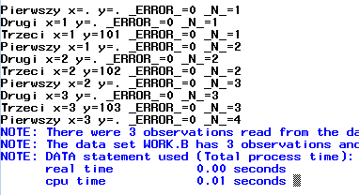



**data** a;

do x=**1** to **5**;

output;

end;

**run**;

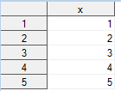

**data** c;

set a;

if mod(x,**2**)=**0** then v=v+**1**;

**run**;

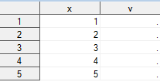

**data** c;

v=**0**;

set a;

if mod(x,**2**)=**0** then v=v+**1**;

**run**;

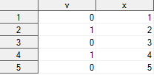

**data** c;

if _n_=**1** then v=**0**;

set a;

if mod(x,**2**)=**0** then v=v+**1**;

**run**;

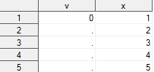

**data** c;

retain v **0**;

set a;

if mod(x,**2**)=**0** then v=v+**1**;

**run**;

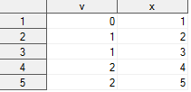

**data** c;

retain v **0**;

set a;

if mod(x,**2**)=**0** then v=v+**1**;

keep v;

**run**;

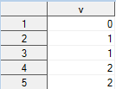

**data** c;

retain v **0**;

set a end=koniec;

if mod(x,**2**)=**0** then v=v+**1**;

if koniec=**1** then output;

keep v;

**run**;



**data** c;

set a end=koniec;

if mod(x,**2**)=**0** then v+**1**;

if koniec then output;

keep v;

**run**;



**data** b;

set a;

y=lag(x);

**run**;

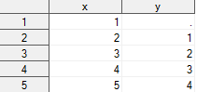

**data** b;

set a;

y=lag2(x);

**run**;

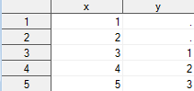

**data** b;

set a;

y=lag(x);

z=dif(x);

**run**;

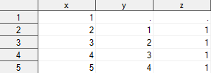

**data** a;

do i=**5** to **1** by (-**1**);

output;

end;

**run**;

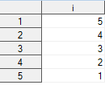

**data** a;

do x='A','B','C';

ile=**1**+floor(**10**\*ranuni(**0**));

do i=**1** to ile;

y=floor(**10**\*ranuni(**0**));

output;

end;

end;

drop i ile;

**run**;

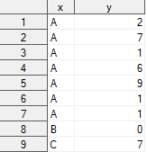

**data** b;

set a;

by x;

p=first.x;

o=last.x;

**run**;

