**data** a;

do x=**1** to **5**;

output;

end;

**run**;

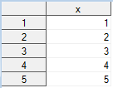

**data** b;

set a;

if not (x=**.**) then new=x;

**run**;

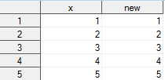

**data** b;

set a;

if not x=**.** then new=x;

**run**;

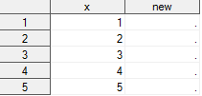

**data** b;

do i=**1** to **5**;

if mod(i,**3**)=**0** then leave;

output;

end;

**run**;



**data** b;

do i=**1** to **5**;

if mod(i,**3**)=**0** then continue;

output;

end;

**run**;

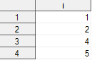

**data** a;

do x=**1** to **3**;

y=**.**;

output;

end;

drop x;

**run**;

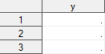

**data** b;

set a;

retain suma **0**;

suma=suma+y;

**run**;

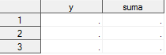

**data** b;

set a;

suma+y; * dziala jak funkcja …………………………… (domyslnie . to zera);

**run**;

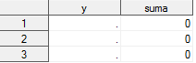

**data** a;

do x='AA', 'BBB', 'CCCC';

do y=**1** to **3**;

z=floor(**10**\*ranuni(**0**));

output;

end;

end;

**run**;

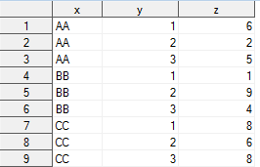

**data** b;

set a;

by x;

put _all_;

**run**;

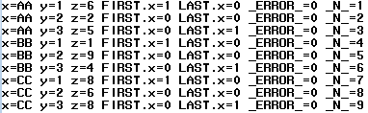

**data** a;

input x y;

cards;

2 3

23 25

23 22

2 4

23 22

1 2

1 2

;

**run**;

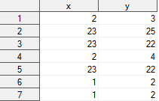

**proc** **sort** data=a out=b;

by x;

**run**;

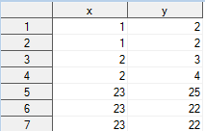

**proc** **sort** data=a out=b;

by x y;

**run**;

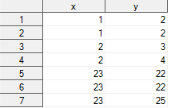

**proc** **sort** data=a out=b noduprecs;

by x;

**run**;

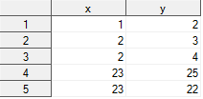

**proc** **sort** data=a out=b nodup;

by x;

**run**;



**proc** **sort** data=a out=b nodupkey;

by x;

**run**;

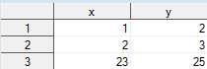

* da info o zbiorze b;

**proc** **contents** data=b out=info;

**run**;

**data** a;

do i=**5** to **1** by (-**1**);

output;

end;

**run**;

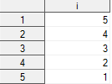

**data** b;

set a;

by descending i;

**run**;

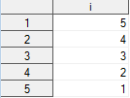

**data** a;

do x='A', 'B', 'C';

ile=**1**+floor(**10**\*ranuni(**0**));

do i=**1** to ile;

output;

end;

end;

keep x;

**run**;

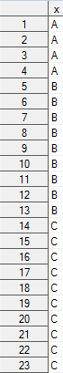

**data** a;

input x1 x2 x3 x4 x5;

cards;

1 2 3 4 5

2 3 4 5 6

3 4 5 6 7

4 5 6 6 8

;

**run**;

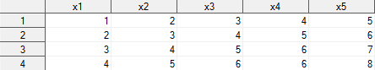

**data** b;

set a;

x1=x1+**100**;

x2=x2+**100**;

x3=x3+**100**;

x4=x4+**100**;

x5=x5+**100**;

**run**;

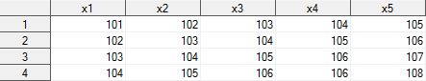

**data** b;

set a;

array tablica(**5**) x1 x2 x3 x4 x5;

do i=**1** to **5**;

tablica(i)=tablica(i)+**100**;

end;

drop i;

**run**;



**data** b;

set a;

array tablica(*) x1-x5;

do i=**1** to dim(tablica);

tablica(i)=tablica(i)+**100**;

end;

drop i;

**run**;



**data** a;

array z(**3**) $ z1 a x ('aa','bbb','ccccc')

**run**;



**data** a;

do x=**1** to **5**;

output;

end;

**run**;

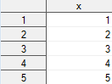

**data** b;

set a;

array tablica(**3**) (**3**\***7**);

**run**;

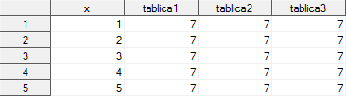

**data** b;

set a;

array tablica(**3**);

if _n_=**1** then

do i=**1** to dim(tablica);

tablica(i)=**7**;

end;

**run**;

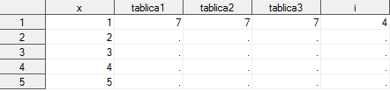

**data** b;

set a;

array tab(**5**) _temporary_;

**run**;



**data** b;

set a end=k;

array tab(**5**) _temporary_;

tab(**6**-_n_)=x;

if k then do;

do i=**1** to dim(tab);

x=tab(i);

output;

end;

end;

keep x;

**run**;

