**data** a;

do x=**1** to **5**;

output;

end;

**run**;

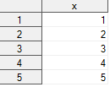

**data** b;

set a;

y=lag(x);

**run**;

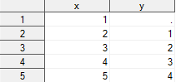

**data** b;

set a;

if mod(x,**2**)=**0** then y=lag(x);

**run**;

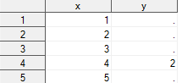

**data** a;

array x(**5**);

**run**;



**data** a;

array x(**10**);

* length;

do i=**1** to **10**;

do j=**1** to dim(x);

x(j)=floor(**10**\*ranuni(**0**));

end;

output;

end;

keep x1-x10;

format x: **1.**;

**run**;

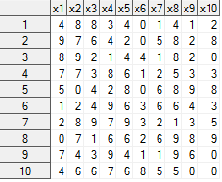

**data** b;

set a;

array tab(*) _all_;

array tymcz(**10**,**10**);

**run**;

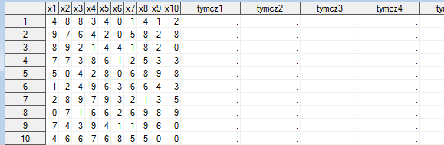

**data** b;

set a;

array tab(*) _all_;

array tymcz(**10**,**10**) _temporary_;

array y(**10**);

do i=**1** to dim(tab);

tymcz(**11**-_N_,i)=tab(i);

end;

if _n_=**10** then

do;

do i=**1** to dim1(tymcz);

do j=**1** to dim2(tymcz);

y(j)=tymcz(i,j);

end;

output;

end;

end;

keep y:;

format y: **1.**;

**run**;

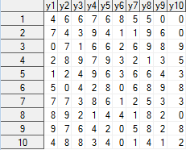

**data** _null_;

set a nobs=ile;

put ile=;

**run**;



**data** c;

if _n_=**1** then put ile=;

set a nobs=ile;

keep ile;

**run**;

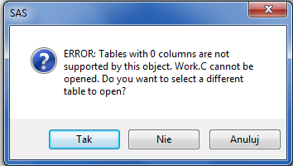

**data** c;

*if _n_=1 then put ile=;

set a nobs=ile;

iile=ile;

keep iile;

**run**;

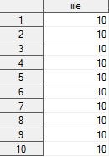

**data** a;

input x;

cards;

1

2

3

;

**run**;

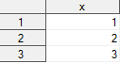

**data** b;

set a;

array t(*) _all_;

**run**;



**data** b;

set a;

array t(*) _all_;

r=dim(t);

put r=;

**run**;

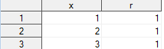



**data** b;

set a;

r=dim(t);

array t(*) _all_;

put r=;

**run**;

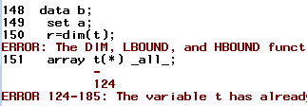

**data** b;

array t(*) _all_;

r=dim(t);

set a;

put r=;

**run**;

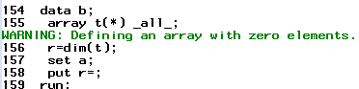

**data** a;

x=**5**;

y='6';

z1=y||x;

z2=x+y;

**run**;



**data** a;

x=**5**;

y='A';

z1=y||x;

z2=x+y;

**run**;

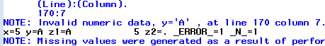

**data** a;

x=**22.45**;

y='123.45';

xtekst=put(x,**5.2**); * -l,-r,-c;

ynum=input(y,**6.2**);

**run**;



**data** a;

do i=**1** to **10**;

output;

end;

**run**;

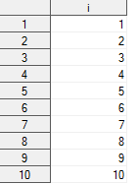

options firstobs=**1** obs=**7**;

**data** b;

set a;

**run**;

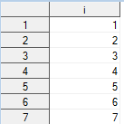

options obs=max;

**data** b;

set a;

**run**;



options firstobs=**5** obs=**7**;

**data** b;

set a;

**run**;

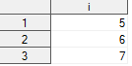

**data** b;

set a end=k;

if k then put _n_;

**run**;





options firstobs=**1** obs=max;

**data** b;

set a (firstobs=**6**);

**run**;

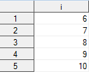

**data** b;

set a;

if mod(i,**2**)=**0** then output;

**run**;

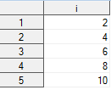

**data** b;

set a;

where mod(i,**2**)=**0**;

put _n_;

**run**;





**data** b;

set a;

x=**3**+i;

where mod(x,**2**)=**0**;

put _n_;

**run**;

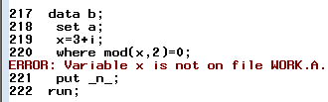

*subsetting if;

**data** b;

set a;

if mod(i,**2**)=**0**;

**run**;



**data** b;

set a;

if mod(i,**2**)=**0**;

put _n_;

**run**;



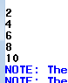

**data** b;

ktora=**5**;

set a point=ktora;

output;

stop;

**run**;

