**data** a;

x1=**13**; x2=**2**; x3=**3**; y7=**70**; y8=**9**; y9=**10**;

format x1-x3 words.;

format y7-y8 roman.;

format y9 **2.**;

**run**;



**data** a;

input id name $ x y z;

cards;

1 Zosia 2 3 4

2 Kasia 3 4 4

;

**run**;



**data** b;

set a (keep=x y z);

**run**;



**data** b;

set a (keep=name-z);

**run**;

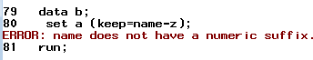

**data** b;

set a (keep=name--z);

**run**;



**data** b;

set a (keep=name-numeric-z);

**run**;



**data** b;

set a (keep=name-char-z);

**run**;



**data** a;

x_a=**1**; x_b=**2**; xc=**3**; y=**8**;

**run**;



**data** b;

set a (keep=x:);

**run**;



**data** b;

set a (keep=x:);

z=sum(of x:);

**run**;



**data** a;

do x=**1** to **5**;

output;

end;

**run**;

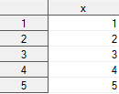

**data** b;

do ktory=ile to **1** by (-**1**);

set a nobs=ile point=ktory;

output;

end;

stop;

**run**;

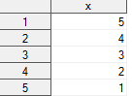

**data** b;

put _all_;

do ktory=ile to **1** by (-**1**);

set a nobs=ile point=ktory;

output;

end;

put _all_;

stop;

**run**;



**data** b;

ktory=**7**;

set a point=ktory;

output;

stop;

**run**;





**data** a;

do x=**1** to **10**;

output;

end;

**run**;

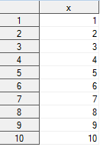

**data** b;

ktory=**3**\*(_n_-**1**)+**1**;

set a point=ktory nobs=ile;

if ktory>ile then stop;

**run**;

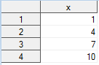

**data** b;

put _all_;

do ktory=ile to **1** by (-**1**);

set a nobs=ile point=ktory;

output;

end;

put _all_;

if _n_>**1** then stop;

**run**;

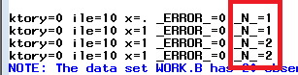

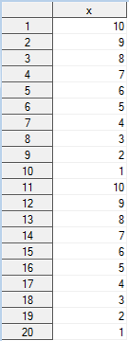

**data** b;

ktory=**3**\*(_n_-**1**)+**1**;

if ktory<=ile then set a point=ktory nobs=ile;

**run**;



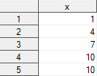

**data** a;

do x=**1** to **3**;

output;

end;

**run**;

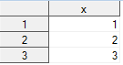

**data** b;

if x=**1** then set a;

**run**;





/* SQL */

/* Structured Query Language */

**data** a;

do id='A','B','C';

do x=**1** to **4**;

y=floor(**10**\*ranuni(**0**));

output;

end;

end;

**run**;

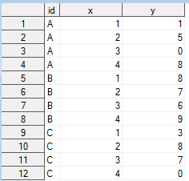

**proc** **sql**;

select x

from a

;

**quit**;



**proc** **sql**; * mozna na stale to ustalic;

create table b as

select x

from a

;

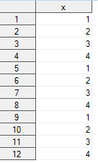

select *

from a

;

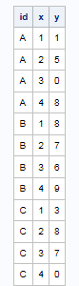

select id, y, y\***100**

from a

;

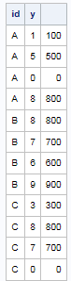

create table b as

select id, y, y\***100**

from a

;

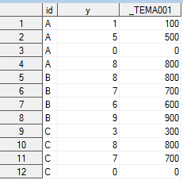

create table b as

select id, y, y\***100** as nowyy

from a

;

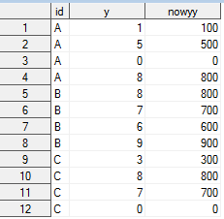

select id, today()

from a

;

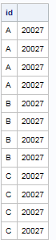

select id, today() as dzis format=ddmmyy10.

from a

;

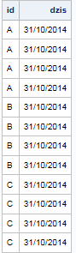

select id, today() as dzis format=ddmmyy10. label='Jaka piekna zmienna'

from a

;

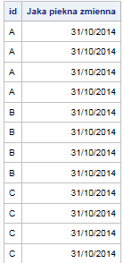

create table b as

select id, today() as dzis format=ddmmyy10. label='Jaka piekna zmienna'

from a

;

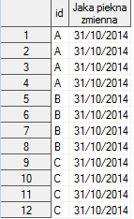

select distinct x

from a

;



select distinct id,x

from a

;



select *

from a

where x=**1**

;



select *

from a

where id in ('A','B')

;



select *

from a

where y between **1** and **2**

;



select *

from a

where y is missing

;



select x,y,x+y as suma

from a

;

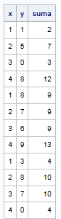

select x,y,x+y as suma

from a

where suma>**1**

;



select x,y,x+y as suma

from a

where x+y>**7**

;

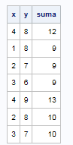

select x,y,x+y as suma

from a

where calculated suma>**7**

;



select x,y,x+y as suma, suma/**2** as polsumy

from a

;



select x,y,x+y as suma, calculated suma/**2** as polsumy

from a

;

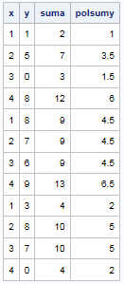

select *

from a

order by x

;



select id, sum(x,y)

from a

;



select id, sum(x)

from a

;

