* Pisanie do plikow tekstowych;

filename plik 'h:\Windows7\Desktop\SAS\wyklady\plik_probny.txt';

**data** _null_;

file plik;

do i=**1** to **10**;

x=ranuni(**0**);

y=ranuni(**0**);

put x y;

end;

**run**;

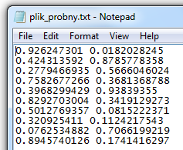

* Tworzenie kilku zbiorow na raz;

**data** a b c;

do i=**1** to **3**;

x=ranuni(**0**); y=ranuni(**0**); z=ranuni(**0**);

output ;

end;

**run**;

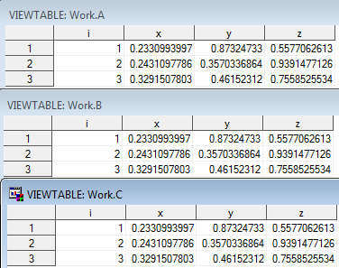

**data** a b c;

do i=**1** to **10**;

x=ranuni(**0**); y=ranuni(**0**); z=ranuni(**0**);

if x+y+z>**1.5** then output a b ;

else output c;

end;

**run**;

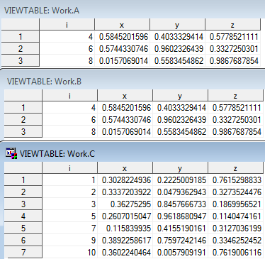

**data** a b c;

do i=**1** to **3**;

x=ranuni(**0**); y=ranuni(**0**); z=ranuni(**0**);

if x+y+z>**1.7** then output a b ;

else output c;

end;

keep x;

**run**;

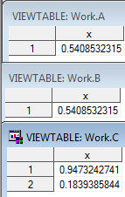

**data** a (keep=x y) b(drop=y) c;

do i=**1** to **3**;

x=ranuni(**0**); y=ranuni(**0**); z=ranuni(**0**);

if x+y+z>**1.7** then output a b ;

else output c;

end;

**run**;

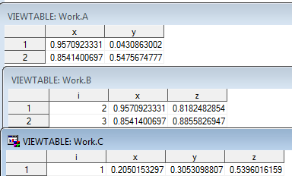

**data** cc;

set b (rename=(x=aaaaa));

**run**;

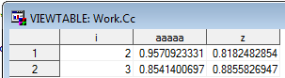

**data** a;

input x y;

cards;

10 3

2 9

2 10

4 1

4 2

2 5

;

**run**;

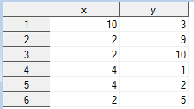

**proc** **sql**;

select avg(y)

from a

;



select *,avg(y)

from a

;

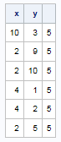

select *

from a

group by x

;



select avg(y)

from a

group by x

;



select x,avg(y)

from a

group by x

;

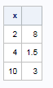

select x,avg(y) as srednia_y

from a

group by x

;

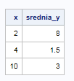

select *,avg(y) as srednia_y

from a

group by x

;

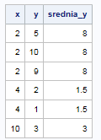

select x,avg(y)

from a

group by x

having avg(y)>**2**

;

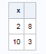

* wybrac y, ktore sa wieksze niz globalna srednia y;

select *

from a

where y>avg(y)

;





select *,avg(y)

from a

;

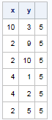

select y

from (select *,avg(y)

from a

)

where y>avg(y)

;



select y

from (select *,avg(y) as srednia_y

from a

)

where y>srednia_y

;



select y

from a

where y>(select avg(y)

from a

)

;



* wybrac wiersze, w ktorych x sa wieksze od wszystkich y;

select x,y

from a

where x>(select y from a)

;



select x,y

from a

where x in (select y from a)

;



select x

from a

where x>any (select y from a)

;



select x

from a

where x>all (select y from a)

;





select x

from a

where x>=all (select y from a)

;



select x

from a

where x>(select max(y)

from a

)

;



select x

from a

where x>(select min(y)

from a

)

;



**data** a;

input id $ x y;

cards;

A 1 1000

B 1 1

C 1 1

;

**run**;

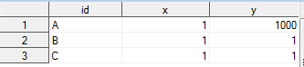

select *

from a

where id ne 'A'

group by x

having avg(y)>**1**

;



select *

from a

where id ne 'A'

group by x

having avg(y)=**1**

;

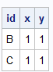

**data** a;

input x y;

cards;

2 4

3 1

4 6

2 5

3 2

4 2

;

**run**;

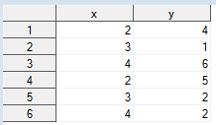

*wybrac te obserwacje, w ktorych x jest wiekszy niz srednia swoich y;

select *

from a as pierwszy

where pierwszy.x> (select avg(y)

from a as drugi

where drugi.x=pierwszy.x

)

;



select *

from a as pierwszy

where x> (select avg(y)

from a as drugi

where drugi.x=pierwszy.x

)

;



select *

from a

group by x

having x>avg(y)

;



/* kolejnosc:

create table

select

from

where

group by

having

order by

*/

**proc** **sql**;

describe table a

;

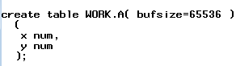

**data** z;

input x $ y;

cards;

A 3

A 2

A 1

B 1

B 2

C 2

C 3

C 4

D 0

;

**run**;

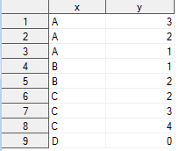

select count(*)

from z

where y>(select avg(y) from z

)

;



select count(distinct y)

from z

where y>(select avg(y) from z

)

;



select *, max(y)-min(y) as rozrzut

from z

group by x

;

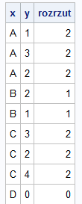

select max(rozrzut)

from

(

select *,max(y)-min(y) as rozrzut

from z

group by x

)

;



select *,max(y)-min(y) as rozrzut

from z

group by x

having rozrzut=max(rozrzut)

;



select *,max(y)-min(y) as rozrzut

from z

group by x

having rozrzut=(select max(rozrzut)

from

(

select *,max(y)-min(y) as rozrzut

from z

group by x

)

)

;

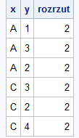

* wybrac te y, ktore znajduja sie w co najmniej dwoch grupach wyznaczonych przez x;

select *

from z

group by y

having count(distinct x)>=**2**

;

