* Laczenie zbiorow w 4GL;

**data** a;

input x $ y;

cards;

A 1

B 2

C 3

;

**run**;

**data** b;

input x $ y;

cards;

x 10

y 20

z 30

;

**run**;

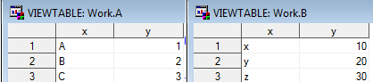

**data** razem;

set a b;

**run**;

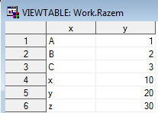

**data** razem;

set b a;

**run**;

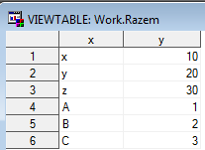

**proc** **append** base=a data=b;

**run**;

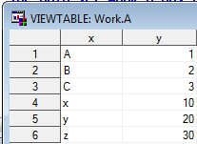

**data** razem;

put 'Pierwszy ' _all_;

set a b;

put 'Drugi ' _all_;

**run**;

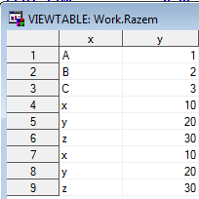

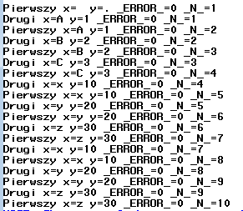

**data** a;

input x $ y;

cards;

A 1

B 2

C 3

;

**run**;

**data** b;

input x $ z;

cards;

x 10

y 20

z 30

;

**run**;

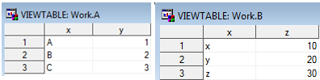

**data** razem;

set a b;

**run**;

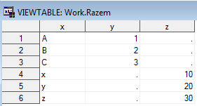

**data** a;

input x $ y;

cards;

A 1

B 2

C 3

;

**run**;

**data** b;

input x $ z;

cards;

A 10

C 20

D 30

;

**run**;

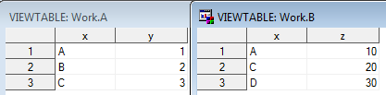

**data** razem;

set a b;

by x;

**run**;

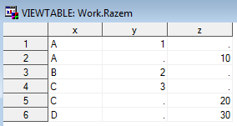

**data** a;

input x$ y;

cards;

a 1

b 2

c 3

d 4

;

**run**;

**data** b;

input u v;

cards;

1 2

3 4

5 6

;

**run**;

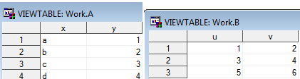

**data** razem;

set a;

set b;

**run**;

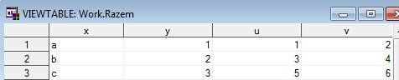

**data** razem;

set b;

set a;

**run**;

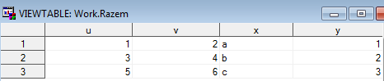

**data** a;

input x$ y;

cards;

a 1

b 2

c 3

d 4

;

**run**;

**data** b;

input x v;

cards;

1 2

3 4

5 6

;

**run**;

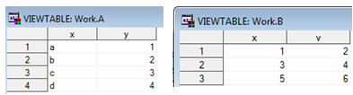

**data** razem;

set a;

set b;

**run**;



**data** a;

input x$ y;

cards;

a 1

b 2

c 3

d 4

;

**run**;

**data** b;

input u v;

cards;

1 2

3 4

5 6

;

**run**;

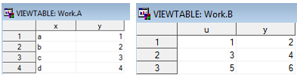

**data** razem;

set a;

set b;

**run**;

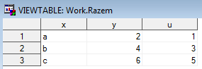

**data** razem;

set a;

set b (rename=(y=ynowy));

**run**;

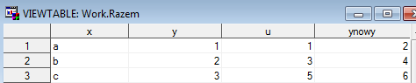

**data** razem;

put 'Pierwszy ' _all_;

set a;

put 'Drugi ' _all_;

set b;

put 'Trzeci ' _all_;

**run**;



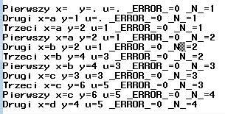

**data** a;

input x$ y;

cards;

A 1

B 2

C 3

;

**run**;

**data** b;

input u$ v;

cards;

AA 1

BB 2

CC 3

DD 4

EE 5

;

**run**;

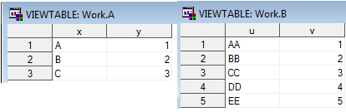

**data** razem;

merge a b;

**run**;

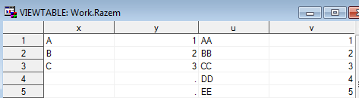

**data** razem;

merge b a;

**run**;

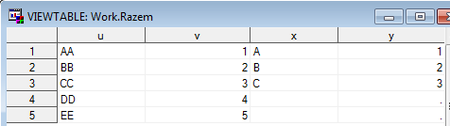

**data** a;

input x$ y;

cards;

A 1

B 2

C 3

;

**run**;

**data** b;

input x$ v;

cards;

AA 1

BB 2

CC 3

DD 4

EE 5

;

**run**;

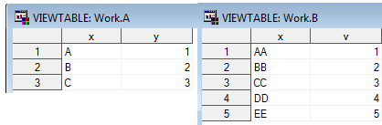

**data** razem;

merge a b;

**run**;

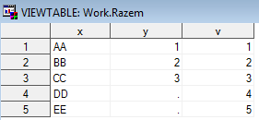

**data** c;

input x1$ y1;

cards;

a 1

b 2

c 3

d 4

;

**run**;

**data** d;

input u1 v1 @@;

cards;

1 2 3 4 5 6

;

**run**;

**data** a;

input x$ y;

cards;

A 1

B 2

C 3

;

**run**;

**data** b;

input u$ v;

cards;

AA 1

BB 2

CC 3

DD 4

EE 5

;

**run**;

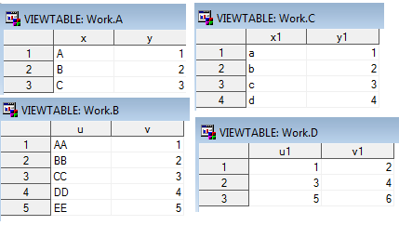

**data** razem;

merge a b;

merge c d;

format x: u: v: y: **3.**;

**run**;

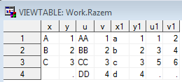

**data** razem;

merge c d;

merge a b;

format x: u: v: y: **3.**;

**run**;

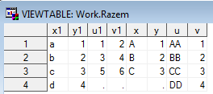

**data** razem;

merge c d a b;

format x: u: v: y: **3.**;

**run**;

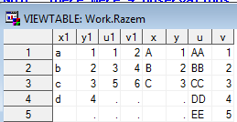

**data** razem;

merge c d;

set a b;

format x: u: v: y: **3.**;

**run**;

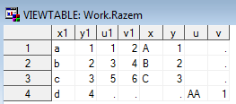

**data** a;

input x$ y;

cards;

A 10

C 20

E 30

;

**run**;

**data** b;

input x$ v;

cards;

A 1

B 2

C 3

D 4

F 5

;

**run**;

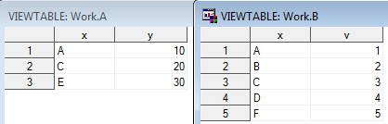

**data** razem;

merge a b;

by x;

**run**;

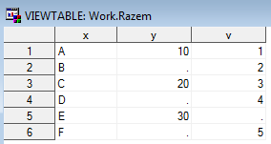

**data** razem;

merge b a;

by x;

**run**;

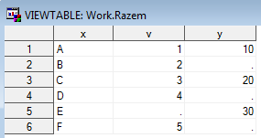

**data** a;

input x$ y;

cards;

A 10

A 20

E 30

;

**run**;

**data** b;

input x$ v;

cards;

A 1

A 2

A 3

D 4

F 5

;

**run**;

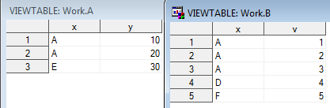

**data** razem;

merge a b;

by x;

**run**;

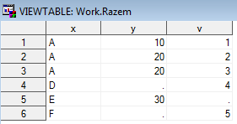

**data** a;

input x$ y;

cards;

A 10

A 20

E 30

;

**run**;

**data** b;

input x$ y;

cards;

A 1

A 2

A 3

D 4

F 5

;

**run**;

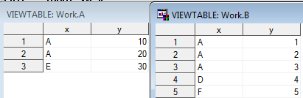

**data** razem;

set a (in=w_a) b (in=w_b);

by x;

**run**;

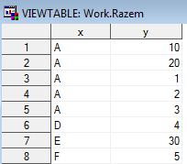

**data** razem;

set a (in=w_a) b (in=w_b);

by x;

wwa=w_a;

wwb=w_b;

**run**;

