**data** a;

input x$ y;

cards;

A 1

B 2

;

**run**;

**data** b;

input u v;

cards;

10 20

30 40

;

**run**;

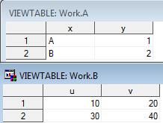

select *

from a, b

;

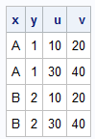

**data** b;

input x$ v;

cards;

A 20

C 40

;

**run**;

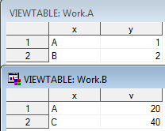

select *

from a, b

;

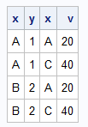

select *

from a,b,a

;

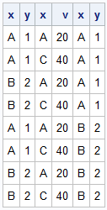

select *

from a, b

where a.x=b.x

;



create table razem_sql as

select *

from a,b

where a.x=b.x

;



create table razem_sql as

select x,y,v

from a,b

where a.x=b.x

;



create table razem_sql as

select a.x,y,v

from a,b

where a.x=b.x

;



**data** razem_4gl;

merge a b;

by x;

**run**;

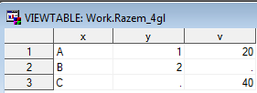

**data** razem_4gl;

merge a (in=w_a) b (in=w_b);

by x;

if w_a and w_b;

**run**;

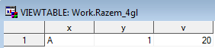

**data** a;

input x$ y;

cards;

A 1

A 2

B 3

C 1

;

**run**;

**data** b;

input x$ v;

cards;

A 20

A 40

A 30

;

**run**;

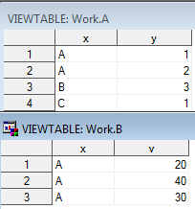

create table razem_sql as

select a.x,y,v

from a,b

where a.x=b.x

;

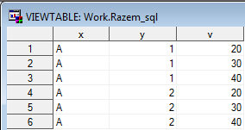

**data** razem_4gl;

merge a (in=w_a) b (in=w_b);

by x;

if w_a and w_b;

**run**;

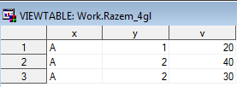

**data** a;

input id imie$;

cards;

1 sdfsdf

2 dfgdfg

3 dfgggg

4 cccccc

;

**run**;

**data** b;

input id placa;

cards;

1 100

2 200

3 300

4 100

;

**run**;

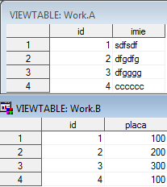

select avg(placa) as srednia

from b

;



select id

from b

where placa>(

select avg(placa) as srednia

from b

)

;



select id

from b, (

select avg(placa) as srednia

from b

)

where placa>srednia

;

