**data** a;

input x$ y;

cards;

A 1

B 2

;

**run**;

**data** b;

input x$ v;

cards;

A 20

C 22

G 222

;

**run**;

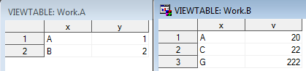

select *

from a,b

where a.x=b.x

;



select *

from a,b

where a.x>b.x

;



select *

from a

left join b on a.x=b.x

;

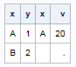

select *

from a

right join b on a.x=b.x

;

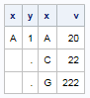

select *

from a

join b on a.x=b.x

;



select *

from a

inner join b on a.x=b.x

;



* inner join = join;

select *

from a

full join b on a.x=b.x

;

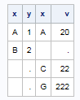

**data** a;

input x$ y;

cards;

A 1

B 2

C 3

;

**data** b;

input x$ u;

cards;

B 20

C 22

D 40

X 30

;

**run**;

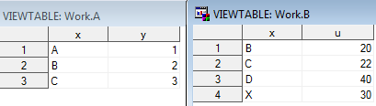

**data** razem_4gl;

merge a b;

by x;

**run**;

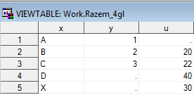

create table razem_sql as

select *

from a

full join b on a.x=b.x

;

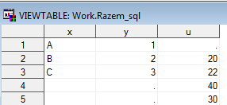

create table razem_sql as

select coalesce(a.x,b.x) as x,y,u

from a

full join b on a.x=b.x

;

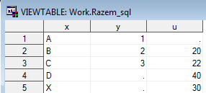

**data** a;

input x $ y;

cards;

A 1

B 2

X 3

D 4

B 2

;

**data** b;

input x$ y;

cards;

A 1

y 20

z 30

;

**run**;

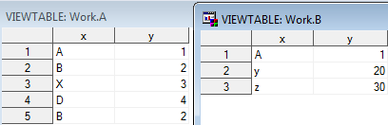

select *

from a

except

select *

from b

;



select *

from a

except all

select *

from b

;



**data** a;

input x $ y;

cards;

A 1

B 2

X 3

D 4

B 2

Z 30

;

**data** b;

input x$ y;

cards;

A 1

y 20

z 30

B 3

;

**run**;

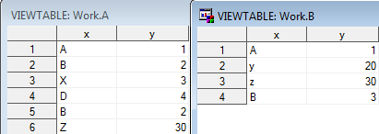

select x

from a

except

select x

from b

;



select x

from a

intersect

select x

from b

;



select x

from a

union

select x

from b

;



select *

from a

outer union

select *

from b

;

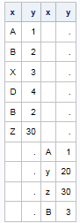

select x

from a

outer union

select x

from b

;



**data** a;

input xx $ yy;

cards;

A 1

B 2

X 3

D 4

B 2

Z 30

;

**data** b;

input x$ y;

cards;

A 1

y 20

z 30

B 3

;

**run**;

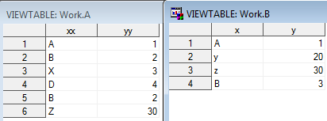

select *

from a

intersect

select *

from b

;



**data** b;

input y xx$ ;

cards;

1 A

20 y

;

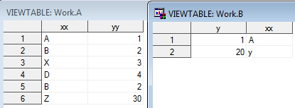

select *

from a

intersect

select *

from b

;

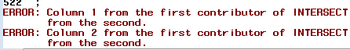

**data** a;

input x $ yy;

cards;

A 1

B 2

X 3

D 4

B 2

Z 30

;

**run**;

**data** b;

input x$ y;

cards;

A 1

y 20

z 30

B 3

A 1

;

**run**;

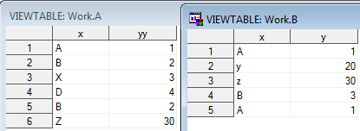

select *

from a

intersect

select *

from b;



select *

from a

intersect corr

select *

from b

;

