/* Agregacja danych */

**data** a;

input x$ y z;

cards;

A 1 10

A 1 20

A 2 30

B 2 40

B 2 23

C 1 8

C 10 20

;

**run**;

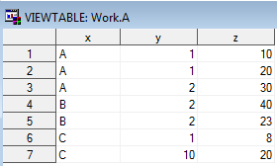

**proc** **freq** data=a;

**run**;

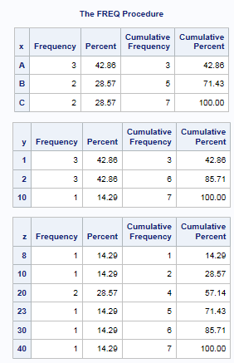

**proc** **freq** data=a;

tables x x*y;

**run**;

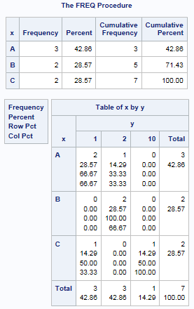

**proc** **freq** data=a;

tables z*y;

by x;

**run**;

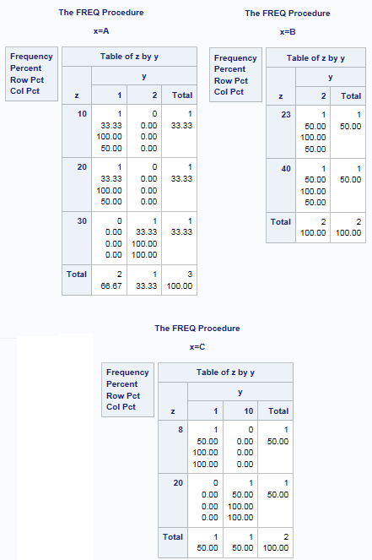

**proc** **freq** data=a noprint;

tables y*z / out=ppp;

**run**;

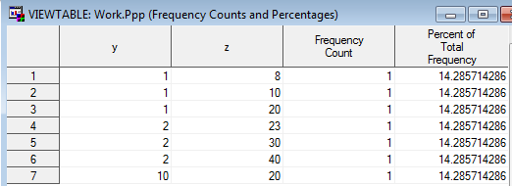

**proc** **freq** data=a noprint;

tables y*z / out=ppp1;

tables x/out=ppp2;

**run**;

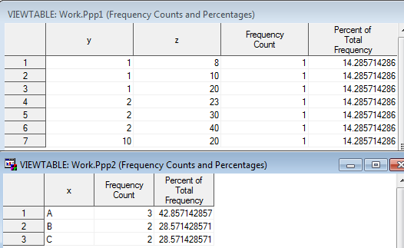

**proc** **means** data=a;

**run**;

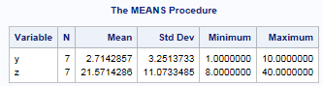

**proc** **means** data=a;

var y;

**run**;

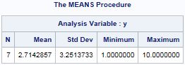

**proc** **means** data=a;

var x;

**run**;



**proc** **means** data=a;

var y;

by x;

**run**;

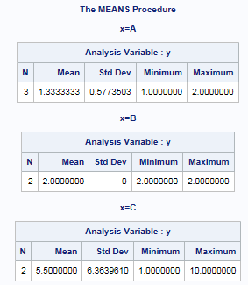

**proc** **means** data=a noprint;

output out=ameans;

**run**;

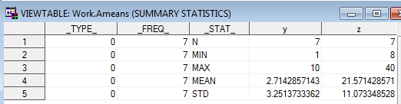

**proc** **summary** data=a;

var y z;

output out=ameans;

**run**;

* to samo, co proc means, tylko nie trzeba noprint;



**proc** **means** data=a noprint;

by x;

output out=ameans;

**run**;

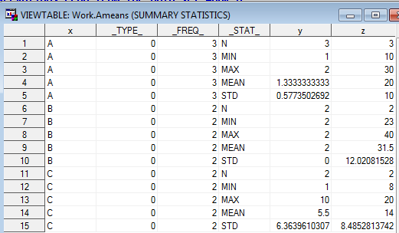

**proc** **means** data=a noprint;

class x;

output out=ameans;

**run**;

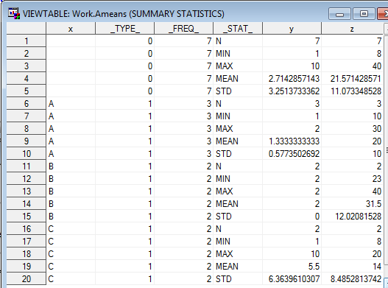

**proc** **means** data=a noprint;

class x;

var y;

output out=ameans;

**run**;

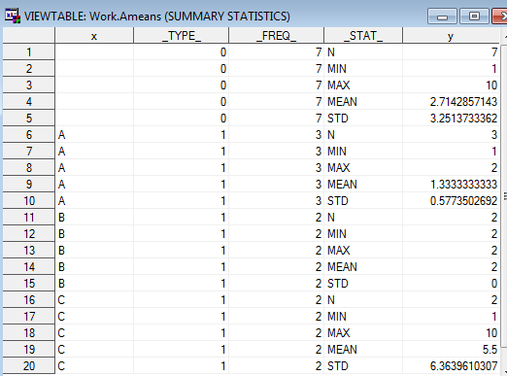

**data** a;

input x$ y z @@;

cards;

A 1 10 A 1 20 A . 30 B 2 40 B 2 23 C 1 8 C 10 20

;

**run**;

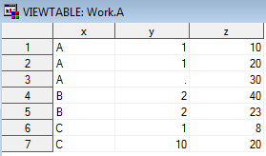

**proc** **means** data=a noprint;

class y;

output out=ameans;

**run**;

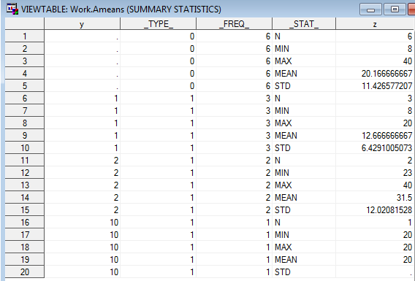

**data** a;

input x$ y z @@;

cards;

A 1 10 A 1 20 A 2 30 B 2 40 B 2 23 C 1 8 C 10 20

;

**run**;



**proc** **means** data=a noprint;

class x y;

output out=ameans;

**run**;

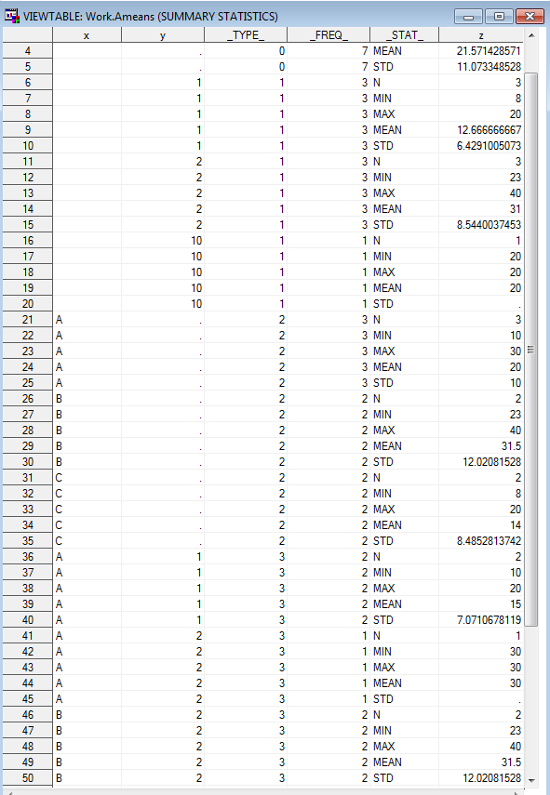

**proc** **means** data=a noprint nway;

class x y;

output out=ameans;

**run**;

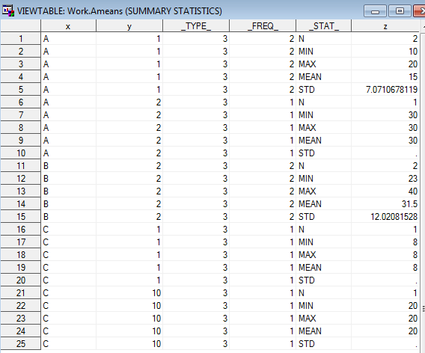

**proc** **means** data=a noprint;

class x y z;

ways **1** **2**;

output out=ameans;

**run**;

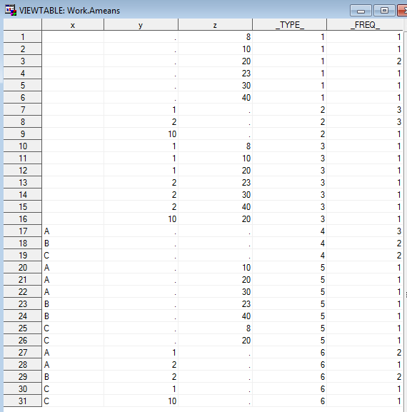

**proc** **means** data=a noprint;

class x y z;

types y y*x z;

output out=ameans;

**run**;

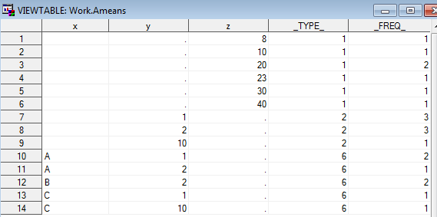

**proc** **means** data=a min q1 median q3 max;

**run**;

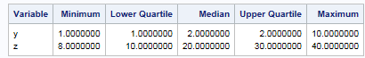

**proc** **means** data=a min q1 median q3 max;

var y;

**run**;

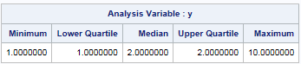

**proc** **means** data=a min q1 median q3 max;

var y;

output out=ameans;

**run**;

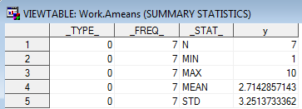

**proc** **means** data=a min q1 median q3 max noprint;

var y;

output out=ameans min=min_y q1=q1_y;

**run**;

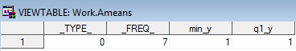

**proc** **means** data=a min q1 median q3 max noprint;

var y z;

output out=ameans min= q1= median= q3= max= / autoname;

**run**;

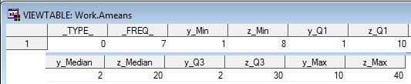

**proc** **univariate** data=a;

var z;

**run**;

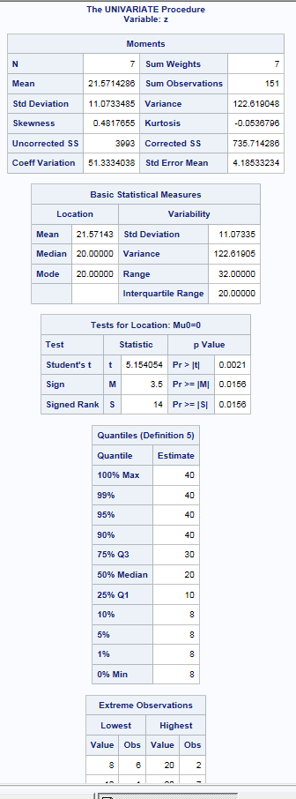

**proc** **univariate** data=a;

var y;

output out=ppp;

**run**;

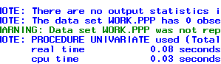

**proc** **univariate** data=a noprint;

var y;

output out=ppp normaltest=zz;

**run**;

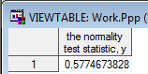

**proc** **univariate** data=a;

output out=ppp normaltest=zz;

**run**;



**proc** **univariate** data=a noprint;

var y z;

output out=ppp normaltest=zz;

**run**;



* cos bez sensu... SAS jest glupi...;

**data** b;

do i=**1** to **100**;

x=rannor(**0**);

output;

end;

drop i;

**run**;

**proc** **univariate** data=b noprint;

var x;

histogram;

**run**;

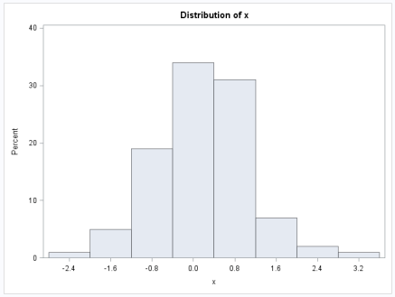

**proc** **univariate** data=b noprint;

var x;

histogram / midpoints=-**3** to **3** by **.5**;

**run**;

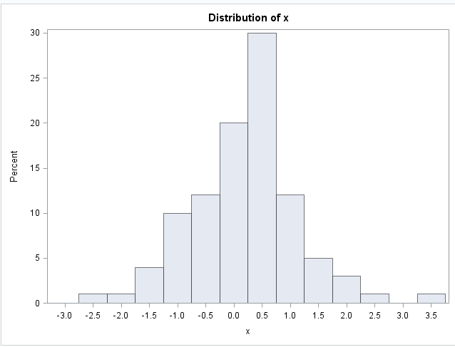

**proc** **univariate** data=b noprint;

var x;

histogram / normal(noprint) midpoints=-**3** to **3** by **.5**;

**run**;

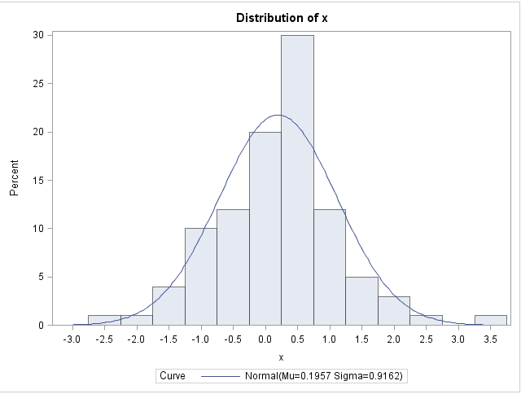

* TWORZENIE FORMATOW;

**proc** **format**;

value moj

**0**-**20**='malo'

**21**-**50**='srednio'

**51**-**60**='duzo'

;

**run**;

**data** d;

do i=**1** to **10**;

x=floor(**60**\*ranuni(**0**));

output;

end;

format x moj.;

drop i;

**run**;

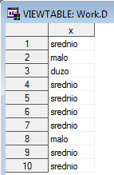

**proc** **sort** data=d out=ds;

by x;

**run**;

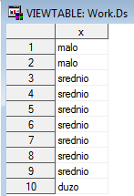

**data** e;

set ds;

by x;

if last.x;

**run**;

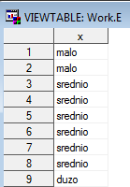

**data** e;

set ds;

by groupformat x;

if last.x;

**run**;

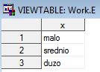

**proc** **format**;

value oddzial

**0**='Centrala'

**1**='Oddzial 1'

other='Blad'

;

**run**;

**data** _null_;

x=-**10**;

put x oddzial.;

**run**;



**proc** **format**;

value $woj

'mazowieckie'='MAZ'

'malopolskie'='MAL'

other='inne'

;

**run**;

**data** _null_;

x='mazowieckie';

put x woj.;

**run**;



**data** _null_;

x='mazowieckie';

put x $woj.;

**run**;

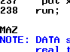

**data** slownik;

input start label$ fmtname$;

cards;

1 Audi auta

2 BMW auta

3 Mercedes auta

;

**run**;

**proc** **format** cntlin=slownik;

**run**;

**data** _null_;

x=**2**;

format x auta.;

put x;

**run**;



**data** a;

input x;

cards;

1

2

3

;

**run**;

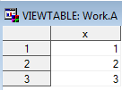

**data** b;

set a;

if put(x,auta.)='BMW';

**run**;



**data** slownik;

input start label$ fmtname$;

cards;

1 Audi auta

2 BMW auta

3 Mercedes auta

4 ja oho

1 on oho

;

**run**;

**proc** **format** cntlin=slownik;

**run**;

* stworzy dwa formaty - auta i oho;

* TWORZENIE INFORMATOW;

**proc** **format**;

invalue info

'jeden'=**1**

'dwa'=**2**

other=_error_

;

**run**;

**data** z;

input x info.;

cards;

jeden

dwa

dsfgdfg

;

**run**;

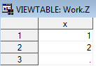

**proc** **format**;

invalue $ info_

'jeden'='1'

'dwa'='2'

other=_same_

;

**run**;

**data** z;

input x $ info_.;

cards;

jeden

dwa

dsfgdfg

;

**run**;

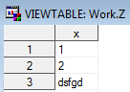

**proc** **format**;

value adsdf

low-<**0**='ujemne'

**0**-high=[commax12.2]

;

**run**;

**data** a;

x=-**10**;

output;

x=**1234.98**;

output;

format x adsdf.;

**run**;

