1. User makes a selection of attributes (Customer, Sales Rep, Deal Value)

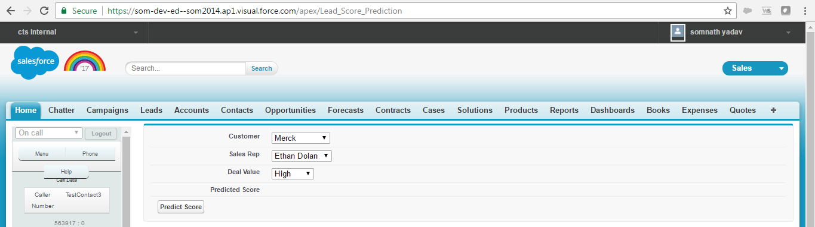

1. Prediction score fetched from trained engine deployed on Prediction Server.

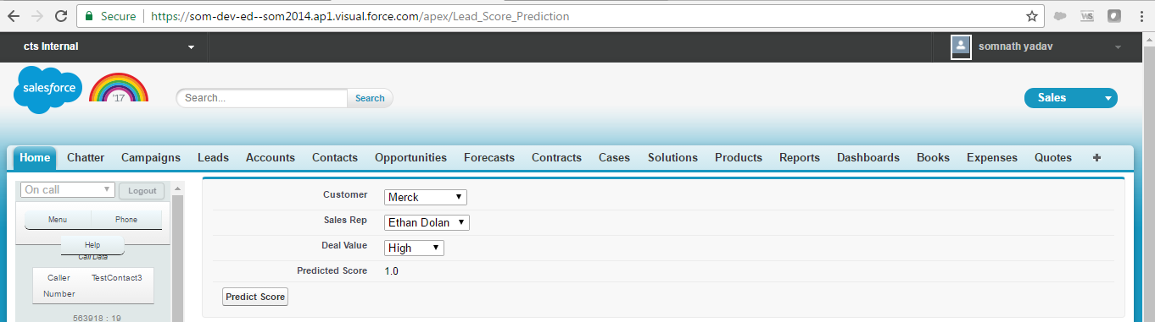

Note: Engine (Naïve Bayes classification template) accepts Integers, so user inputs are mapped to Integers before sending request.

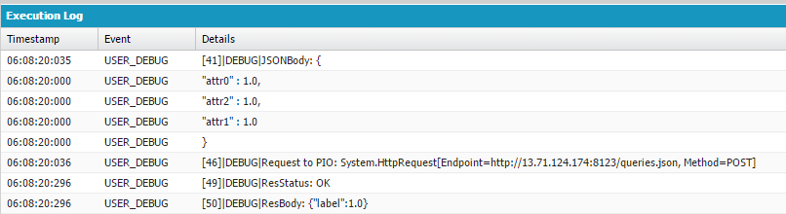

**Training Data:**

|  |  |  |  |
| --- | --- | --- | --- |
| **attrib 0 (Customer)** | **attrib 1 (SalesRep)** | **attrib 2 (Deal Value)** | **Class** |
| Merck | Ethan Dolan | High | Win |
| Merck | Alicia Cargile | Low | Loss |
| AstraZeneca | Alicia Cargile | Low | Loss |
| AstraZeneca | Ethan Dolan | High | Win |
| AstraZeneca | Ethan Dolan | Low | Win |
| Merck | Alicia Cargile | High | Loss |
| AstraZeneca | Alicia Cargile | High | Win |

**Intuition behind prediction:**

|  |  |  |
| --- | --- | --- |
| Customer | |  |
| P (Merck / Win) = 1/4 | P (Merck / Loss) = 2/3 | P (Win) = 4/7 |
| P (AstraZeneca / Win) = 3/4 | P (AstraZeneca / Loss) = 1/3 | P (Loss) = 3/7 |
| SalesRep | |  |
| P (Ethan Dolan / Win) = 3/4 | P (Ethan Dolan / Loss) = 0/3 | P (Win) = 4/7 |
| P (Alicia Cargile / Win) = 1/4 | P (Alicia Cargile / Loss) = 3/3 | P (Loss) = 3/7 |
| SalesRep | |  |
| P (High / Win) = 3/4 | P (High / Loss) = 1/3 | P (Win) = 4/7 |
| P (Low / Win) = 1/4 | P (Low / Loss) = 2/3 | P (Loss) = 3/7 |

Unseen Sample S: Customer = Merck, SalesRep = Alicia Cargile, Deal Value = High

P (S/Win). P (Win) = P (Merck/Win)* P (Alicia Cargile /Win) * P (High/Win) * P (Win)

= 1/4 * 1/4 * 3/4 * 4/7

= 0.027

P (S/Loss).P (Loss) = P (Merck/Loss)* P (Alicia Cargile /Loss) * P (High/Loss) * P (Loss)

= 2/3 * 3/3 * 1/3 * 3/7

= 0.095

S will be classified as ‘Loss’, it maximizes probability.

**Installation:**

1. Create an account with Azure and procure a Linux VM (optional)
2. Install Putty for connection with Linux VM and WinSCP for file transfer (optional)