Customer Shopping Behaviour Analysis
1. Project Overview
This project analyzes customer shopping behaviour using transactional data from 3,900 purchases across various product categories. The goal is to uncover insights into spending patterns, customer segments, product preferences, and subscription behaviour to guide strategic business decisions.
2. Dataset Summary
• Rows: 3,900
• Columns: 18
• Key Features:
- Customer demographics (Age, Gender, Location, Subscription Status)
- Purchase details (Item Purchased, Category, Purchase Amount, Season, Size, Color)
- Shopping behaviour (Discount Applied, Promo Code Used, Previous Purchases, Frequency
of Purchases, Review Rating, Shipping Type)
• Missing Data: 37 values in Review Rating column

3. Exploratory Data Analysis using Python
We began with data preparation and cleaning in Python:
• Data Loading: Imported the dataset using pandas.
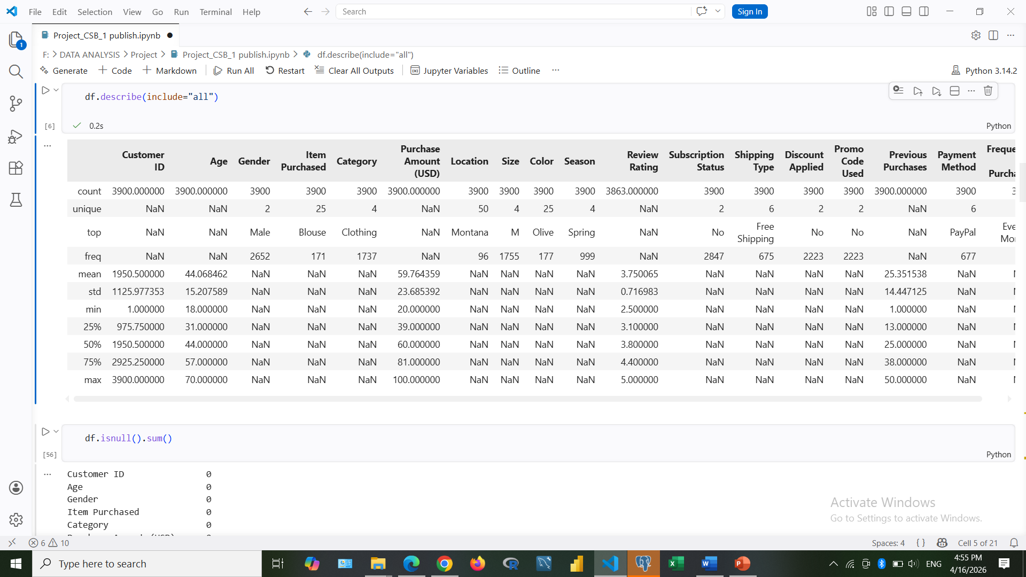
• Initial Exploration: Used df.info() and describe().
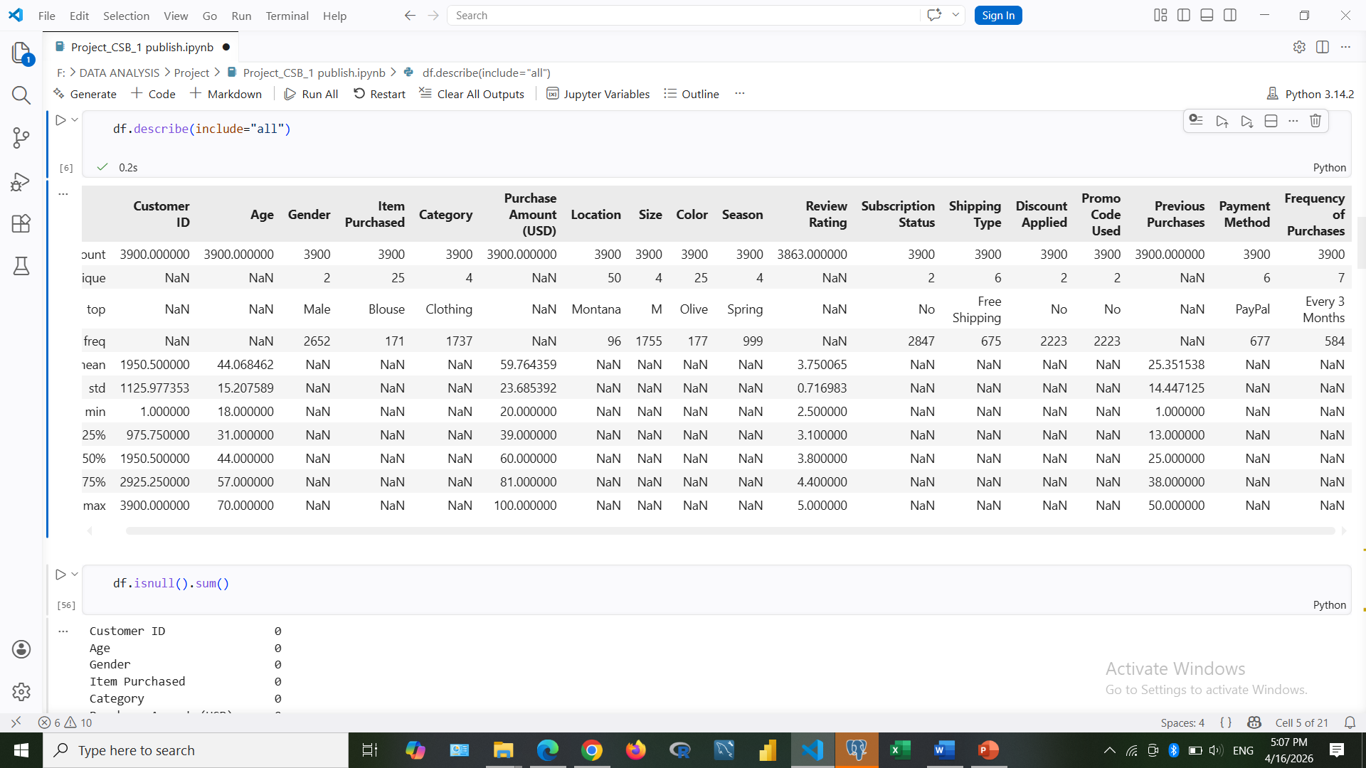

• Missing Data Handling: Imputed missing values in Review Rating using median by category.
• Column Standardization: Renamed columns to snake case for better readability and
documentation.
• Feature Engineering:
- Created age_group column by binning customer ages.
- Created purchase_frequency_days column from purchase data.
• Data Consistency Check: Dropped promo_code_used due to redundancy.
• Database Integration: Loaded cleaned data into PostgreSQL.

4. Data Analysis using SQL (Business Transactions)
We performed structured analysis in PostgreSQL to answer key business questions:
• Revenue by Gender
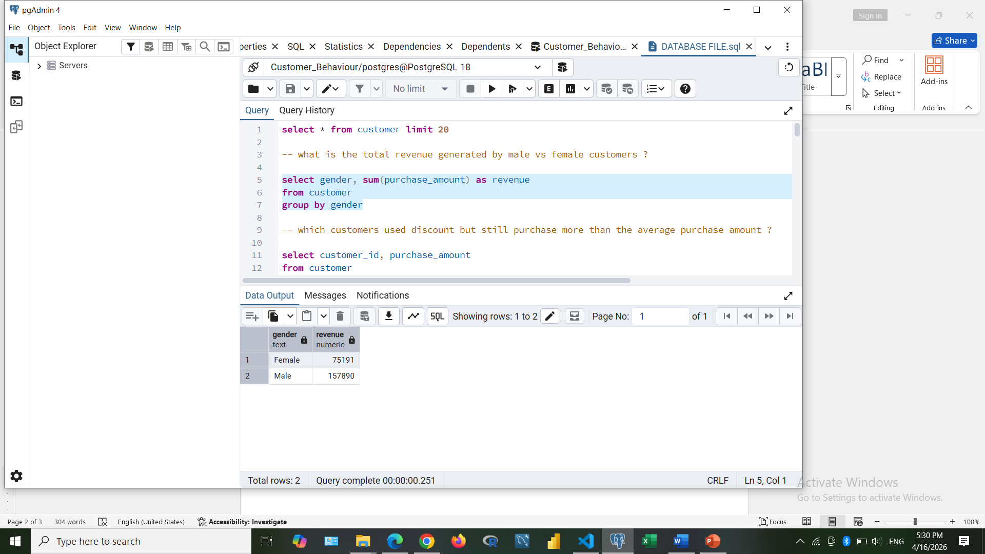
• High-Spending Discount Users
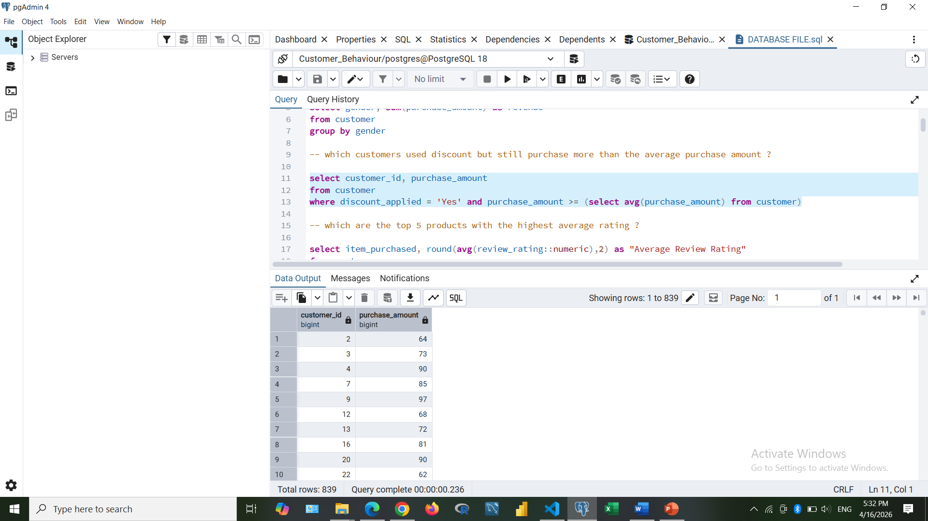

• Top 5 Products by Rating
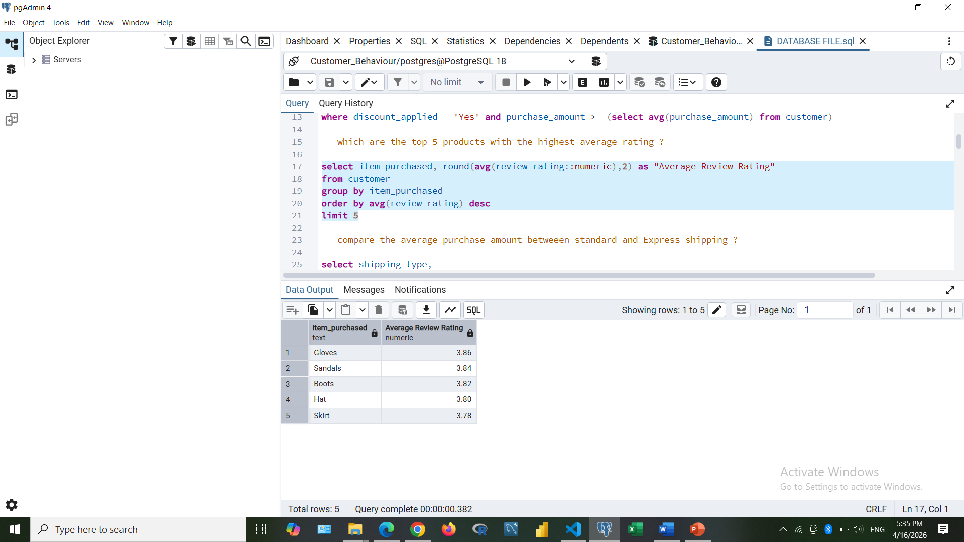
• Shipping Type Comparison
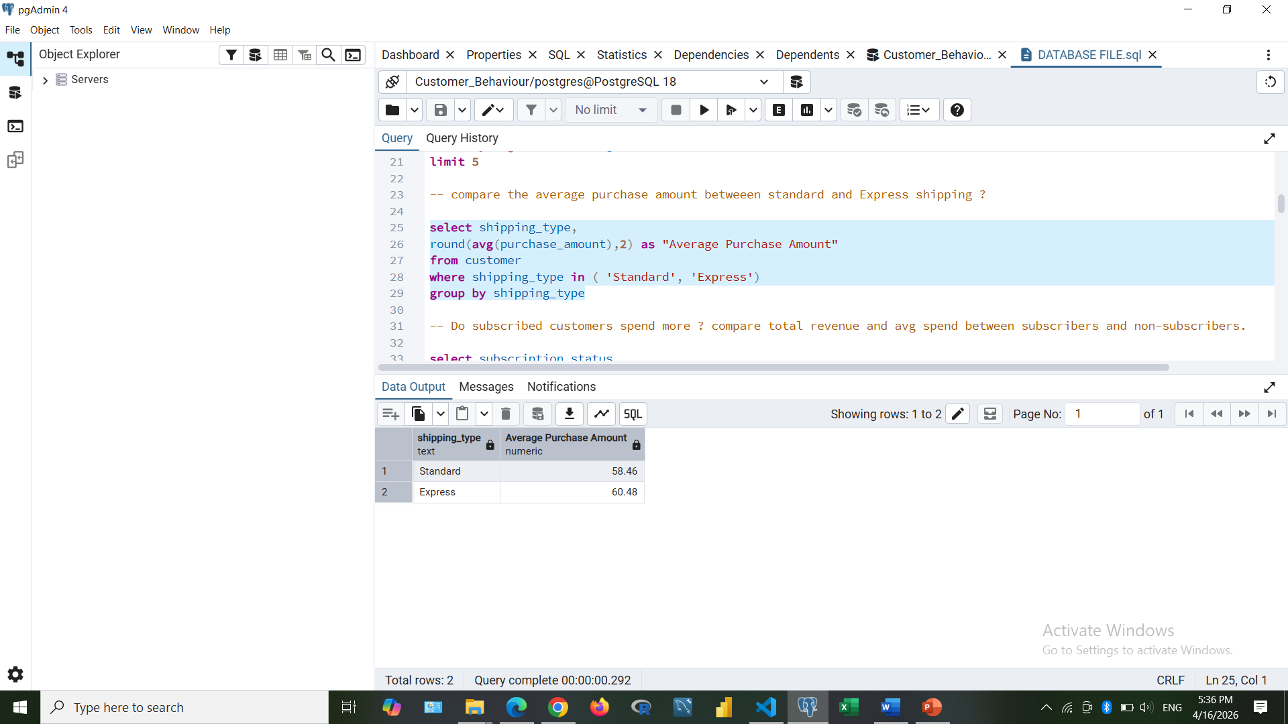
• Subscribers vs Non-Subscribers
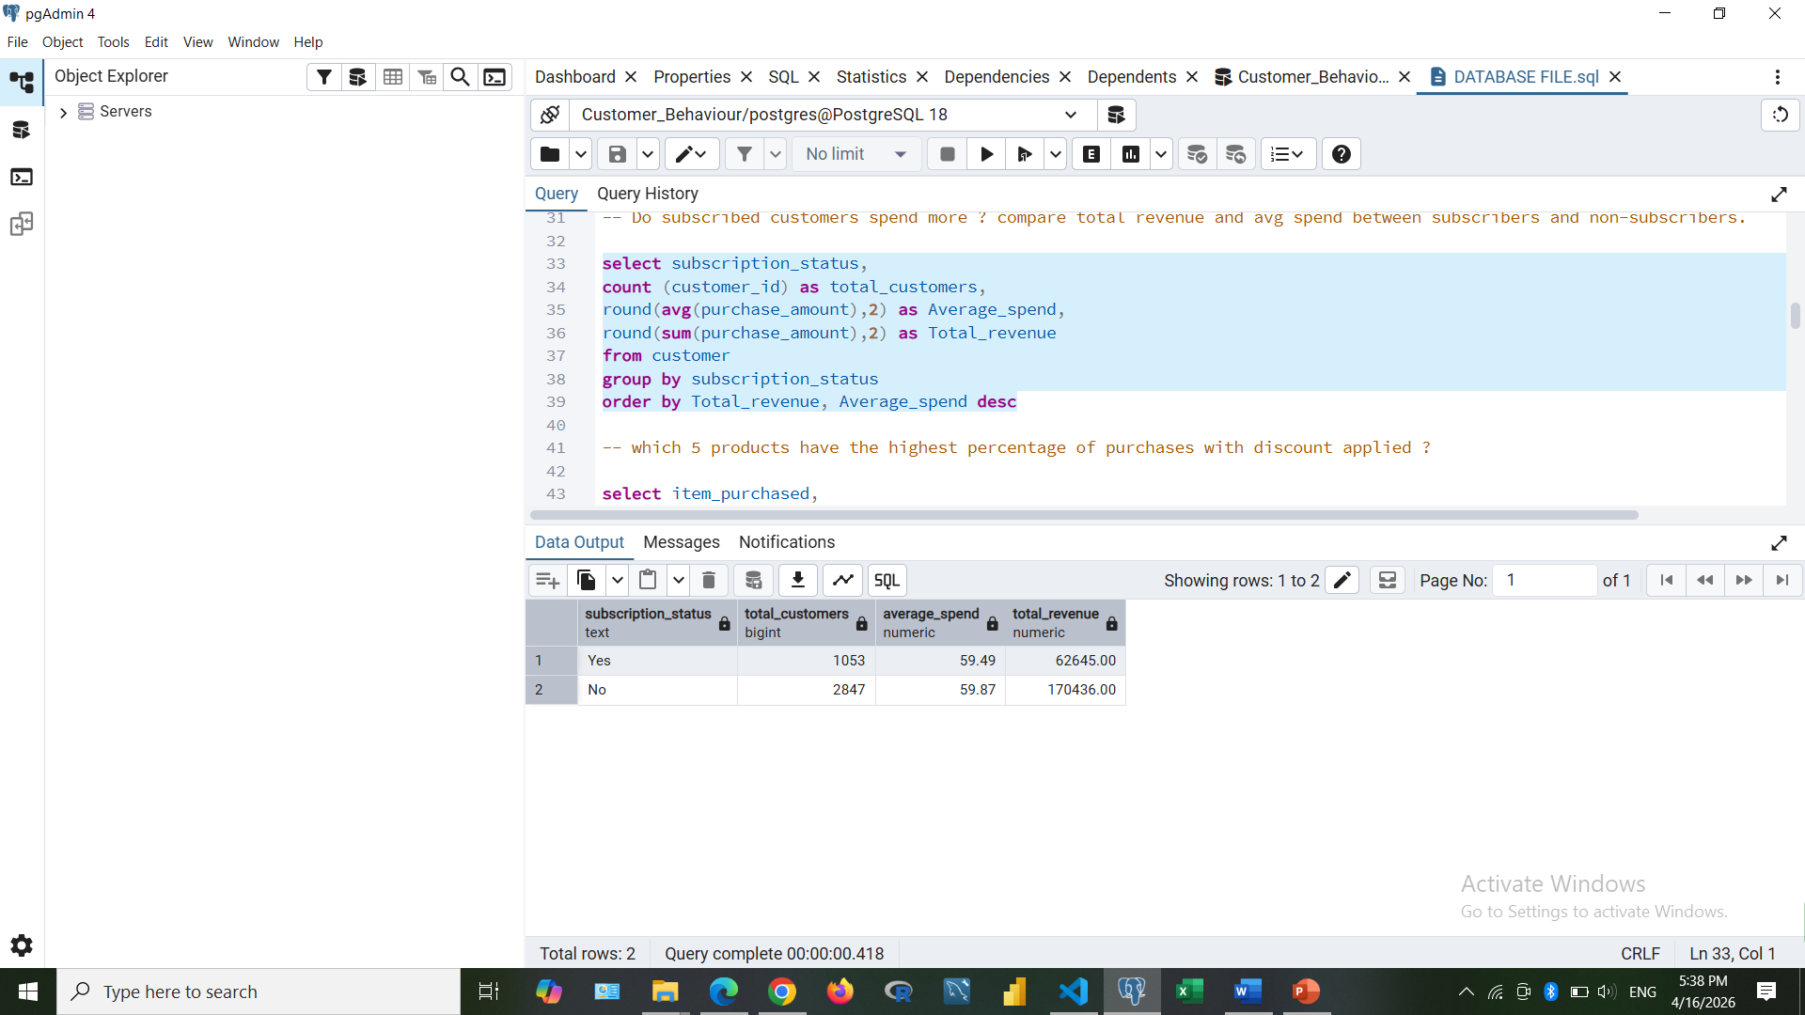
• Discount-Dependent Products
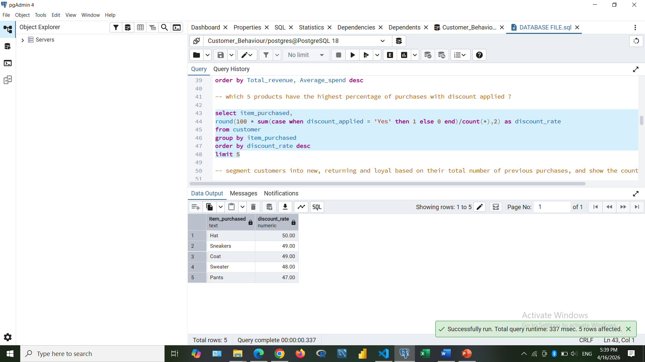
• Customer Segmentation
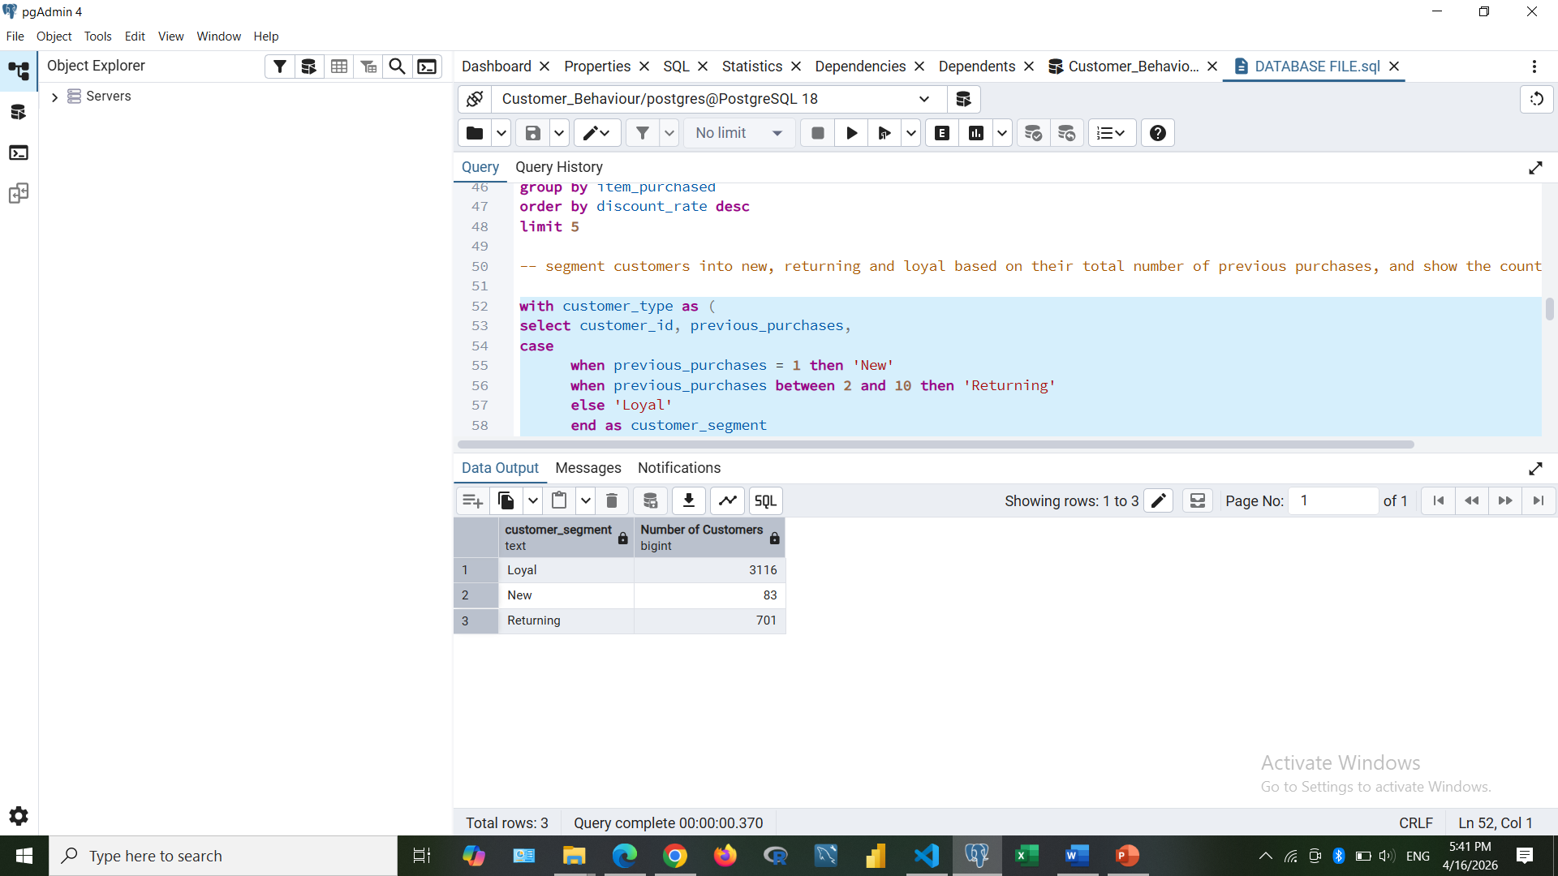
• Top 3 Products per Category
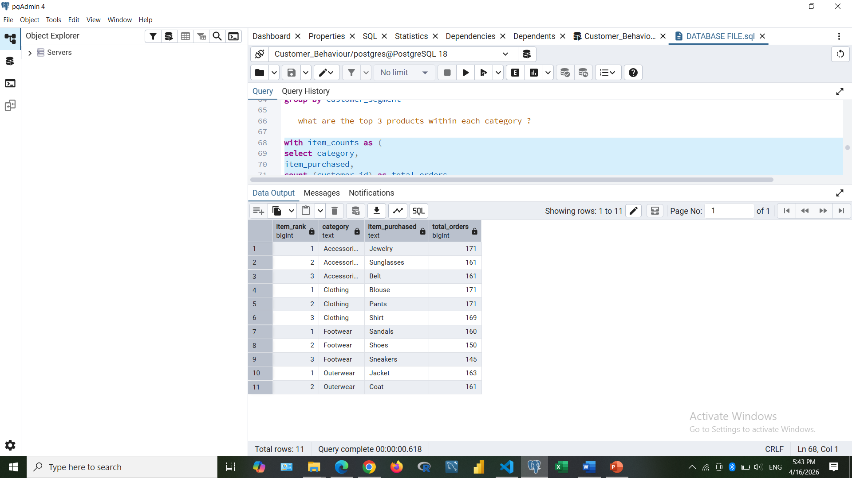
• Repeat Buyers & Subscriptions
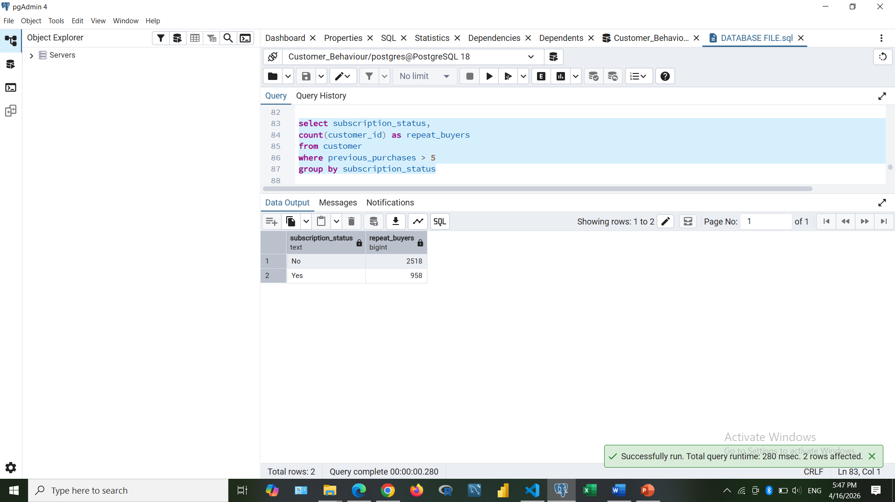
• Revenue by Age Group
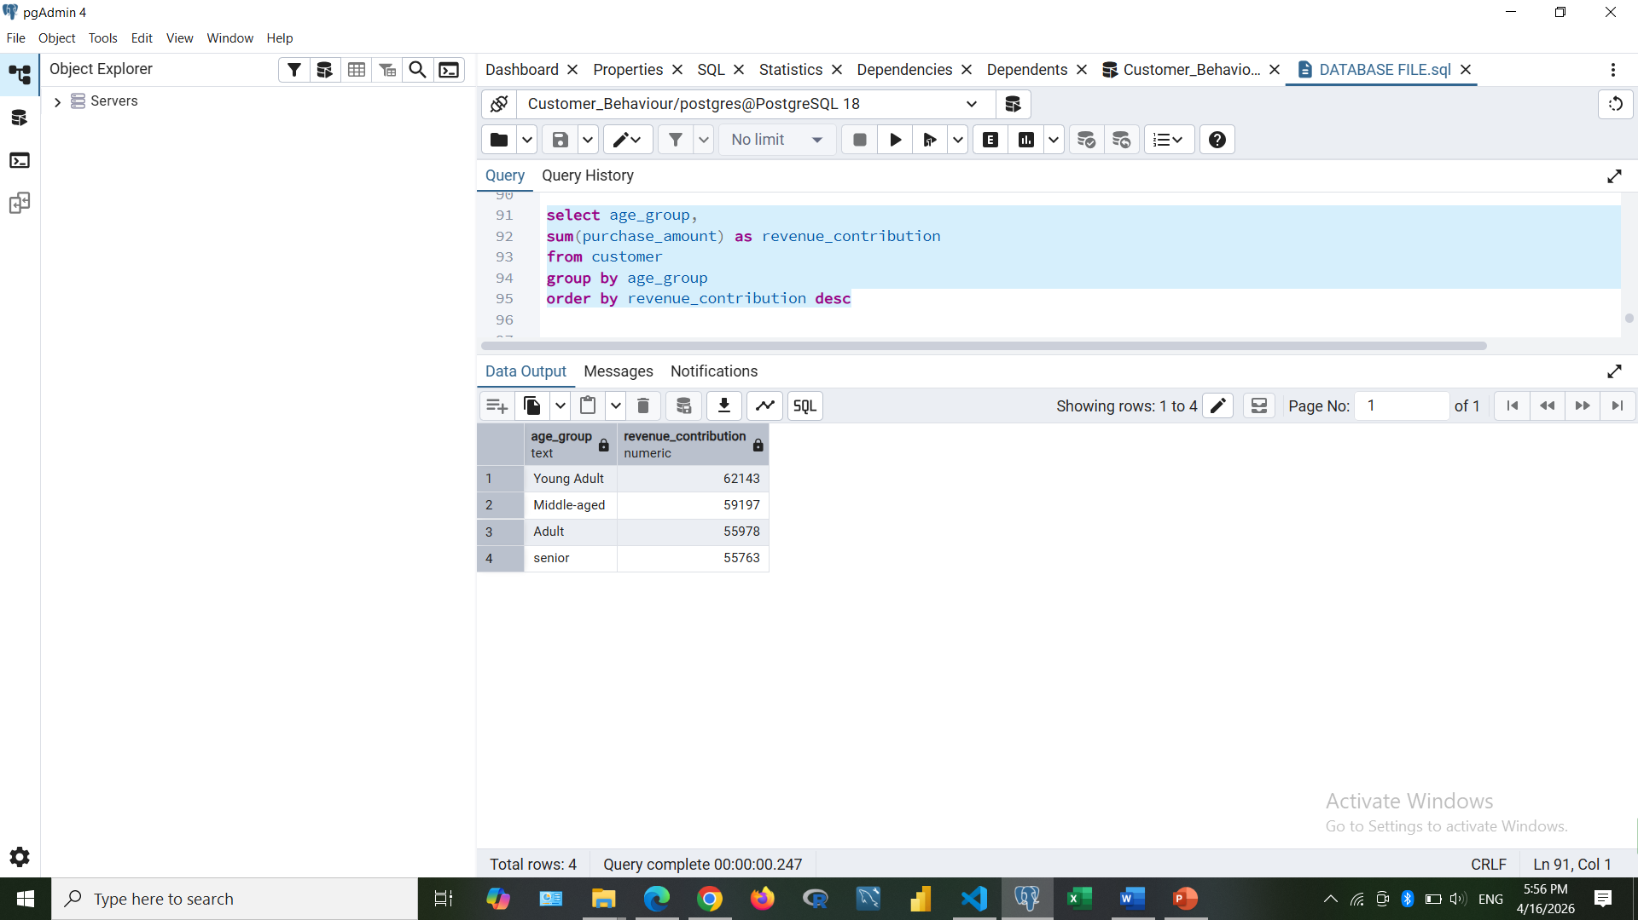

5. Dashboard in Power BI
Finally, we built an interactive dashboard in Power BI to present insights visually.

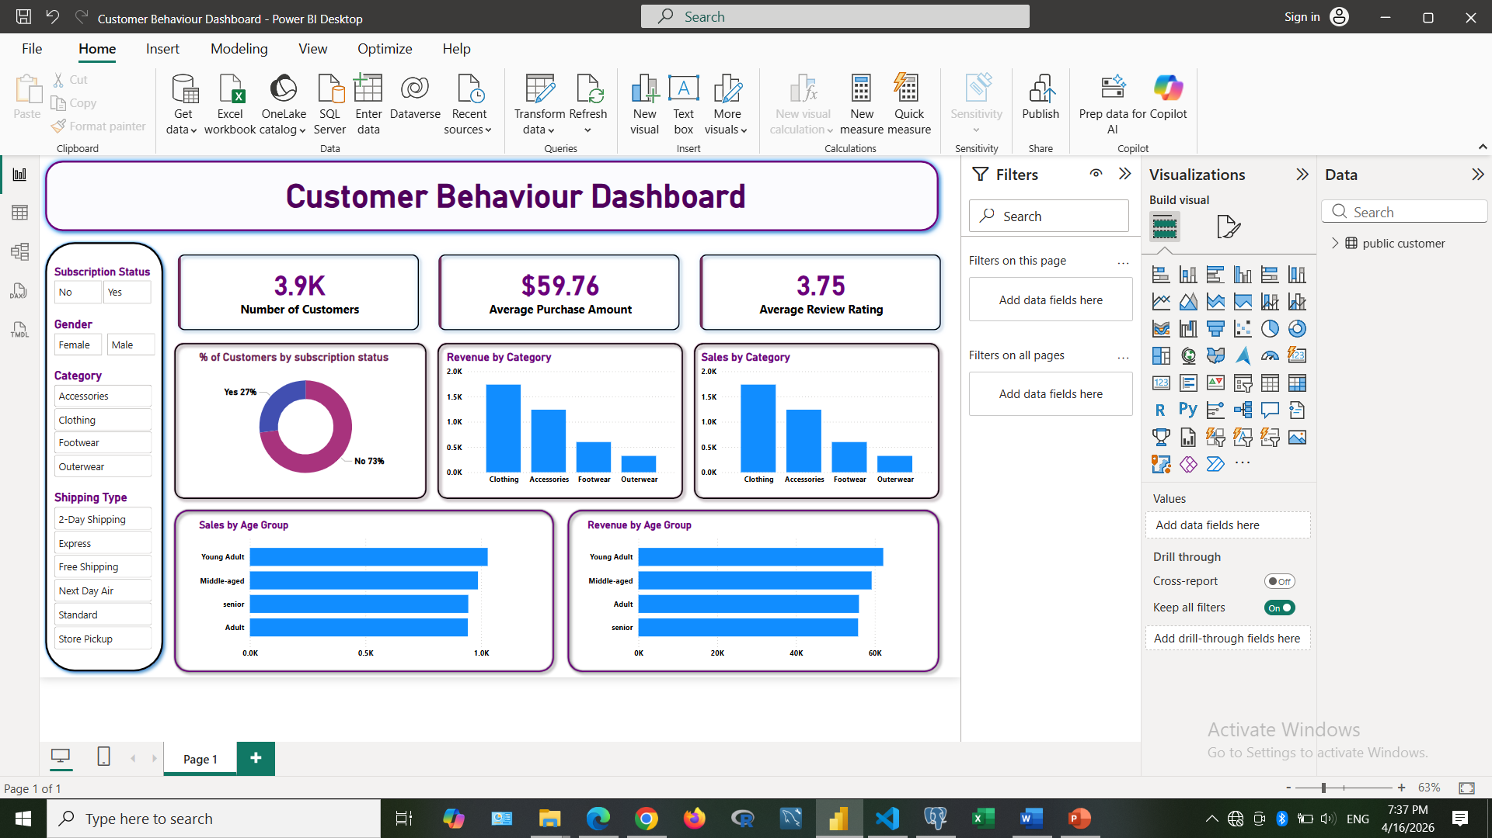

6. Business Recommendations
• Boost Subscriptions – Promote exclusive benefits for subscribers.
• Customer Loyalty Programs – Reward repeat buyers to move them into the 'Loyal' segment.
• Review Discount Policy – Balance sales boosts with margin control.
• Product Positioning – Highlight top-rated and best-selling products in campaigns.
• Targeted Marketing – Focus efforts on high-revenue age groups and express-shipping users.

