All the opreations are performed on the page:--

This page is a jsp page convert it as HTML and run first and then copy the url and use it in below code perticularly on:--

**String baseUrl = "http://localhost:8081/crudWithSpring";**

**driver.get(baseUrl);**

**here baseUrl shuld be that value.**

**<%@ page language="java" contentType="text/html; charset=UTF-8"**

**pageEncoding="UTF-8"%>**

**<!DOCTYPE html PUBLIC "-//W3C//DTD HTML 4.01 Transitional//EN" "http://www.w3.org/TR/html4/loose.dtd">**

**<html>**

**<head>**

**<meta http-equiv="Content-Type" content="text/html; charset=UTF-8">**

**<title>Insert title here</title>**

**</head>**

**<body>**

**<a href="http://localhost:8081/crudWithSpring/getEmpRegPage" id="addEmp">Add Employee</a>**

**<a href="ViewEmp">View Employee</a>**

**<!-- <a href="EmpDelete.jsp">Delete Employee</a> -->**

**<!-- <a href="EmpUpdate.jsp">Update Employee</a> -->**

**<button id="btn1" onclick="msg()">Click Here</button>**

**<div id="st1" style="background-color:black;color:white;">Here div started</div>**

**<script type="text/javascript">**

**function msg(){**

**alert("ok");**

**}**

**</script>**

**</body>**

**</html>**

Image:--

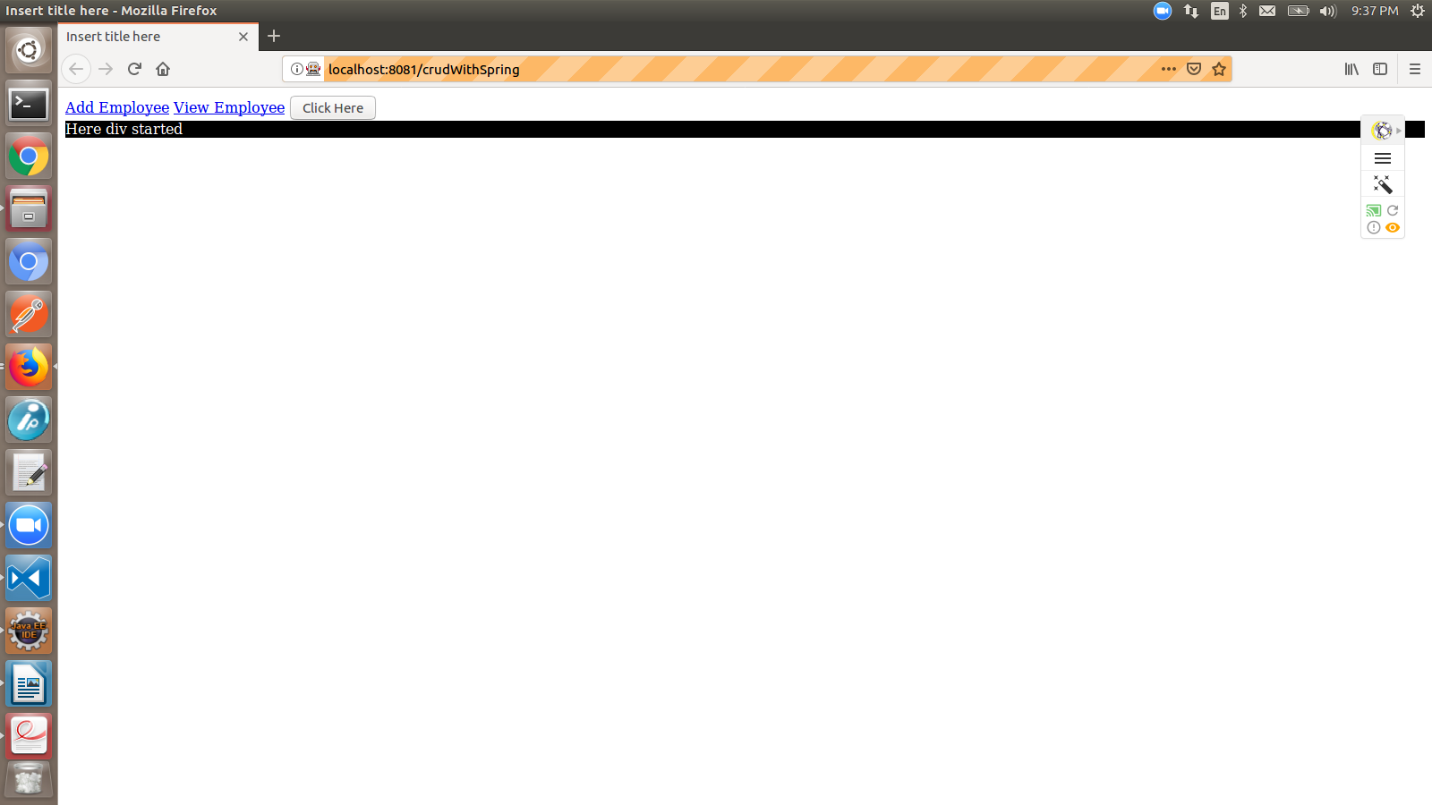

**1.Handling alerts box and Verfying the Alert Text:--**

**Alert is a small message box which displays on-screen notification to give the user some kind of information or ask for permission to perform certain kind of operation. It may be also used for warning purpose.**

Here are few alert types:

1) Simple Alert

This simple alert displays some information or warning on the screen.

2) Prompt Alert.

This Prompt Alert asks some input from the user and selenium webdriver can enter the text using sendkeys(" input…. ").

3) Confirmation Alert.

This confirmation alert asks permission to do some type of operation.

**Example:--**

**package com.ayantsoft.Selenium.webpage;**

**import org.openqa.selenium.Alert;**

**import org.openqa.selenium.By;**

**import org.openqa.selenium.WebDriver;**

**import org.openqa.selenium.WebElement;**

**import org.openqa.selenium.firefox.FirefoxDriver;**

**public class HandlingPrograms {**

**public static void main(String[] args) {**

**// TODO Auto-generated method stub**

**//handling alert boxes**

**WebDriver driver = new FirefoxDriver();**

**String baseUrl = "http://localhost:8081/crudWithSpring";**

**driver.get(baseUrl);**

**/*WebElement addEmp = driver.findElement(By.id("addEmp"));**

**addEmp.click();**

**\*/ // Switching to Alert**

**WebElement btn1 = driver.findElement(By.id("btn1"));**

**btn1.click();**

**Alert alert = driver.switchTo().alert();**

**// Capturing alert message.**

**String alertMessage= driver.switchTo().alert().getText();**

**// Displaying alert message**

**System.out.println(alertMessage);**

**2.Keyboard actions and Mouse actions**

**String baseUrl = "http://localhost:8081/crudWithSpring";**

**driver.get(baseUrl);**

**WebElement st1 = driver.findElement(By.id("st1"));**

**/*Actions builder = new Actions(driver);**

**Action mouseOverHome = builder**

**.moveToElement(st1)**

**.build();**

**String bgColor = st1.getCssValue("background-color");**

**bgColor = st1.getCssValue("background-color");**

**System.out.println("Before hover: " + bgColor);**

**mouseOverHome.perform();**

**bgColor = st1.getCssValue("background-color");**

**System.out.println("After hover: " + bgColor);**

**String hex = Color.fromString(bgColor).asHex();**

**System.out.println(hex);*/**

**//performing key and mouse events**

**/* Actions builder = new Actions(driver);**

**Action seriesOfActions = builder**

**.moveToElement(st1)**

**.click()**

**.keyDown(st1, Keys.SHIFT)**

**.sendKeys(st1, "hello")**

**.keyUp(st1, Keys.SHIFT)**

**.doubleClick(st1)**

**.contextClick()**

**.build();**

**seriesOfActions.perform() ;*/**

}

}