Data Analytics Capstone
Pollution-Prevention Actions and Next-Year Toxic Release Reduction in U.S. Manufacturing
Final Report

Somnath Das
Walsh College
QM640: Data Analytics Capstone
Professor Rishab Pandey
Summer 2026 Term
September 15, 2026

Code and Data Availability
GitHub repository (code, notebooks, sample data, reports, and presentation): https://github.com/somndas3/qm640-tri-pollution-prevention-capstone
Final analysis notebook: notebooks/02_QM640_TRI_2020_2024_final.ipynb
Exploratory data analysis and data preparation notebook: notebooks/02_EDA_QM640_Synopsis_TRI_2020_2024.ipynb
Final report and presentation: reports/QM640_Final_Report_Somnath_Das.docx and presentation/QM640_Walsh_Capstone_Final_Presentation_Somnath_Das.pptx
Raw and processed data, view-only (Google Drive): https://drive.google.com/drive/folders/1oPNHYCAvGwc7uQ1iIP2a_VlZdLnFJuid?usp=sharing
Original data source (U.S. Environmental Protection Agency): https://www.epa.gov/toxics-release-inventory-tri-program/tri-basic-plus-data-files-calendar-years-1987-present
The ten raw source files total 535.6 MB, which exceeds practical repository limits, so they are shared through Google Drive rather than GitHub. Appendix B lists the size and SHA-256 checksum of every file, and Figures D1 to D4 in Appendix D show the shared folder structure and processed files. The final notebook ran from top to bottom without errors. Random elements were fixed with a seed of 42 so that the tuned model and bootstrap intervals can be reproduced.

Abstract
U.S. manufacturing facilities report pollution-prevention actions to the Environmental Protection Agency (EPA) every year, but environmental health and safety (EHS) teams have no simple, evidence-based way to decide which filings deserve review first. This study examined whether reported actions are associated with a meaningful next-year toxic-release reduction and whether available information can rank records by their risk of not reducing. The explanatory path applied chi-square tests, facility-clustered logistic regression, and Holm-corrected comparisons. The predictive path compared an interpretable elastic-net logistic regression with a simple baseline. It was tuned by leave-one-transition-out cross-validation and evaluated once on a sealed out-of-time holdout. The data were Toxics Release Inventory (TRI) Basic Plus Form R records for reporting years 2020 through 2024. The unit of analysis was the facility-chemical-year, and a meaningful reduction meant a next-year on-site release of no more than 90% of the current-year release. The development set held 123,535 records from 14,851 facilities, and the 2023-to-2024 holdout held 39,966 records, of which 39,500 pound-reported records were used for model evaluation. Analyses used Python, statsmodels, and scikit-learn in Google Colab. Reduction rates rose from 27.5% to 35.9% across transitions and varied by about 15 percentage points across subsectors, but the effect sizes were small. After adjustment, reporting any action was associated with 14% higher odds of reduction (odds ratio [OR] = 1.14, 95% confidence interval [CI] [1.06, 1.23], p < .001). Material modification and operating practice or training were the only action types that exceeded the no-action rate after correction. On the holdout, the elastic-net model reached an area under the receiver operating characteristic curve (AUC) of .523, 95% CI [.515, .532], against .502 for the baseline. The gain was reliable but modest. Among the top 5% of ranked records, 73.9% did not reduce, compared with a base rate of about 68%. The results offer four user benefits: triage of fixed review capacity, prioritized evaluation of the two strongest action types, pounds-at-risk weighting, and peer and trend benchmarking. The model suits decision support, not automated or enforcement decisions.
Keywords: Toxics Release Inventory, pollution prevention, source reduction, logistic regression, elastic net, out-of-time validation, environmental health and safety

Pollution-Prevention Actions and Next-Year Toxic Release Reduction in U.S. Manufacturing
Every year, thousands of U.S. manufacturing plants report their toxic releases and the steps they took to release less. An environmental health and safety (EHS) team can review only a small share of these filings. This study tested whether reported pollution-prevention actions carry real information about next-year release reductions and whether that information can help such a team decide where to look first. It is an association and screening study, not a causal one.

Background and Context
The U.S. Environmental Protection Agency (EPA) collects these filings through the Toxics Release Inventory (TRI), a public program whose data support open study of industrial environmental behavior (U.S. Environmental Protection Agency [EPA], 2025b, 2025c, 2025d). The Pollution Prevention Act of 1990 favors preventing waste at the source over recycling, treatment, or disposal (EPA, 2025a), and facilities report such source-reduction actions with standard activity codes.
Plant managers, EHS leaders, sustainability leaders, and regulators need to know whether reported actions line up with lower releases the following year, and which kinds of action do so most strongly. A simple before-and-after comparison cannot answer this, because releases also move with production, reporting changes, and ordinary year-to-year variation.
Earlier TRI research studied disclosure, voluntary programs, and the long-run effects and profitability of prevention (Cagno et al., 2005; Gamper-Rabindran, 2006; Hamilton, 1995; King & Lenox, 2002; Konar & Cohen, 1997; Ranson et al., 2015). None of it gives an EHS team a ready-to-use way to screen this year’s filings, which is the gap this project addresses.

Problem Statement
EHS and plant leaders lack a recent, transparent way to judge whether records carrying reported prevention actions are more likely to show a meaningful next-year reduction in the same chemical’s on-site release. The objective of this study was to explain and predict Y = REDUCTION_10, equal to 1 when the next-year on-site release is no more than 90% of the current-year release, for U.S. manufacturing facility-chemical-year records, using X = reported pollution-prevention actions, current release, production or activity ratio, manufacturing subsector, chemical hazard classification, and action year, over TRI reporting years 2020 through 2024. Success was evaluated with adjusted odds ratios (ORs) and facility-clustered 95% confidence intervals (CIs), and with holdout area under the receiver operating characteristic curve (AUC), Brier score, and top-ranked non-reduction rates against a simple baseline.

Purpose of the Study
The study aimed to explain which factors are associated with next-year reduction and to predict which records are unlikely to reduce, so that EHS teams can prioritize review without replacing engineering judgment. The overarching question was: To what extent can recent EPA TRI information on reported pollution-prevention actions help explain and predict whether a facility will reduce the same chemical’s on-site release by at least 10% in the following year?

Research Questions
Four research questions (RQs) addressed context (RQ1), explanation (RQ2 and RQ3), and prediction (RQ4).
RQ1. Do meaningful next-year reduction rates differ across action-year transitions and manufacturing subsectors?
RQ2. After controlling for current release level, production or activity ratio, manufacturing subsector, chemical hazard classification, and action year, is reporting at least one pollution-prevention action associated with achieving a meaningful next-year reduction?
RQ3. Do meaningful next-year reduction rates differ between each reported pollution-prevention action type and records with no reported action?
RQ4. Can an interpretable model using only action-year information predict which facility-chemical records will fail to achieve a meaningful next-year reduction better than chance and better than a simple baseline model?

Contributions and Expected Value
Practical Contribution. A ranked review list and evidence on which reported action types show the clearest association with reduction, both built from public data that EHS teams already hold.
Technical Contribution. A design that separates adjusted explanation from out-of-time prediction, with facility-clustered inference and a sealed holdout evaluated once.
Value to Stakeholders. EHS teams gain a way to order a fixed workload, sustainability leaders gain peer-aware benchmarks, and regulators gain a candid view of what checkbox-style TRI data can support.

Literature Review

Literature Review Approach
Subject-matter sources on TRI disclosure, voluntary programs, and source reduction were found through Google Scholar and EPA documentation and were kept when they reported U.S. facility-level or firm-level evidence. Method sources were kept when they governed a specific design decision in this study.

Summary of Key Literature
Table 1 summarizes the 10 key sources, and Appendix G, Table G1 summarizes the supporting method and documentation sources. Author names in both tables link to the References.
Table 1
Literature Relevance Matrix for Key Sources
Author (Year) | Domain / Context | Dataset / Setting | Method(s) | Key Findings | How It Supports the RQs or Project Decisions
Hamilton (1995) | TRI disclosure and markets | U.S. public firms named in the first TRI release | Event study | Firms reporting TRI releases had negative abnormal stock returns. | TRI reporting carries real consequences, so reported behavior is worth studying
Konar & Cohen (1997) | Community right-to-know | U.S. firms reporting to TRI | Panel analysis | Firms with the largest stock-price declines later cut emissions more. | Links reported behavior with later releases
Gamper-Rabindran (2006) | EPA 33/50 voluntary program | Manufacturing plants in 48 states | Evaluation controlling for self-selection | No reduction in health-indexed emissions in several key industries; some apparent cuts were transfers to recyclers. | Raw reductions can mislead; supports adjustment, subsector controls, and no causal claims (RQ1, RQ2)
King & Lenox (2002) | Prevention versus treatment | U.S. manufacturing firms, TRI data | Panel regression | Profitable pollution reduction came from preventing waste, not treatment. | Focus on source-reduction codes
Cagno et al. (2005) | Cleaner production economics | 134 prevention project reports | Comparative analysis | Project profitability differed across intervention types. | Compare the five action types separately (RQ3)
Ranson et al. (2015) | Pollution prevention outcomes | U.S. manufacturing facilities in TRI | Facility-level regression | Source-reduction activity was associated with lower releases. | Closest prior study; motivates RQ2 and RQ3 on recent data
Cameron & Miller (2015) | Clustered inference | Econometric practice | Practitioner guide | Ignoring within-cluster correlation understates standard errors. | Facility-clustered errors in RQ1 to RQ3
Holm (1979) | Multiple comparisons | Statistical theory | Step-down procedure | Controls family-wise error with more power than Bonferroni. | Correction for the five RQ3 comparisons
Zou & Hastie (2005) | Regularized regression | Statistical methodology | Elastic-net penalty | Combined lasso and ridge penalties handle correlated predictors. | Choice of the RQ4 elastic-net model
Steyerberg et al. (2010) | Prediction model evaluation | Methodological framework | Performance measures | Discrimination alone is not enough; calibration and usefulness matter. | RQ4 metrics: AUC, Brier score, calibration, lift
Note. The remaining sources (interval estimation, large-sample inference, regression to the mean, functional form, sample size, calibration, and EPA documentation) appear in Appendix G, Table G1. AUC = area under the receiver operating characteristic curve; EPA = U.S. Environmental Protection Agency; RQ = research question; TRI = Toxics Release Inventory.
Public reporting changes behavior, but raw numbers can mislead. The first TRI disclosure moved share prices (Hamilton, 1995), and the firms punished hardest later cut emissions most (Konar & Cohen, 1997). Yet in the EPA’s voluntary 33/50 program, some apparent reductions reflected transfers to recyclers rather than true elimination (Gamper-Rabindran, 2006). Prevention also varies by type. Profitable reduction came from preventing waste rather than treating it (King & Lenox, 2002), project profitability differed across interventions (Cagno et al., 2005), and source reduction was associated with lower releases (Ranson et al., 2015). These studies justify a narrow outcome, adjusted comparisons, and separate analysis of action types.
The methods literature shaped inference and prediction. Clustered standard errors prevent understated uncertainty when facilities repeat (Cameron & Miller, 2015), Holm’s (1979) correction controls error across multiple comparisons, and with very large samples effect sizes matter more than p values (Lin et al., 2013). The elastic net suits correlated predictors (Zou & Hastie, 2005), and prediction models should be judged on calibration and decision usefulness as well as discrimination (Steyerberg et al., 2010; Van Calster et al., 2019).

Gap Addressed by This Study
Prior work shows that disclosure matters, that raw trends mislead, and that prevention types differ. It does not offer a recent, record-level screening tool or a candid estimate of how much predictive signal TRI action fields contain. This study addresses both.

Materials and Method
The study was a retrospective observational analysis of public EPA data with two paths: an explanatory path for RQ1 to RQ3 and a predictive path for RQ4. The final transition was sealed as an out-of-time holdout for the predictive evaluation.

Data Source
Data came from the EPA TRI Basic Plus Data Files (EPA, 2025c, 2025d): File 1A and File 2A for each reporting year from 2020 through 2024. File 1A supplies identifiers, the North American Industry Classification System (NAICS) code, unit, hazard flags, and on-site releases. File 2A supplies the production or activity ratio and up to four source-reduction codes. Files were joined within each year on the document control number (Appendix B), and the data dictionary appears in Appendix E, Table E1.

Population and Unit of Analysis
The population was U.S. TRI-reporting manufacturing facilities with a primary NAICS code beginning with 31, 32, or 33, using Form R records only. The unit of analysis was the facility-chemical-year, forming four transitions from 2020 to 2021 through 2023 to 2024.

Inclusion and Exclusion Criteria
Records were included when they had a matching facility-chemical record in the following year, a current-year release above zero, and the same unit in both years. These rules reduced 315,581 raw rows to 163,501 eligible records (Appendix E, Table E3). Records missing in the next year were excluded rather than scored as reductions.
The development set held 123,535 records from 14,851 facilities, including 122,017 pound-reported records used for RQ2 and RQ4 and 1,518 gram-reported dioxin records analyzed separately. The 2023-to-2024 holdout contained 39,966 eligible records, of which 39,500 pound-reported records formed the RQ4 modeling holdout.

Outcome Definition
REDUCTION_10 equals 1 when release_{t+1} ≤ 0.90 × release_{t} and 0 otherwise, and it is defined only when current release exceeds zero. The 10% threshold was fixed before any modeling as a materiality cutoff, so it could not be tuned to improve results. A round 10% change is easy for managers to interpret and keeps small year-to-year movements from counting as reductions. Alternative thresholds were not tested. The rate was 31.48% in development and 32.05% in the holdout. For RQ4 the positive class was non-reduction, the outcome an EHS team would act on.

Predictors
Predictors were a reported-action indicator and five action-type indicators (material, product, process or equipment, inventory or material management, and operating practice or training), current release, the production ratio, the three-digit subsector, EPA hazard flags for carcinogen, persistent, bioaccumulative, and toxic (PBT), and metal status, and the transition. The 15 subsectors with at least 500 records were kept individually, and the rest formed Other Manufacturing. An action indicator of 0 means that no code was observed, not that no action occurred.

Data Preparation
Every cleaning filter was logged and reconciled against raw counts (Appendix E, Table E2). Duplicate filings were consolidated with a deterministic rule (Appendix C), unit labels were normalized, and 70 activity codes spanning an EPA coding change were mapped to the five action types. The holdout file was written without outcome columns.

Exploratory Data Analysis
Exploratory analysis used development data only. Table 2 links each important finding to its interpretation and modeling consequence, and Appendix A gives the full discussion and figures.
Table 2
Exploratory Findings, Interpretation, and Modeling Consequences
Finding | Interpretation | Modeling or Business Consequence
31.48% of development records met the reduction threshold; only 4.87% reported any action (Figure A1) | The outcome is not severely imbalanced, but the exposure is rare | No resampling; rare exposure, not class imbalance, is the main statistical constraint
Process or equipment modification rose from 1.32% to 2.13%, and material modification from 0.41% to 0.87%, exactly at the 2020-to-2021 code-scheme change (Figures A2, A3) | Part of the rise may be a reporting artifact rather than behavior | Codes mapped to five types; key association repeated without the 2020-to-2021 transition
Reduction rates rose from 27.54% to 35.86% across transitions and spanned 15.4 percentage points across subsectors | Time and industry both shift the outcome | Year and subsector used as RQ2 controls; formal tests reported under RQ1
Subsectors reporting the most actions were not those reducing most often (Figure A4) | An unadjusted action comparison is partly a comparison of industries | Adjusted model required; below-threshold subsectors grouped as Other Manufacturing
Raw gap of 3.61 points for any action; 7 of 19 covariates imbalanced beyond a standardized difference of 0.10 (Figures A5 to A7) | The raw gap is confounded | RQ2 answered only with an adjusted model
Current release: mean 24,737 lb, median 217 lb, skewness 34.6; nonmonotonic rates by release decile (Figures A8 to A10) | Raw scale is unusable; starting level shapes room to fall (regression to the mean) | Log transformation; current release forced into every model
U-shaped reduction rate across production-ratio deciles; 1.62% missing; extreme values (Figures 1, A11) | A linear term would miss the shape; a few extreme values could dominate | Centered quadratic term, median imputation with a missingness flag, 99th-percentile cap
122,017 pound-frame records from 14,836 facilities; 92.8% from multi-record facilities (Figure A3) | Records are not independent | Facility-clustered errors, facility bootstrap, and time-grouped validation
Dioxins reduce at 24.84% versus 31.56%; carcinogen status shows a 0.07-point difference (Figure A12) | Dioxins differ and use grams | Dioxins analyzed separately; hazard flags kept as controls
Cross-year attrition of 7.6% to 9.5%; higher among action-reporting records (Figure A13) | Selection into the matched sample is possible | Reported as a limitation; unmatched records never scored as reductions
Note. Rates and counts refer to the development set. Figure 1 appears in the main text; Figures A1 to A14 appear in Appendix A, where Figure A14 summarizes the 15 data-quality checks.
One finding changed the specification directly. The reduction rate was U-shaped across production-ratio deciles, lowest in the middle decile (29.72%) and highest in the top decile (36.19%), as Figure 1 shows. A centered quadratic term was therefore added.
Figure 1
Reduction Rate by Production-Ratio Decile in the Development Set
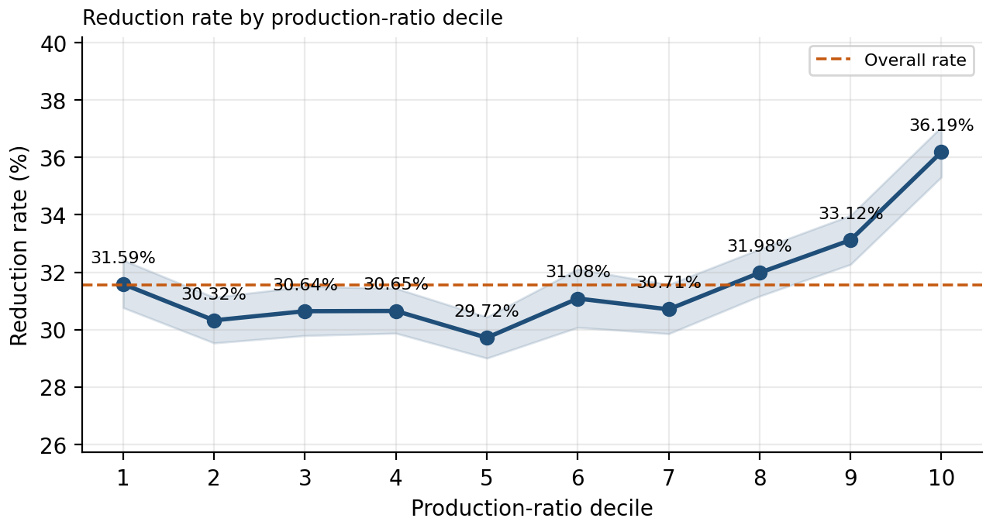
Note. Shaded bands are 95% Wilson confidence intervals; the dashed line is the overall development reduction rate.

Feature Engineering
Table 3 lists the final features and their use. RQ2 used the full adjustment set. The RQ4 model used 13 action-year predictors and excluded action year, because the holdout year was unseen in training. The locked RQ4 specification was limited to release, production, action, and chemical hazard features, so subsector indicators were not included and their added predictive value was not tested.
Table 3
Final Features, Construction, and Use by Research Question
Feature | Construction | Reason | RQ2 | RQ4
Log current release | log(1 + current-year release, lb) | Skewness of 34.6; controls regression to the mean | Yes | Yes
Production ratio, centered | Missing values set to the development median (1.00); capped at the 99th percentile (3.15); centered at the pound-frame mean (1.0444) | Limits extreme values; centering reduces collinearity with the squared term | Yes | Yes
Production ratio squared | Square of the centered ratio | Captures the U-shape; supported by AIC | Yes | Yes
Production ratio missing | 1 when the ratio was originally absent | Keeps information about missingness after imputation | Yes | Yes
Any reported action | 1 when at least one valid source-reduction code is present | Primary RQ2 exposure | Yes | Yes
Five action-type indicators | One indicator per mapped action type; not mutually exclusive | Types may differ; pooling could hide that (RQ3) | No | Yes
Carcinogen and PBT flags | EPA classification flags | Hazard controls | Yes | Yes
Metal flag | EPA metal or metal-compound flag | Chemical-class signal | No | Yes
Manufacturing subsector | 15 qualifying subsectors plus Other Manufacturing; reference NAICS 325 (chemical) | Industry confounding | Yes | No
Action-year transition | Reference 2020 to 2021 | Time trend confounding; holdout year unseen in training | Yes | No
Identifiers | Facility, chemical, CAS number, chemical name | Traceability only | No | No
Note. In RQ4, the three continuous features were standardized inside each cross-validation training fold, and binary indicators were passed through unchanged. Gram-reported dioxin records were outside the pound-reported frame, so a dioxin flag was not modeled. AIC = Akaike information criterion; CAS = Chemical Abstracts Service; PBT = persistent, bioaccumulative, and toxic.
Leakage controls included an outcome-free holdout file, labels rebuilt only after locking, development-only preprocessing values, standardization within training folds, and folds grouped by transition. The imputation, cap, and centering constants were computed once on all development data rather than within each fold, a minor departure from a fully nested design.

Sample Size and Power Justification
Minimum requirements were 1,068 records for RQ1, 10,756 for RQ2, about 290 per action type for RQ3, and 1,269 for RQ4 (Appendix E, Table E4). All were met, and the locked RQ4 model had about 2,963 events per parameter. Because RQ3 was powered for 10-point differences, a nonsignificant action type does not show that the action has no association.

Research Questions and Hypotheses
Table 4 states the hypotheses, method, and decision rule for each question. Tests used α = .05, RQ3 used Holm’s (1979) correction, and RQ4 decisions used 95% facility-bootstrap intervals.
Table 4
Research Questions, Hypotheses, Methods, and Decision Rules
RQ | Null Hypothesis (H₀) | Alternative Hypothesis (H_{a}) | Method | Decision Rule
RQ1a | Meaningful reduction is independent of action-year transition | Reduction rates differ across transitions | Pearson chi-square test, Cramér’s V, Wilson CIs | Reject H₀ if p < .05; judge size by V
RQ1b | Meaningful reduction is independent of manufacturing subsector | Reduction rates differ across subsectors | Pearson chi-square test, Cramér’s V, Wilson CIs | Reject H₀ if p < .05; judge size by V
RQ2 | The adjusted OR for reporting any action equals 1 | The adjusted OR differs from 1 | Logistic regression with facility-clustered standard errors | Reject H₀ if p < .05 and the 95% CI excludes 1
RQ3 | For each action type, the reduction rate equals the no-action rate | The action-type rate differs from the no-action rate | Five 2 × 2 chi-square tests, rate differences, RRs, Holm correction | Reject H₀ for a type if Holm-adjusted p < .05
RQ4a | Holdout AUC of the elastic-net model equals .50 (chance) | Holdout AUC exceeds .50 | Facility bootstrap CI for AUC on the sealed holdout | Reject H₀ if the 95% CI lower bound exceeds .50
RQ4b | Elastic-net holdout AUC does not exceed baseline AUC | Elastic-net holdout AUC exceeds baseline AUC | Paired facility bootstrap of the AUC difference | Reject H₀ if the 95% CI of the difference excludes 0
Note. AUC = area under the receiver operating characteristic curve; CI = confidence interval; OR = odds ratio; RR = relative risk.

Statistical Methods
RQ1 used Pearson chi-square tests with Cramér’s V and Wilson intervals, because significance alone is uninformative with more than 120,000 records (Lin et al., 2013). RQ2 used logistic regression, whose coefficients convert into odds ratios, with standard errors clustered by facility because facilities contribute repeated records (Cameron & Miller, 2015). Diagnostics included variance inflation factors (VIFs), the condition number, and an Akaike information criterion (AIC) comparison of production-ratio forms. RQ3 compared each action type with the no-action group in 2 × 2 chi-square tests, reporting rate differences, relative risks (RRs), and Holm-adjusted p values.

Model Development
The predictive path compared an unpenalized baseline logistic regression, using only the any-action indicator and log current release, with an elastic-net logistic regression using the 13 predictors in Table 3 (Zou & Hastie, 2005). The elastic net stays interpretable, handles correlated action indicators, and resists overfitting. A grid search selected C = 0.01 with an L1 ratio of .1, a heavily penalized fit. Both models were refitted on all development data and locked. Flexible learners were not adopted, because reviewers need to know why a record is flagged.

Validation Strategy
The split was temporal because real use is forward-looking, and a random row-level split could place observations from the same facilities in both training and validation sets, producing an overly optimistic estimate of future performance. Tuning used leave-one-transition-out cross-validation within development data. Holdout labels were rebuilt from raw 2024 filings only after the design was locked, matching all 39,500 pound-reported records, and the holdout was used once. Holdout uncertainty came from 500 facility-level bootstrap resamples.

Evaluation Metrics
Explanatory results were judged by effect sizes and intervals. Predictive models were judged on AUC, Brier score, calibration, and screening lift among top-ranked records (Steyerberg et al., 2010; Van Calster et al., 2019). Accuracy was not a headline metric, because always predicting non-reduction is already correct for about 68% of records (Appendix E, Table E5).

Sensitivity Analyses
Six sensitivity checks tested the time period, the imputation choice, the functional form, facility clustering for RQ1 and RQ3, and separate handling of dioxins (Appendix F, Table F1).

Architecture Diagram and Workflow

System Overview
The pipeline turns raw EPA files into two outputs: statistical evidence for RQ1 to RQ3 and a ranked review list from a locked screening model for RQ4. All stages ran in Python notebooks in Google Colab, with data on Google Drive and code on GitHub.

Architecture Diagram
As shown in Figure 2, the cleaned and joined files form the facility-chemical-year dataset and outcome, which split into development data and a sealed holdout. The explanatory and predictive paths branch after exploratory analysis, and the holdout was opened once, after the design was locked.
Figure 2
End-to-End Workflow From EPA TRI Files to a Ranked EHS Review List
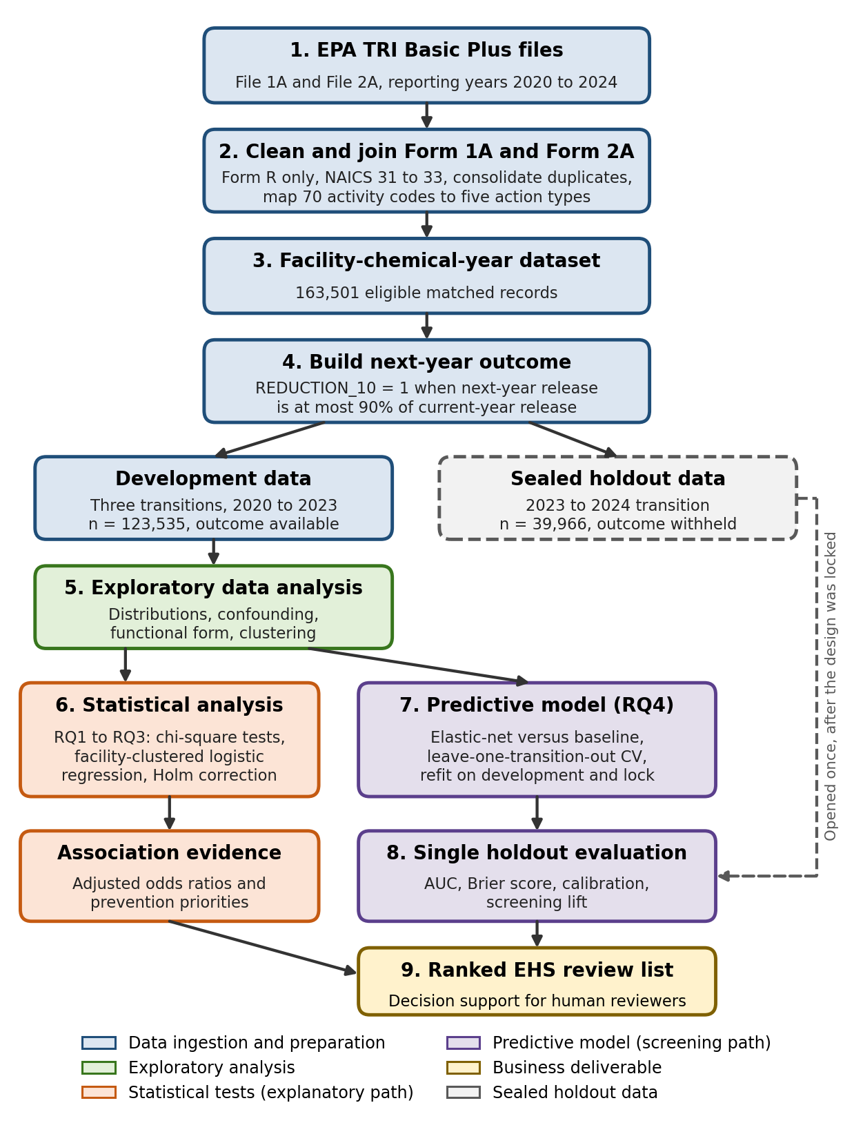
Note. Colors mark stage groups, as shown in the legend. Solid arrows show the flow of development data. The dashed box and arrow show the sealed 2023-to-2024 holdout, which was used only for the single final evaluation. CV = cross-validation; EHS = environmental health and safety; RQ = research question; TRI = Toxics Release Inventory.

Workflow Components
Data ingestion: ten EPA text files. Preprocessing: filtering, consolidation, matching, imputation, capping, and encoding. Exploratory analysis: Table 2. Feature engineering: Table 3. Model development: the RQ2 regression and the baseline and elastic-net RQ4 models. Model evaluation: a single scoring of the 39,500 holdout records. Deployment: no production system was built (see Implementation and User Benefit).

Tools and Technologies
Analysis used Python in Google Colab with pandas 2.2.2, NumPy, SciPy, statsmodels 0.14.6, scikit-learn 1.6.1, and matplotlib. The linear models needed no specialized hardware, and deep learning or agentic methods were not used because the questions required interpretable coefficients.

Results
RQ1 to RQ3 used development data, and RQ4 used the sealed holdout for its single evaluation. Very small p values are reported as p < .001.

Model Performance
Table 5 shows that the elastic-net model outperformed the baseline in cross-validation (AUC .530 versus .522) and on the holdout (.523 versus .502). The holdout AUC interval, [.515, .532], lies above .50, and the paired difference of .021, 95% CI [.014, .027], excludes zero. Brier scores were nearly identical (.2176 and .2180), so the gain lies in ranking rather than in sharper probabilities.
Table 5
Predictive Model Performance Comparison
Model | Features Used | Validation Method | CV AUC (Worst Fold) | CV Brier | Holdout AUC [95% CI] | Holdout Brier | Best
Baseline: unpenalized logistic regression | Any reported action; log current release (2 predictors) | Leave-one-transition-out CV; single sealed holdout | .5222 (.5125) | .2173 | .5023 | .2180
Elastic-net logistic regression (C = 0.01, L1 ratio = .1) | 13 action-year predictors (Table 3) | Leave-one-transition-out CV; single sealed holdout | .5302 (.5234) | .2169 | .5231 [.5149, .5316] | .2176 | Yes
Difference (elastic net minus baseline) |  | Paired facility bootstrap on holdout | .0080 | −.0004 | .0208 [.0140, .0268] | −.0004
Note. The positive class was non-reduction. Development cross-validation (CV) used 122,017 pound-reported records in three folds grouped by transition. The holdout contained 39,500 pound-reported records, of which 67.95% did not reduce. Confidence intervals for holdout AUC come from 500 facility-level bootstrap resamples. At the F1-maximizing threshold chosen on development data (.520), both models flagged nearly every record (elastic net: precision = .679, recall = .9999, F1 = .809), so accuracy-type metrics at that threshold are uninformative. AUC = area under the receiver operating characteristic curve.

Visual Evidence
In Figure 3, the calibration plot showed no large departures from the diagonal within the narrow range of predicted probabilities (about .63 to .73), although no formal calibration slope was estimated. The receiver operating characteristic (ROC) curve for the elastic net lies only slightly above the baseline and chance lines.
Figure 3
Holdout Calibration and Receiver Operating Characteristic Curves
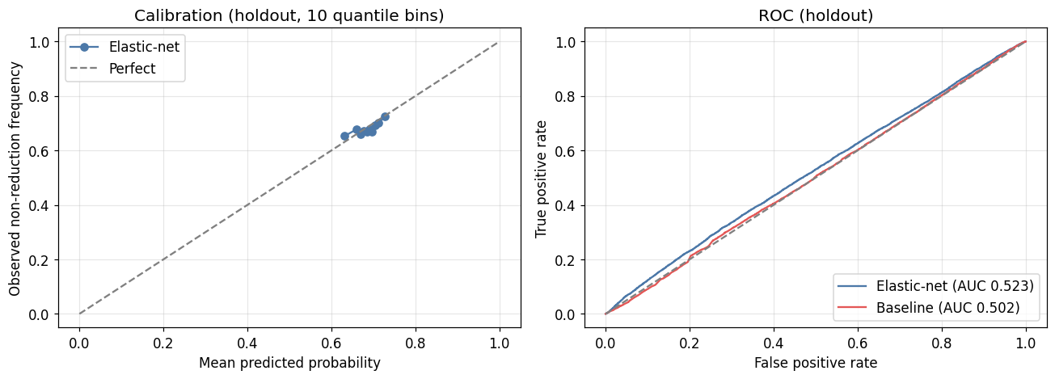
Note. Left panel: observed non-reduction frequency against mean predicted probability in 10 quantile bins for the elastic-net model; the dashed line marks perfect calibration. Right panel: ROC curves for the elastic-net model (AUC = .523) and the baseline (AUC = .502) on 39,500 pound-reported 2023-to-2024 holdout records; the dashed line marks chance. AUC = area under the ROC curve.
Figure 4 shows that reporting any action, PBT status, log release, metal status, and material modification lowered predicted risk most. Even the largest coefficient was about −0.14 on the log-odds scale, consistent with modest discrimination (Appendix F, Table F3).
Figure 4
Elastic-Net Standardized Coefficients for Predicting Non-Reduction
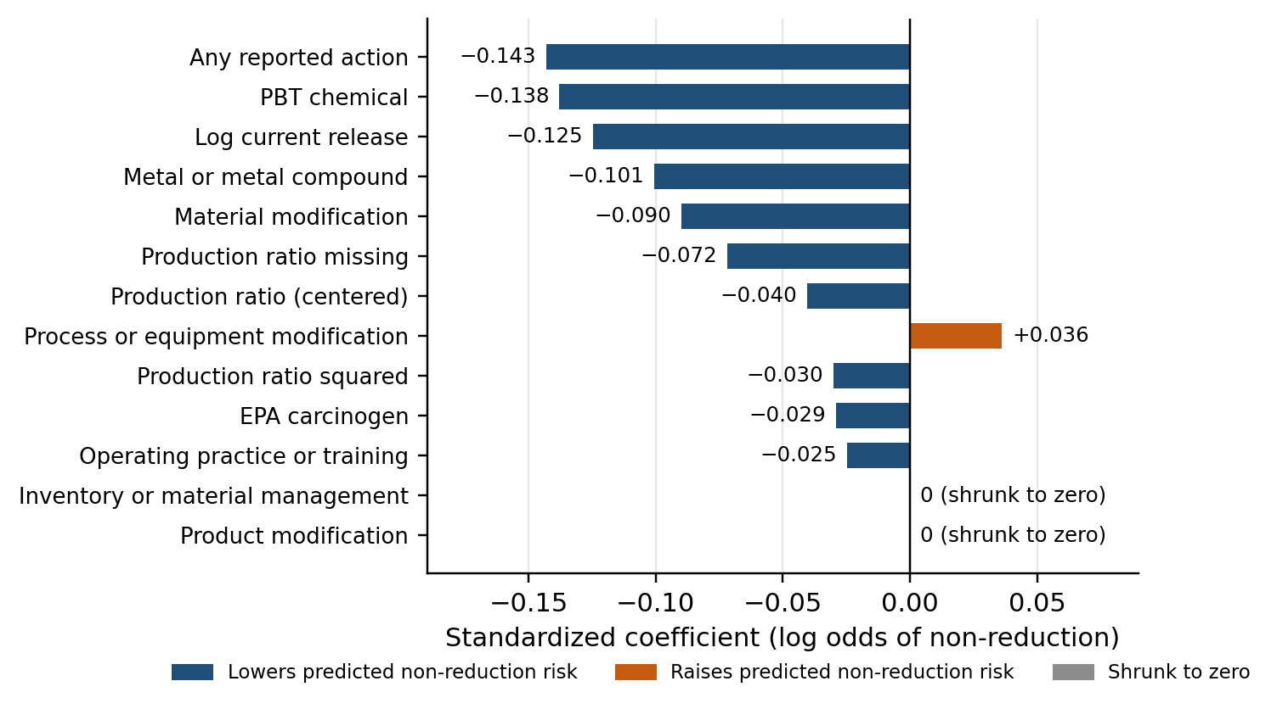
Note. Coefficients are on the log-odds scale of non-reduction. Continuous features were standardized, so coefficients for those features represent a one-standard-deviation change; binary features represent a change from 0 to 1. PBT = persistent, bioaccumulative, and toxic.

Results by Research Question

Research Question 1: Differences by Transition and Subsector
Hypotheses and Method. H₀: reduction is independent of transition, and of subsector. H_{a}: rates differ. Two chi-square tests with Cramér’s V and facility-clustered checks were used.
Result and Decision. Rates rose from 27.5% to 31.1% to 35.9% across transitions, χ²(2) = 663.72, p < .001, and ranged from 25.9% (paper) to 41.3% (furniture) across subsectors, χ²(14) = 280.04, p < .001 (Table 6 and Appendix F, Figures F1 and F2). Both null hypotheses were rejected, and both effects held under facility clustering.
Practical Meaning. The effects were statistically significant but small (Cramér’s V = .073 and .048). Time and industry shift the chance of reduction modestly, so they are controls rather than screening levers.
Table 6
RQ1 Reduction Rates by Transition and Subsector
Factor | Reduction Rate, % [95% CI] | χ² (df) | p | Cramér’s V | Facility-Clustered Check
Action-year transition | 2020 to 2021: 27.54 [27.11, 27.97], n = 41,280  2021 to 2022: 31.09 [30.65, 31.54], n = 41,356  2022 to 2023: 35.86 [35.39, 36.32], n = 40,899 | 663.72 (2) | < .001 | .073 | OR = 1.19 and 1.47 versus 2020 to 2021; both p < .001
Manufacturing subsector (15 qualifying) | Lowest: 322 Paper, 25.89 [24.82, 27.00]  Highest: 337 Furniture, 41.26 [37.92, 44.68]  Spread: 15.4 percentage points | 280.04 (14) | < .001 | .048 | 9 of 14 contrasts with NAICS 325 significant at p < .05
Note. Development set, N = 123,535 for transitions and 122,429 for the 15 qualifying subsectors. Rates for all subsectors appear in Appendix F, Figure F2 and Table F4. CI = confidence interval; NAICS = North American Industry Classification System; OR = odds ratio.

Research Question 2: Adjusted Association With Any Reported Action
Hypotheses and Method. H₀: the adjusted OR for any reported action equals 1. H_{a}: it differs from 1. A facility-clustered logistic regression was fitted to 122,017 records from 14,836 facilities.
Result and Decision. Reporting any action was associated with higher adjusted odds of meaningful reduction, OR = 1.14, 95% CI [1.06, 1.23], p < .001, so H₀ was rejected (Table 7). The diagnostics did not indicate serious multicollinearity (maximum VIF = 1.98, condition number = 81.0), and the AIC comparison supported the quadratic production-ratio specification (150,795.0 versus 150,817.3).
Practical Meaning. Records reporting an action had about 14% higher odds, not 14% higher probability, of reaching the threshold, roughly 3 percentage points at the base rate. This is a modest marker, and because facilities choose whether to act and report, it does not show that the action caused the reduction.
Table 7
RQ2 Adjusted Odds Ratios From the Facility-Clustered Logistic Regression
Term | OR | 95% CI | p
Any reported action (exposure) | 1.143 | [1.058, 1.234] | < .001
Log(1 + current release) | 1.042 | [1.036, 1.047] | < .001
Production ratio, centered | 1.047 | [0.977, 1.122] | .197
Production ratio squared | 1.085 | [1.038, 1.135] | < .001
Production ratio missing | 1.108 | [0.977, 1.256] | .110
EPA carcinogen | 1.020 | [0.993, 1.048] | .140
PBT chemical | 1.230 | [1.167, 1.297] | < .001
Subsector indicators (15 plus Other; reference NAICS 325) | See Table F2
Transition indicators (reference 2020 to 2021) | See Table F2
Note. N = 122,017 pound-reported records from 14,836 facilities; 38,513 met the reduction threshold. Standard errors were clustered by facility. Diagnostics: maximum variance inflation factor = 1.98; condition number = 81.0; AIC = 150,795.0 for the quadratic form versus 150,817.3 for the linear form. The complete coefficient table appears in Appendix F, Table F2. AIC = Akaike information criterion; CI = confidence interval; NAICS = North American Industry Classification System; OR = odds ratio; PBT = persistent, bioaccumulative, and toxic.

Research Question 3: Action Types Compared With No Reported Action
Hypotheses and Method. For each action type, H₀: its reduction rate equals the no-action rate (31.31%). H_{a}: the rates differ. Five chi-square comparisons used Holm correction and facility-clustered checks.
Result and Decision. Two null hypotheses were rejected (Table 8 and Figure 5). Material modification reduced at 38.95%, 7.64 points above no action, and operating practice or training at 35.53%, 4.23 points above, both with Holm-adjusted p < .001 and both robust to clustering. The other three types did not survive correction.
Practical Meaning. These comparisons are observational and unadjusted, so they show where the clearest signals lie, not what causes reductions. For the other three types, “not statistically demonstrated” does not mean “ineffective,” because their intervals remain compatible with small positive or null differences.
Table 8
RQ3 Reduction Rates by Action Type Compared With No Reported Action
Action Type | n | Rate, % [95% CI] | Difference, pp [95% CI] | RR [95% CI] | Holm p | Clustered OR [95% CI] | H₀
Material modification | 778 | 38.95 [35.58, 42.42] | 7.64 [4.20, 11.08] | 1.244 [1.139, 1.359] | < .001 | 1.400 [1.170, 1.674] | Reject
Operating practice or training | 2,015 | 35.53 [33.47, 37.65] | 4.23 [2.12, 6.33] | 1.135 [1.070, 1.205] | < .001 | 1.210 [1.060, 1.379] | Reject
Inventory or material management | 1,038 | 33.53 [30.72, 36.45] | 2.22 [−0.66, 5.10] | 1.071 [0.983, 1.167] | .27 | 1.107 [0.930, 1.316] | Retain
Process or equipment modification | 2,230 | 33.18 [31.26, 35.17] | 1.88 [−0.09, 3.85] | 1.060 [0.999, 1.125] | .18 | 1.090 [0.968, 1.226] | Retain
Product modification | 361 | 32.41 [27.79, 37.40] | 1.10 [−3.73, 5.94] | 1.035 [0.892, 1.202] | .69 | 1.052 [0.812, 1.363] | Retain
No reported action (reference) | 117,523 | 31.31
Note. Action types are not mutually exclusive, so a record reporting more than one type appears in more than one comparison. The reference group contains only records with no valid action code. The smallest expected cell count was 113, so Pearson chi-square tests were valid. Clustered odds ratios come from facility-clustered logistic models of each type against the reference group (p < .001 for material modification and p = .005 for operating practice or training). CI = confidence interval; OR = odds ratio; pp = percentage points; RR = relative risk.
Figure 5
Difference in Reduction Rate by Action Type Relative to No Reported Action
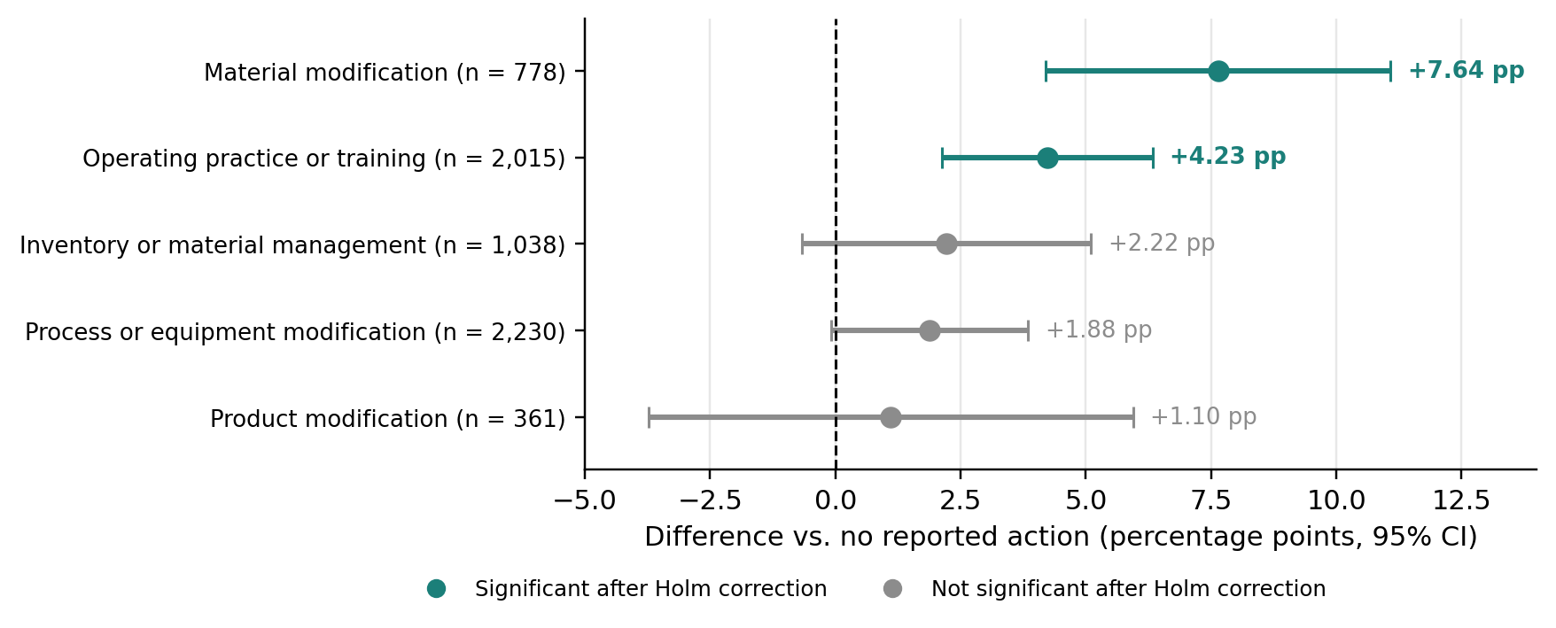
Note. Points show the percentage-point (pp) difference from the no-action rate of 31.31%, with 95% confidence intervals. Teal marks the two action types that remained significant after Holm correction; gray marks the three that did not.

Research Question 4: Predicting Non-Reduction on the Sealed Holdout
Hypotheses and Method. For RQ4a, H₀: holdout AUC equals .50. For RQ4b, H₀: the elastic-net AUC does not exceed the baseline AUC. Each H_{a} states the reverse. The locked models were scored once on 39,500 holdout records.
Result and Decision. The elastic-net AUC was .523, 95% CI [.515, .532], and it exceeded the baseline by .021, 95% CI [.014, .027], so both null hypotheses were rejected (Table 5).
Practical Meaning. The gain is reliable but modest. An AUC of .523 ranks a non-reducer above a reducer only slightly more often than chance, so the model suits ordering a review queue, not automated classification. A real association (RQ2) can coexist with weak prediction, because an odds ratio describes an average group difference, while prediction must separate individual records.

Sensitivity Analyses
All six sensitivity checks supported the main conclusions (Appendix F, Table F1). Without the 2020-to-2021 transition, the adjusted odds ratio was 1.12, 95% CI [1.03, 1.22], and on complete cases it was 1.14. Clustered versions of RQ1 and RQ3 agreed with the main tests, and dioxins were kept out of the pound-reported models.

Screening and Ranking Results
Because no single cutoff separated the classes well, holdout records were ranked by predicted risk (Table 9 and Figure 6). Among the top 5%, 73.9% did not reduce, compared with a base rate of about 68%, and the rate faded to 70.7% in the top 30%.
In business terms, a team reviewing about 2,000 of roughly 40,000 records from the top of the list would find about 117 more genuine non-reducers than an unranked review of the same size. This is an approximate operational estimate, not a guaranteed saving.
Table 9
Screening Lift on the Sealed Holdout When Reviewing the Highest-Risk Records
Review Depth | Records Reviewed | Non-Reducers Found | Non-Reduction Rate (Precision) | Lift | Share of All Non-Reducers (Recall) | Additional vs. Unranked Review
Top 5% | 1,975 | 1,459 | 73.87% | 1.087 | 5.4% | About 117
Top 10% | 3,950 | 2,865 | 72.53% | 1.067 | 10.7% | About 181
Top 20% | 7,900 | 5,640 | 71.39% | 1.051 | 21.0% | About 272
Top 30% | 11,850 | 8,376 | 70.68% | 1.040 | 31.2% | About 324
All records (base rate) | 39,500 | 26,839 | 67.95% | 1.000 | 100.0%
Note. Lift is the non-reduction rate in the reviewed slice divided by the base rate. The last column compares each ranked slice with the expected yield of an unranked review of the same size at the base rate; counts were derived from the reported rates and review sizes and are approximate.
Figure 6
Observed Non-Reduction Rate Among the Highest-Ranked Holdout Records
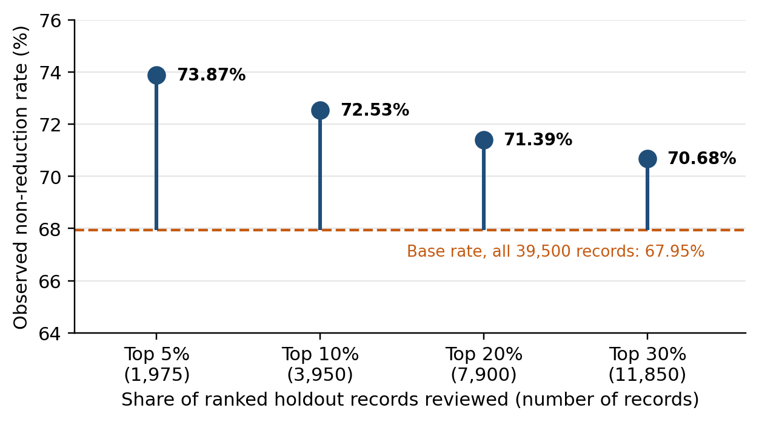
Note. Records were ranked by the locked elastic-net model’s predicted risk of non-reduction. The dashed line marks the base rate across all 39,500 pound-reported holdout records.

Overall Interpretation
Table 10 summarizes the decisions. Time and industry shift reduction rates, reported actions carry a real but modest adjusted association, two action types show the clearest signals, and the screening model ranks records only slightly better than chance and the baseline.
The main constraint was information content. Actions appear on fewer than 5% of records and record only that a box was checked, not cost, timing, or completion. The heavy penalty selected in tuning and the ample events per parameter point to the same conclusion.
Table 10
Summary of Hypothesis Decisions and Practical Meaning
RQ | Test | Key Statistic | H₀ Decision | Size and Practical Meaning
RQ1 | Chi-square tests by transition and subsector | χ²(2) = 663.72; χ²(14) = 280.04; both p < .001 | Reject | Small effects (V = .073 and .048); control for time and industry
RQ2 | Facility-clustered logistic regression | OR = 1.14 [1.06, 1.23], p < .001 | Reject | About 14% higher odds; modest marker, not proof of cause
RQ3 | Five Holm-corrected comparisons | Material +7.64 pp; operating practice +4.23 pp; both Holm p < .001 | Reject for 2 of 5 | Clearest signals for further evaluation; other three not demonstrated
RQ4 | Elastic net versus chance and baseline on sealed holdout | AUC = .523 [.515, .532] versus .502; difference .021 [.014, .027] | Reject | Reliable but modest gain; suitable for triage, not automation
Note. Brackets show 95% confidence intervals. AUC = area under the receiver operating characteristic curve; OR = odds ratio; pp = percentage points; V = Cramér’s V.

Practical Significance
The results support comparing facilities with peers rather than with raw before-and-after changes, treating a reported action as a modest positive marker, prioritizing the two strongest action types for further evaluation, and ordering fixed review capacity with the ranked list. The model tells a team where to look first, not what to conclude.

Implementation and User Benefit
The results translate into four practical benefits for an EHS team: (a) triage with the model, (b) prioritized evaluation of the strongest action types, (c) weighting by pounds at risk, and (d) benchmarking against peers and trend. All four use existing TRI data, need no new data collection, systems, or authority, and leave every decision with a person. This section describes how the model would be deployed and used and then sets out each benefit with its evidence, its value to users, and its main caution.

Deployment Approach
No production application was built. A realistic deployment is an annual batch process: after each EPA data release, the team runs the existing pipeline, applies the locked feature recipe, scores each record, and publishes a ranked spreadsheet or dashboard. The model should be re-validated on the latest completed transition before each cycle.

System Integration
The list can join internal systems through TRI facility and chemical identifiers and feed existing review calendars or environmental management systems. A named owner should reassess performance and calibration each reporting cycle and update the model if needed. It should not be used punitively, which could change reporting behavior and weaken the signal.

User Interaction
Reviewers receive one row per record with predicted risk, rank, release quantity, an optional pounds-at-risk score, the subsector benchmark, and the main features behind the score. They examine top-ranked records with site knowledge and record their own decisions.

Benefits to Users
Table 11 summarizes the four benefits. It separates what the data demonstrated from what an organization could do with it and states what the user gains and the main caution for each.
Table 11
Four User Benefits: Evidence, Organizational Use, Value, and Caution
Benefit | What the Data Demonstrated | What an Organization Could Do | What the User Gains | Caution
1. Triage with the model | Top 5% of ranked holdout records: 73.87% non-reduction versus a 67.95% base rate; AUC = .523 | Hold review capacity fixed and work through the ranked list from the top each reporting cycle | About 117 more non-reducers found in 1,975 reviews for the same effort | Gain is small and concentrated at the top; not for automated or enforcement decisions
2. Prioritize further evaluation of the strongest action types | Material modification (+7.64 pp) and operating practice or training (+4.23 pp) survived Holm correction and facility clustering | Prioritize these types for further evaluation, small pilots, and knowledge sharing across sites | An evidence-based shortlist for limited prevention and pilot budgets | Comparisons are observational and unadjusted; other types are not proven ineffective
3. Weight by pounds at risk | Every scored record carries a predicted risk and its current release quantity | Order reviews by predicted risk multiplied by release volume | Review effort follows likely environmental impact, not likelihood alone | An operational option; not validated as a performance metric in the study
4. Benchmark against peers and trend | Rates spanned 15.4 pp across subsectors and rose from 27.54% to 35.86% across transitions | Compare each facility with its subsector peers and recent trend rather than a single universal target | Fairer, like-for-like performance assessment | Effect sizes are small; small subsectors have wide intervals
Note. Counts for Benefit 1 come from Table 9. AUC = area under the receiver operating characteristic curve; pp = percentage points.

Benefit 1: Triage With the Model
Evidence. The locked elastic-net model ranked the 39,500 pound-reported holdout records by predicted risk of non-reduction. Among the top 5% (1,975 records), 73.87% did not reduce, against a base rate of 67.95%, a lift of 1.087. The top 10% reached 72.53%, and the rate moved back toward the base rate with depth (Table 9, Figure 6).
Value to Users. Review capacity is usually fixed. Working through the ranked list from the top, rather than in an unranked order, would find about 1,459 non-reducers in 1,975 reviews instead of about 1,342, roughly 117 more for the same hours. At the top 10%, the gain is about 181. The benefit is operational efficiency: the same staff time reaches more records that need attention.
Caution. An AUC of .523 is weak discrimination. The gain is small and concentrated at the top of the list, so the ranking should order a queue, not judge individual records or trigger enforcement.

Benefit 2: Prioritize Further Evaluation of the Strongest Action Types
Evidence. Of the five action types, only two remained significant after Holm correction and facility clustering (Table 8). Records reporting material modification reduced at 38.95%, 7.64 points above the 31.31% no-action rate, clustered OR = 1.40, 95% CI [1.17, 1.67]. Records reporting operating practice or training reduced at 35.53%, 4.23 points higher, clustered OR = 1.21, 95% CI [1.06, 1.38].
Value to Users. Prevention is not a single intervention. An organization deciding where to direct limited prevention budgets, pilot slots, or cross-site knowledge sharing gains an evidence-based shortlist instead of treating all action types alike. The benefit is strategic: further evaluation starts where the observed signal is clearest.
Caution. These comparisons were observational and unadjusted, so they do not show that either action caused reductions, and the other three types were not shown to be ineffective. Pilots should be evaluated before any wider rollout.

Benefit 3: Weight Reviews by Pounds at Risk
Evidence. Every scored record carried a predicted risk of non-reduction and its current release quantity. Releases were highly skewed, with a mean of 24,737 lb and a median of 217 lb in the development set (Table 2).
Value to Users. Multiplying predicted risk by current release gives a pounds-at-risk score that turns a statistical ranking into an environmental one. As an illustration, a record with a predicted risk of .65 and 50,000 lb released scores 32,500, whereas a record with a predicted risk of .72 and 100 lb released scores 72. The larger release would be reviewed first even though its predicted risk is lower. The benefit is environmental: review hours follow the likely quantity of pollution involved, not likelihood alone.
Caution. This weighting is an operational option that was not validated as a performance metric in this study, and unweighted pounds do not reflect differences in chemical hazard.

Benefit 4: Benchmark Against Peers and Trend
Evidence. Reduction rates ranged from 25.89% in paper to 41.26% in furniture and related products, a spread of 15.4 points, and rose from 27.54% to 35.86% across transitions (Appendix F, Table F4). Both differences were statistically significant but small (Cramér’s V = .048 for subsector and .073 for transition).
Value to Users. A single universal target, or a comparison with last year alone, would judge facilities partly by their industry and reporting period. Comparing each facility with its subsector peers and recent trend gives a fairer, like-for-like assessment and reduces the risk of flagging facilities whose rates simply reflect their industry. The benefit is managerial: targets and follow-up rest on credible comparisons.
Caution. Effect sizes were small, and smaller subsectors had wide intervals, such as furniture and related products (n = 812, 95% CI [37.92, 44.68]).

Operational, Financial, and Strategic Value
Operational Efficiency. The ranked list lets the same review hours reach about 117 more non-reducers per 1,975 reviews, and peer benchmarks focus follow-up on facilities that lag their own peers.
Financial Impact. No cost, savings, or return on investment was estimated, because TRI does not record the cost of reviews or actions. The financial benefit is indirect: a fixed review budget is directed toward more records that need attention and, with pounds-at-risk weighting, toward larger releases. Quantifying it would require internal cost data.
Strategic Value. Human experts stay in control, because the model tells the team where to look first, not what to conclude. The ranked worklist, the shortlist of action types, and pounds-at-risk scores can also feed green-investment planning, incentive tracking, and sustainability reporting. These are possible uses, not tested results.

Example Use Case
Consider an EHS team with about 40,000 records and capacity for about 2,000 reviews. Using Benefit 1, the team reviews the top 1,975 ranked records and can expect about 1,459 non-reducers rather than about 1,342 from an unranked review. Using Benefit 3, it orders that slice by pounds at risk so the largest releases are examined first. Using Benefit 4, it compares each flagged facility with its subsector trend. Using Benefit 2, where no action was reported, reviewers discuss material modification or operating practice and training as candidates for evaluation. A person makes and records each decision.

Limitations and Further Improvements
The main limitations concern the design, the data, and model performance.

Limitations
Observational Design and Self-Selection. Actions were not assigned, and facilities choose whether to act and to report, so the results are associations and may partly reflect better-managed facilities.
Sparse and Coarse Action Data. Only 4.87% of records reported an action, and TRI does not record cost, timing, completion, capital investment, or process detail. A value of 0 means no code was observed.
Modest Discrimination. A holdout AUC of .523 is only slightly better than chance and is not strong predictive accuracy.
Outcome and Exclusions. REDUCTION_10 cannot separate prevention from production cuts or regression to the mean. Zero-release records and pairs missing the next year were excluded. Attrition was higher among action-reporting records in every transition, ranging from 9.26% to 14.13% versus 7.47% to 9.25% for other records (Figure A13). Because attrition differed by action status, the matched action-reporting sample may be selectively biased, and the direction of that bias cannot be determined.
Low Prevalence and Power. Product and material modification were uncommon, and RQ3 was powered for 10-point rather than smaller differences.
Generalizability and Period Effects. Results apply to pound-reported U.S. manufacturing Form R records from 2020 to 2024, and the first transition combined the pandemic with a coding change.
Design Details. Preprocessing constants were not re-estimated within folds, subsector was not tested in RQ4, alternative reduction thresholds such as 5% or 20% were not examined, and calibration was assessed without a formal slope.

Impact of Limitations
These limits mean the odds ratio and action-type differences should guide further evaluation and pilots rather than guarantee results, and the net direction of bias from self-selection and unreported actions is unknown. Sparse action data appear to limit prediction, so the tool is useful for ordering a queue but unreliable for judging a single record or triggering enforcement. The findings may not transfer to other sectors, dioxins, Form A filers, or other periods.

Future Improvements
The main improvements concern data rather than algorithms. Priority additions are more precise production data, the cost, timing, and completion status of each action, plant and process characteristics, capital and sustainability investment, and multi-year action histories. With richer data, the model can be re-evaluated with fold-level preprocessing, subsector indicators, alternative reduction thresholds, and formal calibration and decision-curve analysis.

Future Scope
New reporting years can be added to re-validate the model and monitor drift, a facility-level model could support site planning, and the approach could extend to other sectors. Causal questions would require data on action timing and assignment that TRI does not provide.

Conclusion
This study asked how far recent TRI action information can explain and predict meaningful next-year reductions in U.S. manufacturing. The answer is: to a limited but real degree.
Reduction rates differed modestly by year and subsector (RQ1). After adjustment, reporting any action was associated with about 14% higher odds of reduction, OR = 1.14, 95% CI [1.06, 1.23] (RQ2), and material modification and operating practice or training showed the clearest signals (RQ3). The elastic-net model beat chance and a simple baseline on the sealed holdout (AUC = .523 versus .502), but only modestly (RQ4).
Two lessons stand out. A real association can coexist with weak prediction, so explanation and prediction must be judged separately. The main constraint on performance appears to be the limited information content of TRI action fields. In practice, the results give EHS teams four benefits: triage of fixed review capacity, a shortlist of action types for further evaluation, pounds-at-risk weighting, and fair peer and trend benchmarks. Within these limits, the study offers a transparent decision-support tool for deciding where to look first, not a decision maker.

References
Agresti, A., & Coull, B. A. (1998). Approximate is better than “exact” for interval estimation of binomial proportions. The American Statistician, 52(2), 119–126. https://doi.org/10.1080/00031305.1998.10480550
Aiken, L. S., & West, S. G. (1991). Multiple regression: Testing and interpreting interactions. Sage.
Akaike, H. (1974). A new look at the statistical model identification. IEEE Transactions on Automatic Control, 19(6), 716–723. https://doi.org/10.1109/TAC.1974.1100705
Barnett, A. G., van der Pols, J. C., & Dobson, A. J. (2005). Regression to the mean: What it is and how to deal with it. International Journal of Epidemiology, 34(1), 215–220. https://doi.org/10.1093/ije/dyh299
Burnham, K. P., & Anderson, D. R. (2002). Model selection and multimodel inference: A practical information-theoretic approach (2nd ed.). Springer.
Cagno, E., Trucco, P., & Tardini, L. (2005). Cleaner production and profitability: Analysis of 134 industrial pollution prevention (P2) project reports. Journal of Cleaner Production, 13(6), 593–605. https://doi.org/10.1016/j.jclepro.2003.12.025
Cameron, A. C., & Miller, D. L. (2015). A practitioner’s guide to cluster-robust inference. Journal of Human Resources, 50(2), 317–372. https://doi.org/10.3368/jhr.50.2.317
Gamper-Rabindran, S. (2006). Did the EPA’s voluntary industrial toxics program reduce emissions? A GIS analysis of distributional impacts and by-media analysis of substitution. Journal of Environmental Economics and Management, 52(1), 391–410.
Hamilton, J. T. (1995). Pollution as news: Media and stock market reactions to the Toxics Release Inventory data. Journal of Environmental Economics and Management, 28(1), 98–113. https://doi.org/10.1006/jeem.1995.1007
Holm, S. (1979). A simple sequentially rejective multiple test procedure. Scandinavian Journal of Statistics, 6(2), 65–70.
King, A. A., & Lenox, M. J. (2002). Exploring the locus of profitable pollution reduction. Management Science, 48(2), 289–299. https://doi.org/10.1287/mnsc.48.2.289.258
Konar, S., & Cohen, M. A. (1997). Information as regulation: The effect of community right to know laws on toxic emissions. Journal of Environmental Economics and Management, 32(1), 109–124. https://doi.org/10.1006/jeem.1996.0959
Lin, M., Lucas, H. C., Jr., & Shmueli, G. (2013). Too big to fail: Large samples and the p-value problem. Information Systems Research, 24(4), 906–917. https://doi.org/10.1287/isre.2013.0480
Peduzzi, P., Concato, J., Kemper, E., Holford, T. R., & Feinstein, A. R. (1996). A simulation study of the number of events per variable in logistic regression analysis. Journal of Clinical Epidemiology, 49(12), 1373–1379. https://doi.org/10.1016/S0895-4356(96)00236-3
Ranson, M., Cox, B., Keenan, C., & Teitelbaum, D. (2015). The impact of pollution prevention on toxic environmental releases from U.S. manufacturing facilities. Environmental Science & Technology, 49(21), 12951–12957. https://doi.org/10.1021/acs.est.5b02367
Riley, R. D., Snell, K. I. E., Ensor, J., Burke, D. L., Harrell, F. E., Jr., Moons, K. G. M., & Collins, G. S. (2019). Minimum sample size for developing a multivariable prediction model: Part II—Binary and time-to-event outcomes. Statistics in Medicine, 38(7), 1276–1296. https://doi.org/10.1002/sim.7992
Steyerberg, E. W., Vickers, A. J., Cook, N. R., Gerds, T., Gonen, M., Obuchowski, N., Pencina, M. J., & Kattan, M. W. (2010). Assessing the performance of prediction models: A framework for traditional and novel measures. Epidemiology, 21(1), 128–138. https://doi.org/10.1097/EDE.0b013e3181c30fb2
U.S. Environmental Protection Agency. (2025a). Pollution prevention and source reduction assistance. https://www.epa.gov/p2
U.S. Environmental Protection Agency. (2025b). Toxics Release Inventory national analysis. https://www.epa.gov/trinationalanalysis
U.S. Environmental Protection Agency. (2025c). TRI Basic Plus data files: Calendar years 1987–present. https://www.epa.gov/toxics-release-inventory-tri-program/tri-basic-plus-data-files-calendar-years-1987-present
U.S. Environmental Protection Agency. (2025d). TRI Basic Plus data files guides. https://www.epa.gov/toxics-release-inventory-tri-program/tri-basic-plus-data-files-guides
Van Calster, B., McLernon, D. J., van Smeden, M., Wynants, L., & Steyerberg, E. W. (2019). Calibration: The Achilles heel of predictive analytics. BMC Medicine, 17, Article 230. https://doi.org/10.1186/s12916-019-1466-7
van Smeden, M., Moons, K. G. M., de Groot, J. A. H., Collins, G. S., Altman, D. G., Eijkemans, M. J. C., & Reitsma, J. B. (2019). Sample size for binary logistic prediction models: Beyond events per variable criteria. Statistical Methods in Medical Research, 28(8), 2455–2474. https://doi.org/10.1177/0962280218784726
Zou, H., & Hastie, T. (2005). Regularization and variable selection via the elastic net. Journal of the Royal Statistical Society: Series B (Statistical Methodology), 67(2), 301–320. https://doi.org/10.1111/j.1467-9868.2005.00503.x

Appendix A

Extended Exploratory Data Analysis
This appendix expands on Table 2 in the main text. The figures were produced by the exploratory data analysis notebook in the project repository using development data only, and every proportion carries a Wilson score interval (Agresti & Coull, 1998). Charts from that notebook keep their original panel labels.

Rare Exposure and a Coding-Scheme Change
Only 6,012 of 123,535 development records (4.87%) reported any prevention action, while 31.48% met the reduction threshold (Figure A1). Rare exposure, not class imbalance, was therefore the main statistical constraint. The EPA also replaced legacy W codes with S codes after 2020 (Figure A2). Process or equipment modification rose from 1.32% to 2.13% and material modification from 0.41% to 0.87% across that boundary, while the other three types stayed flat (Figure A3). Because the jump coincides with the scheme change, part of it may reflect coding rather than behavior, so the key association was re-estimated without the 2020-to-2021 transition.

Industry Composition and a Confounded Raw Gap
Subsectors that reported the most actions were not those that reduced most often. Nonmetallic mineral products reported actions on 1.63% of records but had the second-highest reduction rate (35.04%), while computer and electronic products reported actions on 12.02% of records and reduced at 30.24% (Figure A4). Records reporting any action reduced at 34.91% (n = 6,012), compared with 31.31% for records reporting none (n = 117,523), a gap of 3.61 percentage points, 95% CI [2.37, 4.84] (Figure A5). However, seven of 19 covariates differed by more than a standardized mean difference of 0.10, and the two largest differences (0.244 and 0.232) reflected industry composition (Figure A6). The gap was positive in every displayed stratum, but several stratum intervals included zero (Figure A7). The raw gap could not be interpreted until industry, release level, and year were adjusted, which is the RQ2 question.

Skewed Releases and the Production Ratio
Across 122,017 pound-reported records, the mean current release was 24,737 lb against a median of only 217 lb, with a maximum of 19,750,398 lb and skewness of 34.6 (Figure A8). The extremes were genuine large emitters and were kept. Reduction rates did not rise steadily with release size (Figure A9), which is consistent with regression to the mean (Barnett et al., 2005), and the empirical logit rose broadly with log release (Figure A10). Release therefore entered every model on the log scale as a required control. The production ratio was centered near 1.00, was missing for 1.62% of records, and contained extreme but valid values up to 3,149,500 (Figure A11). Its U-shaped relationship with the outcome is shown in Figure 1 of the main text.

Repeated Facilities, Dioxins, and Attrition
The 122,017 pound-frame records came from 14,836 facilities, an average of 8.22 records per facility (median 4, maximum 210), and 92.8% came from facilities contributing more than one record (Figure A3). Treating these records as independent would understate standard errors (Cameron & Miller, 2015), so facility clustering was a requirement. Dioxins reduced at 24.84%, compared with 31.56% for other chemicals, and were analyzed separately because they are reported in grams (Figure A12). Between 7.6% and 9.5% of facility-chemical pairs did not reappear the following year, with higher attrition among action-reporting records (Figure A13). Of 15 data-quality checks, eight passed without corrective action, five identified issues that were controlled analytically, and two remained limitations of the source data (Figure A14).
Figure A1
Outcome Class Balance and Reported Action Categories
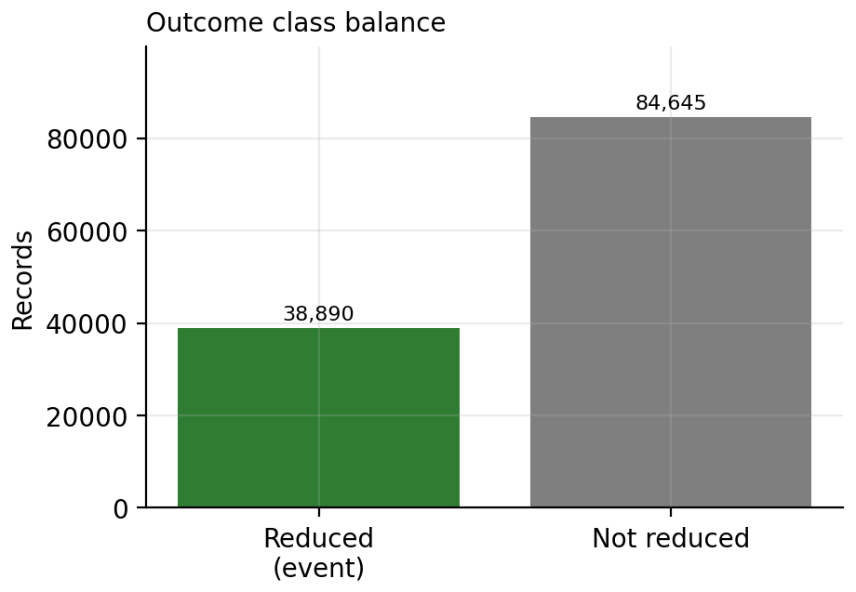
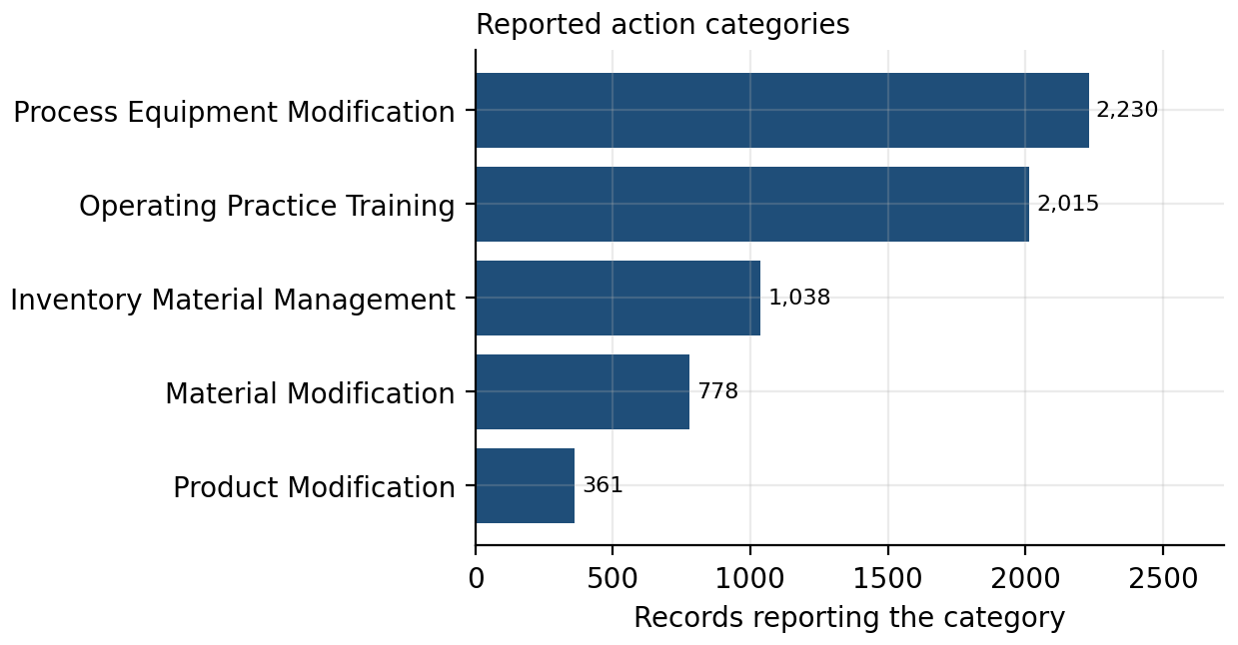
Note. Top: of 123,535 development records, 38,890 (31.48%) met the reduction threshold. Bottom: records reporting each action category; categories are not mutually exclusive. Only 6,012 records (4.87%) reported any action.
Figure A2
Source-Reduction Activity Codes by Coding Scheme and Reporting Year
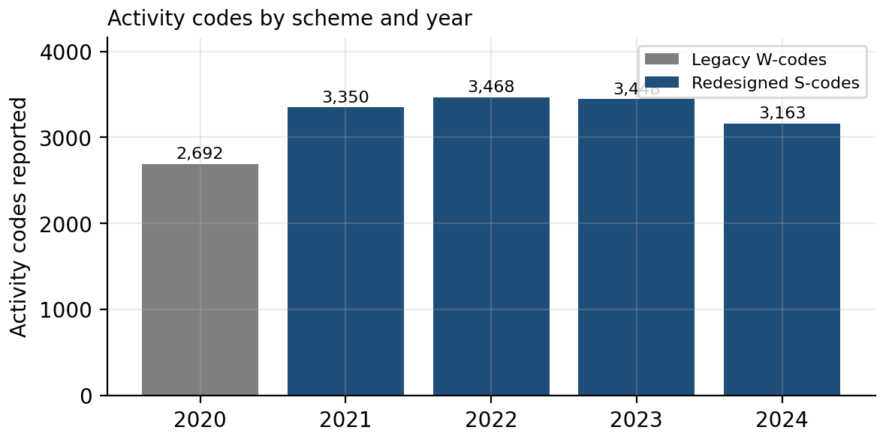
Note. Legacy W codes appear in 2020 and are replaced by redesigned S codes from 2021 onward. All 70 distinct codes were mapped to the five action types, with no unmapped codes. Reporting year 2024 File 2A was used only for this descriptive check.
Figure A3
Facility Cluster Sizes and Action-Category Prevalence by Reporting Year
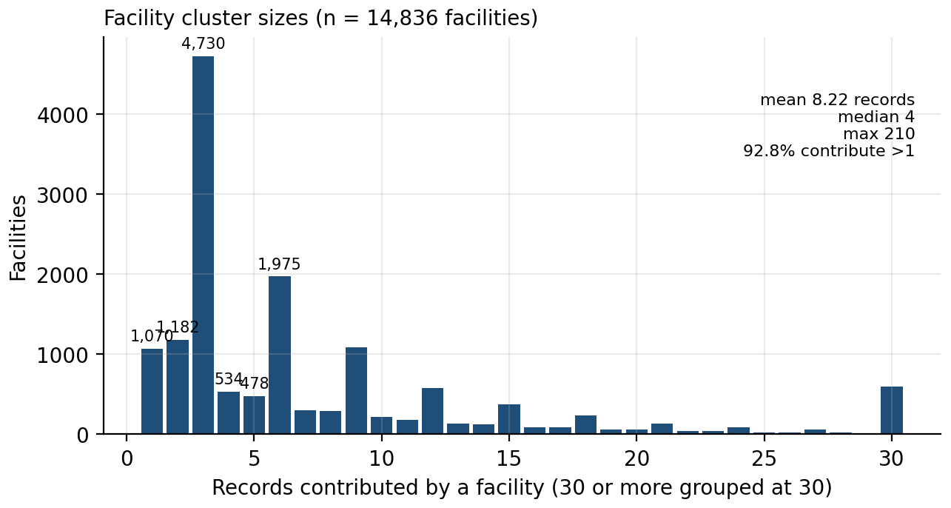
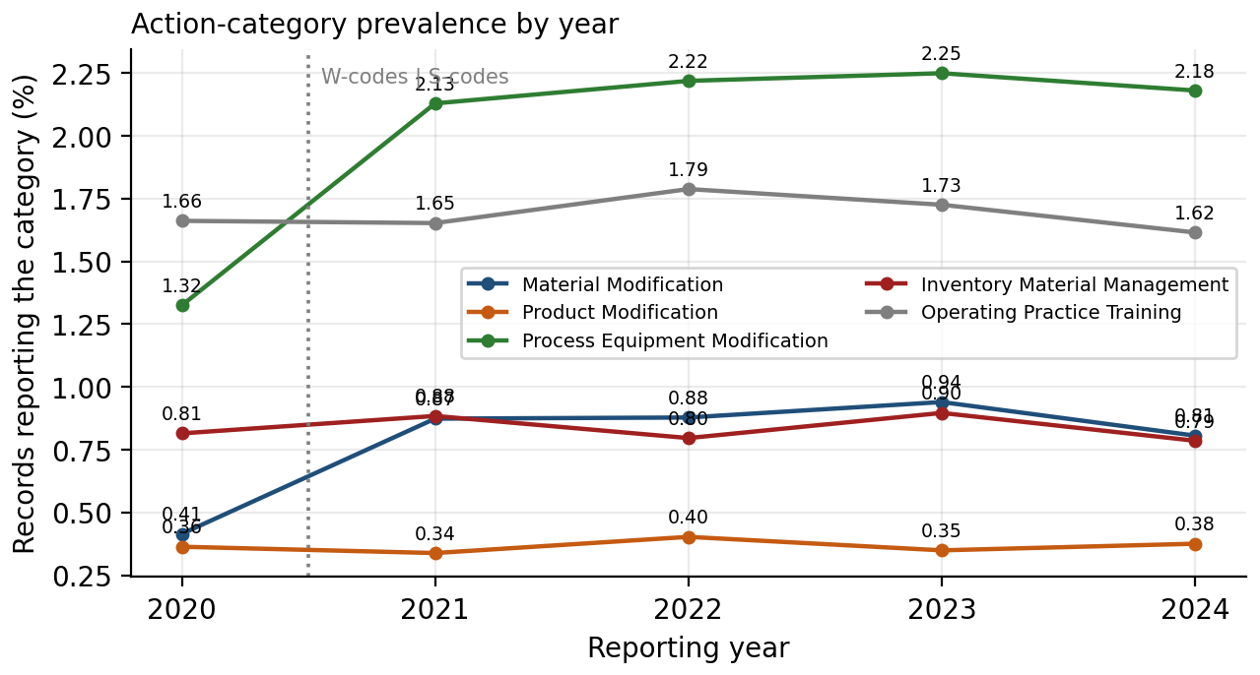
Note. Top: records contributed per facility in the pound-reported frame (mean 8.22, median 4, maximum 210); 92.8% of records come from facilities contributing more than one. Bottom: process or equipment modification rises from 1.32% in 2020 to 2.13% in 2021 and material modification from 0.41% to 0.87%, coinciding with the coding-scheme change.
Figure A4
Action Prevalence by Manufacturing Subsector
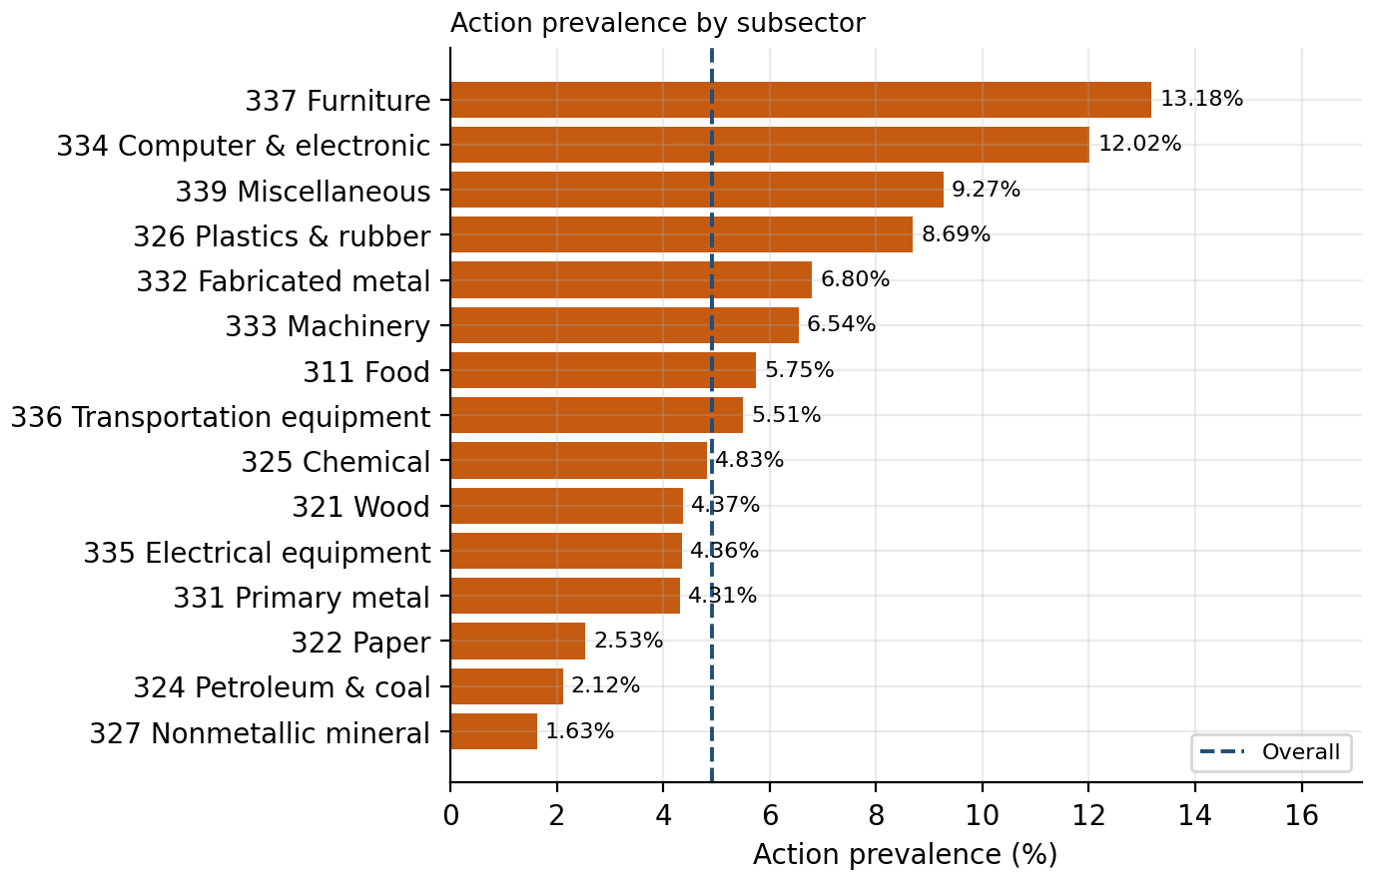
Note. The dashed line marks overall action prevalence. Subsectors reporting the most actions are not those with the highest reduction rates (compare Appendix F, Figure F2).
Figure A5
Unadjusted Reduction Rate for Any Reported Action Versus No Reported Action
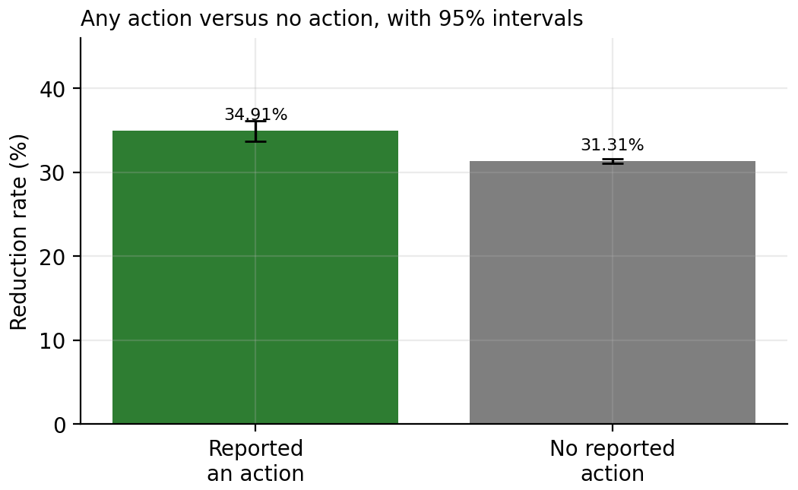
Note. Error bars show 95% Wilson confidence intervals. The unadjusted gap is 3.61 percentage points, 95% CI [2.37, 4.84]. This comparison is not adjusted for industry, release level, or year.
Figure A6
Covariate Balance Between Action and No-Action Groups
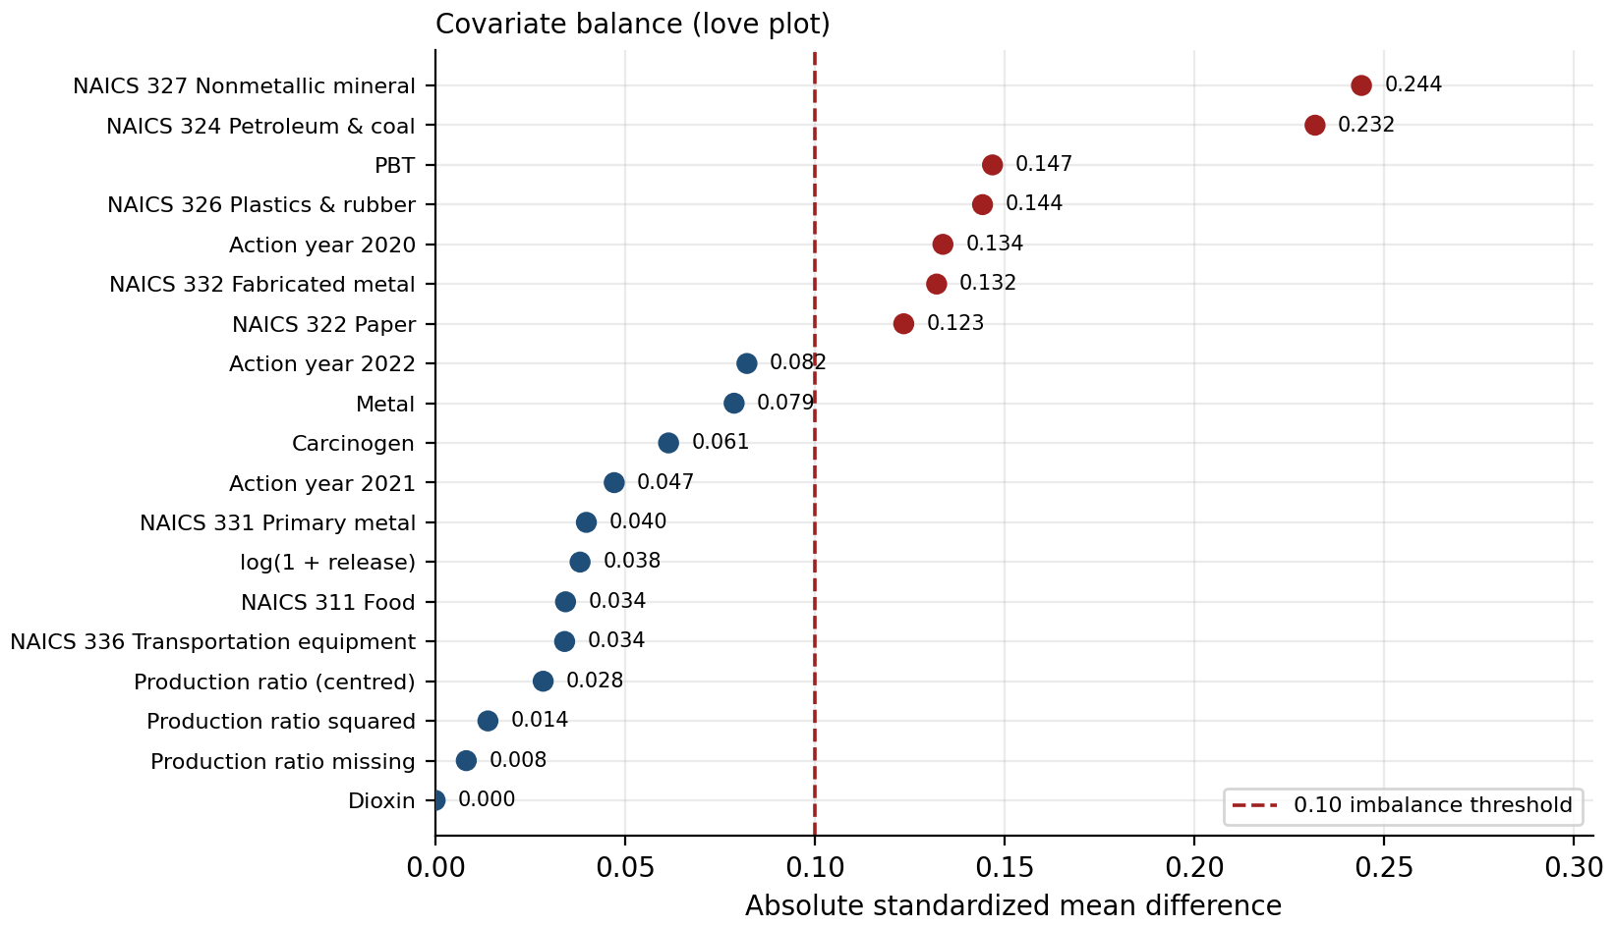
Note. Seven of 19 covariates exceed an absolute standardized mean difference of 0.10 (dashed line). The two largest differences, 0.244 and 0.232, reflect industry composition.
Figure A7
Unadjusted Action Association Within Development Strata
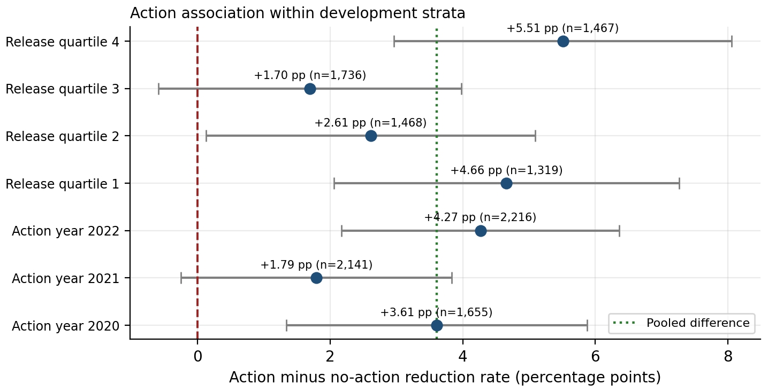
Note. Point estimates are positive in every displayed stratum, but several confidence intervals include zero. These are exploratory consistency checks, not separate evidence of significance.
Figure A8
Distribution of Current-Year Releases
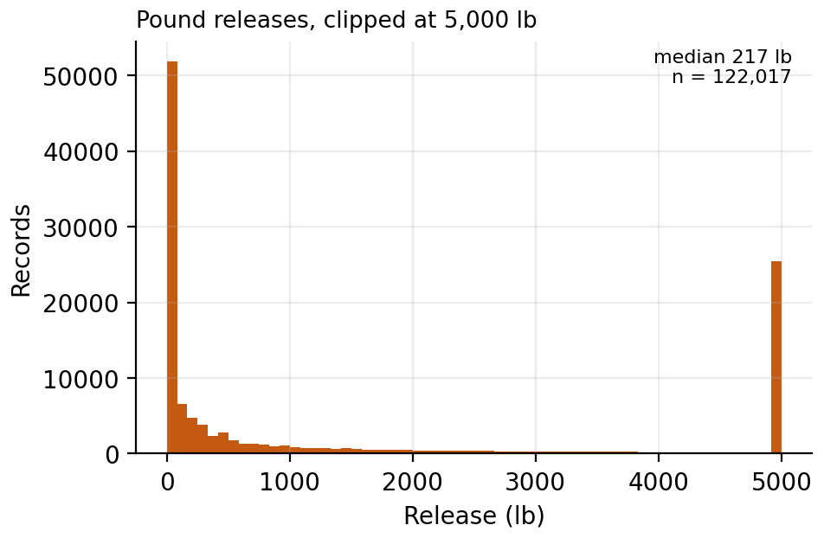
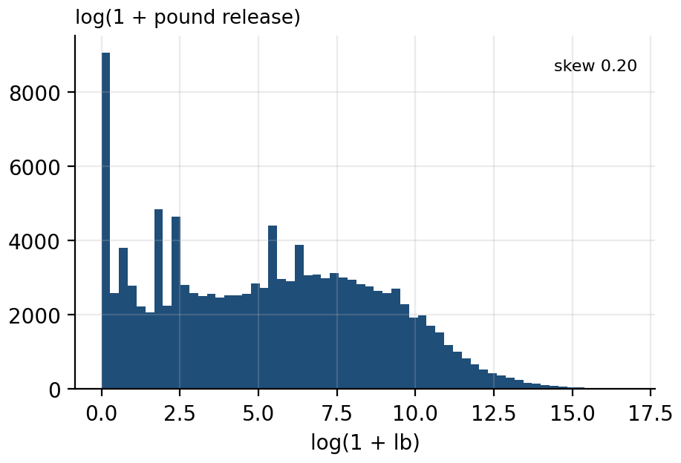
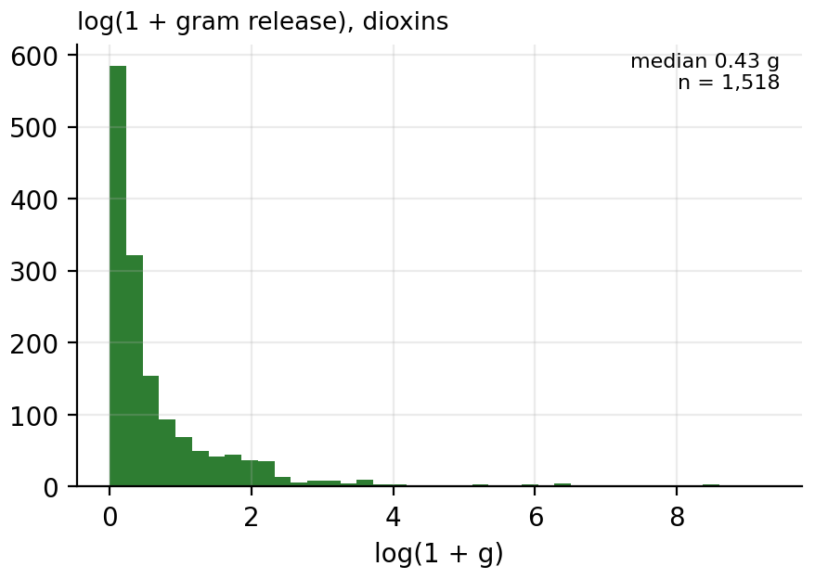
Note. Pound-reported releases are shown clipped at 5,000 lb and on a log scale; gram-reported dioxins are shown separately. Skewness of the raw pound releases is 34.6, with a median of 217 lb and a mean of 24,737 lb.
Figure A9
Reduction Rate by Current-Release Decile
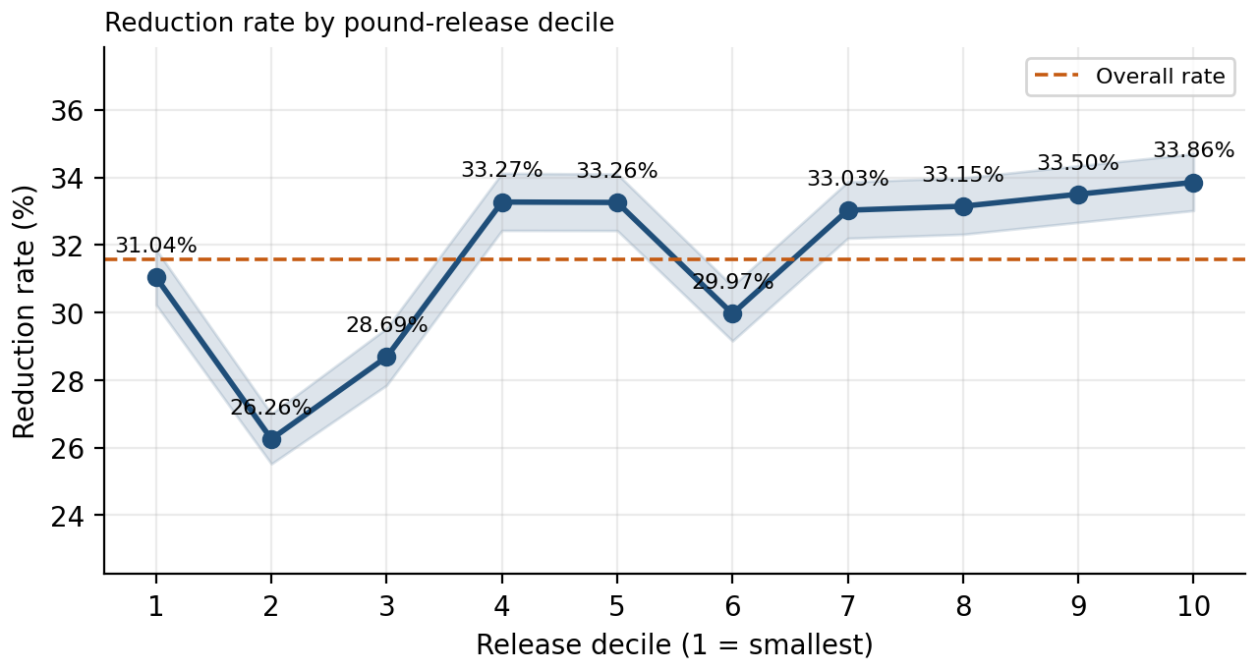
Note. Shaded bands are 95% Wilson confidence intervals. Rates are generally higher in upper deciles, but the pattern is not monotonic, which is consistent with starting level and regression to the mean shaping the room for a percentage reduction.
Figure A10
Observed Reduction Rate Across Log-Release Bins With a Logit Linearity Check
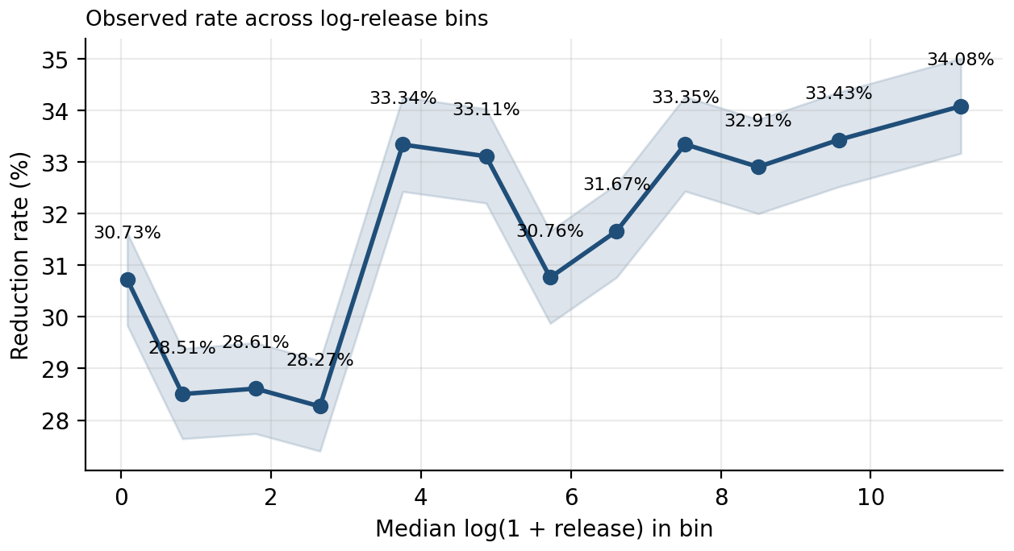
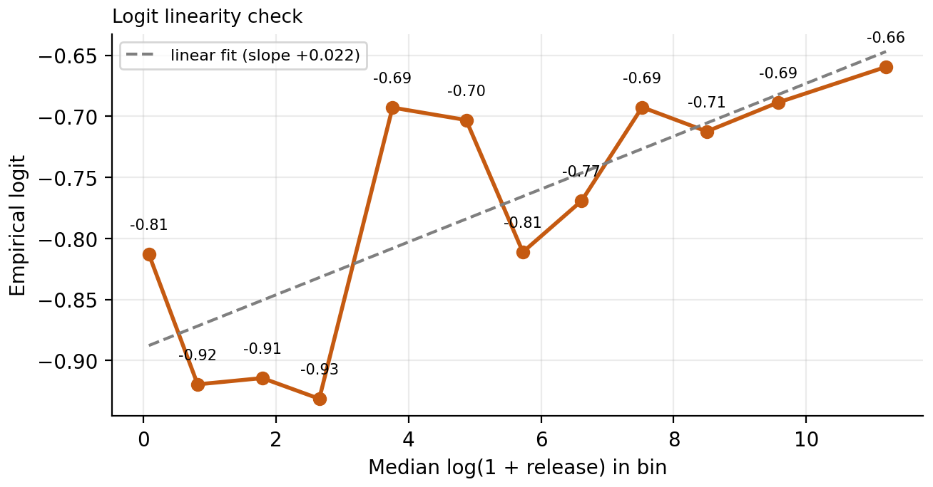
Note. The empirical logit generally increases with log current release, supporting the log transformation. Some departures from linearity remain; a spline comparison is listed as a future check.
Figure A11
Distribution of the Production Ratio and Its Missingness by Action Year
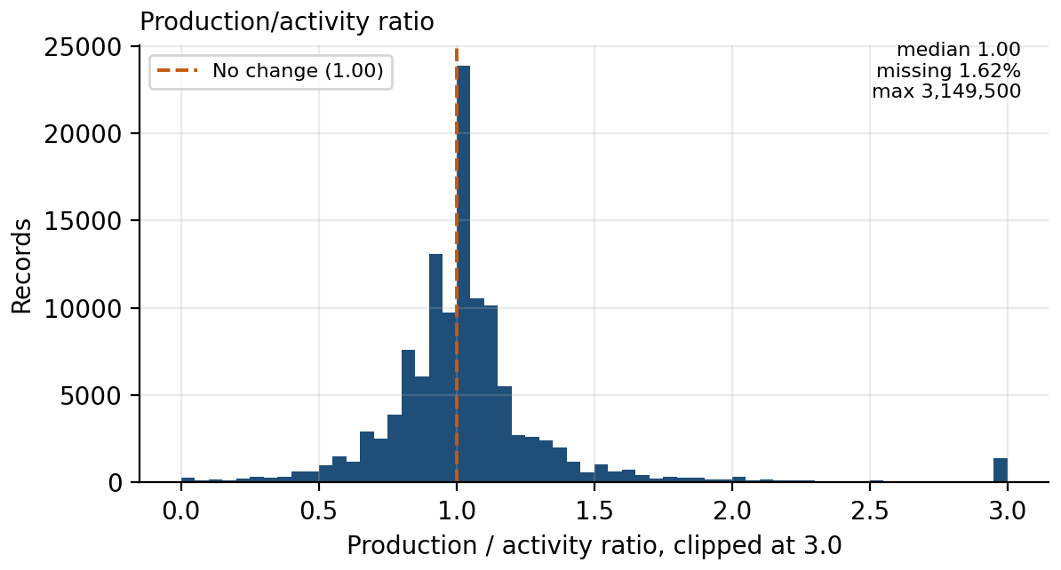
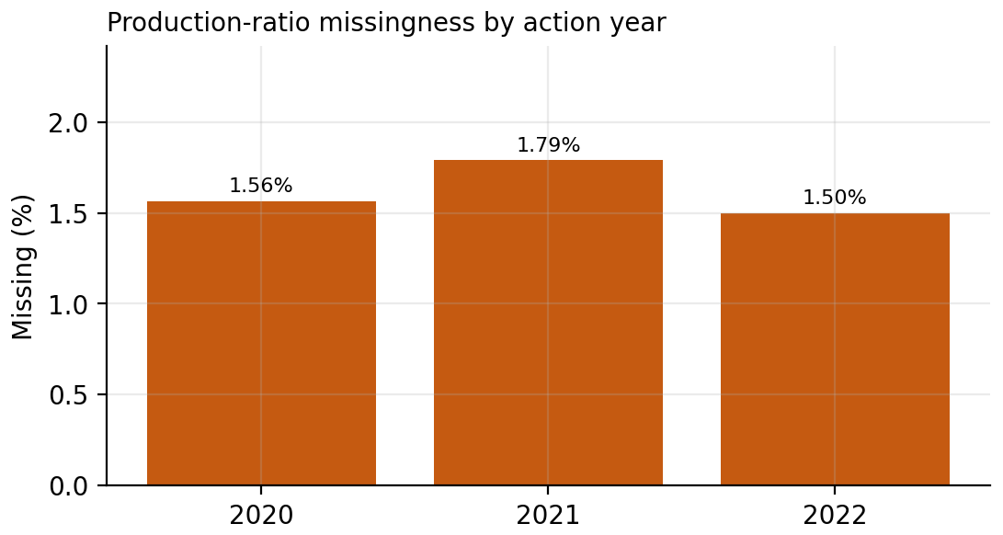
Note. Top: the ratio is centered on 1.00 and is clipped at 3.0 for display; the maximum observed value was 3,149,500. Values were capped at the development 99th percentile (3.15) before centering and squaring. Bottom: missingness ranges from 1.50% to 1.79% across action years; the missingness mechanism cannot be confirmed from observed data.
Figure A12
Reduction Rate by Chemical Hazard Classification
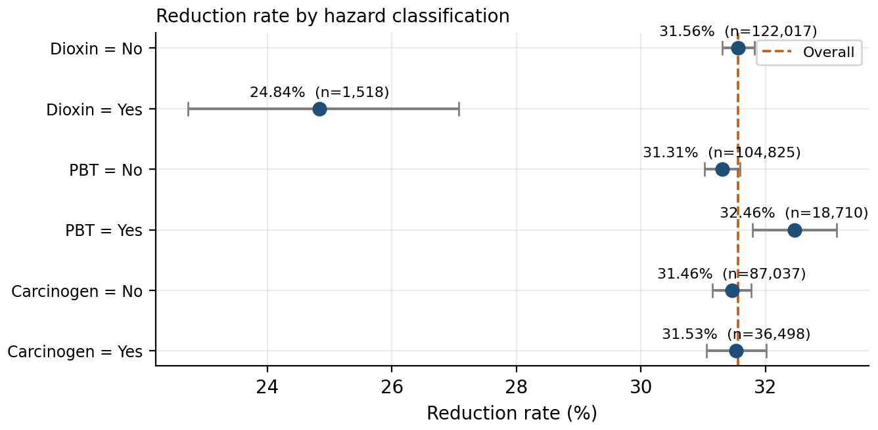
Note. Error bars show 95% Wilson confidence intervals. Carcinogen status shows a difference of 0.07 percentage points. Dioxins reduce about 6.7 points less often than other chemicals and were analyzed separately.
Figure A13
Cross-Year Attrition and Action-Category Co-Occurrence
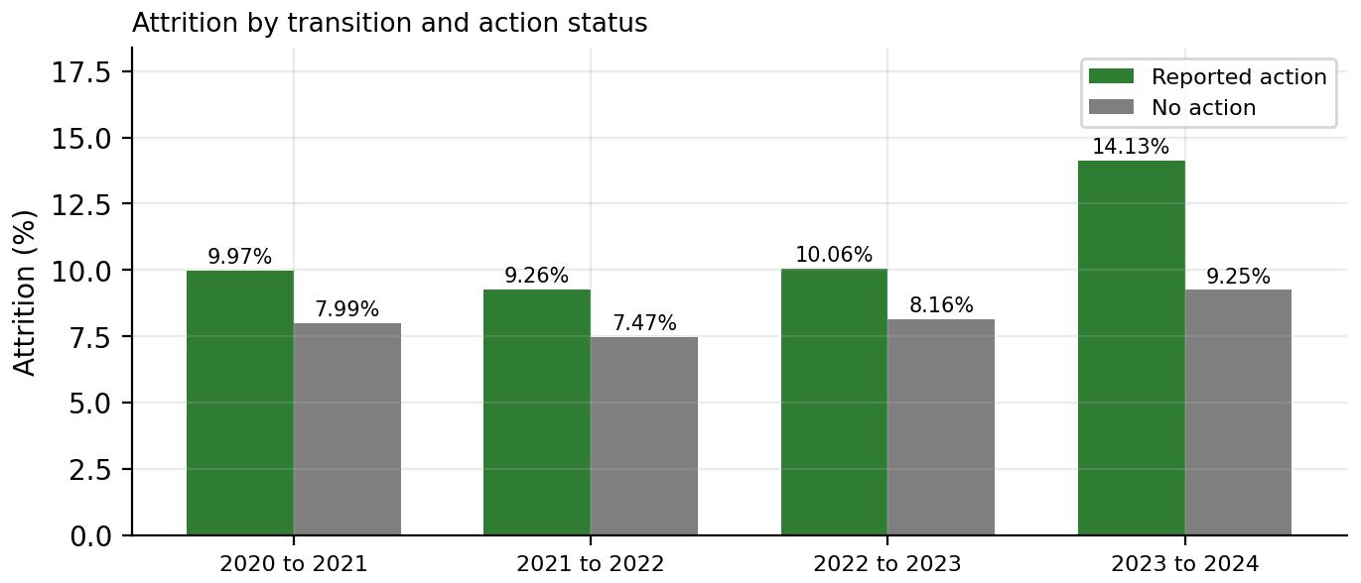
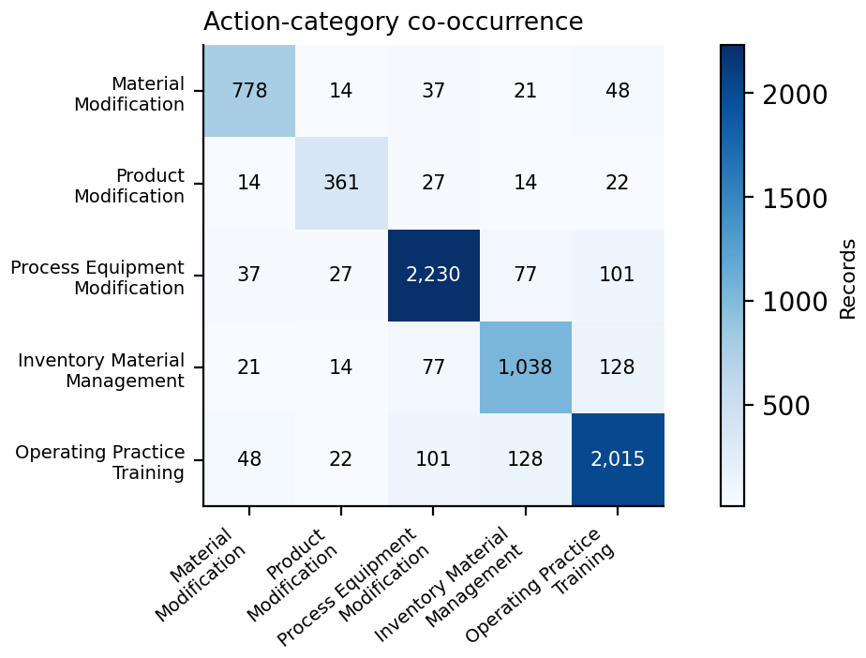
Note. Top: overall attrition ranges from about 7.6% to 9.5% across transitions; within the groups shown, attrition ranges from 7.47% to 14.13% and is higher for action-reporting records in every transition. Bottom: diagonal cells show records per action category, and off-diagonal cells show co-reporting; records reporting an action average 1.07 distinct categories.
Figure A14
Data-Quality Scorecard Outcomes
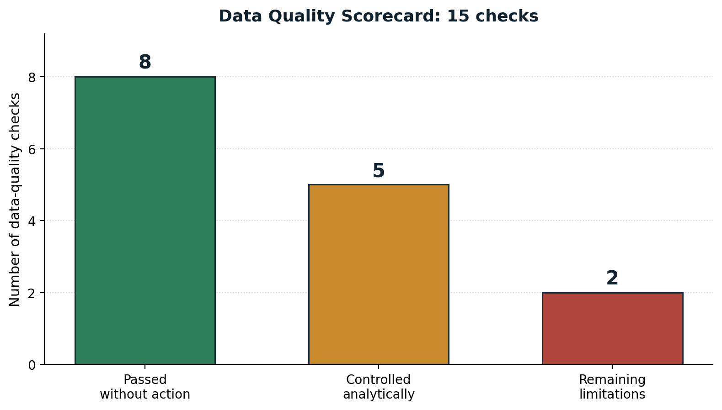
Note. Of 15 data-quality checks, eight passed without corrective action, five identified issues that were controlled analytically, and two (cross-year attrition and TRI coverage limits) remain limitations of the source data.

Appendix B

Source File Provenance, Parsing Rule, and Repository Structure
Table B1 lists the size and SHA-256 checksum of each source file. All ten checksums are distinct, confirming that no file was duplicated during download, and any reader can verify their own copies against these values. Table B2 records the duplicate-consolidation counts by reporting year. File 1A data lines carry 283 fields against a 282-field header because each line ends with a trailing delimiter, so fields were read by position with that offset applied.
Table B1
Source File Sizes and SHA-256 Checksums
Reporting Year | File Type | Size (MB) | SHA-256 (First 16 Characters)
2020 | 1A | 62.6 | b94f8cb1286d7420
2020 | 2A | 44.5 | 5ddaa1624fbba793
2021 | 1A | 62.2 | 73daa53931a58696
2021 | 2A | 44.4 | 805fbdc932f51aef
2022 | 1A | 63.6 | 4cf809c08d11cd8c
2022 | 2A | 45.4 | 16f382966622b5e8
2023 | 1A | 62.6 | 0c60fa25c4ac4348
2023 | 2A | 44.7 | cc3017cd0ca0b310
2024 | 1A | 61.6 | f463ec07ff320968
2024 | 2A | 44.0 | dbedc8bafc05338a
Note. Checksums are truncated for readability. Full 64-character values are printed by the exploratory notebook and stored in the repository. The ten files total 535.6 MB.
Table B2
Duplicate Consolidation Counts by Reporting Year
Year | Before | After | Removed | Groups With Duplicates | Revision Superseded | Originals Summed
2020 | 57,004 | 56,462 | 542 | 321 | 33 | 288
2021 | 56,750 | 56,219 | 531 | 353 | 39 | 314
2022 | 56,725 | 56,155 | 570 | 367 | 13 | 354
2023 | 55,882 | 55,349 | 533 | 333 | 26 | 307
2024 | 54,595 | 54,115 | 480 | 304 | 16 | 288
Note. Unit conflicts and chemical-identifier conflicts were zero in every year. Summing dominates supersession, which is why the consolidation rule in Appendix C sums original filings rather than keeping a single filing.

Repository Structure
The public GitHub repository is organized as follows:
- README.md: problem statement, data source, record counts, and reproduction instructions
- requirements.txt and VALIDATION_CHECKLIST.md: software requirements and validation notes
- data/: download instructions and a 200-row sample of File 1A and File 2A for each reporting year
- notebooks/: the early data exploration notebook, the exploratory data analysis notebook that parsed, consolidated, matched, and exported the data and produced the Appendix A figures, and the final analysis notebook that produced the RQ1 to RQ4 results
- src/data_prep.py: an earlier synopsis-stage preparation script kept for transparency, which the exploratory data analysis notebook superseded (including the revised consolidation rule in Appendix C)
- reports/: the project synopsis and this final report in Word and PDF formats
- presentation/: the final presentation slides

Appendix C

Duplicate-Filing Consolidation Rule
A facility sometimes files more than one Form R for the same chemical in the same reporting year. The original study plan took the release quantity from the filing with the highest document control number. Implementation showed that this rule was wrong for the most common case, so the rule was revised before any analysis. This appendix records the final rule and the evidence for it.
Duplicate filings arise for two different reasons. In the first, a facility submits a revised form that replaces an earlier one. The revision genuinely supersedes the original, so keeping one filing is correct. In the second and much more common case, a facility submits several original forms that each carry part of the year’s total for that chemical. Keeping a single filing would discard real quantity and understate the release. Across the five reporting years, 1,551 duplicate groups were of the second kind and only 127 were of the first.
The final rule is therefore conditional. If one or more filings in a facility-chemical-year group carry a value in either revision-code field, the revision-coded filing with the highest document control number supplies the release quantity and unit, and the other filings are treated as superseded. Source-reduction indicators are taken from that filing, and the production or activity ratio is taken from it when available. If no revision-coded filing exists, the release quantities of the original filings are summed after unit and chemical-identifier consistency checks. The sum uses a minimum-count setting of one, so a group in which every value is missing produces a missing total rather than a false zero. If more than one unit appeared in a group, the release would be set to missing. No such conflict occurred in any year.
Two notes accompany the rule. First, adding the second revision-code field and the minimum-count safeguard changed no results. Revision counts were identical with one field or two, and no group consisted entirely of missing values. Both were kept as defensive measures. Second, an earlier planning remark that duplicate original forms represent separate process units was withdrawn, because the TRI fields available in this study cannot establish that. The forms are summed because summing preserves the reported total, which is defensible whatever the reason for the duplicates. The same rule was applied when the 2024 outcome for the sealed holdout was reconstructed, which yielded 944 superseded and 52,670 summed facility-chemical records among 2024 pound-reported manufacturing filings.

Appendix D

Data Availability Evidence
Figures D1 to D4 document the shared folder structure and dataset contents described in the Code and Data Availability statement and the Data Source section. Access is set to anyone with the link, with viewer permission.
Figure D1
Raw Data Folder Structure on Google Drive
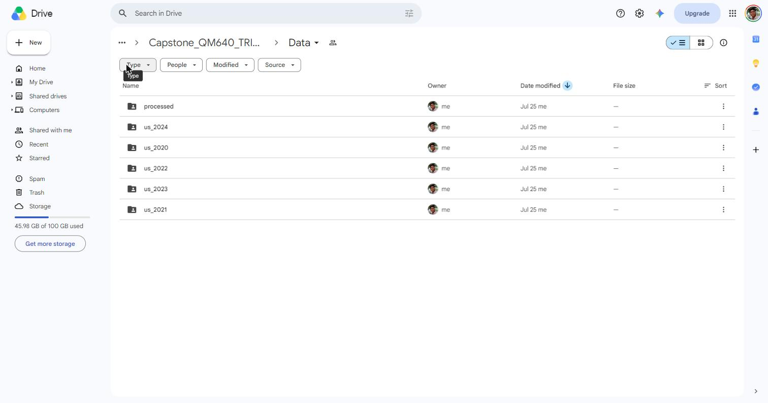
Note. One folder per TRI reporting year, 2020 through 2024, each holding File 1A and File 2A, plus the processed subfolder. TRI = Toxics Release Inventory.
Figure D2
Processed Data Folder Contents
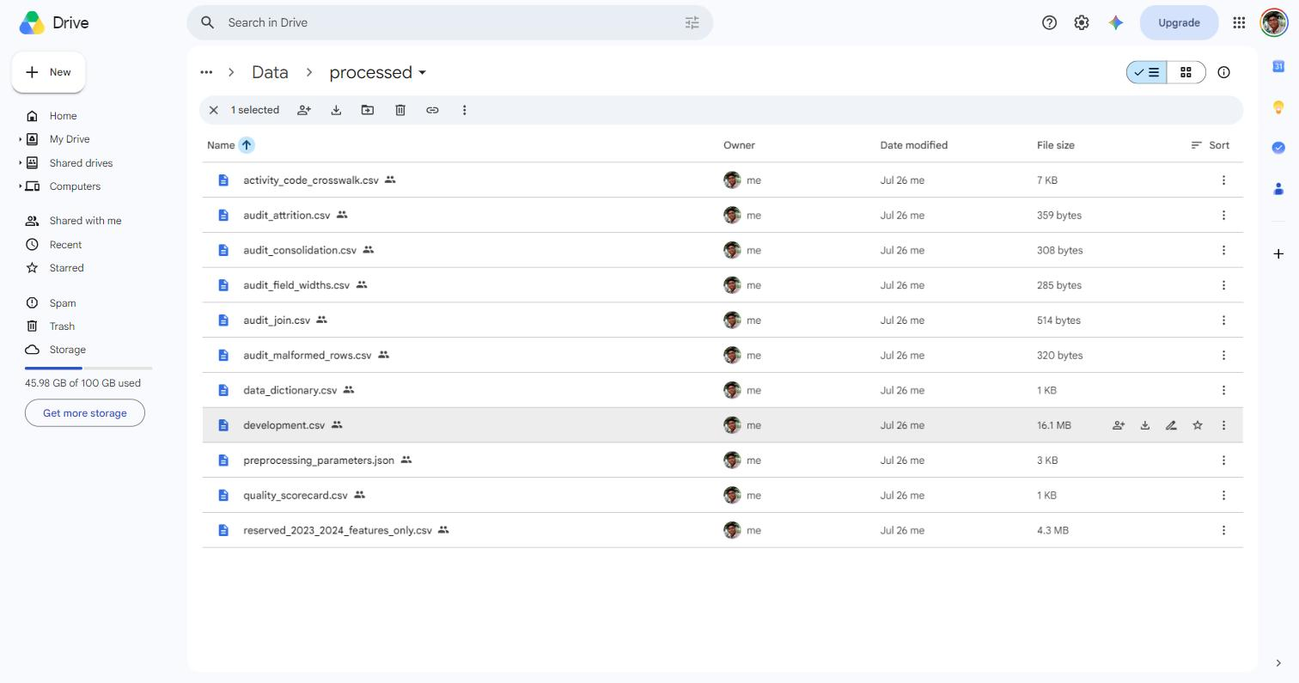
Note. Eleven files. The holdout file (4.3 MB) is smaller than the development dataset (16.1 MB) because it carries no outcome columns.
Figure D3
Preview of the Processed Development Dataset
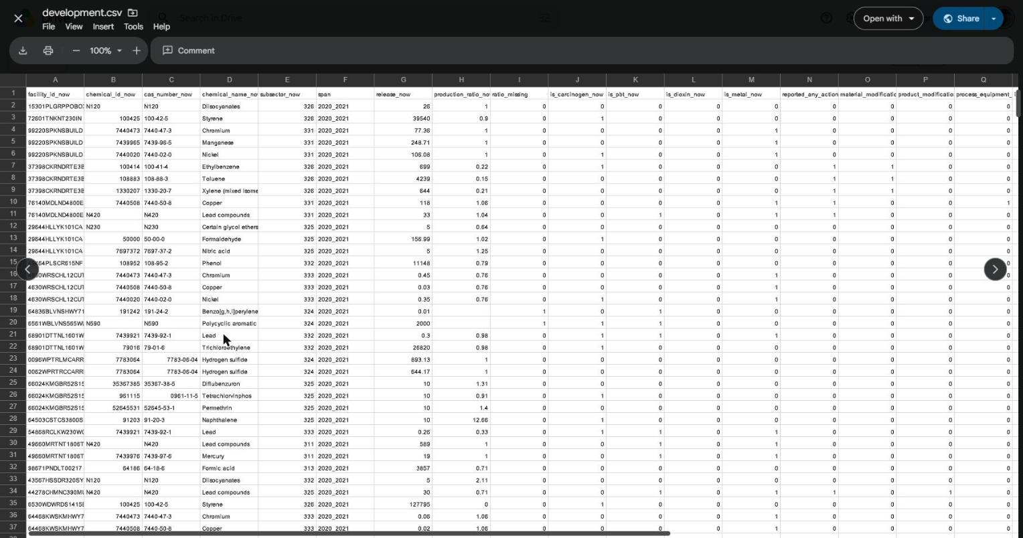
Note. Column order follows the schema declared in code: identifier fields, then predictors, then audit fields. The span column records the action-year to outcome-year transition. Values shown are real records from reporting year 2020.
Figure D4
Activity Code Crosswalk With EPA Descriptions
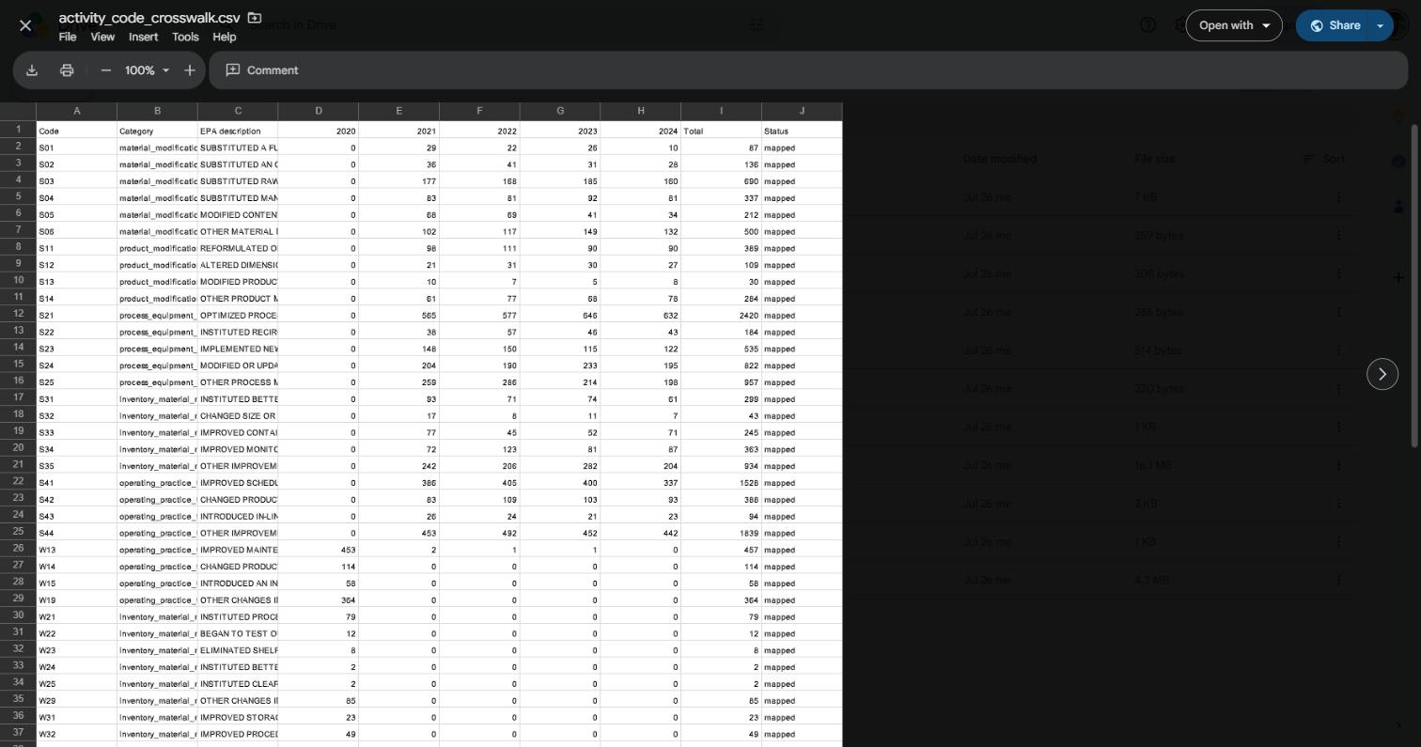
Note. Every observed code is mapped to one of the five action types, with counts by year. Legacy W codes carry counts only in 2020, and S codes carry counts only from 2021 onward. EPA = U.S. Environmental Protection Agency.

Appendix E

Data and Method Supporting Tables
These tables support the Materials and Method section. Table E1 defines the analysis variables, Table E2 records the cleaning decisions, Table E3 reconciles record counts, Table E4 gives the sample-size calculations, and Table E5 lists the evaluation metrics.
Table E1
Data Dictionary for the Analysis Variables
Variable | Definition | Type | Range or Values | Missing-Value Handling | Role
facility_id | TRI facility identifier (TRIFD) | Text | 14,851 distinct facilities | Never missing | Identifier
chemical_id | TRI chemical identifier | Text | 507 distinct chemicals | Never missing | Identifier
cas_number | Chemical Abstracts Service number | Text | As reported | Retained as reported | Identifier
chemical_name | EPA chemical name | Text | As reported | Retained as reported | Identifier
release_now | Current-year total on-site releases | Numeric | Greater than 0; maximum 19,750,398 lb | Zero and missing values excluded at eligibility | Predictor
release_next | Next-year total on-site releases | Numeric | 0 or greater | Unmatched records excluded, never set to zero | Outcome input
reduced (REDUCTION_10) | 1 if release_next is at most 0.90 × release_now | Binary | 0 or 1 | Defined only when release_now is greater than 0 | Outcome
percent_change | Percentage change in release | Numeric | Unbounded | Defined only when release_now is greater than 0 | Outcome (descriptive)
production_ratio_now | Production or activity ratio, current year | Numeric | Median 1.00 | Development median imputed; capped at 3.15; complete-case sensitivity completed | Predictor
ratio_missing | 1 when the production ratio was absent | Binary | 0 or 1 | Derived, never missing | Predictor
subsector_now | First three digits of the primary NAICS code | Categorical | 15 qualifying subsectors plus Other Manufacturing | Record dropped if outside 31 to 33 | Predictor
span | Action-year to outcome-year transition | Categorical | Four transitions | Derived, never missing | Predictor (RQ2)
reported_any_action_now | 1 if any valid source-reduction code is present | Binary | 0 or 1 | Blank codes read as 0 (not reported) | Predictor
Five action-type indicators | Material, product, process or equipment, inventory or material management, operating practice or training | Binary | 0 or 1; not mutually exclusive | Blank codes read as 0 | Predictor
is_carcinogen_now | EPA carcinogen classification | Binary | 0 or 1 | As supplied by EPA | Predictor
is_pbt_now | Persistent, bioaccumulative, and toxic classification | Binary | 0 or 1 | As supplied by EPA | Predictor
is_dioxin_now | Dioxin or dioxin-like compound | Binary | 0 or 1 | As supplied by EPA | Descriptive
is_metal_now | Metal or metal compound | Binary | 0 or 1 | As supplied by EPA | Predictor (RQ4)
unit_of_measure_now | Pounds or grams | Categorical | Pounds or grams | Case normalized; record excluded if units differ across years | Audit
Note. A value of 0 on any action indicator means that no valid code was observed in the four File 2A activity-code fields. It does not prove that the facility took no environmental action. EPA = U.S. Environmental Protection Agency; NAICS = North American Industry Classification System; TRI = Toxics Release Inventory.
Table E2
Data Cleaning Log
Issue | Variables Affected | Detection Method | Treatment Applied | Rationale
Non-Form R filings | All | Form type field | 35,155 rows removed | Form A carries no release quantity
Out-of-scope industries | Primary NAICS code | First two digits of NAICS | 54,065 rows removed | Study scope is manufacturing (31 to 33)
Duplicate facility-chemical forms | All | Grouping on facility, chemical, and year | 2,176 rows consolidated | Separate forms would double-count
Revised filings | Revision code fields 1 and 2 | Either revision field non-blank | 127 groups: revision kept, others superseded | A revision replaces the original
Multiple original forms | Total on-site releases | No revision code in group | 1,551 groups summed with minimum count of 1 | Preserves the total; avoids false zeros
Unit label case | Unit of measure | Value inspection | Labels upper-cased before frame construction | Prevents 864 pound records from being misclassified
Unit conflicts within a group | Unit of measure | More than one unit in a group | None found; release would be set to missing | Pounds and grams must never be added
Unit change between years | Unit of measure | Comparison across the matched pair | Record excluded from eligibility | A unit change makes a percentage change meaningless
Zero or missing base release | release_now | Value check | 41,946 records excluded (with unit changes) | A percentage change needs a nonzero base
Unmatched facility-chemical pairs | Join keys | Left join to following year | 18,738 records excluded | No outcome; not treated as a reduction
Missing production ratio | production_ratio_now | Numeric coercion | Development median (1.00) imputed; ratio_missing flag; complete-case check run | Keeps records while preserving missingness information
Extreme production ratio | production_ratio_now | Percentiles and maximum | Capped at development 99th percentile (3.15) before centering and squaring | Prevents isolated extreme values from dominating
Extreme release skew | release_now | Distribution inspection | Retained; log(1 + release) used in models | Real large emitters, not data errors
Activity-code scheme change | Activity code fields | Cross-tabulation of code by year | 70 codes mapped to five types; zero unmapped asserted | One behavior would otherwise carry two labels
Outcome leakage risk | Holdout outcome columns | Schema assertion | Outcome columns stripped from reserved file; labels rebuilt after lock | Protects the out-of-time evaluation
Note. NAICS = North American Industry Classification System.
Table E3
Record Flow From Raw Files to Analysis Sets
Stage | Records | Removed | Reason
Raw File 1A rows, action years 2020 to 2023 | 315,581 |  | Reporting year 2024 read only to build outcomes
Form R only | 280,426 | 35,155 | Form A carries no release quantity
Manufacturing only (NAICS 31 to 33) | 226,361 | 54,065 | Study scope
Joined one-to-one to File 2A | 226,361 | 0 | Every Form R record matched one File 2A record
After duplicate consolidation | 224,185 | 2,176 | Multiple forms per facility-chemical-year combined (Appendix C)
Matched to the following year | 205,447 | 18,738 | The facility-chemical pair must recur to have an outcome
Eligible: positive current release, same unit | 163,501 | 41,946 | A percentage change needs a nonzero base and a common unit
Development set (2020 to 2023 transitions) | 123,535 |  | Outcome available; used for RQ1 to RQ3 and model development
Pound-reported modeling frame | 122,017 |  | RQ2 and RQ4 development; 14,836 facilities
Gram-reported dioxin records | 1,518 |  | Analyzed separately
Sealed holdout (2023 to 2024 transition) | 39,966 |  | Outcome withheld until the model was locked
Pound-reported RQ4 modeling holdout | 39,500 |  | Single RQ4 evaluation
Gram-reported holdout records | 466 |  | Outside the release-based model
Note. The development and holdout sets sum exactly to the eligible total (123,535 + 39,966 = 163,501). The development set contains 14,851 distinct facilities. NAICS = North American Industry Classification System.
Table E4
Minimum Sample-Size Requirements Compared With Available Records
RQ | Planning Method | Assumptions | Minimum | Available | Margin
RQ1 | 95% CI for a proportion: n = Z²p(1 − p)/e² | p = .50, Z = 1.96, e = .03 | 1,068 | 123,535 | 116×
RQ2 | Power approximation for a binary association | OR = 1.30, α = .05, power = .80, exposure 4.87%, no-action rate .3138 | 10,756 | 122,017 | 11.3×
RQ3 | Two-proportion comparison per action type | 10-point difference, α = .01 for five comparisons, power = .80 | About 290 each | 361 to 2,230 | 1.2× to 7.7×
RQ4 | Events per parameter (Peduzzi et al., 1996) | Planning: 20 parameters, 20 events each, event rate .3155 | 1,269 | 122,017 (38,513 events) | 96×
Note. The locked RQ4 model had 13 parameters and 38,513 events in the smaller outcome class, about 2,963 events per parameter, which also satisfies the more detailed criteria of Riley et al. (2019) and van Smeden et al. (2019) in spirit. Clustering by facility reduces the effective sample size, so the facility-clustered intervals in the Results are the direct evidence of precision. CI = confidence interval; OR = odds ratio.
Table E5
Evaluation Metrics and Formulas
Metric | Formula | Interpretation | Used For
Reduction rate | p = x / n | Share of records meeting the threshold | RQ1, RQ3
Wilson score interval | [p + z²/2n ± z √(p(1 − p)/n + z²/4n²)] / (1 + z²/n) | Interval for a proportion; reliable at extreme values | RQ1, RQ3
Pearson chi-square | χ² = Σ (O − E)² / E | Tests whether rates differ across groups | RQ1, RQ3
Cramér’s V | V = √(χ² / [n × min(r − 1, c − 1)]) | Effect size for a chi-square test | RQ1
Rate difference | d = p₁ − p₀ | Percentage-point gap versus no action | RQ3
Relative risk and Katz interval | RR = p₁ / p₀; SE(ln RR) = √(1/a − 1/n₁ + 1/c − 1/n₀) | Ratio of reduction rates with a log-scale interval | RQ3
Holm-adjusted p | Step-down: compare ordered p_{(i)} with α / (m − i + 1) | Controls family-wise error across five tests | RQ3
Odds ratio | OR = exp(β) | Adjusted association | RQ2
Clustered standard error | Sandwich estimator grouped by facility | Accounts for repeated facility records | RQ1 to RQ3
Variance inflation factor | VIF = 1 / (1 − R_{j}²) | Detects collinearity | RQ2
Akaike information criterion | AIC = 2k − 2 ln(L) | Compares functional forms; lower is better | RQ2
AUC | Area under the true-positive versus false-positive rate curve | Ranking ability; .50 is chance | RQ4
Brier score | B = (1/n) Σ (ŷ_{i} − y_{i})² | Mean squared error of probabilities | RQ4
Precision | TP / (TP + FP) | Share of flagged records that truly do not reduce | RQ4
Recall | TP / (TP + FN) | Share of non-reducers that are flagged | RQ4
F1 score | 2 × Precision × Recall / (Precision + Recall) | Balances precision and recall | RQ4
Lift at depth q | Non-reduction rate in top q / base rate | Gain from ranked review | RQ4
Calibration curve | Observed versus mean predicted rate in 10 quantile bins | Agreement of probabilities with outcomes | RQ4
Facility bootstrap interval | Percentile interval over 500 resamples of whole facilities | Uncertainty that respects clustering | RQ4
Note. In RQ4 the positive class is non-reduction. TP = true positives; FP = false positives; FN = false negatives. AUC = area under the receiver operating characteristic curve.

Appendix F

Supplementary Results
This appendix holds supporting results referenced in the Results section: the RQ1 charts by transition and subsector (Figures F1 and F2), the six sensitivity analyses (Table F1), the complete RQ2 model (Table F2), the locked elastic-net coefficients (Table F3), and reduction rates for every qualifying subsector (Table F4).
Figure F1
Meaningful Reduction Rate by Development Transition
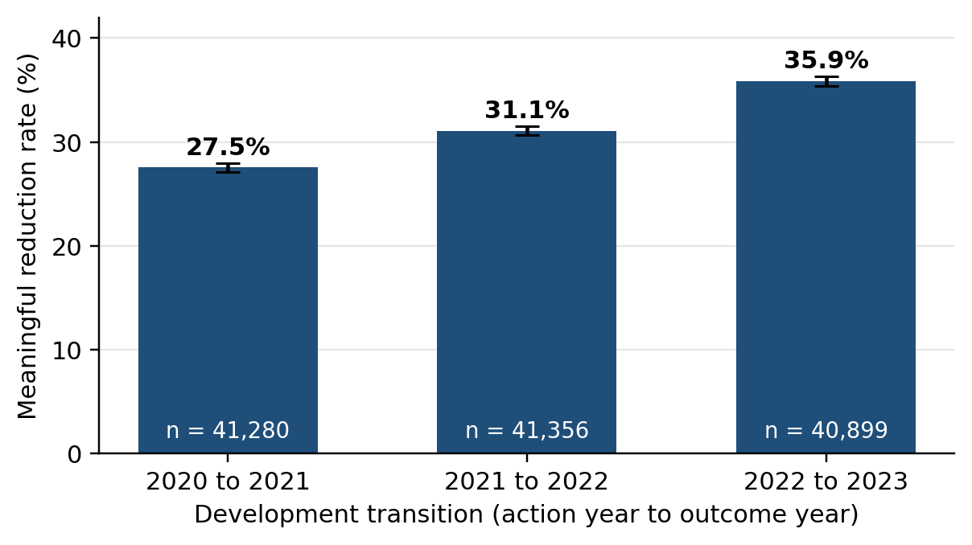
Note. Error bars show 95% Wilson confidence intervals. The 2023-to-2024 transition is excluded because it was the sealed holdout.
Figure F2
Meaningful Reduction Rate by Manufacturing Subsector
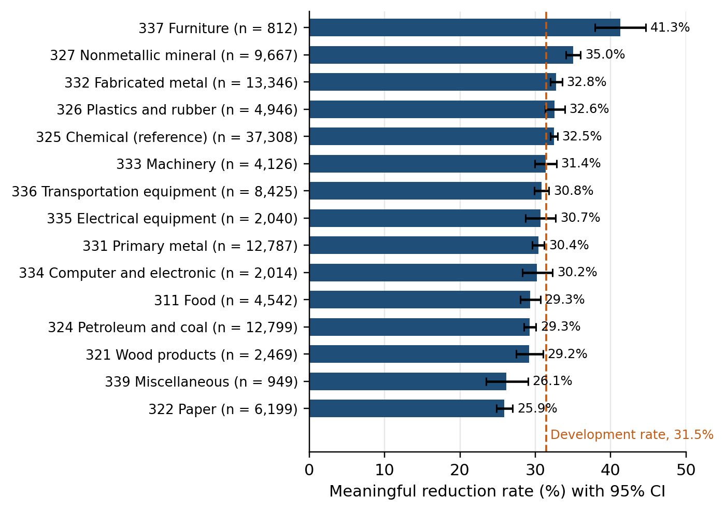
Note. Subsectors are three-digit NAICS codes with at least 500 development records. Error bars show 95% Wilson confidence intervals, and the dashed line marks the overall development rate. NAICS = North American Industry Classification System.
Table F1
Sensitivity Analyses and Their Effect on the Conclusions
Analysis | Concern Addressed | N | Key Result | Conclusion
RQ2 without the 2020-to-2021 transition | Pandemic disruption and coding-scheme change | 81,246 | OR = 1.124 [1.033, 1.223], p = .006 | Association stable
RQ2 complete cases for production ratio | Median imputation of 1.62% missing ratios | 120,045 | OR = 1.139 [1.054, 1.231], p = .001 | Not an imputation artifact
RQ2 functional form | Linear versus quadratic production ratio | 122,017 | AIC difference = 22.35 in favor of the quadratic form | Quadratic term retained
RQ1 facility-clustered models | Repeated records per facility | 123,535 | Transition ORs 1.19 and 1.47, p < .001; 9 of 14 subsector contrasts significant | RQ1 conclusion holds
RQ3 facility-clustered models | Repeated records per facility | Per comparison | Material modification OR = 1.400; operating practice or training OR = 1.210; other three not significant | RQ3 conclusion holds
Gram-reported dioxins analyzed separately | Grams and pounds cannot be combined | 1,518 | 24.84% [22.73, 27.07] versus 31.56% [31.30, 31.82] in the pound frame | Findings limited to pound-reported chemicals
Note. Brackets show 95% confidence intervals. AIC = Akaike information criterion; OR = odds ratio.
Table F2
Complete RQ2 Adjusted Logistic Regression With Facility-Clustered Standard Errors
Term | OR | 95% CI | p
Intercept (baseline odds) | 0.301 | [0.283, 0.320] | < .001
Any reported action | 1.143 | [1.058, 1.234] | < .001
Log(1 + current release) | 1.042 | [1.036, 1.047] | < .001
Production ratio, centered | 1.047 | [0.977, 1.122] | .197
Production ratio squared | 1.085 | [1.038, 1.135] | < .001
Production ratio missing | 1.108 | [0.977, 1.256] | .110
EPA carcinogen | 1.020 | [0.993, 1.048] | .140
PBT chemical | 1.230 | [1.167, 1.297] | < .001
311 Food | 0.821 | [0.753, 0.896] | < .001
321 Wood products | 0.804 | [0.706, 0.915] | < .001
322 Paper | 0.658 | [0.586, 0.739] | < .001
324 Petroleum and coal products | 0.857 | [0.791, 0.928] | < .001
326 Plastics and rubber products | 0.988 | [0.914, 1.068] | .763
327 Nonmetallic mineral products | 1.140 | [1.040, 1.249] | .005
331 Primary metal | 0.941 | [0.876, 1.011] | .097
332 Fabricated metal products | 1.077 | [1.011, 1.148] | .021
333 Machinery | 1.068 | [0.966, 1.180] | .199
334 Computer and electronic products | 0.922 | [0.813, 1.046] | .206
335 Electrical equipment | 0.988 | [0.863, 1.132] | .866
336 Transportation equipment | 0.951 | [0.879, 1.028] | .205
337 Furniture and related products | 1.394 | [1.157, 1.679] | < .001
339 Miscellaneous manufacturing | 0.757 | [0.647, 0.887] | < .001
Other manufacturing | 1.179 | [1.020, 1.363] | .026
Transition 2021 to 2022 | 1.179 | [1.123, 1.238] | < .001
Transition 2022 to 2023 | 1.465 | [1.399, 1.535] | < .001
Note. N = 122,017 pound-reported development records from 14,836 facilities. Subsector reference: 325 Chemical manufacturing. Transition reference: 2020 to 2021. CI = confidence interval; EPA = U.S. Environmental Protection Agency; OR = odds ratio; PBT = persistent, bioaccumulative, and toxic.
Table F3
Locked Elastic-Net Coefficients for Predicting Non-Reduction
Predictor | Standardized Coefficient | Odds Multiplier
Any reported action | −0.143 | 0.867
PBT chemical | −0.138 | 0.871
Log(1 + current release) | −0.125 | 0.883
Metal or metal compound | −0.101 | 0.904
Material modification | −0.090 | 0.914
Production ratio missing | −0.072 | 0.930
Production ratio, centered | −0.040 | 0.961
Process or equipment modification | 0.036 | 1.037
Production ratio squared | −0.030 | 0.970
EPA carcinogen | −0.029 | 0.971
Operating practice or training | −0.025 | 0.975
Product modification | 0.000 | 1.000
Inventory or material management | 0.000 | 1.000
Note. Positive class = non-reduction, so values below 0 (odds multipliers below 1) lower predicted risk. Continuous predictors were standardized. Selected hyperparameters: C = 0.01 and L1 ratio = .1. EPA = U.S. Environmental Protection Agency; PBT = persistent, bioaccumulative, and toxic.
Table F4
Reduction Rate by Manufacturing Subsector
NAICS | Subsector | n | Rate (%) | 95% CI
322 | Paper | 6,199 | 25.89 | [24.82, 27.00]
339 | Miscellaneous manufacturing | 949 | 26.13 | [23.44, 29.02]
321 | Wood products | 2,469 | 29.20 | [27.44, 31.03]
324 | Petroleum and coal products | 12,799 | 29.28 | [28.50, 30.08]
311 | Food | 4,542 | 29.33 | [28.02, 30.67]
334 | Computer and electronic products | 2,014 | 30.24 | [28.27, 32.28]
331 | Primary metal | 12,787 | 30.39 | [29.60, 31.19]
335 | Electrical equipment | 2,040 | 30.69 | [28.72, 32.72]
336 | Transportation equipment | 8,425 | 30.81 | [29.84, 31.81]
333 | Machinery | 4,126 | 31.36 | [29.96, 32.79]
325 | Chemical | 37,308 | 32.46 | [31.99, 32.94]
326 | Plastics and rubber products | 4,946 | 32.57 | [31.28, 33.89]
332 | Fabricated metal products | 13,346 | 32.77 | [31.98, 33.57]
327 | Nonmetallic mineral products | 9,667 | 35.04 | [34.09, 35.99]
337 | Furniture and related products | 812 | 41.26 | [37.92, 44.68]
Note. Development records in the 15 subsectors with at least 500 records (N = 122,429). χ²(14) = 280.04, p < .001, Cramér’s V = .048. CI = 95% Wilson confidence interval; NAICS = North American Industry Classification System.

Appendix G

Supplementary Literature Relevance Matrix
Table G1 covers the supporting sources not shown in Table 1. Author names link to the References.
Table G1
Literature Relevance Matrix for Supporting Sources
Author (Year) | Domain / Context | Dataset / Setting | Method(s) | Key Findings | How It Supports the RQs or Project Decisions
Agresti & Coull (1998) | Binomial interval estimation | Statistical comparison | Coverage comparison | Score-type intervals such as the Wilson interval outperform the simple normal approximation. | All reduction-rate intervals use the Wilson method
Lin et al. (2013) | Large-sample inference | Information systems research | Methodological commentary | With very large samples, p values approach zero for trivial effects. | Report Cramér’s V and intervals with every test
Barnett et al. (2005) | Regression to the mean | Epidemiological measurement | Methodological review | Extreme baseline values tend to move toward the mean; adjusting for baseline helps. | Force current release into every model
Aiken & West (1991) | Regression with nonlinear terms | Regression methodology | Centering | Centering before squaring reduces artificial collinearity. | Centered quadratic production-ratio term
Akaike (1974); Burnham & Anderson (2002) | Model selection | Statistical theory | Information criteria | AIC differences above about 10 leave essentially no support for the weaker model. | AIC test of quadratic versus linear form (RQ2)
Peduzzi et al. (1996) | Logistic regression sample size | Simulation study | Events-per-variable simulation | Too few events per variable produce biased coefficients. | Events-per-parameter floor for RQ4
Riley et al. (2019); van Smeden et al. (2019) | Prediction model sample size | Derivation and simulation | Sample-size criteria | Required size depends on outcome rate, predictor strength, and shrinkage. | RQ4 sample-size check and regularization
Van Calster et al. (2019) | Model calibration | Methodological review | Review | Poorly calibrated models can mislead decisions even with acceptable discrimination. | Calibration check before screening use
EPA (2025a); EPA (2025b) | Pollution prevention policy; national TRI analysis | Federal program information | Program documentation | Describe the source-reduction hierarchy and national TRI trends. | Policy context for the business problem
EPA (2025c); EPA (2025d) | TRI Basic Plus files and guides | Federal data documentation | Program documentation | Define every field, activity code, and file layout used. | Authoritative source for parsing, codes, and units
Note. AIC = Akaike information criterion; EPA = U.S. Environmental Protection Agency; TRI = Toxics Release Inventory.

