Data Analytics Capstone
Pollution-Prevention Actions and Next-Year Toxic Release Reduction in U.S. Manufacturing

Synopsis
Somnath Das
Walsh College
QM640: Data Analytics Capstone
Rishab Pandey
Summer 2026 Term
July 14, 2026

Pollution-Prevention Actions and Next-Year Toxic Release Reduction in U.S. Manufacturing

Background and Context
The U.S. Environmental Protection Agency (EPA) Toxics Release Inventory (TRI) provides annual facility- and chemical-level information on toxic releases, waste management, and source-reduction activities. The TRI does not cover every chemical or every manufacturing facility, but it is a detailed, public, and reproducible source for studying reported environmental performance. Under the Pollution Prevention Act, source reduction is preferred to recycling, treatment, and disposal because it seeks to prevent waste before it is created (U.S. Environmental Protection Agency [EPA], 2025a, 2025b).
Manufacturing leaders face a practical question: do reported pollution-prevention actions correspond with a lower release of the same chemical in the following year? A simple before-and-after comparison is not enough because production changes, starting release level, chemical type, industry process, reporting differences, and unusual events can also affect annual releases. Plant managers, environmental health and safety (EHS) leaders, and process engineers need a simple way to compare records, understand which action types show stronger relationships with improvement, and identify records that may need closer review.
Past TRI research has examined public disclosure, regulatory pressure, facility behavior, and source reduction (Gamper-Rabindran, 2006; Hamilton, 1995; Konar & Cohen, 1997; Ranson et al., 2015), as well as the business case for cleaner production and profitable pollution reduction (Cagno et al., 2005; King & Lenox, 2002). Much of that work used long historical periods or causal research designs. This study has a narrower business purpose. It uses recent data, defines one practical next-year outcome, and combines statistical explanation with an interpretable prediction model. The study will estimate associations and predictive performance; it will not claim that a reported action caused a release reduction.
The analysis will use reporting years from 2020 to 2024. Action-year records from 2020, 2021, 2022, and 2023 will be matched with the same facility and chemical in the next year, creating four transitions: 2020 to 2021, 2021 to 2022, 2022 to 2023, and 2023 to 2024. The first three transitions will support model development. The 2023 to 2024 transition will remain untouched until final testing. This time-based design keeps the project realistic for six weeks and reduces the risk of using future information during model development.

Problem Statement
U.S. manufacturing facilities report many pollution-prevention actions, yet EHS and plant leaders lack a simple recent-data framework for judging whether records with those actions are more likely to achieve a meaningful reduction in the same chemical's on-site release in the following year. This project addresses that gap by examining manufacturing Form R records, measuring a meaningful next-year reduction as at least 10%, comparing broad action types, controlling for a small set of relevant factors, and developing an interpretable screening model. The result is intended to support review and prioritization, not replace engineering judgment or establish causality.

Purpose of the Study
The purpose of this study is to explain and predict meaningful next-year toxic-release reductions at the facility-chemical-year level using EPA TRI Basic Plus data. The study will describe recent patterns, test adjusted associations for any reported pollution-prevention action, compare broad action categories, and evaluate a regularized logistic-regression model on a future-year holdout. The business output will be a transparent screening approach that can help EHS teams focus limited review time on facility-chemical records that appear less likely to improve.

Scope and Objectives
The study population includes U.S. TRI-reporting manufacturing facilities whose primary North American Industry Classification System (NAICS) code begins with 31, 32, or 33. The unit of analysis is one facility, one TRI chemical, and one reporting year. Only Form R records will be retained because the analysis needs detailed release and source-reduction information. The core files are File 1A and File 2A for each year from 2020 through 2024. Other Basic Plus files will be excluded from the main analysis because they are not required to answer the four research questions.
The primary outcome, REDUCTION_10, equals 1 when the next-year total on-site release is no more than 90% of the current-year release and equals 0 otherwise. Percentage reduction is defined only when the current-year release exceeds zero. A missing next-year record will not be treated as a zero release. Dioxin and dioxin-like compounds reported in grams will not be combined with chemicals reported in pounds. A sensitivity analysis will exclude gram-reported chemicals.

Main Research Question
To what extent can recent EPA TRI information on reported pollution-prevention actions help explain and predict whether a U.S. manufacturing facility will reduce the same chemical's on-site release by at least 10% in the following year?

Research Questions and Hypotheses
RQ1: Do meaningful next-year reduction rates differ across action years and major manufacturing subsectors?
H0₁: The proportion of eligible records achieving REDUCTION_10 is equal across the compared years and subsectors.
H1₁: At least one compared year or subsector has a different proportion of records achieving REDUCTION_10.
RQ2: After controlling for current release level, production/activity ratio, manufacturing subsector, selected chemical characteristics, and action year, is reporting at least one pollution-prevention action associated with achieving REDUCTION_10?
H0₂: The adjusted odds ratio for REPORTED_ANY_SOURCE_REDUCTION_ACTION equals 1.00 (β₁ = 0).
H1₂: The adjusted odds ratio for REPORTED_ANY_SOURCE_REDUCTION_ACTION differs from 1.00 (β₁ ≠ 0).
RQ3: Which broad pollution-prevention action categories are associated with achieving REDUCTION_10 after applying the same controls?
H0₃: For each action category k, the adjusted odds ratio equals 1.00 (βₖ = 0).
H1₃: For at least one action category k, the adjusted odds ratio differs from 1.00 (βₖ ≠ 0).
RQ4: Can an interpretable model using only action-year information predict which facility-chemical records will fail to achieve REDUCTION_10 in the following year better than chance?
H0₄: The holdout receiver operating characteristic area under the curve equals 0.50 (AUC = 0.50).
H1₄: The holdout receiver operating characteristic area under the curve is greater than 0.50 (AUC > 0.50).

Table 1 shows how each research question contributes to the main research question and identifies the planned analytical method.
Table 1
How the Four Questions Support the Main Research Question
Research question | Contribution to the main research question | Statistical or predictive method
RQ1 | Establishes where and when meaningful reductions differ. | Descriptive statistics and chi-square tests
RQ2 | Tests whether any reported action has an adjusted association with reduction. | Binary logistic regression
RQ3 | Compares broad action types without treating them as identical. | Category-level logistic regression
RQ4 | Tests whether action-year information can screen future nonreduction risk. | Regularized logistic regression and holdout evaluation

Sample Size Calculation
The study will use a separate planning calculation for each research question and will adopt the largest minimum requirement. Table 2 presents only the decision inputs and results needed in the synopsis. Appendix B provides the full concepts, formulas, variable definitions, substitutions, rounding rules, assumptions, and diagnostic limitations. Moving these technical details to an appendix keeps the main text readable while preserving a complete audit trail, consistent with the synopsis page-count rule that excludes appendices.

Table 2 summarizes the sample-size method, planning parameters, and minimum eligible-record requirement for each research question.
Table 2
Minimum Sample-Size Requirements
Research question | Sample-size planning method | Assumed or preliminary parameter values | Minimum eligible records required
RQ1 | 95% confidence interval for a proportion | p = .50 (conservative assumption); Z = 1.96 (95% CI); e = .03 (chosen precision) | 1,068
RQ2 | Power approximation for a binary association | α = .05 and power = .80 (design choices); OR = 1.30 (planning effect); action prevalence = 4.86% (preliminary data) | 10,789
RQ3 | Rare-category stability requirement | 200 exposed records (stability rule); product-modification prevalence = 0.20% (preliminary data) | 100,000
RQ4 | Prediction-model event requirement | 20 parameters and 20 events/parameter (planning limits); event rate = 31.5% (preliminary data) | 1,270

The governing minimum is 100,000 eligible transition records because RQ3 produces the largest requirement. The preliminary analysis contains 123,688 eligible development records and 40,002 eligible holdout records for 2023 to 2024. Therefore, the study will retain all eligible records rather than sample them. See Appendix B for the derivation of every value shown in Table 2.

Data Description
The official sources are the EPA TRI Basic Plus Data Files webpage and the related field guides (EPA, 2025a, 2025b). Broader program context on source reduction and national release trends is available through EPA resources on pollution prevention and the annual TRI National Analysis (EPA, 2025c, 2025d). File 1A supplies release, chemical, facility, unit, and industry fields. File 2A supplies production or activity information and up to four reported Source Reduction Activity Codes. The two files will be joined within each reporting year using DOCUMENT CONTROL NUMBER after applying the Form R and manufacturing filters.
Per course requirements, this project provides open access to the complete code and data pipeline through a public GitHub repository: https://github.com/somndas3/qm640-tri-pollution-prevention-capstone. The repository contains the README (problem statement and dataset source), a data dictionary and download instructions with a 200-row sample per reporting year, an exploratory-analysis notebook, a data-preparation script, this synopsis, and dataset screenshots. Dataset screenshots and the repository folder-tree structure are provided in Appendix E.
The study will preserve the exact ZIP files and checksums used. Duplicate facility-chemical forms will be consolidated before consecutive years are matched. The detailed inclusion rules, field-level sources, code positions, formulas, numerator and denominator definitions, duplicate handling, and exclusion logic are documented in Appendix A. This keeps the main data section compact without leaving any table value undefined.

Table 3 presents the preliminary data-preparation counts for each TRI reporting year.
Table 3
Preliminary Data-Preparation Counts
TRI reporting year | Form R manufacturing records before consolidation | Unique facility-chemical-year records after consolidation | Records reporting at least one Source Reduction Activity Code (%)
2020 | 57,004 | 56,462 | 4.08%
2021 | 56,750 | 56,219 | 5.61%
2022 | 56,725 | 56,155 | 5.88%
2023 | 55,882 | 55,349 | 5.95%
2024 | 54,595 | 54,115 | 5.58%

Note. Counts and rates are preliminary. The reported-action percentage equals the number of consolidated facility-chemical-year records containing at least one valid Source Reduction Activity Code, divided by all consolidated facility-chemical-year records in that year. The displayed rounded rates imply approximately 2,304 of 56,462 records in 2020, 3,154 of 56,219 in 2021, 3,302 of 56,155 in 2022, 3,293 of 55,349 in 2023, and 3,020 of 54,115 in 2024. The final validation script will report exact numerators before submission. See Appendix A, Tables A1 and A2.

Table 4 presents the preliminary counts produced by matching facility-chemical records across consecutive reporting years.
Table 4
Preliminary Consecutive-Year Matching Counts
Action-year to outcome-year transition | Facility-chemical records present in both years | Matched records with current-year release equal to zero | Eligible matched records with current-year release greater than zero | Eligible records achieving at least a 10% next-year reduction (%)
2020 to 2021 | 51,907 | 10,579 | 41,328 | 27.52%
2021 to 2022 | 51,962 | 10,563 | 41,399 | 31.11%
2022 to 2023 | 51,510 | 10,549 | 40,961 | 35.90%
2023 to 2024 | 50,068 | 10,066 | 40,002 | 31.94%

Note. A missing next-year record is excluded rather than treated as a zero release. REDUCTION_10 is calculated only for matched records with a positive current-year release and consistent units. In the preliminary counts shown, eligible records equal matched records minus current-year zero-release records; the final validation log will separately report any exclusions for missing values, unit conflicts, or identifier conflicts. See Appendix A, Tables A3 and A4.

Core Variables
Table 5 summarizes the core analysis variables, their EPA sources or derivation rules, and their analytical roles.
Table 5
Core Analysis Variables
Analysis variable or identifier | Exact EPA source field or derivation rule | Analytical role and treatment
Facility identifier | TRIFD, Files 1A and 2A | Cross-year facility match and clustered standard errors.
Chemical identifier | TRI_CHEM_ID, Files 1A and 2A | Matches the same reported chemical across years.
Current and next-year on-site release | TOTAL ON-SITE RELEASES, File 1A | Constructs the outcome and current-release control.
Reported any source-reduction action | Derived from the first, second, third, and fourth Source Reduction Activity Code fields in File 2A | Main RQ2 predictor.
Action-category indicators | Derived by mapping valid Source Reduction Activity Codes to five prespecified groups | RQ3 predictors.
REDUCTION_10 | Derived from current and next-year releases | Binary outcome for RQ1 to RQ4.
Appendix A contains the full data dictionary, exact EPA header labels, transformation rules, and examples. In particular, it distinguishes reported actions from unobserved actions: a value of 0 means that no valid action code was present in the selected TRI fields, not that the facility performed no environmental activity.

Analytic Approach
The main text summarizes the method chosen for each question. Appendix C provides the full examiner-safe structure for every question: concept, mathematical principle, variable definitions, setup, decision rule, business interpretation, and diagnostic limitations. Placing symbolic specifications and metric formulas in Appendix C avoids repeating technical detail in the main narrative.

Table 6 summarizes the statistical or predictive method and hypothesis decision rule for each research question.
Table 6
Analysis Plan by Research Question
Research question | Statistical or predictive method | Reported result and hypothesis decision rule
RQ1 | Year and subsector proportions, confidence intervals, Pearson chi-square test, and Cramer's V | Report differences in REDUCTION_10 rates; reject H0₁ when p < .05, while emphasizing effect size.
RQ2 | Binary logistic regression with facility-clustered standard errors | Report the adjusted odds ratio and 95% confidence interval for REPORTED_ANY_SOURCE_REDUCTION_ACTION; reject H0₂ when the interval excludes 1.00 and p < .05.
RQ3 | Limited multivariable logistic regression with five nonexclusive action-category indicators | Report category odds ratios, confidence intervals, exposure counts, and rare-category warnings.
RQ4 | Regularized logistic regression trained on 2020 to 2022 action years and tested once on 2023 to 2024 | Test AUC against .50 and assess Brier score, calibration, precision, recall, and F1 against simple benchmarks.

RQ4 will use only information available in the action year. Transformations and tuning will be learned during the development period, after which the model will be locked and evaluated once on the 2023 to 2024 holdout. No performance value will be promised before testing.

Sensitivity and Quality Checks
The association models will be repeated without the 2020-2021 transition and without gram-reported chemicals. The analysis will also document missingness, unit conflicts, extreme production or activity ratios, separation, multicollinearity, influential records, calibration, and subgroup performance. Appendix C states the diagnostic rule and response for each issue.
The scope remains limited to two source files per year, one primary outcome, four linked research questions, one main prediction model, and one optional comparison model. Detailed definitions are written once in the appendices and cited from the main text, reducing repetition and helping the core synopsis remain within the required page range. The planned six-week execution schedule is provided in Appendix D.

Recommendation and Application
The target users are plant managers, EHS leaders, process engineers, corporate environmental managers, and TRI analysts. The output can help them compare broad reported action types and prioritize facility-chemical records that appear unlikely to achieve a meaningful next-year reduction. It will not prescribe an engineering change or establish noncompliance.
Recommendations will depend on the observed adjusted associations, uncertainty, and holdout performance. The site EHS leader is the proposed process owner, supported by plant management and process engineering. Human technical review will remain the final decision point.

References
Cagno, E., Trucco, P., & Tardini, L. (2005). Cleaner production and profitability: Analysis of 134 industrial pollution prevention project reports. Journal of Cleaner Production, 13(6), 593–605. https://doi.org/10.1016/j.jclepro.2003.12.025
Gamper-Rabindran, S. (2006). Did the EPA's Toxics Release Inventory reduce pollution? Evidence from a regression discontinuity design. Journal of Environmental Economics and Management, 51(3), 303–328. https://doi.org/10.1016/j.jeem.2005.11.002
Hamilton, J. T. (1995). Pollution as news: Media and stock market reactions to the Toxics Release Inventory data. Journal of Environmental Economics and Management, 28(1), 98–113. https://doi.org/10.1006/jeem.1995.1007
King, A. A., & Lenox, M. J. (2002). Exploring the locus of profitable pollution reduction. Management Science, 48(2), 289–299. https://doi.org/10.1287/mnsc.48.2.289.258
Konar, S., & Cohen, M. A. (1997). Information as regulation: The effect of community right-to-know laws on toxic emissions. Journal of Environmental Economics and Management, 32(1), 109–124. https://doi.org/10.1006/jeem.1996.0959
Peduzzi, P., Concato, J., Kemper, E., Holford, T. R., & Feinstein, A. R. (1996). A simulation study of the number of events per variable in logistic regression analysis. Journal of Clinical Epidemiology, 49(12), 1373–1379. https://doi.org/10.1016/S0895-4356(96)00236-3
Ranson, M., Cox, B., Keenan, C., & Teitelbaum, D. (2015). The impact of pollution prevention on toxic environmental releases from U.S. manufacturing facilities. Environmental Science & Technology, 49(21), 12951–12957. https://doi.org/10.1021/acs.est.5b02367
Riley, R. D., Snell, K. I. E., Ensor, J., Burke, D. L., Harrell, F. E., Jr., Moons, K. G. M., & Collins, G. S. (2019). Minimum sample size for developing a multivariable prediction model: Part II—Binary and time-to-event outcomes. Statistics in Medicine, 38(7), 1276–1296. https://doi.org/10.1002/sim.7992
Steyerberg, E. W., Vickers, A. J., Cook, N. R., Gerds, T., Gonen, M., Obuchowski, N., Pencina, M. J., & Kattan, M. W. (2010). Assessing the performance of prediction models: A framework for traditional and novel measures. Epidemiology, 21(1), 128–138. https://doi.org/10.1097/EDE.0b013e3181c30fb2
U.S. Environmental Protection Agency. (2025a). TRI Basic Plus data files: Calendar years 1987–present. https://www.epa.gov/toxics-release-inventory-tri-program/tri-basic-plus-data-files-calendar-years-1987-present
U.S. Environmental Protection Agency. (2025b). TRI Basic Plus data files guides. https://www.epa.gov/toxics-release-inventory-tri-program/tri-basic-plus-data-files-guides
U.S. Environmental Protection Agency. (2025c). Pollution prevention and source reduction assistance. https://www.epa.gov/p2
U.S. Environmental Protection Agency. (2025d). Toxics Release Inventory National Analysis. https://www.epa.gov/trinationalanalysis
Van Calster, B., McLernon, D. J., van Smeden, M., Wynants, L., & Steyerberg, E. W. (2019). Calibration: The Achilles heel of predictive analytics. BMC Medicine, 17, Article 230. https://doi.org/10.1186/s12916-019-1466-7
Van Smeden, M., Moons, K. G. M., de Groot, J. A. H., Collins, G. S., Altman, D. G., Eijkemans, M. J. C., & Reitsma, J. B. (2019). Sample size for binary logistic prediction models: Beyond events per variable criteria. Statistical Methods in Medical Research, 28(8), 2455–2474. https://doi.org/10.1177/0962280218784726

Appendix A

Data Definitions, Derivations, and Table Construction Rules
This appendix defines every displayed data count and derived variable. It is referenced in the Data Description section so that the main synopsis remains concise while the calculation trail remains complete and reproducible. Exact EPA field labels and column positions are verified against the TRI Basic Plus field guide (EPA, 2025b).

Table A1 defines the population filters, record units, consolidation rules, and rate calculations used to construct the preliminary data-preparation counts.
Table A1
Definitions for the Preliminary Data-Preparation Counts
Table column heading | Operational definition | Exact derivation or counting rule
TRI reporting year | The REPORTING YEAR value in the national TRI Basic Plus files. | One table row is produced for each year from 2020 through 2024.
Form R manufacturing records before consolidation | Rows that remain after retaining FORM TYPE = R and a PRIMARY NAICS CODE that begins with 31, 32, or 33. | Count raw qualifying File 1A records after the one-to-one File 1A/File 2A join by DOCUMENT CONTROL NUMBER and before duplicate facility-chemical forms are consolidated.
Unique facility-chemical-year records after consolidation | Distinct combinations of TRIFD, TRI_CHEM_ID, and REPORTING YEAR are created after duplicate Form R records have been combined. | Group by TRIFD + TRI_CHEM_ID + REPORTING YEAR. Sum release quantities only when unit and chemical identifiers agree, combine reported action codes, and retain a duplicate-form count.
Records reporting at least one Source Reduction Activity Code (%) | Percentage of consolidated facility-chemical-year records with at least one valid reported action code in the four File 2A activity-code fields. | Numerator = count(REPORTED_ANY_SOURCE_REDUCTION_ACTION = 1). Denominator = all consolidated facility-chemical-year records for the year. Rate = numerator / denominator × 100.

Table A2 explains how the four EPA Source Reduction Activity Code fields are converted into the reported-action indicator and the five action-category indicators.
Table A2
Derivation and Coding of Reported Source-Reduction Variables
Analysis variable | Exact EPA source fields or derivation rule | Coding or calculation rule
Source Reduction Activity Code | File 2A columns 145, 155, 165, and 175: FIRST, SECOND, THIRD, and FOURTH SOURCE REDUCTION ACTIVITY CODE. | Each nonblank valid code describes an action reported for the chemical on that Form R.
REPORTED_ANY_SOURCE_REDUCTION_ACTION | Derived from the four activity-code fields after duplicate forms are consolidated. | 1 if at least one valid code is present; 0 if all four consolidated fields are blank or contain no valid code.
Action-category indicators | Valid codes mapped to material modification, product modification, process/equipment modification, inventory/material management, and operating practice/training. | Each category is coded 1 when one or more mapped codes are present and 0 otherwise. Categories may co-occur. Legacy W codes are retained separately until their treatment is justified.
REPORTED_ANY_SOURCE_REDUCTION_ACTIONᵢ = I(CODE1ᵢ ∨ CODE2ᵢ ∨ CODE3ᵢ ∨ CODE4ᵢ is valid)
Here, I(.) is an indicator function. A value of 1 confirms that at least one action code was reported in the selected File 2A fields. A value of 0 does not prove that no pollution-prevention activity occurred; it means only that no valid code was observed in those fields.

Table A3 defines every column used in the consecutive-year matching table and states the exact counting and exclusion rules.
Table A3
Definitions for Consecutive-Year Matching Counts
Table column heading | Operational definition | Exact derivation or counting rule
Action-year to outcome-year transition | A pair of consecutive reporting years used to connect predictors to a later outcome. | 2020 to 2021, 2021 to 2022, 2022 to 2023, and 2023 to 2024.
Facility-chemical records present in both years | Consolidated action-year records matched to the same TRIFD and TRI_CHEM_ID in the following year. | Inner join action year t to year t+1 using TRIFD + TRI_CHEM_ID; validate CAS number and unit consistency.
Matched records with current-year release equal to zero | Matched records for which current-year TOTAL ON-SITE RELEASES = 0. | Count matched records with R_t = 0. These are excluded from percentage reduction because the denominator would be zero.
Eligible matched records with current-year release greater than zero | Matched records with R_t > 0, a nonmissing R_t+1, and consistent units. | Eligible N = matched records - current-year zero records - records failing missingness or unit checks.
Eligible records achieving at least a 10% next-year reduction (%) | Percentage of eligible matched records for which the next-year release is no more than 90% of the current-year release. | Numerator = count(REDUCTION_10 = 1). Denominator = eligible matched records. Rate = numerator / denominator × 100.

Table A4 presents the mathematical derivation of the primary outcome variable, REDUCTION_10.
Table A4
Primary Outcome Derivation
REDUCTION_10ᵢ = 1 when Rᵢ,ₜ₊₁ ≤ 0.90 × Rᵢ,ₜ; otherwise REDUCTION_10ᵢ = 0, provided Rᵢ,ₜ > 0.
Percentage changeᵢ = [(Rᵢ,ₜ₊₁ - Rᵢ,ₜ) / Rᵢ,ₜ] × 100
R_(i,t) is the total on-site release for facility-chemical record i in the action year, and R_(i,t+1) is the same facility and chemical in the following year. A next-year zero is a valid reduction. A missing next-year record is not converted to zero. Pound and gram quantities are never added together.

Table A5 provides the field-level data dictionary and analytical treatment of each core variable.
Table A5
Core Field Dictionary and Transformation Notes
EPA field or derived analysis variable | EPA source file or derivation | Operational definition and analytical treatment
DOCUMENT CONTROL NUMBER | Files 1A and 2A | Within-year form-level join key. Uniqueness and join cardinality are audited before the analysis.
TRIFD | Files 1A and 2A | Facility identifier used for cross-year matching and facility-clustered standard errors.
TRI_CHEM_ID | Files 1A and 2A | Primary chemical identifier for consolidation and cross-year matching. CAS NUMBER is a validation field.
PRIMARY NAICS CODE | Files 1A and 2A | Filter to codes beginning with 31, 32, or 33; first three digits define the manufacturing subsector.
TOTAL ON-SITE RELEASES | File 1A | Reported annual quantity used for the current-release control and next-year outcome. log(1 + release) is used as a control when appropriate.
PROD RATIO/ACTIVITY INDEX | File 2A | Current-year production or activity control. Duplicate values are summarized by the median; missingness and extreme values are reported.
UNIT OF MEASURE | File 1A | Used to prevent an invalid combination of pounds and grams. Inconsistent matched pairs are excluded from percentage-change calculations.

Appendix B

Sample-Size Calculations and Substitution Details
This appendix contains the full calculations supporting Table 2. Each substituted value is identified as a statistical constant, a researcher-selected planning assumption, a published methodological planning rule, or a preliminary rate calculated from the development transitions. Preliminary rates are feasibility inputs rather than final findings.

Table B1 identifies the value, classification, source, and rationale for every sample-size parameter.
Table B1
Source and Derivation of Sample Size Substitution Values
Substitution value | Value used | Classification and source | Derivation or rationale
Z critical value for a 95% confidence interval | 1.96 | Statistical constant | The standard-normal critical value for a two-sided 95% confidence interval.
Conservative proportion for RQ1 | 0.50 | Researcher-selected conservative assumption | Used because p(1-p) is largest at p = .50, producing the largest required N when the true proportion is not fixed in advance.
Margin of error for RQ1 | 0.03 | Researcher-selected precision target | Chosen to estimate major-group proportions within approximately plus or minus 3 percentage points.
Significance level and power for RQ2 | α = .05; power = .80 | Conventional design choices | Used for the two-sided planning calculation before the analysis is conducted.
Planning odds ratio for RQ2 | 1.30 | Researcher-selected small effect for planning | Represents a modest association worth detecting; it is not a claimed result. Sensitivity to other planning effects will be reported if required.
Baseline REDUCTION_10 probability | 0.313 | Preliminary unexposed-group rate | Eligible development records without a reported action and with REDUCTION_10 = 1 divided by all eligible development records without a reported action. The validation script will print the exact numerator and denominator.
Reported-action prevalence | 0.0486 (4.86%) | Preliminary development data rate | Eligible development records coded 1 for REPORTED_ANY_SOURCE_REDUCTION_ACTION are divided by all eligible development records. The validation script will print the exact numerator and denominator; .0486 is the rounded planning value.
Rare product-modification prevalence | 0.0020 (0.20%) | Preliminary development data rate | Approximately 245 eligible product-modification records divided by 123,688 eligible development records: 245/123,688 = .00198, rounded to .0020 for planning.
Minimum exposed records for RQ3 | 200 | Researcher-selected stability threshold | Provides a transparent minimum exposure count for a rare category; the final analysis will also inspect outcome events, separation, and confidence-interval width.
Maximum effective parameters for RQ4 | 20 | Prespecified scope limit | The interpretable prediction model will be restricted to no more than 20 effective parameters after sparse-level grouping.
Events per parameter for RQ4 | 20 | Conservative planning screen (Riley et al., 2019; van Smeden et al., 2019) | Used only as a feasibility check; the final report will also consider shrinkage, calibration, and overfitting.
Development event rate for RQ4 | 0.315 (31.5%) | Preliminary development data rate | Number of eligible development records with REDUCTION_10 = 1 divided by all eligible development records, rounded to three decimals.

RQ1: Confidence-Interval Precision
Concept: Estimate a proportion with a 95% confidence interval and a margin of error of .03.
Formula or Mathematical Principle: n = Z²p(1 - p)/e².
n = (1.96² × .50 × .50)/.03² = 1,067.11
Variable Definition: n is the required number of eligible records; Z = 1.96 is the two-sided 95% standard-normal critical value; p = .50 is the conservative assumed proportion; e = .03 is the selected margin of error.
Substitution, Setup, or Step-by-Step Explanation: Substitute Z = 1.96, p = .50, and e = .03 into the formula: n = (1.96² × .50 × .50)/(.03²) = 1,067.11. Because a partial record cannot be used, round upward.
Final Answer: Round upward to 1,068 eligible records.
Limitation, Risk, or Diagnostic Note: Precision is lower within small subgroups, even when the overall N is adequate.

RQ2: Binary-Association Power Approximation
Concept: Plan for a small association when reported action exposure is uncommon.
p₁ = (OR × p₀) / [1 - p₀ + (OR × p₀)]
p₁ = (1.30 × .313) / [1 - .313 + (1.30 × .313)] = .37197
Variable Definition: p₀ = .313 is the preliminary REDUCTION_10 probability among eligible development records without a reported action; p₁ is the expected probability among records with a reported action; OR = 1.30; q = .0486 is the exposed-group allocation; r = (1 - q)/q is the unexposed-to-exposed allocation ratio; α = .05; power = .80; Z₁₋α/₂ = 1.96; and Z₁₋β = 0.842.
Formula and Substitution: Let r = (1 - .0486)/.0486 = 19.576. Let p̄ = (p₁ + rp₀)/(1 + r) = .31587. The required exposed-group size is n₁ = {Z₁₋α/₂√[(1 + 1/r)p̄(1 - p̄)] + Z₁₋β√[p₁(1 - p₁) + p₀(1 - p₀)/r]}²/(p₁ - p₀)². Substitution gives n₁ = 524.26. Therefore, total n = n₁(1 + r) = 10,788.25, rounded upward.
Final Answer: RQ2 requires approximately 10,789 eligible development records under the stated planning assumptions.
Limitation, Risk, or Diagnostic Note: This is a transparent planning approximation. Facility clustering can increase uncertainty in the fitted model.

RQ3: Rare-Category Stability
n = m/π = 200/.0020 = 100,000
Variable Definition: m = desired exposed records in the rare category; pi = preliminary category prevalence of .0020, or .20%.
Substitution, Setup, or Step-by-Step Explanation: At a reduction rate near .315, 200 exposed records yield about 200 × .315 = 63 reduction events. This supports one category coefficient in a deliberately limited model.
Final Answer: Approximately 100,000 eligible records.
Limitation, Risk, or Diagnostic Note: If the final category remains sparse or separated, its estimate will be labeled "exploratory," or the category will be pooled only with a documented operational rationale.

RQ4: Prediction-Model Planning
Required events = 20 × P = 20 × 20 = 400
n = required events / event rate = 400 / 0.315 = 1,269.84
Variable Definition: P = the prespecified maximum of 20 effective predictor parameters; 20 is the selected events-per-parameter planning screen; event rate = .315 is the preliminary development REDUCTION_10 rate; n is the required development records.
Substitution, Setup, or Step-by-Step Explanation: First calculate required events: 20 events per parameter × 20 parameters = 400 events. Then divide by the preliminary event rate: n = 400/.315 = 1,269.84. Round upward.
Final Answer: Round upward to 1,270 development records, plus a separate holdout set.
Limitation, Risk, or Diagnostic Note: This is a planning screen based on the events-per-variable heuristic (Peduzzi et al., 1996) rather than the final Riley-style calculation. Calibration, shrinkage, predictor prevalence, and overfitting will also be evaluated.

Appendix C

Research-Question Models, Decision Rules, and Evaluation Metrics

RQ1 Mathematical Specification
p̂g = yg/ng
χ² = ΣᵢΣⱼ[(Oᵢⱼ - Eᵢⱼ)²/Eᵢⱼ]
yg is the number of REDUCTION_10 events in group g; ng is the eligible count; Oᵢⱼ and Eᵢⱼ are observed and expected contingency-table counts. Report confidence intervals and Cramer's V because a large N can make minor differences statistically significant.

RQ2 Mathematical Specification
log[pᵢ/(1 - pᵢ)] = β₀ + β₁Aᵢ + β₂log(1 + Rᵢ) + β₃Pᵢ + γᵀXᵢ
Aᵢ is REPORTED_ANY_SOURCE_REDUCTION_ACTION; Rᵢ is the current-year on-site release; Pᵢ is the production or activity ratio; Xᵢ contains the year, three-digit NAICS subsector, and selected chemical controls. exp(β₁) is the adjusted odds ratio. Reject H0₂ when its 95% confidence interval excludes 1.00 and p < .05.

RQ3 Mathematical Specification
log[pᵢ/(1 - pᵢ)] = β₀ + Σₖ₌₁⁵βₖCᵢₖ + δᵀZᵢ
Cᵢₖ is the indicator for action category k, and Zᵢ contains the RQ2 controls. Categories are not mutually exclusive. Report exposure counts, event counts, adjusted odds ratios, confidence intervals, and overlap of uncertainty.

RQ4 Penalized Prediction Model
L(β) = -Σᵢ[yᵢlog(pᵢ) + (1 - yᵢ)log(1 - pᵢ)] + λ[(1 - αᵣ)||β||₂²/2 + αᵣ||β||₁]
λ controls penalty strength, and αᵣ controls the elastic-net mix. All preprocessing and tuning occur within the development period. The 2023 to 2024 transition is used once as the final holdout.

Table C1 defines the prediction metrics used to assess the final holdout model, following established guidance on evaluating prediction-model performance and calibration (Steyerberg et al., 2010; Van Calster et al., 2019).
Table C1
Prediction Metrics and Interpretation
Metric | Formula or definition | Interpretation
Precision | TP / (TP + FP) | Among records flagged as positive, the proportion was correctly flagged.
Recall | TP / (TP + FN) | Among all actual positive records, the proportion is detected.
F1 | 2 × Precision × Recall / (Precision + Recall) | Balances precision and recall for the stated positive class.
Brier score | (1/n) Σ(pᵢ - yᵢ)² | Mean squared probability error; lower is better.
ROC-AUC | Probability that a randomly selected positive record receives a higher score than a randomly selected negative record. | Ranking performance across thresholds; .50 represents chance ranking.
Calibration | Agreement between predicted probabilities and observed event rates. | Assessed with a calibration plot and calibration summaries.
For operational reporting, nonreduction may be coded as the positive class. The class definition will be stated before metrics are calculated and will not change across analyses.

Table C2 presents the prespecified diagnostic checks and the planned response when each issue is identified.
Table C2
Prespecified Diagnostic Checks
Risk or diagnostic | Check | Planned response
Missing data | Report missingness by variable and year. | Use complete cases when missingness is small; otherwise use a simple development-only imputation or missing category and disclose it.
Unit conflict | Compare UNIT OF MEASURE across each matched pair. | Exclude inconsistent pairs from percentage-change calculations; report excluded counts.
Sparse action category | Review exposed records and outcome events. | Label exploratory, simplify, or pool only with statistical and environmental-management justification.
Multicollinearity | Inspect coding overlap and variance-inflation diagnostics. | Remove or regroup redundant controls.
Separation or unstable logistic estimates | Inspect convergence, large coefficients, and wide intervals. | Apply regularization or simplify the model; do not present unstable rankings.
Temporal disruption | Repeat association models without 2020 to 2021. | Compare direction and magnitude with the primary result.
Prediction drift or poor calibration | Compare holdout discrimination and calibration with development results. | Do not recommend operational screening when holdout performance is weak.

Appendix D

Six-Week Execution Plan
Table D1 presents the planned six-week work schedule and expected deliverables.
Table D1
Six-Week Work Plan
Project week | Activities to be completed | Expected deliverable
1 | Verify file versions, exact headers, code mappings, merge keys, counts, and literature. | Validated Appendix A definitions and feasibility log.
2 | Clean Files 1A and 2A, consolidate duplicates, and create transitions. | Analysis-ready dataset and validation waterfall.
3 | Complete RQ1 and RQ2. | Descriptive results and adjusted any-action model.
4 | Complete RQ3 and prespecified sensitivity checks. | Category estimates and diagnostic table.
5 | Train the RQ4 model and evaluate the locked 2023 to 2024 holdout. | Prediction scorecard and calibration output.
6 | Write findings, recommendations, limitations, code notes, and slides. | Final report, repository, and presentation.

Appendix E

GitHub Repository: Data Screenshots, Reconciliation, and Folder Structure
Per course requirements, the complete code and data pipeline for this project are maintained in a public GitHub repository with open access for reviewers:
https://github.com/somndas3/qm640-tri-pollution-prevention-capstone
The repository contains the README, a data folder with EPA download instructions and a 200-row sample per reporting year, an exploratory-analysis notebook, a data-preparation script, this synopsis document, and the images shown below.

E.1 Repository Folder Structure
qm640-tri-pollution-prevention-capstone/
|-- README.md (problem statement + dataset source)
|-- requirements.txt
|-- data/
| |-- README.md (EPA download links + reproduction instructions)
| `-- sample/ (200-row sample, File 1A + 2A, 2020-2024)
|-- notebooks/
| `-- 01_data_exploration.ipynb (shape, head, dtypes, missing values, Table 3 reconciliation)
|-- src/
| `-- data_prep.py (Form R + manufacturing NAICS filter + consolidation, 1A/2A join)
|-- reports/
| `-- QM640_Synopsis_TRI_2020_2024.docx
`-- images/
`-- 01-07_*.png (preview, shape, info, describe, missing, target, reconciliation)

E.2 Reconciling GitHub Screenshots With Table 3
Images 01 through 05 below show the RAW File 1A/2A shape and structure straight off disk, before any filtering. This raw view is useful for confirming the source files themselves, but it is not the same count reported in Table 3 of the Data Description section, which reflects records after the Form R filter, the manufacturing NAICS (31, 32, or 33) filter, and duplicate consolidation. Figure E1 below reconciles the two: it walks each reporting year from raw rows through both filters to the final consolidated count, confirming an exact match with Table 3 for every year, including the 2024 test/holdout year.
Figure E1
Reconciliation of Raw File Row Counts With Table 3 Analysis-Ready Counts
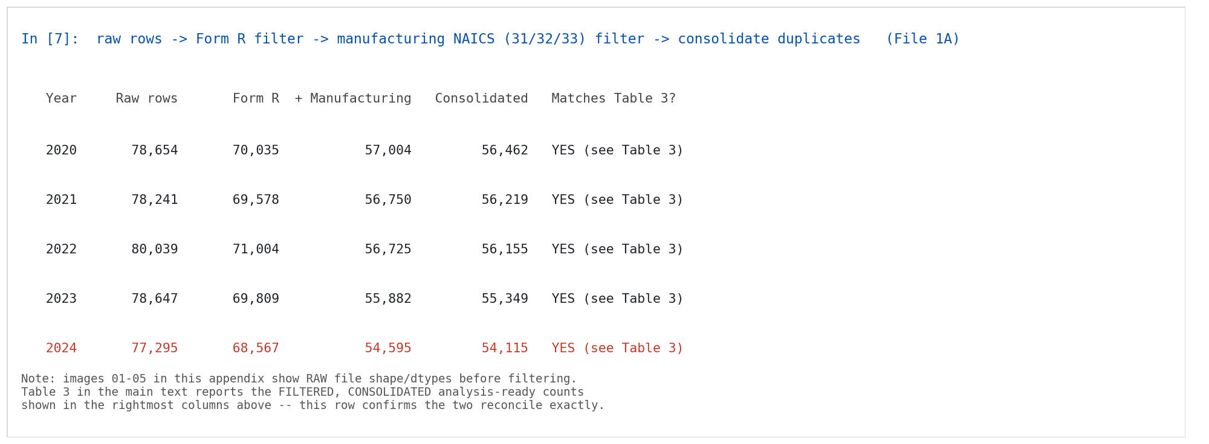

E.3 Dataset Screenshots (All Reporting Years, 2020-2024)
The following screenshots were produced directly from the raw EPA TRI Basic Plus File 1A and File 2A data for every reporting year in scope (see notebooks/01_data_exploration.ipynb). Reporting year 2024 is highlighted in red throughout because it is the held-out test transition (2023 to 2024) used only for the final RQ4 evaluation and never for model development, per the synopsis analytic approach. These images show raw file structure before filtering; see Figure E1 above for the reconciliation with Table 3's filtered, consolidated counts.
Figure E2
Raw Dataset Preview — df.head(3) on File 1A Key Fields, by Reporting Year
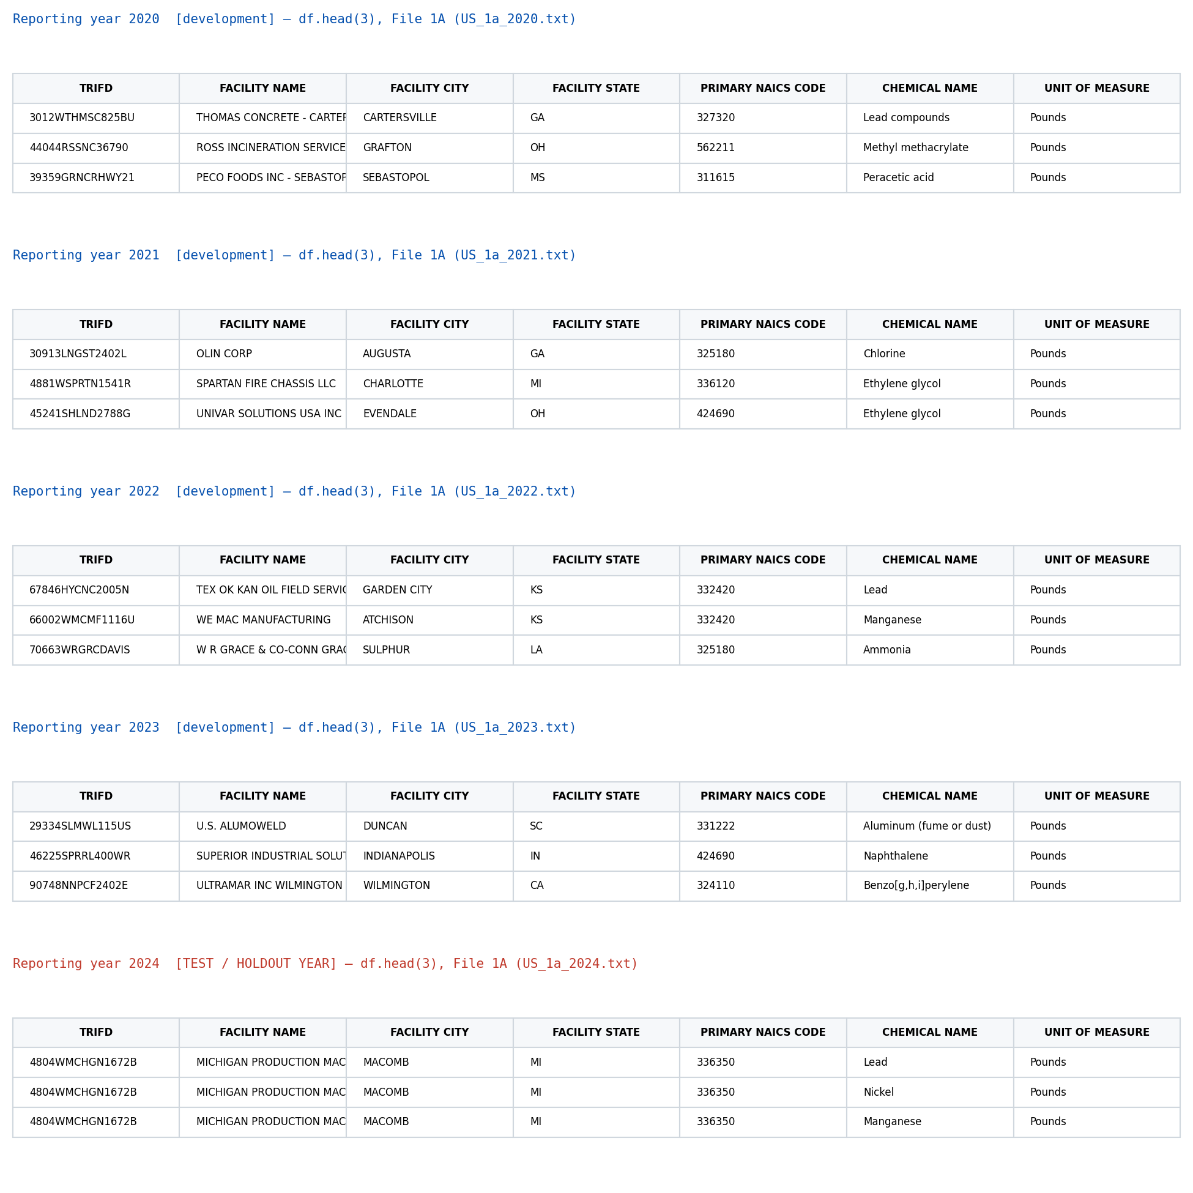
Figure E3
Raw Dataset Shape — Rows and Columns for File 1A and File 2A, by Reporting Year
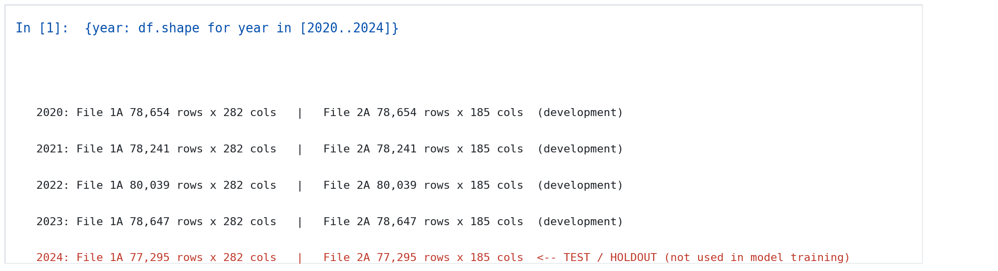
Figure E4
Column Types and Memory Footprint — df.info() Summary, by Reporting Year
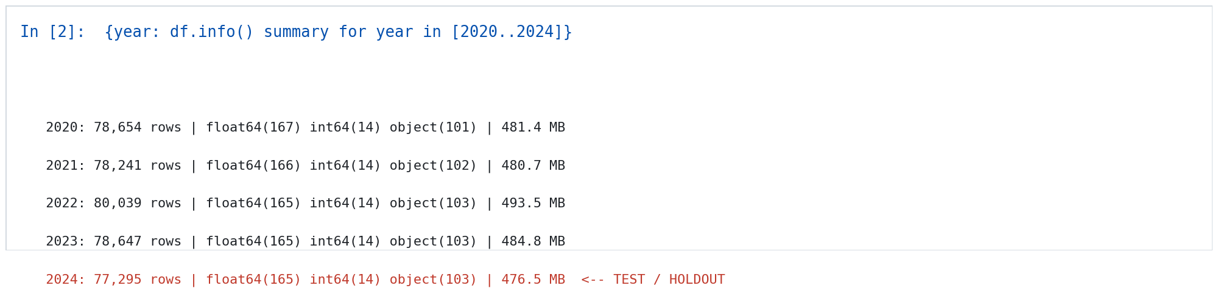
Figure E5
Summary Statistics — df.describe() on PROD RATIO/ACTIVITY INDEX (File 2A), by Reporting Year
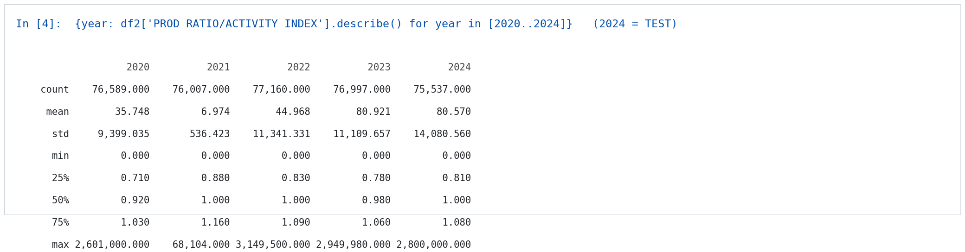
Figure E6
Missing-Values Summary — Top 5 Columns by Missing Count, File 1A, by Reporting Year
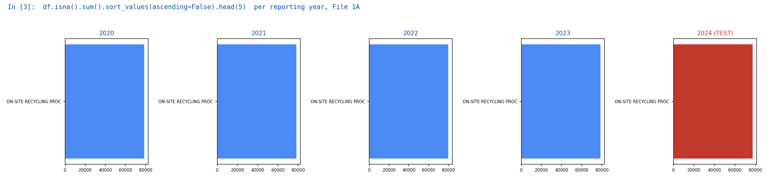
Figure E7
Reported Pollution-Prevention Action Rate by Year, 2020-2024 (Matches Table 3)
