+ Abstraction

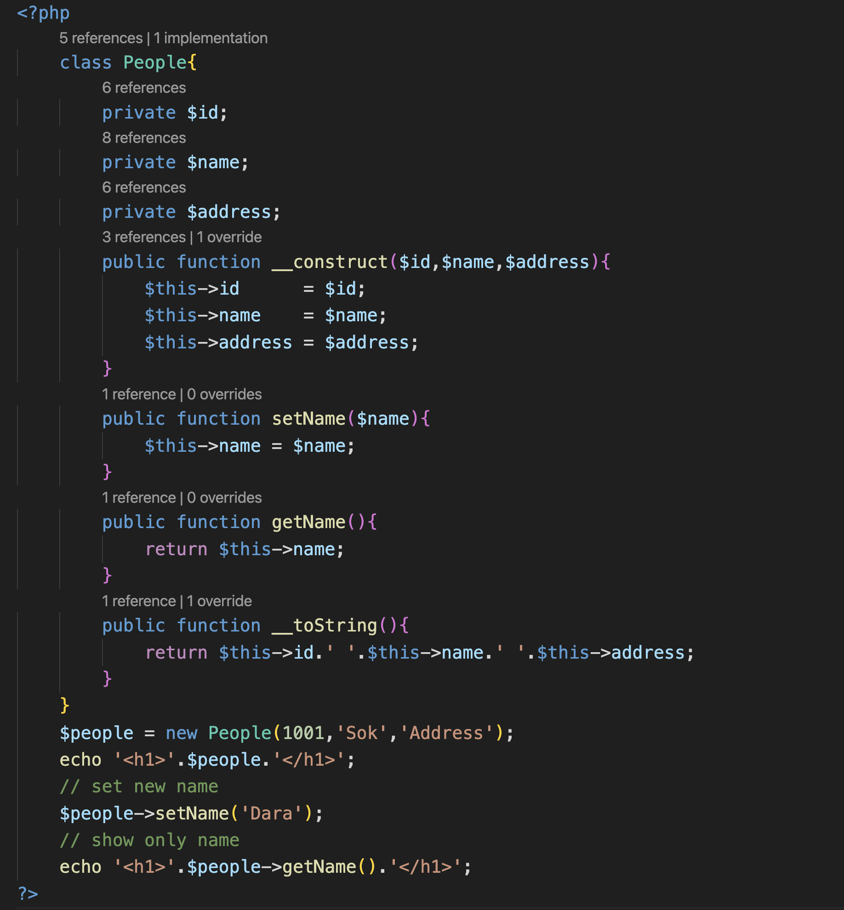

+ Inheritance and Interface

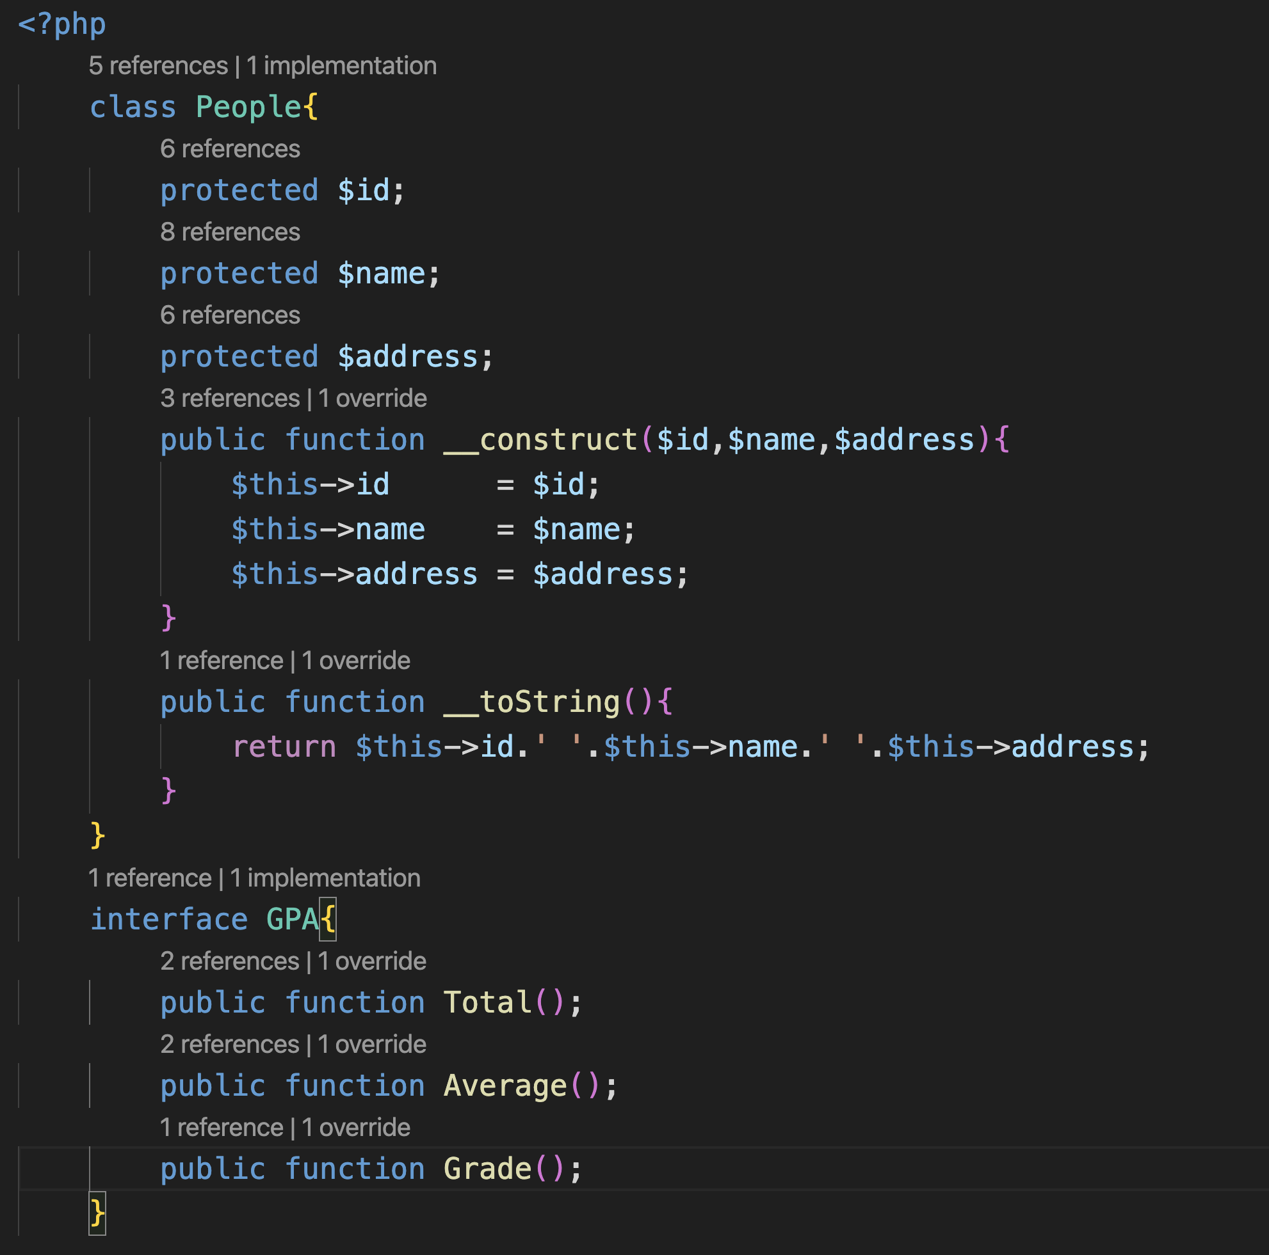

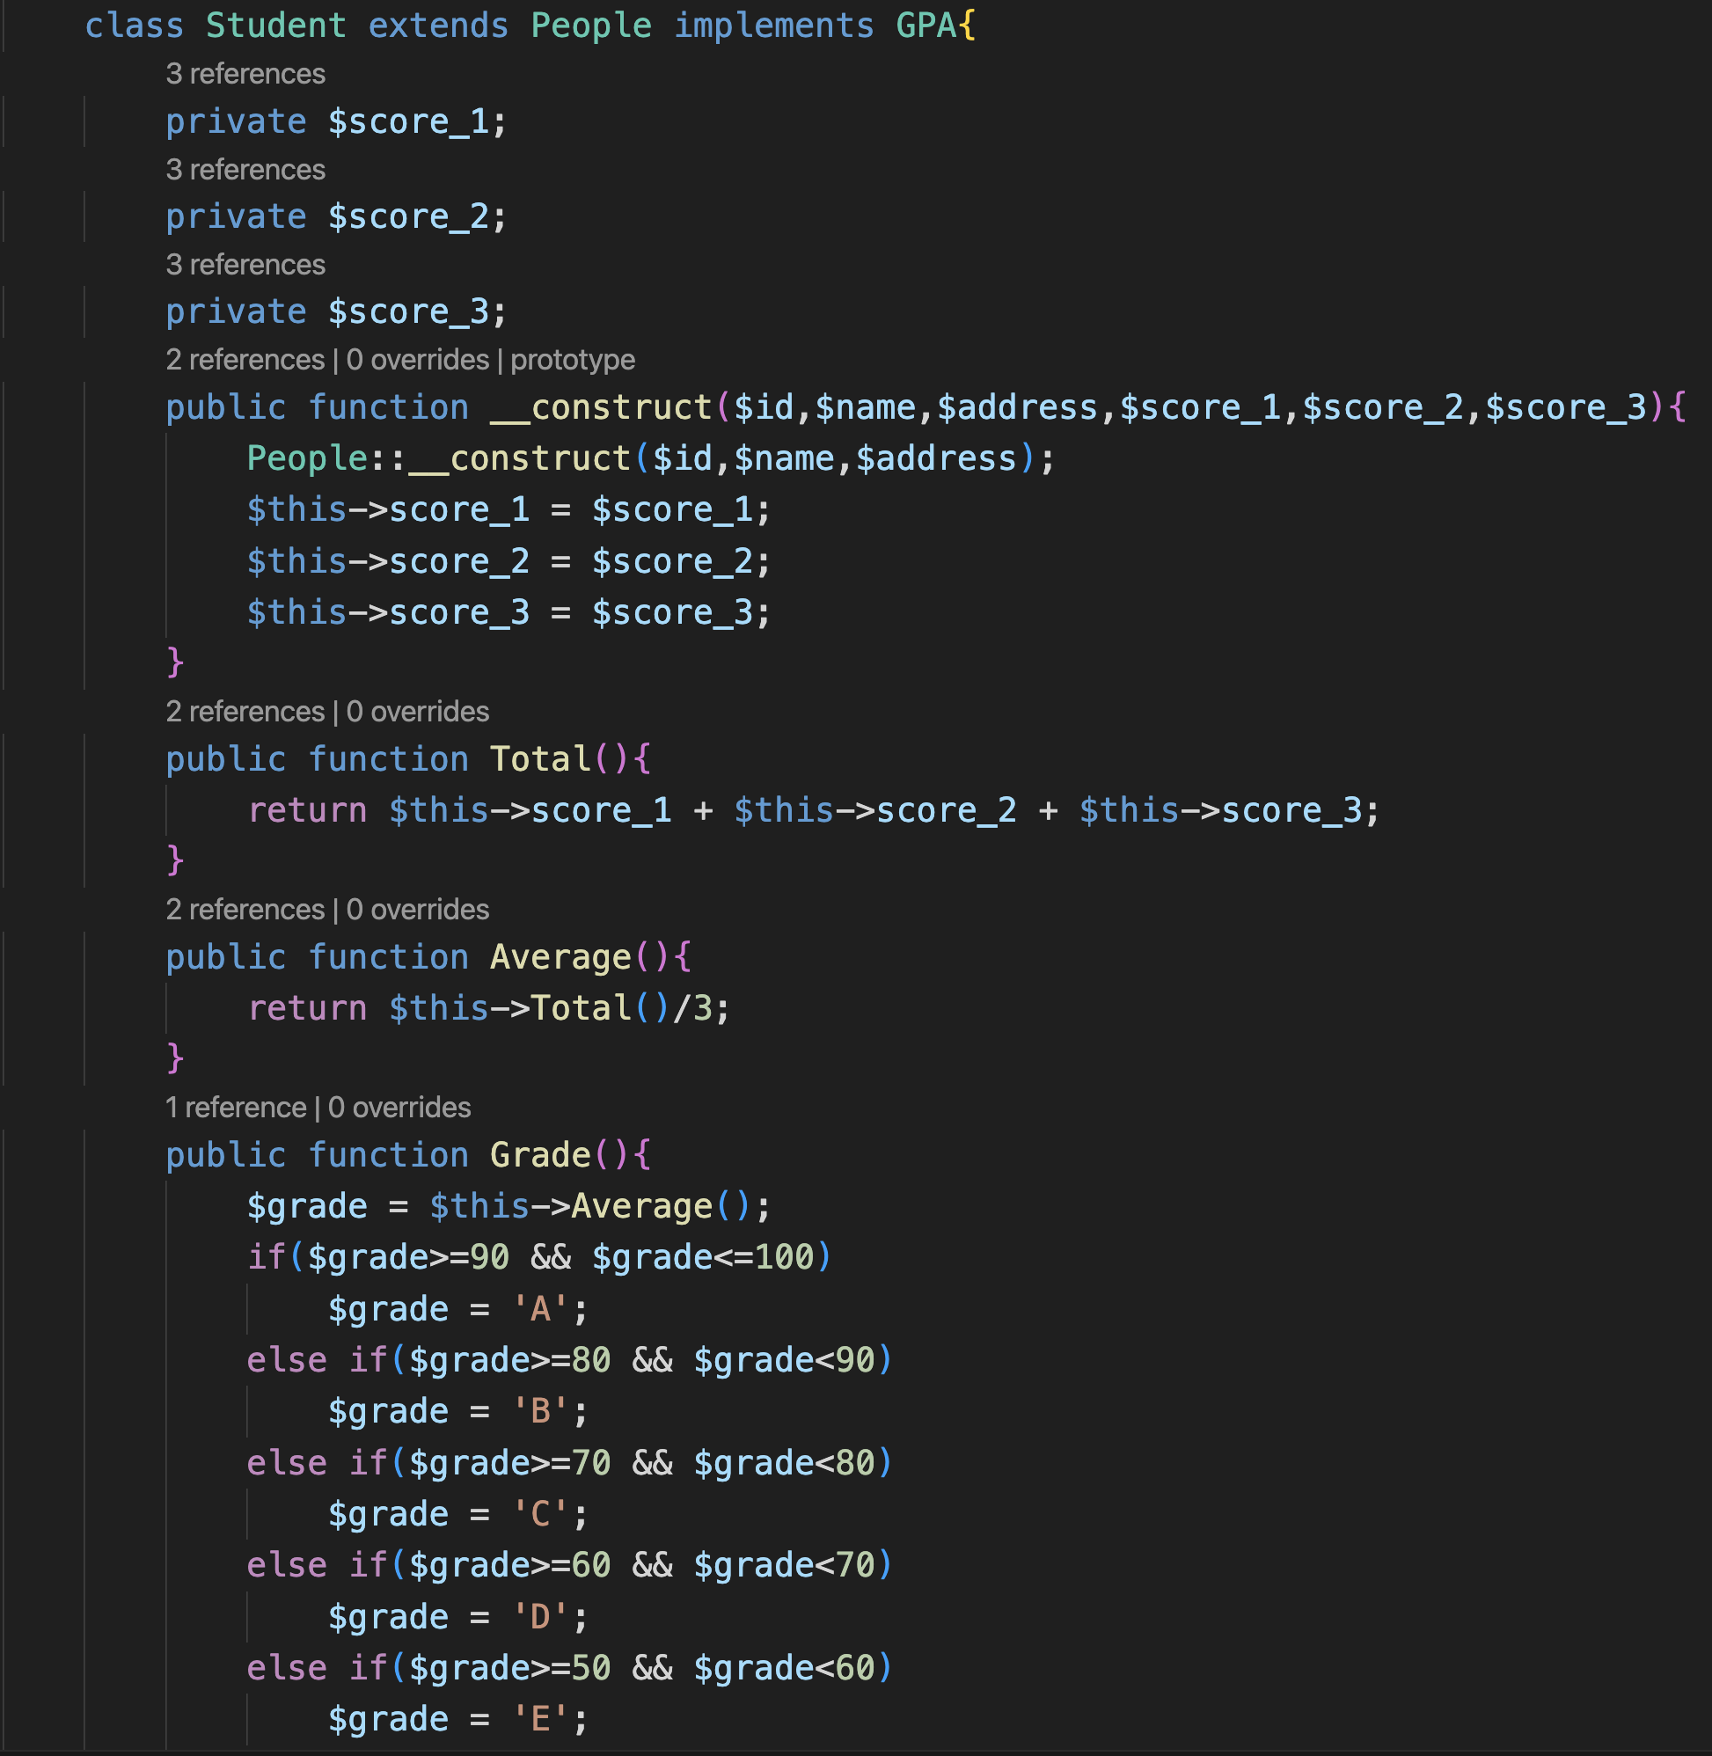

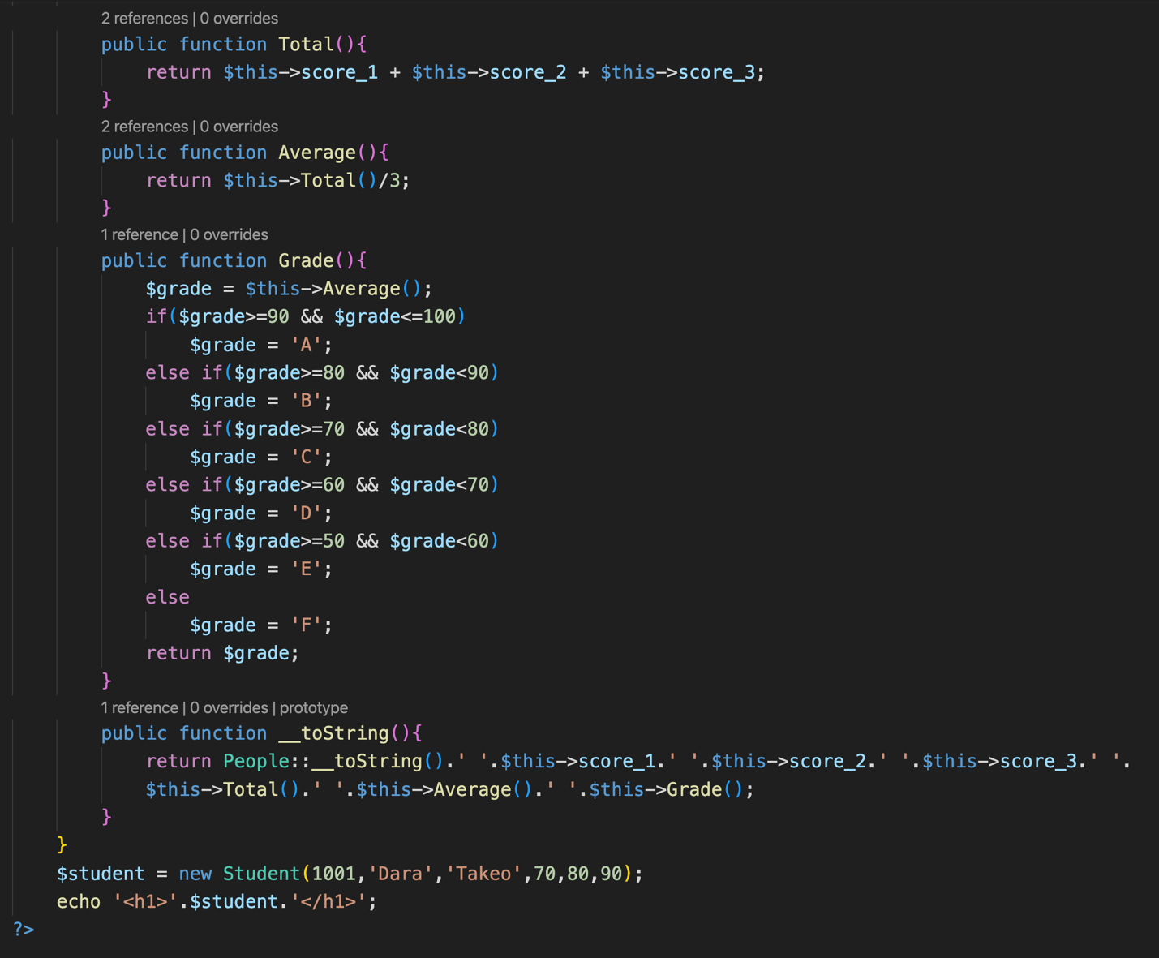

+ Polymorphism with Abstract class

+ Abstract class



