Your first task at EN-CO (extra)

# Task description

If you’re reading this, you’re most probably through with the base task, so congratulations! If you liked the task and want to spend a little more time with it then here are a couple of mind-breakers for you ☺

# Task #1 – Flight time calculation (easy)

Flight logs contain lots of unneccessary fixes at the start and end of the log. This is because the logger stays switched on for a longer time than the actual flight time. We’d love to know the actual flight time though! (based on the time of fixes belonging to actual takeoff and landing)

Your task: Find the fix where speed rises above 40kph at takeoff and the fix where it falls below this speed at landing. Calculate the flight time with these fixes.

*Hint: That distance calculator function in the previous document is there for a reason ☺*

# Task #2 – Log colouring (medium)

The flight drawn on map is currently drawn in one colour. In practice these logs are usually colourful in order to present the change of some kind of flight parameter. Let this parameter be altitude in our example. This can be found here in a ’B’ record:

B1040334619875N01844550E**A00674**0071501609

This represents the altitude above mean sea level in 5 digits, in meter. So currently it’s showing 674m.

Your task: Colour the log in the following way:

* The lowest fix shall be full red
* The highest fix shall be full blue
* Anything in between them shall be coloured with a gradient of red-orange-yellow-green-turquoise-blue in proportion of altitude.

In the image below you can see a continuous climb from the top to the bottom of the image.

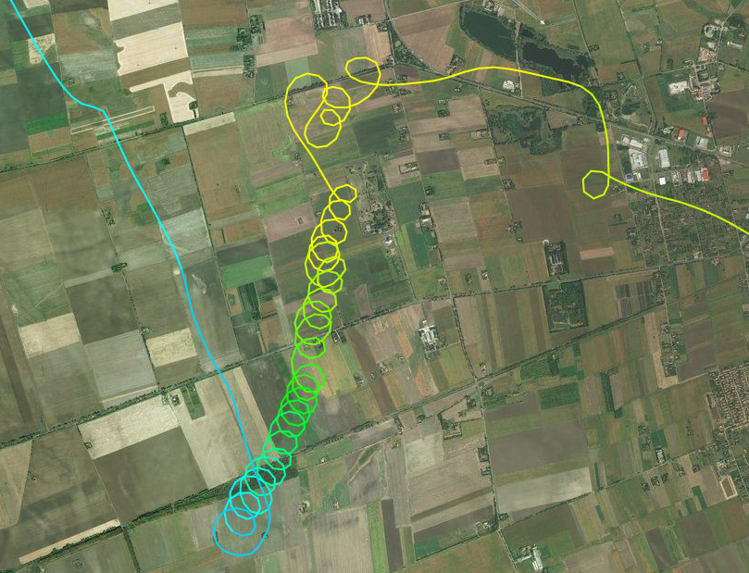

# Task #3 – Distance optimization (hardcore)

A little math ☺   
For sailplane flights it’s always a goal to maximize distance. However, when distance is not measured on a predefined route, we have to find a proper route after the flight that enables us to measure its distance.

Your task: Find those 5 fixes which make the ’First fix of log – Fix 1 – Fix 2 – Fix 3 – Fix 4 – Fix 5 – Last fix of log’ distance maximal. Draw this polyline of 6 segments onto the map.

In the end you should see something like this magenta line:

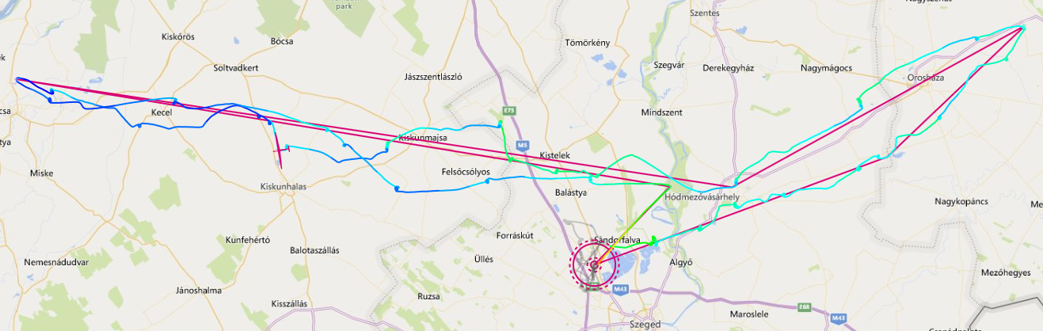

Good luck ☺