Project 2 – Constrained Optimization

AA 222 Spring 2019
Somrita Banerjee

Description of method chosen

I chose the same optimization procedure for all five problems. I used a quadratic penalty function that sums the squares of all positive constraint evaluations. The function I optimized over was . I started with . In order to carry out the 1D optimization, I used a modified version of Hooke-Jeeves where I kept a very close tab on the number of evaluations to prevent any double evaluations. I also kept track of the last feasible x found and only returned that x at the end of the Hooke-Jeeves run. Each Hooke-Jeeves run was limited to 10 evaluations, after which the penalty method would re-adjust the penalty by doubling it and call Hooke-Jeeves with the new penalized function.

I carry out exactly 1000 evaluations for all the functions. I only use f(x) and do not use g(x). Both f(x) and c(x) are called exactly 1000 times.

I have satisfactory results for all the functions except Secret2. Following is a summary of my results from the last submission report from Vocareum:

Name of function | Max Num Function Evals | Max Num Constraint Evals | Avg Score
simple1 | 1000 | 1000 | 0.2615526815854302
simple2 | 1000 | 1000 | -3.7556059604000556
simple3 | 1000 | 1000 | 1.6809371733235292
secret1 | 1000 | 1000 | 158.29562125985518
secret2 | 1000 | 1000 | -2.147483648e9 (constraint violations)

Note that the grading report for secret1 sometimes fails because it is unable to satisfy constraints for all the 5000 initial points for the grading report. However, I’ve submitted 3 times and I’ve never had the submission report fail for secret1. Going by a Piazza post, I decided to suspend further work on secret1.

Plots showing path taken
These plots show the contours of the function (in gray) and the two constraints in red and blue, with darker corresponding to lower values. The constraint contours are plotted only for the levels (-2, -1, 0). We can see the path taken from 3 different starting points, where the red final point gets close to the true minimum known analytically. Note that only the feasible points returned by each 10 run batch of Hooke-Jeeves are plotted here. Any infeasible points have been discarded to make the plot cleaner.
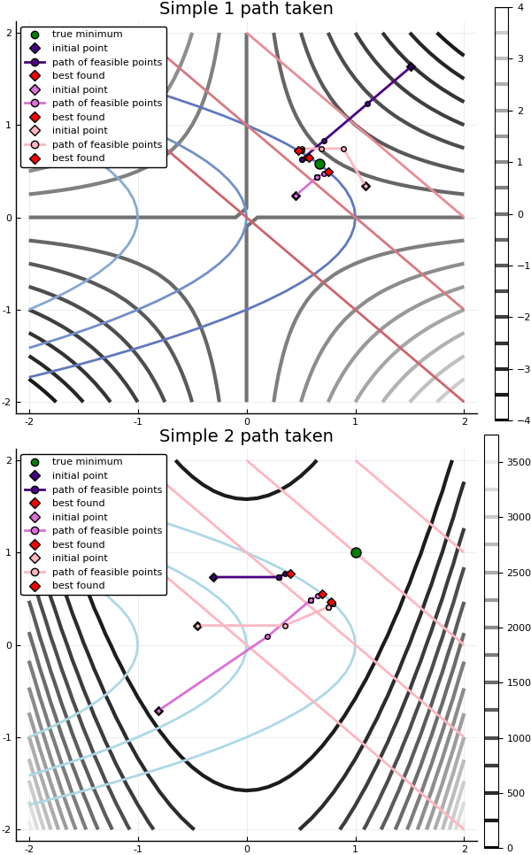

Convergence plots
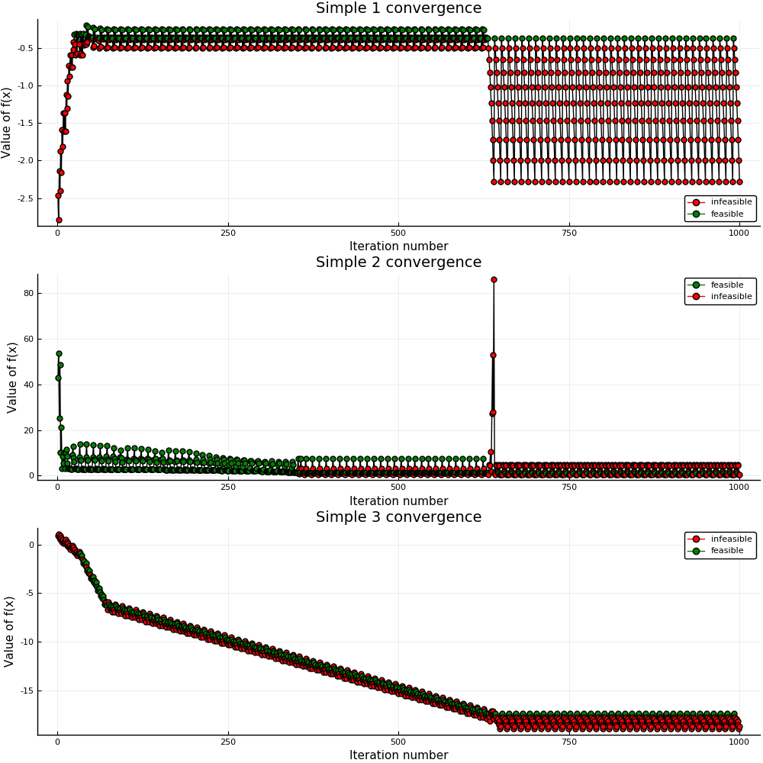
The following plots show the convergence of the optimization for all three simple problems. Only the f(x) function values are plotted here. The impact of the constraints is shown by shading the feasible points in green and infeasible points in red. Notice that in general, the algorithm attempts to first find feasibility, and then attempts to optimize the value of the function for those feasible points. The large oscillations are due to the nature of the Hooke-Jeeves algorithm that searches in all 4 basis directions for a 2D case. In all three cases, we returns the best feasible point that we found across all iterations.

