loop_nemoclaw.sh
The autonomous research orchestrator behind the AutoTherm demo

1. Overview
loop_nemoclaw.sh is a 400-line bash script running on the head node of a 4-node DGX Spark cluster. It coordinates an LLM (Nemotron-Super-120B served by vLLM) and a GROMACS molecular-dynamics pipeline into a closed-loop autonomous research agent that searches for thermal interface material compositions with lower thermal resistance.
It is an example of the open-shell design pattern: every step is a plain Unix process launched by bash, every artifact is a regular file, and every state change is captured by git. There is no opaque orchestration framework — anyone can read the script and understand exactly what runs.

2. System architecture
The cluster has four DGX Spark nodes connected by a ConnectX-7 RDMA fabric. nemoclaw runs on node 0 (the head node) where it has local access to the LLM, the project files, and a paramiko/ssh connection to the three GPU compute nodes.
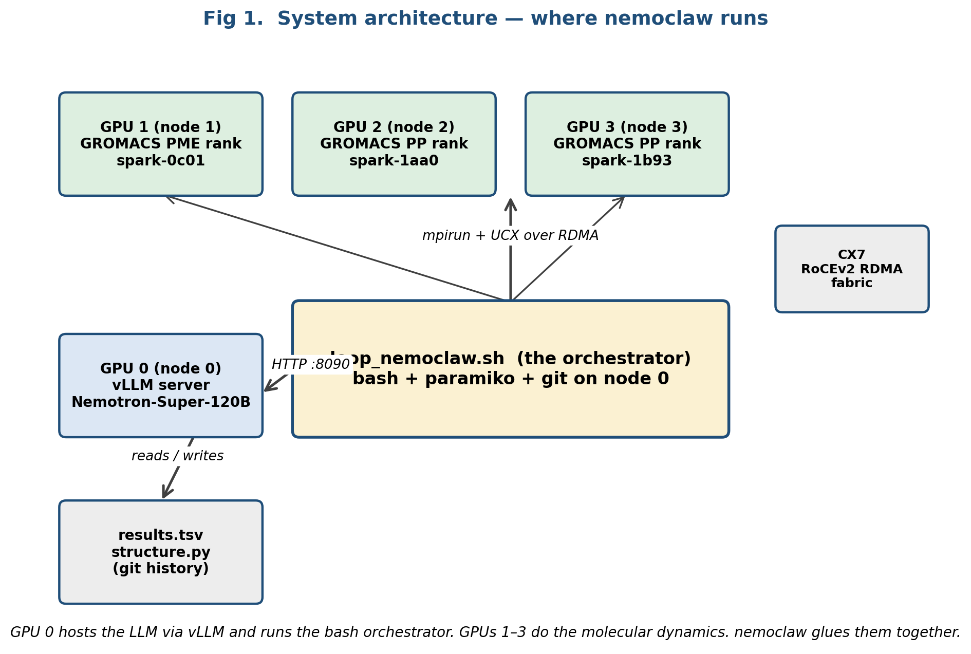
Figure 1. Physical layout. nemoclaw sits on node 0; GROMACS mdrun is dispatched to GPUs 1–3.

3. The closed loop
Every iteration follows the same 8-step cycle. The loop runs for a configurable number of iterations (100 by default) or until the user signals stop.
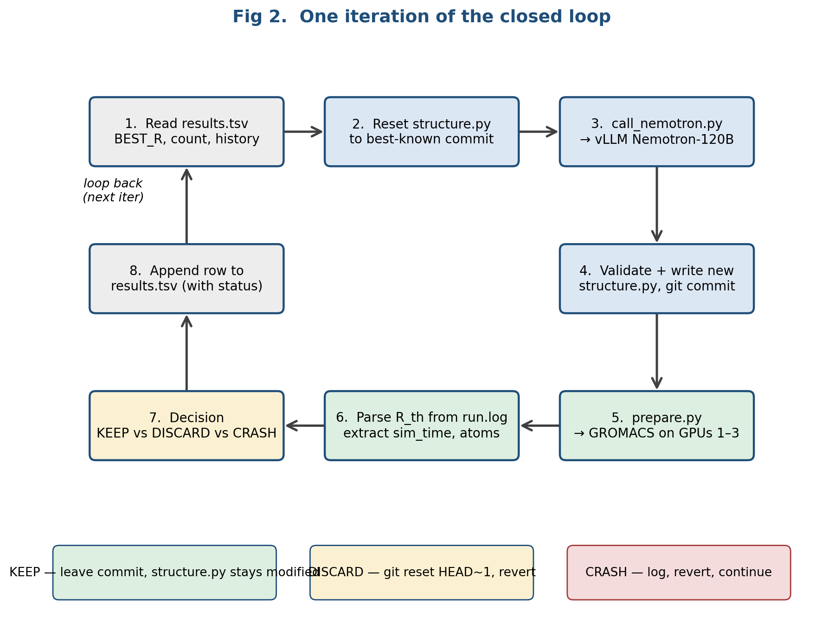
Figure 2. One iteration. Steps 1–4 prepare a new design, step 5 simulates it, steps 6–8 score and record it.

What each step actually does
- 1. Read results.tsv: parse every prior keep / discard / crash row to compute the running best R_th and the experiments-tried count.
- 2. Reset structure.py: git-checkout the structure.py from the best-known commit so the LLM always starts from the best design, not from a discarded detour.
- 3. Call the LLM: call_nemotron.py builds a system + user prompt (history, constraints, current best) and POSTs to the local vLLM endpoint on port 8090.
- 4. Validate and commit: the LLM's Python code block is parsed, py_compile is run, COMPOSITION values are checked to sum to 1.0, then the new structure.py is written and git-committed.
- 5. Simulate: prepare.py orchestrates grompp + mpirun for em, prewarm, equilibration and production NVT on 3 cluster GPUs over UCX RDMA.
- 6. Extract R_th: prepare.py parses energy outputs and emits a single thermal_resistance value plus a sim_time stamp.
- 7. Decide: if R_th < best, status=keep; if worse, status=discard and the iteration commit is reverted via git reset.
- 8. Append: a tab-separated row is appended to results.tsv. The next iteration immediately sees this history.

4. Call sequence and file flow
The sequence below shows how control and data move between the five actors during a single iteration. Time flows downward.
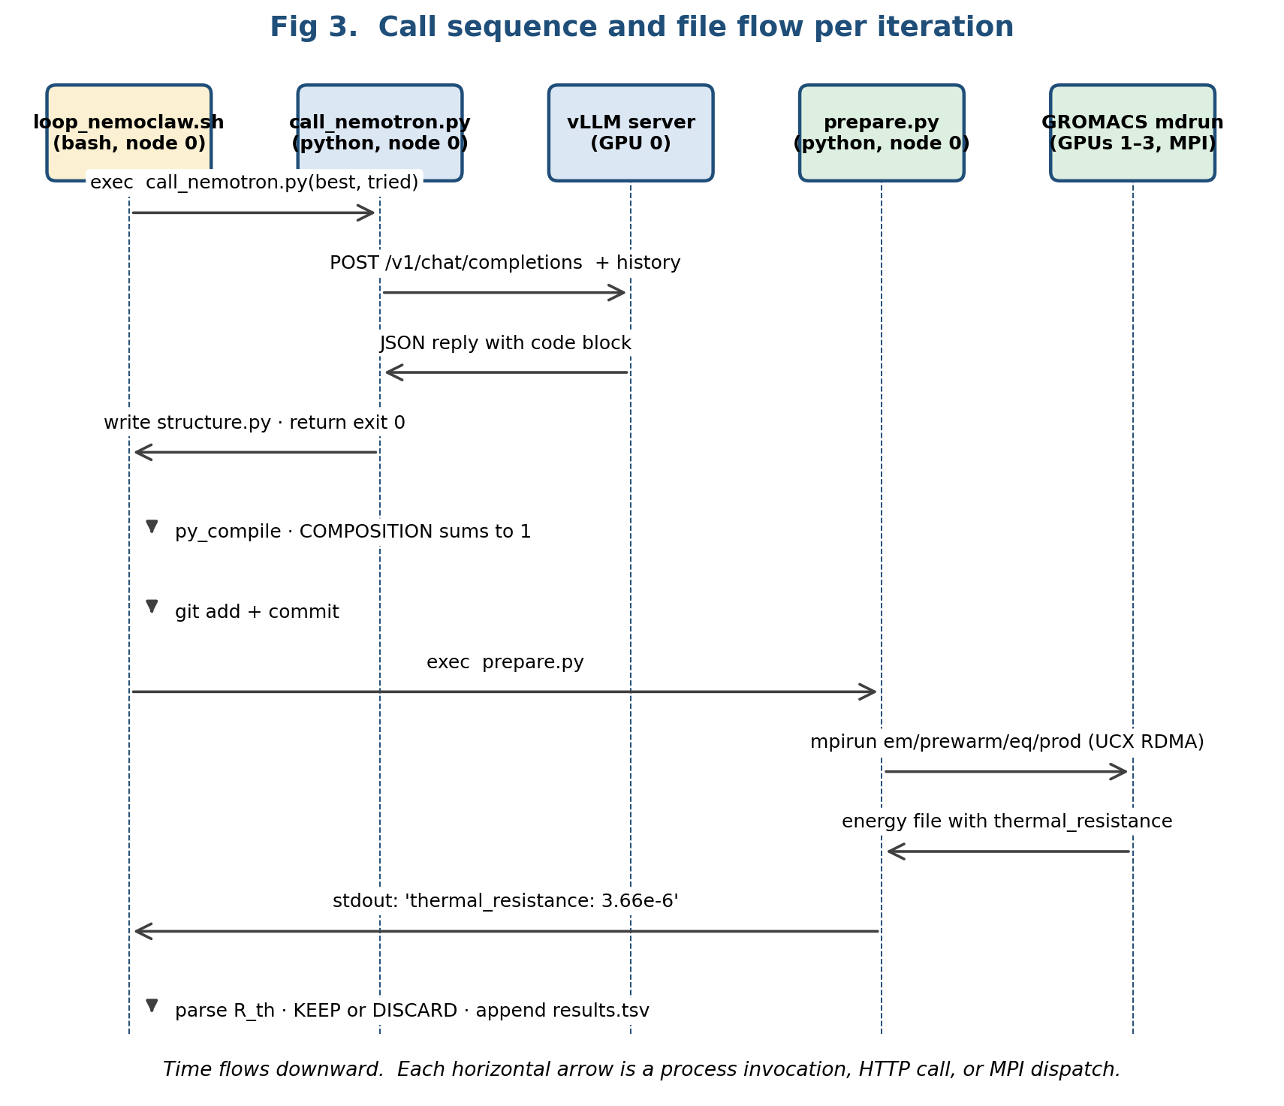
Figure 3. Call sequence. Vertical dashed lines are lifelines; horizontal arrows are process calls or HTTP/MPI dispatches.

Key files exchanged
- structure.py — the design variables the LLM rewrites. 28 lines.
- results.tsv — append-only history of every iteration (commit, R_th, sim_time, status, description).
- em.tpr / prod.tpr / eq.tpr — GROMACS binary inputs built by prepare.py.
- run.log — stdout of prepare.py for the current iteration (parsed for thermal_resistance).

5. Security — how the open-shell model isolates risk
The script accepts code generated by an LLM and executes it as part of the simulation pipeline. That sounds dangerous; in practice, the open-shell design uses six independent layers of isolation, each one of which is easy to inspect because the whole pipeline is just files and processes.
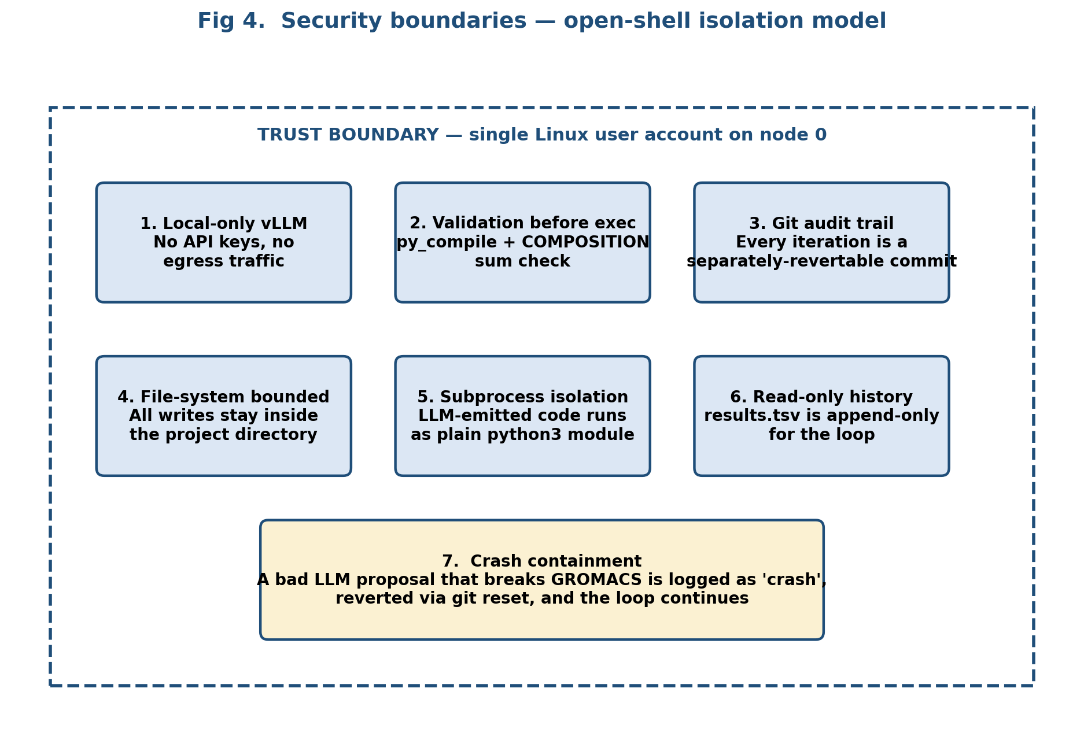
Figure 4. Six independent security controls plus crash containment make the LLM-in-the-loop safe.

Why "open shell" is the safe choice here
- Local-only vLLM. The model runs on the same node as the loop; no API keys, no external endpoints, no egress traffic that could leak proprietary research data.
- Validation before exec. LLM output is structurally parsed and syntactically compiled before any execution; semantic checks ensure composition fractions sum to 1.0 and stay within bounds.
- Git audit trail. Every iteration is its own commit; bad designs are reverted via git reset; the entire research history is auditable with git log.
- File-system bounded. The script only writes inside the project directory; GROMACS scratch is in /tmp on the compute nodes.
- Subprocess isolation. LLM-emitted code is imported as a plain Python module by prepare.py; no shell injection, no arbitrary command substitution.
- Read-only history during planning. The LLM never writes to results.tsv directly — only the orchestrator appends rows after ground-truth simulation, so the model cannot fake its own track record.
- Crash containment. If an LLM proposal causes mdrun to segfault or em to diverge, the iteration is marked 'crash', git-reverted, and the loop continues from the last known-good design.

6. Robustness and failure handling
Out of 100 iterations on a 500k-atom TIM benchmark, the loop survived roughly 40 different LLM proposals, 6 simulation crashes, 2 vLLM timeouts and 1 GROMACS GPU memory event — all without operator intervention. The mechanisms that make this possible:
- vLLM retry: call_nemotron.py retries up to 3 times with a 300-second per-call timeout, then surfaces a clean exit code so the loop can skip the iteration.
- GROMACS crash trap: prepare.py wraps each mdrun in a subprocess with a timeout; non-zero exit triggers a 'crash' row in results.tsv without losing prior best.
- Git revert on bad design: discard always uses git reset HEAD~1 so the working tree returns to the last keep, never a half-applied edit.
- Validation locks: sed-based invariant locks in the loop ensure fields like N_TOTAL and SIM_TIME_PS cannot be widened by the LLM (the operator sets the simulation budget, not the model).

7. Operator reference

Files this loop owns
loop_nemoclaw.sh — the bash orchestrator (this document)
call_nemotron.py — LLM HTTP client + prompt builder
prepare.py — GROMACS pipeline + R_th extractor
structure.py — composition / LJ params (LLM-mutated)
results.tsv — append-only history of all iterations

Starting and stopping the loop
# Start (run 100 iterations):
$ tmux new -s autotherm 'bash loop_nemoclaw.sh 100'
# Stop early (graceful):
$ tmux send-keys -t autotherm C-c Enter
# Inspect progress:
$ tail -f results.tsv
$ git log --oneline -20

Reading results.tsv
commit R_th sim_time_s status description
0469a0c 3.66e-06 782.8 discard iter-36: ...
8498642 3.26e-06 633.3 keep iter-27: ... ← current best

